Français
Tile Drainage Act
R.R.O. 1990, REGULATION 1032
BORROWING BY-LAWS, DEBENTURES AND LOANS
Note: This Regulation was revoked on November 21, 2012. (See: O. Reg. 382/12, ss. 9, 10)
Last amendment: O. Reg. 382/12.
This is the English version of a bilingual regulation.
Skip Table of Contents
CONTENTS
 |  | Sections
 |  | 1-8
Schedule
Form 1 | Borrowing by-law — for use by municipalities not within district or regional municipalities
Form 2 | Borrowing by-law — for use by municipalities within district or regional municipalities
Form 3 | Borrowing by-law — for use by district or regional municipalities
Form 4 | Tile drainage debenture
Form 5 | Tile drainage debenture — for use by district or regional municipalities
Form 6 | Affidavit of clerk
Form 7 | Application for loan
Form 8 | Inspection and completion certificate
Form 9 | Offer to sell
Form 10 | Offer to sell
Form 11 | Rating by-law
1. (1) The borrowing by-law referred to in subsection 2 (1) of the Act, for use by municipalities not within district or regional municipalities, shall be in Form 1. R.R.O. 1990, Reg. 1032, s. 1 (1).
(2) The borrowing by-law referred to in subsection 2 (1) of the Act, for use by municipalities within district or regional municipalities, shall be in Form 2. R.R.O. 1990, Reg. 1032, s. 1 (2).
2. The borrowing by-law, for use by district or regional municipalities on behalf of an area municipality, shall be in Form 3. R.R.O. 1990, Reg. 1032, s. 2.
3. (1) The debenture referred to in subsection 2 (1) of the Act, for use by municipalities not within district or regional municipalities, shall be in Form 4. R.R.O. 1990, Reg. 1032, s. 3 (1).
(2) The debenture referred to in subsection 2 (1) of the Act, for use by district or regional municipalities on behalf of an area municipality, shall be in Form 5. R.R.O. 1990, Reg. 1032, s. 3 (2).
4. The affidavit of the clerk of the municipality referred to in subsection 2 (5) of the Act shall be in Form 6. R.R.O. 1990, Reg. 1032, s. 4.
5. The application for a loan referred to in section 3 of the Act shall be in Form 7. R.R.O. 1990, Reg. 1032, s. 5.
6. The inspection and completion certificate referred to in section 4 of the Act shall be in Form 8. R.R.O. 1990, Reg. 1032, s. 6.
7. (1) The offer to sell a debenture referred to in subsection 5 (8) of the Act, for use by a municipality, shall be in Form 9. R.R.O. 1990, Reg. 1032, s. 7 (1).
(2) The offer to sell a debenture referred to in subsection 5 (8) of the Act, for use by a district or regional municipality, shall be in Form 10. R.R.O. 1990, Reg. 1032, s. 7 (2).
8. The rating by-law referred to in section 8 of the Act shall be in Form 11. R.R.O. 1990, Reg. 1032, s. 8.
the corporation of the . . . . . . . . . . . . . . . . . . . . . . . . . . . . . . . .
by-law no. . . . . . . . . . . . . . . . . . . . . .
Schedule
. . . . . . . . . . . . . . . . . . . . . . . . . . . . . . . . . . . . . . . . . . . . . . . . . . . . . . . . . . . . . . . . . . . . . . . . . . . . . .

Name and Address of Owner | Description of Land Drained | Proposed Date of Loan | Sum to be Loaned $ | Annual Rate to be Imposed $
 | *Total Principal of Debenture and Total Sum Shown on By-Law |  | $
 |  |  | *Total
R.R.O. 1990, Reg. 1032, Sched.
Form 1
BORROWING BY-LAW — For Use by Municipalities Not Within District or Regional Municipalities
Tile Drainage Act
Insert regs\graphics\1990\1032\032001au.tif
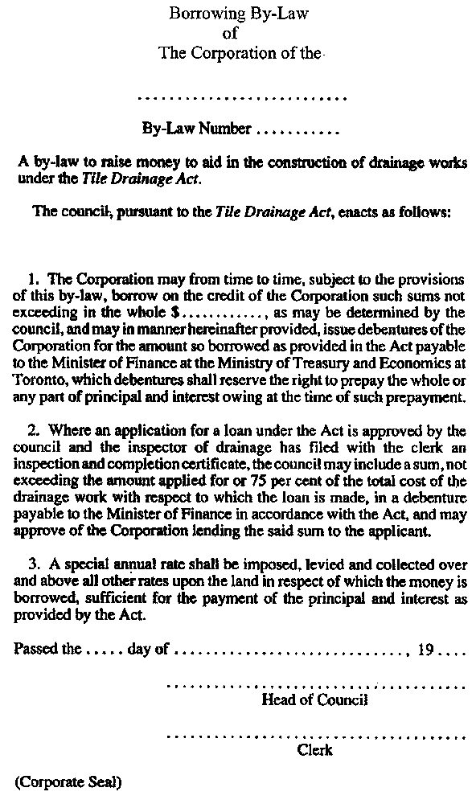
R.R.O. 1990, Reg. 1032, Form 1.
Form 2
BORROWING BY-LAW — For Use by Municipalities Within District or Regional Municipalities
Tile Drainage Act
Insert regs\graphics\1990\1032\032002au.tif
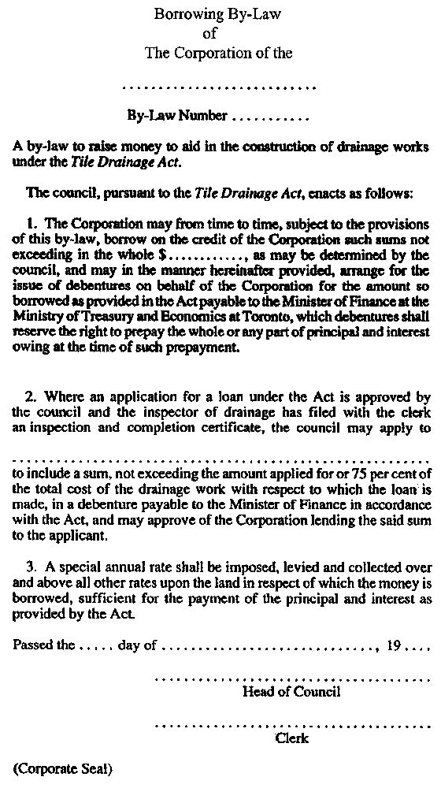
R.R.O. 1990, Reg. 1032, Form 2.
Form 3
BORROWING BY-LAW — For Use by District or Regional Municipalities
Tile Drainage Act
Insert regs\graphics\1990\1032\032003au.tif
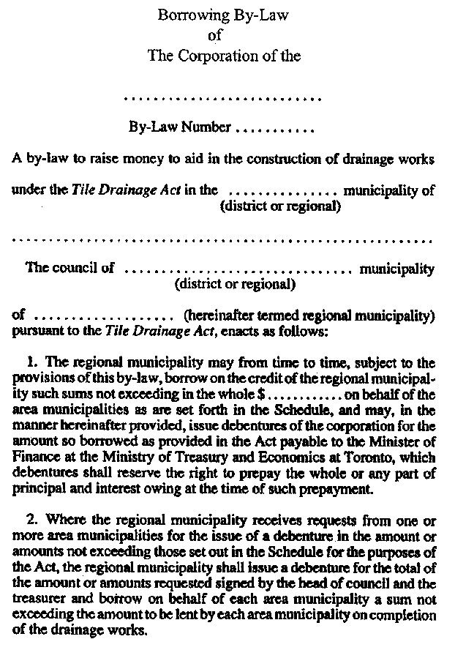
Insert regs\graphics\1990\1032\032003bu.tif
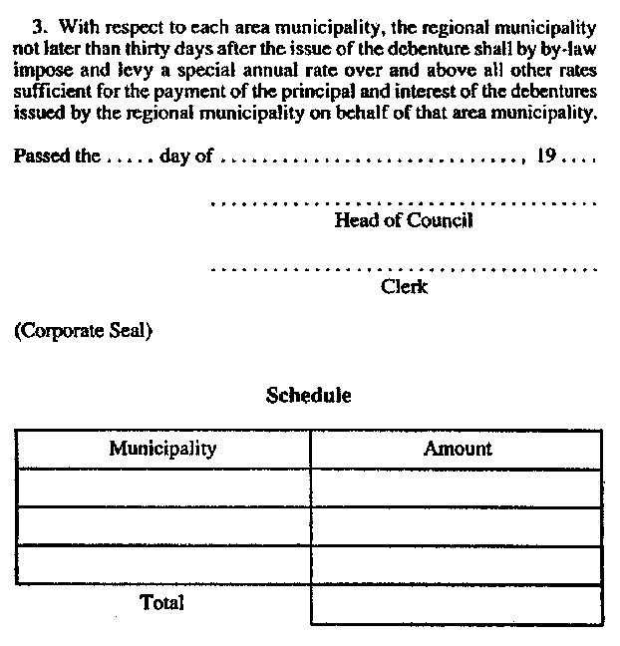
R.R.O. 1990, Reg. 1032, Form 3.
Form 4
TILE DRAINAGE DEBENTURE
Tile Drainage Act
Insert regs\graphics\1990\1032\032004au.tif
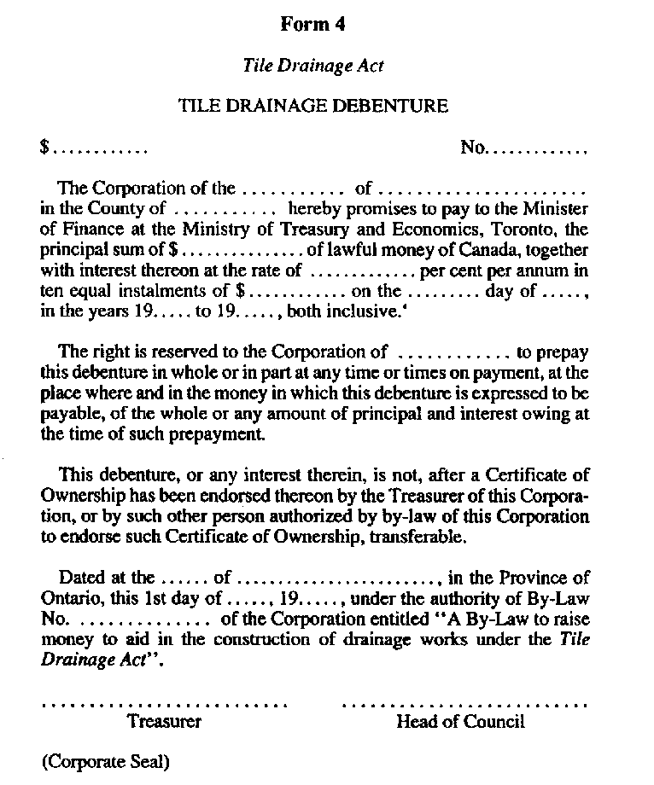
R.R.O. 1990, Reg. 1032, Form 4.
Form 5
TILE DRAINAGE DEBENTURE — For Use by District or Regional Municipalities
Tile Drainage Act
Insert regs\graphics\1990\1032\032005au.tif
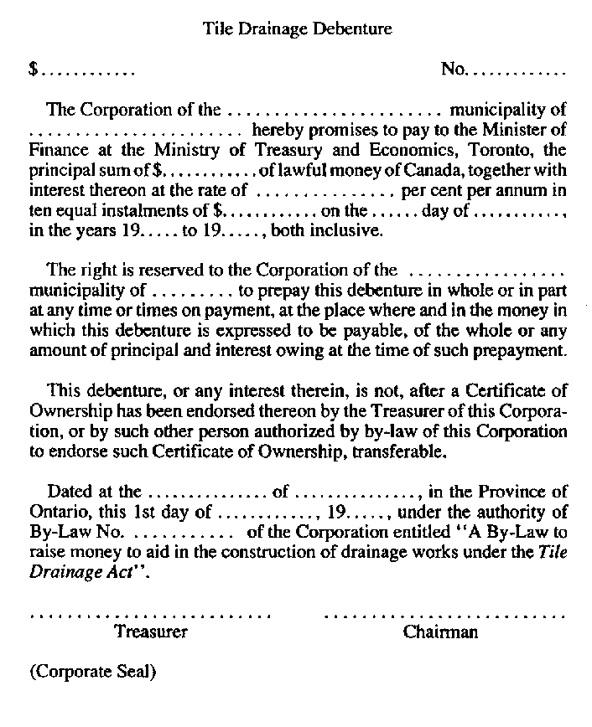
R.R.O. 1990, Reg. 1032, Form 5.
Form 6
AFFIDAVIT OF CLERK
Tile Drainage Act
Insert regs\graphics\1990\1032\032006au.tif
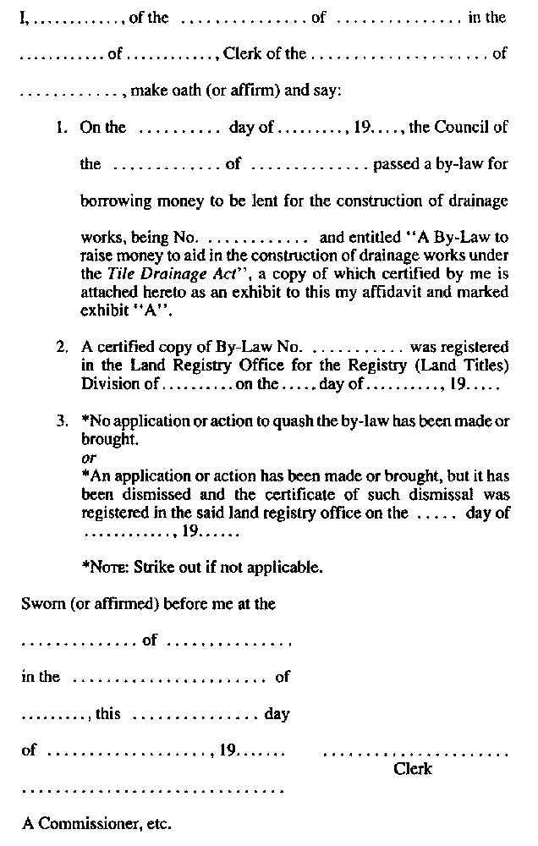
R.R.O. 1990, Reg. 1032, Form 6.
Form 7
APPLICATION FOR LOAN
Tile Drainage Act
Insert regs\graphics\1990\1032\032007au.tif
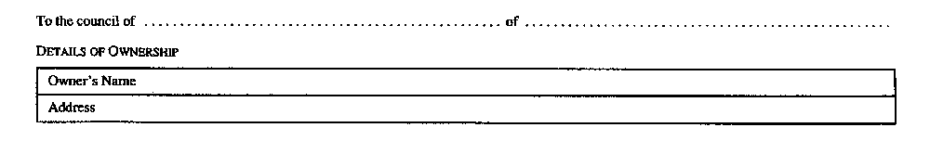
Insert regs\graphics\1990\1032\032007bu.tif
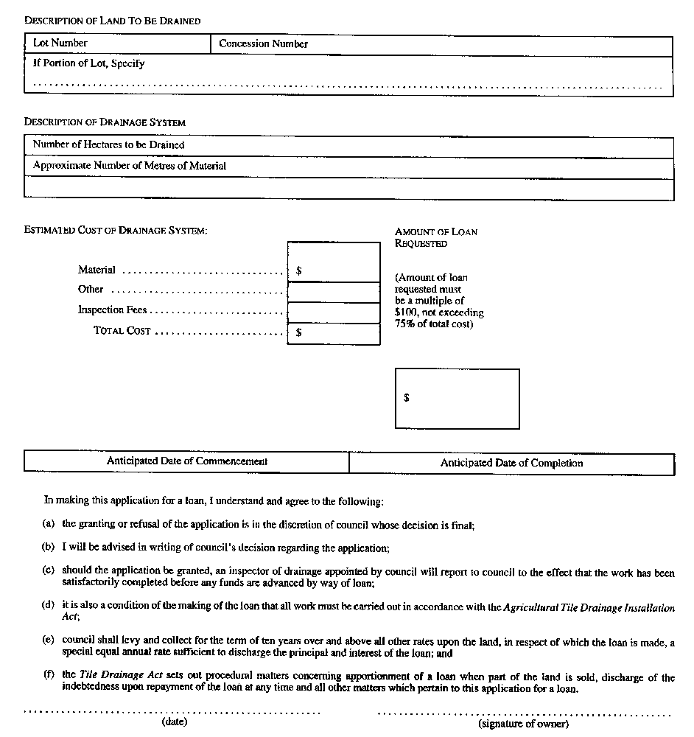
R.R.O. 1990, Reg. 1032, Form 7.
Form 8
INSPECTION AND COMPLETION CERTIFICATE
Tile Drainage Act
Insert regs\graphics\1990\1032\032008au.tif
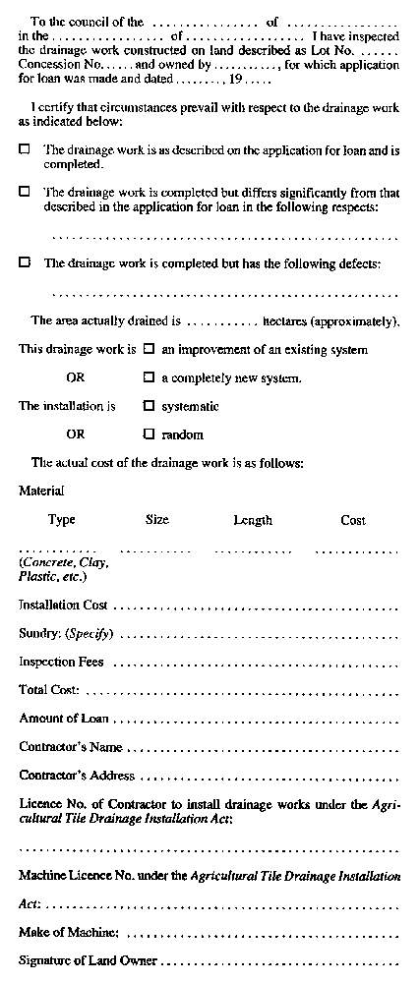
Insert regs\graphics\1990\1032\032008bu.tif
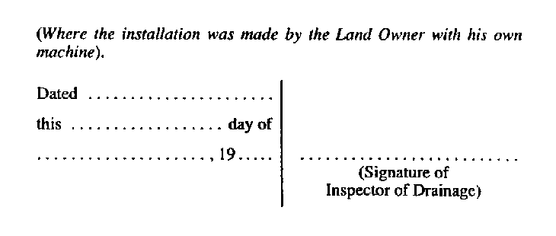
R.R.O. 1990, Reg. 1032, Form 8.
Form 9
OFFER TO SELL
Tile Drainage Act
Insert regs\graphics\1990\1032\032009au.tif
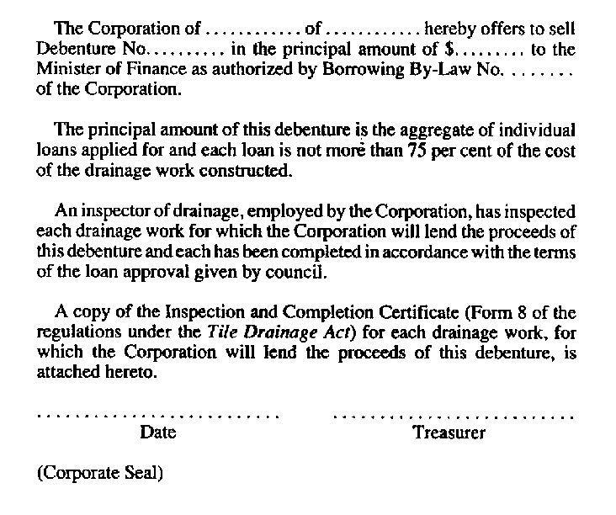
R.R.O. 1990, Reg. 1032, Form 9.
Form 10
OFFER TO SELL
Tile Drainage Act
Insert regs\graphics\1990\1032\032010au.tif
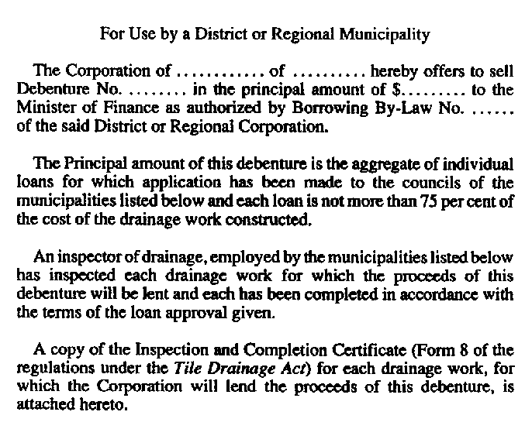
Insert regs\graphics\1990\1032\032010bu.tif
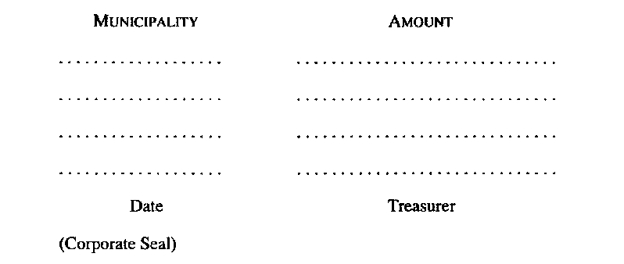
R.R.O. 1990, Reg. 1032, Form 10.
Form 11
RATING BY-LAW
Tile Drainage Act
Insert regs\graphics\1990\1032\032011au.tif
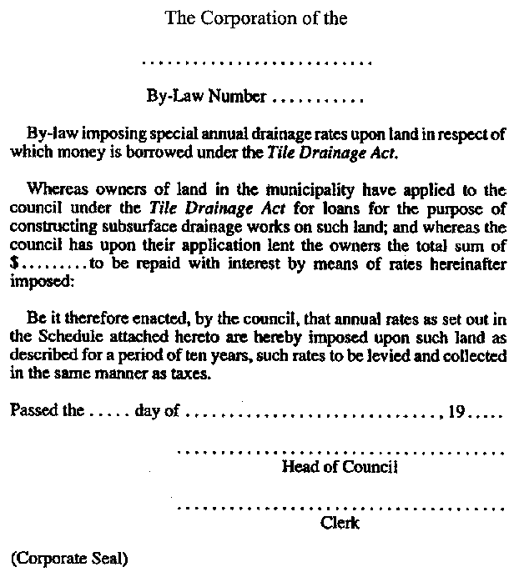
R.R.O. 1990, Reg. 1032, Form 11.

Français

Back to top

