Community Small Business Investment Funds Act, 1992
Loi de 1992 sur les fonds communautaires de placement dans les petites entreprises
ONTARIO REGULATION 591/92
SPECIFIED EMPLOYEE OWNERSHIP CORPORATIONS
Note: This Regulation was revoked on September 3, 2010. See: O. Reg. 339/10, ss. 1, 2.
Last amendment: O. Reg. 339/10.
This Regulation is made in English only.
Skip Table of Contents
CONTENTS
 |  | Sections
PART I | GENERAL
 | Interpretation and Application | 1-2
 | Financial Statements | 3
PART II | TRADING IN PRESCRIBED SHARES
 | Regulation of Distributions | 4-6
 | Disclosure Documents | 7-16
 | Prohibited Actions | 17
 | Trust Arrangements | 18
 | Trade Confirmation | 19
 | Independent Advisers | 20
PART III | CONTINUOUS DISCLOSURE
 | Prohibited Trading and Tipping | 21
 | Disclosure of Material Developments | 22
 | Financial Disclosure | 23-27
 | Other Disclosure | 28
 | Incorporation of Continuous Disclosure Documents into Disclosure Documents | 29-30
PART IV | INSIDER TRADING AND REPORTING | 31-32
PART V | PROXIES AND PROXY SOLICITATION | 33
PART VI | TAKE-OVER BIDS AND ISSUER BIDS | 34
PART VII | EXEMPTION | 35
Form 1 | Disclosure document
Form 2 | Material development report of a specified employee ownership corporation
PART I
GENERAL
Interpretation and Application
1. (1) A word or expression in this Regulation that is defined or interpreted in the Securities Act has the same meaning as in the Securities Act unless the word or expression is otherwise defined or interpreted in the Labour Sponsored Venture Capital Corporations Act, 1992 or this Regulation. O. Reg. 591/92, s. 1 (1).
(2) In this Regulation,
“auditor’s report”, “generally accepted accounting principles” and “generally accepted auditing standards” mean the report, principles and standards, respectively, recommended in the Handbook of the Canadian Institute of Chartered Accountants, if a recommendation that is applicable in the circumstances has been made in the Handbook;
“continuous disclosure document” means a document filed by a specified employee ownership corporation under Part III, other than,
(a) a document filed under subsection 22 (2) so long as the document remains filed on a confidential basis, and
(b) a document filed under section 28;
“eligible business” means an eligible business as defined in Part II of the Act;
“material development”, with respect to a specified employee ownership corporation, means a change in the business, operations or capital of the corporation or the eligible business in which it has invested that would reasonably be expected to have a significant effect on the price or value of the prescribed shares of the corporation and includes a decision to implement such a change made by the board of directors of the corporation or by senior management of the corporation who believe that confirmation of the decision by the board of directors is probable;
“prescribed share” means a Class A share of a specified employee ownership corporation or any other share of a prescribed class of shares of a specified employee ownership corporation;
“promoter” means a promoter as defined in the Securities Act but excludes an eligible employee of an eligible business, a trade union and an association or federation of trade unions, in respect of his, her or its activities in assisting, directly or indirectly,
(a) in the foundation, organization or substantial reorganization of a specified employee ownership corporation or the eligible business in which a specified employee ownership corporation proposes to invest or has invested, or
(b) in the registration of a specified employee ownership corporation under the Act,
if such activities are incidental to his, her or its principal occupation. O. Reg. 591/92, s. 1 (2).
(3) For the purpose of paragraph (c) of the definition of “distribution” in subsection 1 (1) of the Securities Act, employees of an eligible business who hold prescribed shares of a specified employee ownership corporation that has invested or proposes to invest in the eligible business shall be deemed, collectively, not to be a person or combination of persons solely by reason of their relationship as employees or the existence of a collective agreement or other contract governing their employment with the eligible business. O. Reg. 591/92, s. 1 (3).
2. This Regulation does not apply in respect of a specified employee ownership corporation that is a reporting issuer. O. Reg. 591/92, s. 2.
Financial Statements
3. (1) The financial statements permitted or required by this Regulation shall be prepared in accordance with this Regulation and generally accepted accounting principles. O. Reg. 591/92, s. 3 (1).
(2) Except as otherwise provided in this Regulation, each financial statement required by this Regulation shall include an auditor’s report on the statement. O. Reg. 591/92, s. 3 (2).
(3) An auditor’s report on a financial statement required by this Regulation shall be prepared in accordance with this Regulation and generally accepted auditing standards. O. Reg. 591/92, s. 3 (3).
(4) Despite anything in the Act or this Regulation, it is not necessary to state in a financial statement permitted or required by this Regulation any matter that in all the circumstances is of relative insignificance. O. Reg. 591/92, s. 3 (4).
PART II
TRADING IN PRESCRIBED SHARES
Regulation of Distributions
4. A specified employee ownership corporation shall file with the Director,
(a) a copy of the disclosure document that the corporation proposes to deliver to eligible employees under clause 4 (4) (b) of the Act; and
(b) a copy of the business, investment and human resources plans that the corporation proposes to file with the Minister under subsection 5 (2) of the Act. O. Reg. 591/92, s. 4.
5. (1) Subject to subsection (2), the Director shall issue a receipt for a disclosure document filed under this Part. O. Reg. 591/92, s. 5 (1).
(2) The Director shall not issue a receipt for a disclosure document filed under this Part if,
(a) it appears to the Director that the disclosure document or any other document required to be filed under this Part fails to comply in any substantial respect with a requirement of this Part;
(b) it appears to the Director that the disclosure document contains a misrepresentation;
(c) it appears to the Director that the information in the disclosure document does not fairly reflect the business plan filed with the Director under section 4;
(d) it appears to the Director that the arrangements prescribed in this Part for depositing and holding in trust subscription money from a distribution of prescribed shares have not been complied with; or
(e) the specified employee ownership corporation that filed the disclosure document has ceased to be a specified employee ownership corporation. O. Reg. 591/92, s. 5 (2).
(3) The Director shall not refuse to issue a receipt for a disclosure document under subsection (2) before giving the person who filed the disclosure document an opportunity to be heard. O. Reg. 591/92, s. 5 (3).
(4) The Director shall notify the Commission of the Director’s decision under subsection (2) not to issue a receipt for a disclosure document. O. Reg. 591/92, s. 5 (4).
6. No person shall, as principal or agent, sell or otherwise dispose of a prescribed share of a specified employee ownership corporation for valuable consideration or accept a subscription for a prescribed share of such corporation, if the sale, the disposition or the acceptance of the subscription, as the case may be, would be a distribution of the prescribed share, unless,
(a) a disclosure document of the corporation has been filed with the Director; and
(b) a receipt for the disclosure document has been issued by the Director within twelve months before the sale, the disposition or the acceptance of the subscription, as the case may be. O. Reg. 591/92, s. 6.
Disclosure Documents
7. (1) A disclosure document of a specified employee ownership corporation shall,
(a) disclose, in plain language, all material facts relating to the corporation, the eligible business in which the corporation has invested or proposes to invest and the prescribed shares to be distributed;
(b) be in Form 1; and
(c) comply with the requirements of the Act and this Regulation. O. Reg. 591/92, s. 7 (1).
(2) The fact that Form 1 requires disclosure of particular items does not qualify or limit the obligations under clauses (l) (a) and (c). O. Reg. 591/92, s. 7 (2).
8. A disclosure document of a specified employee ownership corporation shall contain a certificate in the form set out in Form 1, and the certificate shall be signed,
(a) by,
(i) each person who signs the proposal of the corporation under subsection 5 (5) of the Act and one director of the corporation duly authorized to sign the certificate on behalf of the board of directors, in the case of a disclosure document prepared in connection with the initial distribution of prescribed shares of the corporation, or
(ii) one director of the corporation duly authorized to sign the certificate on behalf of the board of directors and one officer of the corporation, in the case of any other disclosure document;
(b) by each selling security holder on whose behalf a distribution of prescribed shares of the corporation will be made under the disclosure document; and
(c) by each promoter of the corporation. O. Reg. 591/92, s. 8.
9. (1) If a solicitor, auditor, accountant, engineer, appraiser or other person whose profession gives authority to a statement made by the person is named in a disclosure document as having prepared or certified any part of the disclosure document or a report, valuation, other document or part thereof used in or in connection with the disclosure document, the written consent of the person to being so named and to such use of the report, valuation, other document or part thereof shall be filed with the Director when the disclosure document is filed. O. Reg. 591/92, s. 9 (1).
(2) The consent of an auditor or accountant required under subsection (1) shall,
(a) state the date of the report, valuation, document or part thereof prepared or certified by the auditor or accountant;
(b) state the dates of the financial statements or other information that the auditor or accountant referred to in preparing or certifying the report, valuation, document or part thereof; and
(c) if the auditor or accountant prepared or certified a report on financial statements or other information, state that the auditor or accountant has read the disclosure document and has no reason to believe that there are any misrepresentations in the information contained in it that is derived from the financial statements or other information on which the auditor or accountant reported or that is within the knowledge of the auditor or accountant as a result of his or her audit of such financial statements or other information. O. Reg. 591/92, s. 9 (2).
10. (1) A disclosure document of a specified employee ownership corporation shall disclose, for each person whose written consent is required under subsection 9 (1),
(a) the person’s interests, if any, in property of and in securities of the corporation;
(b) the person’s interests, if any, in property of and in securities of the eligible business in which the corporation proposes to invest or has invested;
(c) the person’s interests, if any, in property of and in securities of each associate of the corporation;
(d) the person’s interests, if any, in property of and in securities of each associate of the eligible business in which the corporation proposes to invest or has invested;
(e) the person’s interests, if any, in property of and in securities of each affiliate of the corporation; and
(f) the person’s interests, if any, in property of and in securities of each affiliate of the eligible business in which the corporation proposes to invest or has invested. O. Reg. 591/92, s. 10 (1).
(2) Subsection (1) applies whether the person’s interest,
(a) is direct or indirect;
(b) is legal or beneficial; or
(c) has been received or is expected to be received. O. Reg. 591/92, s. 10 (2).
(3) If a person whose written consent is required under subsection 9 (1) is or is expected to be elected, appointed or employed as a director, officer or employee of,
(a) the specified employee ownership corporation;
(b) the eligible business in which the corporation proposes to invest or has invested; or
(c) an associate or affiliate of the corporation or the eligible business,
the fact or expectation shall be disclosed in the corporation’s disclosure document. O. Reg. 591/92, s. 10 (3).
11. (1) Subject to subsection (3), a disclosure document of a specified employee ownership corporation shall contain,
(a) a balance sheet of the corporation as at the end of its most recently completed fiscal year;
(b) a balance sheet of the corporation as at the end of the completed fiscal year, if any, immediately preceding the corporation’s most recently completed fiscal year;
(c) an income statement, a statement of retained earnings and a statement of changes in financial position of the corporation for its most recently completed fiscal year;
(d) an income statement, a statement of retained earnings and a statement of changes in financial position of the corporation for each of the four completed fiscal years, if any, immediately preceding the corporation’s most recently completed fiscal year; and
(e) the financial statements and auditor’s reports pertaining to the eligible business in which the corporation has invested that were included in the proposal filed with the Minister under subsection 5 (2) of the Act. O. Reg. 591/92, s. 11 (1).
(2) If the end of the most recently completed fiscal year of a specified employee ownership corporation is more than ninety days before the date its disclosure document is filed with the Director, the disclosure document shall contain, in addition to the financial statements referred to in subsection (1),
(a) a balance sheet of the corporation as at a date that is not more than ninety days before the date its disclosure document is filed with the Director; and
(b) an income statement, a statement of retained earnings and a statement of changes in financial position of the corporation for the period for which the balance sheet referred to in clause (a) is made up and for the comparative period in the immediately preceding fiscal year of the corporation, if any. O. Reg. 591/92, s. 11 (2).
(3) A disclosure document of a specified employee ownership corporation that has not completed a fiscal year shall contain, instead of the financial statements referred to in subsection (1),
(a) a balance sheet of the corporation as at a date that is not more than ninety days before the date its disclosure document is filed with the Director;
(b) an income statement, a statement of retained earnings and a statement of changes in financial position of the corporation for the period for which the balance sheet referred to in clause (a) is made up; and
(c) the financial statements and auditor’s reports pertaining to the eligible business in which the corporation has invested that were included in the proposal filed with the Minister under subsection 5 (2) of the Act. O. Reg. 591/92, s. 11 (3).
(4) This section does not apply to a disclosure document prepared in connection with the initial distribution of prescribed shares of a specified employee ownership corporation. O. Reg. 591/92, s. 11 (4).
12. (1) A disclosure document prepared in connection with the initial distribution of prescribed shares of a specified employee ownership corporation shall contain,
(a) a balance sheet of the corporation as at a date that is not more than ninety days before the date its disclosure document is filed with the Director;
(b) a pro forma balance sheet as at the date of the balance sheet prepared under clause (a), combining the assets and liabilities of the eligible business in which the corporation proposes to invest with the assets and liabilities of the corporation as shown on the balance sheet prepared under clause (a); and
(c) the financial statements and auditor’s reports pertaining to the eligible business in which the corporation proposes to invest that will be included in the proposal to be filed with the Minister under subsection 5 (2) of the Act. O. Reg. 591/92, s. 12 (1).
(2) An auditor’s report prepared in connection with the pro forma balance sheet required under clause (1) (b) may be a compilation report. O. Reg. 591/92, s. 12 (2).
13. A disclosure document of a specified employee ownership corporation may contain any other financial information that the proposal filed or to be filed with the Minister under subsection 5 (2) of the Act contains or will contain. O. Reg. 591/92, s. 13.
14. If an annual or interim financial statement of a specified employee ownership corporation is placed before the corporation’s board of directors for approval after the corporation’s disclosure document is filed with the Director but before a receipt for the disclosure document is issued by the Director, the corporation shall, after the financial statement is approved by the board of directors but before a receipt for the disclosure document is issued by the Director,
(a) amend the disclosure document by including the financial statement in it; and
(b) file the amended disclosure document with the Director. O. Reg. 591/92, s. 14.
15. A financial statement of a specified employee ownership corporation that is included in a disclosure document need not be reported on by an auditor if,
(a) the financial statement relates to a part of the corporation’s fiscal year which,
(i) immediately follows a completed fiscal year, and
(ii) ends not more than ninety days before the date of the receipt issued by the Director for the disclosure document; and
(b) the disclosure document includes a balance sheet of the corporation as at the end of its most recently completed fiscal year. O. Reg. 591/92, s. 15.
16. (1) Every financial statement of a specified employee ownership corporation that is required under this Part to be contained in a disclosure document shall be approved by the board of directors of the corporation, and the approval shall be evidenced by the manual signatures of two directors duly authorized to signify the approval. O. Reg. 591/92, s. 16 (1).
(2) If the board of directors of a specified employee ownership corporation has an audit committee, every financial statement of the corporation that is required under this Part to be contained in a disclosure document shall be submitted to the audit committee for review before the financial statement is submitted to the board of directors for approval. O. Reg. 591/92, s. 16 (2).
Prohibited Actions
17. No person, with the intention of effecting a trade of a prescribed share of a specified employee ownership corporation shall,
(a) participate in an act, advertisement, solicitation, conduct or negotiation that,
(i) distorts or provides information that conflicts with the information contained in the disclosure document of the corporation,
(ii) is a misrepresentation,
(iii) is false, misleading or deceptive,
(iv) could reasonably be regarded as constituting high pressure sales tactics, having regard to the likely consequences for the eligible business in which the corporation proposes to invest or has invested if the offering contemplated by the disclosure document of the corporation is not completed,
(v) includes any form of representation, undertaking, forecast or prediction (other than a representation, undertaking, forecast or prediction made in the disclosure document of the corporation) about,
(A) the potential success of the offering contemplated by the disclosure document,
(B) the future performance or prospects of the corporation, the eligible business in which the corporation has invested or proposes to invest or the industry in which the corporation or the eligible business operates, or
(C) the future value or price of the prescribed shares being offered for sale,
(vi) forms part of a sales campaign that could reasonably be regarded as sensational,
(vii) places undue emphasis on income tax implications of investing in prescribed shares,
(viii) uses any form of the words “liquid”, “preferred”, “guaranteed” or “indemnity” in a way that is misleading,
(ix) refers to a result that is dependent on a contingency without referring to the contingency, or
(x) includes an extravagant claim or statement;
(b) except in respect of the redemption feature of the prescribed share, make a representation, written or oral, that a person will resell, repurchase or refund the whole or a part of the purchase price of the prescribed share;
(c) make a representation, written or oral, that the prescribed shares will be listed on a stock exchange; or
(d) make a representation, written or oral, that the Minister, the Employee Ownership Advisory Board, the Director, the Commission or any other person has passed upon,
(i) the merits of the prescribed share, or
(ii) the financial standing, fitness or conduct of the person effecting the trade, the specified employee ownership corporation or the eligible business in which the corporation has invested or proposes to invest. O. Reg. 591/92, s. 17.
Trust Arrangements
18. (1) A specified employee ownership corporation shall deposit with a financial institution all subscription money received by the corporation on a distribution of prescribed shares and shall enter into a trust agreement with the financial institution concerning the money so deposited. O. Reg. 591/92, s. 18 (1).
(2) The trust agreement required under subsection (1) shall stipulate,
(a) the maximum period of time that the subscription money may remain on deposit with the financial institution;
(b) that the specified employee ownership corporation shall provide to the financial institution in writing,
(i) the name of each subscriber on whose behalf subscription money is deposited with the institution, and
(ii) the amount of the subscription money deposited with the institution on behalf of the subscriber;
(c) that the financial institution shall hold the deposited subscription money in trust;
(d) that the financial institution shall not release to the specified employee ownership corporation the subscription money that relates to a particular purchase of prescribed shares before the day on which that purchase closes;
(e) that the financial institution shall not release any subscription money to the specified employee ownership corporation before the day on which the corporation makes the eligible investment for which the subscription money was raised, as described in the business plan contained in the proposal filed by the corporation with the Minister under subsection 5 (2) of the Act;
(f) that at the end of the period referred to in clause (a), the specified employee ownership corporation shall notify the financial institution,
(i) whether any of the conditions for the release of deposited subscription money to the corporation, as stipulated in the trust agreement, has not been fulfilled, and
(ii) whether any of such conditions that may be waived has been waived; and
(g) that the financial institution shall return to a subscriber the subscription money that was deposited with the institution on behalf of that subscriber, immediately on being notified by the specified employee ownership corporation under clause (f) that a condition for the release of the money to the corporation was not fulfilled or waived. O. Reg. 591/92, s. 18 (2).
Trade Confirmation
19. (1) When a distribution of one or more prescribed shares is made to a purchaser, a confirmation of purchase shall promptly be sent by prepaid mail or delivered to the purchaser,
(a) by the person who acted as agent for the seller in connection with the distribution; or
(b) if no person acted as agent for the seller in connection with the distribution, by the principal selling the prescribed shares to the purchaser. O. Reg. 591/92, s. 19 (1).
(2) A confirmation of purchase required under subsection (1) shall contain a copy of the most recent valuation, if any, relating to the prescribed shares purchased and shall set out,
(a) a description of the prescribed shares purchased;
(b) the quantity of prescribed shares purchased;
(c) the consideration paid or payable by the purchaser for the prescribed shares purchased;
(d) the name of the principal selling the prescribed shares purchased and, if the shares were sold through an agent, the name of the agent; and
(e) the commission, if any, charged in respect of the purchase. O. Reg. 591/92, s. 19 (2).
Independent Advisers
20. In order to qualify as an independent adviser for the purpose of clause 4 (4) (c) of the Act, a person shall,
(a) have sufficient experience, demonstrated ability and education to provide the advice required under clause 4 (4) (c) of the Act, as determined by the Minister of Industry, Trade and Technology; and
(b) be independent from,
(i) the corporation that intends to apply for registration as an employee ownership labour sponsored venture capital corporation,
(ii) the eligible business in which the proposed applicant corporation intends to invest,
(iii) the respective associates of the proposed applicant corporation and the eligible business in which it intends to invest, and
(iv) the respective affiliates of the proposed applicant corporation and the eligible business in which it intends to invest,
as determined by the proposed applicant corporation. O. Reg. 591/92, s. 20.
PART III
CONTINUOUS DISCLOSURE
Prohibited Trading and Tipping
21. (1) Subsection 1 (9) of the Act shall not apply to deem a prescribed share not to be a security for the purposes of section 76 of the Securities Act. O. Reg. 591/92, s. 21 (1).
(2) A specified employee ownership corporation shall be deemed to be a reporting issuer for the purposes of section 76 of the Securities Act. O. Reg. 591/92, s. 21 (2).
(3) In applying section 76 of the Securities Act to a specified employee ownership corporation that is deemed under subsection (2) to be a reporting issuer, the term “material change”, wherever it appears in section 76, shall be deemed to include a material development. O. Reg. 591/92, s. 21 (3).
Disclosure of Material Developments
22. (1) Subject to subsection (2), if a material development occurs in the affairs of a specified employee ownership corporation, the corporation shall,
(a) immediately issue and file with the Commission a press release authorized and certified by a senior officer of the corporation disclosing the nature and substance of the development; and
(b) file with the Commission as soon as practicable and in any event within ten days after the material development occurs, a report of the material development in Form 2. O. Reg. 591/92, s. 22 (1).
(2) A specified employee ownership corporation may, instead of complying with clause (l) (a), file the report required under clause (l) (b) with the Commission on a confidential basis, if,
(a) in the opinion of the corporation, the disclosure required by subsection (1) would be unduly detrimental to its interests; or
(b) the material development consists of a decision by senior management of the corporation to implement a change, and senior management,
(i) believe that confirmation of their decision by the board of directors is probable, and
(ii) have no reason to believe that persons with knowledge of the material development have made use of such knowledge in purchasing or selling securities of the corporation. O. Reg. 591/92, s. 22 (2).
(3) When a specified employee ownership corporation files a report required under subsection (1) on a confidential basis in reliance on subsection (2), the corporation shall simultaneously file with the Commission the reasons for filing the report on a confidential basis. O. Reg. 591/92, s. 22 (3).
(4) Subject to subsection (5), a report required under subsection (1) shall be filed with the Commission in an envelope marked “Continuous Disclosure — LSVCC”. O. Reg. 591/92, s. 22 (4).
(5) A report required under subsection (1) that is filed on a confidential basis in reliance on subsection (2) shall be marked “Confidential” and shall be filed with the Commission in an envelope marked “Confidential Continuous Disclosure — LSVCC”. O. Reg. 591/92, s. 22 (5).
(6) If a specified employee ownership corporation files a report required under subsection (1) on a confidential basis in reliance on subsection (2) and if the corporation believes that the report should continue to remain confidential, the corporation shall so advise the Commission in writing within ten days after the report is filed and every ten days thereafter,
(a) until the material development is disclosed in the manner referred to in clause (l) (a); or
(b) if the material development consists of a decision of the type referred to in clause (2) (b), until that decision has been rejected by the board of directors of the corporation. O. Reg. 591/92, s. 22 (6).
(7) If a specified employee ownership corporation files a report required under subsection (1) on a confidential basis in reliance on subsection (2), no person shall distribute prescribed shares of the corporation,
(a) until the material development is disclosed in the manner referred to in clause (l) (a); or
(b) if the material development consists of a decision of the type referred to in clause (2) (b), until that decision has been rejected by the board of directors of the corporation. O. Reg. 591/92, s. 22 (7).
(8) At the request of a person proposing to distribute prescribed shares of a specified employee ownership corporation, the corporation, if it is satisfied that the trade of prescribed shares by the person would be a distribution, shall inform the person in writing on a confidential basis whether a report referred to in clause (1) (b) has been filed with the Commission on a confidential basis in reliance on subsection (2) and whether the report remains filed on a confidential basis. O. Reg. 591/92, s. 22 (8).
Financial Disclosure
23. (1) Subject to subsections (2) and (3), a specified employee ownership corporation shall file with the Commission, for each fiscal year of the corporation, an interim financial statement for each of the following periods:
1. The period, if any, commencing at the beginning of the fiscal year and ending nine months before the end of the fiscal year.
2. The period, if any, commencing at the beginning of the fiscal year and ending six months before the end of the fiscal year.
3. The period, if any, commencing at the beginning of the fiscal year and ending three months before the end of the fiscal year. O. Reg. 591/92, s. 23 (1).
(2) A specified employee ownership corporation shall file an interim financial statement for a period referred to in subsection (1) only if the corporation is a specified employee ownership corporation at some point during that period. O. Reg. 591/92, s. 23 (2).
(3) No interim financial statement need be filed under subsection (1) for a period of less than three months. O. Reg. 591/92, s. 23 (3).
(4) Each interim financial statement required to be filed under subsection (1) shall be filed with the Commission within sixty days after the end of the period for which it is required to be made. O. Reg. 591/92, s. 23 (4).
(5) When a specified employee ownership corporation files an interim financial statement for a period referred to in subsection (1), the corporation shall simultaneously file with the Commission a comparative interim financial statement for the corresponding period in the immediately preceding fiscal year of the corporation, if any. O. Reg. 591/92, s. 23 (5).
24. An interim financial statement required to be filed under section 23,
(a) shall include a statement of changes in financial position and an income statement;
(b) need not include an auditor’s report;
(c) may include, in addition to the information for the required period, financial information for the three-month period immediately preceding the date to which the financial statement is made; and
(d) may include, if the additional information referred to in clause (c) is included, comparative financial information for the corresponding three-month period in the immediately preceding fiscal year, if any. O. Reg. 591/92, s. 24.
25. (1) A specified employee ownership corporation shall file with the Commission, within 140 days after the end of each fiscal year of the corporation, comparative financial statements which shall relate separately to,
(a) the most recently completed fiscal year of the corporation; and
(b) the fiscal year of the corporation, if any, immediately preceding its most recently completed fiscal year. O. Reg. 591/92, s. 25 (1).
(2) A financial statement required to be filed under this section shall include an income statement, a statement of retained earnings, a statement of changes in financial position and a balance sheet, each prepared for or as at the end of the required period, as applicable. O. Reg. 591/92, s. 25 (2).
(3) A financial statement required to be filed under this section shall be approved by the board of directors of the specified employee ownership corporation, and the approval shall be evidenced by the manual or facsimile signatures of two directors duly authorized to signify the approval. O. Reg. 591/92, s. 25 (3).
26. When a specified employee ownership corporation files a financial statement under section 23 or 25, the corporation shall send the financial statement to each holder of a prescribed share of the corporation. O. Reg. 591/92, s. 26.
27. When a specified employee ownership corporation provides to its shareholders a quarterly or annual share valuation in accordance with its undertaking under clause 6 (1) (h) of the Act, the corporation shall file with the Commission two copies of the valuation and two copies of each report prepared by or for the corporation about the valuation. O. Reg. 591/92, s. 27.
Other Disclosure
28. (1) When a specified employee ownership corporation sends material to its security holders, the corporation shall file two copies of the material with the Commission. O. Reg. 591/92, s. 28 (1).
(2) A specified employee ownership corporation shall file with the Commission two copies of all material that,
(a) is filed by the corporation with an agency or ministry of the Ontario government or of a government of a jurisdiction other than Ontario, in connection with the securities or corporation law of Ontario or the other jurisdiction;
(b) is not specifically required to be filed in Ontario or the other jurisdiction by the terms of any statute, regulation or similar instrument;
(c) is filed in Ontario or the other jurisdiction on the basis that it is relevant to investors; and
(d) has not already been filed with the Commission in the same or a different form. O. Reg. 591/92, s. 28 (2).
(3) The specified employee ownership corporation shall file the copies required to be filed with the Commission under subsection (2) when it files the original material with the agency or ministry referred to in clause (2) (a). O. Reg. 591/92, s. 28 (3).
(4) If the material referred to in subsection (2) is filed with the agency or ministry referred to in clause (2) (a) on a confidential basis, the Commission shall keep the copies filed with it under subsection (2) confidential, so long as the material remains filed on a confidential basis with the agency or ministry. O. Reg. 591/92, s. 28 (4).
(5) All material filed with the Commission under this section shall be filed in an envelope marked “Disclosure — LSVCC”. O. Reg. 591/92, s. 28 (5).
Incorporation of Continuous Disclosure Documents into Disclosure Documents
29. (1) If a continuous disclosure document is filed by a specified employee ownership corporation after the date of the receipt for the most recently filed disclosure document of the corporation, the continuous disclosure document shall be deemed to be contained in the disclosure document as of the date on which the continuous disclosure document is filed, and the corporation shall amend the disclosure document by attaching to it,
(a) a list of the continuous disclosure documents filed after the date of the receipt for the disclosure document;
(b) copies of such continuous disclosure documents; and
(c) a statement that all such continuous disclosure documents are attached to the disclosure document and are deemed to be contained in the disclosure document. O. Reg. 591/92, s. 29 (1).
(2) If a disclosure document is amended in accordance with subsection (1), the specified employee ownership corporation or selling security holder on whose behalf a distribution of prescribed shares is made under the disclosure document shall send the amended disclosure document by prepaid mail to each purchaser of a prescribed share whose purchase was not completed before the amendment of the disclosure document. O. Reg. 591/92, s. 29 (2).
30. (1) If there is a conflict between information in a disclosure document or in a continuous disclosure document deemed to be contained in the disclosure document and information in a subsequently filed continuous disclosure document, the information in the subsequently filed continuous disclosure document shall be deemed to modify or supersede the earlier conflicting information. O. Reg. 591/92, s. 30 (1).
(2) Subsection (1) applies whether or not the subsequently filed continuous disclosure document,
(a) states that it modifies or supersedes earlier conflicting information; or
(b) refers to the earlier conflicting information or the document containing that information. O. Reg. 591/92, s. 30 (2).
(3) If earlier information is deemed to be modified or superseded by information in a subsequently filed continuous disclosure document under subsection (1), the earlier information in its unmodified or unsuperseded form shall be deemed not to be contained in the disclosure document. O. Reg. 591/92, s. 30 (3).
(4) The filing of a continuous disclosure document containing information that conflicts with information in a previously filed disclosure document or continuous disclosure document is not an admission that the earlier conflicting information, when provided, was a misrepresentation. O. Reg. 591/92, s. 30 (4).
PART IV
INSIDER TRADING AND REPORTING
31. In this Part,
“insider”, of a specified employee ownership corporation, means,
(a) the specified employee ownership corporation,
(b) an affiliate of the specified employee ownership corporation,
(c) a person who,
(i) beneficially owns, directly or indirectly,
(ii) exercises control or direction over, or
(iii) has a combination of beneficial ownership of and control or direction over,
shares of a specified employee ownership corporation carrying more than 10 per cent of the voting rights attached to all voting securities of the corporation for the time being outstanding;
(d) a director or officer of the specified employee ownership corporation, and
(e) a director or officer of a person that is itself an insider of the specified employee ownership corporation. O. Reg. 591/92, s. 31.
32. (1) A person who becomes an insider of a specified employee ownership corporation shall, within ten days after the end of the month in which the person becomes an insider, file a report with the Commission disclosing, as at the day the person becomes an insider of the corporation,
(a) the person’s beneficial ownership, direct or indirect, of shares of the corporation; and
(b) the person’s control or direction over shares of the corporation. O. Reg. 591/92, s. 32 (1).
(2) Subsection (3) applies to a person,
(a) who has filed or is required to file a report under this section;
(b) whose direct or indirect beneficial ownership of or control or direction over shares of the specified employee ownership corporation changes from that disclosed or required to be disclosed in the most recent report filed or required to be filed by the person under this section; and
(c) who is an insider of the specified employee ownership corporation at any time during a month in which such change takes place. O. Reg. 591/92, s. 32 (2).
(3) A person referred to in subsection (2) shall, within ten days after the end of a month in which a change referred to in clause (2) (b) takes place, file a report with the Commission disclosing,
(a) the change together with the details of each transaction causing the change;
(b) the person’s beneficial ownership, direct or indirect, of shares of the specified employee ownership corporation as at the end of the month in which the change takes place; and
(c) the person’s control or direction over shares of the specified employee ownership corporation as at the end of the month in which the change takes place. O. Reg. 591/92, s. 32 (3).
(4) The reports required to be filed under subsections (1) and (3) shall be in Form 36 under Regulation 1015 of the Revised Regulations of Ontario, 1990 made under the Securities Act and shall be marked “Insider Reporting — LSVCC”. O. Reg. 591/92, s. 32 (4).
(5) A person who becomes an insider of a specified employee ownership corporation is exempt from the requirement of filing a report under subsection (1) if,
(a) the transaction as a result of which the person becomes an insider is a transaction referred to in subsection (7); and
(b) an officer of the corporation has filed with the Commission a notice disclosing that the person has become an insider of the corporation and describing the transaction as a result of which the person has become an insider. O. Reg. 591/92, s. 32 (5).
(6) A person referred to in subsection (2) is exempt from the requirement of filing a report under subsection (3) if,
(a) the transaction causing the change is a transaction referred to in subsection (7); and
(b) an officer of the corporation has filed with the Commission a notice disclosing the change and describing the transaction causing the change. O. Reg. 591/92, s. 32 (6).
(7) For the purposes of clauses (5) (a) and (6) (a), the transactions are the following:
1. A stock dividend, including a distribution through a stock dividend plan.
2. A stock split.
3. A consolidation.
4. An amalgamation, reorganization or other similar corporate event.
5. An acquisition of shares of a specified employee ownership corporation through a share purchase plan or other plan available to holders of shares. O. Reg. 591/92, s. 32 (7).
PART V
PROXIES AND PROXY SOLICITATION
33. (1) Subsection 1 (9) of the Act does not apply so as to deem a prescribed share not to be a security for the purposes of Part XIX of the Securities Act. O. Reg. 591/92, s. 33 (1).
(2) A specified employee ownership corporation shall be deemed to be a reporting issuer for the purposes of Part XIX of the Securities Act. O. Reg. 591/92, s. 33 (2).
PART VI
TAKE-OVER BIDS AND ISSUER BIDS
34. (1) Subsection 1 (9) of the Act does not apply so as to deem a prescribed share not to be a security for the purposes of Part XX and sections 131 and 133 of the Securities Act. O. Reg. 591/92, s. 34 (1).
(2) A specified employee ownership corporation shall be deemed to be a reporting issuer for the purposes of Part XX of the Securities Act. O. Reg. 591/92, s. 34 (2).
(3) Subsections (1) and (2) do not apply if the take over bid or issuer bid is an action referred to in subclause 26 (1) (c) (ii) of the Act. O. Reg. 591/92, s. 34 (3).
(4) Despite subsection 91 (1) of the Securities Act, for the purpose of Part XX of the Securities Act, employees of an eligible business who acquire, offer to acquire or exercise control or direction over prescribed shares of a specified employee ownership corporation that has invested or proposes to invest in the eligible business shall be deemed not to be a group of persons acting jointly or in concert solely by reason of their relationship as employees, their ownership of prescribed shares or the existence of a collective agreement or other contract governing their employment with the eligible business. O. Reg. 591/92, s. 34 (4).
PART VII
EXEMPTION
35. The Commission may exempt any person or class of persons or any class of shares from this Regulation, in whole or in part, with or without conditions, if the Minister of Revenue determines that the person, class of persons or class of shares complies with the intent of the Act. O. Reg. 591/92, s. 35.
Form 1
DISCLOSURE DOCUMENT
Community Small Business Investment Funds Act, 1992
Insert regs\graphics\1992\591\591001au.tif
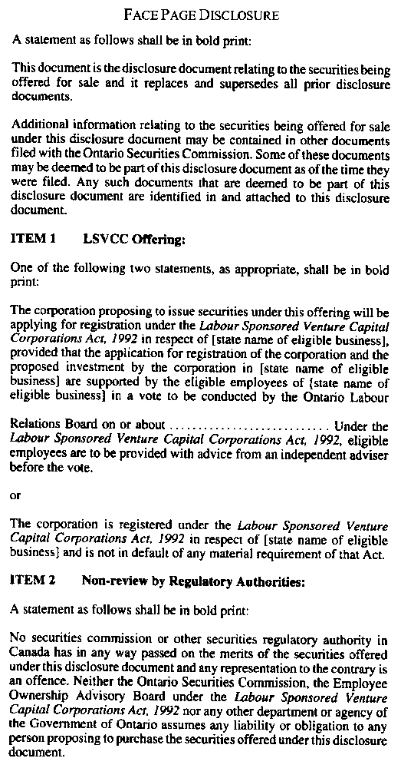
Insert regs\graphics\1992\591\591001bu.tif
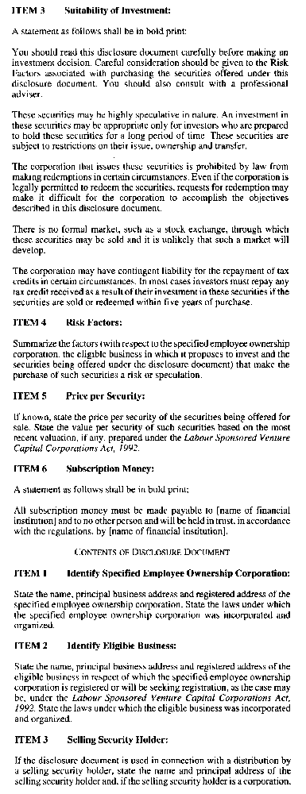
Insert regs\graphics\1992\591\591001cu.tif
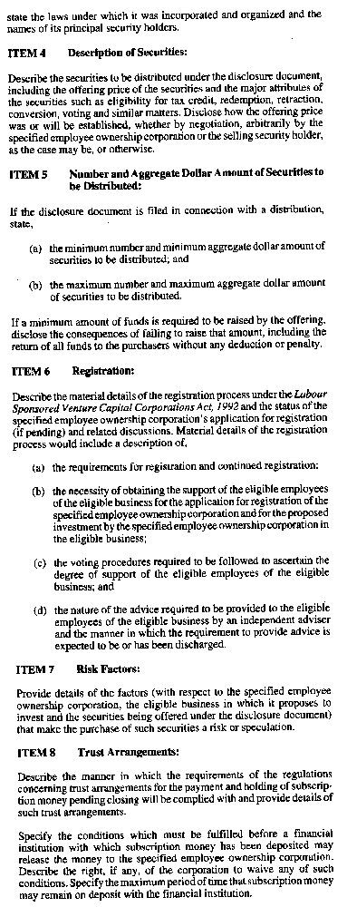
Insert regs\graphics\1992\591\591001du.tif
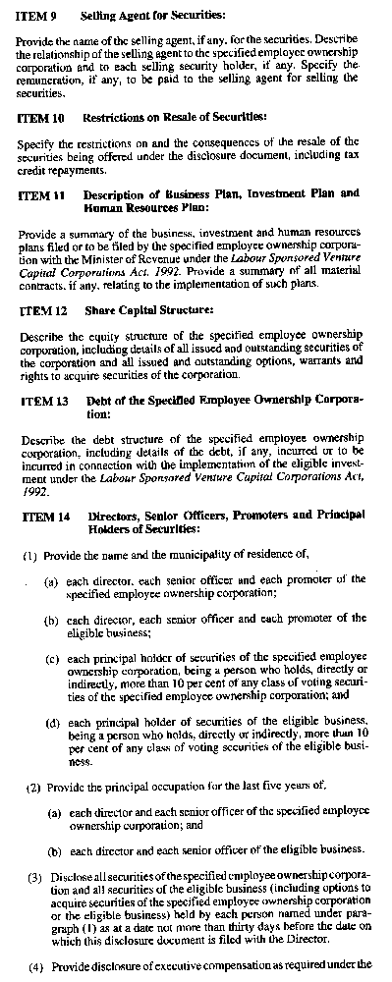
Insert regs\graphics\1992\591\591001eu.tif
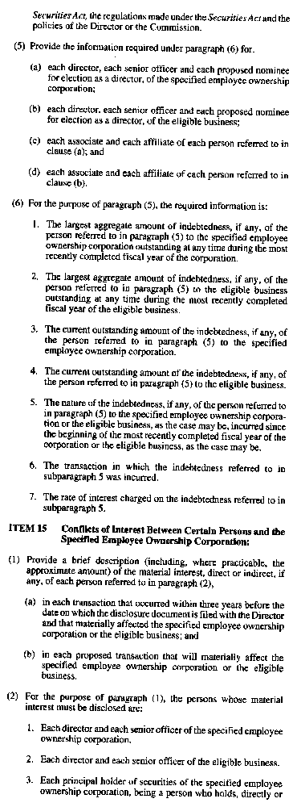
Insert regs\graphics\1992\591\591001fu.tif
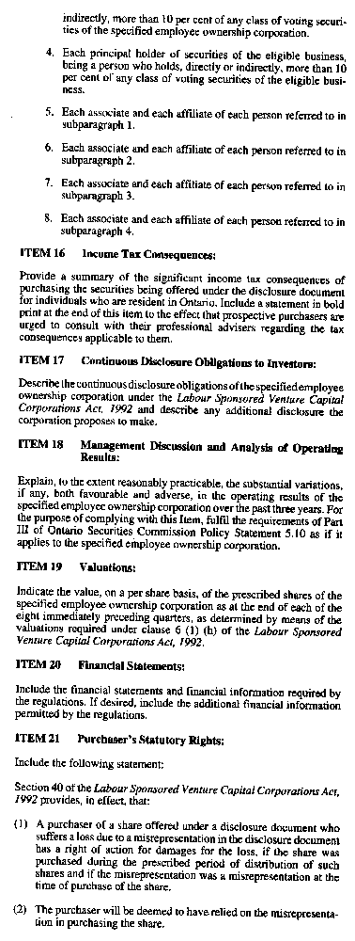
Insert regs\graphics\1992\591\591001gu.tif
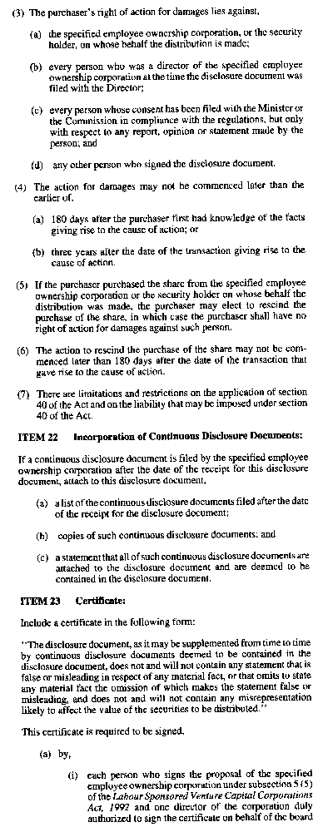
Insert regs\graphics\1992\591\591001hu.tif
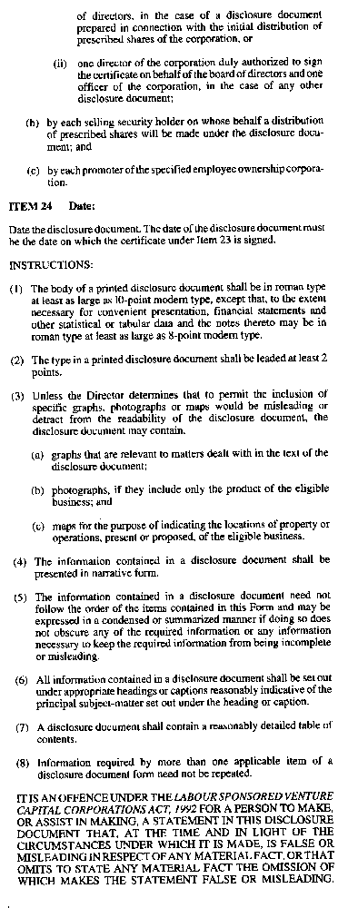
O. Reg. 591/92, Form 1.
Form 2
MATERIAL DEVELOPMENT REPORT OF A SPECIFIED EMPLOYEE OWNERSHIP CORPORATION
Community Small Business Investment Funds Act, 1992
Insert regs\graphics\1992\591\591002au.tif
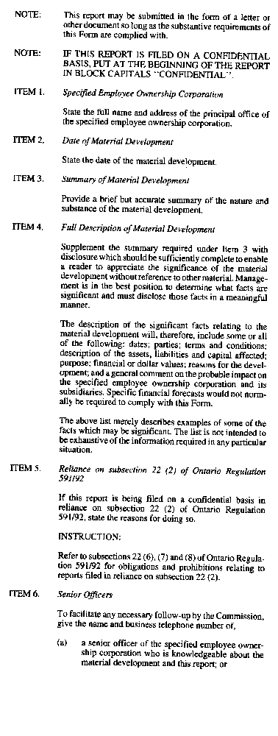
Insert regs\graphics\1992\591\591002bu.tif

O. Reg. 591/92, Form 2.

Back to top

