Highway Traffic Act
Code de la route
R.R.O. 1990, REGULATION 628
VEHICLE PERMITS
Historical version for the period September 1, 2008 to November 26, 2009.
Last amendment: O. Reg. 303/08.
This Regulation is made in English only.
Skip Table of Contents
CONTENTS
 |  | Sections
 | Interpretation | 1
 | Permits | 2-8.3
 | Number Plates | 9-11
 | Restricted Permits | 12-13.4
 | Commercial Vehicle Exemptions | 14-16.1
 | General Fees | 17
 | Validation Fees | 17.1-19
 | Fee Exemptions | 20-22.1
 | Penalty | 23
Schedule 1
Schedule 2
Schedule 3
Schedule 4
Schedule 5 | Validation fee by number of months for additional classes of vehicles
Interpretation
1. (1) In this Regulation,
“carrying capacity” means,
(a) in the case of a school bus, the weight in kilograms that is obtained when the seating capacity of the bus is multiplied by forty, and
(b) in the case of a bus, other than a school bus, the weight in kilograms that is obtained when the seating capacity of the bus is multiplied by sixty;
“emissions inspection report” and “conditional emissions inspection report” have the same meanings as in Ontario Regulation 361/98 made under the Environmental Protection Act;
“expanded program area” has the same meaning as in Ontario Regulation 361/98 made under the Environmental Protection Act;
“farmer” means a resident of Ontario who owns farm property that is used in a farming enterprise which, in a normal production year, produces farm products having a gross value of at least,
(a) $5,000 where the farm property is located in that part of Ontario lying east of the westerly boundaries of the counties of Northumberland, Victoria and Peterborough or north of the southerly boundaries of the County of Haliburton and The District Municipality of Muskoka, and
(b) $8,000 where the farm property is located elsewhere in Ontario other than that part described in clause (a);
“farm products” does not include products preserved by freezing, pickling, cooking, smoking or curing, other than cured tobacco leaves;
“Greater Toronto Area” has the same meaning as in Ontario Regulation 361/98 made under the Environmental Protection Act;
“gross weight” means,
(a) in the case of a bus, the combined weight and carrying capacity of the bus, and
(b) in the case of a commercial motor vehicle, other than a bus, the combined weight of the motor vehicle and load or, where a commercial motor vehicle is drawing a trailer or trailers, the combined weight of the motor vehicle, trailer or trailers and load but, where a trailer transmits to the highway a total weight of 2,800 kilograms or less, that weight shall not be included in determining gross weight;
“historic vehicle” means, despite the definition in subsection 7 (1.1) of the Act, a motor vehicle that,
(a) is at least 30 years old,
(b) is operated on a highway in parades, for purposes of exhibition, tours or similar functions organized by a properly constituted automobile club or for purposes of repair, testing or demonstration for sale,
(c) is substantially unchanged or unmodified from the original manufacturer’s product, and
(d) does not have attached to it year-of-manufacture plates;
“hybrid vehicle” means a motor vehicle that is equipped by its manufacturer with an internal combustion engine as a source of power and an electric motor as an auxiliary source of power;
“kit car” has the same meaning as in Ontario Regulation 361/98 made under the Environmental Protection Act;
“reassembled motor vehicle” means a motor vehicle assembled using the body of a motor vehicle with a model year of 1981 or later and the chassis frame assembly of another motor vehicle, both of which were manufactured utilizing a full frame assembly as part of the vehicle’s structure;
“registered gross weight” has the same meaning as in Ontario Regulation 340/94 made under the Act;
“resident of Northern Ontario” means a person, other than a corporation, who ordinarily resides in the Territorial District of Algoma, Cochrane, Kenora, Manitoulin, Nipissing, Parry Sound, Rainy River, Sudbury, Timiskaming or Thunder Bay;
“RUO sticker” means a sticker that is evidence of validation effected under subsection 5 (4);
“special permit” means a permit issued under section 12;
“temporary validation” means validation issued under section 5.2;
“urban and commuter areas” has the same meaning as in Ontario Regulation 361/98 made under the Environmental Protection Act;
“year-of-manufacture plates” means number plates that are described in subsection 7 (7.2) of the Act. R.R.O. 1990, Reg. 628, s. 1; O. Reg. 337/97, s. 1; O. Reg. 540/98, s. 1; O. Reg. 654/98, s. 1; O. Reg. 508/00, s. 1; O. Reg. 691/00, s. 1; O. Reg. 331/01, s. 1; O. Reg. 353/01, s. 1; O. Reg. 379/02, s. 1; O. Reg. 398/04, s. 1; O. Reg. 183/05, s. 1; O. Reg. 71/08, s. 1 (1).
(2) For the purposes of sections 5.2 and 12 and subsection 17 (1), a commercial motor vehicle is considered to be laden in the following circumstances:
1. It is towing another motor vehicle.
2. It is carrying any goods or cargo.
3. It is drawing a trailer that is carrying any goods or cargo.
4. It is drawing a trailer chassis that is carrying an inter-modal shipping container.
5. It is a bus carrying two or more passengers. O. Reg. 71/08, s. 1 (2).
(3) Despite subsection (2), a commercial motor vehicle described in paragraph 1, 2, 3 or 4 of that subsection is considered to be unladen if its gross weight is 4,500 kilograms or less. O. Reg. 71/08, s. 1 (2).
Permits
2. (1) It is a requirement for receiving a permit for a used motor vehicle or for a motor vehicle classified as salvage or rebuilt,
(a) that the applicant submit a safety standards certificate issued upon an inspection of the vehicle that was completed within the preceding 36 days;
(b) if the application is in respect of a motor vehicle with a registered gross weight of 4,500 kilograms or less, that the Ministry is satisfied that an emissions inspection report has been issued in respect of the vehicle within the preceding 12 months; and
(b.1) Revoked: O. Reg. 423/03, s. 1 (1).
(c) if the application is in respect of a motor vehicle with a registered gross weight of more than 4,500 kilograms, that the Ministry is satisfied that an emissions inspection report has been issued in respect of the vehicle within the preceding 12 months. O. Reg. 299/99, s. 1 (1); O. Reg. 353/01, s. 2 (1, 2); O. Reg. 379/02, s. 2 (1); O. Reg. 423/03, s. 1 (1).
(2) Subject to subsection (2.1), subsection (1) does not apply,
(a) where the permit applied for is a CAVR cab card or an IRP cab card;
(b) where the applicant is the spouse or the estate of the person who is registered in Ontario as the owner of the vehicle or the spouse of the person whose estate is registered in Ontario as the owner of the vehicle;
(b.1) Revoked: O. Reg. 358/05, s. 1 (1).
(c) where the applicant is a motor vehicle dealer who is registered under the Motor Vehicle Dealers Act or holds an exemption certificate issued under that Act;
(d) to an application for a permit for a motor vehicle that has been operated 6,000 kilometres or less and for which a permit has been issued under section 7 of the Act in the name of a motor vehicle dealer referred to in clause (c) and has not been in the name of a person other than such a dealer;
(e) where the vehicle portion of the permit applied for is to be issued in the name of the person who is registered in Ontario as the owner of the vehicle;
(f) to an application for a permit for a commercial motor vehicle, other than a dump truck, that is registered in another jurisdiction, where the person applying to be the permit holder does not reside in Ontario;
(g) to an application for a permit for a motor vehicle that is registered in another jurisdiction, where the applicant has, within the preceding twelve months, been the holder of a currently validated permit that was issued for the vehicle by the Province of Ontario; or
(h) where the permit applied for is in respect of a vehicle being transferred by one leasing company to another leasing company and, at the time of the transfer, the vehicle is in the possession of a lessee under a lease agreement. R.R.O. 1990, Reg. 628, s. 2 (2); O. Reg. 245/95, s. 1; O. Reg. 87/00, s. 1 (1); O. Reg. 666/00, s. 1; O. Reg. 691/00, s. 2 (1); O. Reg. 358/05, s. 1 (1).
(2.1) Unless an emissions inspection report required under clause (1) (b) or (c) has been issued in respect of a motor vehicle, evidence of validation shall not be furnished for the motor vehicle where,
(a) any of clauses (2) (a) to (g) applies to the motor vehicle; and
(b) an emissions inspection report would be required under section 8.1 or 8.2. O. Reg. 691/00, s. 2 (2); O. Reg. 423/03, s. 1 (2).
(3) Clause (1) (a) does not apply in respect of a motor assisted bicycle. O. Reg. 540/98, s. 2 (2).
(4) Clause (1) (b) does not apply in respect of,
(a) a motor vehicle the model year of which is 1987 or older;
(b) a current model year motor vehicle or a future model year motor vehicle;
(c) a motorcycle or a motor assisted bicycle;
(d) a vehicle to which paragraph 2 of subsection 19 (1) applies;
(e) any motor vehicle that does not use an internal combustion engine as its source of power;
(f) a kit car; or
(g) a hybrid vehicle. O. Reg. 540/98, s. 2 (2); O. Reg. 654/98, s. 2 (2); O. Reg. 299/99, s. 1 (2); O. Reg. 691/00, s. 2 (3); O. Reg. 353/01, s. 2 (3); O. Reg. 183/05, s. 2 (1); O. Reg. 588/05, s. 1.
(5) Clause (1) (b) only applies in respect of an application if the applicant’s address, as shown on the plate portion of the permit, is within the Greater Toronto Area, the urban and commuter areas or the expanded program area. O. Reg. 423/03, s. 1 (3).
(5.1) Clause (1) (c) does not apply in respect of,
(a) a motor vehicle that does not use an internal combustion engine as its source of power;
(a.1) a hybrid vehicle; or
(b) a current model year motor vehicle or a future model year motor vehicle. O. Reg. 691/00, s. 2 (4); O. Reg. 183/05, s. 2 (2).
(5.2) Clause (1) (c) only applies in respect of an application respecting a motor vehicle that uses fuel other than diesel fuel if the applicant’s address, as shown on the plate portion of the permit, is within the Greater Toronto Area, the urban and commuter areas or the expanded program area. O. Reg. 423/03, s. 1 (4).
(6) The emissions inspection report required under clause (1) (b) or (c) shall be based on the emissions test for the relevant motor vehicle as set out in Ontario Regulation 361/98 made under the Environmental Protection Act. O. Reg. 691/00, s. 2 (5).
(6.1) Revoked: O. Reg. 691/00, s. 2 (5).
(7) Where a person to whom subsection (1) applies does not submit the safety standards certificate with the application, a permit marked “unfit motor vehicle” may be issued. O. Reg. 540/98, s. 2 (2).
(8) Where a permit marked “unfit motor vehicle” has been issued for a vehicle, nothing in subsection (2) shall be construed so as to allow a permit that is not marked “unfit motor vehicle” to be issued for the vehicle unless the applicant submits a safety standards certificate issued upon an inspection of the vehicle that was completed within the preceding 36 days. O. Reg. 379/02, s. 2 (2).
(9) Where the Ministry is not satisfied that an emissions inspection report has been issued in respect of a vehicle where clause (1) (b) or (c) applies to the applicant, the vehicle portion of a permit may be issued, but no number plates shall be attached to the vehicle and no evidence of validation for the permit shall be furnished unless the requirement set out in clause (1) (b) or (c) is met. O. Reg. 540/98, s. 2 (2); O. Reg. 654/98, s. 2 (4); O. Reg. 299/99, s. 1 (5).
(10) Where a permit is issued under subsection (9) while the requirement set out in clause (1) (b) or (c) is unmet, nothing in subsection (2) shall be construed so as to allow a plate portion of the permit to be issued. O. Reg. 540/98, s. 2 (2); O. Reg. 299/99, s. 1 (6).
(11) For the purpose of clause (2) (b),
“spouse” has the same meaning as in Part III of the Family Law Act. O. Reg. 358/05, s. 1 (2).
Tables 1, 2 Revoked: O. Reg. 423/03, s. 1 (5).
2.1 (1) It is a requirement for receiving a permit for a motor vehicle for the first time after it was reclassified as rebuilt under subsection 199.1 (22) of the Act that the applicant submit a structural inspection certificate issued for the vehicle. O. Reg. 379/02, s. 3.
(2) Subsection (1) does not apply to a motor vehicle for which the applicant held, at any time in the 12 months immediately before the application for the permit is made, a currently validated permit issued under the Act for the vehicle and that is registered in another jurisdiction at the time of the application for the permit. O. Reg. 379/02, s. 3.
3. Where a vehicle for which a permit is currently validated is modified so that it does not correspond to the description of the vehicle on the permit, the owner of the vehicle shall apply to the Ministry for a new permit for the vehicle within six days after the modification. R.R.O. 1990, Reg. 628, s. 3.
4. (1) For the purposes of clause 7 (1) (a) of the Act, a permit for a motor vehicle ceases to be currently validated with the expiration of the expiry day, month and year shown on the permit or, in the case of a permit bearing evidence of validation, on the expiration of the expiry day shown on the permit in the month and year shown on the evidence of validation. R.R.O. 1990, Reg. 628, s. 4 (1).
(2) Subsection (1) does not apply to a permit issued for,
(a) a motor vehicle where the permit holder is the Government of the Province of Ontario; or
(b) a commercial motor vehicle to which section 5 applies. R.R.O. 1990, Reg. 628, s. 4 (2).
(3) Subsection (1) does not apply to a permit issued for a commercial motor vehicle where the permit holder is a municipal fire department. R.R.O. 1990, Reg. 628, s. 4 (3).
(3.1) Subsection (1) does not apply to a special permit or temporary validation of a permit. O. Reg. 71/08, s. 2.
(4) A permit issued to a permit holder referred to in clause (2) (a) and subsection (3) ceases to be currently validated when surrendered to the Ministry. R.R.O. 1990, Reg. 628, s. 4 (4).
5. (1) For the purpose of clause 7 (1) (a) of the Act, a permit for a commercial motor vehicle ceases to be currently validated with the expiration of the month and year shown on the permit or, in the case of a permit bearing evidence of validation, on the expiration of the month and year shown on the evidence of validation. R.R.O. 1990, Reg. 628, s. 5 (1).
(2) Subject to subsections (3), (5) and (6), the period for which a permit for a commercial motor vehicle may be validated is any number of consecutive months between a minimum of three and a maximum of fifteen. R.R.O. 1990, Reg. 628, s. 5 (2).
(3) A bus permit that expires before the 1st day of August may be validated in that year for July and August or August only of that year if the bus,
(a) is operated under the authority of a public vehicle licence issued under the Public Vehicles Act that restricts the use of the bus to school purposes only or is operated for school purposes only within the corporate limits of one urban municipality;
(b) is primarily used for the purpose of transporting children to or from school;
(c) is operated under a contract with a school board or other authority in charge of a school or if the permit holder is a municipality or school board; and
(d) during the period of validation authorized by the RUO sticker, is intended to be,
(i) occupied by the driver only, or
(ii) used only for driver examination or driver training, and the trainer holds a proper driver’s licence. R.R.O. 1990, Reg. 628, s. 5 (3).
(4) A permit referred to in subsection (3) is validated when a RUO sticker is issued in respect of the permit and such sticker is affixed to the number plate in accordance with subsection 9 (2). R.R.O. 1990, Reg. 628, s. 5 (4).
(5) Subject to subsection (6), where the fee for a permit is prorated under a reciprocity agreement or arrangement with another jurisdiction, the period for which the permit may be validated is,
(a) in the case of a conversion or new registration, any number of consecutive months between a minimum of three and a maximum of fifteen; and
(b) in the case of a renewal, twelve consecutive months. R.R.O. 1990, Reg. 628, s. 5 (5).
(5.1) Despite subsection (5), beginning March 3, 2000 and up to and including July 31, 2001, where the fee for a permit is prorated under a reciprocity agreement or arrangement with another jurisdiction, the permit may be validated, in the case of a conversion, new registration or renewal, for a number of consecutive months between a minimum of three and a maximum of 15, as determined by the Ministry. O. Reg. 146/00, s. 1; O. Reg. 666/00, s. 2 (1).
(5.2) The period of validation under subsection (5.1) shall be determined by the Ministry as necessary in order to allow for a conversion of the permit to a cab card issued under the reciprocal agreement known as the International Registration Plan by August 1, 2001. O. Reg. 146/00, s. 1; O. Reg. 666/00, s. 2 (2).
(6) This section does not apply to a special permit or temporary validation of a permit. O. Reg. 71/08, s. 3.
(7) This section does not apply to a permit for a commercial motor vehicle that has a gross weight of 3,000 kilograms or less unless the vehicle is a bus. R.R.O. 1990, Reg. 628, s. 5 (7).
5.1 (1) A permit for a passenger car, a motorized mobile home, an historic vehicle, a motorcycle, a motor assisted bicycle, a commercial motor vehicle with a gross weight of not more than 3,000 kilograms or a combination of a commercial motor vehicle and a trailer with a gross weight of not more than 3,000 kilograms may be validated for a period of not less than three months and not more than 26 months. O. Reg. 367/04, s. 1.
(1.1) A Dealer permit, a Service permit or a Dealer and Service permit may be validated for a period of not less than three months and not more than 26 months. O. Reg. 367/04, s. 1.
(2) Validation of a permit upon renewal shall not be issued for a period of time beyond the date upon which the vehicle would next require proof of having complied with the emissions requirements of Ontario Regulation 361/98 made under the Environmental Protection Act in order to obtain validation. O. Reg. 540/98, s. 3.
(3) Subject to subsection (2), a permit is validated until the expiry date set out on it and, after renewal, a permit is validated until the first, second or third anniversary date of the original expiry date, as set out on the renewed permit. O. Reg. 262/00, s. 1.
(4) Subsection (3) does not apply to a permit to which subsection 8.1 (8) applies. O. Reg. 262/00, s. 1.
5.2 (1) A permit for any motor vehicle may be temporarily validated for a period of 10 days. O. Reg. 71/08, s. 4.
(2) Subject to subsection (3), temporary validation may not be issued more than twice to the same holder of a permit for the same vehicle. O. Reg. 71/08, s. 4.
(3) If, after being issued one or two consecutive temporary validations of a permit for a vehicle, the permit is validated on payment of a fee prescribed under section 18 or 19, the permit may again be temporarily validated one or two consecutive times. O. Reg. 71/08, s. 4.
(4) Temporary validation shall not be issued for a motor vehicle if the permit for the motor vehicle is marked “unfit motor vehicle” or, in the case of a permit issued by another jurisdiction, the equivalent of unfit in that jurisdiction. O. Reg. 71/08, s. 4.
(5) Temporary validation shall not be issued for a motor vehicle if the permit for the motor vehicle indicates that the motor vehicle is classified as irreparable or salvage or, in the case of a permit issued by another jurisdiction, the equivalent of irreparable or salvage in that jurisdiction. O. Reg. 71/08, s. 4.
(6) Evidence of temporary validation shall be affixed to the number plate that corresponds to the temporary permit, in accordance with subsection 9 (1). O. Reg. 71/08, s. 4.
(7) Evidence of temporary validation shall not be displayed on the number plate of a commercial motor vehicle that is laden. O. Reg. 71/08, s. 4.
(8) Section 2 does not apply to the furnishing of evidence of temporary validation issued under this section. O. Reg. 71/08, s. 4.
6. A permit for a motor vehicle shall be validated by means of evidence of validation provided by the Ministry and affixed in the appropriate space provided on the permit. R.R.O. 1990, Reg. 628, s. 6.
7. A permit for a trailer expires when it is surrendered to the Ministry or replaced by a permit issued by another jurisdiction. R.R.O. 1990, Reg. 628, s. 7.
8. (1) It is a condition applying to every permit, other than a CAVR cab card, IRP cab card or special permit, that it bear the signature of the holder thereof, written in ink. O. Reg. 71/08, s. 5.
(2) Where the permit holder is a corporation, the signature of a person authorized to sign on behalf of the corporation is compliance with subsection (1). R.R.O. 1990, Reg. 628, s. 8 (2).
8.1 (1) This section applies to applications for the renewal of a motor vehicle permit for motor vehicles,
(a) that use an internal combustion engine as their source of power; and
(b) that have a registered gross weight of 4,500 kilograms or less. O. Reg. 423/03, s. 2.
(2) This section does not apply in respect of,
(a) a kit car;
(a.1) a hybrid vehicle;
(b) a motorcycle or a motor assisted bicycle; or
(c) a vehicle to which paragraph 2 of subsection 19 (1) applies. O. Reg. 423/03, s. 2; O. Reg. 183/05, s. 3.
(3) Despite anything in this Regulation, no motor vehicle permit, other than a special permit, shall be renewed or evidence of validation, other than evidence of temporary validation, shall be furnished in respect of a motor vehicle to which this section applies unless the Ministry is satisfied that an emissions inspection report or a conditional emissions inspection report has been issued in respect of the vehicle within 12 months before the permit expires or, if the application for renewal is made after the expiry of the permit, within 12 months before the application for renewal. O. Reg. 71/08, s. 6.
(4) Subsection (3) applies in respect of a motor vehicle the model year of which is 1988 or later in the fifth calendar year after its model year and in every second calendar year after that. O. Reg. 588/05, s. 3.
(5) Subsection (3) only applies to an application for renewal if the applicant’s address, as shown on the plate portion of the permit, is within the Greater Toronto Area, the urban and commuter areas or the expanded program area. O. Reg. 423/03, s. 2.
(6) The emissions inspection report or conditional emissions inspection report required under this section shall be based on the emissions tests that are applicable to the vehicle in respect of which the application for renewal is made, as set out in Ontario Regulation 361/98 made under the Environmental Protection Act. O. Reg. 423/03, s. 2.
(7) No permit shall be validated for a period that ends more than 36 months after the date on which the emissions inspection report or conditional emissions inspection report required under this section was issued. O. Reg. 423/03, s. 2.
(8) Despite anything in this section, a permit may be renewed or validated without the required emissions inspection report or conditional emissions inspection report if the Ministry is satisfied that it was not reasonably possible for the permit holder to have the vehicle tested for emissions. O. Reg. 423/03, s. 2.
(9) Subsection (8) may be applied only one time in respect of a permit holder for a vehicle. O. Reg. 423/03, s. 2.
8.2 (1) This section applies to applications for the renewal of a motor vehicle permit for motor vehicles,
(a) that use an internal combustion engine as their source of power; and
(b) that have a registered gross weight of more than 4,500 kilograms. O. Reg. 423/03, s. 2.
(1.1) This section does not apply in respect of a hybrid vehicle. O. Reg. 183/05, s. 4.
(2) Despite anything in this Regulation, no motor vehicle permit, other than a special permit, shall be renewed or evidence of validation, other than evidence of temporary validation, shall be furnished in respect of a motor vehicle described in subsection (1) unless the Ministry is satisfied that an emissions inspection report has been issued in respect of the vehicle within 12 months before the permit expires or, if the application for renewal is made after the expiry of the permit, within 12 months before the application for renewal. O. Reg. 71/08, s. 7.
(3) Subsection (2) applies in respect of a motor vehicle in the fifth calendar year after its model year and in every calendar year after that, but only once in any 12-month period. O. Reg. 423/03, s. 2; O. Reg. 588/05, s. 4.
(4) Subsection (2) does not apply to an application for renewal that is made in, or in respect of a permit that expires in, an eligible year in respect of a vehicle that uses diesel fuel if the Ministry is satisfied that the last emissions inspection report for the vehicle,
(a) was issued within 24 months before the permit expires or, if the application for renewal is made after the expiry of the permit, within 24 months before the application for renewal; and
(b) indicates that the vehicle achieved opacity of 20 per cent or less in the opacity test required for that emissions inspection report. O. Reg. 423/03, s. 2.
(5) Subsection (2) only applies to an application for renewal in respect of a vehicle that uses fuel other than diesel fuel if the applicant’s address, as shown on the plate portion of the permit, is within the Greater Toronto Area, the urban and commuter areas or the expanded program area. O. Reg. 423/03, s. 2.
(6) The emissions inspection reports required under this section shall be based on the emissions tests that are applicable to the vehicle in respect of which the application for renewal is made, as set out in Ontario Regulation 361/98 made under the Environmental Protection Act. O. Reg. 423/03, s. 2.
(7) Despite anything in this section, a permit may be renewed or validated without the required emissions inspection report if the Ministry is satisfied that it was not reasonably possible for the permit holder to have the vehicle tested for emissions. O. Reg. 423/03, s. 2.
(8) For the purposes of subsection (4),
“eligible year” means,
(a) for a vehicle with an odd-numbered model year, 2005 and every second calendar year after that,
(b) for a vehicle with an even-numbered model year, 2006 and every second calendar year after that. O. Reg. 423/03, s. 2.
8.3 (1) This section applies to applications for evidence of validation of a motor vehicle permit in respect of a year or part of a year when there is in force a City of Toronto by-law levying a tax in respect of motor vehicles. O. Reg. 303/08, s. 1.
(2) Despite anything in this Regulation, evidence of validation of a motor vehicle permit, other than evidence of validation of a special permit or evidence of temporary validation, shall not be furnished in respect of a motor vehicle unless the Ministry is satisfied that the tax levied in respect of the motor vehicle by the by-law described in subsection (1) has been paid. O. Reg. 303/08, s. 1.
(3) Subsection (2) does not apply where the person applying for the evidence of validation of a motor vehicle permit is exempt under section 20 or subsection 21 (2) from paying a fee for validation of a motor vehicle permit or for evidence of validation of a motor vehicle permit. O. Reg. 303/08, s. 1.
Number Plates
9. (1) Evidence of validation issued for use on a number plate shall be affixed,
(a) where the permit is for a commercial motor vehicle, in the upper right corner of the number plate exposed on the front of the motor vehicle; and
(b) in all other cases, in the upper right corner of the number plate exposed on the rear of the motor vehicle. R.R.O. 1990, Reg. 628, s. 9 (1).
(2) Despite subsection (1), a RUO sticker shall be affixed in the upper left corner of the number plate exposed on the front of the bus. R.R.O. 1990, Reg. 628, s. 9 (2).
(3) The number plates for a motor vehicle, other than a motorcycle or a motor assisted bicycle, shall be attached to and exposed in a conspicuous position on the front and rear of the motor vehicle. R.R.O. 1990, Reg. 628, s. 9 (3).
(3.1) Where the number plates attached to the vehicle are year-of-manufacture plates, and only one plate was issued by the Ministry in that year for display on a motor vehicle, that plate shall be attached to and exposed in a conspicuous position at the rear of the vehicle. O. Reg. 331/01, s. 2.
(4) The number plate for a motorcycle, motor assisted bicycle or trailer shall be attached to and exposed in a conspicuous position on the rear of the vehicle. R.R.O. 1990, Reg. 628, s. 9 (4).
(5) This section does not apply in respect of Dealer permits and number plates, Service permits and number plates or Dealer and Service permits and number plates. O. Reg. 367/04, s. 2.
10. (1) For the purpose of subsection 11 (3) of the Act, a number plate may be affixed to a trailer and number plates, one of which bears evidence of current validation, may be affixed to a motor vehicle where the permit holder is in possession of,
(a) the vehicle portion of the permit issued for the vehicle and the transfer application completed and signed by both the person named in the vehicle portion and the new owner;
(b) the plate portion of the permit that corresponds with the number plates to be affixed to the vehicle; and
(c) in the case of a used motor vehicle, a safety standards certificate issued upon an inspection of the vehicle that was completed within the preceding thirty-six days. R.R.O. 1990, Reg. 628, s. 10 (1).
(2) Clause (1) (b) does not apply where the permit that corresponds with the number plates is a permit that was issued before the 1st day of December, 1982. R.R.O. 1990, Reg. 628, s. 10 (2).
(3) Clause (1) (c) does not apply where a safety standards certificate would not be required to be submitted to the Ministry in order to obtain a permit other than a permit marked “unfit motor vehicle”. R.R.O. 1990, Reg. 628, s. 10 (3).
(4) Where a plate holder, as the first owner or first lessee of the vehicle, takes possession of a motor vehicle from a dealer registered under the Motor Vehicle Dealers Act,
(a) a copy of the dealer’s bill of sale or some other document establishing ownership; or
(b) a copy of the dealer’s bill of sale and a copy of the lease agreement,
may be substituted for the requirement under clause 10 (1) (a). R.R.O. 1990, Reg. 628, s. 10 (4).
(5) Where a corporation signs the transfer application referred to in clause 10 (1) (a), the signature of a person authorized to sign on behalf of the corporation is a sufficient signing of the transfer application. R.R.O. 1990, Reg. 628, s. 10 (5).
(6) A person driving a motor vehicle or drawing a trailer on a highway under the authority of subsection 11 (4) of the Act is required to carry the applicable documents referred to in subsection (1) or true copies thereof, and must surrender them for inspection upon the demand of a police officer. R.R.O. 1990, Reg. 628, s. 10 (6).
11. Revoked: O. Reg. 71/08, s. 8.
Restricted Permits
12. (1) A special permit that is valid for 10 days may be issued for the following motor vehicles:
1. A commercial motor vehicle.
2. A motor vehicle or trailer owned by a manufacturer or dealer in motor vehicles or trailers.
3. A motor vehicle or trailer bought at an auction if the Ministry has authorized the issuance of special permits at the auction.
4. A motor vehicle or trailer that is entering Ontario solely for the purpose of passing through Ontario.
5. A motor vehicle or trailer that is being taken out of Ontario.
6. A motor vehicle that is a roadworthy prototype vehicle. O. Reg. 71/08, s. 8.
(2) A special permit shall not be issued if the applicant has not complied with subsection 11 (2) of the Act. O. Reg. 71/08, s. 8.
(3) A person to whom a special permit is issued for a vehicle may be issued only one further special permit for the same vehicle in any 12-month period. O. Reg. 71/08, s. 8.
(4) Subsection (3) does not apply in respect of a special permit for which the fee prescribed under subparagraph 15 iv, v, vi or vii of subsection 17 (1) is paid. O. Reg. 71/08, s. 8.
(5) A special permit shall be affixed in a clearly visible position,
(a) to the windshield of the motor vehicle; or
(b) in the case of a special permit issued for a trailer, to the windshield of the motor vehicle drawing the trailer. O. Reg. 71/08, s. 8.
(6) Despite subsection (5), if a special permit provides for another method for affixing or carrying the special permit, it shall be affixed or carried as stated and not as provided by subsection (5). O. Reg. 71/08, s. 8.
(7) A special permit shall not be issued for a motor vehicle or trailer if the permit for the motor vehicle or trailer is marked “unfit motor vehicle” or “unfit” or, in the case of a permit issued by another jurisdiction, the equivalent of unfit in that jurisdiction. O. Reg. 71/08, s. 8.
(8) A special permit shall not be issued for a motor vehicle or trailer if the permit for the motor vehicle or trailer indicates that it is classified as irreparable or salvage or, in the case of a permit issued by another jurisdiction, the equivalent of irreparable or salvage in that jurisdiction. O. Reg. 71/08, s. 8.
(9) A special permit shall not be displayed on a laden commercial motor vehicle unless the fee paid for the special permit was the fee prescribed by subparagraph 15 v, vi or vii of subsection 17 (1). O. Reg. 71/08, s. 8.
(10) Subsection (9) does not apply to a special permit issued for a trailer if,
(a) the trailer is drawn by a motor vehicle for which the vehicle permit was not issued under this section; and
(b) the trailer and the motor vehicle drawing it are in compliance with subsection 121 (1) of the Act. O. Reg. 71/08, s. 8.
(11) Clauses 7 (1) (b) and (c) of the Act do not apply in respect of a motor vehicle for which a special permit is issued while the special permit is valid. O. Reg. 71/08, s. 8.
(12) Clause 7 (4) (b) of the Act does not apply in respect of a trailer with a valid special permit. O. Reg. 71/08, s. 8.
(13) Section 2 does not apply to the issuance of a special permit. O. Reg. 71/08, s. 8.
13. (1) Upon filing satisfactory evidence as to the need for it, a Dealer permit and number plate may be issued to a dealer in motor vehicles other than motorcycles and motor assisted bicycles. O. Reg. 367/04, s. 3 (1).
(2) A Dealer number plate may be used only on a motor vehicle that is owned, by the person to whom the Dealer permit corresponding to the Dealer number plate is issued, as part of the inventory that is offered for sale by the person and only for private use in Ontario or for purposes related to the sale of the motor vehicle. O. Reg. 367/04, s. 3 (1).
(3) A Dealer number plate may be used only on a commercial motor vehicle that is owned, by the person to whom the Dealer permit corresponding to the Dealer number plate is issued, as part of the inventory that is offered for sale by the person and only for purposes related to the sale of the commercial motor vehicle. O. Reg. 367/04, s. 3 (1).
(4) A Dealer number plate shall not be used on a motor vehicle, including a commercial motor vehicle, that is kept for private use or for hire. O. Reg. 367/04, s. 3 (1).
(5) A Dealer number plate shall not be used on a commercial motor vehicle that is loaded with goods. O. Reg. 367/04, s. 3 (1).
13.1 (1) Upon filing satisfactory evidence as to the need for it, a Service permit and number plate may be issued to a person engaged in the business of repairing, customizing, modifying or transporting trailers or motor vehicles other than motorcycles and motor assisted bicycles or to a person engaged in the business of manufacturing or selling trailers. O. Reg. 367/04, s. 3 (1).
(2) A Service number plate may be used on a trailer or motor vehicle other than a motorcycle or motor assisted bicycle only,
(a) for purposes related to the repair, road testing, customization or modification of the vehicle, if the vehicle is in the possession of the person to whom the Service permit corresponding to the Service number plate is issued;
(b) for the purpose of transporting the vehicle by a person engaged in the business of transporting vehicles;
(c) for purposes related to the manufacture or sale of a trailer; or
(d) for the purpose of towing the vehicle by a person engaged in the business of transporting vehicles,
(i) to a location where its load will be removed as required by section 82.1 of the Act, or
(ii) to an impound facility pursuant to subsection 82.1 (19) of the Act. O. Reg. 367/04, s. 3 (1).
(3) A Service number plate may be used only on a commercial motor vehicle owned by or in the possession of the person to whom the Service permit corresponding to the Service number plate is issued and only,
(a) for purposes related to the repair, road testing, customization or modification of the commercial motor vehicle; or
(b) in the case of a person engaged in the business of transporting commercial motor vehicles, for purposes of transporting the commercial motor vehicle. O. Reg. 367/04, s. 3 (1).
(4) A Service number plate shall not be used on a vehicle, including a commercial motor vehicle, that is kept for private use or for hire. O. Reg. 367/04, s. 3 (1).
(5) Except as permitted by subclause (2) (d) (i), a Service number plate shall not be used on a commercial motor vehicle or trailer that is loaded with goods. O. Reg. 367/04, s. 3 (1).
13.2 (1) Upon filing satisfactory evidence as to the need for it, a Dealer and Service permit and number plate may be issued to a manufacturer of or dealer in motorcycles or motor assisted bicycles or to a person engaged in the business of repairing, customizing, modifying or transporting motorcycles or motor assisted bicycles. O. Reg. 367/04, s. 3 (1).
(2) A Dealer and Service permit and number plate may be used only on a motorcycle or motor assisted bicycle,
(a) that is owned by the person to whom the Dealer and Service permit corresponding to the Dealer and Service number plate is issued as part of the inventory that is offered for sale by the person and only for private use in Ontario or for purposes related to the sale of the motorcycle or motor assisted bicycle;
(b) for purposes related to the repair, road testing, customization or modification of the motorcycle or motor assisted bicycle, if the motorcycle or motor assisted bicycle is in the possession of the person to whom the Dealer and Service permit corresponding to the Dealer and Service number plate is issued; or
(c) for the purpose of transporting the motorcycle or motor assisted bicycle by a person engaged in the business of transporting motorcycles or motor assisted bicycles. O. Reg. 367/04, s. 3 (1).
(3) A Dealer and Service number plate shall not be used on a motorcycle or motor assisted bicycle that is kept for private use or for hire. O. Reg. 367/04, s. 3 (1).
13.3 (1) A Dealer number plate or a Service number plate shall be attached to and exposed in a conspicuous position on the rear of the rear-most vehicle being towed or operated under the authority of the corresponding permit. O. Reg. 367/04, s. 3 (1).
(2) A Dealer and Service number plate for a motorcycle or motor assisted bicycle shall be attached to and exposed in a conspicuous position on the rear of the motorcycle or motor assisted bicycle. O. Reg. 367/04, s. 3 (1).
(3) Where a Dealer permit, a Service permit or a Dealer and Service permit issued under section 13.2 is validated, evidence of validation shall be affixed in the upper right corner of the number plate that corresponds with the permit. O. Reg. 367/04, s. 3 (1).
(4) Subsections 11 (3) and (4) of the Act do not apply to a manufacturer, dealer or other person referred to in subsection 13 (1), 13.1 (1) or 13.2 (1) with respect to vehicles that are in the person’s possession for purposes related to the sale, repair, customization or modification of the vehicles or, in the case of a person engaged in the business of transporting vehicles, for purposes of transporting the vehicles. O. Reg. 367/04, s. 3 (1).
13.4 Revoked: O. Reg. 367/04, s. 3 (2).
Commercial Vehicle Exemptions
14. (1) A commercial motor vehicle is exempt from section 7 of the Act while the vehicle is being driven or operated in Ontario, if it,
(a) is registered in a reciprocating province that grants exemptions for commercial motor vehicles similar to the exemptions granted by this section; and
(b) is owned or leased by a resident of the reciprocating province. R.R.O. 1990, Reg. 628, s. 14 (1).
(2) Subsection (1) does not apply to a bus operating on a regular route or schedule between a place in Ontario and a place in any other province. O. Reg. 637/05, s. 1.
15. (1) A commercial motor vehicle that,
(a) is registered in a reciprocating state of the United States of America that grants exemptions for commercial motor vehicles similar to the exemptions granted by this section; and
(b) is owned or leased by a resident of the reciprocating state,
is exempt from section 7 of the Act while the vehicle is being driven or operated in Ontario if the vehicle is,
(c) a hearse or ambulance;
(d) a motor vehicle commonly known as a motorized mobile home that is designed, equipped and used exclusively for living accommodation;
(e) a public vehicle operated on a scheduled service in Ontario within sixteen kilometres of its point of entry on the international boundary line between Canada and the United States of America or operated on a chartered trip originating outside Ontario;
(f) a commercial motor vehicle having a gross weight of 2,800 kilograms or less, or a combination of a commercial motor vehicle and trailer or trailers where the trailer or trailers transmit to the highway a total weight of 2,800 kilograms or less, that is being operated in Ontario for the purpose of transporting goods owned by the owner or lessee of the commercial motor vehicle;
(g) being operated in Ontario for the purpose of transporting from a farm natural products of a farm or livestock, or both, owned by the owner or lessee of the commercial motor vehicle;
(h) being operated in Ontario for the purpose of transporting objects and materials used in the production of cultural presentations or exhibitions, if the presentations or exhibitions are not carried on solely for the purpose of financial gain; or
(i) a commercial motor vehicle having a gross weight of 8,200 kilograms or less, or a combination of a commercial motor vehicle and trailer or trailers having a gross weight of 8,200 kilograms or less, that is being operated in Ontario for the purpose of transporting used household goods owned by the owner or lessee of the commercial motor vehicle. R.R.O. 1990, Reg. 628, s. 15 (1).
(2) Clauses (1) (g) and (h) do not apply to provide an exemption for a commercial motor vehicle being operated in Ontario on a continuous trip originating at a point outside Ontario and destined to a point outside Ontario. R.R.O. 1990, Reg. 628, s. 15 (2).
15.1 From April 1, 2001 to December 31, 2001, a commercial motor vehicle is exempt from section 7 of the Act if the vehicle is registered in a jurisdiction other than Ontario that is a member of the International Registration Plan. O. Reg. 666/00, s. 4.
16. A trailer in Ontario that displays a valid number plate issued by another province or a state of the United States of America or that is in compliance with the law, in respect of registration of trailers, of the jurisdiction in which the owner or lessee of the trailer resides is exempt from section 7 of the Act. R.R.O. 1990, Reg. 628, s. 16; O. Reg. 666/00, s. 5.
16.1 (1) Subject to subsections (2) and (3), the following classes of vehicle are exempt from subsections 7 (1), (4) and (5) of the Act:
1. Commercial motor vehicles and vehicles that are used for hauling,
i. raw forest products, or
ii. materials, supplies or equipment required for, or used in a process related to, the harvesting or processing of raw forest products.
2. Vehicles with a manufacturer’s gross vehicle weight rating exceeding 63,500 kilograms that are used exclusively for transporting between steel production facilities,
i. steel slabs, steel coils or related partly-processed or finished goods, or
ii. steel production equipment. O. Reg. 343/97, s. 1; O. Reg. 123/01, s. 1 (1, 2).
(2) The exemption in paragraph 1 of subsection (1) applies only while the following conditions are satisfied:
1. The driver, owner and operator of the commercial motor vehicle and vehicle are complying with the Act, other than subsections 7 (1), (4) and (5), the Compulsory Automobile Insurance Act and the Dangerous Goods Transportation Act, and with the regulations under those Acts.
2. The commercial motor vehicle and vehicle are not being operated on a highway other than to cross it directly at the intersection of a private road and,
i. the King’s Highway known as No. 105 in the Township of Ear Falls in the District of Kenora, or
ii. the King’s Highway known as No. 657 in the Township of Ear Falls in the District of Kenora.
3. There is an outstanding permit issued under clause 34 (2) (f) of the Public Transportation and Highway Improvement Act permitting the use of the private road as a means of access to the highways referred to in paragraph 2.
4. There is a vehicle portion of the permit for both the commercial motor vehicle and the vehicle.
5. The driver of the commercial motor vehicle shall surrender the vehicle portion of the permits for the commercial motor vehicle and vehicle, or a copy of them, upon the demand of a police officer. O. Reg. 343/97, s. 1; O. Reg. 123/01, s. 1 (3).
(3) The exemption in paragraph 2 of subsection (1) applies only while the following conditions are satisfied:
1. The vehicle is only operated in the City of Hamilton,
i. while directly crossing the roadway known as Depew Street at a point 320 metres south of the roadway known as Burlington Street East and 48 metres north of the roadway known as Gertrude Street, or
ii. on the following parts of highways:
A. That part of the roadway known as Kenilworth Avenue North lying between its northern limit and a point at its intersection with the roadway known as Dofasco Road.
B. That part of the roadway known as Dofasco Road lying between a point at its intersection with the roadway known as Kenilworth Avenue North and a point at its intersection with the roadway known as Beach Road.
C. That part of the roadway known as Ottawa Street North lying between its northern limit and a point at its intersection with the roadway known as Beach Road.
D. That part of the roadway known as Beach Road lying between a point at its intersection with the roadway known as Kenilworth Avenue North to a point 200 metres west of the roadway known as Ottawa Street North.
E. That part of the roadway known as Burlington Street East lying between a point at its intersection with the roadway known as Ottawa Street North and a point at its intersection with the roadway known as Strathearne Avenue.
F. That part of the roadway known as Strathearne Avenue lying between its northern limit and a point at its intersection with the roadway known as Brampton Street.
2. There is a current written agreement between the City of Hamilton and the operator of the vehicle relating to the use of vehicles as described in paragraph 2 of subsection (1) on the parts of highways described in subparagraphs 1 i and ii.
3. The operator of the vehicle is in compliance with the agreement described in paragraph 2. O. Reg. 123/01, s. 1 (4).
General Fees
17. (1) The following fees shall be paid to the Ministry:

1. | For a permit for a motor vehicle or trailer | $10
2. | For a permit and number plates for a motor vehicle | 20
2.1 | For a Dealer permit and number plate for a motor vehicle other than a motorcycle or motor assisted bicycle | 30
3. | For a permit and number plate for a trail | 35
4. | For a permit and number plates for a commercial motor vehicle, where a municipal fire department will be operating the vehicle and is applying to be the permit holder | 35
5. | For a duplicate validated permit for a motor vehicle or a duplicate permit for a trailer, in case of loss or destruction | 10
6. | For a duplicate validated permit, number plates and evidence of validation for a motor vehicle or a duplicate permit and number plates for a trailer, in case of loss or destruction | 20
6.0.1 | For replacement of a Dealer permit and number plate and evidence of validation in case of loss or destruction | 30
6.1 | For a motor vehicle permit and number plates bearing a requested graphic | 75
6.2 | For a duplicate validated motor vehicle permit, number plates bearing the same requested graphic and evidence of validation, in case of loss or destruction | 50
7. | For a motor vehicle permit and number plates bearing a requested number | 225
7.1 | For a motor vehicle permit and number plates bearing a requested number and graphic | 300
7.2 | For a permit issued under subsection 7 (7.1) of the Act to match existing number plates for a historic vehicle, where a permit has not previously been issued under that subsection matching those specific number plates for that specific historic vehicle | 225
8. | For a motor vehicle permit and number plates bearing an amateur radio call sign | 30
9. | For the replacement of number plates bearing a requested number, with or without a requested graphic, with number plates bearing the same number and graphic, if any,
 | i. in the case of loss or destruction | 90
 | ii. in the case of the plates being stolen and a police report submitted | 50
9.1 | For the replacement of number plates bearing a requested number with number plates bearing the same number and adding a requested graphic | 125
9.2 | For the replacement of number plates bearing a requested number and graphic with number plates bearing the same number but a different graphic | 125
9.3 | For a sample number plate | 15
9.4 | For a sample number plate bearing a requested graphic | 30
10. | For the replacement of number plates bearing an amateur radio call sign with number plates bearing the same amateur radio call sign, in case of loss or destruction | 15
11. | For evidence of validation only, in case of loss or destruction | 7
12. | For a permit for a used motor vehicle or used trailer that is issued by a person licensed under the Act to deal in motor vehicles or trailers or registered as a motor vehicle dealer in accordance with the Motor Vehicle Dealers Act, where the vehicle for which the permit is issued is held for resale | 5
13. | To increase by 7,000 kilograms the permitted gross weight of a vehicle in accordance with subsection 121 (2) of the Act, for an annual term from the 1st day of April to the 31st day of March | 300
14. | For a permit for a commercial motor vehicle, laden or unladen, used exclusively to replace a disabled commercial motor vehicle designated and registered as a Category “A” commercial motor vehicle pursuant to the Canadian Agreement on Vehicle Registration | 10
15. | For a special permit for,
 | i. a trailer | 15
 | ii. a motor vehicle that is not a commercial motor vehicle | 15
 | iii. an unladen commercial motor vehicle for which temporary validation is not issued | 15
 | iv. a roadworthy prototype vehicle | 15
 | v. a laden commercial motor vehicle not drawing a trailer | 75
 | vi. a commercial motor vehicle drawing a trailer, either or both of which are laden | 132
 | vii. a commercial motor vehicle on whose chassis there is a machine or apparatus that is not designed or used primarily for the transportation of persons or property | 132
16. | For each search of vehicle records by plate number, vehicle identification number, name or identification number of registered owner or permit holder | 12
17. | For a copy of any writing, paper or document, other than an accident report, filed in the Ministry or any statement containing information from the records | 6
18. | For a copy of an accident report | 12
19. | For certification of a copy of any writing, paper or document filed in the Ministry or any statement containing information from the records | 6
20. | For administrative costs associated with the issuance or validation of a permit, the fee for which is prorated under a reciprocity agreement or arrangement with another jurisdiction | 25
R.R.O. 1990, Reg. 628, s. 17; O. Reg. 309/92, s. 3; O. Reg. 404/93, s. 1; O. Reg. 820/93, s. 1; O. Reg. 576/94, s. 1 (1); O. Reg. 332/95, s. 1; O. Reg. 193/00, s. 1; O. Reg. 290/04, s. 1; O. Reg. 367/04, s. 4; O. Reg. 15/05, s. 1; O. Reg. 71/08, s. 9.
(2) Despite paragraphs 9.3 and 9.4 of subsection (1), no fee is payable for a sample plate or a sample plate with a requested graphic issued to the Government of Ontario or for non-commercial use. O. Reg. 576/94, s. 1 (2).
(3) No fee is payable under paragraph 6.1, 6.2, 9, 9.1, 9.2 or 9.4 of subsection (1) where the number plates referred to in that paragraph bear a veteran graphic and are issued to a person who is certified by the Royal Canadian Legion — Ontario Command to be a veteran. O. Reg. 437/03, s. 1.
(4) Despite paragraph 7.1 of subsection (1), the fee payable under that paragraph for a motor vehicle permit and number plates bearing a requested number and a veteran graphic issued to a person who is certified by the Royal Canadian Legion — Ontario Command to be a veteran is $200. O. Reg. 437/03, s. 1.
(5) In subsections (3) and (4),
“veteran graphic” means a graphic honouring veterans that is made available by the Ministry. O. Reg. 437/03, s. 1.
Validation Fees
17.1 The fee for temporary validation of a permit is $15. O. Reg. 71/08, s. 10.
18. (1) For validation of a permit referred to in Schedule 5, the fee shown opposite the appropriate number of months under the appropriate permit number in Schedule 5 is payable to the Ministry. O. Reg. 337/97, s. 3.
(2) If the portion of a commercial motor vehicle designed to carry a load is occupied solely by a self-contained dwelling unit designed, equipped and used exclusively for living accommodation, the weight of the unit is not included in determining the gross weight of the vehicle for the purpose of ascertaining fees for permit numbers 10 and 11. O. Reg. 337/97, s. 3.
(3) The fee for validation, for a part of a month, of a permit is the fee payable for the full month. O. Reg. 337/97, s. 3.
(4) Upon renewal, the fee for validation of a permit referred to in Schedule 5 for less than 12 months shall be the fee payable for 12 months and the fee for validation of a permit referred to in Schedule 5 for more than 12 months but less than 24 months shall be the fee payable for 24 months. O. Reg. 262/00, s. 2.
(5) Despite subsection (4), if a person demonstrates to the Ministry that it was not possible to operate the vehicle during any period before the application for renewal was made, the Ministry shall refund to the person the difference between the amount paid for renewal of the permit validation and the amount payable under Schedule 5 for the number of months for which the vehicle could be operated, less a $5 administrative fee. O. Reg. 262/00, s. 2.
(6) Subsection (4) does not apply to a person who surrenders plates for a permit referred to in Schedule 5 to the Ministry three or more months prior to the end of a period of validation purchased on renewal; the Ministry shall refund to such person in respect of the remaining months of validation an amount equal to the fee for that number of months under the appropriate permit number in Schedule 5, less a $5 administrative fee. O. Reg. 262/00, s. 2.
(7) Subsections (1) and (3) apply, and subsection (4) does not apply, to,
(a) a permit to which subsection 8.1 (8) applies;
(b) a Dealer permit, a Service permit or a Dealer and Service permit; and
(c) a permit for which the anniversary date of its expiry date has been changed. O. Reg. 262/00, s. 2; O. Reg. 367/04, s. 5.
(8) This section does not apply to a permit for a commercial motor vehicle, farm vehicle, bus or bus described in subsection 5 (3), to which year-of-manufacture vehicle plates have been attached if,
(a) the operation of the vehicle is governed by section 16, 107 or 190 of the Act;
(b) the operation of the vehicle is governed by section 23.1 or 191.0.1 of the Act;
(c) the operation of the vehicle is governed by Part I, II or III of the Motor Vehicle Transport Act, 1987 (Canada);
(d) the operation of the vehicle is governed by section 2 of the Public Vehicles Act;
(e) the operation of the vehicle is governed by section 3 of the Dangerous Goods Transportation Act (Canada);
(f) the vehicle is a commercial motor vehicle with a gross weight of more than 3,000 kilograms; or
(g) the vehicle is a bus or a bus described in subsection 5 (3) with a gross weight of more than 2,500 kilograms. O. Reg. 331/01, s. 3; O. Reg. 637/05, s. 2.
19. (1) For validation of a permit for a commercial motor vehicle, the following fees shall be paid to the Ministry:
1. For a commercial motor vehicle or a combination of a commercial motor vehicle and trailer or trailers, other than a bus, having a gross weight of more than 3,000 kilograms, the applicable fee set out in Schedule 1.
2. For a commercial motor vehicle or a combination of a commercial motor vehicle and trailer or trailers, other than a bus, having a gross weight of more than 3,000 kilograms, where the permit holder is a farmer and the vehicle is used for,
i. the farmer’s personal transportation,
ii. the uncompensated transportation of farm products, supplies or equipment, or
iii. the compensated transportation of farm products, supplies or equipment in the month of September, October or November,
the applicable fee set out in Schedule 2.
3. For a bus, the applicable fee set out in Schedule 3.
4. For a bus described in subsection 5 (3), the applicable fee set out in Schedule 4. R.R.O. 1990, Reg. 628, s. 19 (1).
(2) Where application is made under the Canadian Agreement on Vehicle Registration for validation of a permit for a commercial motor vehicle, the fees set out in Schedules 1 and 3 may be prorated and the prorated fee for the permit shall be determined in accordance with the Canadian Agreement on Vehicle Registration. R.R.O. 1990, Reg. 628, s. 19 (2).
(3) The fee for validation of a permit for a commercial motor vehicle is one-half the applicable fee set out in Schedule 1, if it,
(a) is used exclusively for the transportation of road building machinery owned by the permit holder; or
(b) has a machine or apparatus mounted upon the chassis thereof that is not designed or used primarily for the transportation of persons or property and only incidentally operated or moved over the highways. R.R.O. 1990, Reg. 628, s. 19 (3).
Fee Exemptions
20. (1) No fee is payable for a permit, number plates or evidence of validation issued for a motor vehicle where the permit holder or person applying to be the permit holder is,
(a) the Governor General;
(b) the Lieutenant Governor;
(c) the government of a province or of Canada;
(d) a foreign government or a representative of a foreign government who has taken a post in Ontario in the capacity of,
(i) ambassador, high commissioner or chargé d’affaires,
(ii) head of delegation or head of office,
(iii) minister-counsellor or minister,
(iv) counsellor,
(v) first, second or third secretary,
(vi) attaché,
(vii) military, air or naval attaché or advisor,
(viii) assistant military, air or naval attaché or advisor,
(ix) consul-general, consul, vice-consul or consular agent;
(e) the spouse or child of any representative referred to in clause (d);
(f) a person serving or employed on the technical or support staff of a diplomatic or consular mission or high commission provided that the person,
(i) is authorized as eligible for exempt status by the Department of External Affairs (Canada),
(ii) is not a Canadian citizen or permanent resident of Canada as defined in the Immigration Act (Canada), and
(iii) is assigned to duty from the foreign government being represented and not engaged locally by the mission or commission;
(g) the spouse or child of any person described in clause (f), provided that the spouse or child meets the requirements set out in subclause (f) (ii);
(h) an international organization that is authorized as eligible for exempt status by the Department of External Affairs (Canada);
(i) a representative of an international organization described in clause (h) who is posted in Ontario and,
(i) is authorized as eligible for exempt status by the Department of External Affairs (Canada),
(ii) is not a Canadian citizen or permanent resident of Canada as defined in the Immigration Act (Canada), and
(iii) is assigned to the post from the international organization and is not engaged locally by it; or
(j) the spouse or child of any person described in clause (i), if the spouse or child meets the requirements set out in subclause (i) (ii). R.R.O. 1990, Reg. 628, s. 20; O. Reg. 309/92, s. 4; O. Reg. 87/00, s. 2 (1); O. Reg. 358/05, s. 2 (1).
(2) In this section,
“spouse” has the same meaning as in Part III of the Family Law Act. O. Reg. 358/05, s. 2 (2).
21. (1) No fee is payable for validation of a permit for,
(a) a commercial motor vehicle, where the permit holder is a band, as defined by and to which the Indian Act (Canada) applies, and the vehicle’s operation outside a reserve is exclusively for the carriage of goods owned by the band;
(b) a commercial motor vehicle, where the permit holder is the Canadian Red Cross Society or any branch thereof or the Order of St. John;
(c) a commercial motor vehicle, where the permit holder is a municipal fire department; or
(d) a bus, where the permit holder is a church Sunday school, church day school, a nondenominational school or a religious organization. R.R.O. 1990, Reg. 628, s. 21 (1).
(2) No fee is payable for the validation of a permit issued in Ontario for a validation period coinciding with the balance of the period of validity of a permit issued by another jurisdiction to the same permit holder in respect of the same motor vehicle where,
(a) the permit holder is a member of the Canadian Armed Forces who has moved into Ontario and surrendered the permit for the vehicle issued by the other jurisdiction; or
(b) the permit holder is a member of the armed forces of the United States of America who has been assigned to duty in Ontario for a period exceeding three months and surrendered the permit for the vehicle issued by the other jurisdiction. R.R.O. 1990, Reg. 628, s. 21 (2).
22. (1) The fees set out in paragraphs 1, 2 and 3 of section 17 do not apply with respect to,
(a) a permit and number plate, where the fee for the permit is prorated under a reciprocity agreement or arrangement with another jurisdiction;
(b) a permit for a commercial motor vehicle, where the person applying to be the permit holder is the Canadian Red Cross Society or any branch thereof or the Order of St. John;
(c) a permit and number plate, where the number plate is issued as a replacement for a number plate that bears the international symbol of access for the disabled;
(d) a permit issued to a person licensed under the Act to wreck vehicles, where the vehicle for which the permit is issued is held for wrecking; or
(e) a permit that is issued to correct information contained thereon. R.R.O. 1990, Reg. 628, s. 22 (1).
(2) The fee set out in paragraph 7 of section 17 does not apply with respect to a permit and number plate bearing a requested number where the number plate is issued as a replacement for a number plate bearing a requested number and the international symbol of access for the disabled. R.R.O. 1990, Reg. 628, s. 22 (2).
22.1 The fee set out in paragraph 20 of subsection 17 (1) does not apply to the conversion of the registration of a commercial motor vehicle from the Canadian Agreement on Vehicle Registration to the International Registration Plan. O. Reg. 666/00, s. 6.
Penalty
23. If a person purports to pay a vehicle-related fee or tax, other than a tax described in section 8.3, by a cheque that is not honoured, and the fee or tax is not paid within thirty days after the date of a letter from the Ministry notifying the person that the cheque was not honoured, the person shall pay a penalty of the greater of,
(a) 10 per cent of the amount of the fee or tax outstanding; and
(b) $5 for each number plate or permit. R.R.O. 1990, Reg. 628, s. 23; O. Reg. 303/08, s. 2.
Schedule 1
Insert regs\graphics\1990\628\628s01au.tif
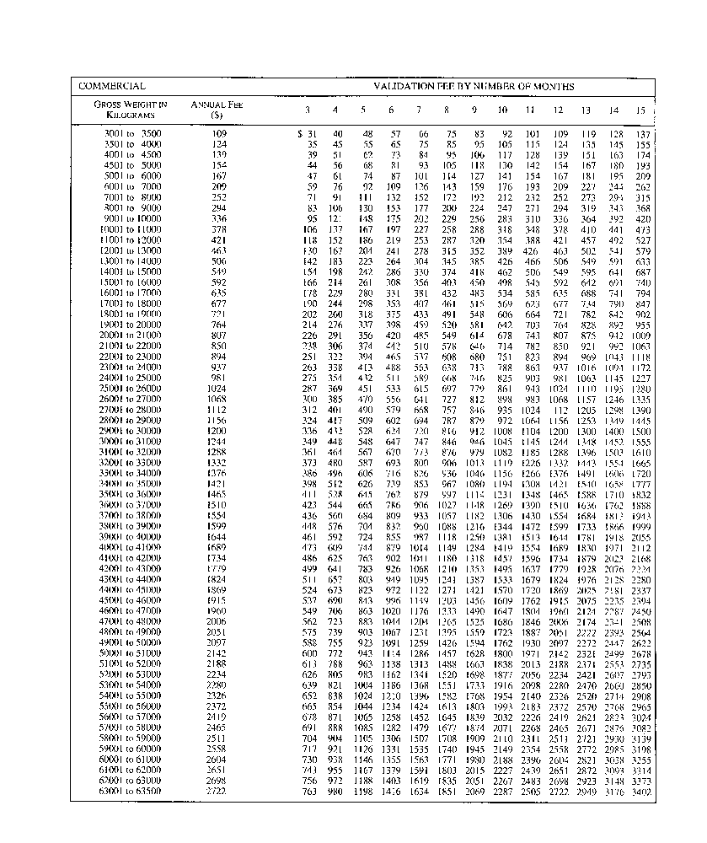
R.R.O. 1990, Reg. 628, Sched. 1.
Schedule 2
Insert regs\graphics\1990\628\628s02au.tif
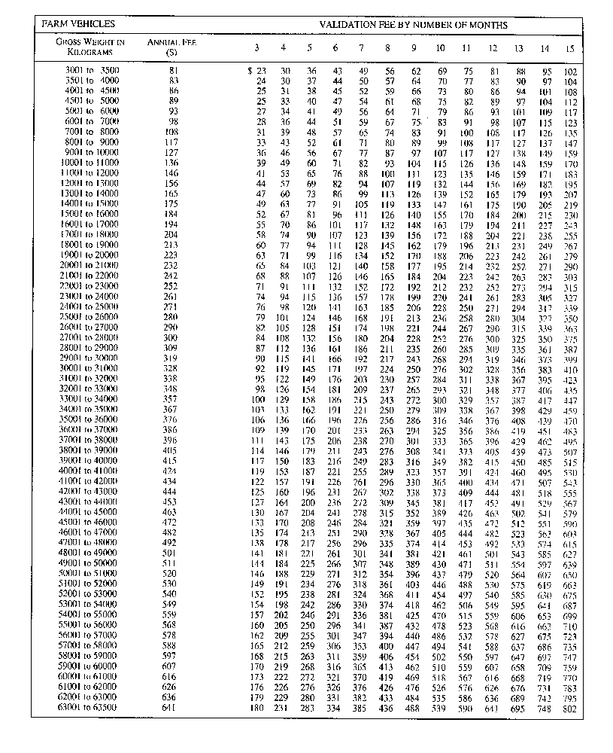
R.R.O. 1990, Reg. 628, Sched. 2.
Schedule 3
Insert regs\graphics\1990\628\628s03au.tif
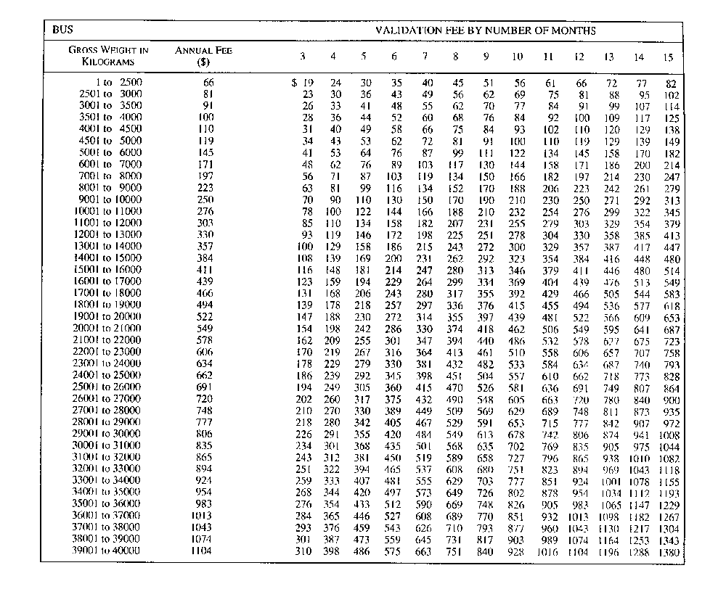
R.R.O. 1990, Reg. 628, Sched. 3.
Schedule 4
Insert regs\graphics\1990\628\628s04au.tif
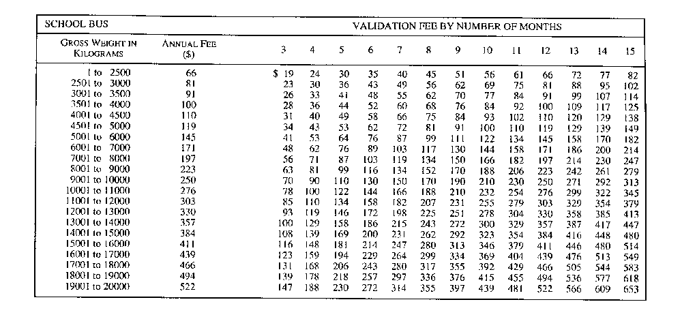
R.R.O. 1990, Reg. 628, Sched. 4.
Schedule 5
Validation Fee by Number of Months for Additional Classes of Vehicles

Months | Permit number 1, 9 & 10 | Permit number 2 & 11 | Permit number 3 | Permit number 4 | Permit number 5 | Permit number 6 | Permit number 7 | Permit number 8
3 | $18.50 | $9.25 | $4.50 | $10.50 | $5.25 | $3.00 | $39.00 | $21.75
4 | 24.65 | 12.35 | 6.00 | 14.00 | 7.00 | 4.00 | 52.00 | 29.00
5 | 30.85 | 15.40 | 7.50 | 17.50 | 8.75 | 5.00 | 65.00 | 36.25
6 | 37.00 | 18.50 | 9.00 | 21.00 | 10.50 | 6.00 | 78.00 | 43.50
7 | 43.15 | 21.60 | 10.50 | 24.50 | 12.25 | 7.00 | 91.00 | 50.75
8 | 49.35 | 24.65 | 12.00 | 28.00 | 14.00 | 8.00 | 104.00 | 58.00
9 | 55.50 | 27.75 | 13.50 | 31.50 | 15.75 | 9.00 | 117.00 | 65.25
10 | 61.65 | 30.85 | 15.00 | 35.00 | 17.50 | 10.00 | 130.00 | 72.50
11 | 67.85 | 33.90 | 16.50 | 38.50 | 19.25 | 11.00 | 143.00 | 79.75
12 | 74.00 | 37.00 | 18.00 | 42.00 | 21.00 | 12.00 | 156.00 | 87.00
13 | 80.15 | 40.10 | 19.50 | 45.50 | 22.75 | 13.00 | 169.00 | 94.25
14 | 86.35 | 43.15 | 21.00 | 49.00 | 24.50 | 14.00 | 182.00 | 101.50
15 | 92.50 | 46.25 | 22.50 | 52.50 | 26.25 | 15.00 | 195.00 | 108.75
16 | 98.65 | 49.35 | 24.00 | 56.00 | 28.00 | 16.00 | 208.00 | 116.00
17 | 104.85 | 52.40 | 25.50 | 59.50 | 29.75 | 17.00 | 221.00 | 123.25
18 | 111.00 | 55.50 | 27.00 | 63.00 | 31.50 | 18.00 | 234.00 | 130.50
19 | 117.15 | 58.60 | 28.50 | 66.50 | 33.25 | 19.00 | 247.00 | 137.75
20 | 123.35 | 61.65 | 30.00 | 70.00 | 35.00 | 20.00 | 260.00 | 145.00
21 | 129.50 | 64.75 | 31.50 | 73.50 | 36.75 | 21.00 | 273.00 | 152.25
22 | 135.65 | 67.85 | 33.00 | 77.00 | 38.50 | 22.00 | 286.00 | 159.50
23 | 141.85 | 70.90 | 34.50 | 80.50 | 40.25 | 23.00 | 299.00 | 166.75
24 | 148.00 | 74.00 | 36.00 | 84.00 | 42.00 | 24.00 | 312.00 | 174.00
25 | 154.15 | 77.10 | 37.50 | 87.50 | 43.75 | 25.00 | 325.00 | 181.25
26 | 160.35 | 80.15 | 39.00 | 91.00 | 45.50 | 26.00 | 338.00 | 188.50
The permit number refers to a vehicle described opposite the permit number as follows:

Permit Number
1. | For a motor vehicle to which year-of-manufacture plates have been attached, other than a motor vehicle described in subsection 18 (8) or a motorcycle, or for a passenger car or motorized mobile home.
2. | For a motor vehicle to which year-of-manufacture plates have been attached, other than a motor vehicle described in subsection 18 (8) or a motorcycle, or for a passenger car or a motorized mobile home, if the permit holder is a resident of Northern Ontario.
3. | For an historic vehicle.
4. | For a motorcycle, including a motorcycle to which year-of-manufacture plates have been attached.
5. | For a motorcycle, including a motorcycle to which year-of-manufacture plates have been attached, if the permit holder is a resident of Northern Ontario.
6. | For a motor assisted bicycle.
7. | For a Dealer permit or a Service permit for a motor vehicle or trailer.
8. | For a Dealer and Service permit for a motorcycle or motor assisted bicycle.
9. | For a commercial motor vehicle or a combination of a commercial motor vehicle and trailer or trailers, other than a bus, with a gross weight of not more than 3,000 kilograms.
10. | For a commercial motor vehicle or a combination of a commercial motor vehicle and trailer or trailers, other than a bus, with a gross weight of not more than 3,000 kilograms, if the vehicle is used primarily for personal transportation.
11. | For a commercial motor vehicle or a combination of a commercial motor vehicle and trailer or trailers, other than a bus, with a gross weight of not more than 3,000 kilograms, if the permit holder is a resident of Northern Ontario who uses the vehicle primarily for personal transportation.
O. Reg. 337/97, s. 4; O. Reg. 331/01, s. 4; O. Reg. 367/04, s. 6.

Back to top

