Repair and Storage Liens Act
R.R.O. 1990, REGULATION 1002
FORMS
Historical version for the period November 22, 1993 to March 19, 2018.
Last amendment: O. Reg. 743/93
This is the English version of a bilingual regulation.
1. A direction to seize under subsection 14 (1) of the Act shall be in Form 1. R.R.O. 1990, Reg. 1002, s. 1.
2. An application under subsection 24 (3) of the Act shall be in Form 2. R.R.O. 1990, Reg. 1002, s. 2.
3. An initial certificate of payment into court under subsection 24 (5) of the Act shall be in Form 3. R.R.O. 1990, Reg. 1002, s. 3.
4. A notice of objection by a respondent under subsection 24 (6) of the Act shall be in Form 4. R.R.O. 1990, Reg. 1002, s. 4.
5. A final certificate of payment into court under subsection 24 (7) of the Act shall be in Form 5. R.R.O. 1990, Reg. 1002, s. 5.
6. A writ of seizure under subsection 24 (9) of the Act shall be in Form 6. R.R.O. 1990, Reg. 1002, s. 6.
7. A receipt for release of an article under subsection 24 (11) of the Act shall be in Form 7 or 8. R.R.O. 1990, Reg. 1002, s. 7.
8. A waiver of further claim under subsection 24 (11) of the Act shall be in Form 9. R.R.O. 1990, Reg. 1002, s. 8.
9. An irrevocable letter of credit under subsection 24 (4) or (7) of the Act shall be in Form 10. R.R.O. 1990, Reg. 1002, s. 9.
10. A financial guarantee bond under subsection 24 (4) or (7) of the Act shall be in Form 11. R.R.O. 1990, Reg. 1002, s. 10.
11. An application to the Small Claims Court under subsection 23 (1) of the Act shall be in Form 12. R.R.O. 1990, Reg. 1002, s. 11.
Form 1
DIRECTION TO SEIZE UNDER SECTION 14
Repair and Storage Liens Act
Insert regs\graphics\1990\1002\002001ae.tif
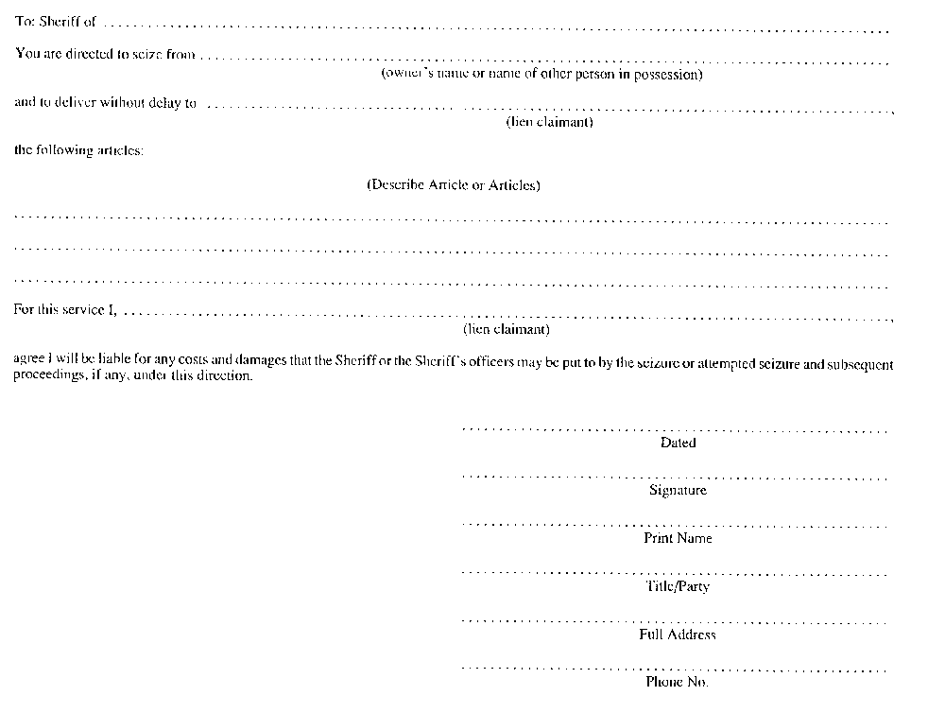
R.R.O. 1990, Reg. 1002, Form 1.
Form 2
APPLICATION FOR INITIAL CERTIFICATE UNDER SECTION 24
Repair and Storage Liens Act
Insert regs\graphics\1990\1002\002002ae.tif
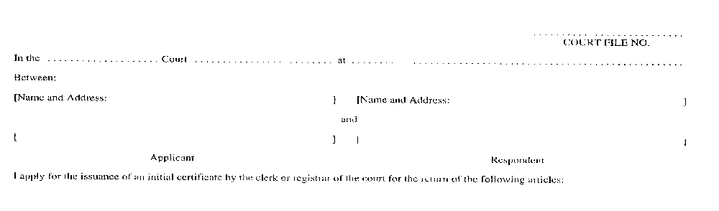
Insert regs\graphics\1990\1002\002002be.tif
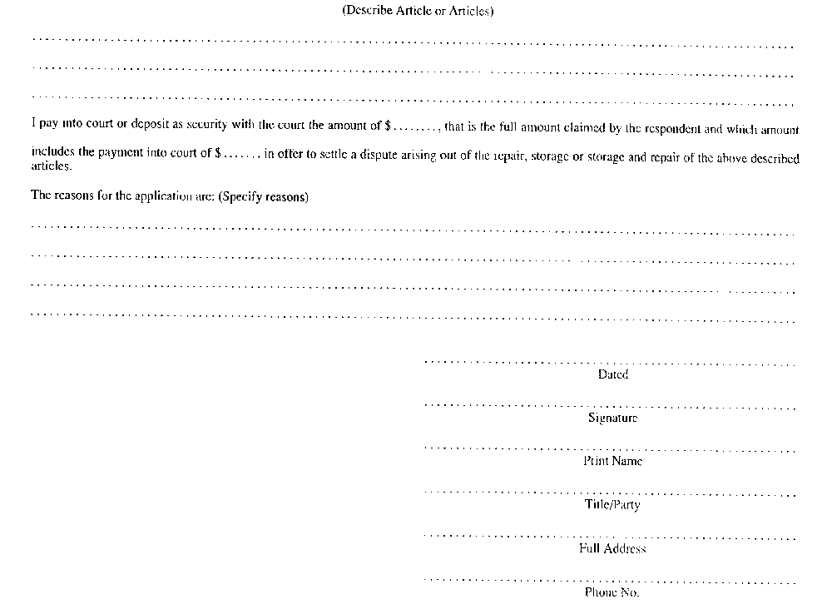
R.R.O. 1990, Reg. 1002, Form 2.
Form 3
INITIAL CERTIFICATE UNDER SECTION 24
Repair and Storage Liens Act
Insert regs\graphics\1990\1002\002003ae.tif
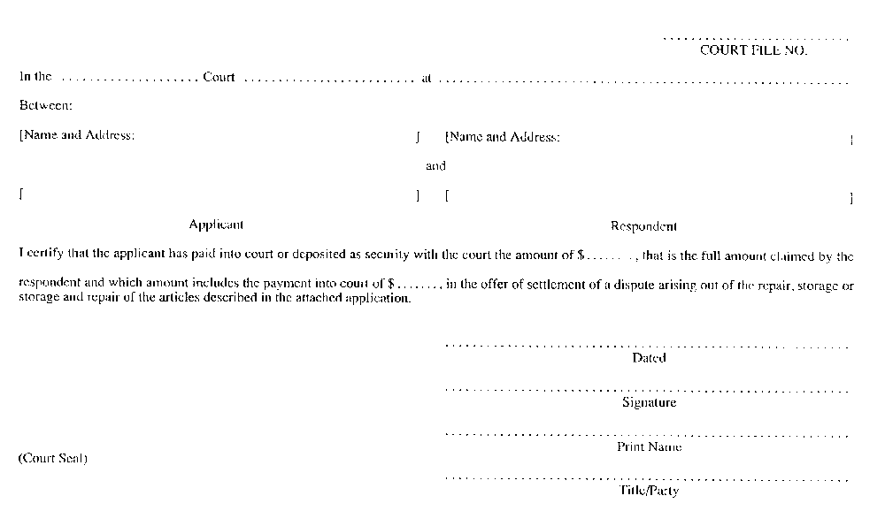
Insert regs\graphics\1990\1002\002003be.tif
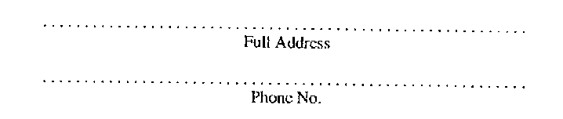
R.R.O. 1990, Reg. 1002, Form 3.
Form 4
NOTICE OF OBJECTION UNDER SECTION 24
Repair and Storage Liens Act
Insert regs\graphics\1990\1002\002004ae.tif
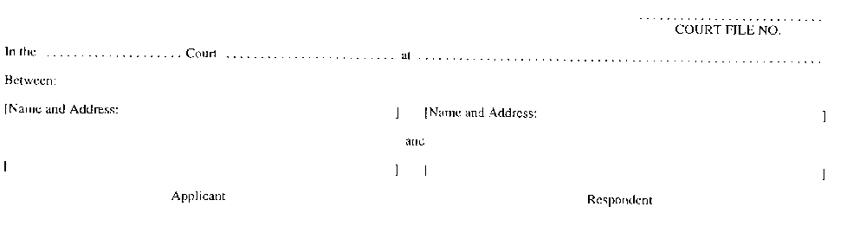
Insert regs\graphics\1990\1002\002004be.tif
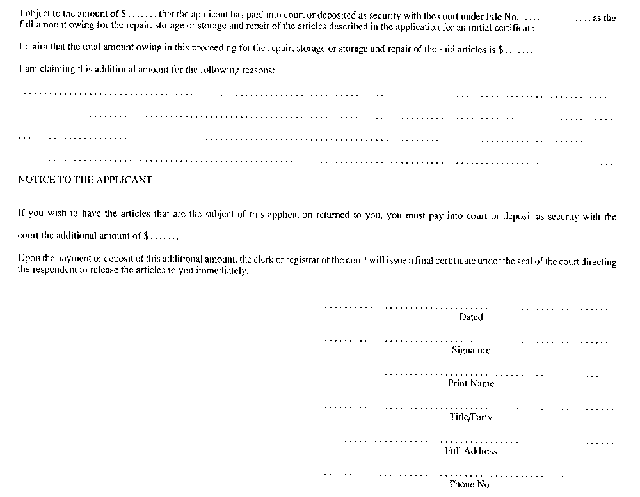
R.R.O. 1990, Reg. 1002, Form 4.
Form 5
FINAL CERTIFICATE UNDER SECTION 24
Repair and Storage Liens Act
Insert regs\graphics\1990\1002\002005ae.tif
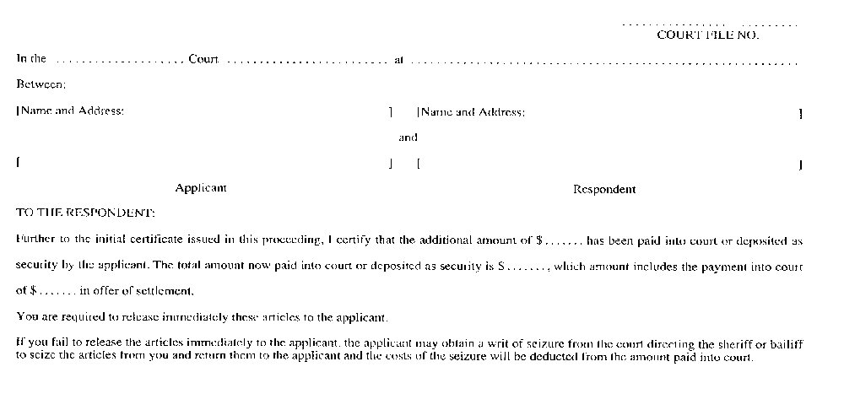
Insert regs\graphics\1990\1002\002005be.tif
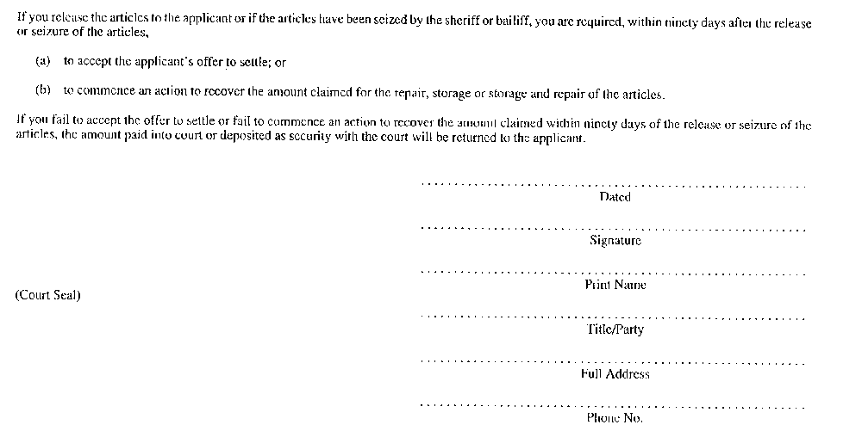
R.R.O. 1990, Reg. 1002, Form 5.
Form 6
WRIT OF SEIZURE UNDER SECTION 24
Repair and Storage Liens Act
Insert regs\graphics\1990\1002\002006ae.tif
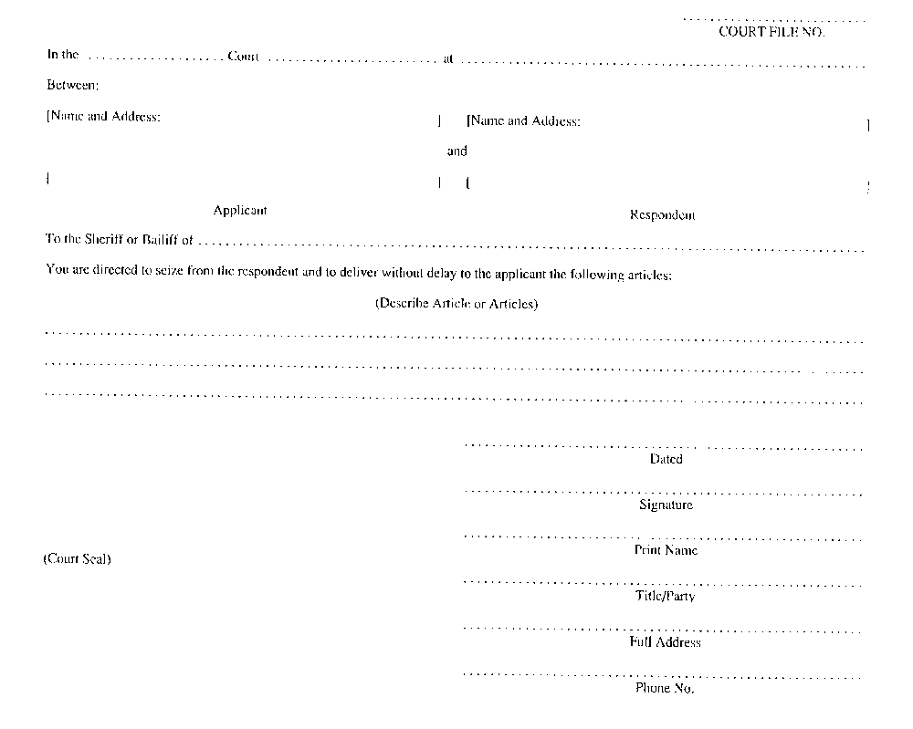
R.R.O. 1990, Reg. 1002, Form 6.
Form 7
RECEIPT FOR ARTICLE UNDER SECTION 24
Repair and Storage Liens Act
Insert regs\graphics\1990\1002\002007ae.tif
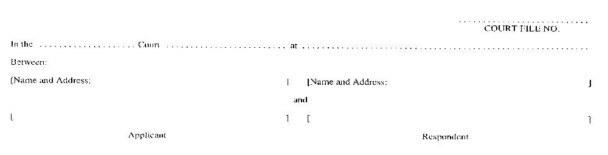
Insert regs\graphics\1990\1002\002007be.tif
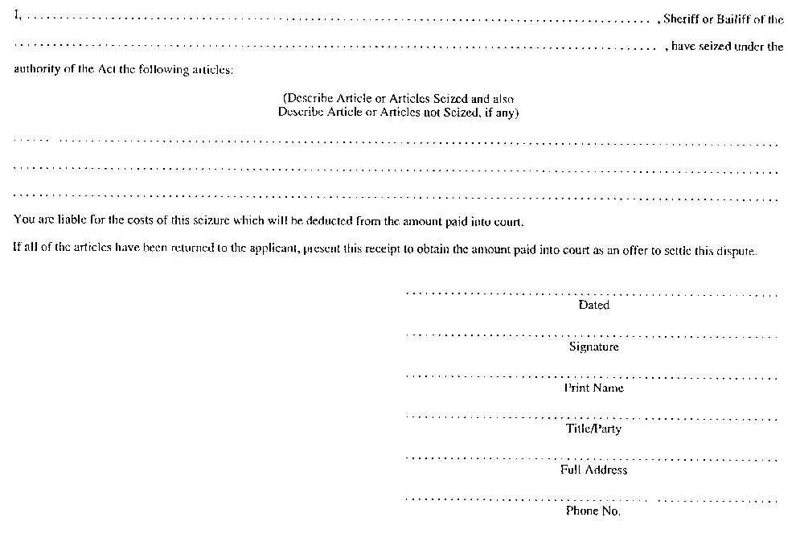
R.R.O. 1990, Reg. 1002, Form 7.
Form 8
RECEIPT FOR ARTICLE UNDER SECTION 24
Repair and Storage Liens Act
Insert regs\graphics\1990\1002\002008ae.tif
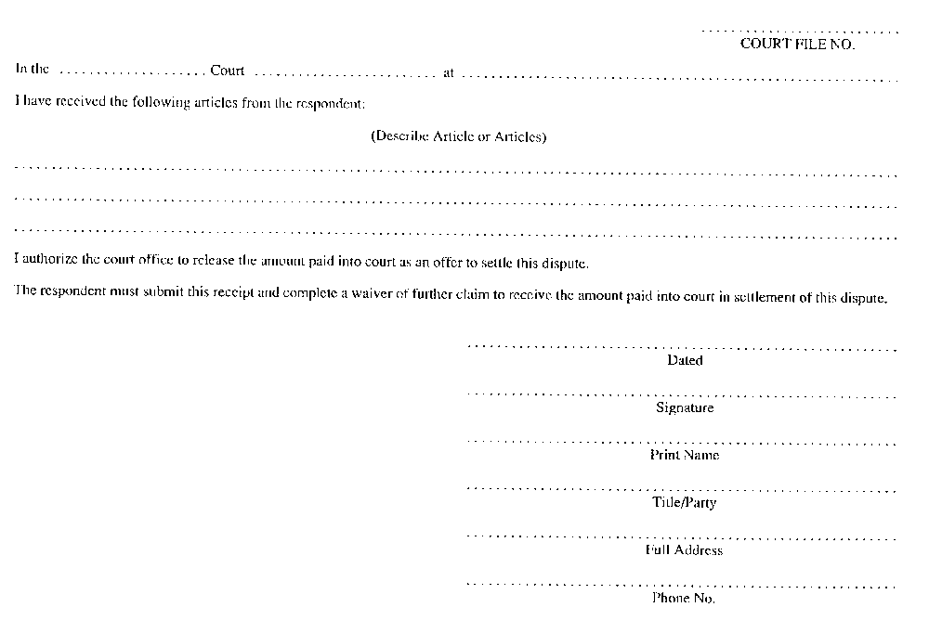
R.R.O. 1990, Reg. 1002, Form 8.
Form 9
WAIVER OF FURTHER CLAIM UNDER SECTION 24
Repair and Storage Liens Act
Insert regs\graphics\1990\1002\002009ae.tif
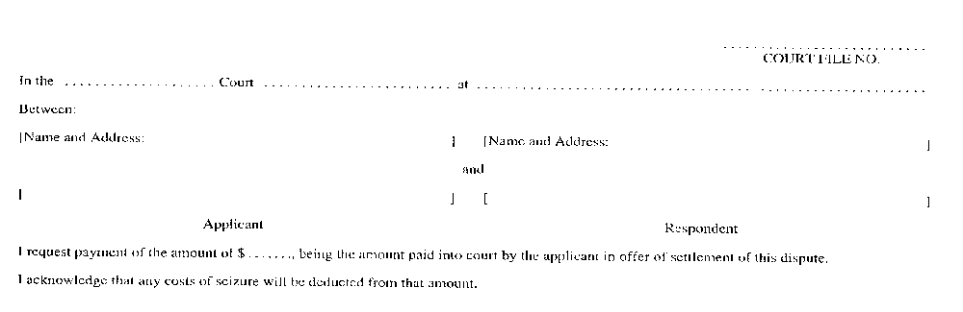
Insert regs\graphics\1990\1002\002009be.tif
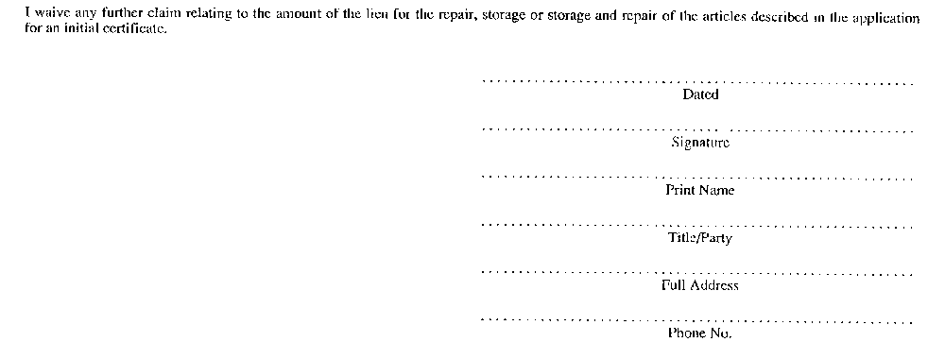
R.R.O. 1990, Reg. 1002, Form 9.
Form 10
IRREVOCABLE LETTER OF CREDIT
Repair and Storage Liens Act
Insert regs\graphics\1990\1002\002010ae.tif
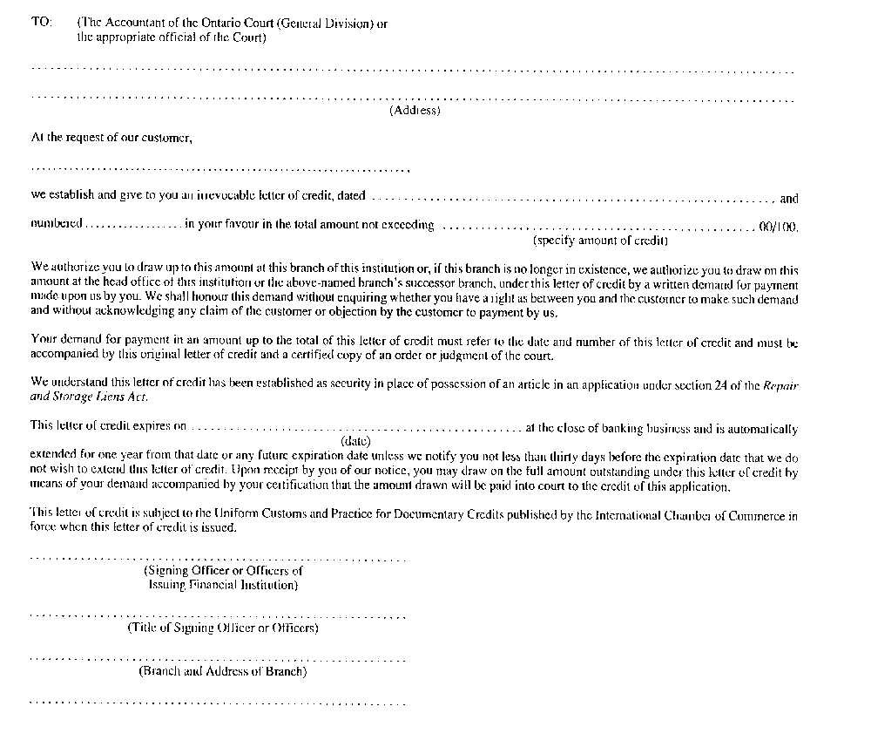
R.R.O. 1990, Reg. 1002, Form 10.
Form 11
FINANCIAL GUARANTEE BOND UNDER SECTION 24
Repair and Storage Liens Act
Insert regs\graphics\1990\1002\002011ae.tif
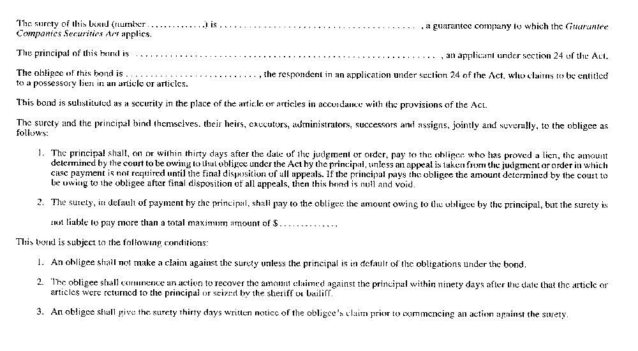
Insert regs\graphics\1990\1002\002011be.tif
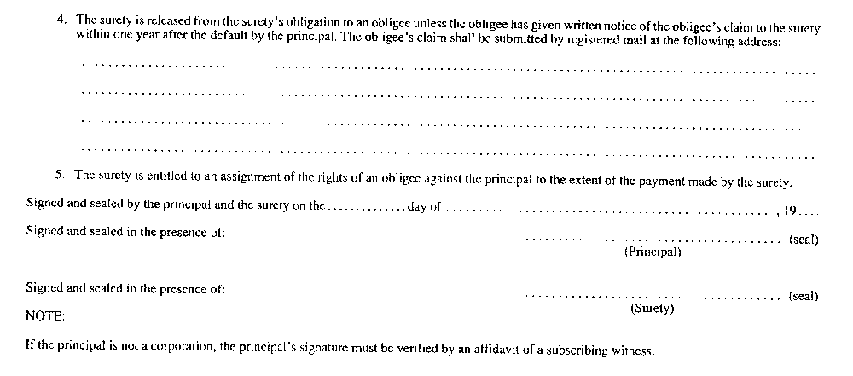
R.R.O. 1990, Reg. 1002, Form 11.
Form 12
APPLICATION UNDER SECTION 23 SMALL CLAIMS COURT
Repair and Storage Liens Act
Insert regs\graphics\1990\1002\002012ae.tif
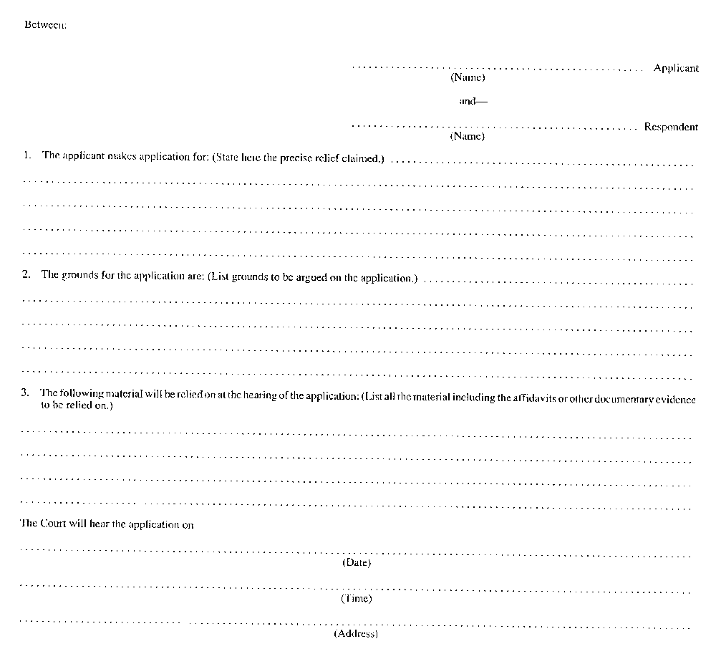
Insert regs\graphics\1990\1002\002012be.tif
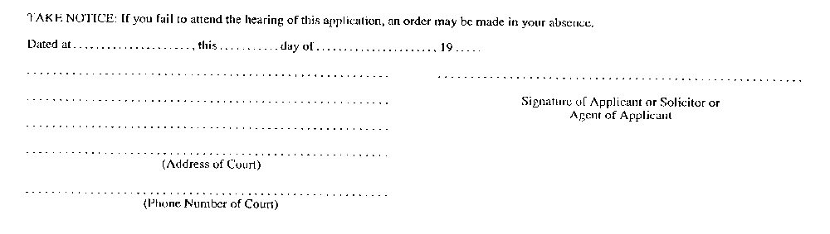
R.R.O. 1990, Reg. 1002, Form 12.

