Securities Act
Loi sur les valeurs mobilières
R.R.O. 1990, REGULATION 1015
GENERAL
Historical version for the period April 30, 2010 to November 28, 2010.
Last amendment: O. Reg. 141/10.
This Regulation is made in English only.
CONTENTS
 |  | Sections
PART I | GENERAL
 | Interpretation | 1
 | Financial Statements | 2
PART II | CONTINUOUS DISCLOSURE
 | Non-Financial Matters | 3-13
PART III | PROSPECTUS REQUIREMENTS | 14-39
 | Format | 40.-42-80.-82
PART V | REGISTRATION REQUIREMENTS | 96-106.-109
 | Conditions of Registration — Capital Requirements | 110-130.-133
 | Examination | 134-150., 151
PART VI | OVER-THE-COUNTER TRADING
 | General | 152-153
 | Trade Reporting | 154
 | Market-Making | 155-156
 | General | 157-159
PART VII | ONTARIO SECURITIES COMMISSION PROCEDURE AND RELATED MATTERS
 | Endorsement of Warrants | 160
 | Execution and Certification of Documents | 161
 | Fees and Filing | 162
 | Investigations | 163
PART VIII | INSIDER TRADING
 | General | 164-174
 | Insider Trading | 175-233
PART XIV | LABOUR SPONSORED INVESTMENT FUND CORPORATIONS | 234-245
PART XV | ELECTRONIC FILING | 246-247
PART XVI | CIVIL LIABILITY FOR SECONDARY MARKET DISCLOSURE | 248-252
Form 1 | Summons to a witness before a person appointed under section ...... of the Act
Form 2 | Affidavit of service
Form 8 | Summons to a witness before a person designated under section 31 of the Act
Form 37 | Report by a registered owner of securities beneficially owned by an insider
Form 38 | Report under section 117 of the Act
Form 39 | Endorsement of warrant
Form 41 | Application for approval to be a market-maker in a coats security
PART I
GENERAL
Interpretation
1. (1) Every term used in this Regulation that is,
(a) defined in section 1 of the Act is used in this Regulation as so defined unless it is otherwise defined in this Regulation or the context otherwise requires;
(b) defined in a Part of the Act for purposes of that Part, is used as so defined in those sections of this Regulation that relate to the subject-matter of that Part; and
(c) defined only for a Part or section of this Regulation is, unless otherwise provided, so defined only for the purposes of such Part or section. R.R.O. 1990, Reg. 1015, s. 1 (1).
(2) In this Regulation,
“insurance company” means an issuer licensed under the Insurance Act;
“natural resource company” means a mining, gas, oil or exploration issuer designated by the Director as a natural resource company. R.R.O. 1990, Reg. 1015, s. 1 (2); O. Reg. 491/05, s. 1; O. Reg. 357/09, s. 1.
(3) Subject to subsection (4), for the purposes of the Act and this Regulation,
(a) where the terms “generally accepted accounting principles”, “auditor’s report” and “generally accepted auditing standards” are used in reference to a financial statement to which National Instrument 52-107 Acceptable Accounting Principles, Auditing Standards and Reporting Currencies applies, those terms have the meanings provided for in that Instrument; and
(b) in all other cases, where a recommendation has been made in the Handbook of the Canadian Institute of Chartered Accountants which is applicable in the circumstances, the terms “generally accepted accounting principles”, “auditor’s report” and “generally accepted auditing standards” mean the principles, report and standards, respectively, recommended in the Handbook. O. Reg. 72/04, s. 1.
(4) Except as otherwise provided in National Instrument 52-107 Acceptable Accounting Principles, Auditing Standards and Reporting Currencies, in National Instrument 71-101 The Multijurisdictional Disclosure System and in Ontario Securities Commission Rule 71-801 The Multijurisdictional Disclosure System, where an issuer is incorporated or organized in a jurisdiction other than Canada or a province or territory of Canada, “generally accepted accounting principles” may, at the option of the issuer, mean such principles as prescribed in the incorporating jurisdiction by or pursuant to applicable legislation or where a recommendation has been made by an association in that jurisdiction equivalent to the Canadian Institute of Chartered Accountants, the principles recommended by that association, but where an option is exercised under this subsection, the notes to the financial statements shall state which option has been applied in the choice of generally accepted accounting principles. O. Reg. 72/04, s. 1.
(5) Where the Act or this Regulation requires the disclosure of the number or percentage of securities beneficially owned by a person and, by virtue of subsection 1 (5) of the Act, one or more companies will also have to be shown as beneficially owning the securities, a statement disclosing all the securities beneficially owned by the person or deemed to be beneficially owned, and indicating whether the ownership is direct or indirect and, if indirect, indicating the name of the controlled company or company affiliated with the controlled company through which the securities are indirectly owned and the number or percentage of the securities so owned by the company, shall be deemed sufficient disclosure without disclosing the name of any other company which is deemed to beneficially own the same securities. R.R.O. 1990, Reg. 1015, s. 1 (5).
(6) Where the Act or this Regulation requires the disclosure of the number or percentage of securities beneficially owned by a company and, by virtue of subsection 1 (6) of the Act, one or more other companies will also have to be shown as beneficially owning the securities, a statement disclosing all securities beneficially owned or deemed to be beneficially owned by the parent company and indicating whether the ownership is direct or indirect and, if indirect, indicating the name of the subsidiary through which the securities are indirectly owned and the number or percentage of the securities so owned, shall be deemed sufficient disclosure without disclosing the name of any other company which is deemed to beneficially own the same securities. R.R.O. 1990, Reg. 1015, s. 1 (6).
(7) A company shall be deemed to be another’s holding company or parent company if that other is its subsidiary. R.R.O. 1990, Reg. 1015, s. 1 (7).
Financial Statements
2. (1) Subject to subsections (3) and (4), the financial statements permitted or required by the Act or this Regulation shall be prepared in accordance with generally accepted accounting principles and with any applicable provision of the Act or this Regulation. R.R.O. 1990, Reg. 1015, s. 2 (1).
(2) Revoked: O. Reg. 215/05, s. 1 (1).
(3) Revoked: O. Reg. 72/04, s. 2.
(4) Despite subsection (1), where a financial statement is not prepared in accordance with generally accepted accounting principles,
(a) the Director may accept the financial statement for the purposes for which it is to be filed,
(i) where the Director is satisfied that it is not reasonably practicable for the issuer to revise the presentation in the financial statement to conform to generally accepted accounting principles, or
(ii) where the Commission by its order under clause (b) has previously accepted a financial statement of the same issuer with a corresponding variation from generally accepted accounting principles and the Director is satisfied that there has been no material change in the circumstances upon which the decision of the Commission was based; or
(b) the Commission may, by order, accept the financial statement after giving interested parties an opportunity to be heard if the Commission is satisfied in all the circumstances of the particular case that the variation from generally accepted accounting principles is supported or justified by considerations that outweigh the desirability of uniform adherence to generally accepted accounting principles and the Commission shall publish written reasons for any acceptance of financial statements under this paragraph. R.R.O. 1990, Reg. 1015, s. 2 (4).
(5)-(7) Revoked: O. Reg. 215/05, s. 1 (2).
part ii
continuous disclosure
Non-Financial Matters
3. (1) Revoked: O. Reg. 215/05, s. 2 (1).
(1.1) Every report required to be filed under subsection 75 (2) of the Act by a reporting issuer shall be prepared in accordance with Form 51-102F3 of National Instrument 51-102 Continuous Disclosure Obligations except that,
(a) the reference in Item 3 of the Form to section 7.1 of National Instrument 51-102 shall be read as if it were a reference to subsection 75 (1) of the Act; and
(b) the references in Items 6 and 7 of the Form to subsection 7.1 (2) , (5) or (7) of National Instrument 51-102 shall be read as if they were references to subsection 75 (3), (4) or (5), respectively, of the Act. O. Reg. 56/04, s. 2; O. Reg. 215/05, s. 2 (2).
(1.2) Every report required to be filed under subsection 75 (2) of the Act shall, subject to section 4, be delivered to the Commission in an envelope addressed to the Commission and marked “Continuous Disclosure”. O. Reg. 56/04, s. 2.
(2) The requirements in this section apply except as otherwise provided in National Instrument 71-101 The Multijurisdictional Disclosure System and in Ontario Securities Commission Rule 71-801 The Multijurisdictional Disclosure System. O. Reg. 568/98, s. 3.
4. Where the reporting issuer files,
(a) the report required by subsection 75 (2) of the Act in reliance on,
(i) subsection 75 (3) of the Act, or
(ii) Item 7 of Form 51-102F3 of National Instrument 51-102 Continuous Disclosure Obligations; or
(iii) Revoked: O. Reg. 215/05, s. 3.
(b) the notification required by subsection 75 (4) of the Act,
everything that is required to be filed thereby shall be marked “Confidential” and placed in an envelope addressed to the Secretary marked “Confidential — s. 75”. R.R.O. 1990, Reg. 1015, s. 4; O. Reg. 56/04, s. 3; O. Reg. 215/05, s. 3.
5. Revoked: O. Reg. 56/04, s. 4.
6. Revoked: O. Reg. 215/05, s. 4.
6.1 Revoked: R.R.O. 1990, Reg. 1015, s. 6.1 (2). (See: O. Reg. 636/00, s. 1.)
7. Revoked: R.R.O. 1990, Reg. 1015, s. 7 (3). (See: O. Reg. 636/00, s. 2.)
8. Revoked: R.R.O. 1990, Reg. 1015, s. 8 (2). (See: O. Reg. 636/00, s. 3.)
9. Revoked: R.R.O. 1990, Reg. 1015, s. 9 (2). (See: O. Reg. 636/00, s. 4.)
9.1 Revoked: R.R.O. 1990, Reg. 1015, s. 9.1 (2). (See: O. Reg. 636/00, s. 5.)
10. Revoked: R.R.O. 1990, Reg. 1015, s. 10 (3). (See: O. Reg. 636/00, s. 6.)
11. Revoked: R.R.O. 1990, Reg. 1015, s. 11 (2). (See: O. Reg. 636/00, s. 7.)
12. Revoked: O. Reg. 507/97, s. 1.
13. Revoked: R.R.O. 1990, Reg. 1015, s. 13 (2). (See: O. Reg. 636/00, s. 8.)
PART III
PROSPECTUS REQUIREMENTS
14. Revoked: O. Reg. 662/98, s. 1.
15. Revoked: O. Reg. 130/98, s. 2.
16.-32. Revoked: O. Reg. 662/98, s. 1.
33. Revoked: O. Reg. 91/01, s. 1.
34.-37. Revoked: O. Reg. 632/00, s. 3.
38. Revoked: O. Reg. 453/05, s. 1.
39. Revoked: O. Reg. 632/00, s. 5.
Format
40.-42. Revoked: O. Reg. 632/00, s. 5.
43. If a prospectus is required to be filed in respect of an issuer bid, the information required in Form 62-504F2 in Rule 62-504 Take-Over Bids and Issuer Bids, other than the certificate in Item 31 of Part 2 of the form, shall be included in the prospectus. O. Reg. 589/07, s. 1.
44. Revoked: O. Reg. 31/08, s. 1.
45.-49. Revoked: O. Reg. 632/00, s. 6.
50., 51. Revoked: O. Reg. 631/00, s. 1.
52. Revoked: O. Reg. 632/00, s. 7.
53. Revoked: O. Reg. 632/00, s. 7.
54. Revoked: O. Reg. 31/08, s. 1.
55.-59. Revoked: O. Reg. 632/00, s. 7.
60. Revoked: O. Reg. 562/07, s. 1.
61.-66. Revoked: O. Reg. 632/00, s. 8.
67., 68. Revoked: O. Reg. 662/98, s. 1.
69. (1) Revoked: O. Reg. 423/01, s. 1.
(2) Revoked: O. Reg. 491/05, s. 2.
(3) Revoked: O. Reg. 662/98, s. 1.
(4), (5) Revoked: O. Reg. 657/98, s. 1.
70. Revoked: O. Reg. 423/01, s. 2.
71.-78. Revoked: O. Reg. 491/05, s. 3.
79. Revoked: O. Reg. 453/05, s. 2.
80.-82. Revoked: O. Reg. 632/00, s. 10.
Part iv (ss. 83-95) Revoked: O. Reg. 358/09, s. 1.
PART V
REGISTRATION REQUIREMENTS
96. Revoked: O. Reg. 358/09, s. 2.
97. Revoked: O. Reg. 357/09, s. 2.
98.-104. Revoked: O. Reg. 358/09, s. 2.
105. Revoked: O. Reg. 357/09, s. 2.
106.-109. Revoked: O. Reg. 358/09, s. 2.
Conditions of Registration — Capital Requirements
110. (1) Every dealer, other than an exempt market dealer as defined in National Instrument 31-103 Registration Requirements and Exemptions, shall participate in a compensation fund or contingency trust fund approved by the Commission and established by,
(a) a recognized self-regulatory organization referred to in section 21.1 of the Act;
(b) a recognized stock exchange; or
(c) a trust corporation registered under the Loan and Trust Corporations Act. O. Reg. 453/05, s. 7; O. Reg. 358/09, s. 3.
(2) The Commission may vary the amount required to be contributed by any participant where in its opinion it would not be prejudicial to the public interest to do so, provided that the variation is published by the Commission in a publication published by it prior to the variation taking effect. R.R.O. 1990, Reg. 1015, s. 110 (2).
111.-113. Revoked: O. Reg. 358/09, s. 4.
114. Revoked: O. Reg. 1/99, s. 1.
115.-123. Revoked: O. Reg. 358/09, s. 4.
124. Revoked: O. Reg. 468/00, s. 2.
125. Revoked: O. Reg. 1/99, s. 1.
126. Revoked: O. Reg. 468/00, s. 3.
127. Revoked: O. Reg. 358/09, s. 4.
128. Revoked: O. Reg. 393/01, s. 1.
129. Revoked: O. Reg. 16/03, s. 1.
130.-133. Revoked: O. Reg. 358/09, s. 4.
Examination
134. A summons for an examination under section 33.1 of the Act shall be in Form 8. R.R.O. 1990, Reg. 1015, s. 134; O. Reg. 357/09, s. 3.
135. Revoked: O. Reg. 453/05, s. 10.
136. Revoked: O. Reg. 16/03, s. 3.
137., 138. Revoked: O. Reg. 453/05, s. 10.
139.-142. Revoked: O. Reg. 358/09, s. 4.
143. Revoked: O. Reg. 357/09, s. 4.
144., 145. Revoked: O. Reg. 358/09, s. 4.
146. Revoked: O. Reg. 357/09, s. 4.
147. (1) Revoked: O. Reg. 453/05, s. 15 (1).
(2) Revoked: O. Reg. 358/09, s. 4.
148. Revoked: O. Reg. 491/05, s. 6.
149. Revoked: O. Reg. 424/01, s. 1.
150., 151. Revoked: O. Reg. 491/05, s. 7.
PART VI
OVER-THE-COUNTER TRADING
General
152. In this Part,
“approved market-maker” means a registered dealer who is approved under this Regulation to act as a market-maker in a security;
“COATS security” means,
(a) a share of a company,
(b) a right or warrant, but not an option, to purchase a share of a company, or
(c) any combination of a share of a company and a right or warrant, but not an option, to purchase a share of a company,
but does not include,
(d) a security of a private issuer as defined in subsection 2.4 (1) of National Instrument 45-106 Prospectus and Registration Exemptions,
(d.1) a security that, under subsection 2.13 (1), 2.20 (1), 2.21 (1), 2.34 (2), 2.35 (1), 2.36 (2), 2.37 (1) or 2.38 (1) of National Instrument 45-106 Prospectus and Registration Exemptions, is exempt from registration,
(d.2) a security that, under subsection 2.4 (1), 2.5 (1) or 2.6 (1) or (2) of Ontario Securities Commission Rule 45-501 Ontario Prospectus and Registration Exemptions, is exempt from registration, or
(d.3) Revoked: O. Reg. 491/05, s. 8 (3).
(e) a security that is traded on a marketplace as defined in National Instrument 21-101 Marketplace Operation;
“COAT System” means the system developed for trading in the over-the-counter market and known as the Canadian Over-the-Counter Automated Trading System. R.R.O. 1990, Reg. 1015, s. 152; O. Reg. 393/01, s. 2; O. Reg. 424/01, s. 2; O. Reg. 491/05, s. 8.
153. The Commission, itself or through an agent, shall operate the COAT System and for such purpose it shall develop computer software and provide and operate computer facilities. R.R.O. 1990, Reg. 1015, s. 153.
Trade Reporting
154. (1) Every purchase or sale in Ontario of a COATS security made by a registered dealer, as principal or agent, shall be reported on the COAT System except a trade that is,
(a) made through the facilities of a stock exchange or other organized market recognized by the Commission for the purpose of this Part;
(b) a distribution by or on behalf of an issuer; or
(c) a trade made in reliance on an exemption set out in section 2.3, 2.7, 2.8, 2.10 or 2.15 of National Instrument 45-106 Prospectus and Registration Exemptions. R.R.O. 1990, Reg. 1015, s. 154 (1); O. Reg. 424/01, s. 3; O. Reg. 491/05, s. 9.
(2) Every purchase or sale in a COATS security that is required to be reported under subsection (1) shall be reported on the COAT System in accordance with the following provisions:
1. The registered dealer, if any, through or by whom the sale is made shall report the trade.
2. Where the sale is not made by or through a registered dealer, the registered dealer by or through whom the purchase is made shall report the trade.
3. The report shall be made in accordance with the requirements of the COAT System. R.R.O. 1990, Reg. 1015, s. 154 (2).
Market-Making
155. (1) A registered dealer, other than a security issuer, mutual fund dealer or scholarship plan dealer, may apply to the Director for approval to act as a market-maker in a COATS security of a class that trades in Ontario. R.R.O. 1990, Reg. 1015, s. 155 (1).
(2) An application for approval to act as a market-maker in a security shall be in Form 41 and shall be filed with the Director. R.R.O. 1990, Reg. 1015, s. 155 (2).
156. (1) A registered dealer shall not post quotations for a security on the COAT System,
(a) unless the dealer has been approved by the Director to act as a market-maker in the security;
(b) until the day and time set out in the Director’s approval; and
(c) unless the Director has determined that it is not contrary to the public interest for the security to be quoted on the COAT System. R.R.O. 1990, Reg. 1015, s. 156 (1).
(2) Once an approved market-maker has posted a quotation on the COAT System with respect to a security, the market-maker, so long as it is an approved market-maker in the security, shall make continuous and uninterrupted quotations with respect to the security from 9.30 a.m. to 5.00 p.m. on any day that is not a Saturday or holiday and, where it does not make continuous and uninterrupted quotes, it shall be deemed to have ceased being an approved market-maker in the security. R.R.O. 1990, Reg. 1015, s. 156 (2).
(3) An approved market-maker shall not quote an ask price for a security on the COAT System unless a bid price for the security is also quoted by the market-maker. R.R.O. 1990, Reg. 1015, s. 156 (3).
General
157. The Director may direct registered dealers to discontinue quoting or trading, or both, in a security in which a trade would be reportable on the COAT System in order to assist in the dissemination of information and to re-establish orderly trading. R.R.O. 1990, Reg. 1015, s. 157.
158. Every registered dealer shall pay the applicable COAT System fees. R.R.O. 1990, Reg. 1015, s. 158.
159. (1) The forms, fees and other requirements of the Commission’s agent in the operation of the COAT System, including the fees charged to commercial vendors of information for information reported thereon, are subject to the approval of the Commission and the forms, fees and other requirements, and any amendment to any of them, shall be published by the Commission in the month following the approval. R.R.O. 1990, Reg. 1015, s. 159 (1).
(2) The Commission may inspect all books, documents, correspondence and other records of any description maintained in relation to the COAT System by a registered dealer and by the Commission’s agent. R.R.O. 1990, Reg. 1015, s. 159 (2).
PART VII
ONTARIO SECURITIES COMMISSION PROCEDURE AND RELATED MATTERS
Endorsement of Warrants
160. The endorsement of a warrant by a provincial judge or justice of Ontario provided for by section 125 of the Act shall be in accordance with Form 39. R.R.O. 1990, Reg. 1015, s. 160; O. Reg. 80/95, s. 14; O. Reg. 56/04, s. 6.
Execution and Certification of Documents
161. Except as otherwise provided in the Act, section 11, 174 or 181 of this Regulation, Ontario Securities Commission Rule 55-502 Facsimile Filing or Delivery of Section 109 Reports, National Instrument 55-102 System for Electronic Disclosure by Insiders (SEDI) or National Instrument 71-102 Continuous Disclosure and Other Exemptions Relating to Foreign Issuers,
(a) every document required or permitted to be filed with the Commission by an individual that is required to be signed or certified shall be manually signed and shall include below the signature the name of the individual in typewritten or printed form;
(b) subject to clause (c) every document required or permitted to be filed with the Commission by a company or person, other than an individual, that is required to be signed or certified, shall be manually signed by an officer or director of the company or person or, subject to clause (d), by the attorney or agent of such person or company and shall include below the signature the name of the officer, director, attorney or agent in a typewritten or printed form;
(c) where a partner signs or certifies on behalf of a professional partnership, the partner is not required to sign his or her name but if an individual other than a partner signs or certifies, the individual shall sign his or her name manually and the name of the individual shall be included below his or her signature in typewritten or printed form; and
(d) where a document required or permitted to be filed with the Commission by an individual, company or person has been executed by an attorney or agent of the individual, company or person, a duly completed power of attorney or document of authority authorizing the signing of the document shall be filed with the document unless the Director permits the filing of the document without the power of attorney or document of authority. R.R.O. 1990, Reg. 1015, s. 161; O. Reg. 80/95, s. 15; O. Reg. 166/98, s. 1; O. Reg. 388/01, s. 1; O. Reg. 57/04, s. 1.
Fees and Filing
162. (1) Revoked: O. Reg. 165/98, s. 1.
(2) Where any material that is filed is not prepared in accordance with the Act or this Regulation, the Director may, or the Commission may require the Director to, return the material to the person or company that is required to comply with the provisions. R.R.O. 1990, Reg. 1015, s. 162 (2).
(3) Where any material is returned to a person or company under subsection (2), the fee paid upon the filing of the material shall not be refunded without the consent of the Commission. R.R.O. 1990, Reg. 1015, s. 162 (3).
Investigations
163. The following practices and procedures apply to investigations conducted under the Act:
1. Every summons issued by a person under subsection 11 (4) or section 13 of the Act shall be served personally on the individual summoned who shall be paid the like fees and allowances for his or her attendance before the person as are paid for the attendance of a witness summoned to attend before the Supreme Court.
2. Every summons to a witness to appear before a person appointed to make an investigation under section 11 or 13 of the Act shall be in Form 1.
3. The service of a summons on a witness, the payment or tender of fees and allowances to the witness and the service of a notice on a witness may be proved by an affidavit in Form 2. R.R.O. 1990, Reg. 1015, s. 163.
PART VIII
INSIDER TRADING
General
164. The disclosure required by section 40 of the Act with respect to a person or company that would be an insider of the adviser if the adviser were a reporting issuer is required only where such person or company participates in the formulation of, or has access prior to implementation to, investment decisions made on behalf of or the advice given to clients of the adviser. R.R.O. 1990, Reg. 1015, s. 164.
165. Revoked: O. Reg. 13/96, s. 1.
166., 167. Revoked: O. Reg. 141/10, s. 1.
168. Every report required to be filed under section 109 of the Act shall be prepared in accordance with Form 37. R.R.O. 1990, Reg. 1015, s. 168.
169. Every report required to be filed under section 117 of the Act shall be prepared in accordance with Form 38. R.R.O. 1990, Reg. 1015, s. 169.
170., 171. Revoked: O. Reg. 141/10, s. 1.
172. Revoked: O. Reg. 126/01, s. 1.
173. (1) A person or company that is required under this Part and under Part XXI of the Act to file a report prepared in accordance with Form 36 shall be deemed to have complied with such requirements if a report prepared in accordance with Form 55-102 F6 (made under National Instrument 55-102 System for Electronic Disclosure by Insiders (SEDI)) is filed in a Canadian jurisdiction other than Ontario with a securities commission or other agent that has been designated by the Commission for the purpose of accepting such filings. R.R.O. 1990, Reg. 1015, s. 173; O. Reg. 388/01, s. 2 (1).
(2) This section does not apply to insiders who are required by National Instrument 55-102 System for Electronic Disclosure by Insiders (SEDI) to file the report in electronic format. O. Reg. 388/01, s. 2 (2).
174. (1) A report prepared in accordance with Form 55-102 F6 (made under National Instrument 55-102 System for Electronic Disclosure by Insiders (SEDI)) that is filed with the Commission may contain the facsimile signature of the individual, officer, director, agent or attorney required to sign the form, if an original manually signed copy is filed concurrently with a securities commission in Canada designated by the Commission for the purpose of accepting such filings. R.R.O. 1990, Reg. 1015, s. 174; O. Reg. 388/01, s. 3 (1).
(2) This section does not apply to insiders who are required by National Instrument 55-102 System for Electronic Disclosure by Insiders (SEDI) to file the report in electronic format. O. Reg. 388/01, s. 3 (2).
Insider Trading
175. (1) A person or company that purchases or sells securities of a reporting issuer with knowledge of a material fact or material change with respect to the reporting issuer that has not been generally disclosed is exempt from subsection 76 (1) of the Act and from liability under section 134 of the Act, where the person or company proves that,
(a) no director, officer, partner, employee or agent of the person or company who made or participated in making the decision to purchase or sell the securities of the reporting issuer had actual knowledge of the material fact or material change; and
(b) no advice was given with respect to the purchase or sale of the securities to the director, officer, partner, employee or agent of the person or company who made or participated in making the decision to purchase or sell the securities by a director, partner, officer, employee or agent of the person or company who had actual knowledge of the material fact or the material change,
but this exemption is not available to an individual who had actual knowledge of the material fact or change. R.R.O. 1990, Reg. 1015, s. 175 (1).
(2) A person or company that purchases or sells securities of a reporting issuer with knowledge of a material fact or material change with respect to the reporting issuer that has not been generally disclosed is exempt from subsection 76 (1) of the Act and from liability under section 134 of the Act, where the person or company proves that,
(a) the purchase or sale was entered into as agent of another person or company pursuant to a specific unsolicited order from that other person or company to purchase or sell;
(b) the purchase or sale was made pursuant to participation in an automatic dividend reinvestment plan, share purchase plan or other similar automatic plan that was entered into by the person or company prior to the acquisition of knowledge of the material fact or material change; or
(c) the purchase or sale was made to fulfil a legally binding obligation entered into by the person or company prior to the acquisition of knowledge of the material fact or material change. R.R.O. 1990, Reg. 1015, s. 175 (2).
(3) In determining whether a person or company has sustained the burden of proof under subsection (1), it shall be relevant whether and to what extent the person or company has implemented and maintained reasonable policies and procedures to prevent contraventions of subsection 76 (1) of the Act by persons making or influencing investment decisions on its behalf and to prevent transmission of information concerning a material fact or material change contrary to subsection 76 (2) or (3) of the Act. R.R.O. 1990, Reg. 1015, s. 175 (3).
(4) A person or company who purchases or sells a security of a reporting issuer as agent or trustee for a person or company who is exempt from subsection 76 (1) of the Act and from liability under section 134 of the Act by reason of clause (2) (b) or (c), is also exempt from subsection 76 (1) of the Act and from liability under section 134 of the Act. R.R.O. 1990, Reg. 1015, s. 175 (4).
(5) A person or company is exempt from subsections 76 (1), (2) and (3) of the Act where the person or company proves that such person or company reasonably believed that,
(a) the other party to a purchase or sale of securities; or
(b) the person or company informed of the material fact or material change,
as the case may be, had knowledge of the material fact or material change. R.R.O. 1990, Reg. 1015, s. 175 (5).
Part IX (ss. 176-181) Revoked: O. Reg. 215/05, s. 6.
PART X
182. Revoked: O. Reg. 222/00, s. 1.
183.-189. Revoked: O. Reg. 589/07, s. 2.
190.-192. Revoked: O. Reg. 80/95, s. 22.
193.-196. Revoked: O. Reg. 589/07, s. 2.
197. Revoked: O. Reg. 133/00, s. 1.
198. Revoked: O. Reg. 589/07, s. 2.
199. Revoked: O. Reg. 133/00, s. 1.
200.-203. Revoked: O. Reg. 589/07, s. 2.
203.1 Revoked: O. Reg. 48/03, s. 1.
203.2 Revoked: O. Reg. 48/03, s. 2.
PART XI
204. Revoked: O. Reg. 358/09, s. 4.
205. Revoked: O. Reg. 357/09, s. 4.
206. Revoked: O. Reg. 491/05, s. 11.
207. Revoked: O. Reg. 149/98, s. 4.
208. Revoked: O. Reg. 358/09, s. 4.
209. (1)-(9) Revoked: O. Reg. 358/09, s. 4.
(10) Revoked: O. Reg. 357/09, s. 4.
210., 211. Revoked: O. Reg. 358/09, s. 4.
Part XII (ss. 212-218) Revoked: O. Reg. 358/09, s. 5.
PART XIII
219. Revoked: O. Reg. 358/09, s. 6.
220. Revoked: O. Reg. 357/09, s. 4.
221., 222. Revoked: O. Reg. 1/99, s. 1.
223. Revoked: O. Reg. 358/09, s. 6.
224. Revoked: O. Reg. 504/01, s. 2.
225.-228. Revoked: O. Reg. 358/09, s. 6.
229. Revoked: O. Reg. 273/01, s. 3.
230. Revoked: O. Reg. 358/09, s. 6.
231. Revoked: O. Reg. 357/09, s. 4.
232. Revoked: O. Reg. 358/09, s. 6.
233. Revoked: O. Reg. 357/09, s. 4.
PART XIV
LABOUR SPONSORED INVESTMENT FUND CORPORATIONS
234. In this Part,
“eligible investment” means an eligible investment as defined in section 204.8 of the Income Tax Act (Canada);
“employee organization” and “labour sponsored investment fund corporation” have the meanings specified in the Labour Sponsored Venture Capital Corporations Act, 1992. O. Reg. 455/92, s. 1; O. Reg. 209/93, s. 1; O. Reg. 468/00, s. 6.
235. Despite the definition of “promoter” in subsection 1 (1) of the Act, if an employee organization incorporates a company to incorporate, organize and register another company as a labour sponsored investment fund corporation, the employee organization and its members shall be deemed not to be a promoter of the labour sponsored investment fund corporation. O. Reg. 455/92, s. 1.
236. Revoked: O. Reg. 468/00, s. 6.
237. Revoked: O. Reg. 31/08, s. 1.
238. (1) The Director shall not refuse to issue a receipt for a prospectus of a labour sponsored investment fund corporation under subsection 61 (1) or (2) of the Act if the circumstance forming the basis for a refusal under subsection 61 (1) or (2) of the Act is permitted under the Labour Sponsored Venture Capital Corporations Act, 1992 or this Part. O. Reg. 455/92, s. 1.
(2) Despite subsection 61 (1) of the Act, the Director shall not issue a receipt for a prospectus of a labour sponsored investment fund corporation if,
(a) it appears to the Director that the corporation is in contravention of this Part; or
(b) the Director receives notice from the Minister of Revenue that the Minister of Revenue has served notice under section 31 of the Labour Sponsored Venture Capital Corporations Act, 1992 of a proposal to revoke the registration of the labour sponsored investment fund corporation. O. Reg. 455/92, s. 1.
(3) Clause (2) (b) ceases to apply if the Director receives notice from the Minister of Revenue that the Minister of Revenue will not revoke the registration of the labour sponsored investment fund corporation. O. Reg. 455/92, s. 1.
(4) The Director shall not refuse to issue a receipt under clause (2) (a) before giving the labour sponsored investment fund corporation that filed the prospectus an opportunity to be heard. O. Reg. 455/92, s. 1.
(5) Immediately after making a decision to refuse to issue a receipt under clause (2) (a), the Director shall notify the Commission of the decision. O. Reg. 455/92, s. 1.
(6) Within thirty days of the Director’s decision to refuse to issue a receipt under clause (2) (a), the Commission may notify the Director and any person or company directly affected by the Director’s decision of the Commission’s intention to convene a hearing to review the decision. O. Reg. 455/92, s. 1.
239. The Commission shall not make an order under subsection 70 (1) of the Act requiring that the distribution of securities under a prospectus of a labour sponsored investment fund corporation cease, if the circumstance forming the basis for an order under subsection 70 (1) of the Act is permitted under the Labour Sponsored Venture Capital Corporations Act, 1992 or this Part. O. Reg. 455/92, s. 1.
240. (1) If a rule, policy or practice of the Commission or the Director pertaining to mutual funds conflicts with a provision of the Labour Sponsored Venture Capital Corporations Act, 1992 pertaining to labour sponsored investment fund corporations, the rule, policy or practice of the Commission or the Director pertaining to mutual funds shall not apply to labour sponsored investment fund corporations. O. Reg. 455/92, s. 1; O. Reg. 3/00, s. 5 (1).
(2) Without limiting the generality of subsection (1), a rule, policy or practice of the Commission or the Director respecting any of the following subjects shall not apply to labour sponsored investment fund corporations:
1. The incorporation and initial capitalization of mutual funds.
2. Investment restrictions on mutual funds.
3. The borrowing of money by mutual funds.
4. The making of illiquid investments by mutual funds.
5. The lending of money by mutual funds.
6. The guaranteeing by mutual funds of debts or obligations of other persons or companies.
7. The management or control of other issuers by mutual funds.
8. The sale or redemption of securities of mutual funds.
9. Revoked: O. Reg. 215/05, s. 7 (2).
O. Reg. 455/92, s. 1; O. Reg. 3/00, s. 5 (2); O. Reg. 215/05, s. 7.
241. For the purpose of subsection 107 (1) of the Act, a labour sponsored investment fund corporation shall be deemed not to be a mutual fund. O. Reg. 455/92, s. 1.
242. Despite clause 110 (2) (b) of the Act, for the purposes of sections 111 to 115 of the Act, an eligible investment of a labour sponsored investment fund corporation shall be deemed not to be an investment by the labour sponsored investment fund corporation in a person or company in which it is a substantial security holder. O. Reg. 455/92, s. 1.
243. When a labour sponsored investment fund corporation provides to its shareholders a quarterly or annual share valuation in accordance with its undertaking under clause 14 (1) (h) of the Labour Sponsored Venture Capital Corporations Act, 1992, the corporation shall file with the Commission a copy of the valuation and a copy of all reports prepared by or for the corporation about the valuation. O. Reg. 455/92, s. 1.
244. A labour sponsored investment fund corporation is exempt from the requirements of Part IV that are inconsistent with the Labour Sponsored Venture Capital Corporations Act, 1992 or the regulations made under that Act. O. Reg. 455/92, s. 1.
245. The Commission may exempt any person or company from a requirement of this Regulation that relates to labour sponsored investment fund corporations or may vary a provision of this Regulation that relates to labour sponsored investment fund corporations as it applies to any person or company, if the Commission is satisfied that to do so would not be prejudicial to the public interest, having regard to the spirit and intent of the Labour Sponsored Venture Capital Corporations Act, 1992. O. Reg. 455/92, s. 1.
PART XV
ELECTRONIC FILING
246. Despite the requirement for manual or facsimile signatures in sections 11, 64, 93, 161 and 181, a document to be filed in electronic format under the rule entitled National Instrument 13-101 — System for Electronic Document Analysis and Retrieval (SEDAR) that is subject to any of those provisions shall be signed in the manner required under that rule. O. Reg. 549/96, s. 3; O. Reg. 636/00, s. 9.
247. Despite the requirement to file in duplicate or triplicate in subsections 6 (1) and 12 (1) and section 203, a document to be filed in electronic format under the rule entitled National Instrument 13-101 — System for Electronic Document Analysis and Retrieval (SEDAR) that is subject to any of those provisions shall be filed in the manner required under that rule. O. Reg. 549/96, s. 3; O. Reg. 423/01, s. 3.
part xvi
civil liability for secondary market disclosure
248. In this Part,
“equity security” has the same meaning as it has in subsection 89 (1) of the Act. O. Reg. 453/05, s. 19.
249. For the purposes of Part XXIII.1 of the Act, “market capitalization” means, in respect of an issuer, the amount determined as follows:
1. For each class of equity securities for which there is a published market, determine the sum of the number of outstanding securities of the class at the close of trading on each of the 10 trading days before the day on which the misrepresentation was made or the failure to make timely disclosure first occurred.
2. Divide the sum determined under paragraph 1 by 10.
3. Multiply the quotient determined under paragraph 2 for each class by the trading price of the securities of the class on the principal market for the securities for the 10 trading days before the day on which the misrepresentation was made or the failure to make timely disclosure first occurred.
4. Add the amounts determined under paragraph 3 for each class of equity securities for which there is a published market.
5. For each class of equity securities not traded on a published market, determine the fair market value of the outstanding securities of that class as of the day on which the misrepresentation was made or the failure to make timely disclosure first occurred.
6. Add the amounts determined under paragraph 5 for each class of equity securities not traded on a published market.
7. Add the amount determined under paragraph 4 to the amount determined under paragraph 6 to determine the market capitalization of the issuer. O. Reg. 453/05, s. 19.
250. For the purposes of Part XXIII.1 of the Act,
“principal market” means, in respect of a class of securities of a responsible issuer,
(a) the published market in Canada on which the greatest volume of trading in securities of that class occurred during the 10 trading days before the day on which the misrepresentation was made or the failure to make timely disclosure first occurred, or
(b) the published market on which the greatest volume of trading in securities of that class occurred during the 10 trading days before the day on which the misrepresentation was made or the failure to make timely disclosure first occurred, if securities of that class are not traded during those 10 trading days on a published market in Canada. O. Reg. 453/05, s. 19.
251. For the purposes of Part XXIII.1 of the Act, “trading price” means, in respect of a security of a class of securities for which there is a published market, the amount determined under the following rules:
1. Subject to paragraphs 2 and 3, the trading price of the security is the volume weighted average price of securities of that class on the published market during the period for which the trading price is to be determined.
2. Subject to paragraph 3, if there was trading in the securities of that class in the published market on fewer than half of the trading days during the period for which the trading price of the securities is to be determined, the trading price of the security is determined as follows:
i. Calculate the sum of the average of the highest bid and lowest ask prices for each trading day in the period on which there were no trades in securities of that class in the published market.
ii. Divide the amount determined under subparagraph i by the number of trading days on which there were no trades in securities of that class in the published market.
iii. Add to the amount determined under subparagraph ii the volume weighted average price of securities of that class on the published market for those trading days on which securities of that class were traded.
iv. Divide by two the amount determined under subparagraph iii.
3. If there were no trades of securities of that class in the published market during the period for which the trading price is to be determined, the trading price of the security is the fair market value of the security. O. Reg. 453/05, s. 19.
252. (1) Part XXIII.1 of the Act applies to the acquisition of an issuer’s security pursuant to an exemption from section 53 or 62 of the Act that is set out in clause 72 (7) (b) of the Act, which exemption is prescribed for the purposes of clause 138.2 (b) of the Act. O. Reg. 453/05, s. 19.
(2) Part XXIII.1 of the Act applies to the acquisition or disposition of an issuer’s security in connection with or pursuant to a take-over bid that is exempt under section 100, 100.3 or 100.4 of the Act or an issuer bid that is exempt under section 101.2, 101.4 or 101.5 of the Act and those bids are prescribed for the purposes of clause 138.2 (c) of the Act. O. Reg. 589/07, s. 4.
Schedule 1 Revoked: O. Reg. 48/03, s. 3.
Form 1
SUMMONS TO A WITNESS BEFORE A PERSON APPOINTED UNDER SECTION ...... OF THE ACT
Securities Act
Insert regs\graphics\1990\1015\015001au.tif
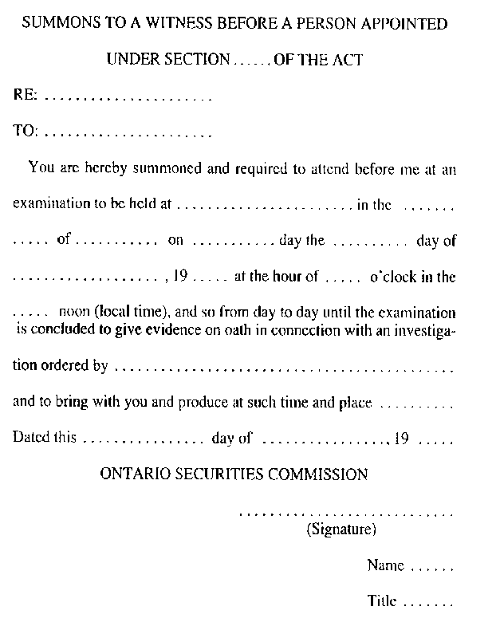
R.R.O. 1990, Reg. 1015, Form 1.
Form 2
AFFIDAVIT OF SERVICE
Securities Act
Insert regs\graphics\1990\1015\015002au.tif
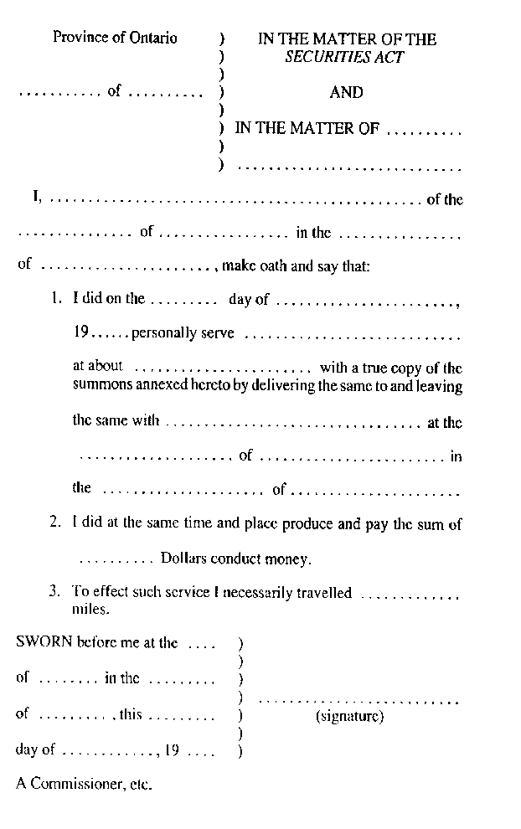
R.R.O. 1990, Reg. 1015, Form 2.
Form 3 Revoked: O. Reg. 358/09, s. 7.
Form 4 Revoked: O. Reg. 16/03, s. 6.
Form 5, 6 Revoked: O. Reg. 358/09, s. 7.
Form 7 Revoked: O. Reg. 453/05, s. 22.
Form 8
SUMMONS TO A WITNESS BEFORE A PERSON DESIGNATED UNDER SECTION 31 OF THE ACT
Securities Act
Insert regs\graphics\1990\1015\015008au.tif
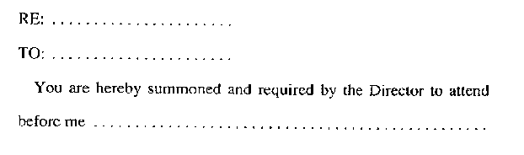
Insert regs\graphics\1990\1015\015008bu.tif
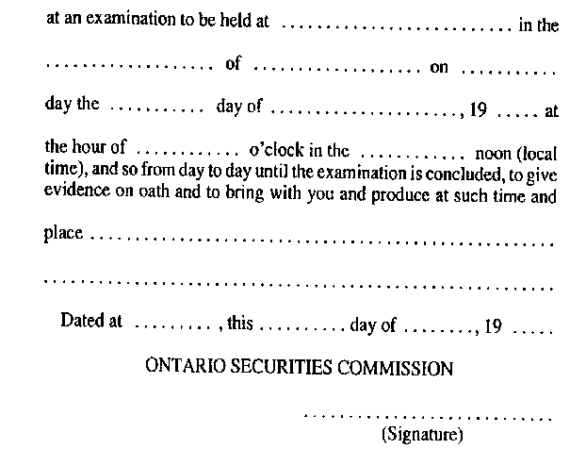
R.R.O. 1990, Reg. 1015, Form 8.
Form 9 Revoked: O. Reg. 358/09, s. 7.
Form 10 Revoked: O. Reg. 357/09, s. 5.
Form 11 Revoked: O. Reg. 424/01, s. 6.
FormS 12-14 Revoked: O. Reg. 632/00, s. 11.
Form 15 Revoked: O. Reg. 31/08, s. 2.
Form 16 Revoked: O. Reg. 91/01, s. 6.
FormS 17-19 Revoked: O. Reg. 453/05, s. 22.
FormS 20, 21 Revoked: O. Reg. 662/98, s. 3.
FormS 22, 23 Revoked: O. Reg. 423/01, s. 5.
FormS 24-26 Revoked: O. Reg. 491/05, s. 13.
Form 27 Revoked: O. Reg. 215/05, s. 8.
Form 28 Revoked: O. Reg. 56/04, s. 14 (2).
Form 29 Revoked: O. Reg. 507/97, s. 4.
Form 30 Revoked: O. Reg. 215/05, s. 9.
FORMS 31-35 Revoked: O. Reg. 589/07, s. 3.
Form 36 Revoked: O. Reg. 13/96, s. 2.
Form 37
REPORT BY A REGISTERED OWNER OF SECURITIES BENEFICIALLY OWNED BY AN INSIDER
Securities Act
Insert regs\graphics\1990\1015\015037au.tif
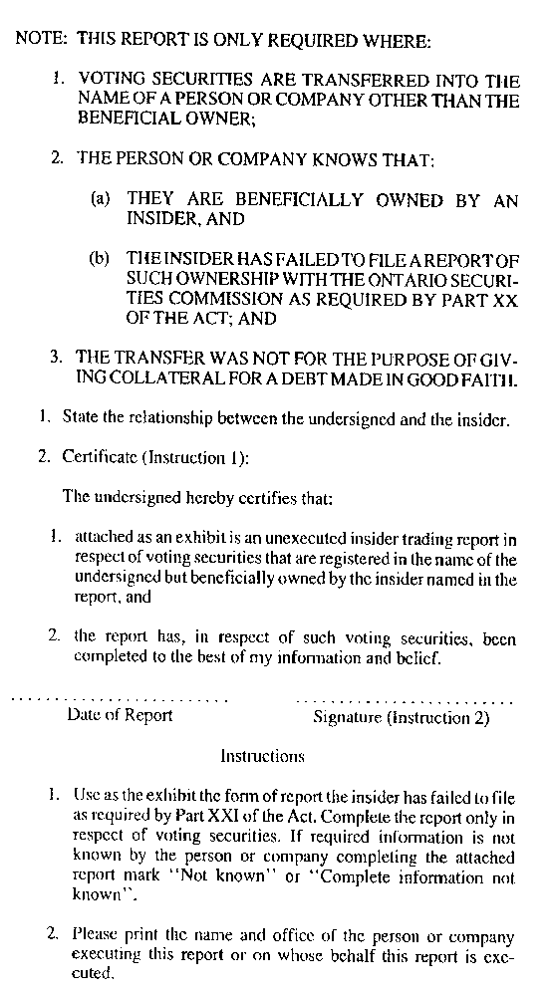
R.R.O. 1990, Reg. 1015, Form 37.
Form 38
REPORT UNDER SECTION 117 OF THE ACT
Securities Act
Insert regs\graphics\1990\1015\015038au.tif
Insert regs\graphics\1990\1015\015038bu.tif
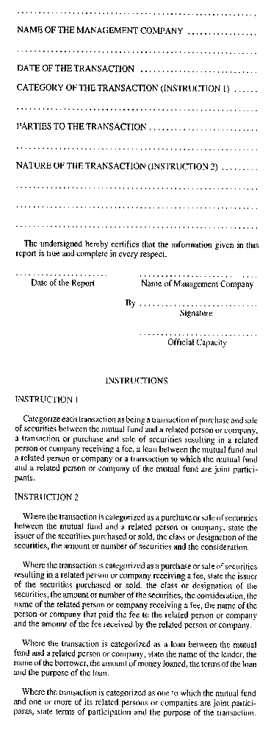
R.R.O. 1990, Reg. 1015, Form 38.
Form 39
ENDORSEMENT OF WARRANT
Securities Act
Insert regs\graphics\1990\1015\015039au.tif
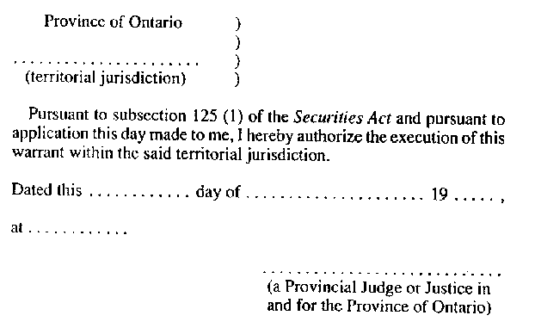
R.R.O. 1990, Reg. 1015, Form 39.
Form 40 Revoked: O. Reg. 56/04, s. 14 (4).
Form 41
APPLICATION FOR APPROVAL TO BE A MARKET-MAKER IN A COATS SECURITY
Securities Act
Insert regs\graphics\1990\1015\015041au.tif
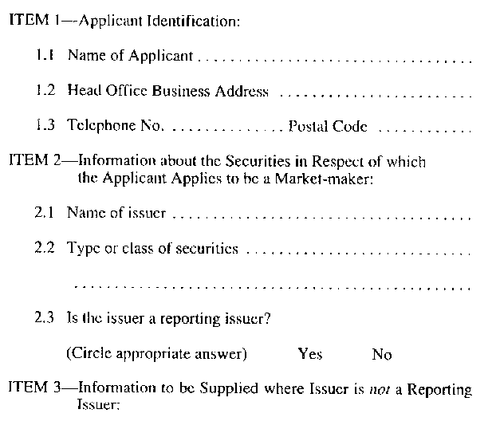
Insert regs\graphics\1990\1015\015041bu.tif
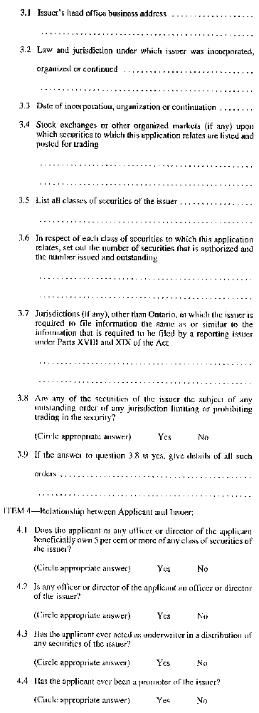
Insert regs\graphics\1990\1015\015041cu.tif
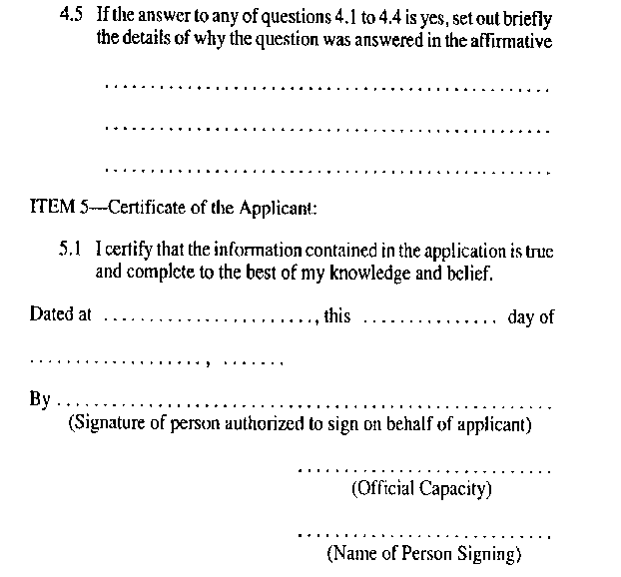
R.R.O. 1990, Reg. 1015, Form 41.
FormS 42-44 Revoked: O. Reg. 48/03, s. 4.
Form 45 Revoked: O. Reg. 31/08, s. 2.

