Français
Shoreline Property Assistance Act
R.R.O. 1990, REGULATION 1017
GENERAL
Consolidation Period: From October 30, 1997 to the e-Laws currency date.
Last amendment: 392/97.
Legislative History: 358/92, 392/97.
This is the English version of a bilingual regulation.
1. (1) No loan made under the Act for the construction of works shall exceed 75 per cent of the total cost of the works or the amount obtained by multiplying the number of metres of shoreline of the property in respect of which the loan is made by $500, whichever is the lesser. R.R.O. 1990, Reg. 1017, s. 1 (1).
(2) No loan made under the Act for building raising, building relocation or building repairs shall exceed 75 per cent of the total cost of the raising, relocation or repairs or $20,000, whichever is the lesser. R.R.O. 1990, Reg. 1017, s. 1 (2).
2. (1) The borrowing by-law referred to in subsection 3 (1) of the Act, for use by a municipality not within a district, metropolitan or regional municipality, shall be in Form 1. R.R.O. 1990, Reg. 1017, s. 2 (1).
(2) The borrowing by-law referred to in subsection 3 (1) of the Act, for use by a municipality within a district, metropolitan or regional municipality, shall be in Form 2. R.R.O. 1990, Reg. 1017, s. 2 (2).
(3) The borrowing by-law, for use by a district, metropolitan or regional municipality on behalf of an area municipality, shall be in Form 3. R.R.O. 1990, Reg. 1017, s. 2 (3).
3. The debenture referred to in subsection 3 (1) of the Act shall be in Form 4. R.R.O. 1990, Reg. 1017, s. 3.
4. The affidavit of the clerk of the municipality referred to in subsection 3 (4) of the Act shall be in Form 5. R.R.O. 1990, Reg. 1017, s. 4.
5. The application for a loan and the accompanying declaration referred to in the Act shall be in Form 6 and Form 7 respectively. R.R.O. 1990, Reg. 1017, s. 5.
6. The inspection and completion certificate referred to in section 5 of the Act shall be in Form 8. R.R.O. 1990, Reg. 1017, s. 6.
7. (1) The offer to sell a debenture referred to in subsection 6 (10) of the Act, for use by a municipality, shall be in Form 9. R.R.O. 1990, Reg. 1017, s. 7 (1).
(2) The offer to sell a debenture referred to in subsection 6 (10) of the Act, for use by a district, metropolitan or regional municipality, shall be in Form 10. R.R.O. 1990, Reg. 1017, s. 7 (2).
8. The rating by-law referred to in section 9 of the Act shall be in Form 11. R.R.O. 1990, Reg. 1017, s. 8.
9. (1) The rate of interest for the purposes of subsection 6 (4) of the Act is 8 per cent a year. R.R.O. 1990, Reg. 1017, s. 9 (1).
(2) The rate of interest for the purposes of subsection 10 (2) of the Act is 8 per cent a year calculated on such amount of the annual payment of principal and interest as is in default. R.R.O. 1990, Reg. 1017, s. 9 (2).
(3) Despite subsection (1), the rate of interest under subsection 6 (4) of the Act for debentures issued on or after the day this subsection comes into force is 6.8 per cent a year. O. Reg. 392/97, s. 1.
(4) Despite subsection (2), the rate of interest under subsection 10 (2) of the Act for any payment of principal and interest that comes into default on or after the day this subsection comes into force is 6.8 per cent a year. O. Reg. 392/97, s. 1.
10. The term of the debentures sold under this Act shall be for a period of ten years. R.R.O. 1990, Reg. 1017, s. 10.
11. (1) The rate of interest for the purposes of subsection 13 (7) of the Act is 8 per cent a year. R.R.O. 1990, Reg. 1017, s. 11 (1).
(2) The rate of interest for the purposes of clause 14 (1) (a) of the Act is 8 per cent a year calculated on such amount of the annual payment of principal and interest as is in default. R.R.O. 1990, Reg. 1017, s. 11 (2).
(3) Despite subsection (1), the rate of interest under subsection 13 (7) of the Act for money lent by the Minister on or after the day this subsection comes into force is 6.8 per cent a year. O. Reg. 392/97, s. 2.
(4) Despite subsection (2), the rate of interest under clause 14 (1) (a) of the Act for any payment of principal and interest that comes into default on or after the day this subsection comes into force is 6.8 per cent a year. O. Reg. 392/97, s. 2.
Form 1
Shoreline Property Assistance Act

For use by Municipalities not within a District, Metropolitan or Regional Municipality
Borrowing By-Law of The Corporation of the
……………………………………
ByLaw Number ………………..
A by-law to raise money to aid in the construction of works and building repairs under the Shoreline Property Assistance Act.
The council, pursuant to the Shoreline Property Assistance Act, enacts as follows:
1. The Corporation may from time to time, subject to the provisions of this by-law, borrow on the credit of the Corporation such sums not exceeding the aggregate $......................... as may be determined by the council, and may in the manner hereinafter provided, issue debentures of the Corporation for the amount so borrowed as provided in the Act payable to the Treasurer of Ontario at the Legislative Building, Toronto, which debentures shall reserve the right to pay at any time, with or without giving notice or at such times and on such notice and in accordance with such terms and conditions as may be prescribed by regulations made under the Act, the whole or any part of the amount then outstanding and to be relieved from liability to pay any interest on the amount so paid other than accrued interest.
2. Where an application for a loan under the Act is approved by the council and the inspector has filed with the clerk an inspection and completion certificate, the council may include a sum, not exceeding the amount applied for or such other maximum amount as is prescribed by the regulations under the Act, in a debenture payable to the Treasurer of Ontario in accordance with the Act, and may approve of the Corporation lending the said sum to the applicant.
3. A special annual rate shall be imposed, levied and collected over and above all other rates upon the land in respect of which the money is borrowed, sufficient for payment of the principal and interest as provided by the Act.

Read a First and Second time the …….….. day of ……………….., 19…….
Read a Third time the ……….. day of …………………………, 19 ……….
……………..…………………….………
Head of Council
(Corporate Seal) | ……………..…………………………….  Clerk

R.R.O. 1990, Reg. 1017, Form 1.
Form 2
Shoreline Property Assistance Act

For use by Municipalities within a District, Metropolitan or Regional Municipality
Borrowing By-Law of The Corporation of the
…………………………………….
By-Law Number ……………..
A by-law to raise money to aid in the construction of works and building repairs under the Shoreline Property Assistance Act.
The council, pursuant to the Shoreline Property Assistance Act, enacts as follows:
1. The Corporation may from time to time, subject to the provisions of this by-law, borrow on the credit of the Corporation such sums not exceeding in the aggregate $................................ as may be determined by the council, and may in the manner hereinafter provided, arrange for the issue of debentures on behalf of the Corporation for the amount so borrowed as provided in the Act payable to the Treasurer of Ontario at the Legislative Building, Toronto, which debentures shall reserve the right to pay, with or without giving notice or at such times and on such notice and in accordance with such other terms and conditions as may be prescribed by regulations made under the Act, the whole or any part of the amount then outstanding and to be relieved from liability to pay any interest on the amount so paid other than accrued interest.
2. Where an application for a loan under the Act is approved by the council and the inspector has filed with the clerk an inspection and completion certificate, the council may apply to include a sum not exceeding the amount applied for or such other maximum amount as is prescribed by the regulations under the Act, in a debenture payable to the Treasurer of Ontario in accordance with the Act, and may approve of the Corporation lending the said sum to the applicant.
3. A special annual rate shall be imposed, levied and collected over and above all other rates upon the land in respect of which the money is borrowed, sufficient for the payment of the principal and interest as provided by the Act.
Read a First and Second time the …….. day of ………………….., 19 ……….
Read a Third time the ………… day of …………………………., 19 ………..
……………..…………………….………
Head of Council
(Corporate Seal) | ……………..…………………………….  Clerk

R.R.O. 1990, Reg. 1017, Form 2.
Form 3
Shoreline Property Assistance Act

For use by a District, Metropolitan or Regional Municipality
Borrowing By-Law of The Corporation of the
........................................................................
By-Law Number ...........................................
A by-law to raise money to aid in the construction of works and building repairs under the Shoreline Property Assistance Act, in the
........................................................................................................................
(district, metropolitan or regional)
Municipality of .............................................................................................
The Council of ..............................................................................................
(district, metropolitan or regional)
Municipality of ........................................................................ (hereinafter referred to as the regional municipality) pursuant to the Shoreline Property Assistance Act, enacts as follows:
1. The regional municipality may from time to time, subject to the provisions of this by-law, borrow on the credit of the regional municipality such sums not exceeding in the aggregate $................................ and may in the manner hereinafter provided, issue debentures of the regional municipality for the amount so borrowed as provided in the Act payable to the Treasurer of Ontario at the Legislative Building, Toronto, which debentures shall reserve the right to pay at any time, with or without giving notice or at such times and on such notice and in accordance with such other terms and conditions as may be prescribed by regulations made under the Act, the whole or any part of the amount then outstanding and to be relieved from liability to pay any interest on the amount so paid other than accrued interest.
2. When the regional municipality receives an application from an area municipality for the purposes of the Act, the regional municipality shall by resolution direct the issue of a debenture as aforesaid and borrow on behalf of the area municipality a sum not exceeding the amount to be lent by the area municipality on completion of the works or building repairs.
3. With respect to each area municipality, the regional municipality shall impose, levy and collect a special annual rate over and above all other rates sufficient for the payment of the principal and interest of the debentures issued by the regional municipality on behalf of that area municipality.
Read a First and Second time the ……. day of ………………., 19 ………….
Read a Third time the ………… day of ……………………, 19 …………….
……………..…………………….………
Chairman
(Corporate Seal) | ……………..…………………………….  Clerk

R.R.O. 1990, Reg. 1017, Form 3.
Form 4
DEBENTURE
Shoreline Property Assistance Act

$ ........................... | Number ………………..…..
The Corporation of …………………………., hereinafter referred to as the Corporation, for value received hereby, promises to pay to the Treasurer of Ontario at the Legislative Building, Toronto, the principal sum of $ ............................... of lawful money of Canada, together with interest thereon at the rate of ………..…….. per cent per year in ……..…..… equal instalments of $ ..................... on
the ………... day of …………..……….., hereinafter referred to as “the instalment date”, in the years ……….…. to ……..…..., both inclusive,
OR
the unpaid balance of the principal sum outstanding together with interest thereon at the rate of ………………… per cent per year in such equal annual instalments as may be determined by the Treasurer of Ontario in accordance with the provisions hereinafter contained.
The right is reserved to the Corporation to pay at any time, with or without giving notice, or at such times and on such notice and in accordance with such other terms and conditions as may be prescribed by regulations made under the Shoreline Property Assistance Act at the place where and in the money in which this debenture is expressed to be payable, the whole or any amount of the principal sum owing at the time of such payment. After the date of payment, interest on the amount of the principal sum so paid shall cease to accrue and the balance of the principal sum owing after the payment as determined by the Treasurer of Ontario and set out on the Schedule on the reverse hereof shall be paid in the equal annual instalments stipulated on the said Schedule due on each instalment date in the years remaining in the term of this debenture following the date of payment.
This debenture, or any interest therein, is not, after a Certificate of Ownership has been endorsed thereon by the Treasurer of the Corporation, or by such other person authorized by by-law of the Corporation to endorse such Certificate of Ownership, transferable.
Dated at the …………….……. of ……….……….. in the Province of Ontario, this 1st day of ……………………….., 19 ………., under the authority of Borrowing By-Law Number …………… of the Corporation entitled “A By-law to raise money to aid in the construction of works and building repairs under the Shoreline Property Assistance Act”.
……………..………………………..  Treasurer | ……………..…………………….………  Head of Council
(Corporate Seal)

Schedule
Date | Amount of Principal Paid | Amount of Principal Outstanding | Number of Years Remaining | Amount of Equal Annual Instalment | Notation made on behalf of the Treasurer of Ontario by

R.R.O. 1990, Reg. 1017, Form 4.
Form 5
AFFIDAVIT OF CLERK
Shoreline Property Assistance Act
I, ......................................................................................., of the ........................................... of ........................................................... in the ............................ of ..................................... Clerk of the ..................................................... of .............................................. make oath and say:
1. | On the ………… day of …………………………, 19 ……….., the Council of the …………………….. of ………………… passed a by-law for borrowing money to be lent for the construction of works and building repairs being No. ………… and entitled “A By-Law to raise money to aid in the construction of works and building repairs under the Shoreline Property Assistance Act”, a copy of which certified by me is attached hereto as an exhibit to this my affidavit and marked exhibit “A”.
2. | A certified copy of By-Law No. .............. was registered in the Land Registry Office (Land Titles) Division of ............................... on the ..................... day of ......................................., 19 ............
3. | No application or action to quash the by-law has been made or brought.*
 | or
 | An application or action has been made or brought, but it has been dismissed.*
 | (*strike out if not applicable)
Sworn before me at the .........................................................
of ............................ in the ....................................................
of ...................................... this ...................................... day |  | ...............................................................................................
 |  | clerk
of ....................................................., 19 ...............................
...............................................................................................
A Commissioner
R.R.O. 1990, Reg. 1017, Form 5.
Form 6
APPLICATION FOR LOAN
Shoreline Property Assistance Act
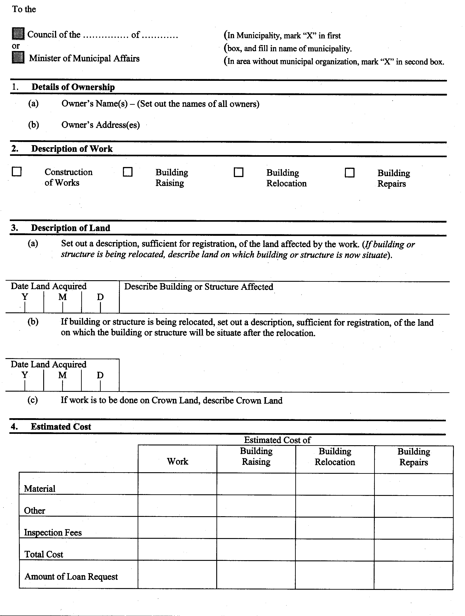
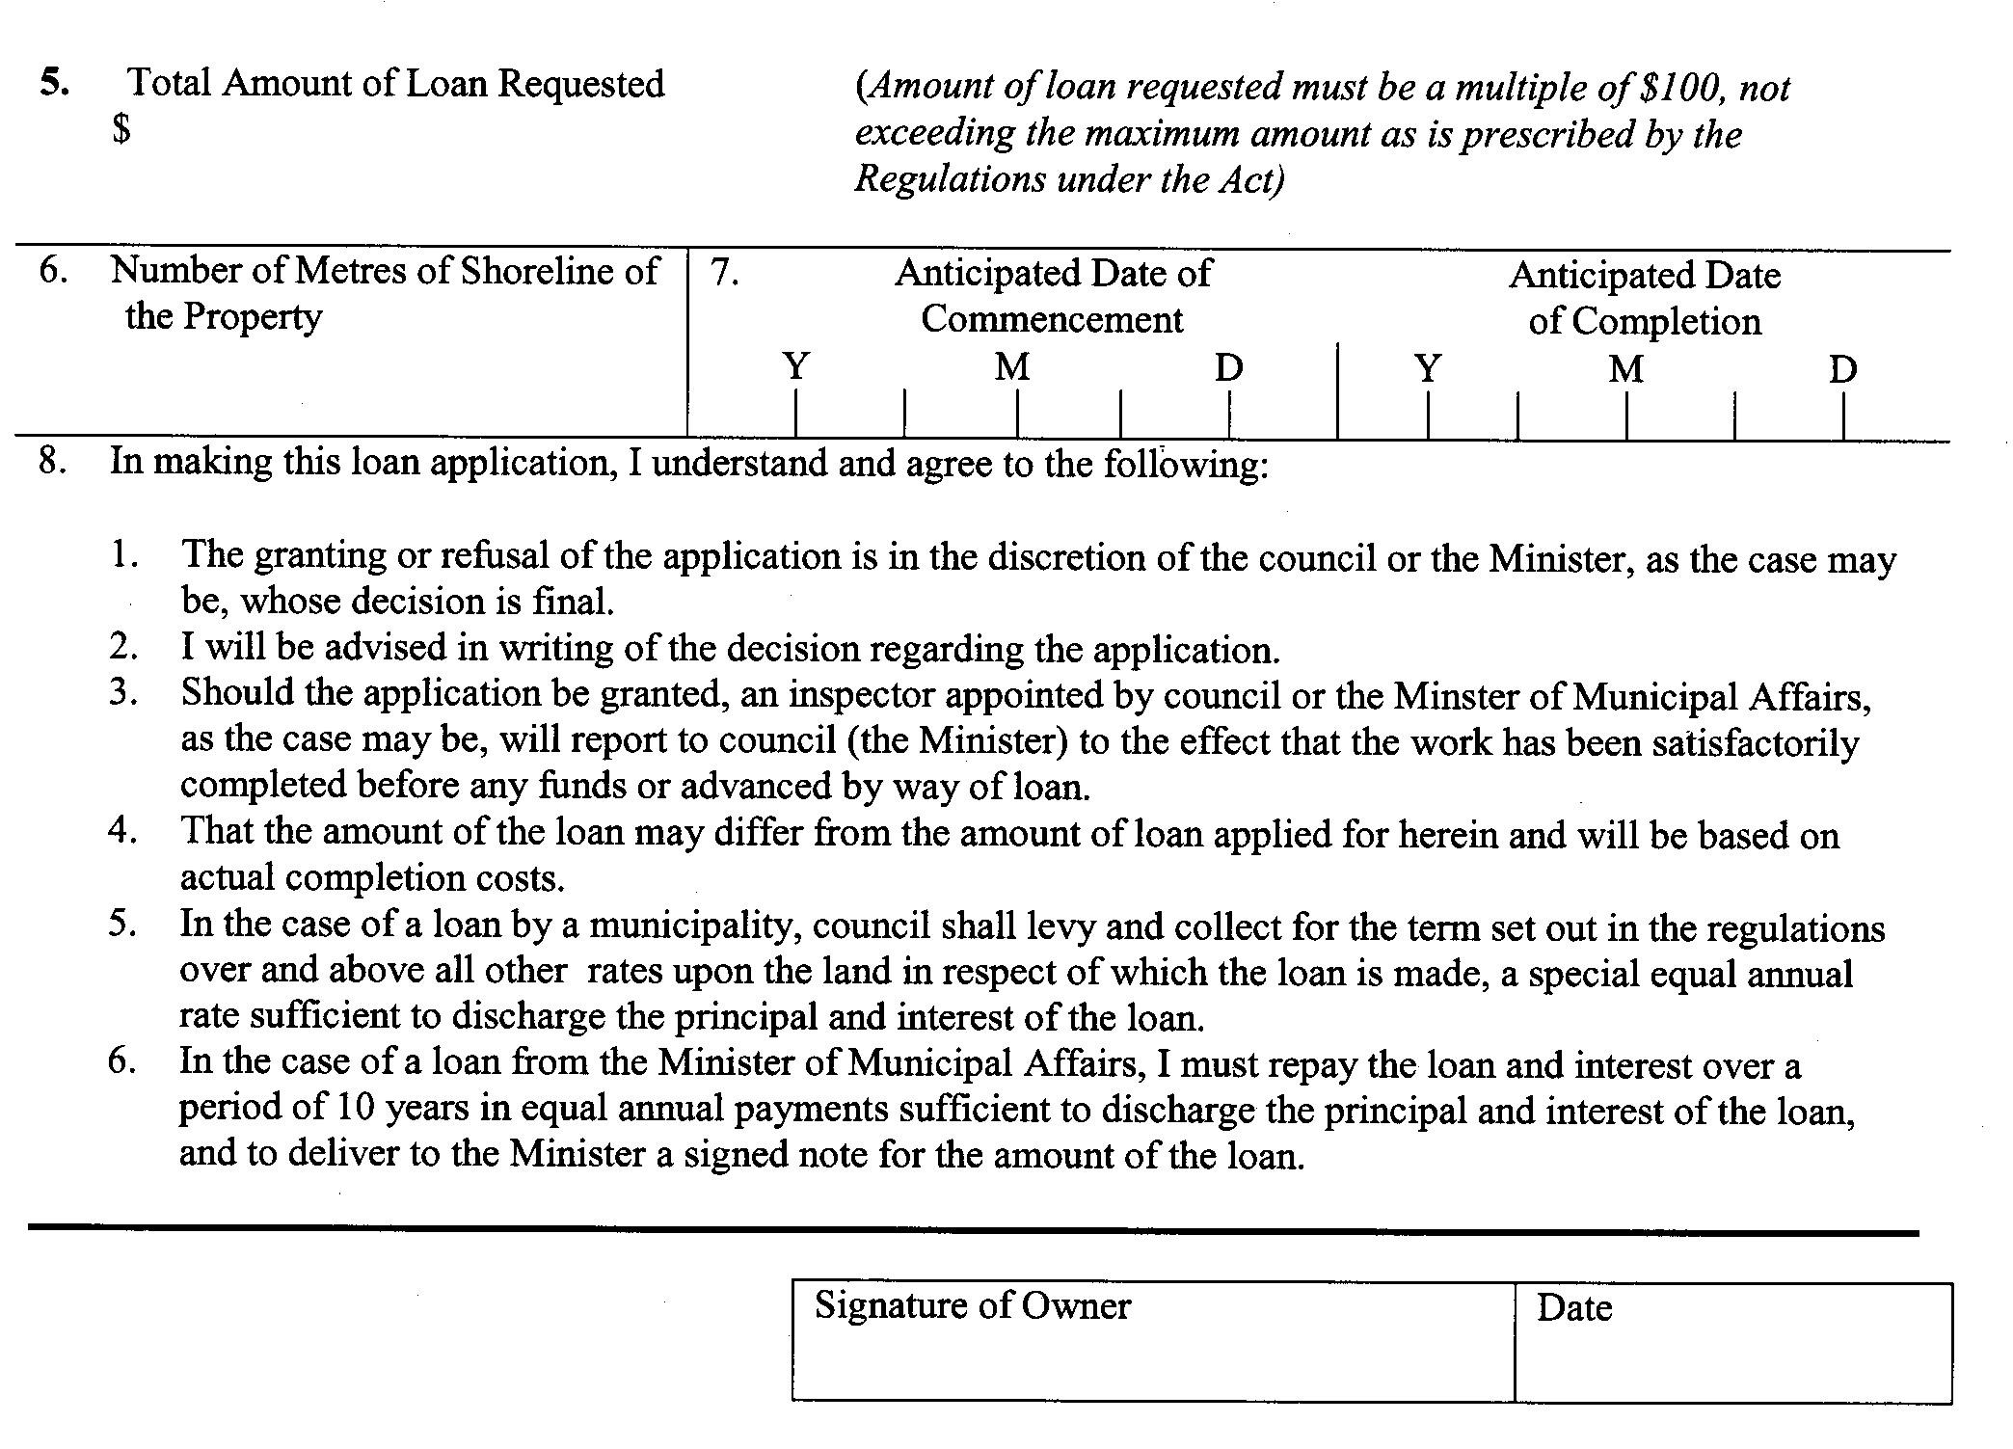
R.R.O. 1990, Reg. 1017, Form 6.
Form 7
DECLARATION AS TO OWNERSHIP
Shoreline Property Assistance Act

Province of Ontario
TO WIT:
I/WE, ………………………….……………….. of the …….………………, of ………. in the ……………….. of ………………………… do solemnly declare that:
1. |  | I/We am/are the actual owner of: (Provide description sufficient for registration)
(a) |  | the land affected by the work and described as follows: (If a building or structure is being relocated describe the land on which the building or structure is now situate)
(b) |  | the land to which a building or structure is being relocated and described as follows: (Delete if inapplicable)
Strike out inapplicable paragraphs
2. |  | The land described in subsection 1 (a) of this declaration is free from encumbrance.
 |  | Or
3. |  | The land described in subsection 1(a) is encumbered as follows:
Name and Address of Mortgagee(s) |  |  | Name and Address of Encumbrancer(s) | Name and Address of Assignee(s)
(Attach Schedule if more space is required)
4. |  | The land described in subsection 1 (b) of this declaration is free from encumbrance.
 |  | Or
5. |  | The land described in subsection 1 (b) is encumbered as follow:
Name and Address of Mortgagee(s) |  |  | Name and Address of Encumbrancer(s) | Name and Address of Assignee(s)
(Attach Schedule if more space is required)
6. |  | The application for loan is for a loan to construct works on Crown lands which Crown lands are described as follows:
7. |  | AND I/WE, make this solemn declaration conscientiously believing it to be true, and knowing that it is of the same force and effect as if made under oath.
Declared before me at the .................................................................................
of ......................................................................................................................
this ............................. day of ....................................................., 19 ..............
.....................................................................  A Commissioner, etc. |  |  | ..................................................................  Signature

R.R.O. 1990, Reg. 1017, Form 7.
Form 8
INSPECTION AND COMPLETION CERTIFICATE
Shoreline Property Assistance Act
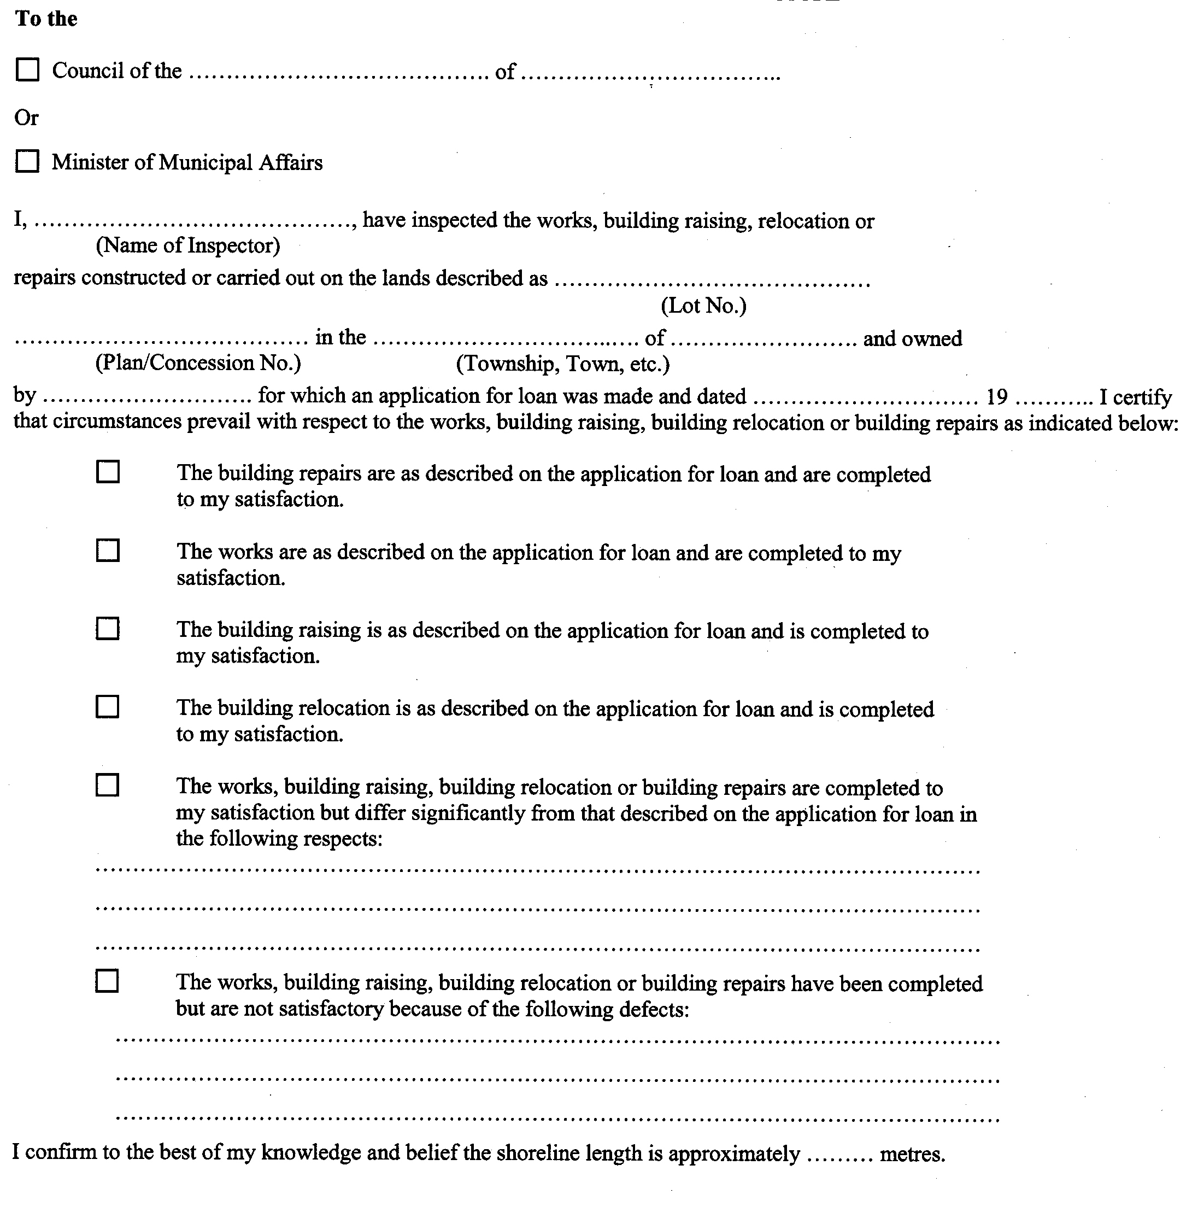
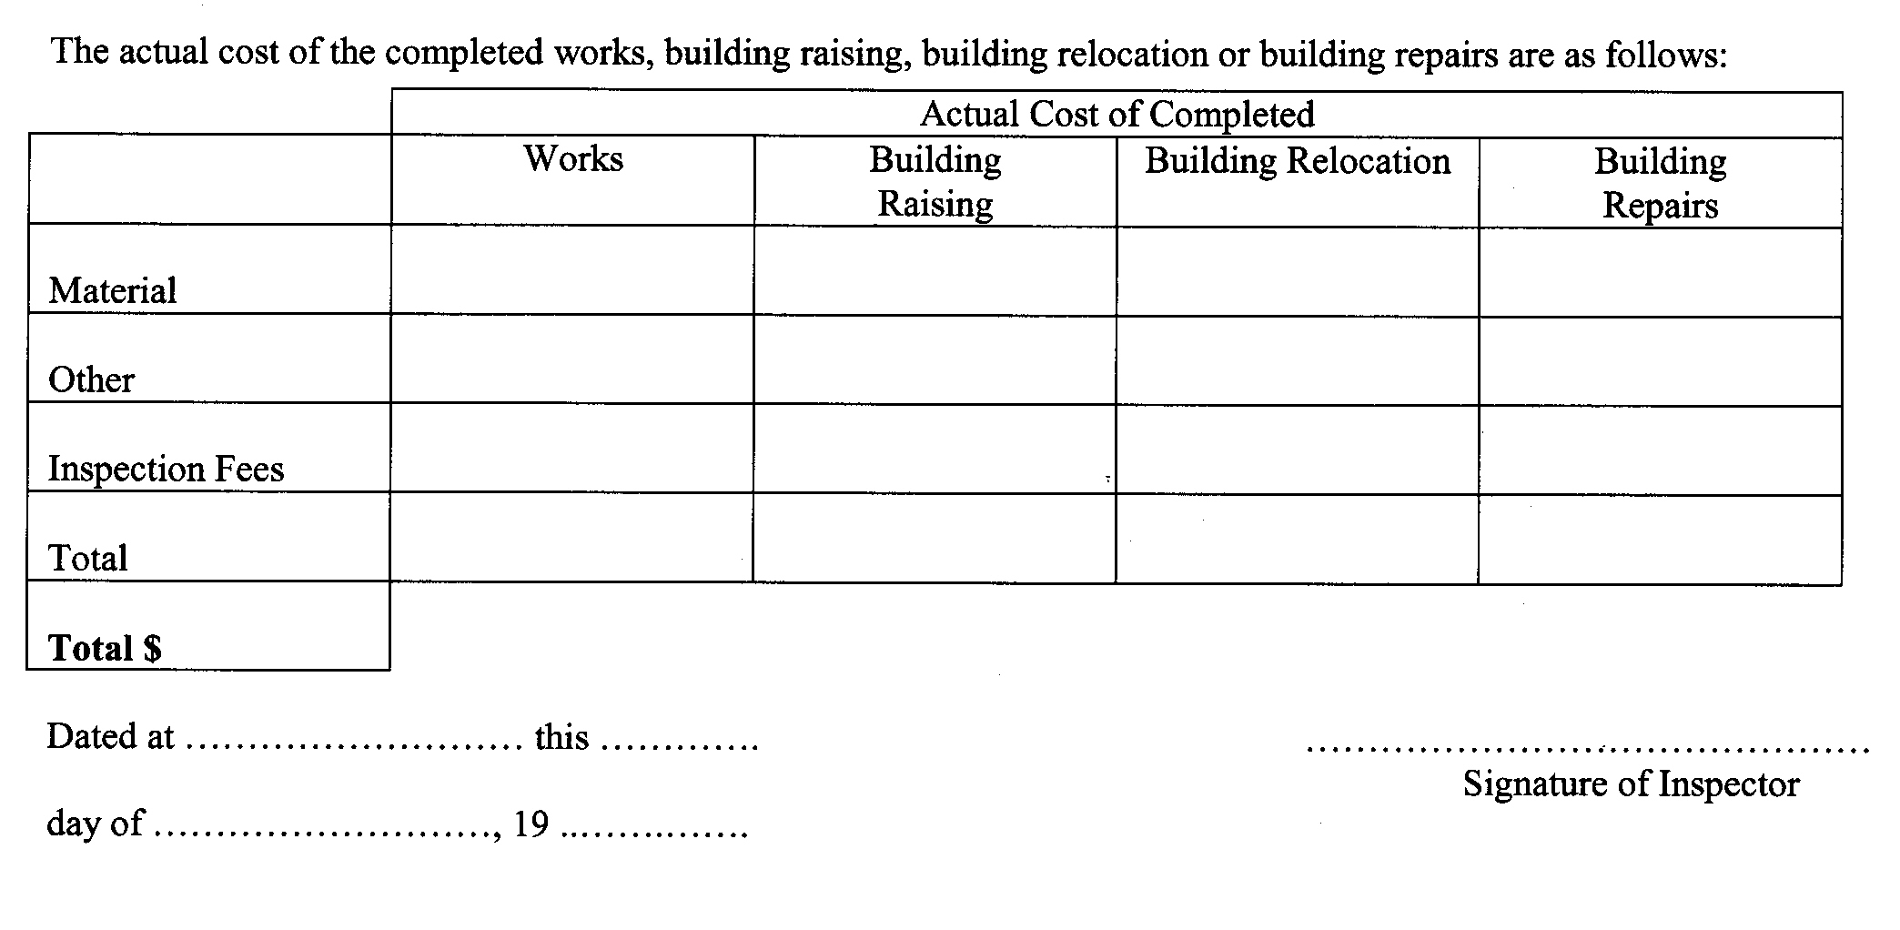
R.R.O. 1990, Reg. 1017, Form 8.
Form 9
OFFER TO SELL
Shoreline Property Assistance Act

For use by a Municipality other than a District, Metropolitan or Regional Municipality
The Corporation of ………………………… of …………………………… hereby offers to sell Debenture No. ……………………. in the principal amount of $ ………………………. to the Treasurer of Ontario as authorized by Borrowing By-Law No. …………………… of the Corporation.
The principal amount of this debenture is the aggregate of individual loans applied for and each loan is not more than the maximum amount prescribed by the regulations.
An inspector, employed by the Corporation, has inspected the works or building repairs for which the Corporation will lend the proceeds of this debenture, and each has been completed in accordance with the terms of the loan approval given by council. A copy of the Inspection and Completion Certificate for each project in respect of which the Corporation will lend the proceeds of this debenture is attached hereto.
……………………………………………………..  Date | ……………………………………………………..  Treasurer
(Corporate Seal)

R.R.O. 1990, Reg. 1017, Form 9.
Form 10
OFFER TO SELL
Shoreline Property Assistance Act

For use by a District, Metropolitan or Regional Municipality
The Corporation of …………….…….…. of ………….………… hereby offers to sell Debenture No. …..………… in the principal amount of $ ……….…………. to the Treasurer of Ontario as authorized by Borrowing By-law No. ………………………. of the Regional Corporation.
The principal amount of this debenture is the aggregate of individual loans for which application has been made to the councils of the municipalities listed below and each loan is not more than the maximum amount prescribed by the regulations.
An inspector, employed by the municipalities listed below, has inspected the works or building repairs for which the proceeds of this debenture will be lent, and each has been completed in accordance with the terms of the loan approval given. A copy of the Inspection and Completion Certificate for each project in respect of which the Corporation will lend the proceeds of this debenture is attached hereto.
MUNICIPALITY | AMOUNT
…………..…………………..……….  Date | ……………………..…………………..  Treasurer
(Corporate Seal)

R.R.O. 1990, Reg. 1017, Form 10.
Form 11
RATING BY-LAW
Shoreline Property Assistance Act

The Corporation of the
……………………………………
By-Law Number …………………
By-law imposing special annual rates upon land in respect of which money is borrowed under the Shoreline Property Assistance Act.
Whereas owners of land in the municipality have applied to the council of the Corporation under the Shoreline Property Assistance Act, for loans for the purpose of constructing works or making building repairs on such land; and whereas the council has upon their application lent the owners the total sum of $............................ to be repaid with interest by means of rates hereinafter imposed:
The council, pursuant to the Shoreline Property Assistance Act, enacts as follows:
1. | The annual rates as set out in the Schedule attached hereto are, subject to the provisions of this by-law, hereby imposed upon such land as described for a period of ……………….years**, such rates to be levied and collected in the same manner as taxes.
2. | Where an owner obtains a discharge of indebtedness under section 12 of the said Act in respect of land described in the attached Schedule,
(a) | no annual rate shall thereafter be imposed upon such land; and
(b) | the attached Schedule may be amended from time to time by deleting the entries relating to such land.
3. | A certified true copy of this by-law shall be registered by the Clerk of the Corporation in the proper Land Registry Office forthwith after the passing of this by-law.
Passed this ……………. day of …………..…………………., 19 …………
………………………………………….
Head of Council
……….…………………………………..
Clerk

 |  |  | The Corporation of the .……….…..………
 |  |  | …………………………………….…………..
 |  |  | By-Law Number …………………………….
 |  |  | Registration Number ………………………
(Corporate Seal)
Note: |  | **For the purpose of completing paragraph 1, the period of years set out shall be the same as is prescribed under the regulations made under the Act as of the day the by-law is passed.

Schedule

Name and Address of Owner | Description of Land | Proposed Date of Loan | Sum to be Loaned $ | Annual Rate to be Imposed $
* Total Principal of Debenture and
Total Sum Shown on By-Law
 |  |  | $
 |  |  | * Total
R.R.O. 1990, Reg. 1017, Form 11.

Français

Back to top

