Français
ONTARIO REGULATION 426/00
made under the
Municipal Elections Act, 1996
Made: July 5, 2000
Filed: July 5, 2000
Amending O. Reg. 101/97
(General)
1. Section 5 of Ontario Regulation 101/97 is amended by adding the following paragraph:
3. In the case of a registrant for a question, 50 cents for each elector entitled to vote on the question.
2. The Regulation is amended by adding the following sections:
11.1 A notice of extension of campaign period under subsection 68 (1) of the Act shall be in Form 6.
11.2 A notice of registration under section 39.1 of the Act shall be in Form 7.
11.3 A financial statement under section 78 of the Act, as made applicable by section 82.1 of the Act, that does not require an auditor’s report shall be in Form 8.
11.4 Where an auditor’s report is required under section 78 of the Act, as made applicable by section 82.1 of the Act, a financial statement and auditor’s report shall be in Form 9.
3. Form 1 of the Regulation is amended by,
(a) adding “or e-mailed” after “faxed” in the first line of the Note at the beginning; and
(b) adding “E-mail Address” after the heading “Fax No.” in the last line before the “Consent of Nominee and Declaration of Qualification”.
4. Form 2.1 of the Regulation is revoked and the following substituted:
Form 2.1
Municipal Elections Act, 1996
(Section 41)
Ballot
Insert regs\Graphics\Source Law\2000\426\426021ae.tif
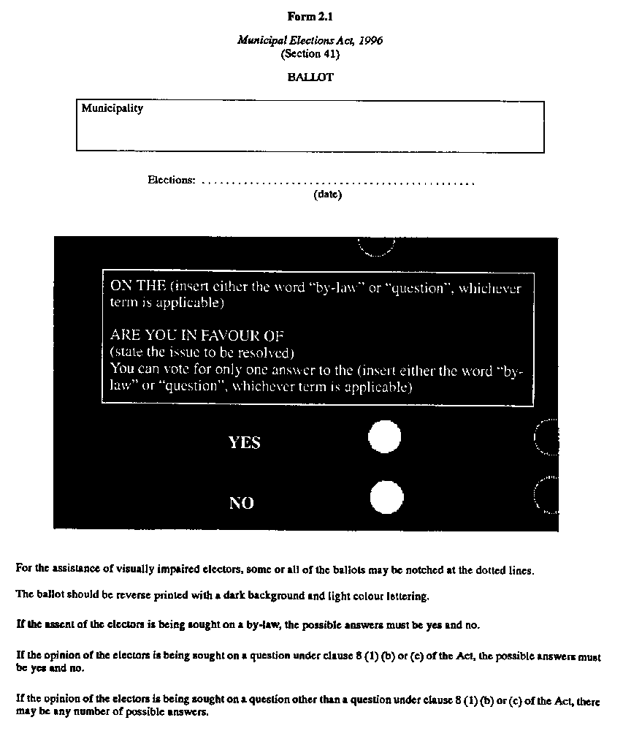
5. Form 3 of the Regulation is amended by adding “or same–sex partner” after “spouse”,
(a) in the last paragraph of the Instructions; and
(b) in the box entitled “Relationship of Elector Appointed to Elector Making the Appointment” in Box B.
6. Form 4 of the Regulation is amended,
(a) by adding “or same–sex partner” after “spouse” in the second paragraph; and
(b) by adding “E-mail Address” after “Fax No.” under the heading “Name of Candidate and Office”.
7. Form 5 of the Regulation is amended by,
(a) adding “E-mail Address” after “Fax No.” under the heading “Name of Candidate and Office”.
(b) by adding “or same–sex partner” after “spouse” in the fourth paragraph of Part I of the “Statement of Determination of Surplus or Deficit and Disposition of Surplus”; and
(c) by adding “E-mail Address” after “Fax No.” at the end of the Auditor’s Report.
8. The Regulation is amended by adding the following Forms:
Form 6
Municipal Elections Act, 1996
(Sections 68, 82.1)
notice of extension of campaign period
Insert regs\Graphics\Source Law\2000\426\426006ae.tif
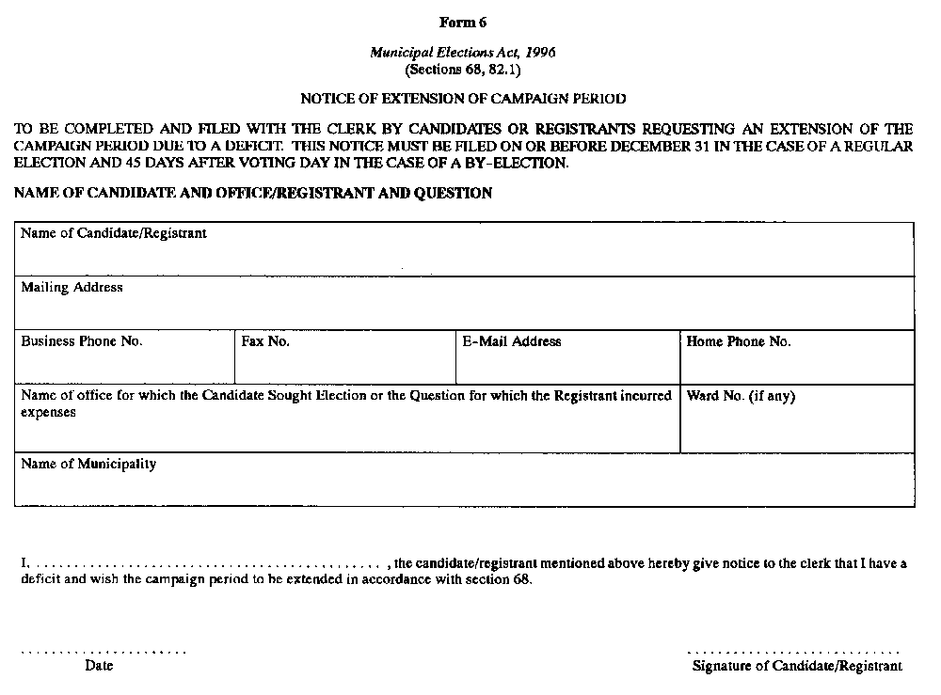
Form 7
Municipal Elections Act, 1996
(Section 39.1)
notice of registration
Insert regs\Graphics\Source Law\2000\426\426007ae.tif
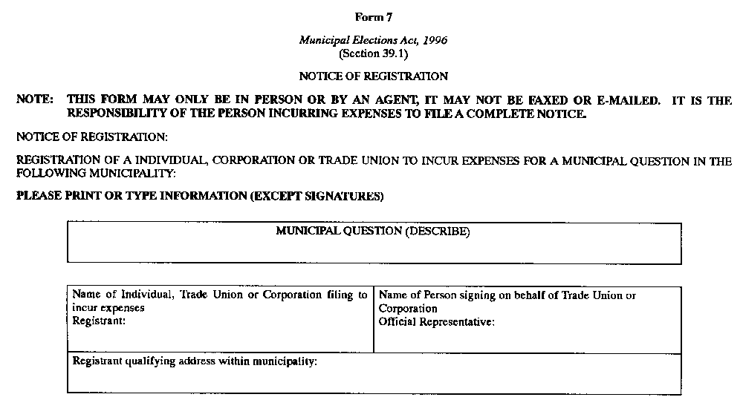
Insert regs\Graphics\Source Law\2000\426\426007be.tif
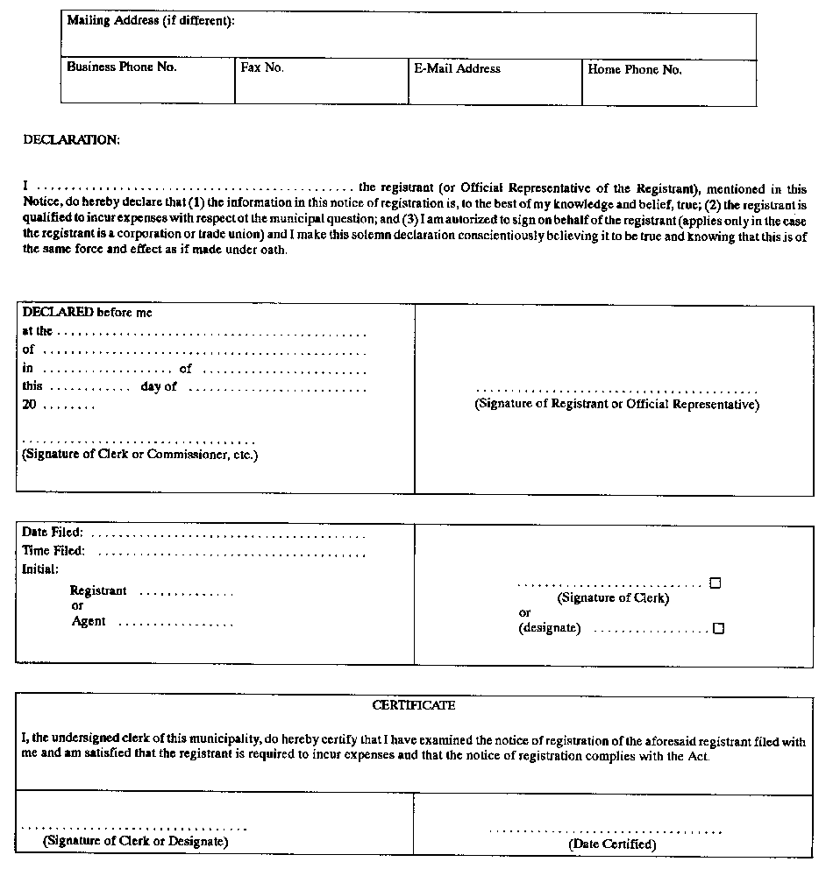
Form 8
Municipal Elections Act, 1996
(Sections 78, 82.1)
financial statement
Insert regs\Graphics\Source Law\2000\426\426008ae.tif
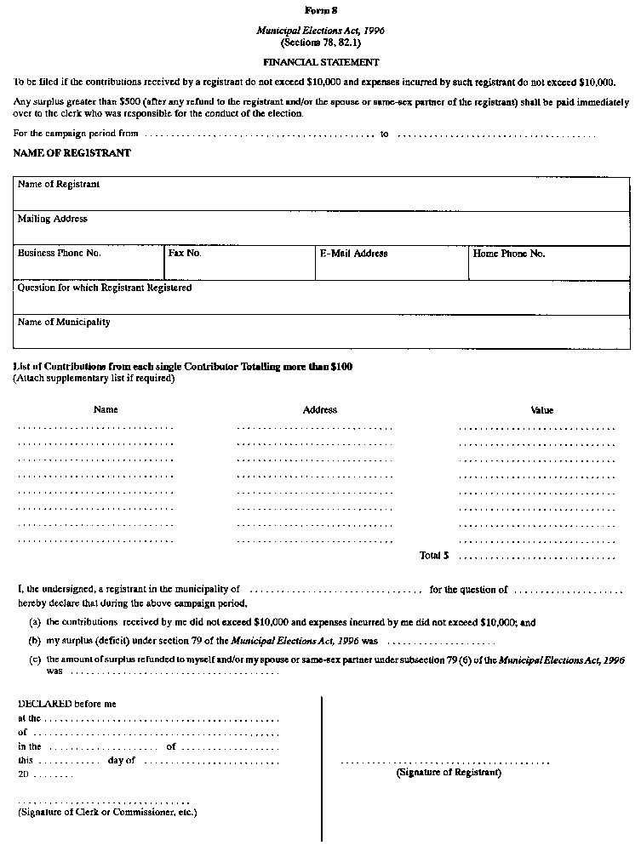
Form 9
Municipal Elections Act, 1996
(Sections 78, 82.1)
financial statement and auditor’s report
Insert regs\Graphics\Source Law\2000\426\426009ae.tif
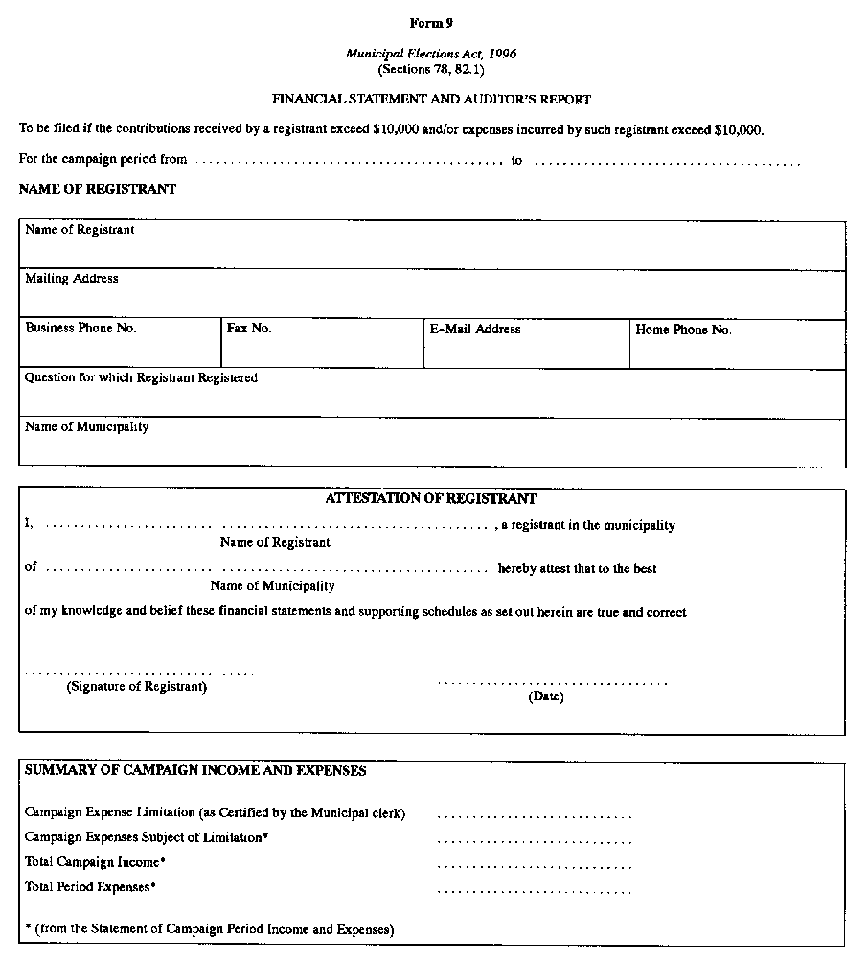
Insert regs\Graphics\Source Law\2000\426\426009be.tif
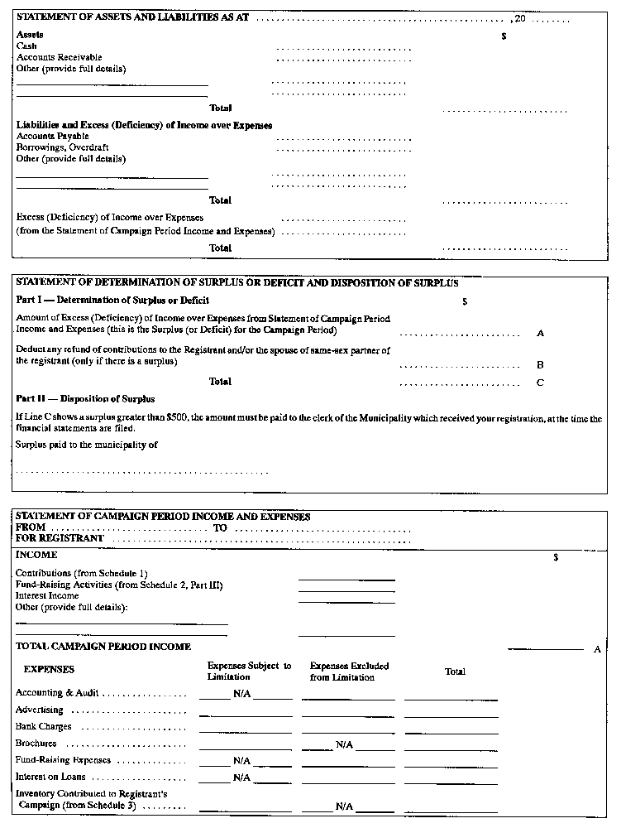
Insert regs\Graphics\Source Law\2000\426\426009ce.tif
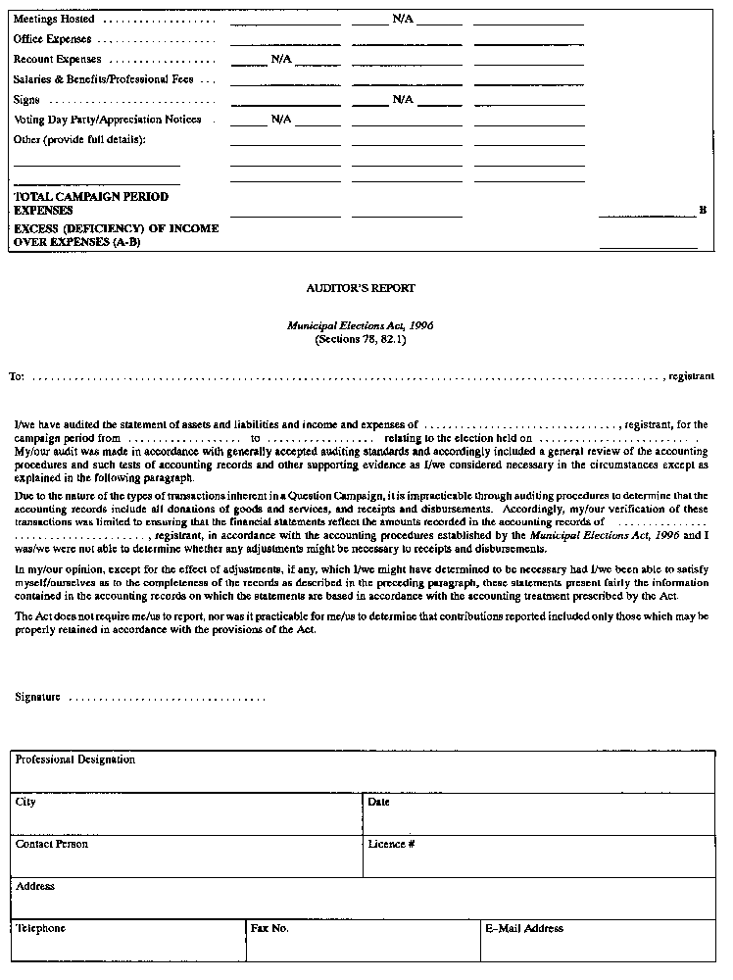
Insert regs\Graphics\Source Law\2000\426\426009de.tif
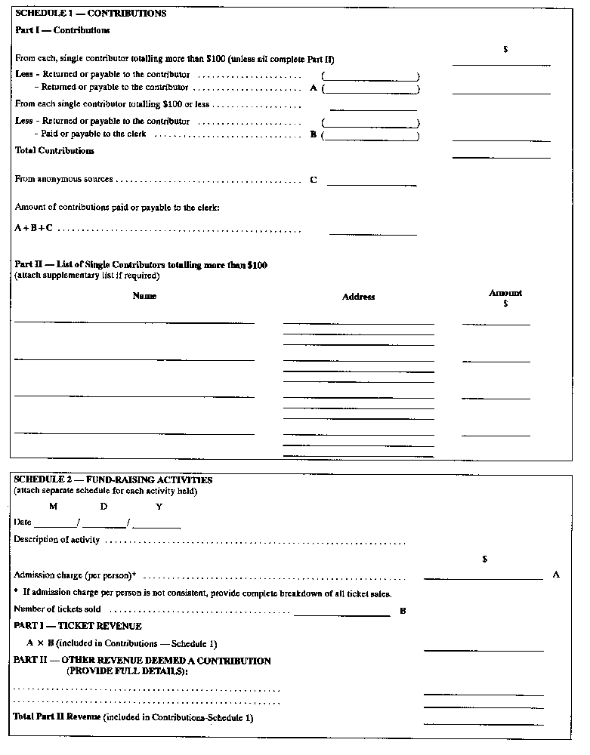
Insert regs\Graphics\Source Law\2000\426\426009ee.tif
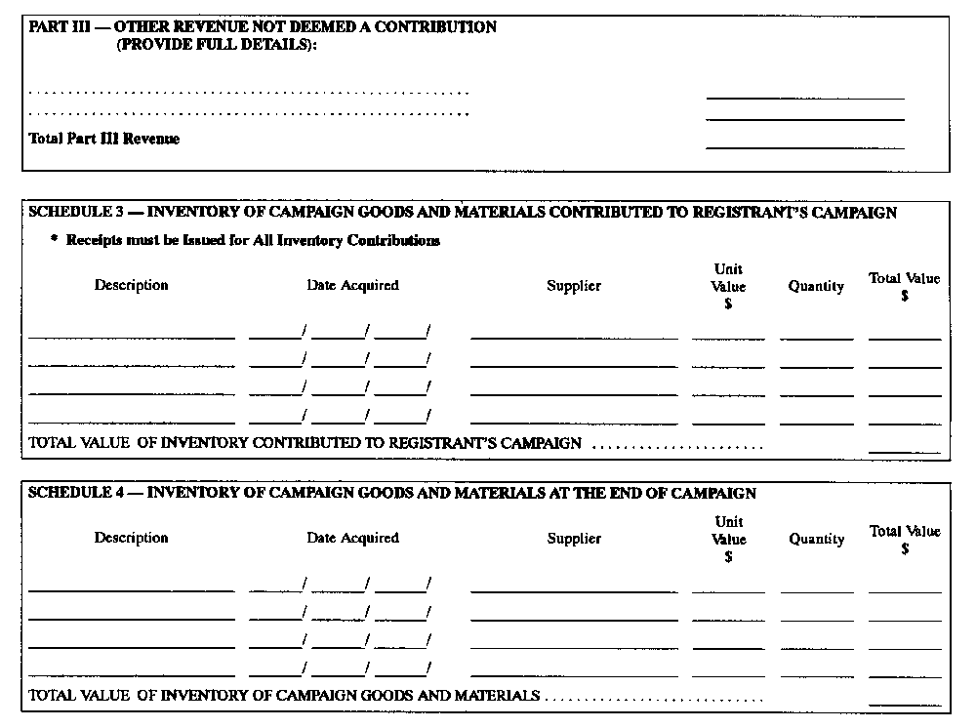
Tony Clement
Minister of Municipal Affairs and Housing
Ministre des Affaires municipales et du Logement
Dated on July 5, 2000.
Fait le 5 juillet 2000.

Français

Back to top

