ONTARIO regulation 16/03
made under the
Securities Act
Made: November 13, 2002
Approved: January 10, 2003
Filed: February 5, 2003
Printed in The Ontario Gazette: February 22, 2003
Amending Reg. 1015 of R.R.O. 1990
(General)
1. The heading before section 129 and section 129 of Regulation 1015 of the Revised Regulations of Ontario, 1990 is revoked.
2. Section 135 of the Regulation is revoked and the following substituted:
135. Upon receipt and review of a notice to the Director under Multilateral Instrument 33-109 Registration Information, the Director may require an application for amendment of registration prepared in accordance with Form 7.
3. Section 136 of the Regulation is revoked.
4. (1) Clauses 5 (1) (a) and (b) and the portion of subsection 5 (2) before clause (a) of Schedule 1 to the Regulation are amended by striking out “Form 4 (or a letter in lieu thereof)” wherever it appears and substituting in each case “Form 33-109F2 or 33-109F4 (made under Multilateral Instrument 33-109 Registration Information)”.
(2) Clause 5 (2) (a) of Schedule 1 to the Regulation is revoked and the following substituted:
(a) filed as part of an application in Form 3; or
(3) Clause 6 (c) of Schedule 1 to the Regulation is revoked and the following substituted:
(c) $375 for each individual who is a representative, partner or officer of the applicant, other than a partner or officer who is not resident in Ontario and is not registered to advise in Ontario.
(4) Section 7 of Schedule 1 to the Regulation is amended by striking out the portion before clause (b) and substituting the following:
7. An application for registration as a representative, partner or officer of an adviser in Form 33-109F2 or 33-109F4 (made under Multilateral Instrument 33-109 Registration Information) shall be accompanied by a fee of $375 unless it is,
(a) filed as part of an application in Form 3; or
(5) Subsection 9 (1) of Schedule 1 to the Regulation is revoked.
(6) Subsection 9 (2) of Schedule 1 to the Regulation is amended by striking out “within thirty days after the applicant’s anniversary date” and substituting “on or before December 31 in each year”.
(7) Clauses 9 (3) (a), (b) and (c) of Schedule 1 to the Regulation are revoked and the following substituted:
(a) the number of branch and sub-branch offices on December 31 of the current year, as shown in the records of the Commission;
(b) the salespersons, representatives, partners and officers on December 31 of the current year, as shown in the records of the Commission; and
(c) the information contained in the audited consolidated financial statements or Financial Questionnaire and Report filed most recently prior to December 31 of the current year.
(8) Section 12 of Schedule 1 to the Regulation is revoked and the following substituted:
12. (1) A notice submitted by a dealer or adviser under Multilateral Instrument 33-109 shall be accompanied by a fee of $125 for each of the following changes:
1. A change in the address for service of the dealer or adviser.
2. A change in the head office address of the dealer or adviser.
3. A change in the name of the dealer or adviser.
4. A change in a category of registration of the dealer or adviser.
5. A change in the auditor of the dealer or adviser.
6. A change in the financial year end of the dealer or adviser.
7. A change in the officers, directors or partners of the dealer or adviser.
8. A change in the holders of the voting securities of the dealer or adviser.
9. The opening of a business location, other than a new head office, and any change to business location information submitted on Form 33-109F3 (made under Multilateral Instrument 33-109 Registration Information).
(2) Upon an amalgamation or merger of two or more registrants, the successor registrant shall pay a fee of $125 in respect of each change referred to in subsection (1) that occurs to each predecessor registrant as a result of the amalgamation or merger.
5. Form 3 of the Regulation is revoked and the following substituted:
Form 3
Securities Act
Application for registration as dealer, advisor or underwriter
Insert regs\Graphics\Source Law\2003\16\160003ae.tif
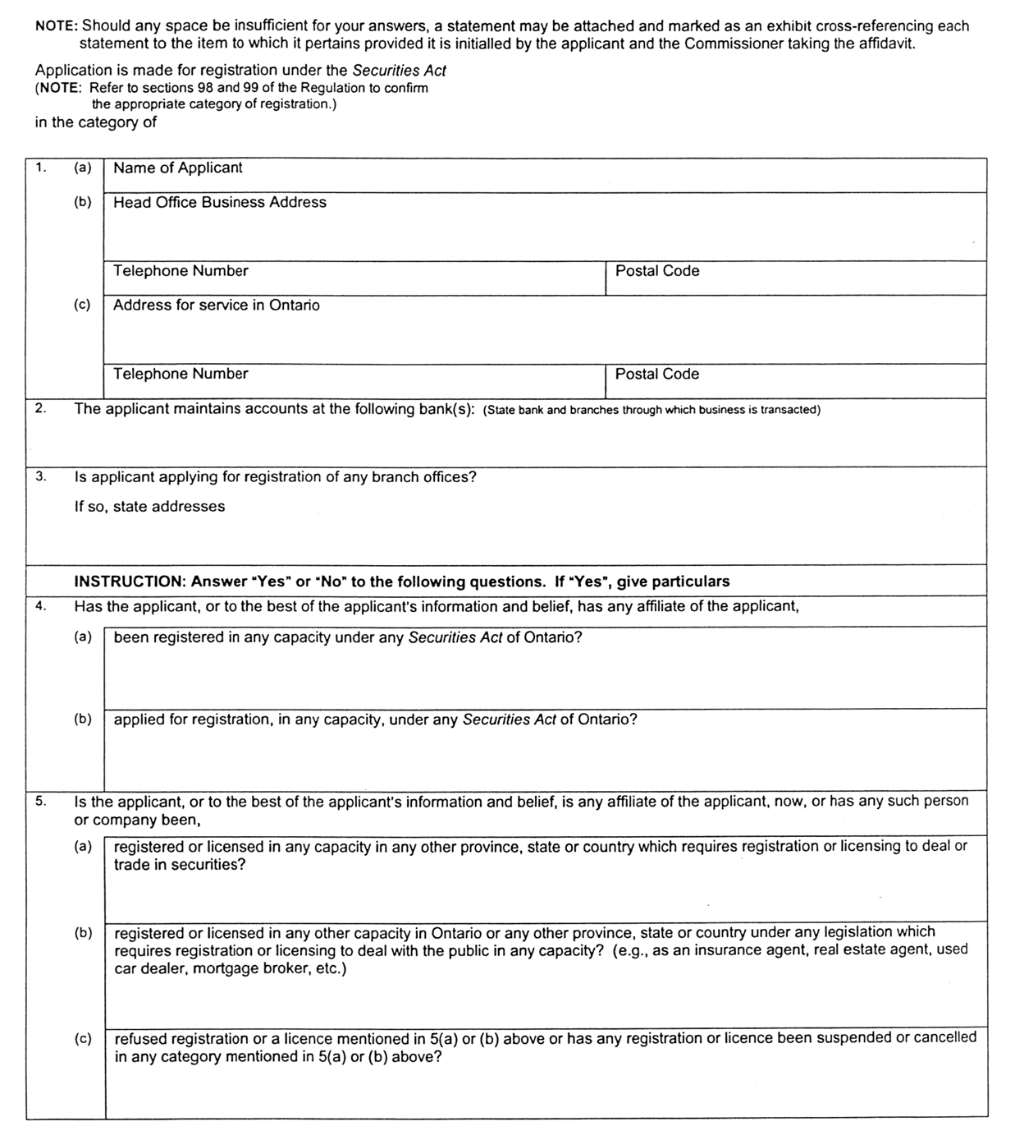
Insert regs\Graphics\Source Law\2003\16\160003be.tif
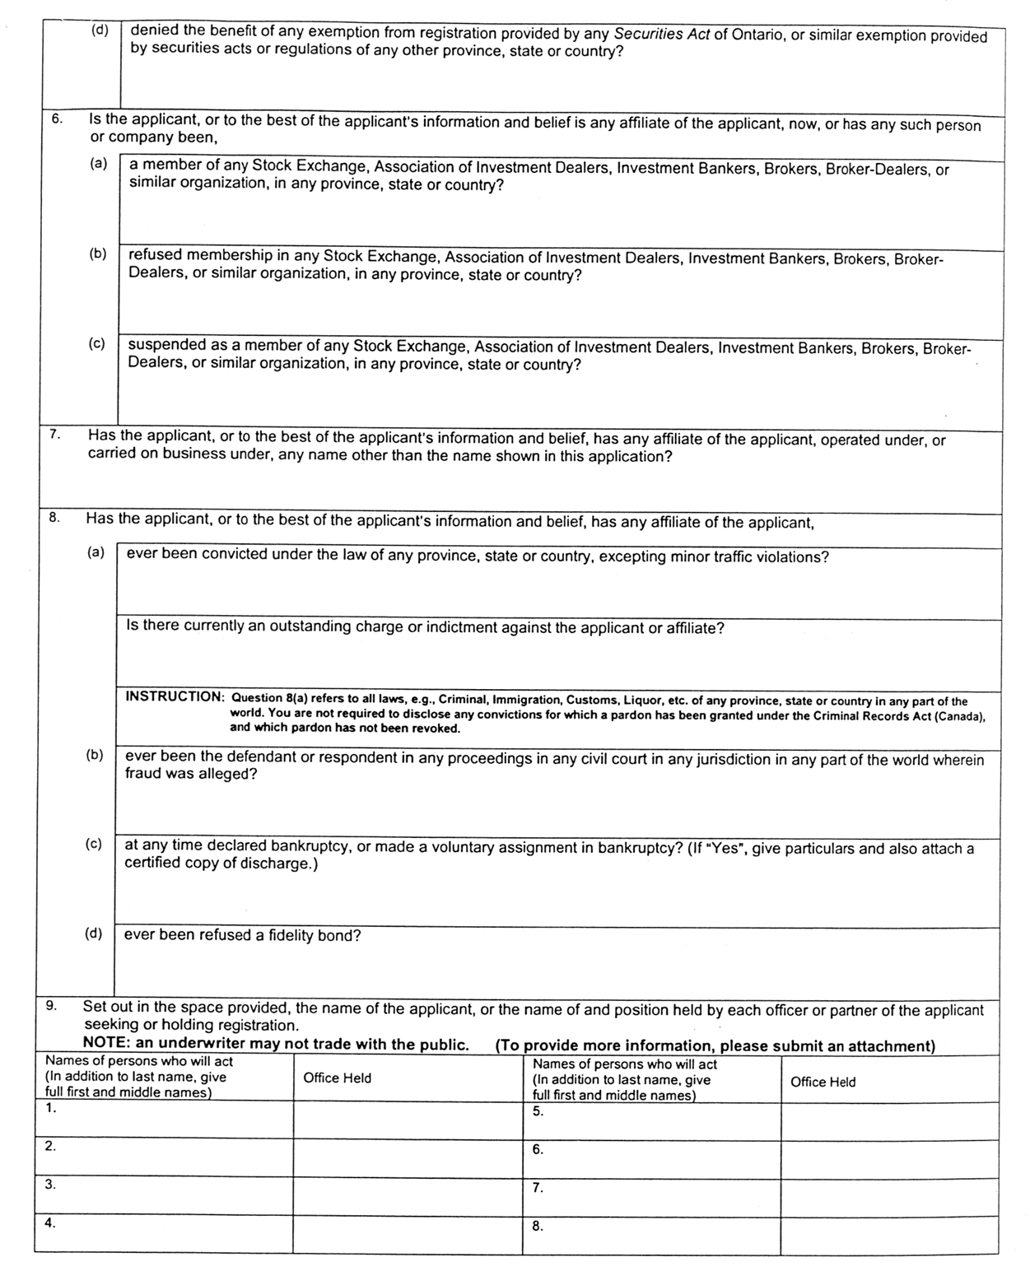
Insert regs\Graphics\Source Law\2003\16\160003ce.tif
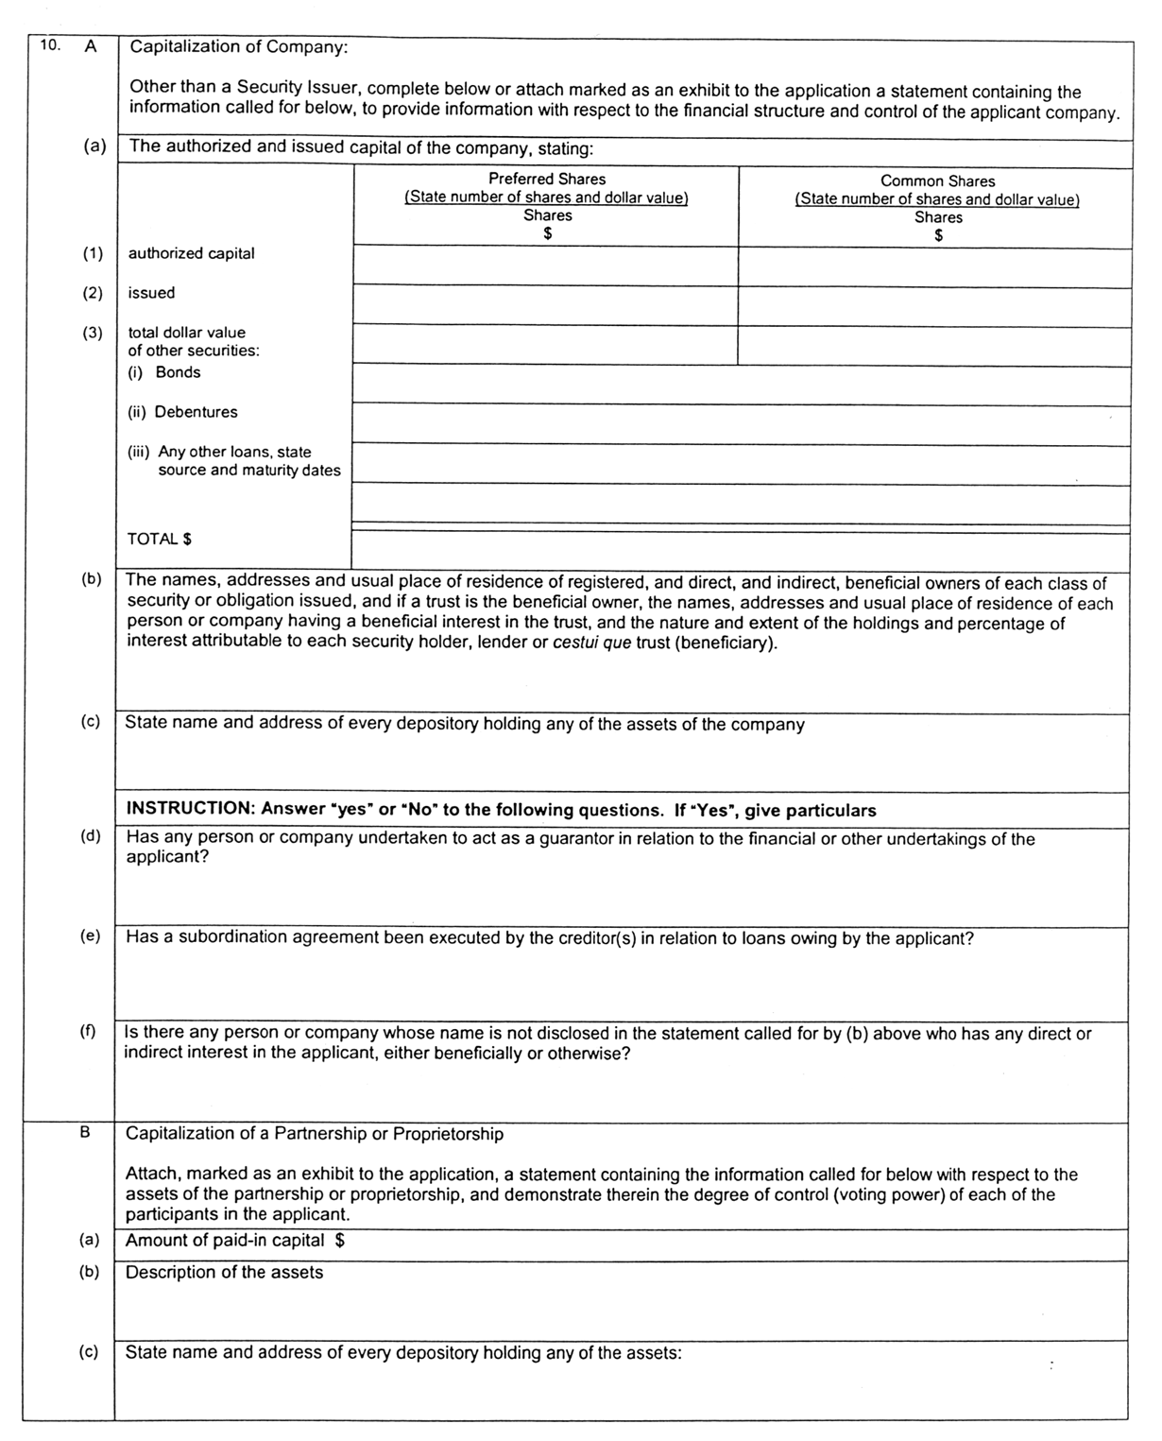
Insert regs\Graphics\Source Law\2003\16\160003de.tif
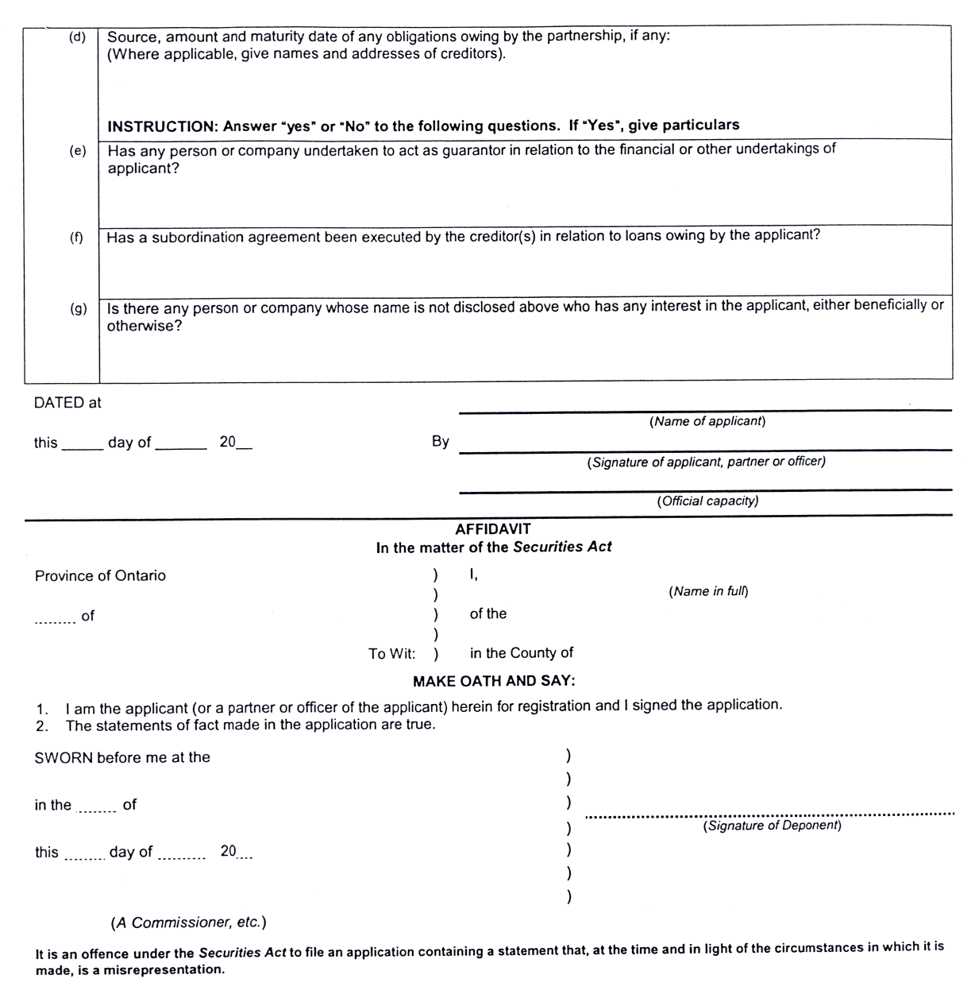
Insert regs\Graphics\Source Law\2003\16\160003ee.tif

6. Form 4 of the Regulation is revoked.
7. This Regulation comes into force on the day that the rule made by the Ontario Securities Commission on November 12, 2002 entitled “Multilateral Instrument 33-109 Registration Information” comes into force.
Ontario Securities Commission:
Howard Wetston
Vice Chair
David A. Brown
Chair
Dated on November 13, 2002.
Note: The rule made by the Ontario Securities Commission on November 12, 2002 entitled “Multilateral Instrument 33-109 Registration Information” comes into force on February 21, 2003.

Back to top

