ontario regulation 453/05
made under the
securities act
Made: July 21, 2005
Filed: July 29, 2005
Printed in The Ontario Gazette: August 13, 2005
Amending Reg. 1015 of R.R.O. 1990
(General)
1. Section 38 of Regulation 1015 of the Revised Regulations of Ontario, 1990 is revoked.
2. Section 79 of the Regulation is revoked.
3. Section 100 of the Regulation is revoked and the following substituted:
100. (1) The registration of a mutual fund dealer, scholarship plan dealer or securities issuer authorizes the dealer or issuer to act as an underwriter for the sole purpose of distributing the securities that the dealer or issuer is registered to trade but not for any other purpose.
(2) The registration of a limited market dealer, international dealer or financial intermediary dealer authorizes the dealer to act as an underwriter for the sole purpose of making a distribution that the dealer is authorized to make by section 208 or 209 or Ontario Securities Commission Rule 31-503 Limited Market Dealers, as the case may be, but not for any other purpose.
4. (1) Subsection 104 (1) of the Regulation is amended by striking out the portion before clause (a) and substituting the following:
(1) A registrant who is a registered dealer or adviser or a partner or officer of a registered dealer or adviser and who proposes to acquire, directly or indirectly, beneficial ownership of or control or direction over any security of another registered dealer or adviser shall give written notice of the proposed acquisition to the Director at least 30 days before the acquisition and shall provide with the notice all relevant facts to permit the Director to determine if the acquisition,
. . . . .
(2) Clause 104 (4) (a) of the Regulation is revoked and the following substituted:
(a) a partner or officer of a registered dealer or adviser who, alone or in combination with any other person or company, proposes to acquire securities that, together with the securities already beneficially owned or over which control or direction is already exercised, do not exceed more than 5 per cent of any class or series of securities of any other registered dealer or adviser that are listed and posted for trading on a stock exchange anywhere in the world;
(3) Clause 104 (4) (d) of the Regulation is revoked and the following substituted:
(d) an acquisition by a registered dealer in the ordinary course of its business of trading in securities.
5. Subsection 107 (5) of the Regulation is revoked.
6. (1) Subsection 108 (3) of the Regulation is amended by striking out “every security issuer, every adviser and every underwriter” and substituting “every security issuer and every adviser”.
(2) Subsection 108 (4) of the Regulation is amended by striking out “dealer, adviser or underwriter” in the portion before clause (a) and substituting “dealer or adviser”.
(3) Subsection 108 (6) of the Regulation is revoked and the following substituted:
(6) The Director may exempt registrants who are members of a recognized self-regulatory organization referred to in section 21.1 of the Act or a recognized stock exchange from compliance with subsection (4) if the Director is satisfied that the registrant is subject to requirements imposed by that organization or exchange that provide at least equal protection for clients to the protection provided under subsection (4).
7. Subsection 110 (1) of the Regulation is revoked and the following substituted:
(1) Every dealer, other than a security issuer, shall participate in a compensation fund or contingency trust fund approved by the Commission and established by,
(a) a recognized self-regulatory organization referred to in section 21.1 of the Act;
(b) a recognized stock exchange; or
(c) a trust corporation registered under the Loan and Trust Corporations Act.
8. (1) Paragraph 8 of subsection 113 (3) of the Regulation is amended by striking out “Subject to subsection 114 (4)” at the beginning and substituting “Subject to section 1.5 of Ontario Securities Commission Rule 31-505 Conditions of Registration”.
(2) Subparagraph 8 iii of subsection 113 (3) of the Regulation is revoked and the following substituted:
iii. in the case of a margin account, a properly executed margin agreement containing the signature of the owner and the guarantor, if any, and the additional information obtained under section 115 of this Regulation and sections 1.2, 1.5 and 1.6 of Ontario Securities Commission Rule 31-505 Conditions of Registration,
9. Subsection 132 (1) of the Regulation is amended by striking out “dealer, adviser or underwriter” and substituting “dealer or adviser”.
10. Sections 135, 137 and 138 of the Regulation are revoked.
11. Section 139 of the Regulation is revoked and the following substituted:
Reporting to Ontario Securities Commission
139. Every mutual fund dealer who is not a member in good standing of a self-regulatory organization that is recognized by the Commission under section 21.1 of the Act, every adviser and every scholarship plan dealer shall deliver to the Commission, not more than 90 days after the end of each financial year of the dealer or adviser, a copy of its financial statements for the year.
12. Sections 141 and 142 of the Regulation are revoked and the following substituted:
141. Every mutual fund dealer who is not a member in good standing of a self-regulatory organization that is recognized by the Commission under section 21.1 of the Act and every scholarship plan dealer shall deliver a report prepared in accordance with Statement C of Form 9 to the Commission not more than 90 days after the end of each financial year of the dealer.
142. Every securities dealer who is not a member in good standing of a self-regulatory organization that is recognized by the Commission under section 21.1 of the Act shall deliver a report prepared in accordance with Form 9 to the Commission not more than 90 days after the end of each financial year of the dealer.
13. Subsection 145 (1) of the Regulation is amended by striking out “self-regulatory body referred to in section 20 of the Act” in the portion before clause (a) and substituting “self-regulatory organization that is recognized by the Commission under section 21.1 of the Act or a recognized stock exchange”.
14. Section 146 of the Regulation is revoked and the following substituted:
146. Every audit under section 21.10 of the Act shall satisfy the audit requirements published by the Commission, in addition to the requirements in that section, and in the event of a conflict, the requirements of section 21.10 prevail.
15. (1) Subsection 147 (1) of the Regulation is revoked.
(2) Subsection 147 (2) of the Regulation is amended by striking out “an audit under section 21 of the Act” at the end and substituting “an audit under section 21.10 of the Act”.
16. Subsection 212 (2) of the Regulation is revoked.
17. (1) Subsection 230 (1) of the Regulation is amended by striking out “other than sections 221 and 222”.
(2) Subsection 230 (5) of the Regulation is revoked.
18. Section 232 of the Regulation is amended by striking out “sections 221 and 222” and substituting “section 2.1 of Ontario Securities Commission Rule 31-505 Conditions of Registration”.
19. The Regulation is amended by adding the following Part:
part xvi
civil liability for secondary market disclosure
248. In this Part,
“equity security” has the same meaning as it has in subsection 89 (1) of the Act.
249. For the purposes of Part XXIII.1 of the Act, “market capitalization” means, in respect of an issuer, the amount determined as follows:
1. For each class of equity securities for which there is a published market, determine the sum of the number of outstanding securities of the class at the close of trading on each of the 10 trading days before the day on which the misrepresentation was made or the failure to make timely disclosure first occurred.
2. Divide the sum determined under paragraph 1 by 10.
3. Multiply the quotient determined under paragraph 2 for each class by the trading price of the securities of the class on the principal market for the securities for the 10 trading days before the day on which the misrepresentation was made or the failure to make timely disclosure first occurred.
4. Add the amounts determined under paragraph 3 for each class of equity securities for which there is a published market.
5. For each class of equity securities not traded on a published market, determine the fair market value of the outstanding securities of that class as of the day on which the misrepresentation was made or the failure to make timely disclosure first occurred.
6. Add the amounts determined under paragraph 5 for each class of equity securities not traded on a published market.
7. Add the amount determined under paragraph 4 to the amount determined under paragraph 6 to determine the market capitalization of the issuer.
250. For the purposes of Part XXIII.1 of the Act,
“principal market” means, in respect of a class of securities of a responsible issuer,
(a) the published market in Canada on which the greatest volume of trading in securities of that class occurred during the 10 trading days before the day on which the misrepresentation was made or the failure to make timely disclosure first occurred, or
(b) the published market on which the greatest volume of trading in securities of that class occurred during the 10 trading days before the day on which the misrepresentation was made or the failure to make timely disclosure first occurred, if securities of that class are not traded during those 10 trading days on a published market in Canada.
251. For the purposes of Part XXIII.1 of the Act, “trading price” means, in respect of a security of a class of securities for which there is a published market, the amount determined under the following rules:
1. Subject to paragraphs 2 and 3, the trading price of the security is the volume weighted average price of securities of that class on the published market during the period for which the trading price is to be determined.
2. Subject to paragraph 3, if there was trading in the securities of that class in the published market on fewer than half of the trading days during the period for which the trading price of the securities is to be determined, the trading price of the security is determined as follows:
i. Calculate the sum of the average of the highest bid and lowest ask prices for each trading day in the period on which there were no trades in securities of that class in the published market.
ii. Divide the amount determined under subparagraph i by the number of trading days on which there were no trades in securities of that class in the published market.
iii. Add to the amount determined under subparagraph ii the volume weighted average price of securities of that class on the published market for those trading days on which securities of that class were traded.
iv. Divide by two the amount determined under subparagraph iii.
3. If there were no trades of securities of that class in the published market during the period for which the trading price is to be determined, the trading price of the security is the fair market value of the security.
252. (1) Part XXIII.1 of the Act applies to the acquisition of an issuer’s security pursuant to an exemption from section 53 or 62 of the Act that is set out in clause 72 (7) (b) of the Act, which exemption is prescribed for the purposes of clause 138.2 (b) of the Act.
(2) Part XXIII.1 of the Act applies to the acquisition or disposition of an issuer’s security in connection with or pursuant to a take-over bid described in clause 93 (1) (a), (b) or (e) of the Act or an issuer bid described in clause 93 (3) (e), (f) or (h) of the Act, which bids are prescribed for the purposes of clause 138.2 (c) of the Act.
- Form 3 is revoked and the following substituted:
form 3
application for registration as dealer or adviser
Securities Act
Insert regs\Graphics\Source Law\2005\453\453FORM3aae.tif
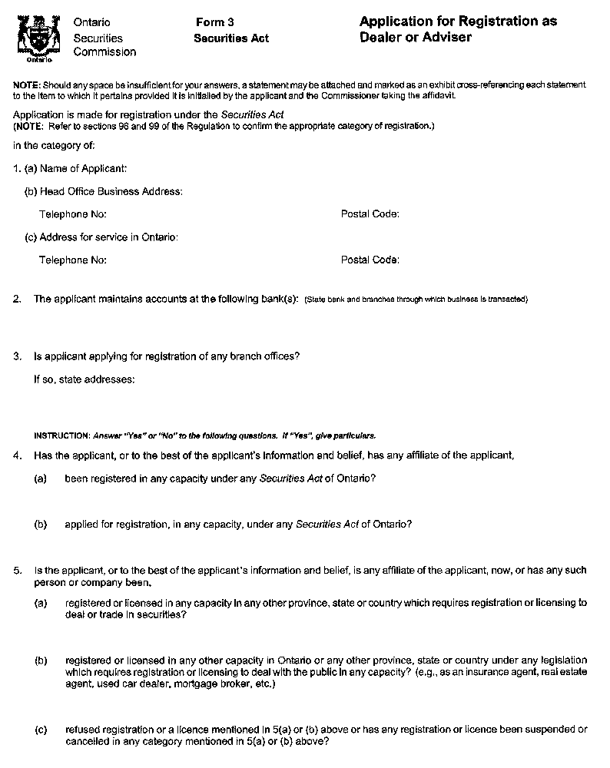
Insert regs\Graphics\Source Law\2005\453\453FORM3abe.tif
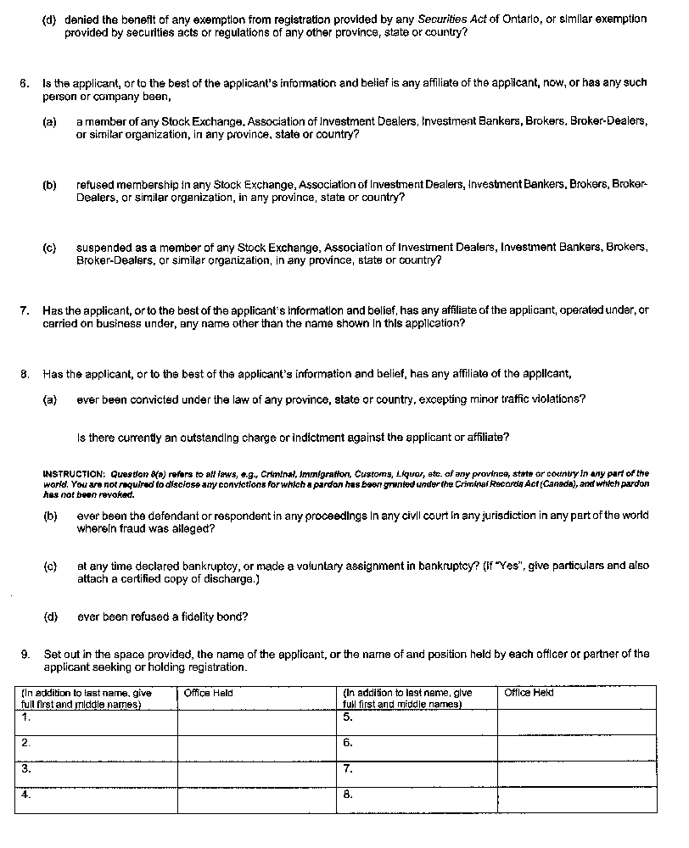
Insert regs\Graphics\Source Law\2005\453\453FORM3ace.tif
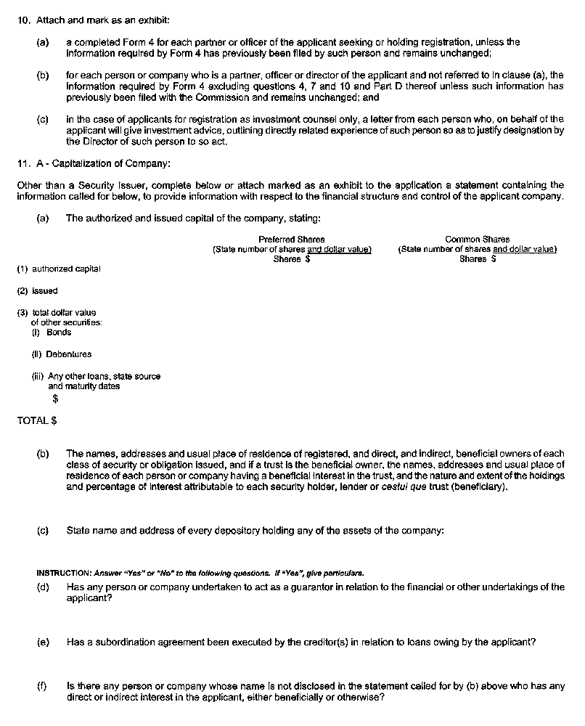
Insert regs\Graphics\Source Law\2005\453\453FORM3ade.tif
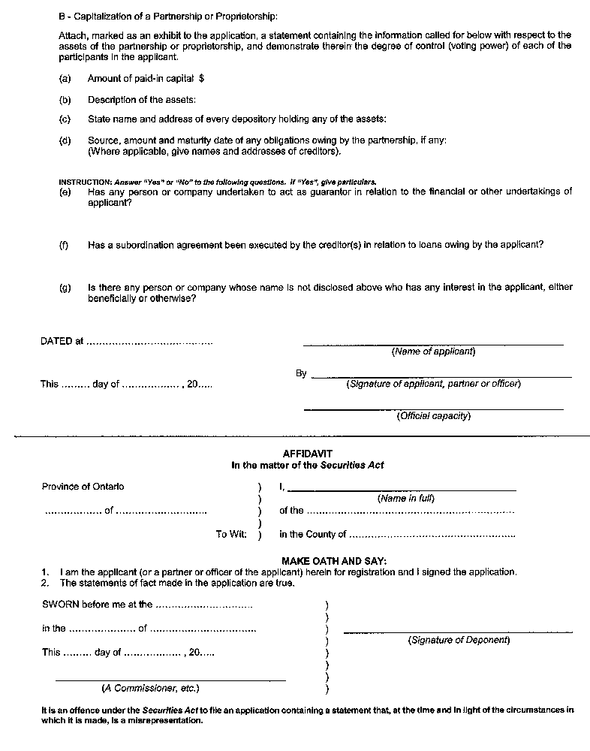
- Form 5 is revoked and the following substituted:
form 5
application FOR renewal of registration as dealer or adviser
Securities Act
Insert regs\Graphics\Source Law\2005\453\453FORM5ae.tif
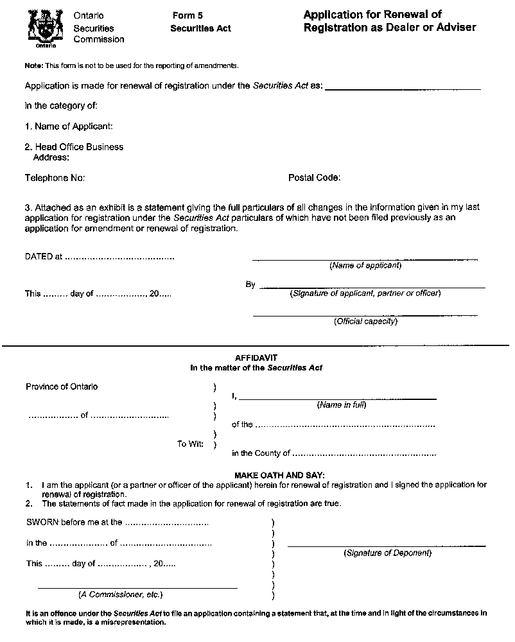
22. Forms 7, 17, 18 and 19 are revoked.
23. (1) Subject to subsection (2), this Regulation comes into force on the day it is filed.
(2) Section 19 comes into force on the day that section 185 of the Keeping the Promise for a Strong Economy Act (Budget Measures), 2002 comes into force.

Back to top

