ontario regulation 500/06
made under the
securities act
Made: June 13, 2006
Approved: September 19, 2006
Filed: November 3, 2006
Published on e-Laws: November 6, 2006
Printed in The Ontario Gazette: November 18, 2006
Amending Reg. 1015 of R.R.O. 1990
(General)
1. Section 115 of Regulation 1015 of the Revised Regulations of Ontario, 1990 is amended by adding the following subsection:
(7) Subsection (6) does not apply in the case of an investment counsel who is acting as a portfolio manager of an investment fund, with respect to a purchase or sale of a security referred to in subsection 6.1 (2) of National Instrument 81-107 Independent Review Committee for Investment Funds if the purchase or sale is made in accordance with that subsection.
2. Subsection 227 (2) of the Regulation is amended by striking out “or” at the end of clause (b) and by adding the following clause:
(b.1) in the case of a registrant who is acting as a portfolio manager in respect of a transaction made in accordance with subsection 4.1 (4) of National Instrument 81-102 Mutual Funds; or
3. Form 15 of the Regulation is revoked and the following substituted:
FORM 15
INFORMATION REQUIRED IN PROSPECTUS OF A MUTUAL FUND
Securities Act
Insert regs\Graphics\Source Law\2006\500\500015ae.tif
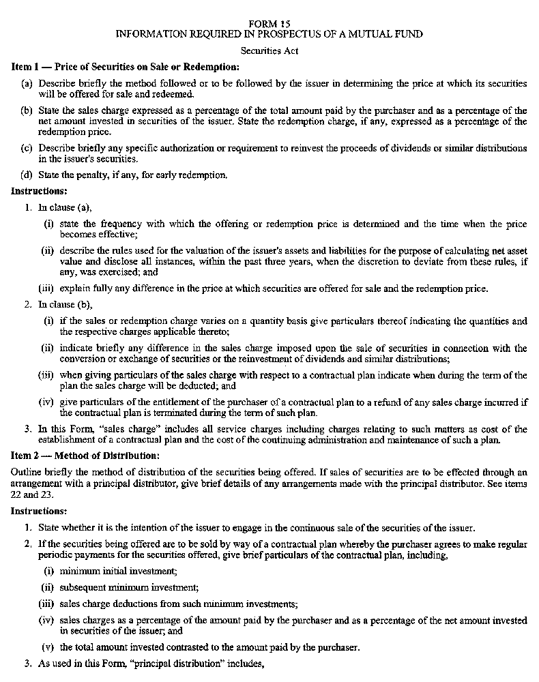
Insert regs\Graphics\Source Law\2006\500\500015be.tif
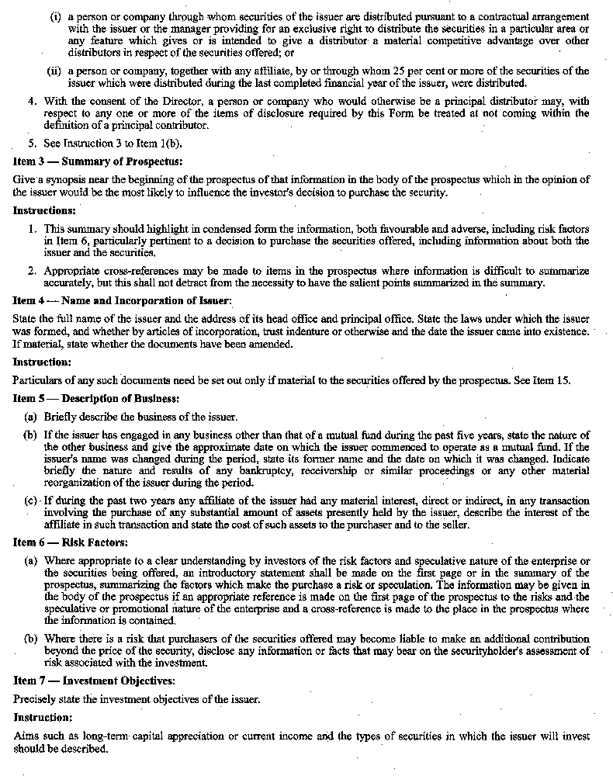
Insert regs\Graphics\Source Law\2006\500\500015ce.tif
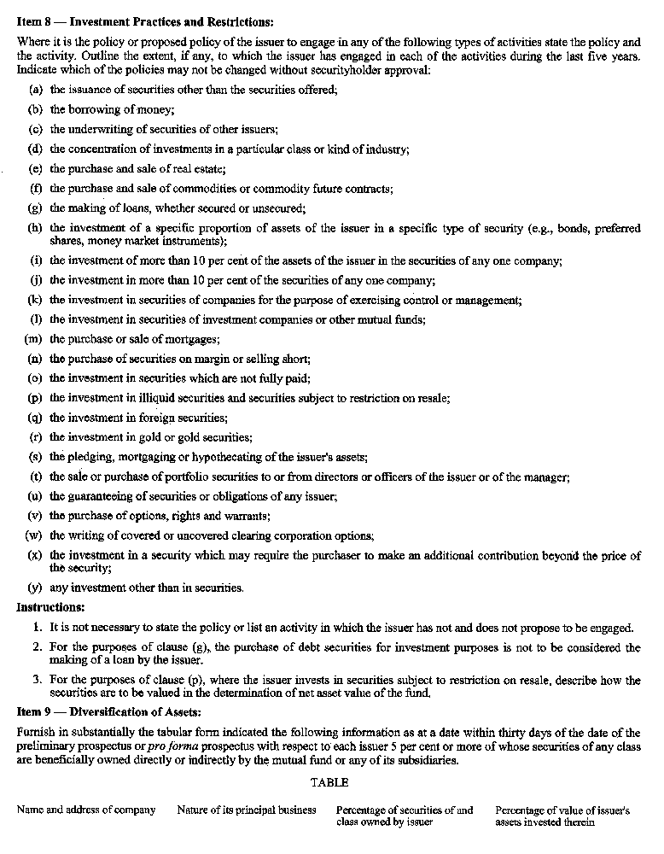
Insert regs\Graphics\Source Law\2006\500\500015de.tif
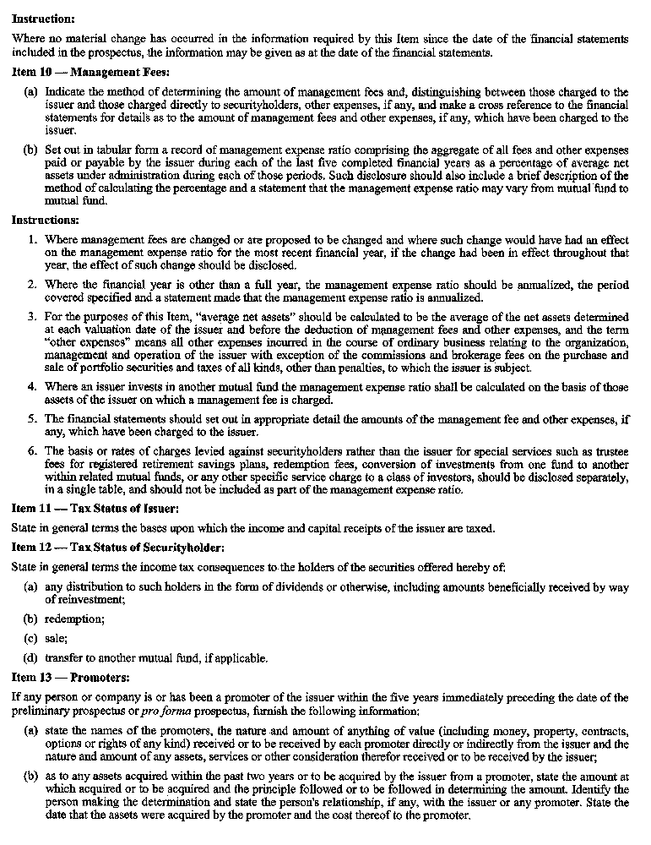
Insert regs\Graphics\Source Law\2006\500\500015ee.tif
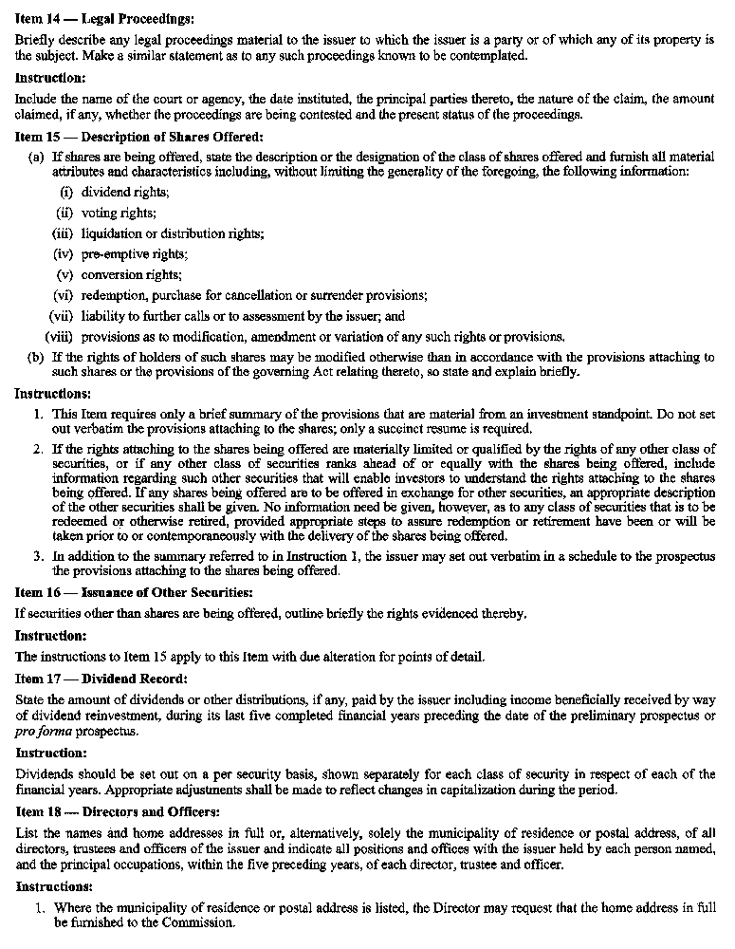
Insert regs\Graphics\Source Law\2006\500\500015fe.tif
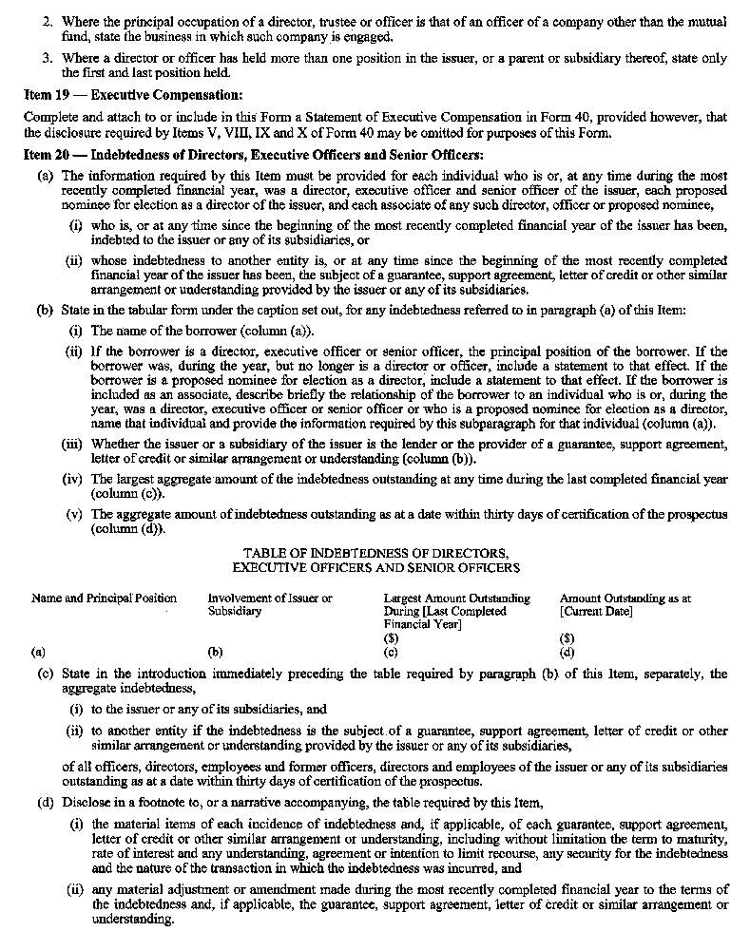
Insert regs\Graphics\Source Law\2006\500\500015ge.tif
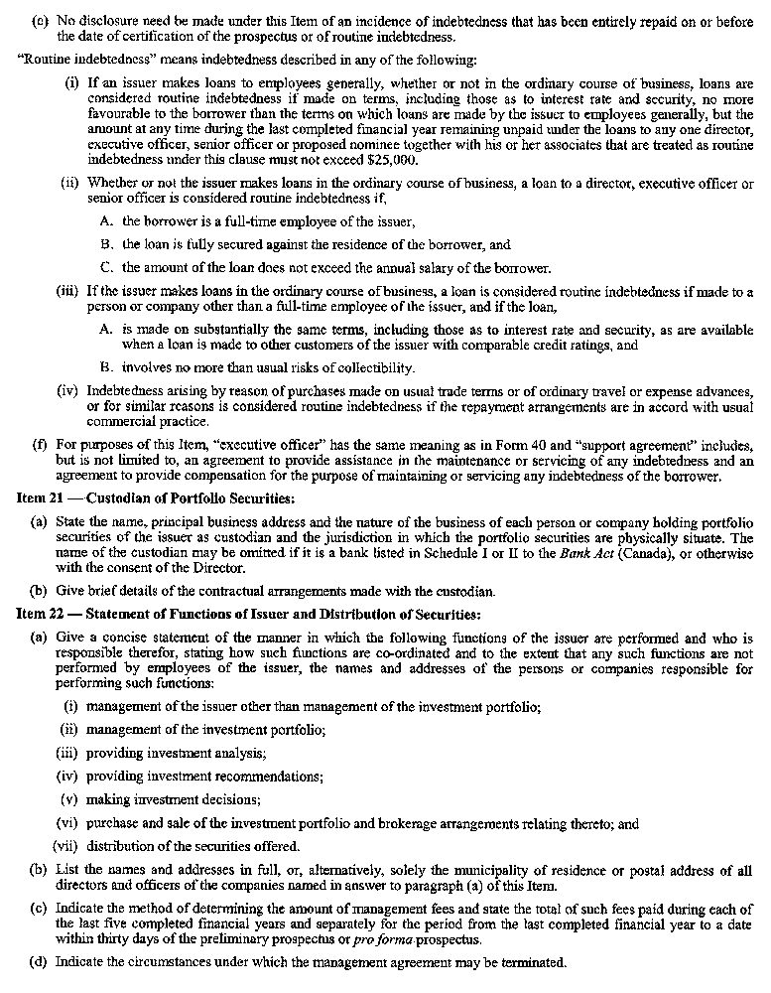
Insert regs\Graphics\Source Law\2006\500\500015he.tif
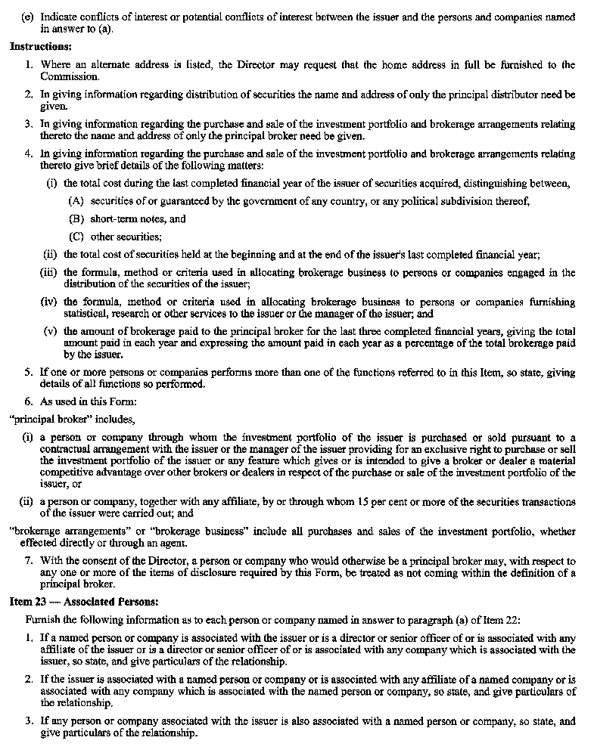
Insert regs\Graphics\Source Law\2006\500\500015ie.tif
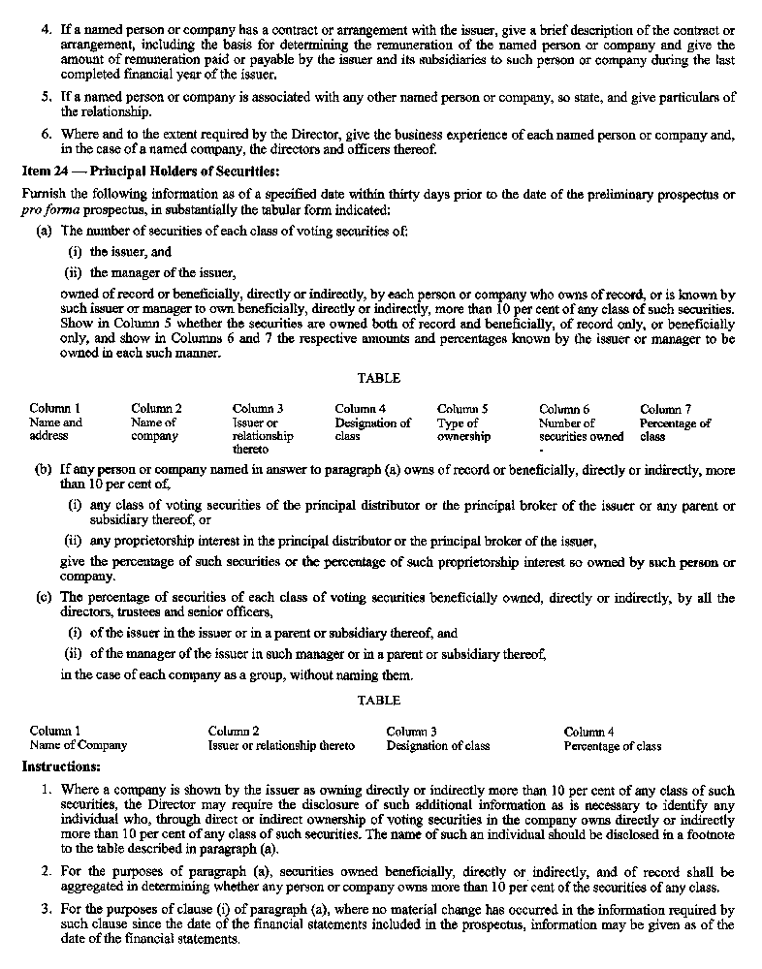
Insert regs\Graphics\Source Law\2006\500\500015je.tif
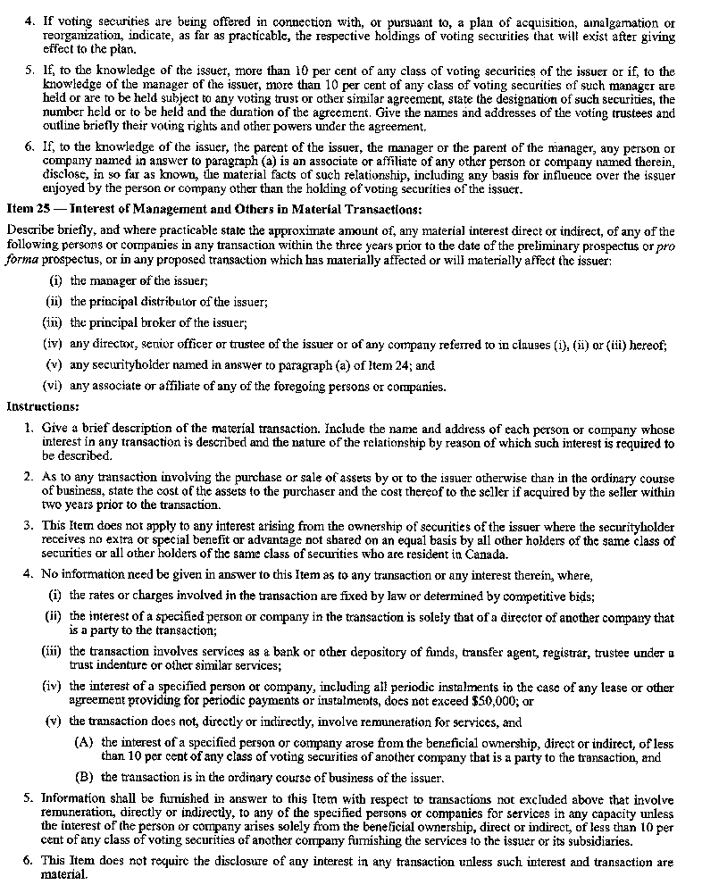
Insert regs\Graphics\Source Law\2006\500\500015ke.tif
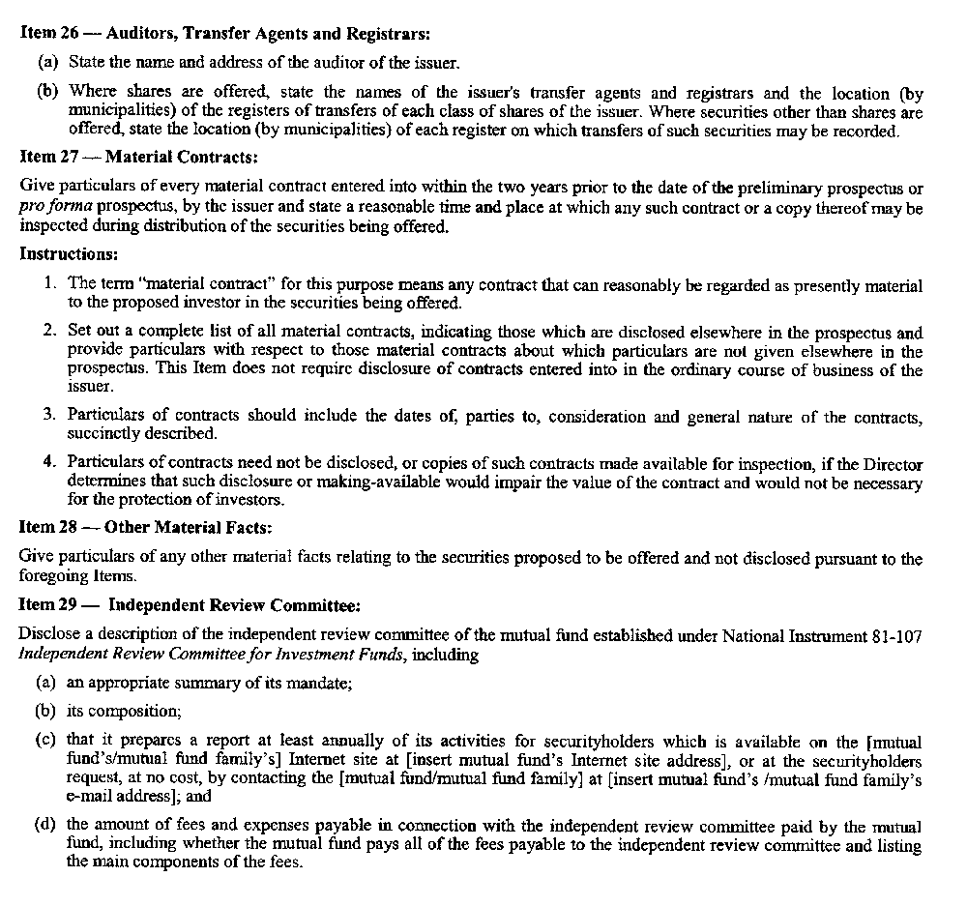
4. Form 45 of the Regulation is revoked and the following substituted:

FORM 45
INFORMATION REQUIRED TO BE INCLUDED IN PROSPECTUS OF A LABOUR SPONSORED INVESTMENT FUND CORPORATION
Securities Act
Insert regs\Graphics\Source Law\2006\500\500045ae.tif
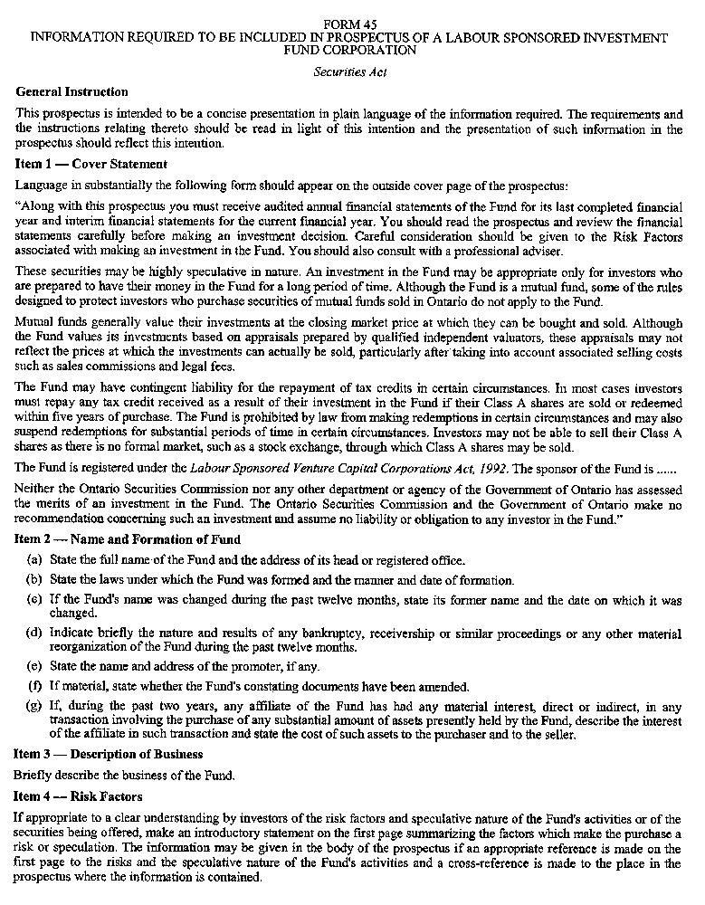
Insert regs\Graphics\Source Law\2006\500\500045be.tif
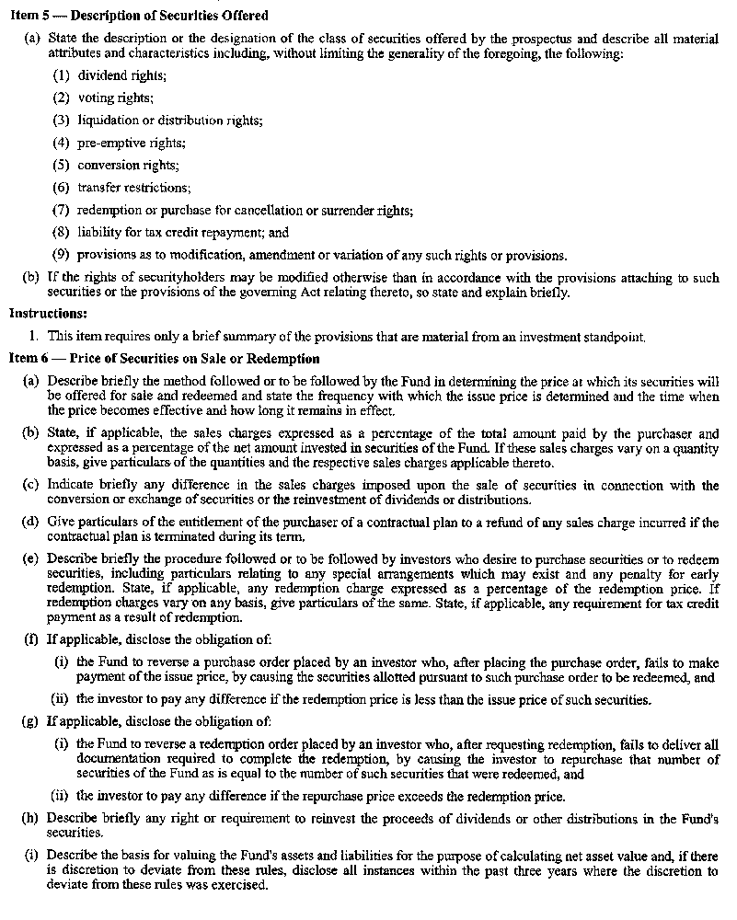
Insert regs\Graphics\Source Law\2006\500\500045ce.tif
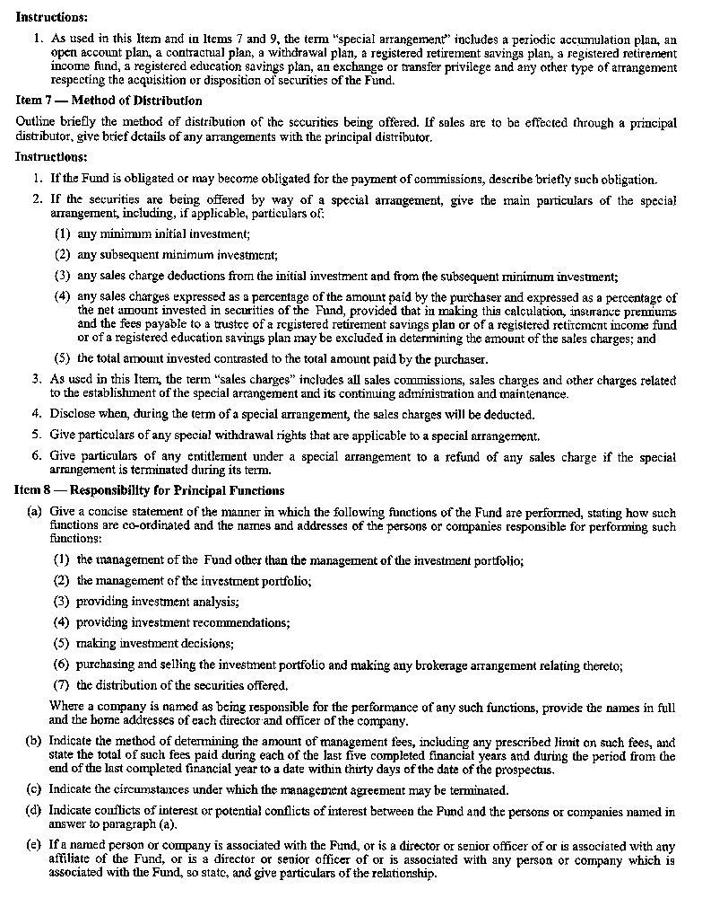
Insert regs\Graphics\Source Law\2006\500\500045de.tif
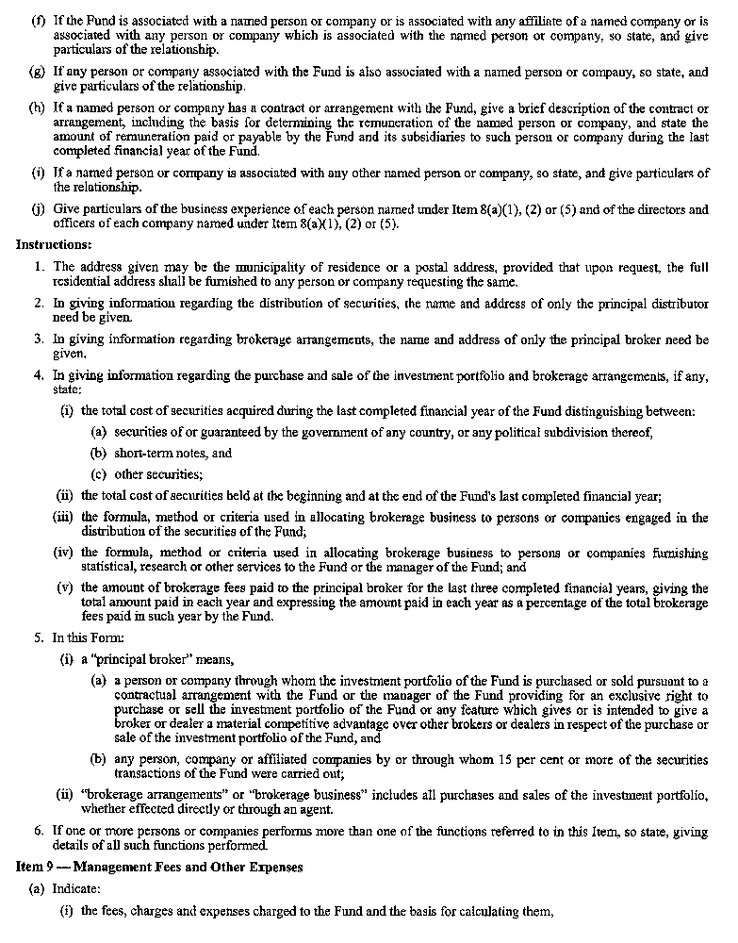
Insert regs\Graphics\Source Law\2006\500\500045ee.tif
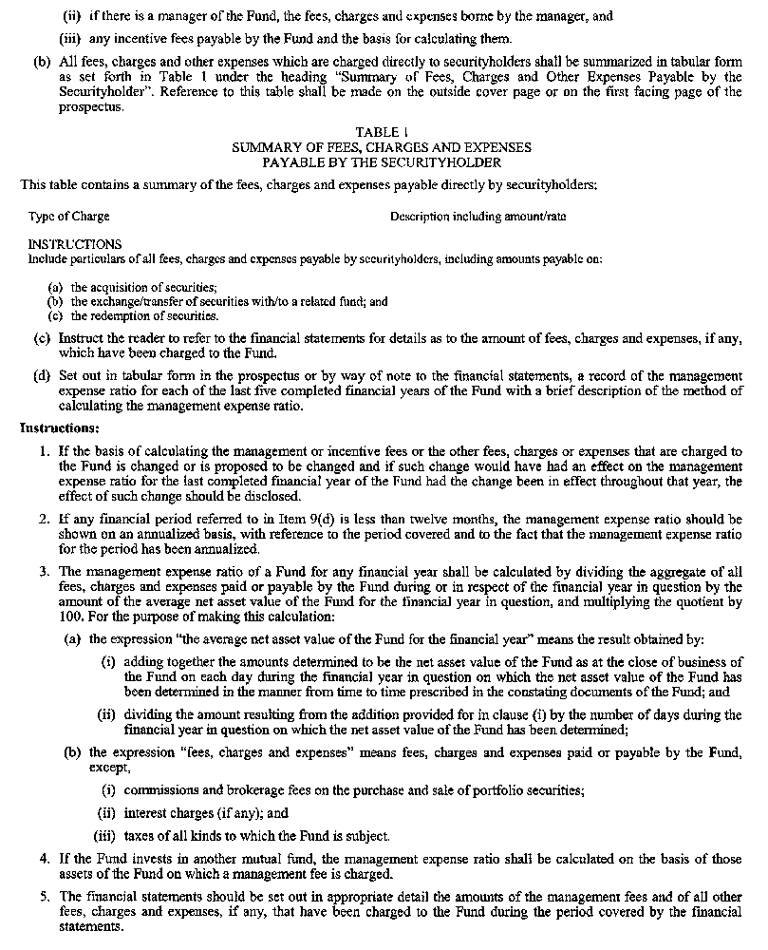
Insert regs\Graphics\Source Law\2006\500\500045fe.tif
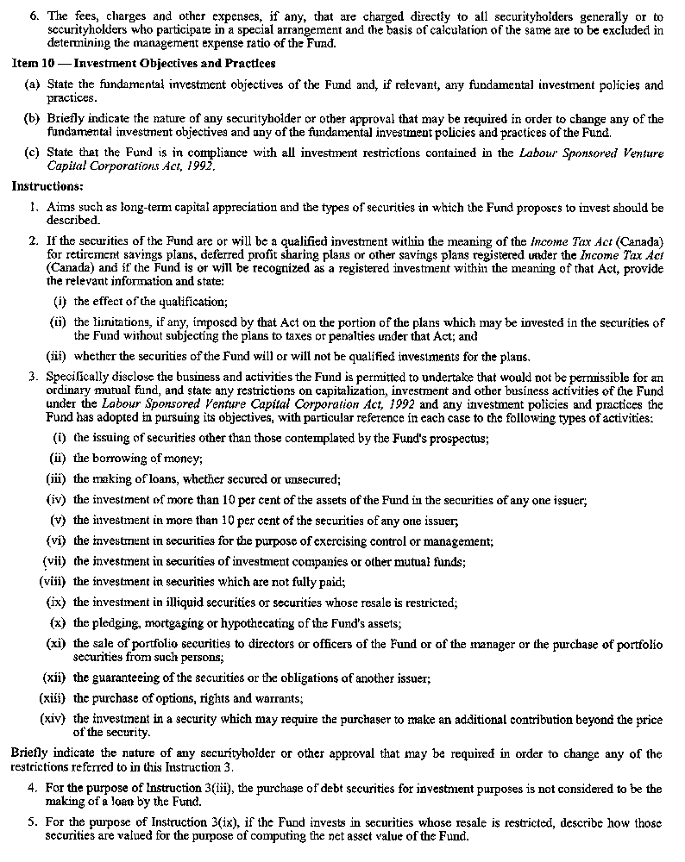
Insert regs\Graphics\Source Law\2006\500\500045ge.tif
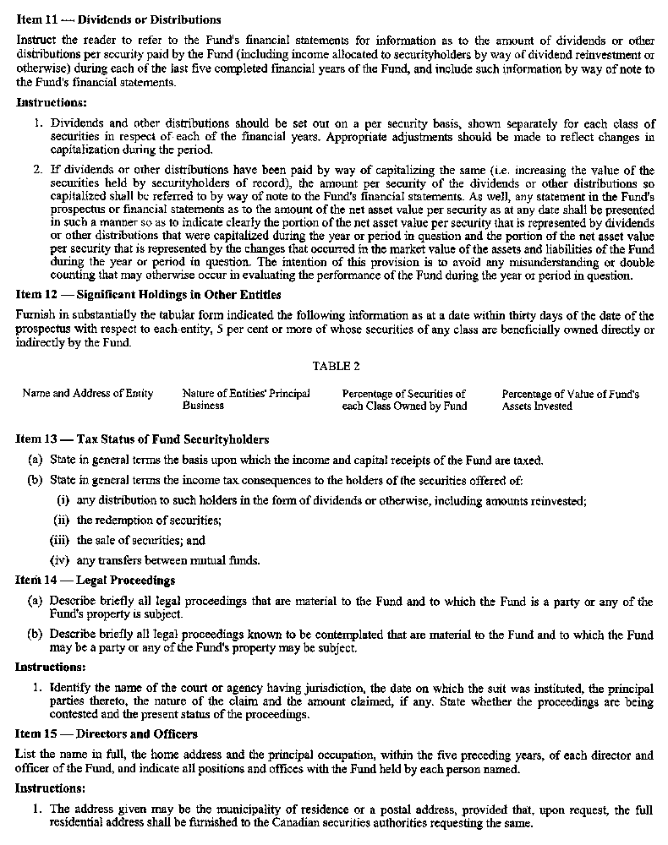
Insert regs\Graphics\Source Law\2006\500\500045he.tif
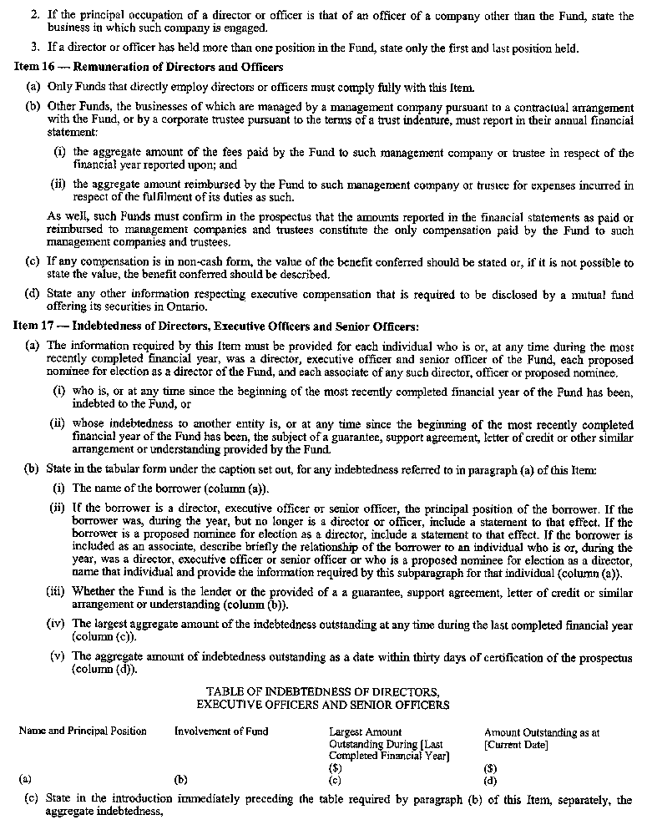
Insert regs\Graphics\Source Law\2006\500\500045ie.tif
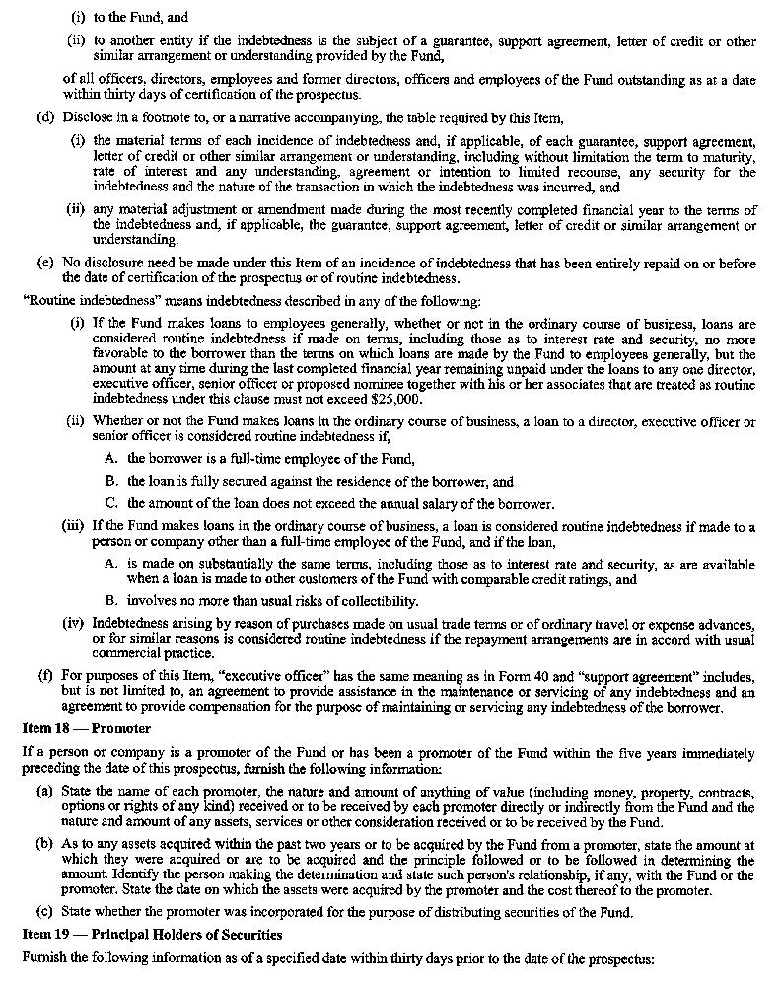
Insert regs\Graphics\Source Law\2006\500\500045je.tif
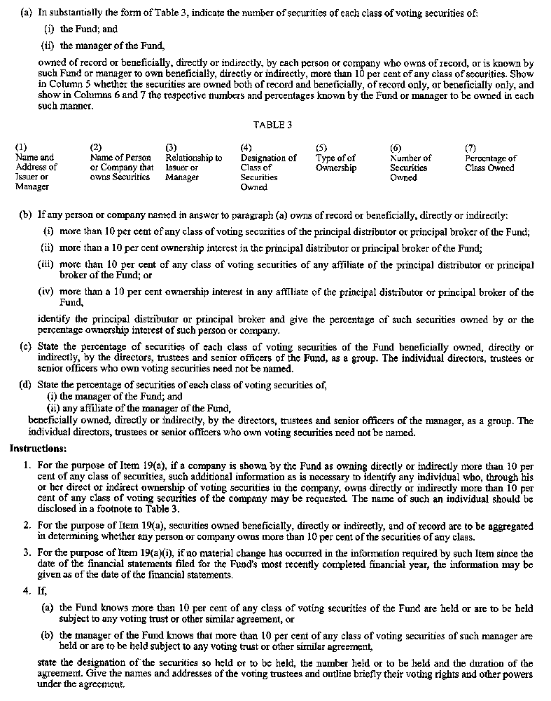
Insert regs\Graphics\Source Law\2006\500\500045ke.tif
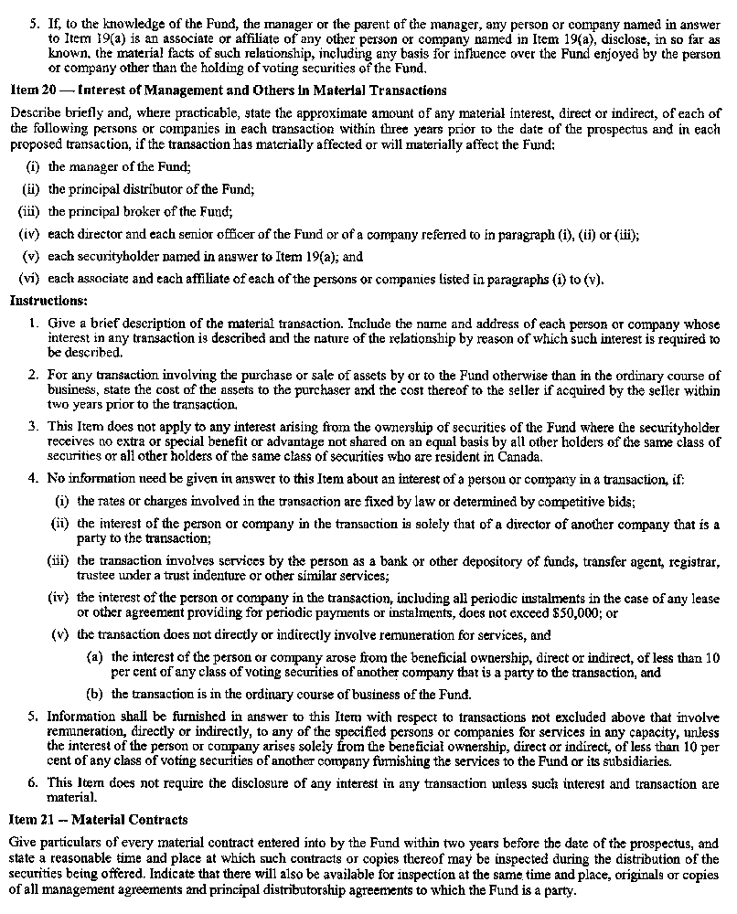
Insert regs\Graphics\Source Law\2006\500\500045le.tif
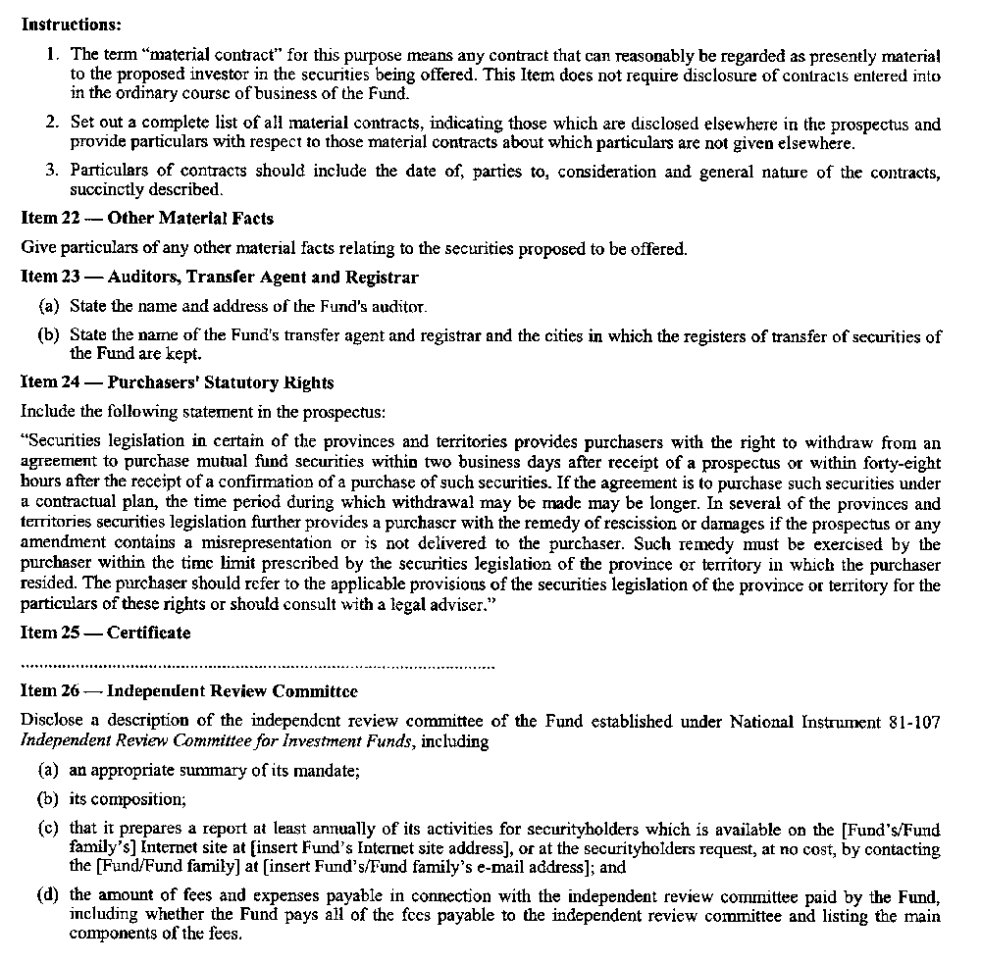
5. This Regulation comes into force on the day that the rule made by the Ontario Securities Commission on June 13, 2006 entitled “National Instrument 81-107 Independent Review Committee for Investment Funds” comes into force.
Made by:
Ontario Securities Commission:
Paul Moore
Vice-Chair
Harold P. Hands
Commissioner
Date made: June 13, 2006.
I certify that I have approved this Regulation.

Gerry Phillips
Minister of Government Services
Date approved: September 19, 2006.
Note: The rule made by the Ontario Securities Commission on June 13, 2006 entitled “National Instrument 81-107 Independent Review Committee for Investment Funds” comes into force on November 1, 2006.

Back to top

