Français
ontario regulation 259/08
made under the
Provincial Offences Act
Made: July 23, 2008
Filed: July 25, 2008
Published on e-Laws: July 31, 2008
Printed in The Ontario Gazette: August 9, 2008
Amending Reg. 950 of R.R.O. 1990
(Proceedings Commenced by Certificate of Offence)
1. Regulation 950 of the Revised Regulations of Ontario, 1990 is amended by adding the following section:
4.3.1 Despite subsections 1 (1), 2 (1) and (2) and section 3, Forms 1, 3, 4 and 6, as they read on December 31, 2008, may continue to be used until June 30, 2009.
2. Section 5 of the Regulation is amended by adding the following subsection:
(2) For the purposes of subsection (1), either the English version or the French version, if any, of a Schedule may be used.
3. Forms 1, 3, 4, 5, 5.1, 6 and 7 of the Regulation are revoked and the following substituted:
form 1
certificate of offence
Provincial Offences Act
Insert regs\Graphics\Source Law\2008\259\259001ab.tif
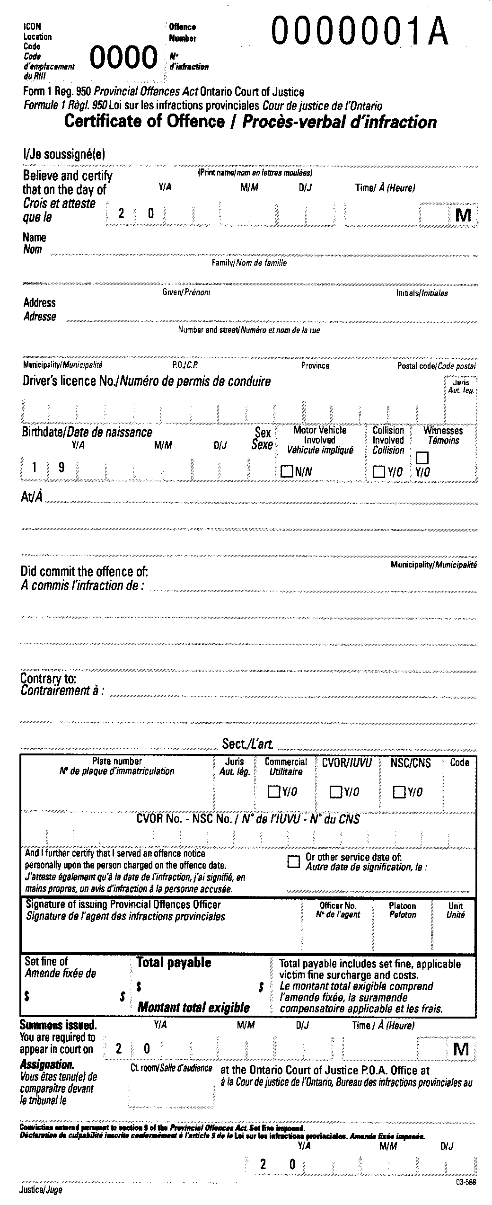
. . . . .
form 3
offence notice
Provincial Offences Act
Insert regs\Graphics\Source Law\2008\259\259003ab.tif
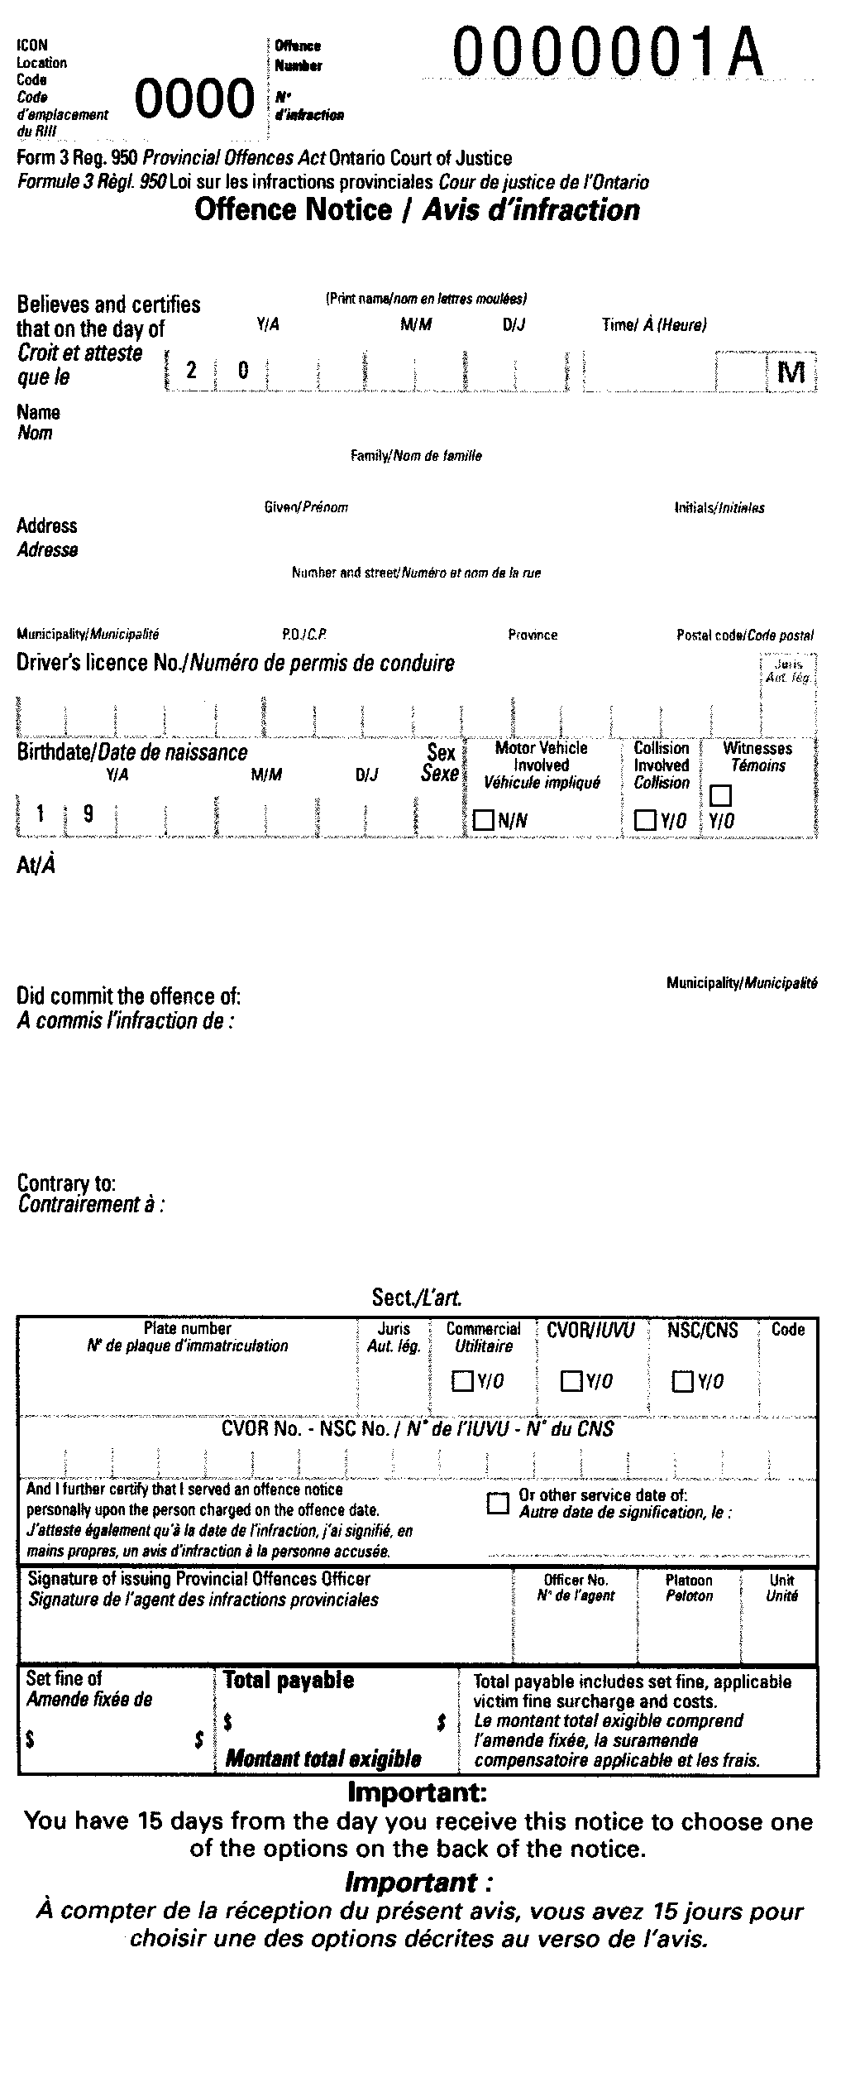
Insert regs\Graphics\Source Law\2008\259\259003bb.tif
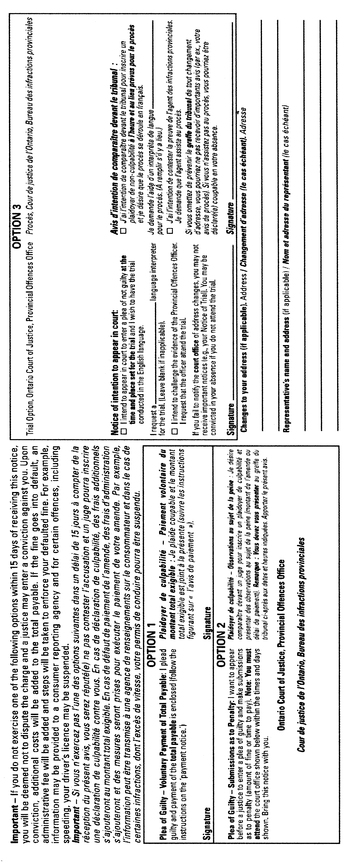
form 4
offence notice
Provincial Offences Act
Insert regs\Graphics\Source Law\2008\259\259004ab.tif
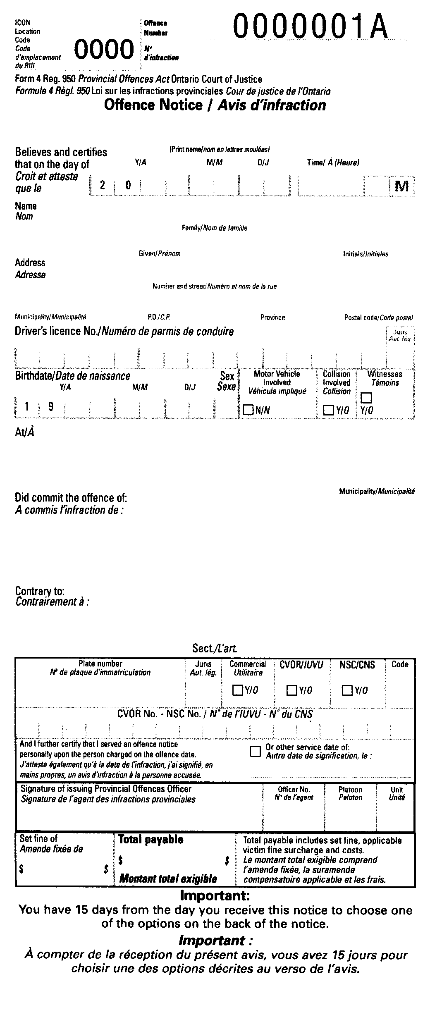
Insert regs\Graphics\Source Law\2008\259\259004bb.tif
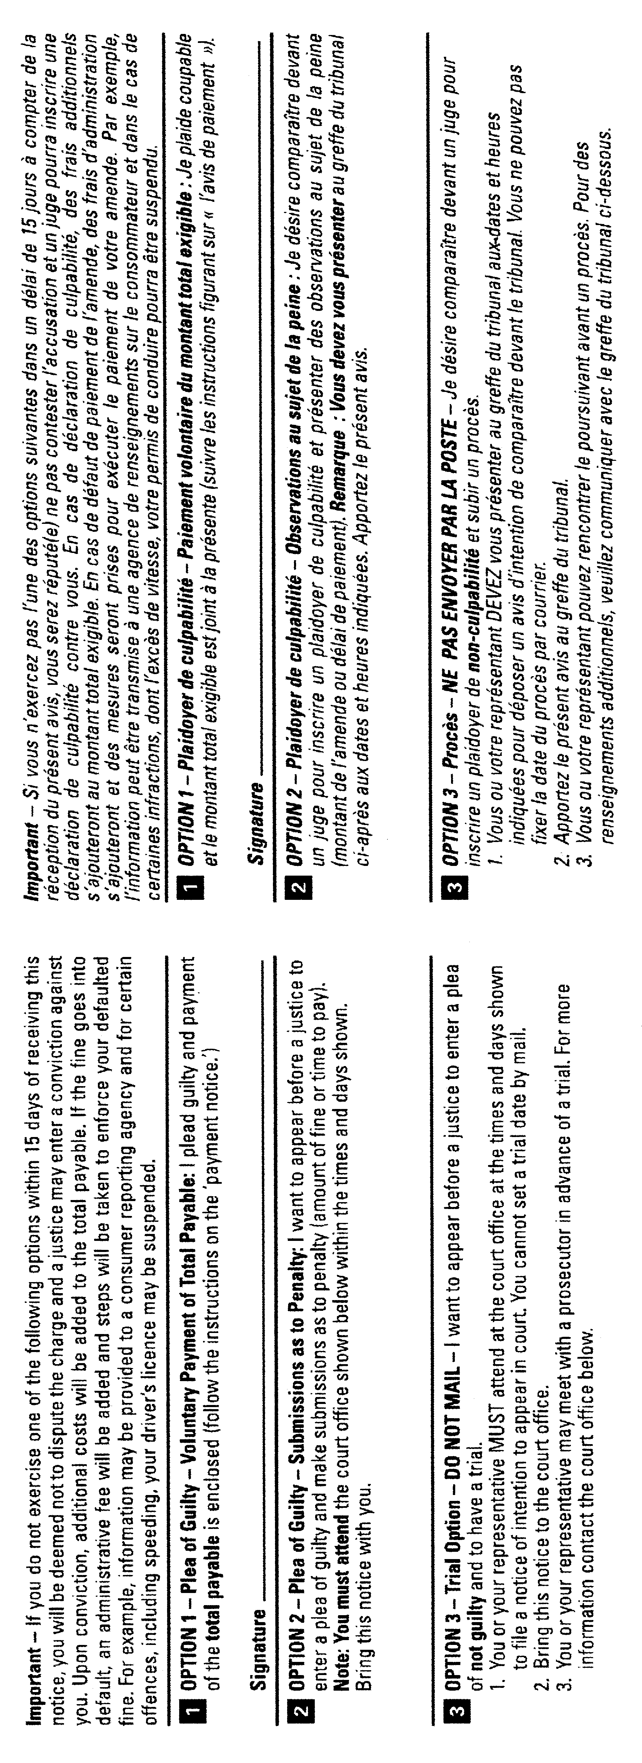
form 5
red light camera system offence notice
Provincial Offences Act
Insert regs\Graphics\Source Law\2008\259\259005ab.tif
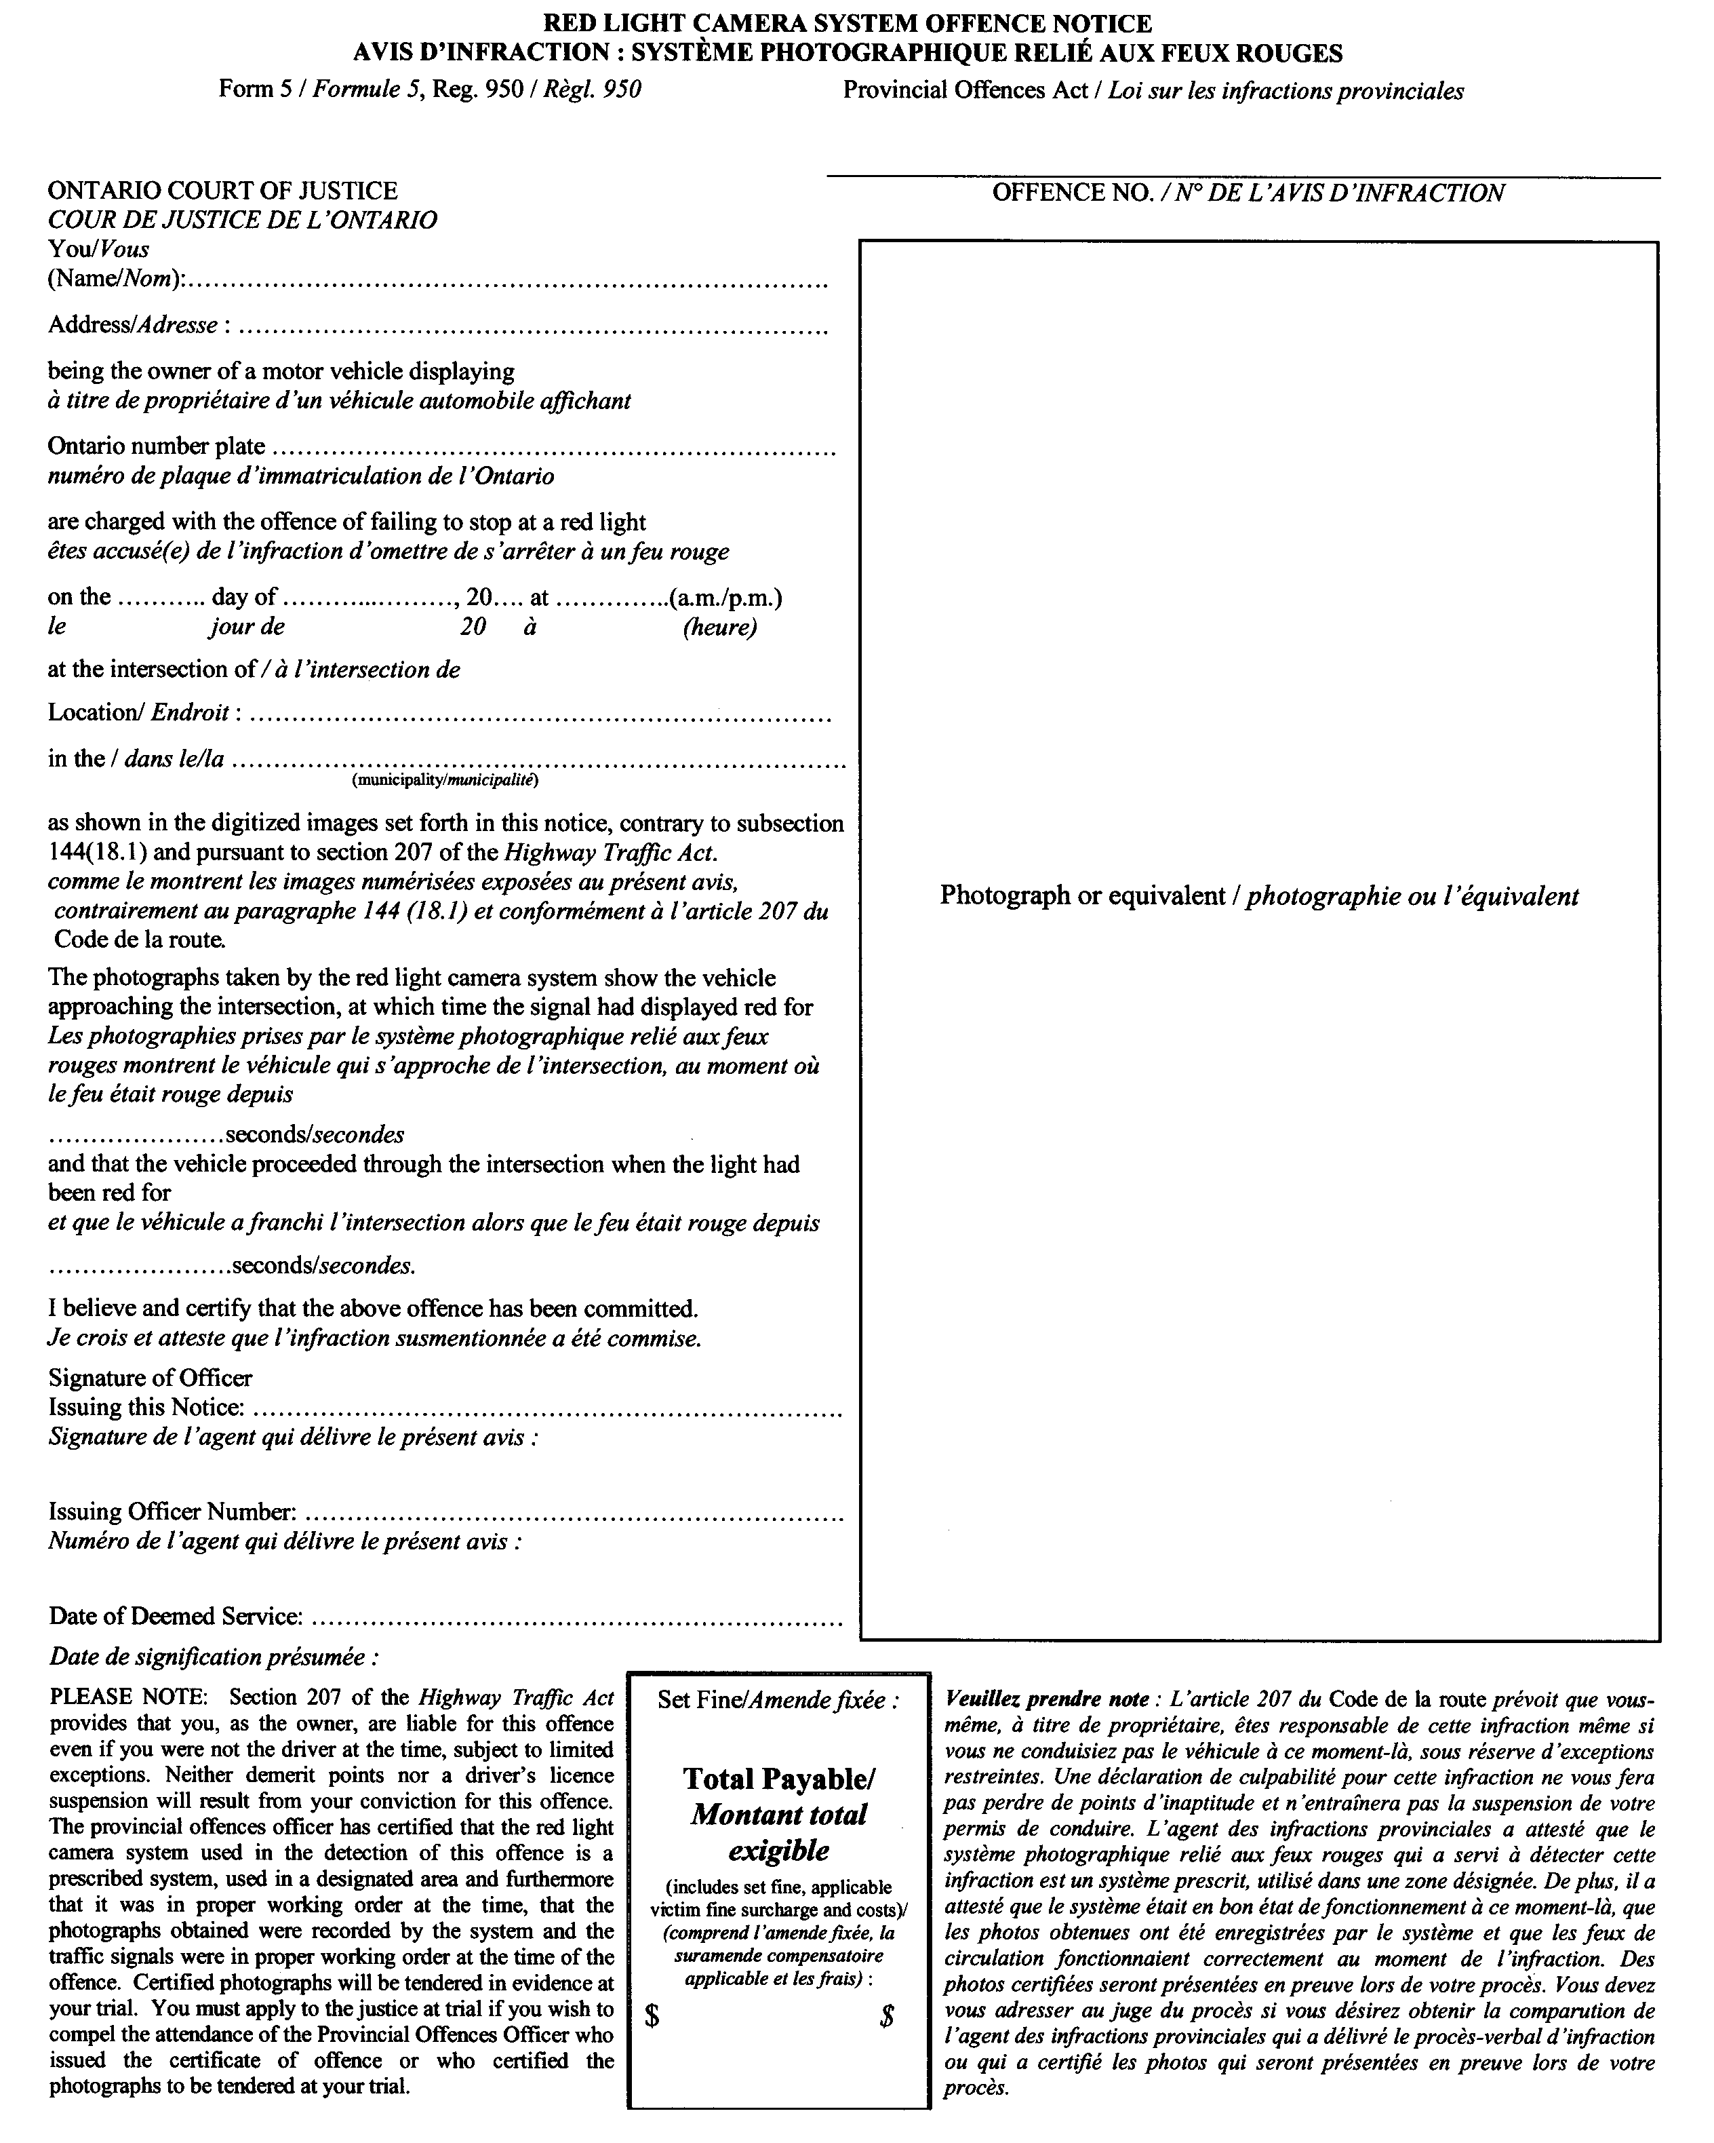
Insert regs\Graphics\Source Law\2008\259\259005bb.tif
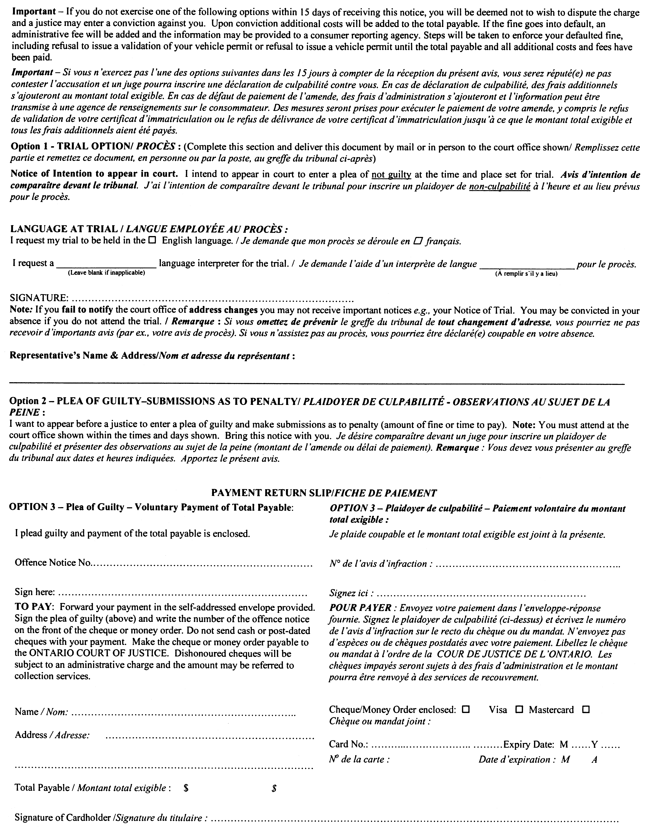
form 5.1
red light camera system offence notice
Provincial Offences Act
Insert regs\Graphics\Source Law\2008\259\259005.1ab.tif
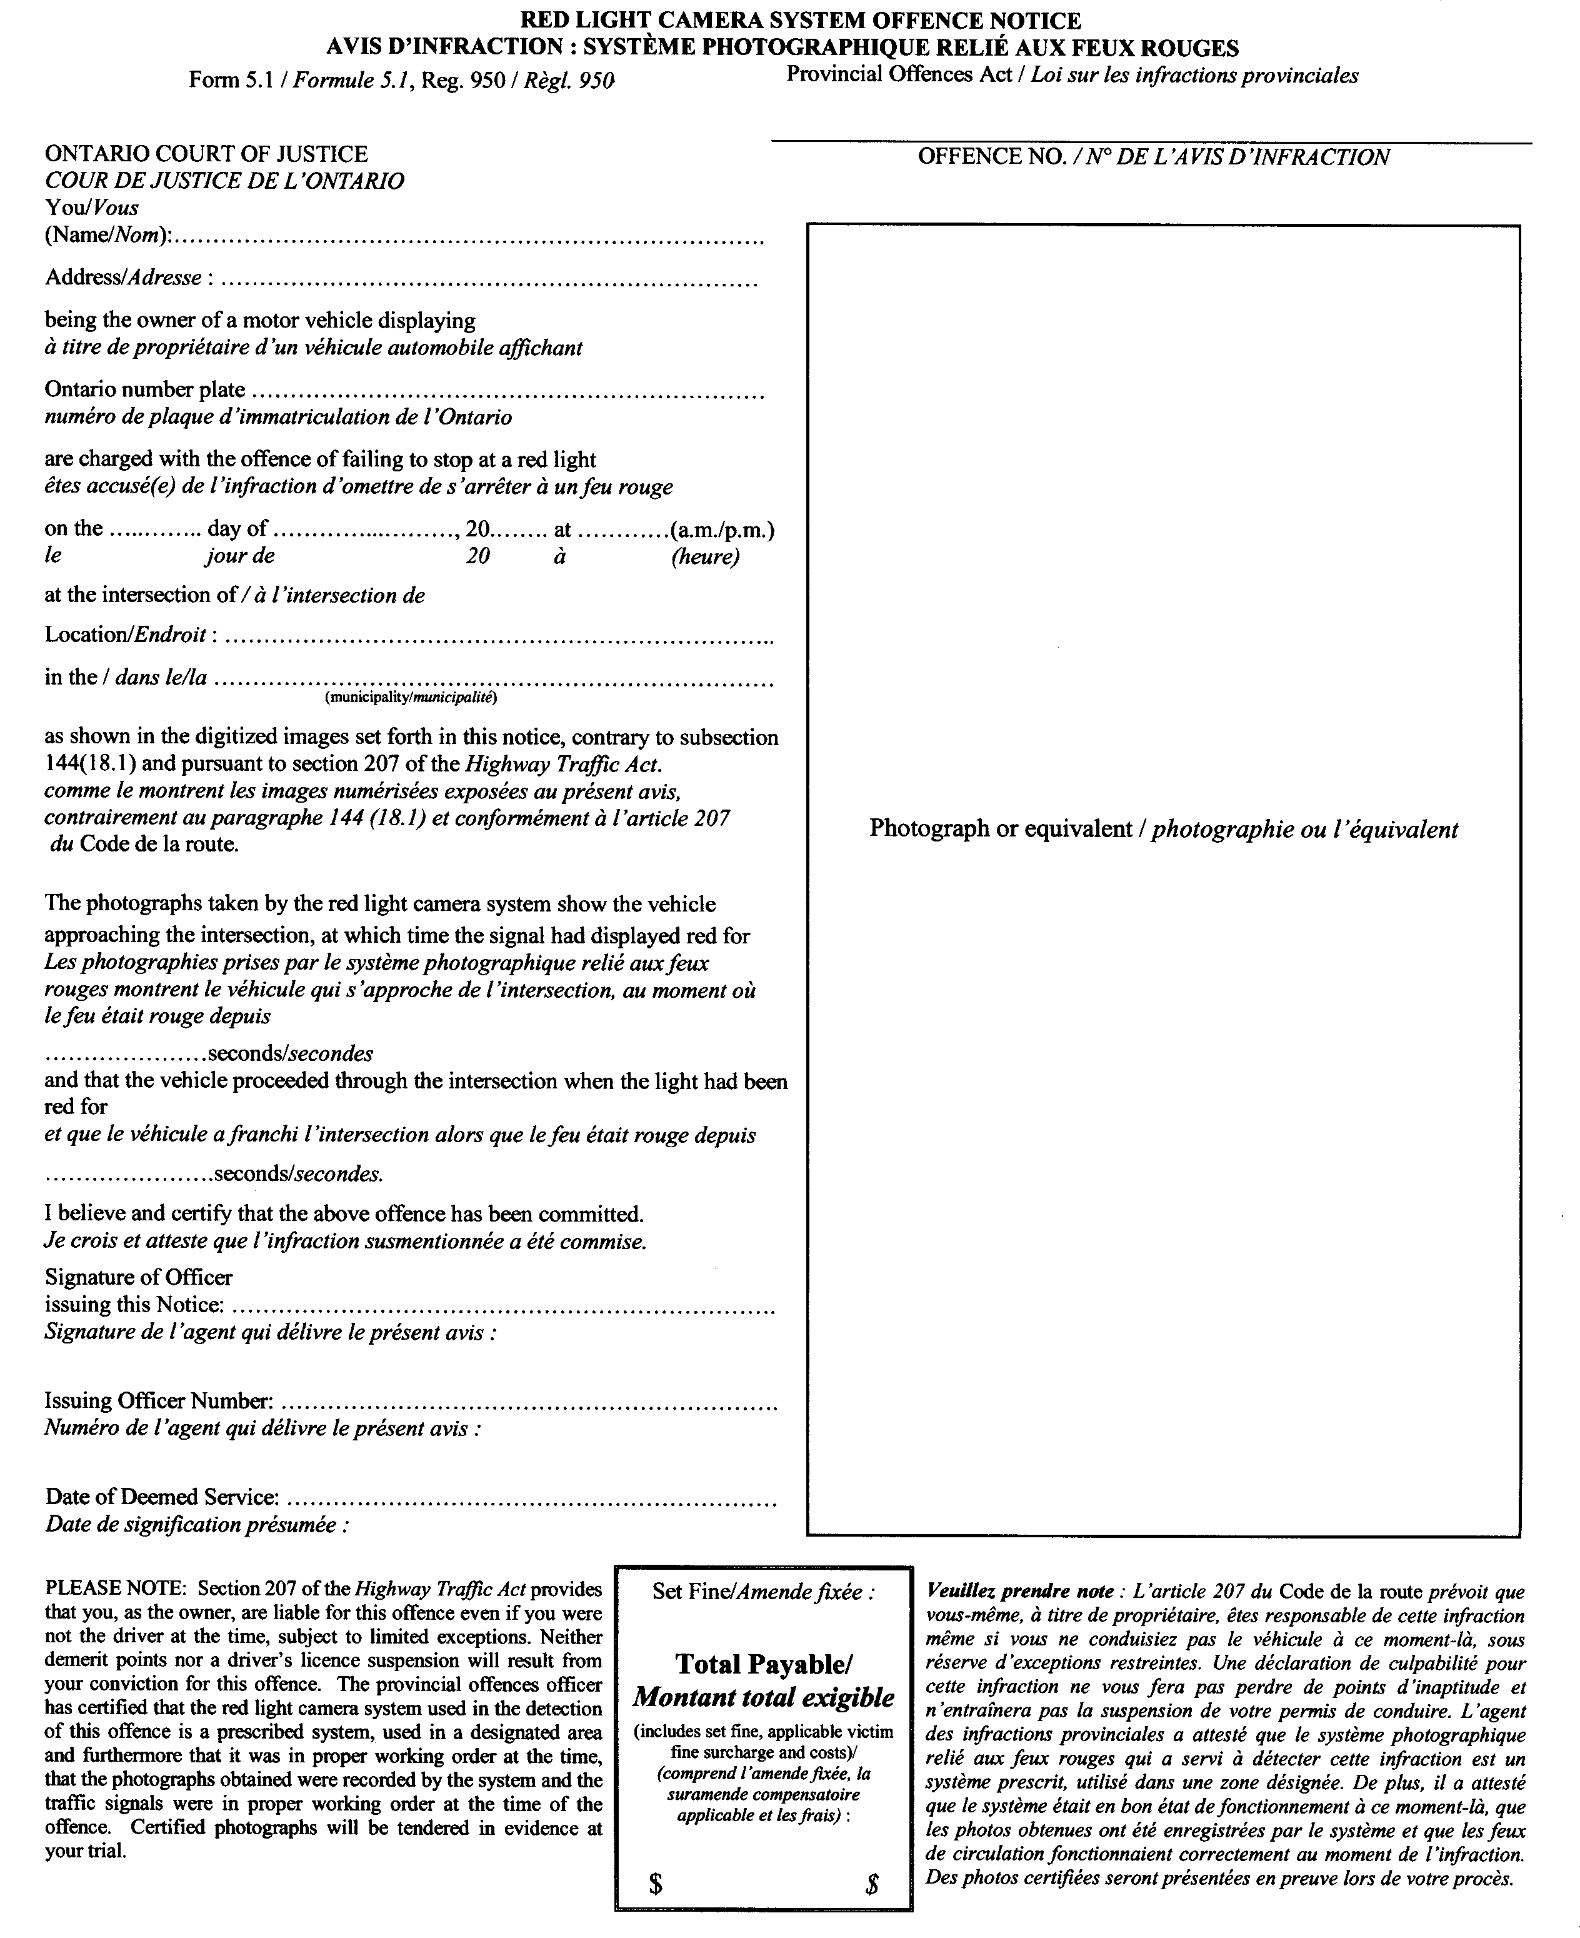
Insert regs\Graphics\Source Law\2008\259\259005.1bb.tif
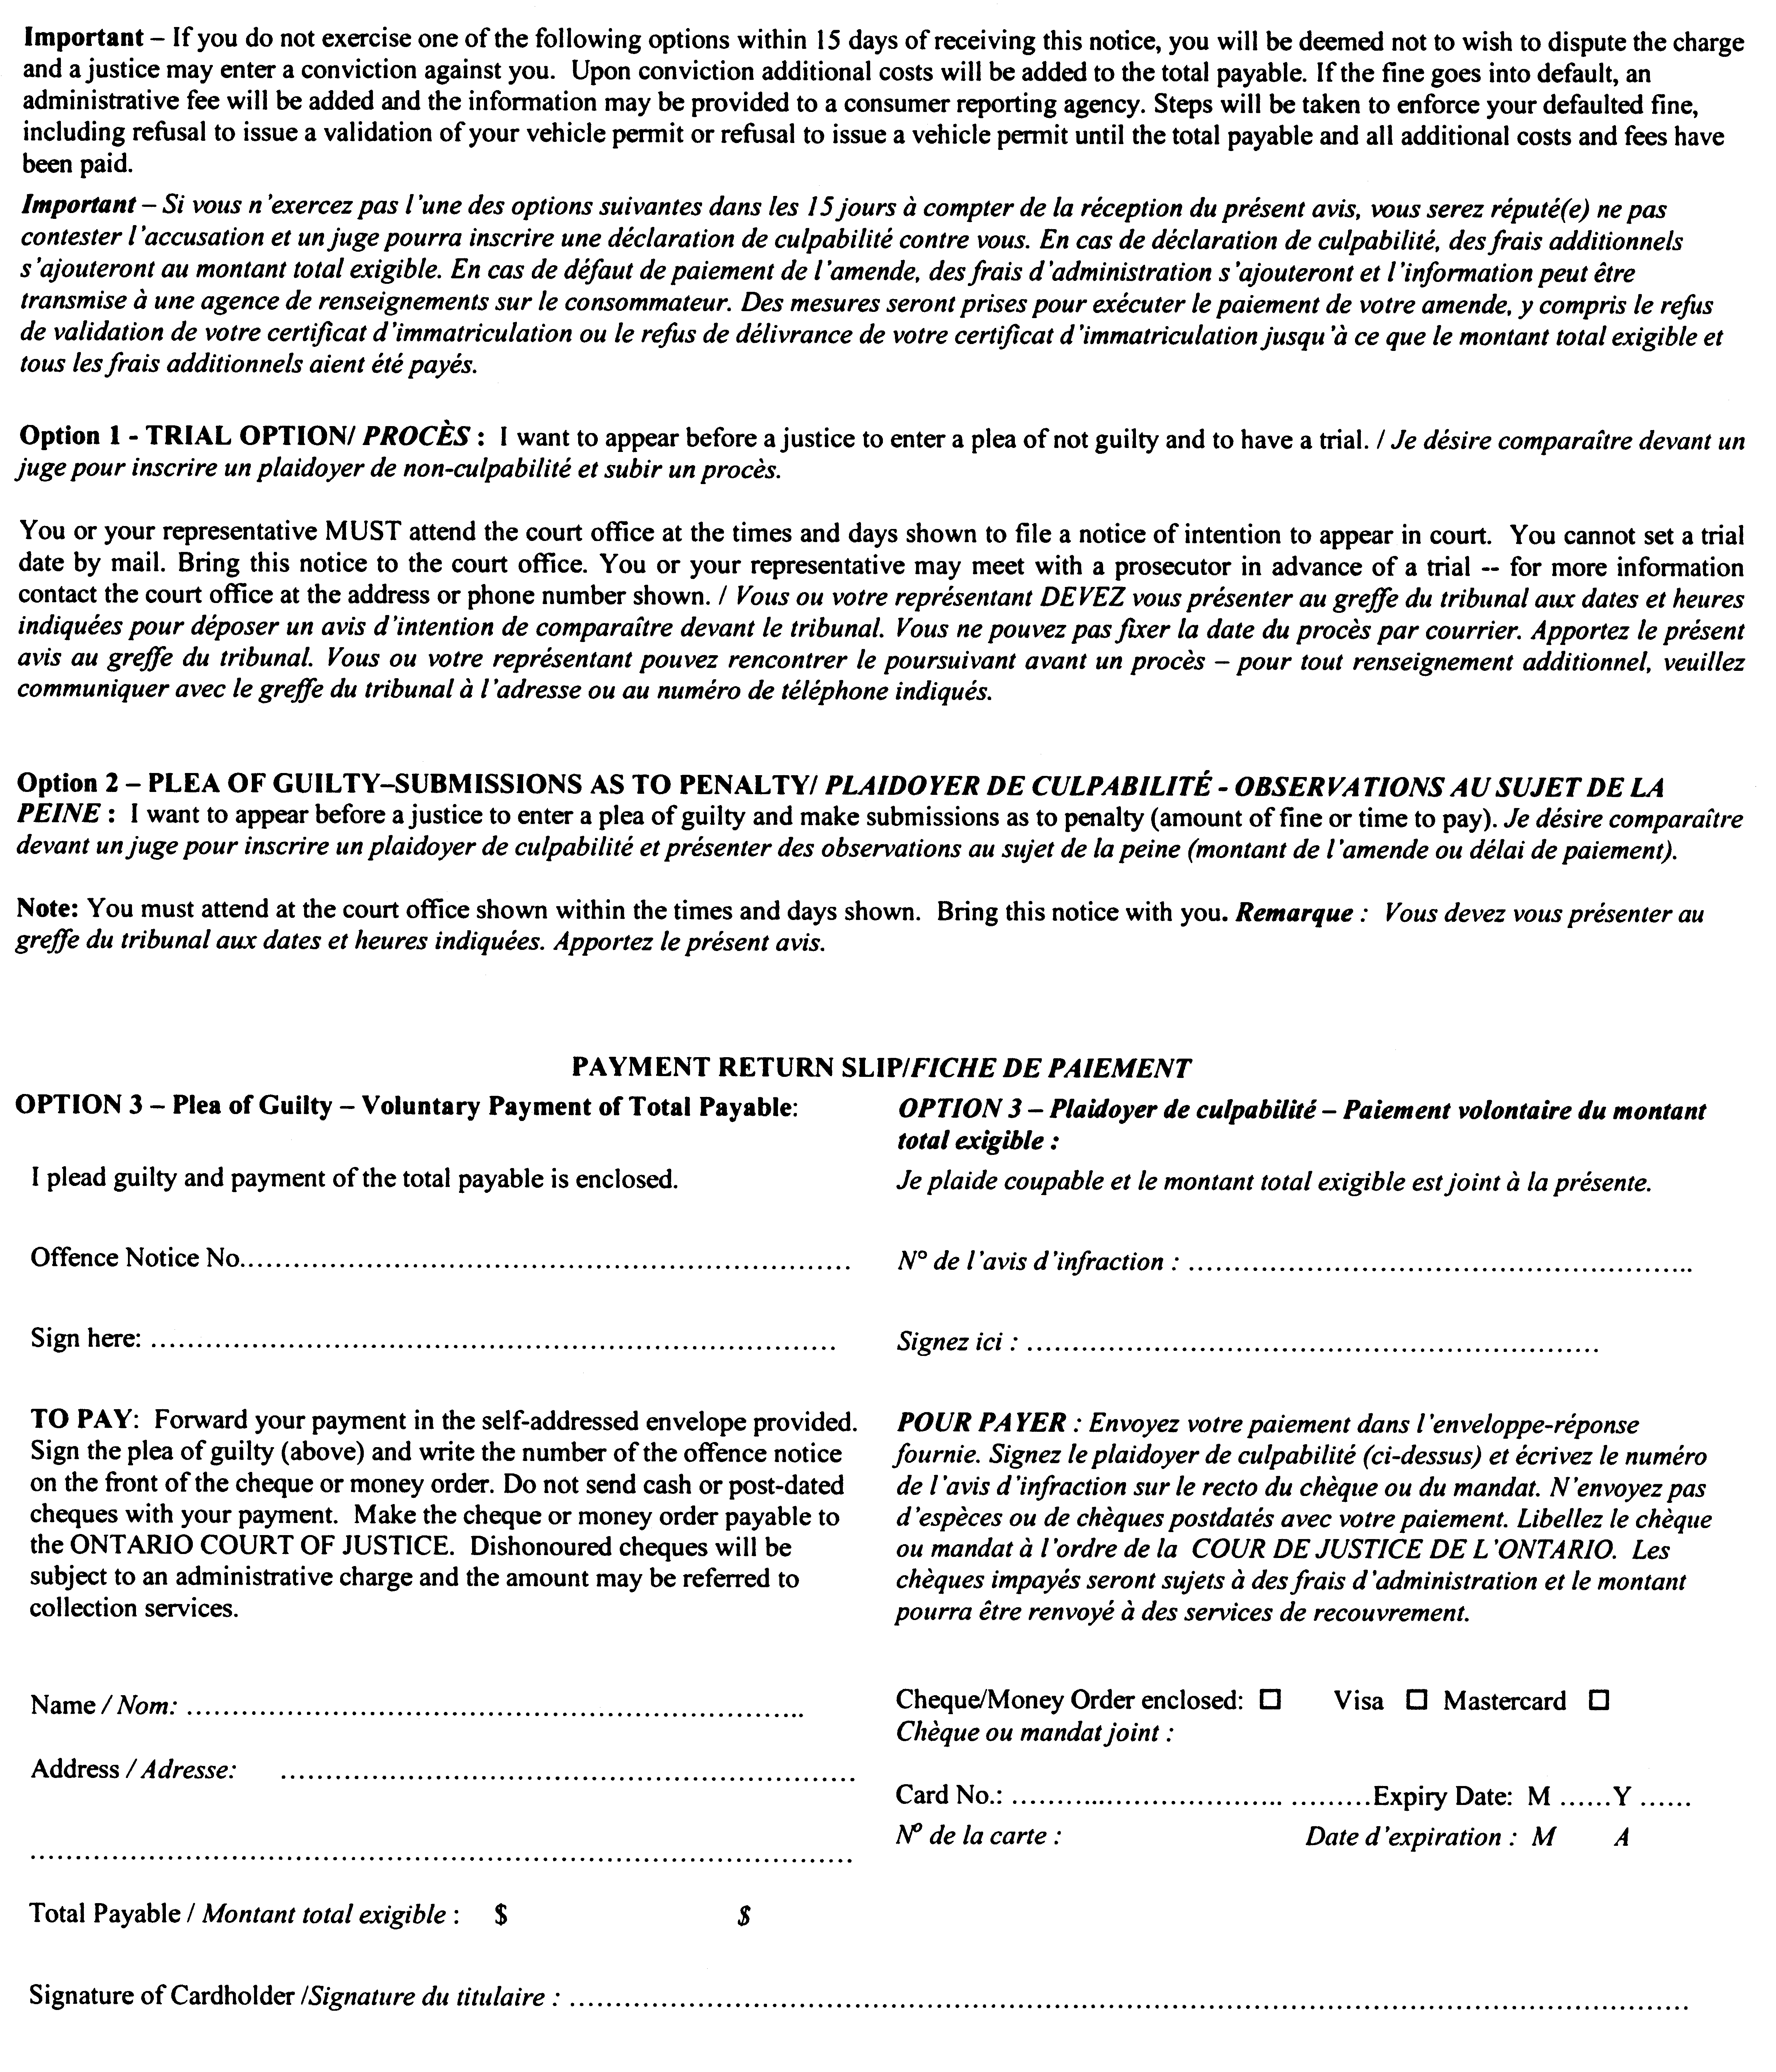
form 6
summons
Provincial Offences Act
Insert regs\Graphics\Source Law\2008\259\259006ab.tif
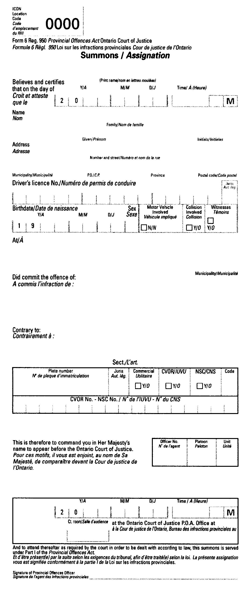
form 7
notice of intention to appear
Provincial Offences Act
Insert regs\Graphics\Source Law\2008\259\259007ab.tif
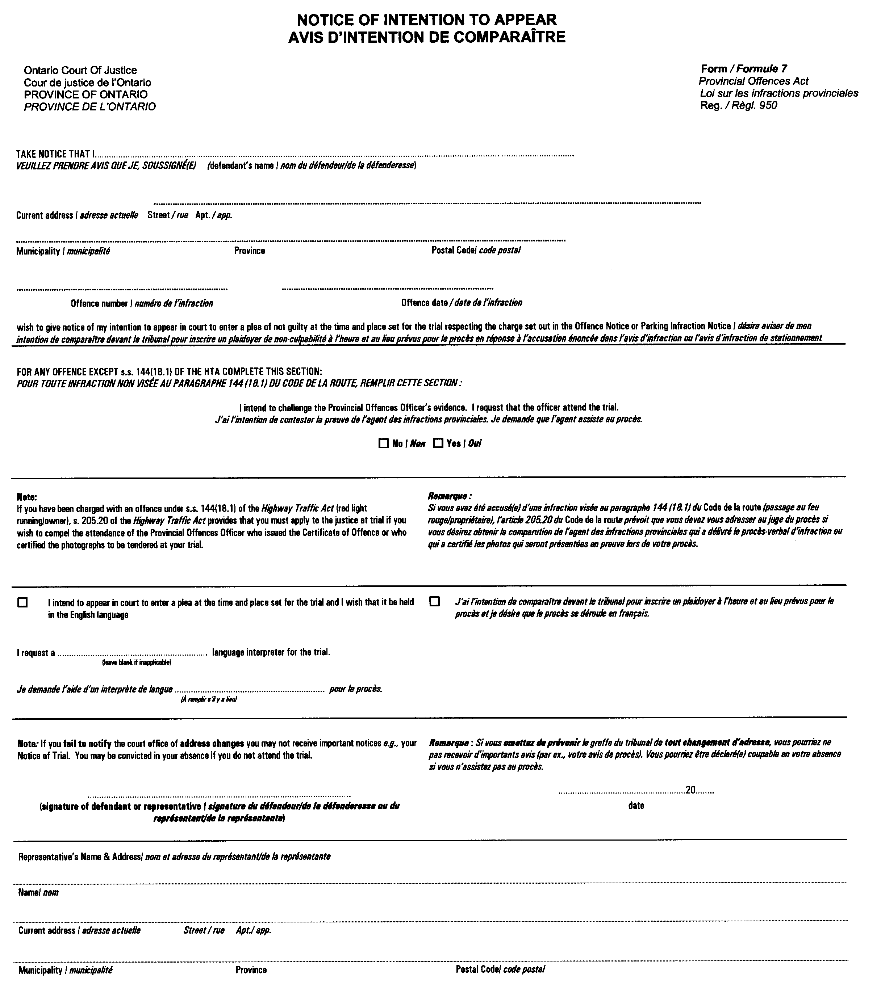
4. Schedules 9, 37, 38, 42, 63.1 and 82 to the Regulation are revoked.
5. (1) Subject to subsection (2), this Regulation comes into force on the day it is filed.
(2) Sections 1 and 3 come into force on January 1, 2009.

Français

Back to top

