ontario regulation 129/10
made under the
Highway Traffic Act
Made: March 31, 2010
Filed: April 6, 2010
Published on e-Laws: April 8, 2010
Printed in The Ontario Gazette: April 24, 2010
Amending Reg. 612 of R.R.O. 1990
(School Buses)
1. Section 1 of Regulation 612 of the Revised Regulations of Ontario, 1990 is revoked and the following substituted:
Interpretation
1. (1) In this Regulation,
“CSA Standard D250” means the Canadian Standards Association Standard D250, School Buses, and includes CSA-D250-M1982, CSA-D250-M1985, CSA-D250-98, CSA-D250-03, CSA-D250-07 and any subsequent CSA-D250 that takes effect on or after November 1, 2010;
“school bus” means a school bus as defined in subsection 175 (1) of the Act;
“school purposes bus” means,
(a) a school bus, or
(b) any other bus operated by or under contract with a school board or other authority in charge of a school while it is being used to transport adults with a developmental disability or children.
(2) For the purposes of this Regulation, the date that a school bus was manufactured is deemed, in the absence of evidence to the contrary, to be the date on the school bus’s compliance label.
Conflicts between standards and regulation
1.1 Where the requirements prescribed in a Canadian Standards Association Standard referred to in this Regulation are different from the requirements set out in this Regulation, the requirements set out in this Regulation prevail unless otherwise specified in this Regulation.
2. (1) Subsection 2 (1) of the Regulation is revoked and the following substituted:
CSA Standard D250
(1) No person shall operate or permit the operation of a school bus registered in Ontario unless the school bus was manufactured in accordance with the following standards:
1. In the case of a school bus manufactured on or after December 1, 1982 and before September 1, 1987, either CSA-D250-M1982 or CSA-D250-M1985.
2. In the case of a school bus manufactured on or after September 1, 1987 and before June 1, 2000, either CSA-D250-M1985 or CSA-D250-98.
3. In the case of a school bus manufactured on or after June 1, 2000 and before January 1, 2005, either CSA-D250-98 or CSA-D250-03.
4. In the case of a school bus manufactured on or after January 1, 2005 and before November 1, 2010, either CSA-D250-03 or CSA-D250-07.
5. In the case of a school bus manufactured on or after November 1, 2010,
i. CSA-D250-07, or
ii. a subsequent CSA Standard D250, if the school bus is manufactured on or after the effective date prescribed in the Standard.
(2) Subsection 2 (2) of the Regulation is amended,
(a) by striking out “that is registered in Ontario on December 1, 2008” and substituting “that was registered in Ontario on December 1, 2008”; and
(b) by striking out “Canadian Standards Association Standard” and substituting “CSA Standard D250”.
(3) Subsection 2 (3) of the Regulation is amended by striking out “Canadian Standards Association Standard” and substituting “CSA Standard D250”.
(4) Subsection 2 (5) of the Regulation is amended by striking out “Canadian Standards Association Standard D250-98 or D250-03” and substituting “CSA-D250-98, CSA-D250-03, CSA-D250-07 or a subsequent CSA Standard D250”.
(5) Section 2 of the Regulation is amended by adding the following subsection:
(6) No person shall operate or permit the operation of a school bus registered in Ontario, manufactured before June 1, 2000 and manufactured in accordance with or modified to comply with CSA-D250-M1982 or CSA-D250-M1985 unless the school bus continues to comply with the colour and identification requirements prescribed,
(a) in Clauses 3.6, 4.7 and 4.18 of CSA-D250-M1982, in the case of a school bus manufactured in accordance with or modified to comply with CSA-D250-M1982; or
(b) in Clauses 4.6, 5.7 and 5.18 of CSA-D250-M1985, in the case of a school bus manufactured in accordance with or modified to comply with CSA-D250-M1985.
3. Section 3 of the Regulation is revoked and the following substituted:
Equipment
3. (1) Every school bus registered in Ontario shall,
(a) be equipped with red only overhead signal lights,
(i) that have,
(A) at least four signal lights that comply with CSA-D250-M1982, CSA-D250-M1985 or CSA-D250-98, in the case of a school bus manufactured before January 1, 2005, or
(B) eight signal lights that comply with the appropriate CSA Standard D250 for the school bus depending on its date of manufacture, as set out in subsection 2 (1), in the case of a school bus manufactured on or after January 1, 2005, and
(ii) that are actuated by a control device accessible to the driver and equipped to give the driver a clear and unmistakable signal either visible or audible when the signal lights are operating;
(b) be equipped with a first aid kit that complies with,
(i) the appropriate CSA Standard D250 for the school bus depending on its date of manufacture, as set out in subsection 2 (1), or
(ii) a subsequent CSA Standard D250;
(c) be equipped with a system of mirrors that comply with the appropriate CSA Standard D250 for the school bus depending on its date of manufacture, as set out in subsection 2 (1), except that,
(i) a school bus manufactured before November 30, 1997 may comply with the mirror requirements prescribed in CSA-D250-98 or CSA-D250-03, and
(ii) a school bus manufactured on or after November 30, 1997 and before January 1, 2005 shall comply with the mirror requirements prescribed in CSA-D250-98 or CSA-D250-03;
(d) display the words “SCHOOL BUS” in upper case letters on the front and rear of the bus in a manner that complies with the requirements of the appropriate CSA Standard D250 for the school bus depending on its date of manufacture, as set out in subsection 2 (1); and
(e) display the words “DO NOT PASS WHEN SIGNALS FLASHING” in upper case letters on the rear of the bus in a manner that complies with the requirements of the appropriate CSA Standard D250 for the school bus depending on its date of manufacture, as set out in subsection 2 (1).
(2) Every school bus registered in Ontario shall be equipped with a stop arm device that,
(a) displays on the front and rear of the device the word “STOP” in upper case letters; and
(b) complies with,
(i) CSA-D250-98 or CSA-D250-03, in the case of a school bus manufactured before January 1, 2005, or
(ii) the appropriate CSA Standard D250 for the school bus depending on its date of manufacture, as set out in subsection 2 (1), in the case of a school bus manufactured on or after January 1, 2005.
(3) Every school bus registered in Ontario that was manufactured before January 1, 2005 shall be equipped with a pedestrian-student safety crossing arm that complies with the requirements of CSA-D250-07.
(4) Every school bus registered in Ontario shall display,
(a) a sign affixed to the bottom of the left window on the rear of the school bus that has the dimensions and bears the markings as illustrated in Figure 1; and
(b) a sign affixed to the bottom of the right window on the rear of the bus that has the dimensions and bears the markings as illustrated in Figure 2.
Figure 1
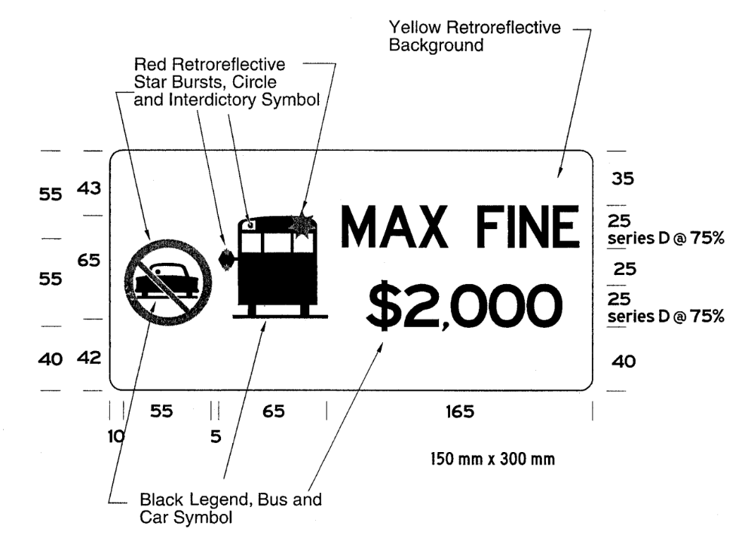
Figure 2
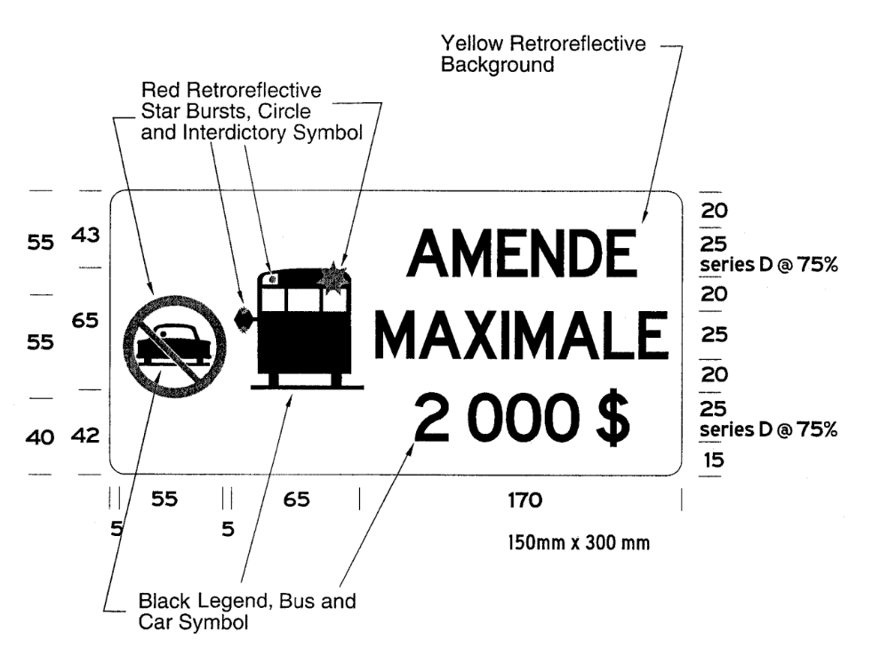
(5) If the dimensions of the left or right window on the rear of a school bus cannot accommodate either or both of the signs as required by subsection (4), both signs shall be affixed to the rear bumper directly below the locations prescribed by clauses (4) (a) and (b).
(6) The signs affixed in accordance with subsection (4) or (5) must be visible at all times to vehicles approaching from the rear of the school bus and shall not be obstructed by any part of or attachment to the school bus.
(7) The signs required by subsection (4) must meet the performance requirements of any of the types of sheeting specified in the American Society for Testing and Materials Standard D 4956-01a and the sheeting must have a Luminance Factor (Y%) of at least 15.
School purposes buses
4. (1) No person shall operate or permit the operation of a school purposes bus in Ontario unless it is equipped with,
(a) a light or lights arranged to provide light to the whole of the interior except the driver’s position, and that are constantly lighted during darkness when there are passengers in the vehicle;
(b) an adequate fire extinguisher securely mounted in such a manner and place as to be readily accessible;
(c) tire chains or snow tires for each driving wheel that is not of the dual type that are placed on the wheels when the conditions of the highway require their use; and
(d) at least one door or exit and,
(i) a door or exit for emergency use situated at the rear of the vehicle or near the rear on the left side of the vehicle and which has a door lock equipped with an interior handle which releases the lock when lifted up, or
(ii) at least three pushout windows on each side of the passenger compartment of the vehicle each of which,
(A) has a minimum height of 500 millimetres and a minimum width of 760 millimetres,
(B) is designed, constructed and maintained to open outwards when a reasonable amount of manual force is applied to the inside of the window, and
(C) displays on or adjacent to the window adequate directions for its emergency use.
(2) A school purposes bus that is equipped in accordance with subclause (1) (d) (ii) must be equipped with an additional pushout window located in the rear of the bus.
4. Section 6 of the Regulation is revoked.
5. This Regulation comes into force on the later of November 1, 2010 and the day this Regulation is filed.

Back to top

