ontario regulation 396/19
made under the
Highway Traffic Act
Made: November 28, 2019
Filed: November 29, 2019
Published on e-Laws: December 2, 2019
Printed in The Ontario Gazette: December 14, 2019
Amending Reg. 615 of R.R.O. 1990
(SIGNS)
1. (1) The Figure to subsection 3 (1) of Regulation 615 of the Revised Regulations of Ontario, 1990 is revoked and the following substituted:
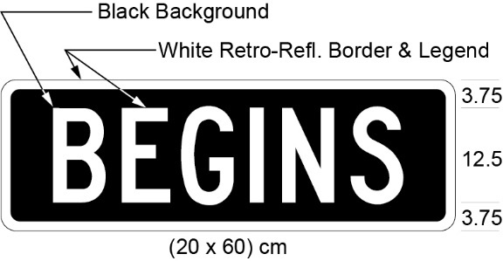
(2) The Figure to subsection 3 (2) of the Regulation is revoked and the following substituted:
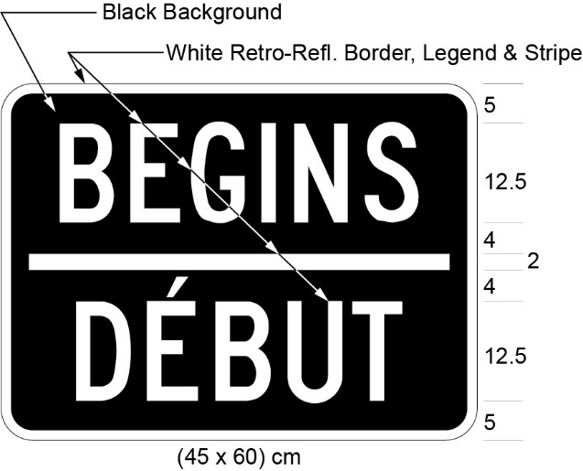
2. Subsection 5.2 (6) of the Regulation is amended by adding the word “additional” before the word “signs” in the portion before clause (a).
3. The Figure to subsection 30 (1) of the Regulation is revoked and the following substituted:
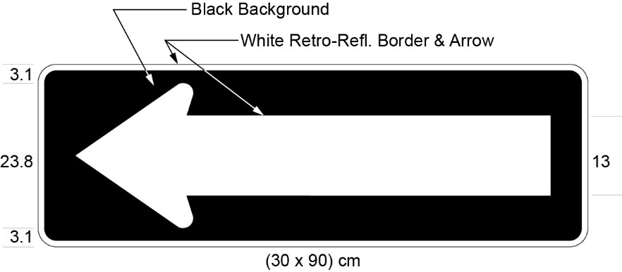
4. Figures 1 to 6 and Figure 8 to subsection 34 (2) of the Regulation are revoked and the following substituted:
Figure 1
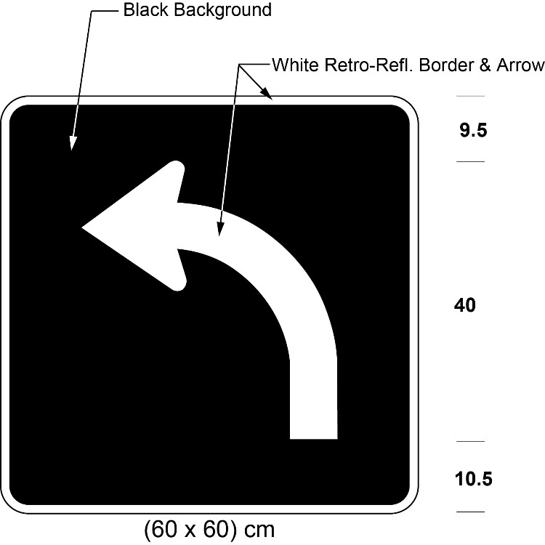
Figure 2
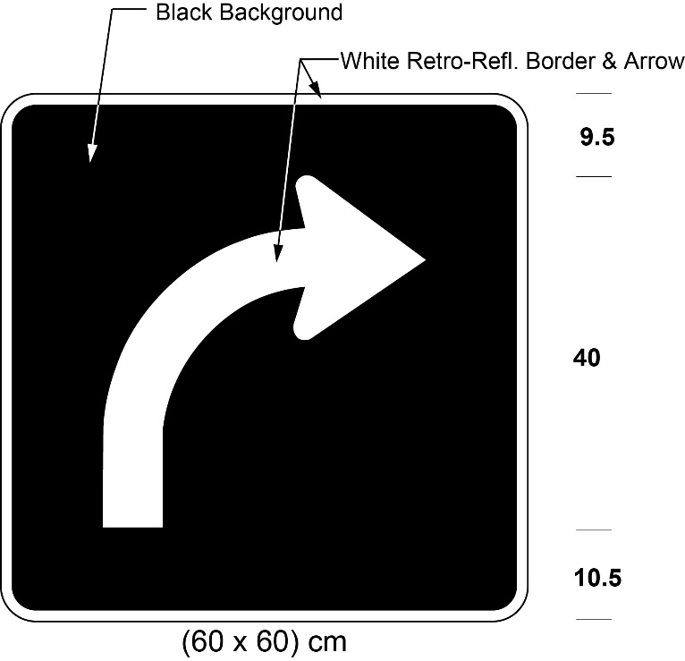
Figure 3
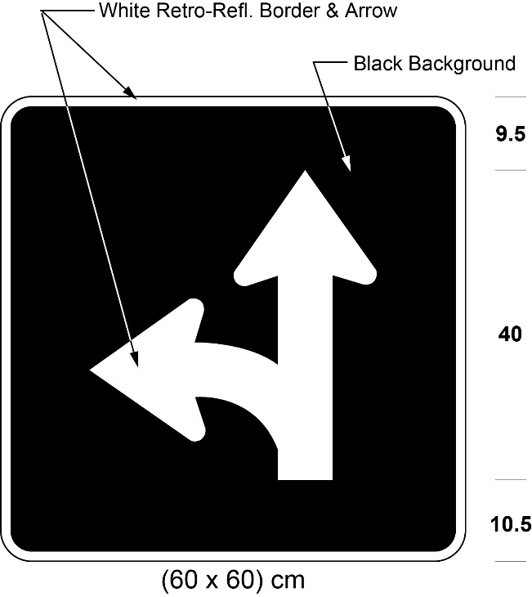
Figure 4
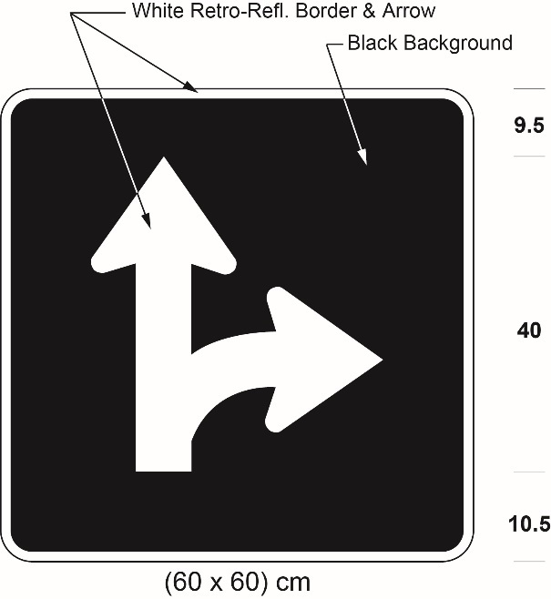
Figure 5
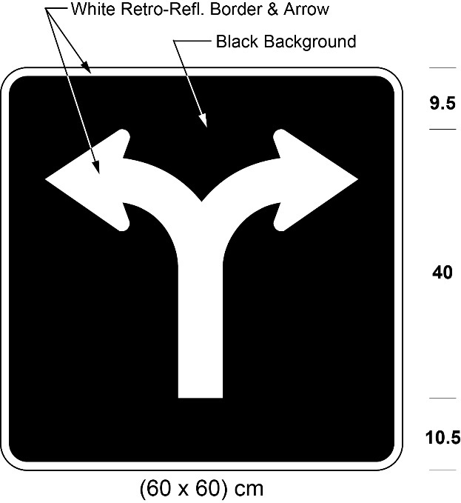
Figure 6
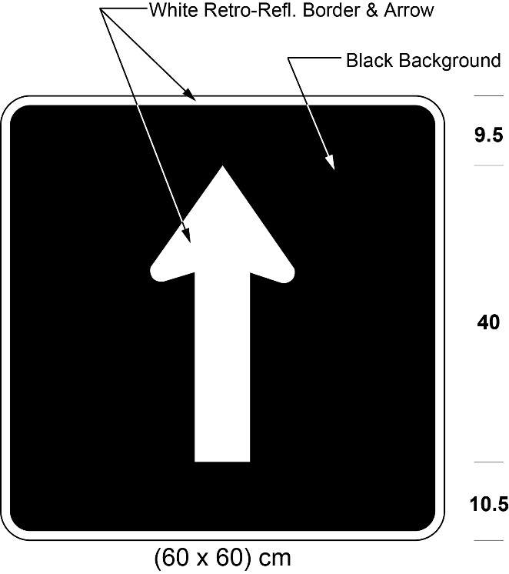
Figure 8
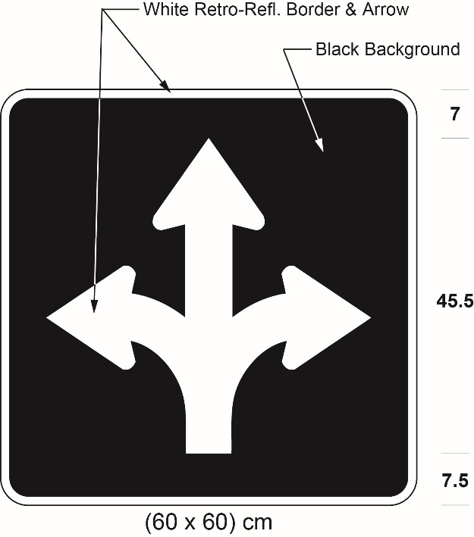
5. (1) The Figure to subsection 40 (1) is revoked and the following substituted:
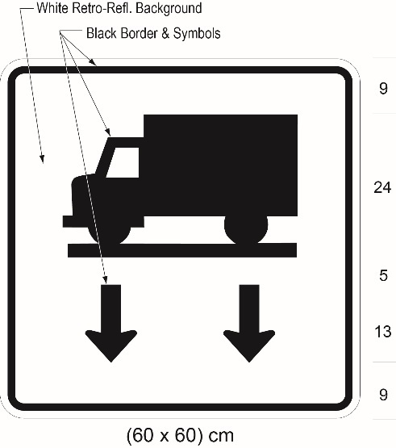
(2) The Figures to subsection 40 (2) are revoked and the following substituted:
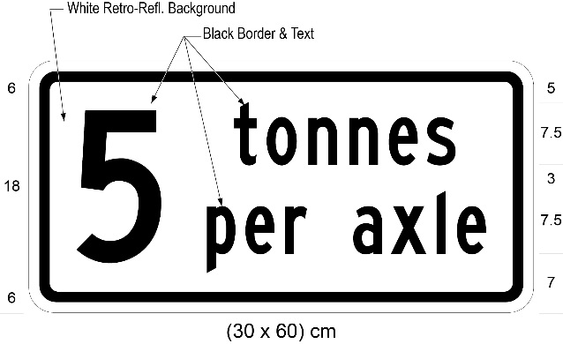
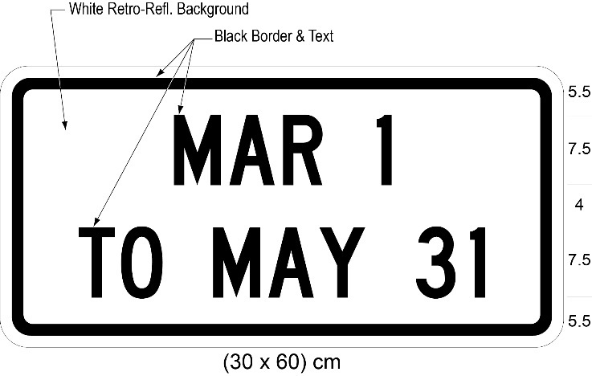
6. The Figures to subsection 40.1 (2) are revoked and the following substituted:
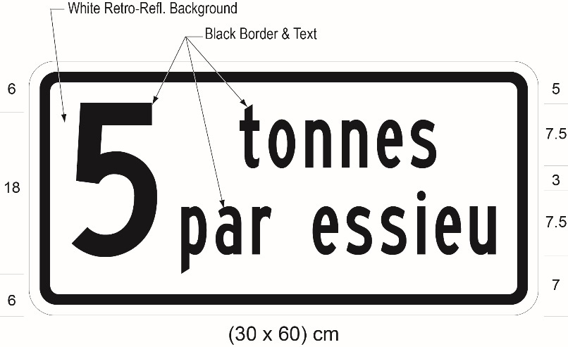
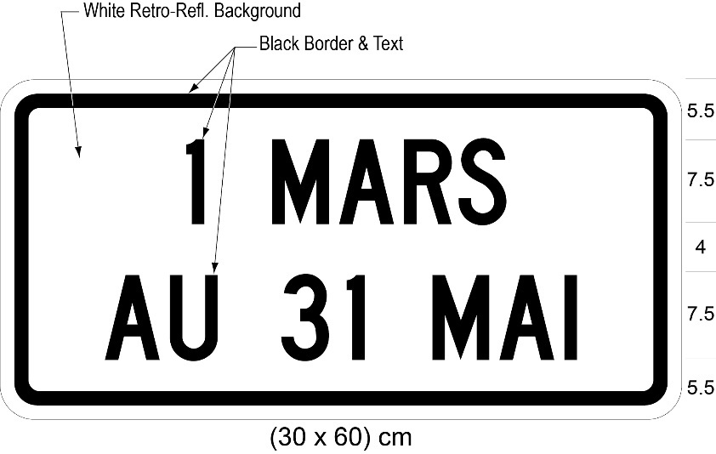
7. (1) The Figure to clause 41 (1) (a) is revoked and the following substituted:
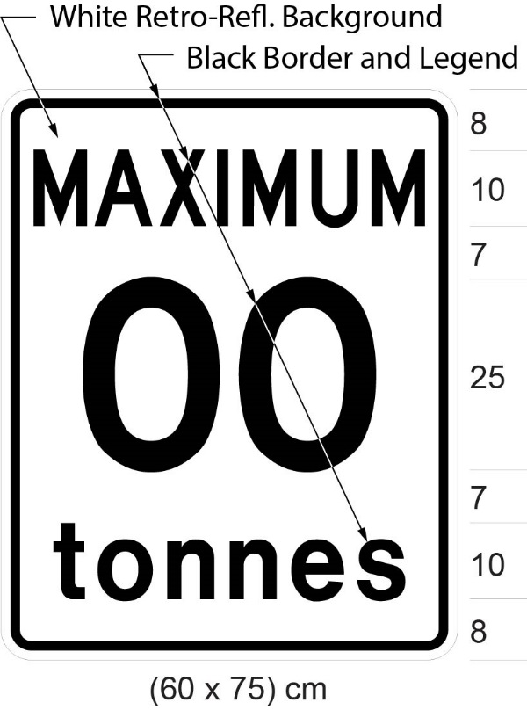
(2) Subclause 41 (1) (b) (i) is revoked and the following substituted:
(i) be not less than 120 centimetres in height and not less than 90 centimetres in width,
(3) The Figure to clause 41 (1) (b) is revoked and the following substituted:
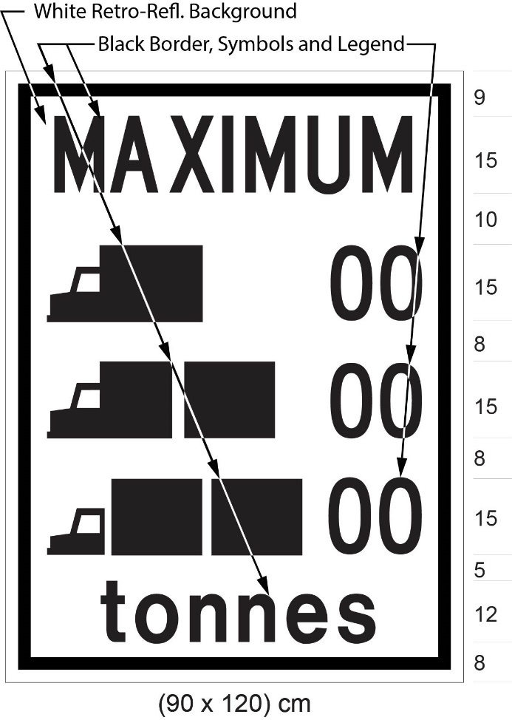
8. The Regulation is amended by adding the following section:
Bicycles Excepted
42.2 (1) A Bicycles Excepted tab sign shall,
(a) be not less than 30 centimetres in height and not less than 60 centimetres in width; and
(b) bear the markings and have the dimension as illustrated in the following Figure:
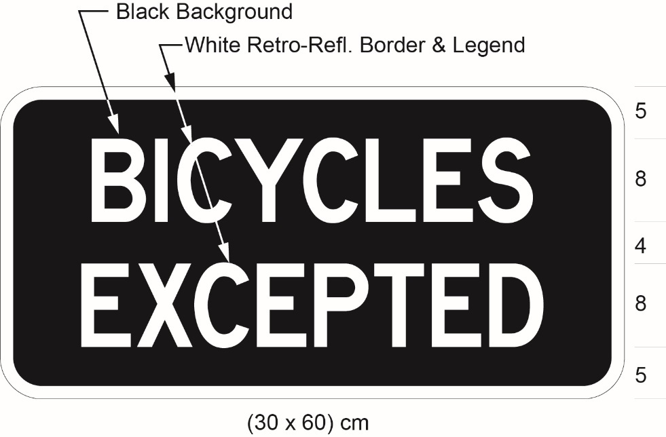
(2) Despite subsection (1), a Bicycles Excepted tab sign in an area designated by the French Language Services Act shall,
(a) be not less than 60 centimetres in height and not less than 60 centimetres in width; and
(b) bear the markings and have the dimensions as illustrated in the following Figure:
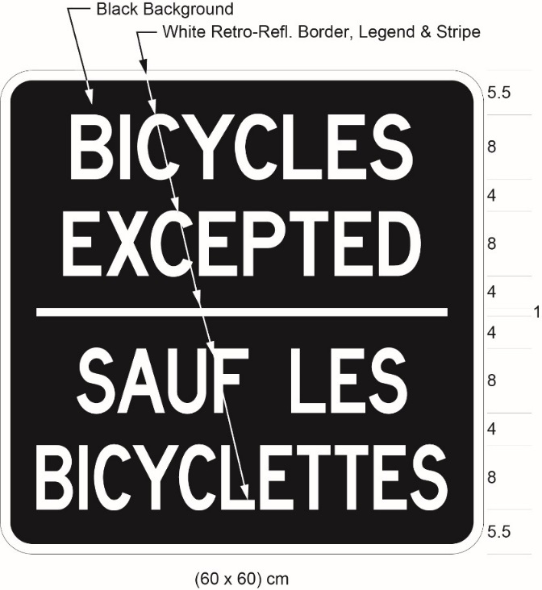
(3) A Bicycles Excepted tab sign as prescribed and illustrated in subsection (1) or (2) may be erected immediately below a sign prescribed in section 21, 22, 31 or 34.
9. Subsection 43 (2) is revoked and the following substituted:
(2) A Buses Excepted tab sign as prescribed and illustrated in subsection (1) or (1.1) may be erected immediately below a sign prescribed in section 21, 22, 31 or 34.
10. (1) Clause 43.1 (1) (a) is revoked and the following substituted:
(a) be not less than 244 centimetres in height and not less than 549 centimetres in width, and
(2) Clause 43.1 (2) (a) is revoked and the following substituted:
(a) be not less than 244 centimetres in height and not less than 793 centimetres in width, and
(3) Figures 1, 2 and 4 to section 43.1 are revoked and the following substituted:
Figure 1
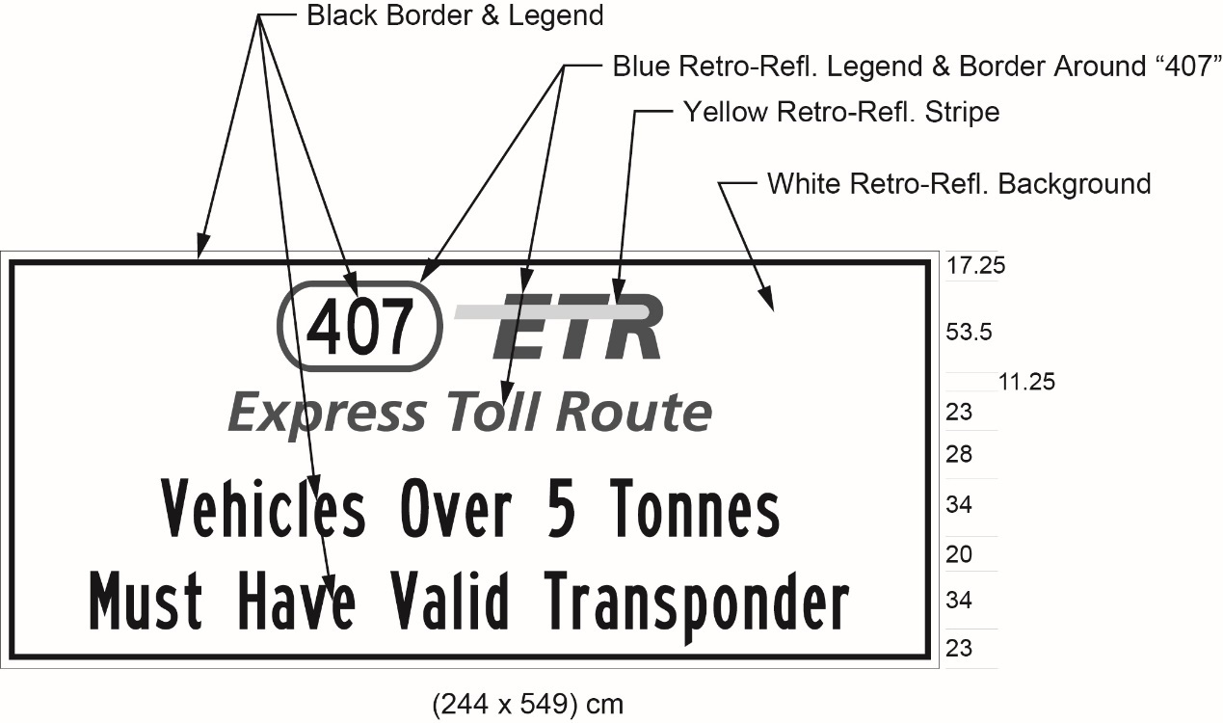
Text alternative: Illustration of sign with “407 ETR” symbol above the words “Express Toll Route” and the text “Vehicles Over 5 Tonnes Must Have Valid Transponder”, on a white retro-reflective background with a black border. Indicated sign size: (244 × 549) cm. This text alternative is provided for convenience only and does not form part of the official law.
Figure 2
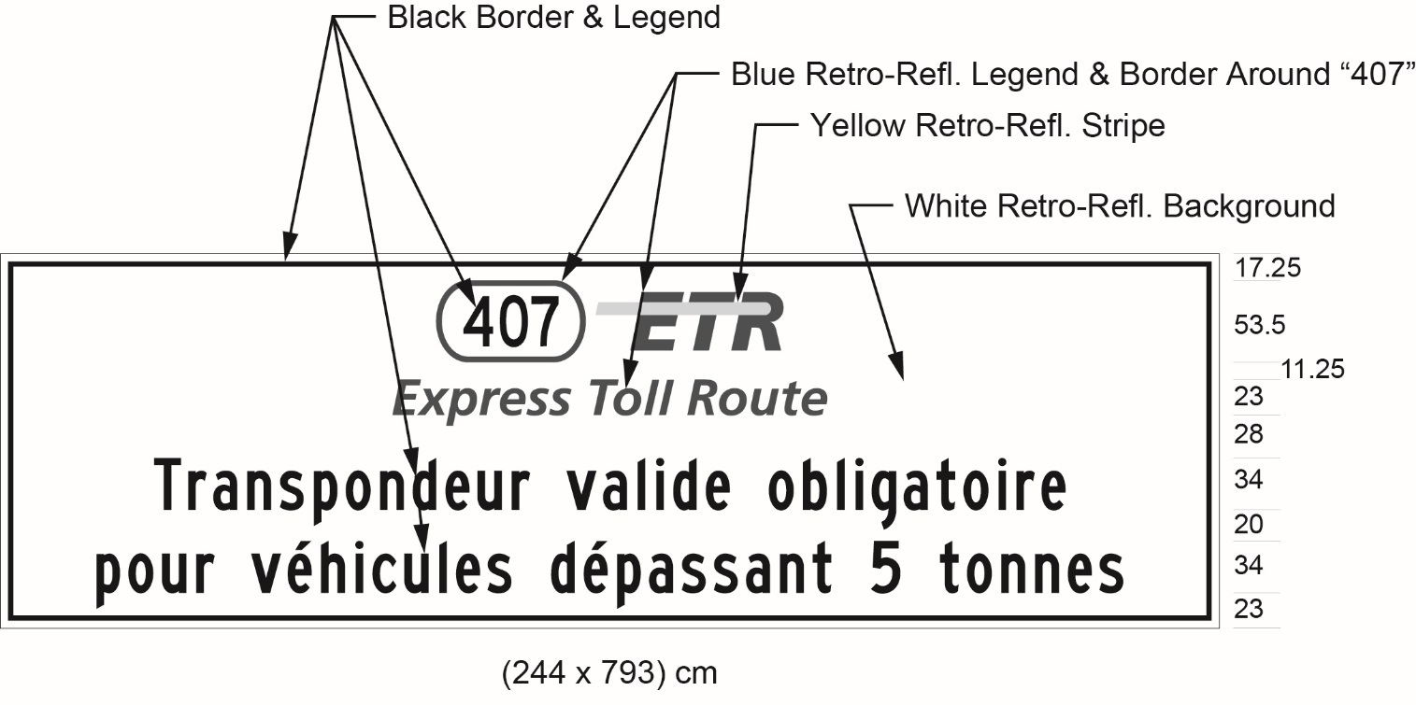
Text alternative: Illustration of sign with 407 ETR symbol above the words “Express Toll Route” and the text “Transpondeur valide obligatoire pour véhicules dépassant 5 tonnes”, on a white retro-reflective background with a black border. Indicated sign size: (244 × 793) cm. This text alternative is provided for convenience only and does not form part of the official law.
Figure 4
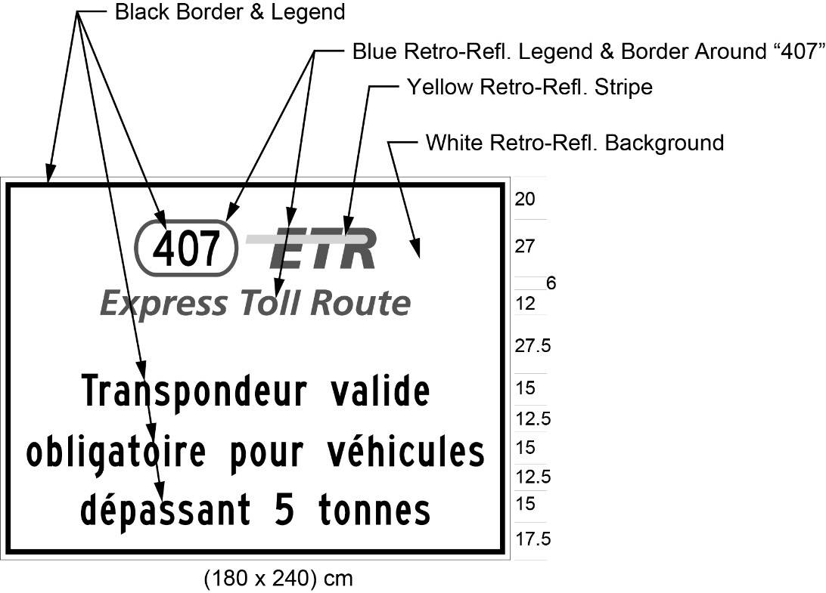
Text alternative: Illustration of sign with “407 ETR” symbol above the words “Express Toll Route” and the text “Transpondeur valide obligatoire pour véhicules dépassant 5 tonnes”, on a white retro-reflective background with a black border. Indicated sign size: (180 × 240) cm. This text alternative is provided for convenience only and does not form part of the official law.
Commencement
11. This Regulation comes into force on the later of January 1, 2020 and the day it is filed.

Back to top

