Change of Name Act
R.R.O. 1990, REGULATION 68
GENERAl
Historical version for the period July 3, 2007 to March 5, 2009.
Last amendment: O. Reg. 203/07.
This is the English version of a bilingual regulation.
Skip Table of Contents
CONTENTS
 |  | Sections
 | Election by Spouse, etc. | 1
 | Change of Name of Person Over Sixteen | 2
 | Change of Child’s Name | 3
 | Accompanying Statement | 4
 | Fees | 5
 | Exception for Publishing Notice of Change of Name | 6
Form 1 | Election to change surname
Form 2 | Election to resume former surname
Form 3 | Joint declaration of conjugal relationship
Form 4 | Declaration that conjugal relationship has ended
Form 5 | Application for change of name
Form 6 | Notice of application
Form 7 | Consent to application to change child’s name
Form 8 | Statement of guarantor
Election by Spouse, etc.
1. (1) An election under subsection 3 (1) of the Act (election by spouse, etc., to change surname) shall be made by filing Form 1 with the Registrar General and providing the applicable prescribed document, if any. R.R.O. 1990, Reg. 68, s. 1 (1).
(2) An election under subsection 3 (2) of the Act (resuming name when marriage dissolved, etc.) shall be made by filing Form 2 with the Registrar General and providing the applicable prescribed document, if any. R.R.O. 1990, Reg. 68, s. 1 (2).
(3) The prescribed documents for the purpose of elections under subsections 3 (1) and (2) of the Act are:
1. A certificate of the spouses’ marriage, issued by the proper authority of the jurisdiction where the marriage was solemnized.
2. A certificate of the death of one of the spouses, issued by the proper authority of the jurisdiction where the death occurred.
3. A certificate of the spouses’ divorce or of the annulment of their marriage, issued by the proper authority of the jurisdiction where the divorce or annulment was granted. R.R.O. 1990, Reg. 68, s. 1 (3).
(4) If all or part of a prescribed document is written in a language other than English or French, a translation into English or French, together with the translator’s written declaration, shall be provided with the prescribed document. R.R.O. 1990, Reg. 68, s. 1 (4).
(5) The translator’s declaration shall state that,
(a) the translator understands both English or French and the language of the original;
(b) the translator is of the opinion that the translation is complete and correct. R.R.O. 1990, Reg. 68, s. 1 (5).
(6) The joint declaration referred to in subsection 3 (6) of the Act (conjugal relationship) shall be in Form 3. R.R.O. 1990, Reg. 68, s. 1 (6).
(7) The declaration referred to in subsection 3 (7) of the Act (revocation of joint declaration) shall be in Form 4. R.R.O. 1990, Reg. 68, s. 1 (7).
Change of Name of Person Over Sixteen
2. (1) An application under subsection 4 (1) of the Act (change of name) shall be in Form 5. R.R.O. 1990, Reg. 68, s. 2 (1).
(2) A notice of application given under subsection 4 (2) of the Act (notice to spouse, etc.) may be in Form 6. R.R.O. 1990, Reg. 68, s. 2 (2).
(3) The written consent referred to in subsection 4 (3) of the Act (consent to application of person under eighteen) may be in Form 7. R.R.O. 1990, Reg. 68, s. 2 (3).
Change of Child’s Name
3. (1) An application under subsection 5 (1) of the Act (change of child’s name) shall be in Form 5. R.R.O. 1990, Reg. 68, s. 3 (1).
(2) The written consent referred to in subsection 5 (2) of the Act (consent of persons with custody, etc.) may be in Form 7. R.R.O. 1990, Reg. 68, s. 3 (2).
(3) A notice of application given under subsection 5 (6) of the Act (notice to persons with access) may be in Form 6. R.R.O. 1990, Reg. 68, s. 3 (3).
(4) A notice of application given under subsection 5 (7) of the Act (notice to spouse, etc.) may be in Form 6. R.R.O. 1990, Reg. 68, s. 3 (4).
Accompanying Statement
4. (1) The statement referred to in subsection 6 (3) of the Act (accompanying statement) shall be in Form 8. R.R.O. 1990, Reg. 68, s. 4 (1).
(2) The following classes of persons are prescribed for the purpose of subsection 6 (3) of the Act:
1. Provincial judges appointed under the Courts of Justice Act.
2. Justices of the peace appointed under the Justices of the Peace Act.
3. Chiefs of Indian bands that are located in Ontario.
4. Persons authorized under the Marriage Act to solemnize marriages.
5. Legally qualified medical practitioners.
6. Members of The Law Society of Upper Canada.
7. Heads of municipal councils in Ontario.
8. Clerks of municipalities in Ontario.
9. Principals of elementary and secondary schools, as defined in the Education Act.
10. Managers or signing officers of Ontario branches of banks listed in Schedule I or II of the Bank Act (Canada), loan corporations, trust corporations, credit unions and caisses populaires. R.R.O. 1990, Reg. 68, s. 4 (2).
Fees
5. The following fees are payable under the Act:

1. | For an election under subsection 3 (1) of the Act made at the time of marriage or at the time of filing a joint declaration | no fee
2. | For an election under subsection 3 (1) of the Act made after the time of marriage or after the time of filing a joint declaration | $25
3. | For an election under subsection 3 (2) of the Act | 25
4. | For an application under subsection 4 (1) of the Act | 137
5. | For an application under subsection 5 (1) of the Act, except as described in paragraph 6 | 137
6. | For an application under subsection 5 (1) of the Act that is made simultaneously with an application under subsection 4 (1) of the Act by the same applicant | 22
R.R.O. 1990, Reg. 68, s. 5; O. Reg. 326/91, s. 1.
Exception for Publishing Notice of Change of Name
6. If a person applies under subsection 4 (1) or 5 (1) of the Act for a change of name, the Registrar General shall not publish a notice of the change of name in The Ontario Gazette under clause 8 (1) (a) of the Act if the applicant provides a letter signed by the applicant and addressed to the Registrar General, requesting that notice of the change of name not be so published because the person to whose name the application relates is, at the time of the application, a transgendered individual. O. Reg. 203/07, s. 1.
Form 1
ELECTION TO CHANGE SURNAME
Change of Name Act
Insert regs\graphics\1990\68\068001ae.tif
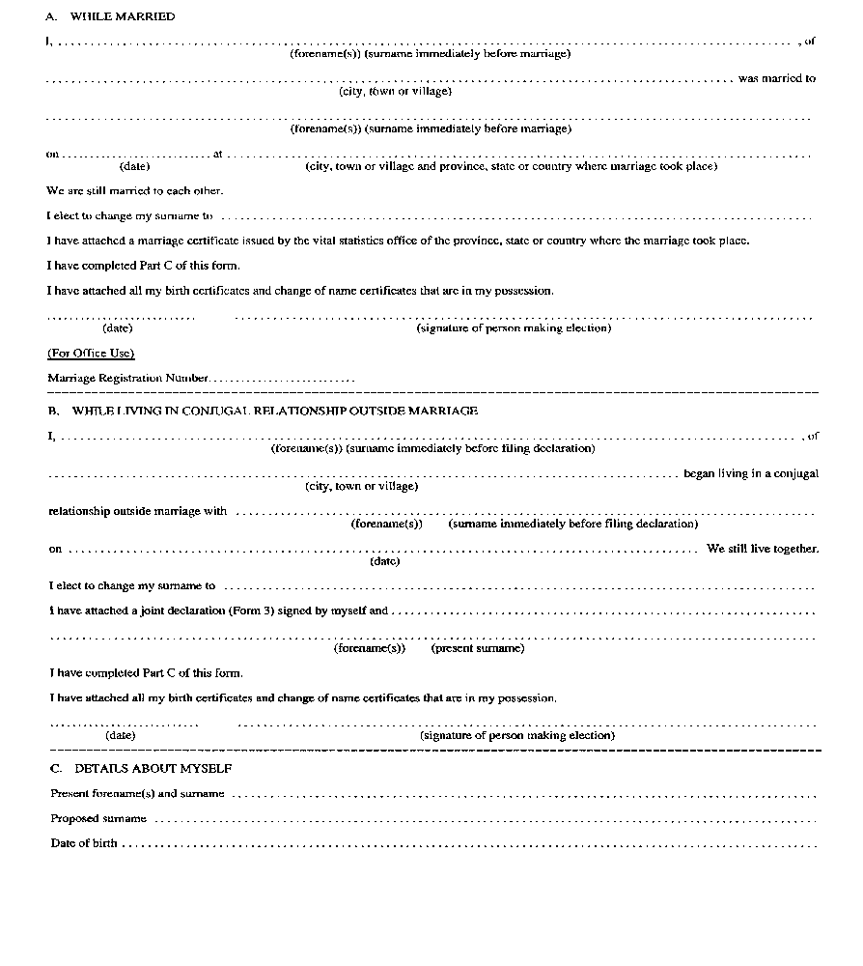
Insert regs\graphics\1990\68\068001be.tif
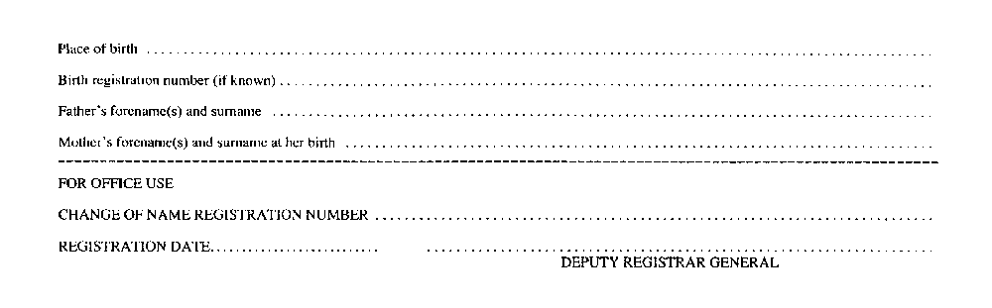
R.R.O. 1990, Reg. 68, Form 1.
Form 2
ELECTION TO RESUME FORMER SURNAME
Change of Name Act
Insert regs\graphics\1990\68\068002ae.tif
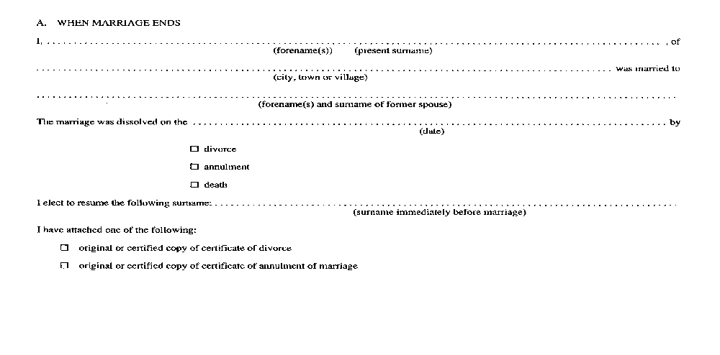
Insert regs\graphics\1990\68\068002be.tif
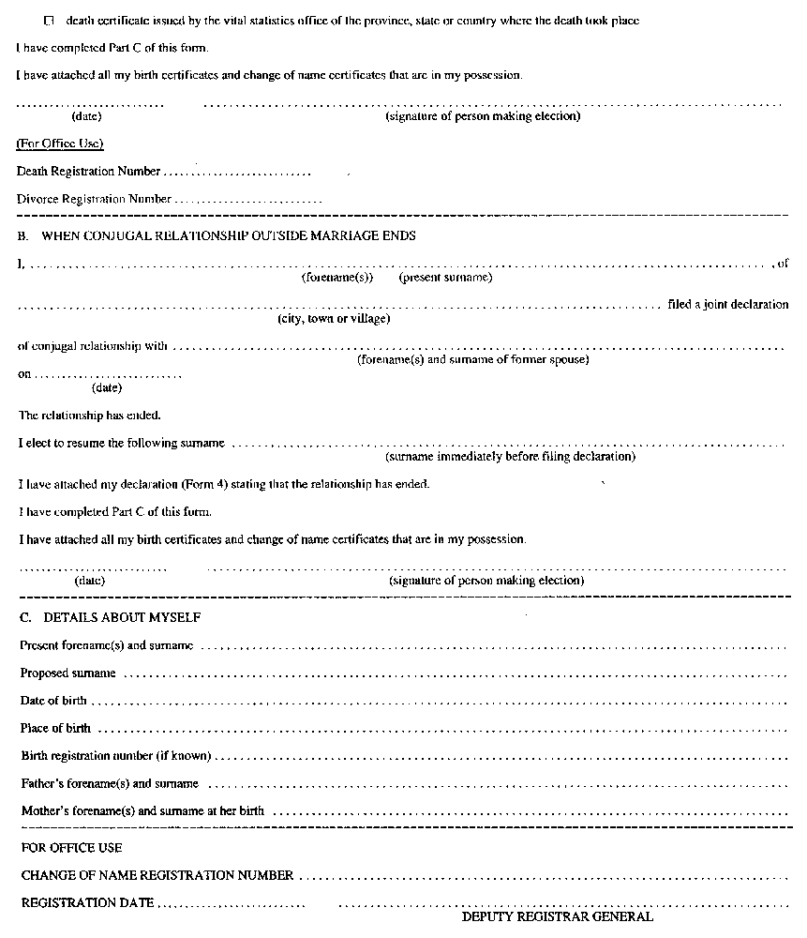
R.R.O. 1990, Reg. 68, Form 2.
Form 3
JOINT DECLARATION OF CONJUGAL RELATIONSHIP
Change of Name Act
Insert regs\graphics\1990\68\068003ae.tif
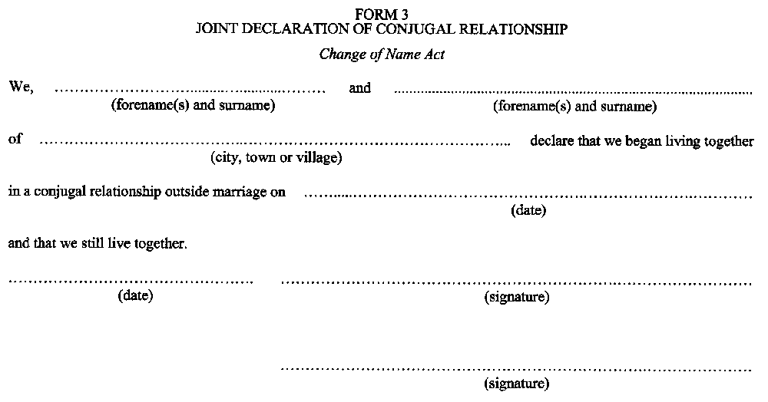

O. Reg. 41/00, s. 1.
Form 4
DECLARATION THAT CONJUGAL RELATIONSHIP HAS ENDED
Change of Name Act
Insert regs\graphics\1990\68\068004ae.tif
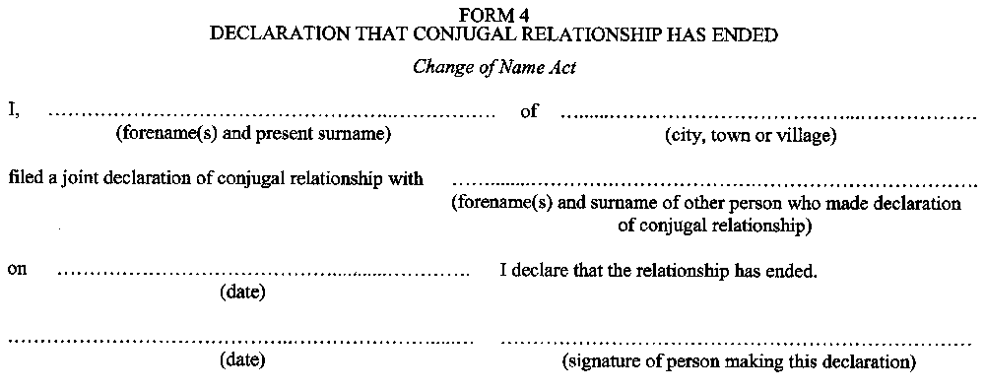

O. Reg. 41/00, s. 1.
Form 5
APPLICATION FOR CHANGE OF NAME
Change of Name Act
Insert regs\graphics\1990\68\068005ae.tif
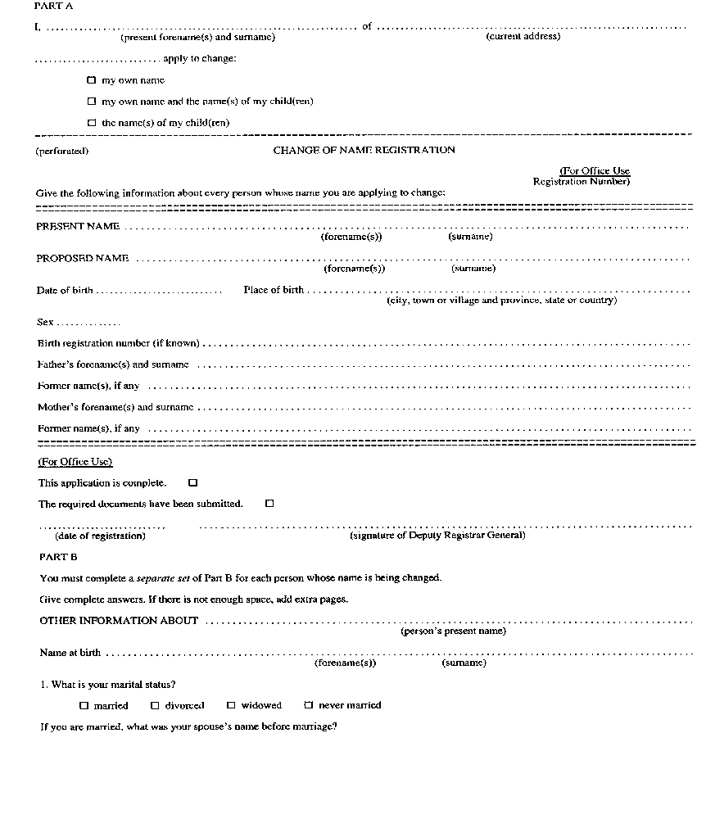
Insert regs\graphics\1990\68\068005be.tif
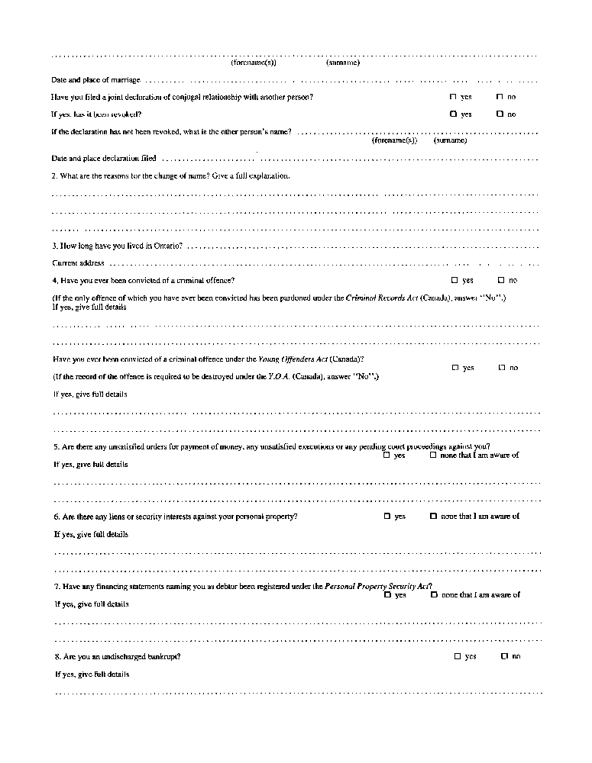
Insert regs\graphics\1990\68\068005ce.tif
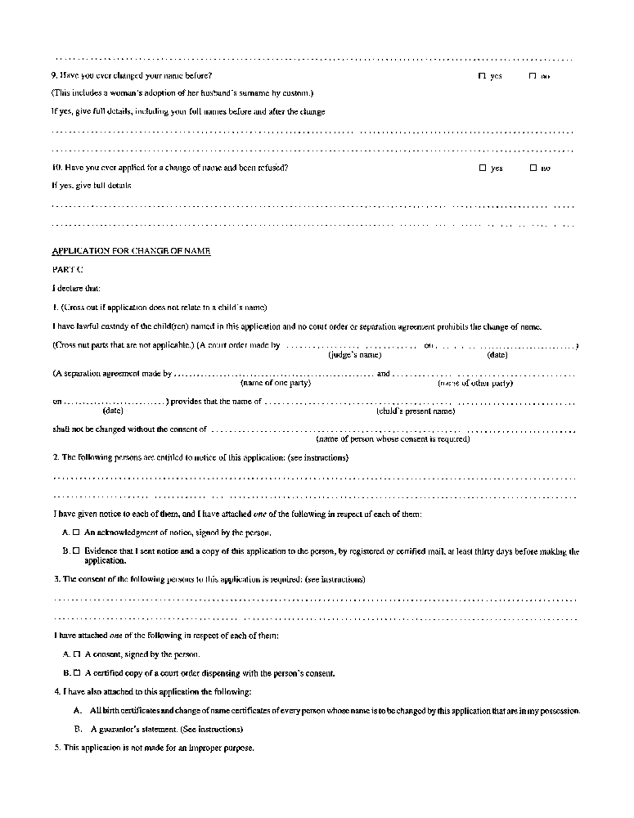
Insert regs\graphics\1990\68\068005de.tif
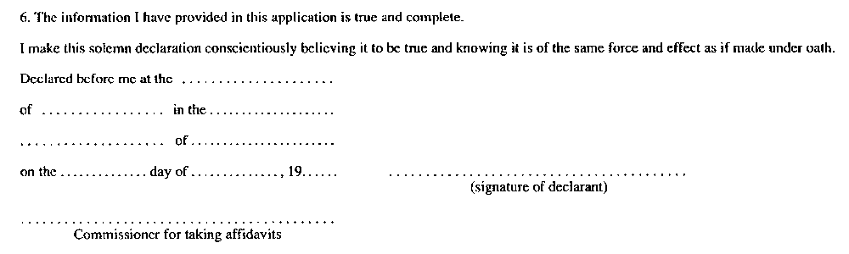
R.R.O. 1990, Reg. 68, Form 5.
Form 6
NOTICE OF APPLICATION
Change of Name Act
Insert regs\graphics\1990\68\068006ae.tif
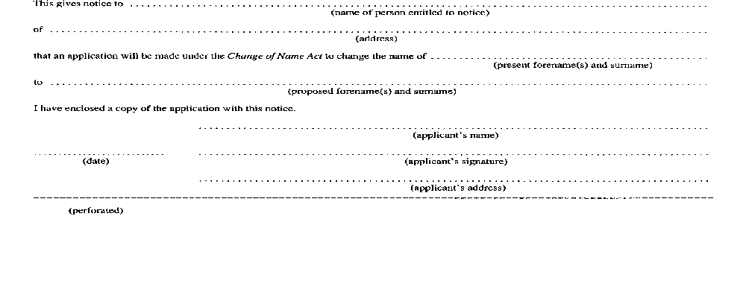
Insert regs\graphics\1990\68\068006be.tif
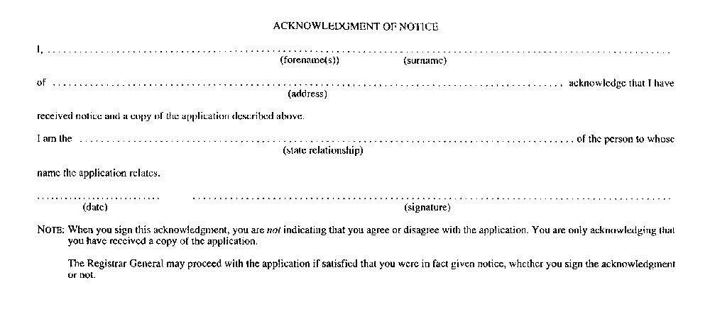
R.R.O. 1990, Reg. 68, Form 6.
Form 7
CONSENT TO APPLICATION TO CHANGE CHILD’S NAME
Change of Name Act
Insert regs\graphics\1990\68\068007ae.tif
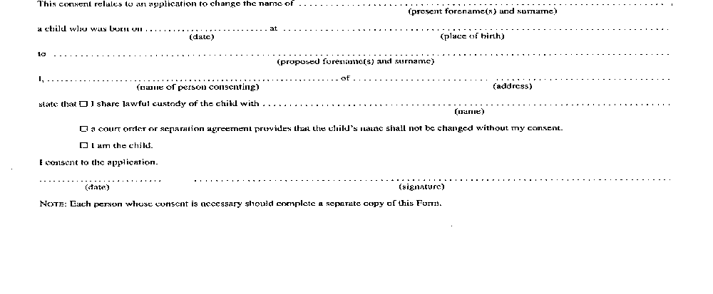
R.R.O. 1990, Reg. 68, Form 7.
Form 8
STATEMENT OF GUARANTOR
Change of Name Act
Insert regs\graphics\1990\68\068008ae.tif
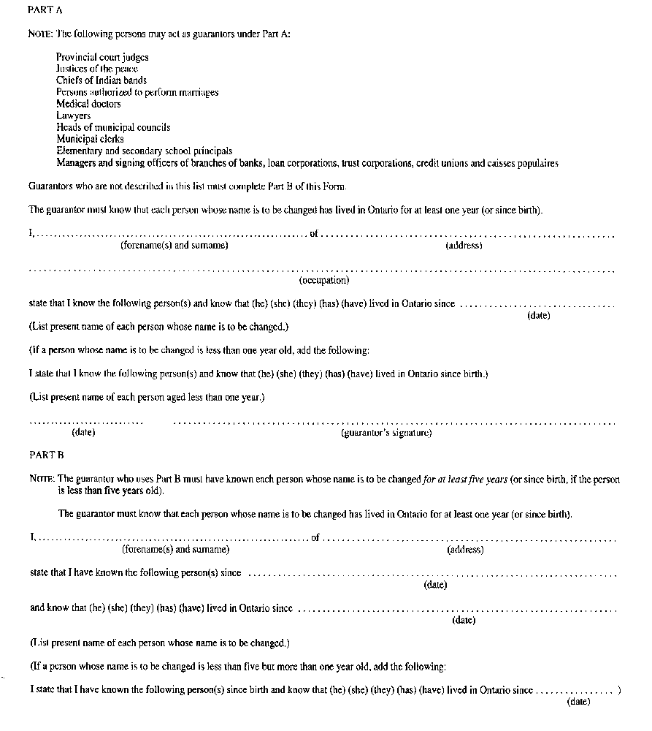
Insert regs\graphics\1990\68\068008be.tif
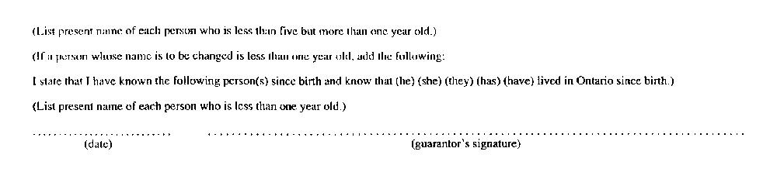
R.R.O. 1990, Reg. 68, Form 8.

Back to top

