Child and Family Services Act
Loi sur les services à l’enfance et à la famille
R.R.O. 1990, REGULATION 71
REGISTER
Historical version for the period March 31, 2000 to January 26, 2009.
Last amendment: O. Reg. 213/00.
This Regulation is made in English only.
1. Revoked: O. Reg. 213/00, s. 1.
2. (1) A society that receives information under section 72 of the Act concerning the abuse of a child shall enquire of the Director who maintains the register established under subsection 75 (5) of the Act, within three days after receiving the information, to determine whether any person referred to in the information has been previously identified in the register. R.R.O. 1990, Reg. 71, s. 2 (1).
(2) A society that makes a report of verified information concerning the abuse of a child under subsection 75 (3) of the Act to the Director shall make the report within fourteen days after the information is verified by the society unless the Director extends the period of time. R.R.O. 1990, Reg. 71, s. 2 (2).
(3) Upon receiving an inquiry from a society under subsection (1), the Director shall forthwith notify the society whether any person referred to in the information received by the society under section 72 of the Act has been previously identified in the register, the date of any such prior identification and the society or other agency that reported the prior identification. R.R.O. 1990, Reg. 71, s. 2 (3).
(4) A report by a society to the Director of verified information concerning the abuse of a child made under subsection 75 (3) of the Act shall be in Form 1. R.R.O. 1990, Reg. 71, s. 2 (4).
(5) Where a case concerning the abuse of a child has been reported by a society under subsection 75 (3) of the Act and the case is not closed by the society, the society shall make a further report in Form 2 to the Director within four months after making of the original report under subsection 75 (3) of the Act. R.R.O. 1990, Reg. 71, s. 2 (5).
(6) Where a case is not closed, a society shall make a subsequent report to the Director in Form 2 on each anniversary of the original report until the case is closed by the society. R.R.O. 1990, Reg. 71, s. 2 (6).
(7) Revoked: O. Reg. 213/00, s. 2.
(8) Revoked: O. Reg. 213/00, s. 2.
3. (1) The Director shall record information reported to the register under subsection 75 (3) of the Act in Form 3. R.R.O. 1990, Reg. 71, s. 3 (1).
(2) The Director shall maintain information in the register established under subsection 75 (5) of the Act for at least twenty-five years from the date of the recording of the information unless the information has been previously expunged or amended pursuant to a decision by the Director. R.R.O. 1990, Reg. 71, s. 3 (2).
4. (1) Every society shall ensure that each child in care of the society is given a medical and dental examination as soon as is practical after the admission of the child to care. R.R.O. 1990, Reg. 71, s. 4 (1).
(2) Every society shall ensure that each child who is in care of the society is given a medical examination and dental examination at least once a year. R.R.O. 1990, Reg. 71, s. 4 (2).
(3) Every society shall keep a record of each medical examination and dental examination of each child admitted into care by the society. R.R.O. 1990, Reg. 71, s. 4 (3).
(4) Every society shall ensure that the treatment recommended as a result of a medical examination or dental examination of a child admitted into care by the society is carried out within the times recommended. R.R.O. 1990, Reg. 71, s. 4 (4).
(5) Psychological and psychiatric assessments or treatment or both shall be provided for each child in the care of a society in accordance with the needs of the child where the society is of the opinion that the behaviour and condition of the child indicate that an assessment or treatment or both is necessary in the circumstances. R.R.O. 1990, Reg. 71, s. 4 (5).
(6) The results of each assessment and treatment carried out under subsection (5) shall be recorded by the society. R.R.O. 1990, Reg. 71, s. 4 (6).
5. (1) No society that admits a child into care shall place the child in a foster home or other home unless the child has previously visited the home at least ten days before the placement. R.R.O. 1990, Reg. 71, s. 5 (1).
(2) Subsection (1) does not apply where it is not practical in the circumstances to have the child visit the home at least ten days before the placement. R.R.O. 1990, Reg. 71, s. 5 (2).
(3) Every society shall ensure that each child placed in a foster home or other home by the society is visited by a social worker,
(a) within seven days after the child’s admission to the home;
(b) at least once within thirty days of the placement; and
(c) at least once every three months after the visit referred to in clause (b),
or at such other interval as the local director directs. R.R.O. 1990, Reg. 71, s. 5 (3).
6. Every society that receives an application to adopt or board a child that is in the care of the society shall, within thirty days after receiving the application, begin an investigation of the applicant and the home of the applicant. R.R.O. 1990, Reg. 71, s. 6.
7. (1) Every society shall open and maintain a separate file with respect to,
(a) each person who is a parent within the meaning of subsection 137 (1) of the Act who relinquishes a child to the society for adoption;
(b) each prospective adoptive parent;
(c) each child who is placed or who is intended to be placed for adoption by the society; and
(d) each foster parent who provides services to the society in connection with an adoption. R.R.O. 1990, Reg. 71, s. 7 (1).
(2) The society shall review each file referred to in subsection (1) and bring the file up to date at least every six months until the file is closed. R.R.O. 1990, Reg. 71, s. 7 (2).
(3) The society shall permanently retain a record of the contents of each file referred to in subsection (1). R.R.O. 1990, Reg. 71, s. 7 (3).
Form 1
REPORT TO CHILD ABUSE REGISTER
Child and Family Services Act
Insert regs\graphics\1990\71\071001au.tif
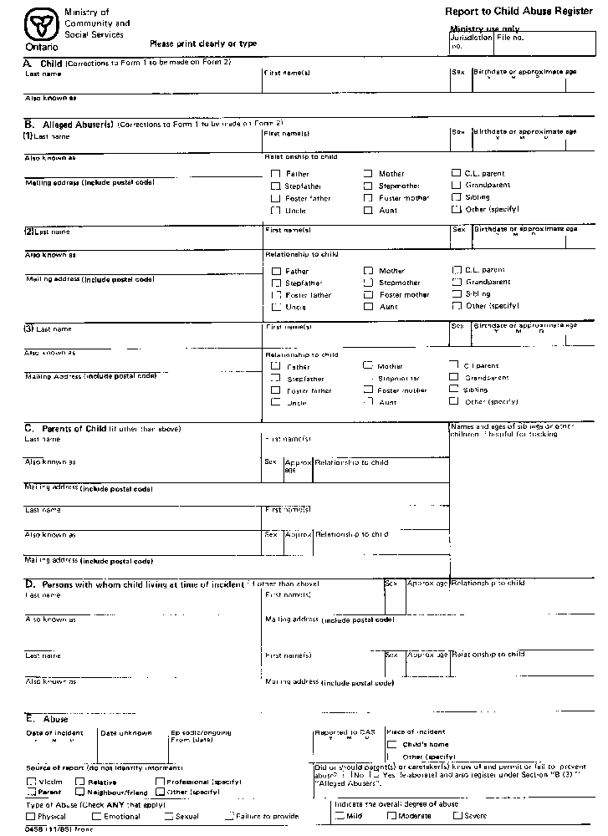
Insert regs\graphics\1990\71\071001bu.tif
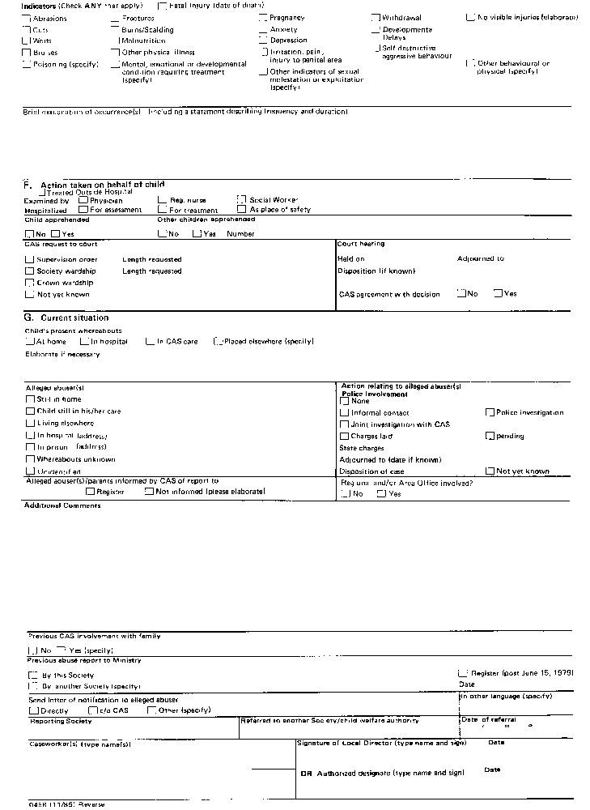
R.R.O. 1990, Reg. 71, Form 1.
FORM 2
FOLLOW-UP REPORT TO CHILD ABUSE REGISTER
Child and Family Services Act
Insert regs\graphics\1990\71\071002au.tif
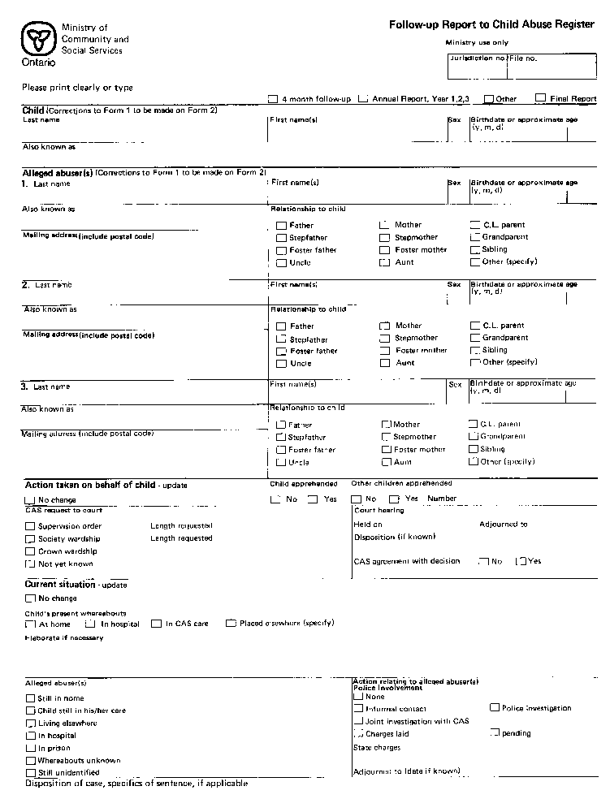
Insert regs\graphics\1990\71\071002bu.tif
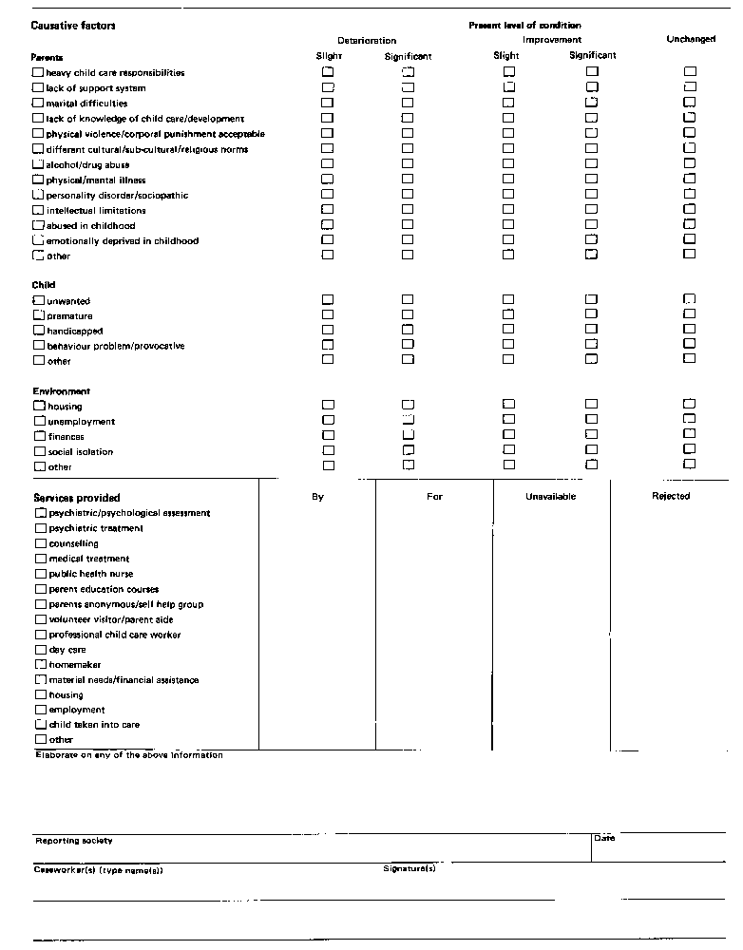
R.R.O. 1990, Reg. 71, Form 2.
FORM 3
CHILD ABUSE REGISTER
Child and Family Services Act
Insert regs\graphics\1990\71\071003au.tif
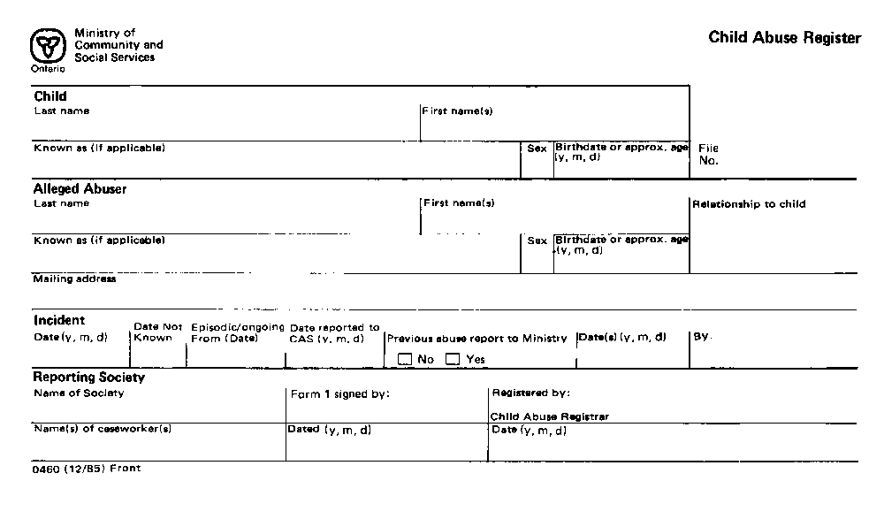
Insert regs\graphics\1990\71\071003bu.tif
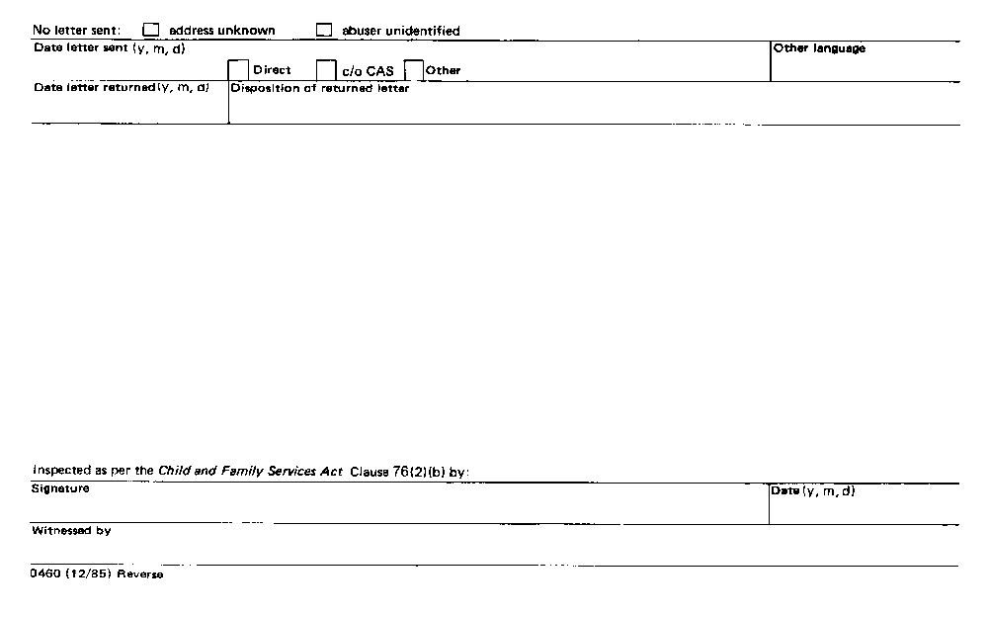
R.R.O. 1990, Reg. 71, Form 3.

Back to top

