Consumer Protection Act
R.R.O. 1990, REGULATION 176
Amended to O. Reg. 19/05
GENERAL
Historical version for the period February 3, 2005 to July 29, 2005.
This is the English version of a bilingual regulation.
Interpretation
1. (1) In this Regulation,
“branch office” means a place at which the public is invited to deal in the conduct of the business of an itinerant seller. R.R.O. 1990, Reg. 176, s. 1 (1).
(2) For the purposes of subsection 19 (1) of the Act,
“warranty or guarantee” means a warranty or guarantee that is enforceable by a buyer against a seller. R.R.O. 1990, Reg. 176, s. 1 (2).
(3) For the purposes of,
(a) subclause 24 (a) (i) of the Act, “cash” includes the sum remaining unpaid under a previous extension of credit, in an amount determined under section 23 of this Regulation, that the borrower and lender agree is to be consolidated with the extension of credit in respect of which the statement is given; and
(b) subclause 24 (a) (ii) of the Act, “cash price” includes the sum remaining unpaid under a previous extension of credit, in an amount determined under section 23 of this Regulation, that the buyer and seller agree is to be consolidated with the extension of credit in respect of which the statement is given. R.R.O. 1990, Reg. 176, s. 1 (3).
Exemptions
2. (1) The Act does not apply to a person who,
(a) borrows in the course of carrying on business or who lends to a person who borrows in the course of carrying on business;
(b) buys goods or services for purposes of resale in the ordinary course of trade or for use in the further production of goods or services; or
(c) who sells goods or services to a person referred to in clause (b). R.R.O. 1990, Reg. 176, s. 2 (1).
(2) Section 19 of the Act does not apply to a buyer or seller under an executory contract under an agreement for variable credit for which the borrower incurs no cost of borrowing. R.R.O. 1990, Reg. 176, s. 2 (2).
(3) Subsections 4 (1) and (3) of the Act do not apply to,
(a) a motor vehicle dealer registered under the Motor Vehicle Dealers Act;
(b) an insurer, insurance agent or an insurance broker licensed under the Insurance Act; or
(c) a funeral director, the operator of a funeral establishment or the operator of a transfer service licensed under the Funeral Directors and Establishments Act. R.R.O. 1990, Reg. 176, s. 2 (3).
(4) Section 21 of the Act does not apply to the sale of,
(a) a motor vehicle by a seller who is registered under the Motor Vehicle Dealers Act;
(b) funeral services, funeral supplies or transfer services by a funeral director or operator of a funeral establishment licensed under the Funeral Directors and Establishments Act; or
(c) transfer services or funeral supplies by the operator of a transfer service licensed under the Funeral Directors and Establishments Act. R.R.O. 1990, Reg. 176, s. 2 (4).
(5) Section 22 of the Act does not apply to a seller who acquires title to a trade-in under an executory contract. R.R.O. 1990, Reg. 176, s. 2 (5).
(6) Section 24 of the Act does not apply to a credit union as defined in the Credit Unions and Caisses Populaires Act. R.R.O. 1990, Reg. 176, s. 2 (6).
PART I
REGISTRATION
3. (1) An application for registration as an itinerant seller or renewal thereof shall be in a form provided by the Minister. R.R.O. 1990, Reg. 176, s. 3 (1).
(2) A notice by an itinerant seller under clause 12 (1) (a) or (b) of the Act shall be in a form provided by the Minister. R.R.O. 1990, Reg. 176, s. 3 (2).
Fees
4. Revoked: O. Reg. 56/98, s. 1.
5. An itinerant seller shall obtain a separate registration, on application for each trade name under which the itinerant seller carries on business as an itinerant seller. R.R.O. 1990, Reg. 176, s. 5.
Terms and Conditions of Registration
6. (1) Every registration expires on the date shown on the certificate of registration unless an application for renewal of registration in a form provided by the Minister, together with the appropriate fee prescribed in section 4, is filed with the Registrar prior to the date of expiry. R.R.O. 1990, Reg. 176, s. 6 (1).
(2) Every registration is conditional for a sixty-day period following registration pending verification of the registrant’s application. R.R.O. 1990, Reg. 176, s. 6 (2).
(3) Every applicant for registration shall state in the application an address for service in Ontario. R.R.O. 1990, Reg. 176, s. 6 (3).
(4) Every person registered as an itinerant seller shall maintain a permanent place of business in Ontario. R.R.O. 1990, Reg. 176, s. 6 (4).
(5) Where the registration of an itinerant seller is revoked, suspended or cancelled or, where the itinerant seller has voluntarily gone out of business, the itinerant seller shall immediately return the certificate of registration to the Registrar by registered mail. R.R.O. 1990, Reg. 176, s. 6 (5).
(6) Where a notice of intention to cancel a bond has been served on the Registrar under section 10, and the bond has been cancelled on the date stated in the notice, the registration of the itinerant seller shall no longer be valid unless prior to that date a replacement bond has been received by the Registrar. R.R.O. 1990, Reg. 176, s. 6 (6).
(7) The Registrar may require further information or material to be submitted by any applicant or any registrant within a specified time limit and may require verification by affidavit or otherwise of any information or material then or previously submitted. R.R.O. 1990, Reg. 176, s. 6 (7).
7. Where an itinerant seller is a corporation it shall, within five days after the event, notify the Registrar in a form provided by the Minister where there is a change in a director of the corporation or where there is a change in its controlling interest. R.R.O. 1990, Reg. 176, s. 7.
Bonds
8. (1) Every application for registration shall be accompanied by the prescribed fee and a bond in such amount and form as is prescribed. R.R.O. 1990, Reg. 176, s. 8 (1).
(2) The bond shall be,
(a) the bond of a guarantee company approved under the Guarantee Companies Securities Act;
(b) a personal bond accompanied by collateral security; or
(c) the bond of a guarantor, other than a guarantee company, accompanied by collateral security,
and shall be in the principal amount of $5,000. R.R.O. 1990, Reg. 176, s. 8 (2).
(3) The classes of negotiable security that may be accepted as collateral security for a bond are,
(a) bonds issued or guaranteed by Canada; or
(b) bonds issued or guaranteed by any province of Canada. R.R.O. 1990, Reg. 176, s. 8 (3).
(4) The market value of the collateral security referred to in subsection (3) shall be posted with the Minister of Finance and maintained at an amount not less than $5,000. R.R.O. 1990, Reg. 176, s. 8 (4).
(5) The bond referred to in subsection (1) shall be in Form 1, 2 or 3, as the case may be. R.R.O. 1990, Reg. 176, s. 8 (5).
Trust Funds
9. (1) All money received by a seller under an executory contract to which Part II of the Act applies and that is subject to rescission shall be retained by the seller in trust for the buyer until the contract is rescinded under section 21 of the Act or until the period for rescission has expired, whichever is the later. R.R.O. 1990, Reg. 176, s. 9 (1).
(2) Where money is paid, whether by way of deposit or otherwise, on account of the proposed purchase of goods or services but no binding contract is entered into in respect of the goods and no delivery of the goods or any part thereof has been made to the buyer or no performance of the services has been made, the seller shall retain the money in trust for the buyer until,
(a) the goods are delivered or the services performed;
(b) the buyer requests the refund in full of the money paid; or
(c) subject to subsection (1), a binding contract is entered into. R.R.O. 1990, Reg. 176, s. 9 (2).
(3) Every seller shall maintain a ledger account in which shall be entered full details of all trust money so received and disbursements therefrom and shall keep all trust money retained by the seller separate and apart from the seller’s own money. R.R.O. 1990, Reg. 176, s. 9 (3).
(4) An entry in a ledger account referred to in subsection (3) shall be retained for a period of six years from the date of the entry. R.R.O. 1990, Reg. 176, s. 9 (4).
Forfeiture of Bonds
10. A bond may be cancelled by any person bound thereunder by giving to the Registrar and the itinerant seller named in the bond, at least two months notice in writing of intention to cancel and, subject to section 11, the bond shall be deemed to be cancelled on the date stated in the notice, which date shall be not less than two months after the receipt of the notice by the Registrar. R.R.O. 1990, Reg. 176, s. 10.
11. For the purpose of every act or omission occurring,
(a) during the period of registration; or
(b) during the period prior to cancellation of the bond under section 10 where there has been no termination of registration,
every bond shall continue in force and the collateral security, if any, shall remain on deposit for a period of two years following the termination of the registration or the cancellation of the bond, as the case may be. R.R.O. 1990, Reg. 176, s. 11.
12. Where a bond has been cancelled or the registration has been terminated, and the bond has not been forfeited, the Minister of Finance may, two years following the termination of the registration to which the bond related or two years after the cancellation of the bond, deliver the collateral security to the person who deposited such security. R.R.O. 1990, Reg. 176, s. 12.
13. The Registrar may declare any bond mentioned in section 8 forfeited,
(a) where a registered itinerant seller, including any member of a partnership, in respect of whose conduct the bond has been conditioned has been convicted of,
(i) an offence under the Act, or
(ii) an offence involving fraud or theft or conspiracy to commit an offence involving fraud or theft under the Criminal Code (Canada), and the conviction has become final;
(b) where a proceeding by or in respect of a registered itinerant seller, including any member of a partnership, in respect of whose conduct the bond has been conditioned, has been taken under the Bankruptcy Act (Canada), either by way of assignment, or by petition, or where a proceeding has been taken by way of winding-up, and in the case of a petition a receiving order under the Bankruptcy Act (Canada), or a winding-up order has been made, and the order has become final;
(c) where a judgment based on a finding of fraud has been given against a registered itinerant seller, including any member of a partnership, in respect of whose conduct the bond has been conditioned and the judgment has become final; or
(d) where judgment has been given against a registered itinerant seller, including any member of a partnership, in respect of whose conduct the bond has been conditioned, on any claim arising out of a sale of goods or services made in the course of business as an itinerant seller, and the judgment has remained unsatisfied for a period of ninety days,
and thereupon the amount thereof becomes due and owing by the person bound thereby as a debt due the Crown in right of Ontario. R.R.O. 1990, Reg. 176, s. 13.
14. Where a bond secured by the deposit of collateral security is forfeited under section 13, the Minister of Finance may sell the collateral security at the current market price. R.R.O. 1990, Reg. 176, s. 14.
15. Where the Crown in right of Ontario becomes a creditor of a person in respect of a debt to the Crown arising from the provisions of section 13, the Registrar may take such steps as the Registrar sees fit under the Bankruptcy Act (Canada), the Courts of Justice Act, the Business Corporations Act or the Winding-up Act (Canada) for the appointment of an interim receiver, custodian, trustee, receiver or liquidator, as the case may be. R.R.O. 1990, Reg. 176, s. 15.
16. (1) The Minister of Finance may in his or her discretion,
(a) assign any bond forfeited under section 13 and transfer the collateral security, if any;
(b) pay over any money recovered under the bond;
(c) pay over any money realized from the sale of the collateral security under section 14,
to any person who,
(d) is a judgment creditor of any itinerant seller, including any member of a partnership, in respect of whose conduct the bond has been conditioned where the judgment was based on a claim arising out of a sale of goods or services;
(e) in respect of a claim for less than $100 against any itinerant seller, including any member of a partnership, in respect of whose conduct the bond has been conditioned, arising out of a sale of goods or services, satisfies the Registrar as to the validity of such claim; or
(f) has proven a claim in bankruptcy against any itinerant seller, including any member of a partnership, in respect of whose conduct the bond has been conditioned, in respect of any claim arising out of a sale of goods or services,
if the claim or transaction occurred during the period referred to in clause 11 (a) or (b). R.R.O. 1990, Reg. 176, s. 16 (1).
(2) The Minister of Finance may, where he or she considers it advisable, without any order, pay the whole or any part of the proceeds referred to in clause (1) (a) or (c) to the Accountant of the Ontario Court in trust for such persons as are or may become entitled to share in the proceeds of the bond under subsection (1). R.R.O. 1990, Reg. 176, s. 16 (2).
17. Where a bond has been forfeited and the Minister of Finance has not received notice in writing of any claim against the proceeds of the bond or such part as remains in the Minister’s hands within two years of the forfeiture, the Minister may pay the proceeds of the bond or the collateral security, or any part remaining, to any person who made a payment under the bond or who deposited the collateral security, after first deducting the amount of any expenses that have been incurred in connection with any investigation or otherwise relating to the itinerant seller, including any member of a partnership, in respect of whose conduct the bond was conditioned. R.R.O. 1990, Reg. 176, s. 17.
part i.1
executory contracts
17.1 For the purposes of section 18 of the Act, the prescribed amount is $50. O. Reg. 279/01, s. 1.
PART II
DISCLOSURE
18. In this Part,
“annual percentage rate” means for the purposes of sections 19 and 20 a percentage that is 365 times greater than a daily percentage rate that, when multiplied by the balance of the principal sum outstanding at the end of each day during the term of the contract will produce a sum that equals the cost of borrowing, or sums, the total of which equal the cost of borrowing; (“taux annuel”)
“approximately” means an interval or amount that does not vary from the average interval or amount by more than 10 per cent; (“approximativement”)
“median amount” means an amount that is half way between one amount and another amount; (“montant médian”)
“payment period” means the number of days that elapse between the dates upon which a payment is required in an agreement; (“période de paiement”)
“principal sum” means the sum stated in clause 24 (a) or (c) of the Act, which shall be deemed to be unpaid or outstanding for at least one day, and the unpaid balances thereof from time to time outstanding but does not include any amount or amounts that are components of the cost of borrowing; (“principal”)
“regular payment contract” means a contract in which payments are required at approximately equal intervals and in approximately equal amounts during the term of the contract. (“contrat à paiements réguliers”) R.R.O. 1990, Reg. 176, s. 18.
19. The percentage required by clause 24 (c) of the Act shall be calculated, expressed and applied with respect to an extension of credit in the following manner:
1. Subject to paragraphs 4 and 5 and to section 20, the percentage that a lender shall disclose with respect to an extension of credit shall be the annual percentage rate applicable to the contract.
2. The annual percentage rate shall be deemed to have been charged not in advance on the principal sum from time to time outstanding, so long as the payments required to be made by the borrower are made as they become due and such payments are applied first to the reduction of the accrued cost of borrowing.
3. For the purposes of paragraph 2, the cost of borrowing shall be deemed to be charged daily and summed until the next succeeding payment becomes due and the accrued cost of borrowing is that amount which is so charged and summed at any given time.
4. Where a contract provides for approximate monthly payment periods, the rate that shall be deemed to have been applied monthly under paragraphs 1, 2 and 3 shall be one-twelfth of the annual percentage rate.
5. Where a contract provides for payments at periods other than approximately monthly, the rate that shall be deemed to have been applied under paragraphs 1, 2 and 3 with respect to each payment shall be the same fraction of the annual percentage rate that the payment period is of one year. R.R.O. 1990, Reg. 176, s. 19.
20. (1) In this section,
“amount of the credit” means the sum stated in clause 24 (a) or (c) of the Act. R.R.O. 1990, Reg. 176, s. 20 (1).
(2) The annual percentage rate required to be disclosed under section 19 may be a rate that differs by not more than one per cent from the annual percentage rate that the cost of borrowing bears to the amount of the credit, except that a greater arithmetic difference may be permitted in a regular payment contract, in which case the annual percentage rate required to be disclosed may be the actual annual percentage rate that the cost of borrowing bears to an amount that differs by not more than $5 from the amount of the credit. R.R.O. 1990, Reg. 176, s. 20 (2).
(3) In addition to the tolerance permitted by subsection (2), where the due date of the first instalment in an extension of credit having approximately monthly payments and a term of six months or more is not less than fifteen or more than forty-five days after the credit is advanced, it may be deemed by the lender, for the purposes of the statement required by section 24 of the Act, that the credit was advanced on a date not more than thirty-one days immediately prior to the due date of the first instalment. R.R.O. 1990, Reg. 176, s. 20 (3).
21. (1) Subject to subsections (2), (3) and (4), the annual percentage or scale of annual percentages that a lender shall disclose pursuant to clause 25 (2) (a) and to section 26 of the Act shall be the rate or scale of annual percentage rates that, when applied in the manner prescribed in subsection (2) or (3) of this section to the unpaid balance at the end of the preceding month or period, will yield a sum that equals the cost of borrowing, or sums, the total of which equals the cost of borrowing. R.R.O. 1990, Reg. 176, s. 21 (1).
(2) Where a contract for variable credit provides for monthly payments, the percentage rate that shall be applied monthly under subsection (1) shall be one-twelfth of the annual percentage rate. R.R.O. 1990, Reg. 176, s. 21 (2).
(3) Where a contract for variable credit provides for payments at periods other than monthly, the percentage rate that shall be applied under subsection (1) with respect to each payment period shall be the same fraction of the annual percentage rate that the payment period is of one year. R.R.O. 1990, Reg. 176, s. 21 (3).
(4) For the purposes of subsection (1), the cost of borrowing may be computed within a range,
(a) not in excess of $10 on the median amount in a selected range of outstanding balances, where the largest amount in the range is not more than $1,000; or
(b) not in excess of $20 on the median amount in a selected range of outstanding balances where the smallest amount in the range is more than $1,000,
so long as the cost of borrowing is applied to all outstanding balances within the range. R.R.O. 1990, Reg. 176, s. 21 (4).
22. (1) In this section,
“denominator” means the sum of the balances of the obligation at the beginning of the contract and at the end of each period in accordance with the schedule of payments required as originally required as originally scheduled; (“dénominateur”)
“lender” includes any assignee of the lender; (“prêteur”)
“numerator” means the sum of the balances at the beginning of the contract and the balances unpaid at the end of each period up to the date of full payment of the total obligation; (“numérateur”)
“obligation” means the total amount payable when the contract was entered into; (“engagement”)
“period” means an interval of time not in excess of thirty-one days; (“période”)
“unit” means the amount produced by dividing the obligation by the number of months in the contract. (“unité”) R.R.O. 1990, Reg. 176, s. 22 (1).
(2) Subject to subsections (4), (5), (6), (7), (8), (9) and (10), where an amount, due under an extension of credit wherein the cost of borrowing is precomputed, is paid in advance of the due date, the lender may retain a proportion of the cost of borrowing calculated, when the amount of the obligation is fully paid, by dividing the numerator by the denominator, so long as the period in the numerator is equal to the period in the denominator, to produce a fraction, which fraction shall be multiplied by the cost of borrowing and the resultant sum is the amount to be retained by the lender. R.R.O. 1990, Reg. 176, s. 22 (2).
(3) Where the original term of the transaction is varied by one or more extensions of payment, the extended payment or payments shall be deemed to have been made as originally scheduled. R.R.O. 1990, Reg. 176, s. 22 (3).
(4) Subject to subsections (5) and (6), the lender shall allow the borrower a rebate of the cost of borrowing less the retention allowed the lender under subsection (2). R.R.O. 1990, Reg. 176, s. 22 (4).
(5) Except where the prepayment is made under an arrangement for refinancing or for the extension of additional credit, the lender is entitled, in addition to the amount allowed under subsection (2), to retain an amount equal to not more than $20 or one-half of the rebate as computed in subsection (4), whichever is the lesser, and the borrower is entitled to a rebate of the remainder of the cost of borrowing. R.R.O. 1990, Reg. 176, s. 22 (5).
(6) Where the rebate required to be given under subsection (4) is less than $2, the borrower is not entitled to the rebate. R.R.O. 1990, Reg. 176, s. 22 (6).
(7) Where a payment is received after it had become due, the lender may deem that the payment had been received on the instalment due date. R.R.O. 1990, Reg. 176, s. 22 (7).
(8) Where a payment is received before it is due, the lender shall deem that the payment has been received not later than the end of the period in which the payment has been received. R.R.O. 1990, Reg. 176, s. 22 (8).
(9) Where a regular payment contract requires payments monthly or more frequently or less frequently than monthly and the obligation is paid in full before the term of the contract has expired, the obligation shall be deemed by the lender to have been substantially prepaid if the actual balance due, exclusive of default charges, at the end of the period immediately preceding the date of the payment in full plus the greater of one unit or 15 per cent of the obligation is less than the balance at the end of the preceding period as such balance was originally scheduled. R.R.O. 1990, Reg. 176, s. 22 (9).
(10) Despite subsection (8), where the obligation has not been substantially prepaid as described in subsection (9), the lender may deem that the balances in the numerator are identical to the balances in the denominator up to the end of the period preceding the payment in full or up to the end of the period in which the payment in full is made, whichever period date is nearest to the actual date of the payment in full. R.R.O. 1990, Reg. 176, s. 22 (10).
23. (1) For the purposes of section 28 of the Act,
“paid in full” includes the consolidation in an agreement to extend credit of a sum owing under a previous agreement to extend credit. R.R.O. 1990, Reg. 176, s. 23 (1).
(2) Where a borrower or a buyer, as the case may be, pays in full under the circumstances referred to in subsection (1), the amount allowed to the borrower or buyer shall be determined under section 22 and shall include the unearned portion of any insurance premium required to be paid by the borrower or the buyer under the original agreement. R.R.O. 1990, Reg. 176, s. 23 (2).
24. (1) Where a lender represents, or causes to be represented, in print, the lender’s charge for credit, the lender shall provide an example of the calculation of the charge and the rate represented thereby. R.R.O. 1990, Reg. 176, s. 24 (1).
(2) The representations required to be made by a lender under section 29 of the Act,
(a) shall, in the case of a lender who advertises in a place other than the lender’s business premises, be printed on the advertisement;
(b) may, in the case of a lender who advertises in the lender’s business premises, be omitted from the advertisement, so long as a statement is printed on the advertisement that the charge for credit and the calculation therefor and the other terms of the credit transaction may be obtained from a source on the lender’s business premises; and
(c) shall, where the advertisement is printed on a page in a catalogue, refer to a page or pages in the catalogue where the charge for credit and the calculation therefor and the other terms of the credit transaction may be obtained. R.R.O. 1990, Reg. 176, s. 24 (2).
(3) Where a lender represents, or causes to be represented, orally the lender’s charge for credit by radio or television broadcast, or otherwise, the lender shall provide an example of the calculation of the charge and the rate represented thereby. R.R.O. 1990, Reg. 176, s. 24 (3).
25. A request for voluntary cancellation of registration under subsection 7 (7) of the Act shall be in a form provided by the Minister. R.R.O. 1990, Reg. 176, s. 25.
Form 1
BOND OF A GUARANTEE COMPANY APPROVED UNDER THE GUARANTEE COMPANIES SECURITIES ACT
Consumer Protection Act
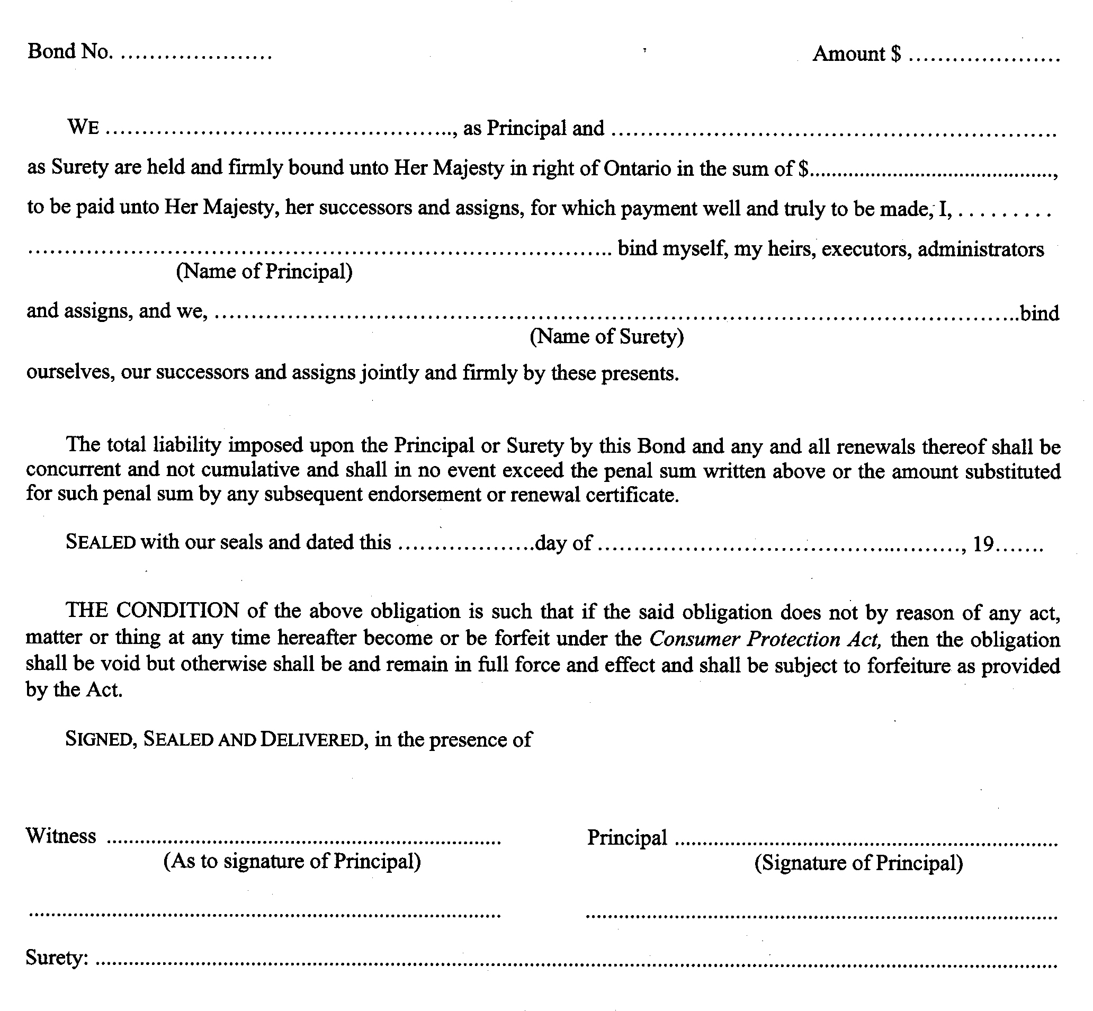
R.R.O. 1990, Reg. 176, Form 1.
Form 2
bond of guarantor other than guarantee company
Consumer Protection Act

R.R.O. 1990, Reg. 176, Form 2.
Form 3
personal bond
Consumer Protection Act
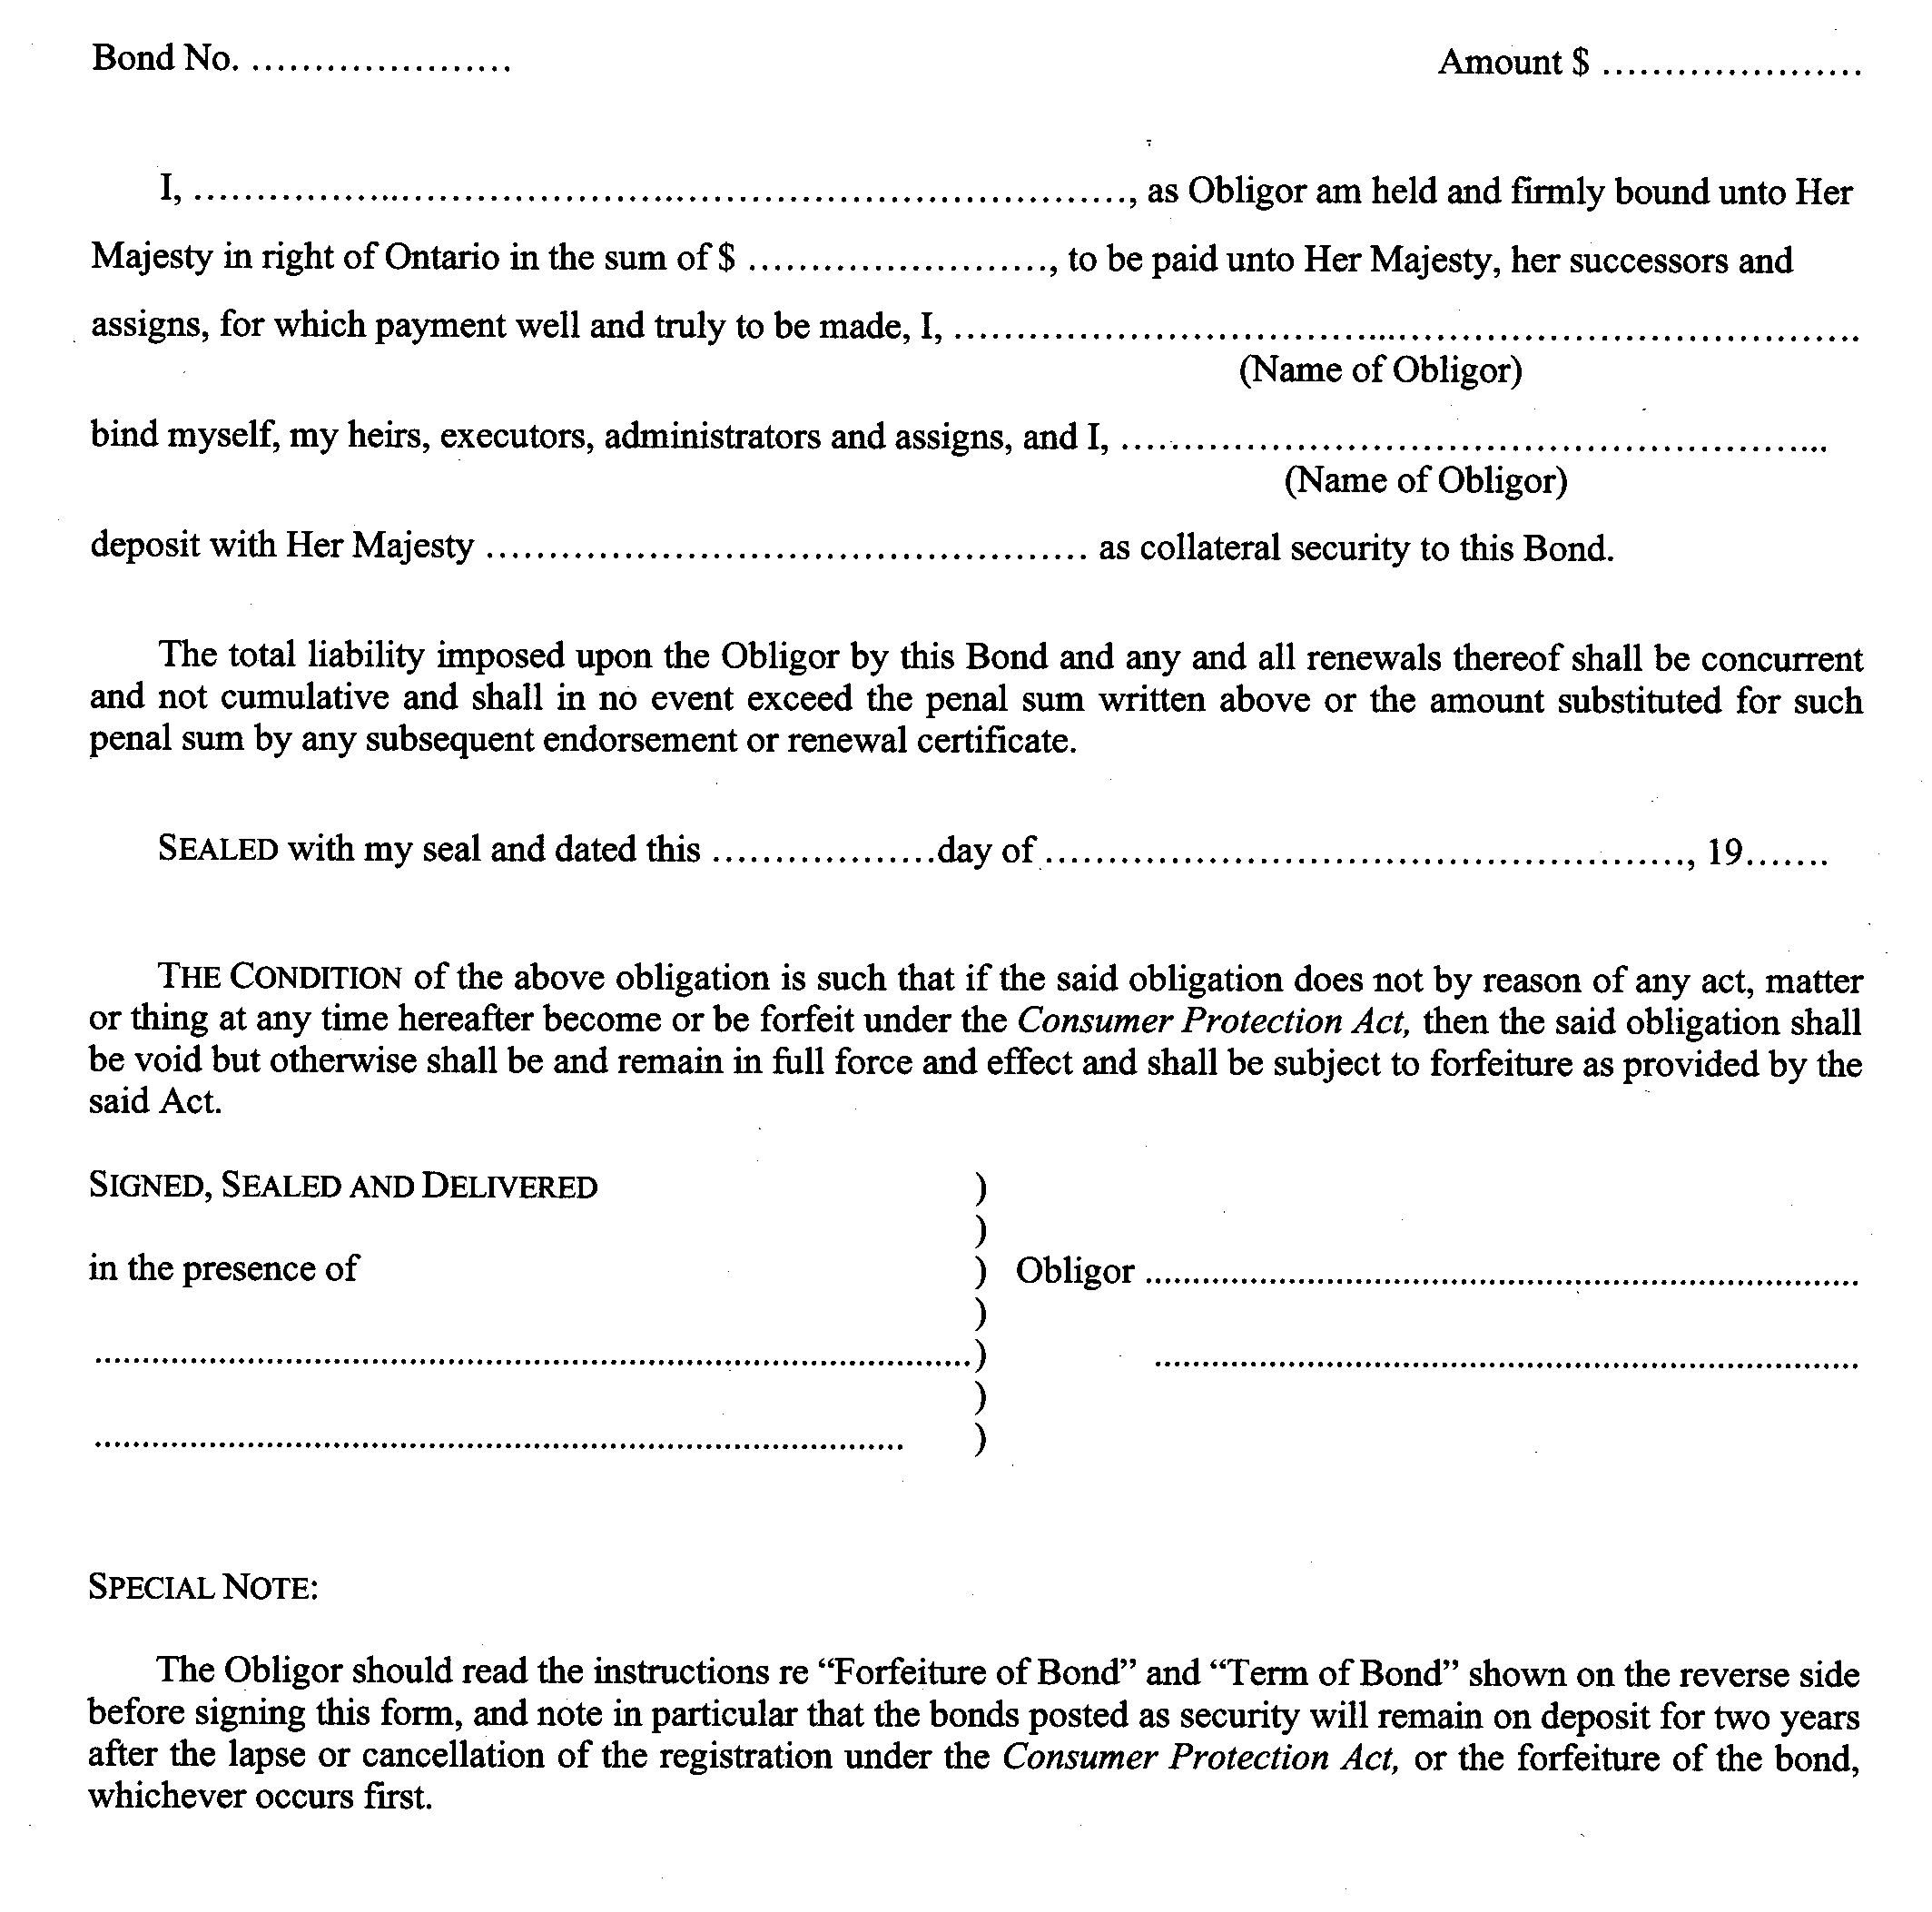
R.R.O. 1990, Reg. 176, Form 3.

Back to top

