Hospital Labour Disputes Arbitration Act
Loi sur l’arbitrage des conflits de travail dans les hôpitaux
R.R.O. 1990, REGULATION 639
RULES OF PROCEDURE
Historical version for the period June 11, 2007 to July 24, 2007.
Last amendment: O. Reg. 260/07
This Regulation is made in English only.
1. (1) In this Regulation,
“Board” means the Ontario Labour Relations Board;
“file” means file with the Board;
“registrar” means the registrar of the Board and includes a deputy registrar;
“respondent” means the person named in an application as a respondent or added as a respondent by the Board. R.R.O. 1990, Reg. 639, s. 1 (1).
(2) Where a period of time is prescribed by this Regulation and expressed as a number of days, the period shall be computed as the number of days expressed, exclusive of holidays. R.R.O. 1990, Reg. 639, s. 1 (2).
2. (1) An application for a declaration that a strike is unlawful shall be made in quadruplicate in Form 1 or 2, as the case may be. R.R.O. 1990, Reg. 639, s. 2 (1).
(2) An application for a declaration that a lockout is unlawful shall be made in quadruplicate in Form 3. R.R.O. 1990, Reg. 639, s. 2 (2).
3. The registrar shall serve each respondent with,
(a) a copy of the application; and
(b) a notice of application and of hearing in Form 4. R.R.O. 1990, Reg. 639, s. 3.
4. A respondent may reply by filing a reply in quadruplicate in Form 5 not later than the sixth day after,
(a) the day on which the registrar served the respondent with the notice of application, where it was served personally; or
(b) the day immediately following the day on which the registrar mailed the notice of application to the respondent, where it was served by mail. R.R.O. 1990, Reg. 639, s. 4.
5. (1) An application for consent to institute a prosecution shall be made in quadruplicate in Form 6. R.R.O. 1990, Reg. 639, s. 5 (1).
(2) The registrar shall serve each respondent with,
(a) a copy of the application; and
(b) a notice of application and of hearing in Form 4. R.R.O. 1990, Reg. 639, s. 5 (2).
6. A respondent may reply by filing a reply in quadruplicate in Form 7 not later than the sixth day after,
(a) the day on which the registrar served the respondent with the notice of application, where it was served personally; or
(b) the day immediately following the day on which the registrar mailed the notice of application to the respondent, where it was served by mail. R.R.O. 1990, Reg. 639, s. 6.
7. Where a notice of hearing in Form 8 is required to be served, it shall be served not less than two days before the day fixed for the hearing. R.R.O. 1990, Reg. 639, s. 7.
8. Except where inconsistent with this Regulation, the rules of procedure of the Ontario Labour Relations Board apply, with necessary modifications, to proceedings under the Act. R.R.O. 1990, Reg. 639, s. 8.
9. (1) Every arbitrator shall, within ten days of issuing an award, file a copy thereof with the Minister. R.R.O. 1990, Reg. 639, s. 9 (1).
(2) A record shall be maintained of each award filed with the Minister under subsection (1) and upon payment of the prescribed fee, the Ministry shall supply a copy of the award to any person applying therefor. R.R.O. 1990, Reg. 639, s. 9 (2).
Note: On the day section 83 of the Legislation Act, 2006 comes into force, subsection (2) is revoked and the following substituted:
(2) A record shall be maintained of each award filed with the Minister under subsection (1) and, upon payment of the fee of 50 cents per page, the Ministry shall supply a copy of the award to any person applying for it. O. Reg. 260/07, s. 1.
See: O. Reg. 260/07, ss. 1, 2. This day has been named as July 25, 2007.
Form 1
APPLICATION FOR DECLARATION THAT STRIKE, CALLED OR AUTHORIZED BY TRADE UNION OR COUNCIL OF TRADE UNIONS, UNLAWFUL BEFORE THE ONTARIO LABOUR RELATIONS BOARD
Hospital Labour Disputes Arbitration Act
Insert regs\graphics\1990\639\639001au.tif
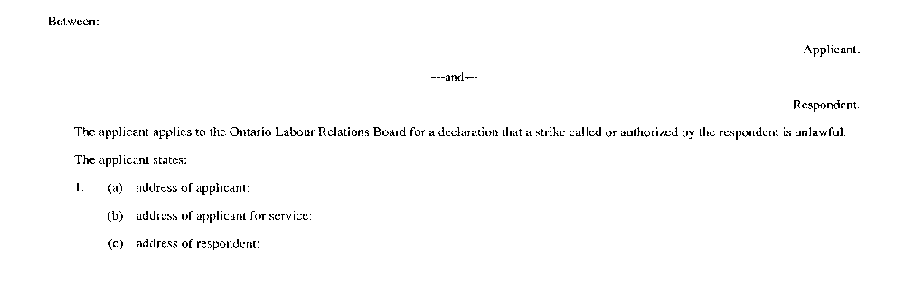
Insert regs\graphics\1990\639\639001bu.tif
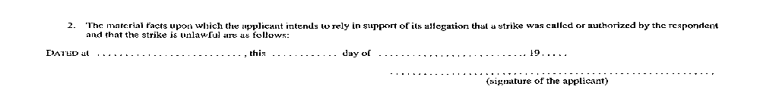
R.R.O. 1990, Reg. 639, Form 1.
Form 2
APPLICATION FOR DECLARATION THAT STRIKE, ENGAGED IN BY EMPLOYEES, UNLAWFUL BEFORE THE ONTARIO LABOUR RELATIONS BOARD
Hospital Labour Disputes Arbitration Act
Insert regs\graphics\1990\639\639002au.tif
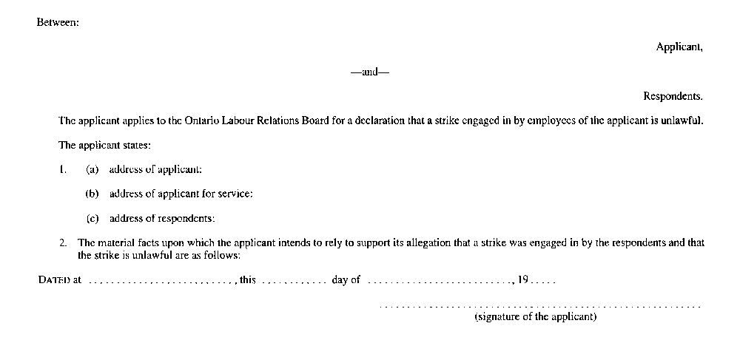
R.R.O. 1990, Reg. 639, Form 2.
Form 3
APPLICATION FOR DECLARATION THAT LOCKOUT UNLAWFUL BEFORE THE ONTARIO LABOUR RELATIONS BOARD
Hospital Labour Disputes Arbitration Act
Insert regs\graphics\1990\639\639003au.tif
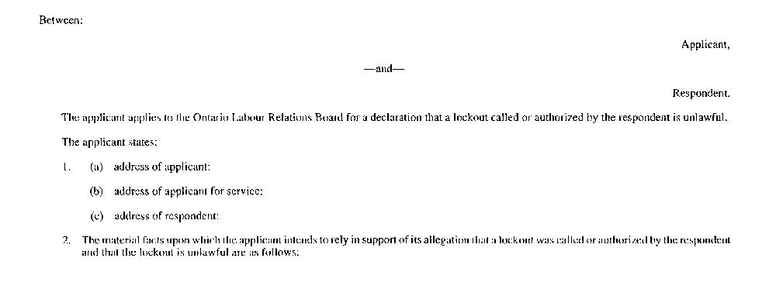
Insert regs\graphics\1990\639\639003bu.tif
R.R.O. 1990, Reg. 639, Form 3.
Form 4
NOTICE OF APPLICATION FOR DECLARATION THAT STRIKE OR LOCKOUT UNLAWFUL OR FOR CONSENT TO INSTITUTE PROSECUTION AND OF HEARING BEFORE THE ONTARIO LABOUR RELATIONS BOARD
Hospital Labour Disputes Arbitration Act
Insert regs\graphics\1990\639\639004au.tif
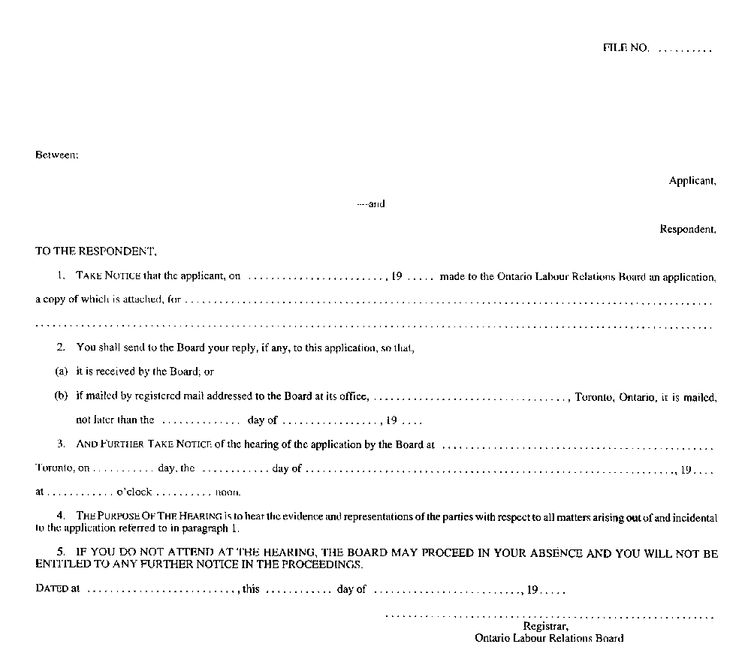
R.R.O. 1990, Reg. 639, Form 4.
Form 5
REPLY TO APPLICATION FOR DECLARATION THAT STRIKE OR LOCKOUT UNLAWFUL BEFORE THE ONTARIO LABOUR RELATIONS BOARD
Hospital Labour Disputes Arbitration Act
Insert regs\graphics\1990\639\639005au.tif
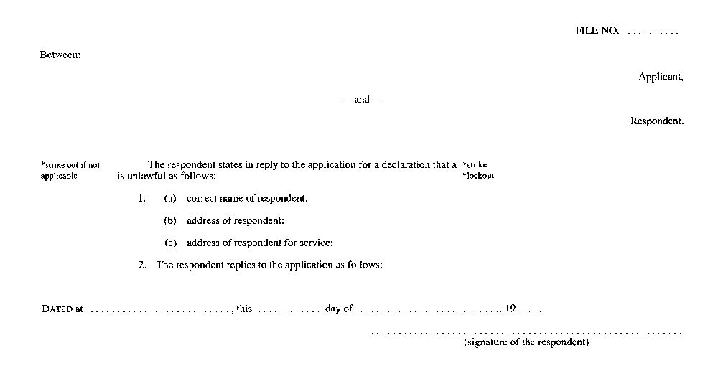
R.R.O. 1990, Reg. 639, Form 5.
Form 6
APPLICATION FOR CONSENT TO INSTITUTE PROSECUTION BEFORE THE ONTARIO LABOUR RELATIONS BOARD
Hospital Labour Disputes Arbitration Act
Insert regs\graphics\1990\639\639006au.tif
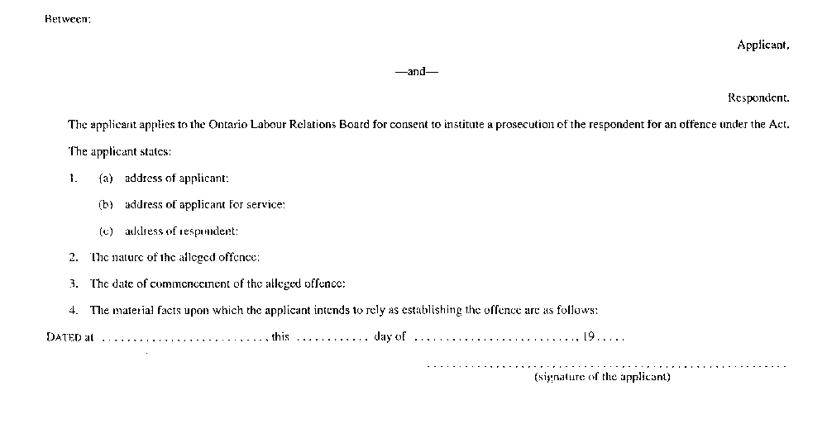
R.R.O. 1990, Reg. 639, Form 6.
Form 7
REPLY TO APPLICATION FOR CONSENT TO INSTITUTE PROSECUTION BEFORE THE ONTARIO LABOUR RELATIONS BOARD
Hospital Labour Disputes Arbitration Act
Insert regs\graphics\1990\639\639007au.tif
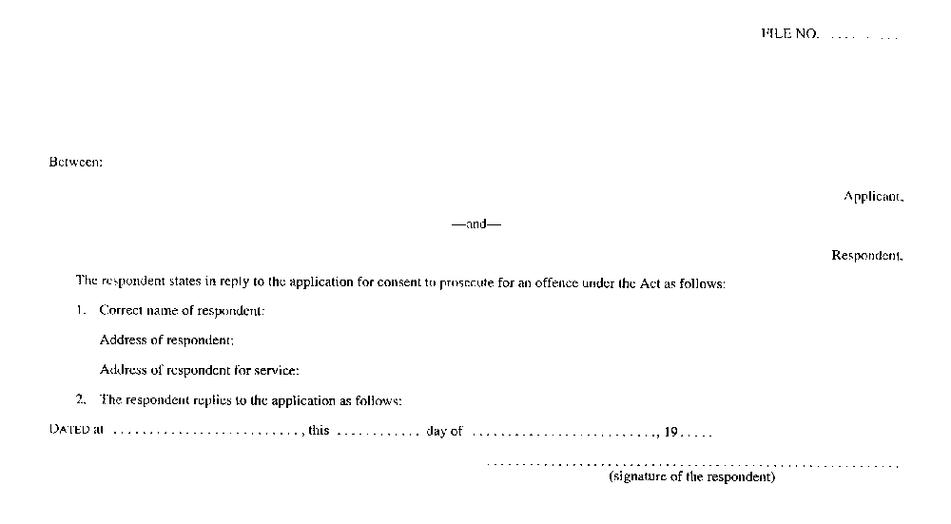
R.R.O. 1990, Reg. 639, Form 7.
Form 8
NOTICE OF HEARING BEFORE THE ONTARIO LABOUR RELATIONS BOARD
Hospital Labour Disputes Arbitration Act
Insert regs\graphics\1990\639\639008au.tif
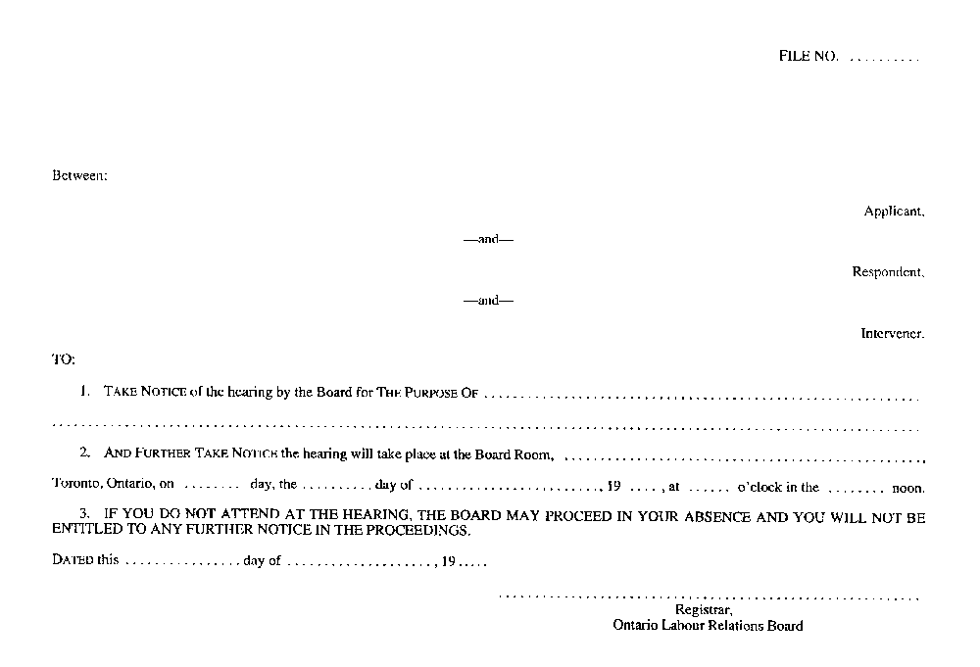
R.R.O. 1990, Reg. 639, Form 8.

Back to top

