Provincial Offences Act
Loi sur les infractions provinciales
R.R.O. 1990, REGULATION 949
PARKING INFRACTIONS
Historical version for the period April 20, 2009 to May 31, 2009.
Last amendment: O. Reg. 158/09.
This Regulation is made in English only.
Skip Table of Contents
CONTENTS
Schedule 0.1
Schedule 1
Schedule 2
Schedule 3
Schedule 4
Schedule 5
Schedule 6
Schedule 7
Schedule 8
Schedule 9
Schedule 10
Schedule 11
Schedule 12
Schedule 13
Schedule 13.1
Schedule 14
Schedule 15
Schedule 16
Schedule 17
Schedule 18
Form 1/Formule 1 | Certificate of parking infraction/procès-verbal d’infraction de stationnement
Form 2/Formule 2 | Parking infraction notice/avis d’infraction de stationnement
Form 3/Formule 3 | Parking infraction notice/avis d’infraction de stationnement
Form 4/Formule 4 | Notice of impending conviction/avis de déclaration de culpabilité imminente
Form 5/Formule 5 | Notice of impending conviction/avis de déclaration de culpabilité imminente
Form 6/Formule 6 | Certificate requesting conviction/certificat de demande de déclaration de culpabilité
Form 7/Formule 7 | Notice of fine and due date/avis d’amende et date d’échéance

1. A certificate of parking infraction shall be in Form 1. O. Reg. 494/94, s. 1.
2. (1) A parking infraction notice shall be in Form 2. O. Reg. 494/94, s. 1.
(2) Despite subsection (1), a parking infraction notice shall be in Form 3 in those municipalities designated for the purposes of section 17.1 of the Act. O. Reg. 494/94, s. 1.
3. A certificate of parking infraction or a parking infraction notice may set out,
(a) more than one infraction as long as each infraction with which a person is charged is clearly indicated on the certificate or notice by a check-mark, an “x”, a punch hole or by some other means;
(b) information related to the voluntary payment of penalties under by-laws adopted under an Act that authorizes such by-laws. O. Reg. 494/94, s. 1.
3.1-3.3 Revoked: O. Reg. 494/94, s. 1.
4. A notice of intention to appear shall be in Form 7 of Regulation 950 of the Revised Regulations of Ontario, 1990 in those municipalities designated for the purposes of section 17.1 of the Act. O. Reg. 494/94, s. 1.
5. A notice of trial under Part II of the Act shall be in Form 8 of Regulation 950 of the Revised Regulations of Ontario, 1990. O. Reg. 494/94, s. 1.
6. (1) A notice of impending conviction shall be in Form 4. O. Reg. 494/94, s. 1.
(2) Despite subsection (1), a notice of impending conviction shall be in Form 5 in those municipalities designated for the purposes of section 17.1 of the Act. O. Reg. 494/94, s. 1.
(3) A certificate requesting a conviction shall be in Form 6 and shall be completed in accordance with the following rules:
1. If the defendant’s driver’s licence number is available, the defendant’s date of birth need not be completed.
2. If the defendant’s driver’s licence number is not available, the defendant’s date of birth must be completed if it is available.
3. If the defendant’s driver’s licence number or date of birth is available, the registration information number (RIN) for the vehicle need not be completed.
4. If neither the defendant’s driver’s licence number nor date of birth is available, then the registration information number for the vehicle must be completed.
5. If the certificate is issued by a municipality designated in the Table to section 13, the defendant’s address, sex, driver’s licence number and date of birth, the registration information number for the vehicle and the by-law number need not be completed. O. Reg. 494/94, s. 1.
(4) A notice of impending conviction and a certificate requesting a conviction issued by a municipality shall be prepared by the clerk of the municipality or another employee who is responsible for parking prosecutions. O. Reg. 494/94, s. 1.
(5) A notice of impending conviction and a certificate requesting a conviction issued by a ministry shall be prepared by the deputy minister of the ministry or another employee who is responsible for parking prosecutions. O. Reg. 494/94, s. 1.
(6) A notice of impending conviction and a certificate requesting a conviction issued by another body shall be prepared by the chief administrator of the body or another employee who is responsible for parking prosecutions. O. Reg. 494/94, s. 1.
(7) A facsimile signature of a person mentioned in subsection (4), (5) or (6) is sufficient authentication of a certificate requesting a conviction. O. Reg. 494/94, s. 1.
7. A notice of fine and due date shall be in Form 7. O. Reg. 494/94, s. 1.
8. Forms referred to in this Regulation may be in English or French, or in both English and French. O. Reg. 494/94, s. 1.
9. (1) If a fine that a municipality is authorized to collect is in default, the clerk of the municipality may notify the supervisor of the Defaulted Fines Control Centre in the Ontario Court (Provincial Division) of the default by sending him or her a certificate requesting plate denial. O. Reg. 494/94, s. 1.
(2) If the supervisor of the Defaulted Fines Control Centre is satisfied that a fine is in default, he or she shall direct that any permit issued to the person in default under Part II of the Highway Traffic Act not be validated and no new permit be issued to that person until the fine is paid. O. Reg. 494/94, s. 1.
10. (1) If a fine that a municipality is not authorized to collect is in default, the clerk of the municipality may notify the clerk of the local court office of the Ontario Court (Provincial Division) of the default by filing with the clerk a certificate requesting plate denial. O. Reg. 494/94, s. 1.
(2) If the clerk of the local office of the Ontario Court (Provincial Division) is satisfied that a fine is in default, he or she shall direct that any permit issued to the person in default under Part II of the Highway Traffic Act not be validated and no new permit be issued to that person until the fine is paid. O. Reg. 494/94, s. 1.
11. (1) The following persons are designated for the purposes of subsection 69 (3) of the Act:
1. The clerk of the court or an assistant clerk, if so authorized by the clerk.
2. The supervisor of the Defaulted Fines Control Centre of the Ontario Court (Provincial Division) or an assistant supervisor, if so authorized by the supervisor. O. Reg. 494/94, s. 1.
(2) The following persons are designated for the purposes of subsection 69 (5) of the Act:
1. The clerk of the court or an assistant clerk, if so authorized by the clerk. O. Reg. 494/94, s. 1.
12. (1) Every municipality or other body that issues a notice of impending conviction is entitled to an allowance of $11. O. Reg. 241/98, s. 1.
(2) Every municipality designated in the Table to section 13 is entitled to an allowance of $2 for each fine it collects in connection with a conviction under subsection 18.2 (6) of the Act. O. Reg. 241/98, s. 1.
(3) The allowance under subsections (1) and (2) shall be deducted from the court costs that are payable upon conviction under subsection 18.2 (6) of the Act, are prescribed in Regulation 945 of the Revised Regulations of Ontario, 1990 and are received in connection with the collected fine. O. Reg. 241/98, s. 1.
12.1 (1) Every municipality is entitled to an allowance of $9 for each fine it collects in connection with a conviction under section 18.4 of the Act. O. Reg. 241/98, s. 2.
(2) The allowance under subsection (1) shall be deducted from the court costs that are payable upon convictions under section 18.4 of the Act, are prescribed in Regulation 945 of the Revised Regulations of Ontario, 1990 and are received in connection with the collected fine. O. Reg. 241/98, s. 2.
13. (1) The municipalities designated in the Table to this section are authorized to collect and retain for their own purposes the fines levied for convictions respecting parking infractions under their by-laws. O. Reg. 494/94, s. 1.
(2) The municipalities designated in the Table may deduct the allowances prescribed under sections 12 and 12.1 from the court costs they collect in connection with a fine referred to in subsection (1) and shall remit the remainder of the court costs to Ontario. O. Reg. 494/94, s. 1; O. Reg. 241/98, s. 3.
TABLE

Amherstburg
Barrie
Belleville
Brampton
Brantford
Brockville
Burlington
Caledon
Cambridge
Centre Wellington
Note: On June 1, 2009, the Table is amended by adding the following:
Collingwood
See: O. Reg. 158/09, ss. 1, 3 (1).
Cornwall
Dryden
Erin
Note: On June 1, 2009, the Table is amended by adding the following:
Essex
See: O. Reg. 158/09, ss. 1, 3 (1).
Fort Erie
Georgina
Grimsby
Guelph
Guelph-Eramosa
Halton Hills
Hamilton
Ingersoll
Innisfil
Kenora
Kingston
Kingsville
Kitchener
Lakeshore
Leamington
Lincoln
London
Madawaska Valley
Mapleton
Markham
Meaford
Milton
Minto
Mississauga
New Tecumseth
Newmarket
Niagara Falls
Niagara-on-the-Lake
Oakville
Orillia
Ottawa
Owen Sound
Pelham
Pembroke
Petawawa
Pickering
Port Colborne
Puslinch
Richmond Hill
Sioux Lookout
St. Catharines
Strathroy-Caradoc
St. Thomas
Thorold
Thunder Bay
Timmins
Toronto
Vaughan
Wainfleet
Wasaga Beach
Waterloo
Welland
Wellington
Wellington North
West Lincoln
West Nipissing
Westport
Windsor
O. Reg. 494/94, s. 1; O. Reg. 538/94, s. 1; O. Reg. 804/94, s. 1; O. Reg. 59/96, s. 1; O. Reg. 617/98, s. 1; O. Reg. 344/00, s. 1; O. Reg. 658/00, s. 1; O. Reg. 19/01, s. 1; O. Reg. 139/01, s. 1; O. Reg. 74/02, s. 1; O. Reg. 378/06, s. 1.
(3)-(5) Spent: O. Reg. 494/94, s. 1.
14. The following persons are designated for the purposes of subsections 17.1 (3) and (6) and 18.1.1 (3) of the Act:
1. The clerk of a municipality, the deputy-clerk or another employee authorized in writing to perform his or her duties for these purposes.
2. The chief administrator of the body that commenced the proceeding or another employee authorized in writing to perform his or her duties for these purposes.
3. The deputy minister of the ministry that issued the notice of parking infraction or another employee authorized in writing to perform his or her duties for these purposes.
4. The clerk of the court. O. Reg. 494/94, s. 1; O. Reg. 776/94, s. 1.
15. The following persons are designated for the purposes of subsections 17 (4), 18.1 (4), 18.1.2 (2) and 18.2 (1.1) of the Act:
1. The clerk of a municipality, the deputy-clerk or another employee authorized in writing to perform his or her duties for these purposes.
2. The chief administrator of the body that commenced the proceeding or another employee authorized in writing to perform his or her duties for these purposes. O. Reg. 494/94, s. 1.
16. The municipalities listed in the Table to this section are designated for the purposes of sections 17.1 and 18.1.1 of the Act.
TABLE

Town of Aurora
City of Brampton
Township of Brock
City of Brockville
City of Burlington
Town of Caledon
City of Cambridge
Municipality of Central Elgin
Municipality of Clarington
City of Cornwall
City of Dryden
Town of East Gwillimbury
Note: On June 1, 2009, the Table is amended by adding the following:
Town of Essex
See: O. Reg. 158/09, ss. 2 (1), 3 (1).
Town of Fort Erie
Town of Fort Frances
Town of Georgina
City of Greater Sudbury
Town of Grimsby
City of Hamilton
Town of Ingersoll
Town of Innisfil
City of Kawartha Lakes
City of Kenora
City of Kingston
Town of Kingsville
Town of Lakeshore
Town of Lincoln
City of London
Township of Lucan Biddulph
Township of Manitouwadge
Town of Marathon
Town of Markham
Town of Milton
City of Mississauga
Town of Newmarket
Town of New Tecumseth
City of Niagara Falls
Town of Niagara-on-the-Lake
Township of Nipigon
Municipality of North Grenville
Town of Oakville
City of Oshawa
City of Ottawa
Town of Parkhill
Town of Pelham
City of Pickering
City of Port Colborne
Town of Richmond Hill
Municipality of Sioux Lookout
Municipality of South Huron
City of Stratford
Township of Strathroy-Caradoc
City of St. Thomas
City of Thorold
City of Thunder Bay
Town of Tillsonburg
Township of Tiny
City of Toronto
City of Vaughan
Township of Wainfleet
Town of Wasaga Beach
City of Welland
Municipality of West Elgin
Township of West Lincoln
Municipality of West Nipissing
Town of Whitby
Town of Whitchurch-Stouffville
City of Windsor
City of Woodstock
O. Reg. 494/94, s. 1; O. Reg. 538/94, s. 2; O. Reg. 581/94, s. 1; O. Reg. 639/94, s. 1; O. Reg. 720/94, s. 1; O. Reg. 804/94, s. 2; O. Reg. 59/96, s. 2; O. Reg. 617/98, s. 2; O. Reg. 344/00, s. 2; O. Reg. 658/00, s. 2; O. Reg. 19/01, s. 2; O. Reg. 139/01, s. 2; O. Reg. 74/02, s. 2; O. Reg. 378/06, s. 2; O. Reg. 158/09, s. 2 (2).
17. The words or expressions set out in Column 1 of a Schedule may be used in a certificate of parking infraction, parking infraction notice or notice of impending conviction to designate the offence described in the provision set out opposite thereto in Column 2 of the Schedule under the Act or regulation set out in the heading to the Schedule. O. Reg. 494/94, s. 1.
18. Section 17 applies to Schedule 0.1 with respect to those regulations set out in Column 1 of the following Table and made under the Conservation Authorities Act with respect to the conservation authorities named opposite in Column 2:
TABLE

Item | Column 1 | Column 2
1. | 98 | Ausable-Bayfield
2. | 99 | Cataraqui Region
3. | 100 | Catfish Creek
4. | 101 | Central Lake Ontario
5. | 102 | Credit Valley
6. | 103 | Crowe Valley
7. | 104 | Essex Region
8. | 105 | Ganaraska Region
9. | 106 | Grand River
10. | 107 | Grey Sauble
11. | 108 | Halton Region
12. | 109 | Hamilton Region
13. | 110 | Kawartha Region
14. | 111 | Kettle Creek
15. | 112 | Lake Simcoe Region
16. | 113 | Lakehead Region
17. | 114 | Long Point Region
18. | 115 | Lower Thames Valley
19. | 116 | Lower Trent Region
20. | 117 | Maitland Valley
21. | 118 | Mattagami Region
22. | 119 | Metro Toronto and Region
23. | 120 | Mississippi Valley
24. | 121 | Moira Region
25. | 122 | Napanee Region
26. | 123 | Niagara Peninsula
27. | 124 | Nickel District
28. | 125 | North Bay-Mattawa
29. | 127 | Nottawasaga Valley
30. | 128 | Otonabee Region
31. | 129 | Prince Edward Region
32. | 130 | Rideau Valley
33. | 131 | St. Clair Region
34. | 133 | Saugeen Valley
35. | 134 | Sault Ste. Marie Region
36. | 135 | South Nation River
37. | 136 | Upper Thames River
O. Reg. 494/94, s. 1.
Schedule 0.1
Regulations listed in the Table to Section 18 and made under the Conservation Authorities Act

Item | Column 1 | Column 2
1. | Park more than one motor vehicle on assigned campsite without permission | subsection 8 (5)
2. | Park more than two motorcycles on assigned campsite without permission | subsection 8 (5)
3. | Park motor vehicle other than where permitted | clause 11 (2) (c)
4. | Park motor vehicle in a position likely to prevent movement of other vehicles | clause 11 (2) (d)
O. Reg. 141/92, s. 2; O. Reg. 494/94, s. 2.
Schedule 1
NORTH GREY REGION CONSERVATION AUTHORITY
Regulation 126 of the Revised Regulations of Ontario, 1990 under the Conservation Authorities Act

Item | Column 1 | Column 2
1. | Park vehicle in Conservation Area other than where permitted | clause 15 (2) (c)
R.R.O. 1990, Reg. 949, Sched. 1.
Schedule 2
Sauble Valley Conservation Authority
Regulation 132 of the Revised Regulations of Ontario, 1990 under the Conservation Authorities Act

Item | Column 1 | Column 2
1. | Park vehicle in Conservation Area other than where permitted | clause 15 (2) (c)
R.R.O. 1990, Reg. 949, Sched. 2.
Schedule 3
Regulation 333 of the Revised Regulations of Ontario, 1990 under the Energy Act

Item | Column 1 | Column 2
1. | Park propane fuelled vehicle with leaks in propane system inside a garage | subsection 2 (1) para. 114 clause 16.16.1
2. | Park propane fuelled vehicle with tank filled beyond capacity inside a garage | subsection 2 (1) para. 114 clause 16.16.1
3. | Park propane fuelled vehicle near source of heat | subsection 2 (1) para. 114 clause 16.16.3
4. | Park propane fuelled vehicle near an open flame | subsection 2 (1) para. 114 clause 16.16.3
5. | Park propane fuelled vehicle near source of ignition | subsection 2 (1) para. 114 clause 16.16.3
6. | Park propane fuelled vehicle near an open pit | subsection 2 (1) para. 114 clause 16.16.3
7. | Park propane fuelled vehicle near a drain | subsection 2 (1) para. 114 clause 16.16.3
R.R.O. 1990, Reg. 949, Sched. 3.
Schedule 4
Regulation 496 of the Revised Regulations of Ontario, 1990 under the Game and Fish Act

Item | Column 1 | Column 2
1. | Fail to park in designated area | clause 3 (a)
2. | Fail to park in designated area | section 4
R.R.O. 1990, Reg. 949, Sched. 4.
Schedule 5
Regulation 502 of the Revised Regulations of Ontario, 1990 under the Game and Fish Act

Item | Column 1 | Column 2
1. | Fail to park in designated area | clause 16 (a)
2. | Fail to park in designated area | clause 16 (a)
3. | Fail to park in designated area | clause 19 (h)
R.R.O. 1990, Reg. 949, Sched. 5.
Schedule 6
Highway Traffic Act

Item | Column 1 | Column 2
0.1 | Possess illegal disabled person parking permit | clause 27 (a)
0.2 | Illegally display disabled person parking permit | clause 27 (b)
0.3 | Fail to surrender disabled person parking permit | clause 27 (c)
0.4 | Illegally use disabled person parking permit on Crown land | clause 27 (d)
1. | Fail to park — off roadway | clause 170 (1) (a)
2. | Fail to stop — off roadway | clause 170 (1) (a)
3. | Fail to stand — off roadway | clause 170 (1) (a)
4. | Park on roadway — no clear view | clause 170 (1) (b)
5. | Stop on roadway — no clear view | clause 170 (1) (b)
6. | Stand on roadway — no clear view | clause 170 (1) (b)
7. | Park on highway — interfere with traffic | subsection 170 (12)
8. | Park on highway — interfere with snow clearing | subsection 170 (12)
9. | Stand on highway — interfere with traffic | subsection 170 (12)
10. | Stand on highway — interfere with snow clearing | subsection 170 (12)
R.R.O. 1990, Reg. 949, Sched. 6; O. Reg. 126/91, s. 1.
Schedule 7
Regulation 604 of the Revised Regulations of Ontario, 1990 under the Highway Traffic Act

Item | Column 1 | Column 2
1. | Parking — improper parallel | section 2
2. | Parking — improper angle | subsection 3 (1)
3. | Parking — obstruct sidewalk | subclause 4 (1) (a) (i)
4. | Parking — obstruct crosswalk | subclause 4 (1) (a) (ii)
5. | Parking — obstruct private entrance | subclause 4 (1) (a) (iii)
6. | Parking — obstruct entrance-way | subclause 4 (1) (a) (iv)
7. | Parking — obstruct fire hydrant | clause 4 (1) (b)
8. | Parking — bridge | clause 4 (1) (c)
9. | Parking — hotel entrance | subclause 4 (1) (d) (i)
10. | Parking — theatre entrance | subclause 4 (1) (d) (ii)
11. | Parking — public hall | subclause 4 (1) (d) (iii)
12. | Parking — intersection | clause 4 (1) (e)
13. | Parking — signal light | clause 4 (1) (f)
14. | Parking — railway crossing | clause 4 (1) (g)
15. | Parking — obstruct other vehicle | clause 4 (1) (h)
16. | Parking — over time limit | clause 4 (1) (i)
17. | Parking — disobey “no parking here to corner” sign | clause 4 (2) (a)
18. | Parking — disobey sign at fire hall | clause 4 (2) (b)
19. | Parking — disobey sign at school | clause 4 (2) (c)
20. | Parking — Schedule ......... highway | subsection 5 (1)
21. | Parking — exceed time limit | subsection 5 (2)
R.R.O. 1990, Reg. 949, Sched. 7.
Schedule 8
Regulation 622 of the Revised Regulations of Ontario, 1990 under the Highway Traffic Act

Item | Column 1 | Column 2
1. | Stop vehicle on part of highway where prohibited | section 1
R.R.O. 1990, Reg. 949, Sched. 8.
Schedule 9
Regulation 804 of the Revised Regulations of Ontario, 1990 under the Motorized Snow Vehicles Act

Item | Column 1 | Column 2
1. | Fail to park off roadway | clause 15 (1) (a)
2. | Fail to stop off roadway | clause 15 (1) (a)
3. | Fail to stand off roadway | clause 15 (1) (a)
4. | Park on roadway — no clear view | clause 15 (1) (b)
5. | Stop on roadway — no clear view | clause 15 (1) (b)
6. | Stand on roadway — no clear view | clause 15 (1) (b)
7. | Park on highway — interfere with traffic | subsection 15 (4)
8. | Stand on highway — interfere with traffic | subsection 15 (4)
9. | Park on highway — interfere with snow clearing | subsection 15 (4)
10. | Stand on highway — interfere with snow clearing | subsection 15 (4)
R.R.O. 1990, Reg. 949, Sched. 9.
Schedule 10
Regulation 829 of the Revised Regulations of Ontario, 1990 under the Niagara Parks Act

Item | Column 1 | Column 2
1. | Park vehicle — area not designated | clause 2 (9) (h)
1.1 | Park vehicle — area designated for disabled | clause 2 (9) (h.1)
2. | Park vehicle — after hours designated | clause 2 (9) (i)
3. | Park vehicle — between midnight and 6 a.m. where unauthorized | clause 2 (9) (j)
4. | Park vehicle — within 15 metres of bridge | clause 13 (1) (a)
5. | Park vehicle — interferes with movement of vehicles | clause 13 (1) (a)
6. | Park vehicle — prohibited area | clause 13 (1) (a)
7. | Park vehicle — over one hour limit | subclause 13 (1) (b) (i)
8. | Park vehicle — over two hour limit | subclause 13 (1) (b) (ii)
9. | Park sight-seeing vehicle — area not designated | clause 13 (1) (c)
10. | Park heavy vehicle | subsection 13 (9)
R.R.O. 1990, Reg. 949, Sched. 10; O. Reg. 47/92, s. 1.
Schedule 11
Regulation 867 of the Revised Regulations of Ontario, 1990 under the Ontario Agricultural Museum Act

Item | Column 1 | Column 2
1. | Park vehicle in place not set aside for parking | clause 13 (1) (l)
R.R.O. 1990, Reg. 949, Sched. 11.
Schedule 12
Regulation 872 of the Revised Regulations of Ontario, 1990 under the Ontario Food Terminal Act

Item | Column 1 | Column 2
1. | Park vehicle within Terminal — interferes with movement of vehicles | clause 5 (a)
2. | Stand vehicle within Terminal — interferes with movement of vehicles | clause 5 (a)
3. | Park vehicle within Terminal — in prohibited area | clause 5 (b)
4. | Stand vehicle within Terminal — in prohibited area | clause 5 (b)
5. | Park vehicle within Terminal — off roadway | section 7
6. | Stand vehicle within Terminal — off roadway | section 7
7. | Park vehicle within Terminal — place not designated for parking | section 7
8. | Stand vehicle within Terminal — place not designated for parking | section 7
9. | Park vehicle other than automobile in area designated for automobiles | clause 13 (3) (a)
10. | Park automobile in designated area for over 24 hours | clause 13 (3) (b)
11. | Park vehicle other than truck in area designated for trucks | clause 13 (4) (a)
12. | Park truck in designated area for over 24 hours | clause 13 (4) (b)
13. | Park vehicle in reserved area — decal not properly affixed | subsection 13 (6)
14. | Park automobile at rear dock of wholesaler | subsection 14 (1)
15. | Stand automobile at rear dock of wholesaler | subsection 14 (1)
16. | Park truck at rear dock of wholesaler | subsection 14 (1)
17. | Stand truck at rear dock of wholesaler | subsection 14 (1)
18. | Park automobile at dock of cold storage section | subsection 14 (1)
19. | Stand automobile at dock of cold storage section | subsection 14 (1)
20. | Park truck at dock of cold storage section | subsection 14 (1)
21. | Stand truck at dock of cold storage section | subsection 14 (1)
22. | Park automobile backed to a dock in buyers’ court | subsection 14 (3)
23. | Park truck backed to a dock in buyers’ court | subsection 14 (3)
24. | Park vehicle in buyers’ court — not buyer | subsection 14 (6)
25. | Park vehicle in buyers’ court between 4 p.m. and 7 p.m. | subsection 14 (7)
26. | Park vehicle in buyers’ court between 4 p.m. Friday and 12 noon Saturday | subsection 14 (8)
27. | Park inoperative vehicle outside building in Terminal | subsection 14 (9)
28. | Park vehicle not currently registered under Highway Traffic Act outside building in Terminal | subsection 14 (9)
R.R.O. 1990, Reg. 949, Sched. 12.
Schedule 13
Ontario Regulation 319/07 made under the Provincial Parks and Conservation Reserves Act, 2006

Item | Column 1 | Column 2
1. | Park motor vehicle in location that blocks or hinders access | subsection 14 (1)
2. | Park all-terrain vehicle in location that blocks or hinders access | subsection 14 (1)
3. | Place boat in location that blocks or hinders access | subsection 14 (1)
4. | Place trailer in location that blocks or hinders access | subsection 14 (1)
5. | Place camping unit in locations that blocks or hinders access | subsection 14 (1)
6. | Leave vehicle unattended in location that blocks or hinders access | subsection 14 (1)
7. | Leave all-terrain vehicle unattended in location that blocks or hinders access | subsection 14 (1)
8. | Leave boat unattended in location that blocks or hinders access | subsection 14 (1)
9. | Leave trailer unattended in location that blocks or hinders access | subsection 14 (1)
10. | Leave camping unit unattended in location that blocks or hinders access | subsection 14 (1)
11. | Park in prohibited area | subsection 14 (2)
12. | Park during a prohibited time | subsection 14 (2)
O. Reg. 524/07, s. 1.
SCHEDULE 13.1
Ontario Regulation 347/07 made under the Provincial Parks and Conservation Reserves Act, 2006

Item | Column 1 | Column 2
1. | Park vehicle in area not designated | subsection 15 (3)
2. | Fail to display permit on parked vehicle | subsection 23 (4)
3. | Park vehicle in position or place that prevents movement of vehicle | subsection 25 (2)
4. | Park vehicle in position or place likely to prevent movement of vehicles | subsection 25 (2)
5. | Park vehicle in prohibited area | subsection 25 (2)
6. | Unlawfully leave vehicle unattended | section 27
7. | Unlawfully leave all-terrain vehicle unattended | section 27
8. | Unlawfully leave boat unattended | section 27
9. | Unlawfully leave camping unit, ice hut or similar equipment unattended | section 27
10. | Unlawfully permit vehicle to be left unattended | section 27
11. | Unlawfully permit all-terrain vehicle to be left unattended | section 27
12. | Unlawfully permit boat to be left unattended | section 27
13. | Unlawfully permit camping unit, ice hut or similar equipment to be left unattended | section 27
O. Reg. 524/07, s. 1.
Schedule 14
Public Lands Act

Item | Column 1 | Column 2
1. | Park vehicle on public land contrary to sign | subsection 28 (2)
R.R.O. 1990, Reg. 949, Sched. 14.
Schedule 15
Ontario Regulation 206/06 under the Public Transportation and Highway Improvement Act

Item | Column 1 | Column 2
1. | Park on commuter parking lot where parking prohibited by sign | subsection 1 (1)
2. | Park on transit station where parking prohibited by sign | subsection 1 (1)
3. | Park on commuter parking lot for more than 120 hours | subsection 1 (2)
4. | Park and leave wide vehicle unattended on commuter parking lot | subsection 1 (3)
5. | Park on rest area where parking prohibited by sign | subsection 2 (1)
6. | Park on service area where parking prohibited by sign | subsection 2 (1)
7. | Park on area other than rest or service area where parking prohibited by sign | subsection 2 (1)
8. | Park on rest area between 11 p.m. and 5 a.m. unless parking is permitted by sign | subsection 2 (2)
9. | Park on service area between 11 p.m. and 5 a.m. unless parking is permitted by sign | subsection 2 (2)
10. | Park on area other than rest or service area between 11 p.m. and 5 a.m. unless parking is permitted by sign | subsection 2 (2)
11. | Camp on rest area unless parking is permitted by sign | section 3
12. | Camp on service area unless parking is permitted by sign | section 3
13. | Camp on area other than rest or service area unless parking is permitted by sign | section 3
O. Reg. 207/06, s. 1.
Schedule 16
Regulation 1022 of the Revised Regulations of Ontario, 1990 under the St. Clair Parkway Commission Act

Item | Column 1 | Column 2
1. | Park vehicle — area not designated | subsection 11 (5)
2. | Park vehicle — area not designated | subsection 21 (4)
R.R.O. 1990, Reg. 949, Sched. 16; O. Reg. 47/92, s. 2.
Schedule 17
Regulation 1023 of the Revised Regulations of Ontario, 1990 under the St. Lawrence Parks Commission Act

Item | Column 1 | Column 2
1. | Park heavy vehicle — on parkway | subsection 11 (2)
2. | Park vehicle — area not designated | section 15
3. | Park vehicle — area not designated | subsection 22 (2)
4. | Place more than one vehicle on camp-site | section 23
5. | Cause to be placed more than one vehicle on camp-site | section 23
6. | Permit motor vehicle to remain in park — after hours | subsection 25 (3)
R.R.O. 1990, Reg. 949, Sched. 17.
Schedule 18
Regulation 1036 of the Revised Regulations of Ontario, 1990 under the Toronto Area Transit Operating Authority Act

Item | Column 1 | Column 2
1. | Park vehicle not incidental to use of transit system | subsection 10 (2)
2. | Park vehicle over 48 hours | subsection 10 (3)
3. | Park vehicle — excessive weight | subsection 10 (4)
4. | Park vehicle outside designated area | subsection 10 (5)
5. | Stand vehicle outside designated area | subsection 10 (5)
6. | Stop vehicle outside designated area | subsection 10 (5)
6.1 | Park vehicle without valid permit | subsection 10 (6)
6.2 | Park vehicle in designated area without displaying valid disabled person parking permit | subsection 10 (9.1)
6.3 | Stand vehicle in designated area without displaying valid disabled person parking permit | subsection 10 (9.1)
6.4 | Stop vehicle in designated area without displaying valid disabled person parking permit | subsection 10 (9.1)
7. | Fail to obey sign | subsection 10 (10)
R.R.O. 1990, Reg. 949, Sched. 18; O. Reg. 127/91, s. 1; O. Reg. 372/93, s. 1.
Form 1/Formule 1
certificate of parking infraction/procÈs-verbal d’infraction de stationnement
Provincial Offences Act/Loi sur les infractions provinciales
Insert regs\graphics\1990\949\949001ab.tif
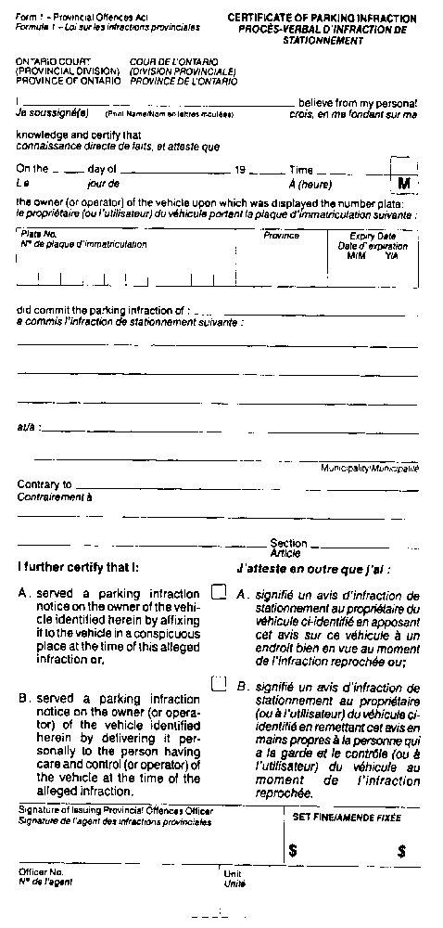
Insert regs\graphics\1990\949\949001bb.tif
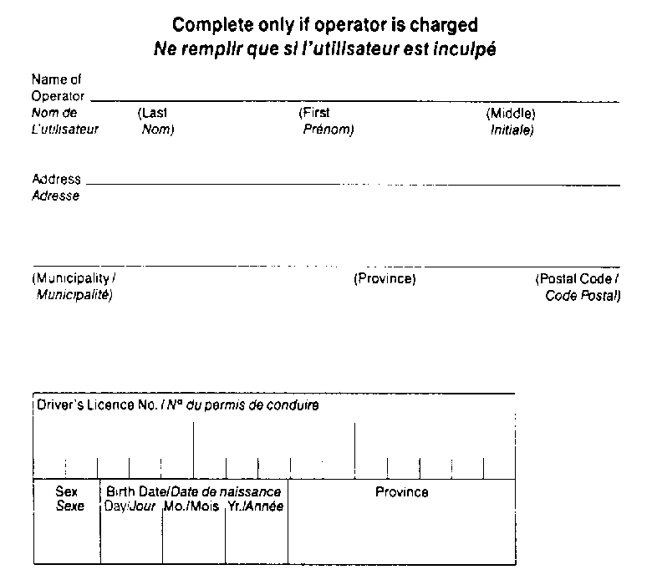
O. Reg. 494/94, s. 3.
Form 2/Formule 2
parking infraction notice/avis d’infraction de stationnement
Provincial Offences Act/Loi sur les infractions provinciales
Insert regs\graphics\1990\949\949002ab.tif
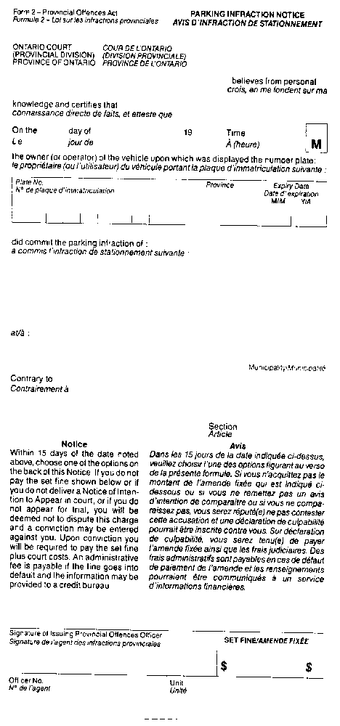
Insert regs\graphics\1990\949\949002bb.tif
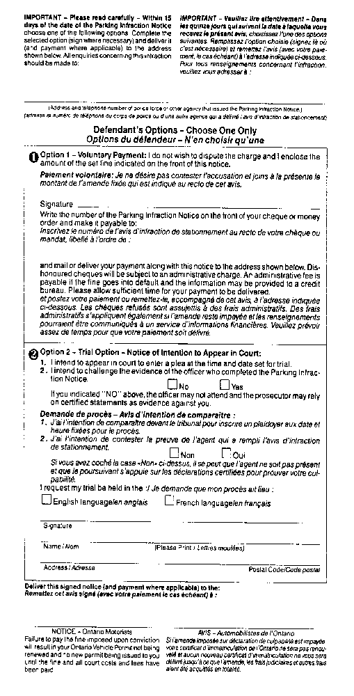
O. Reg. 494/94, s. 3.
Form 3/Formule 3
parking infraction notice/avis d’infraction de stationnement
Provincial Offences Act/Loi sur les infractions provinciales
Insert regs\graphics\1990\949\949003ab.tif
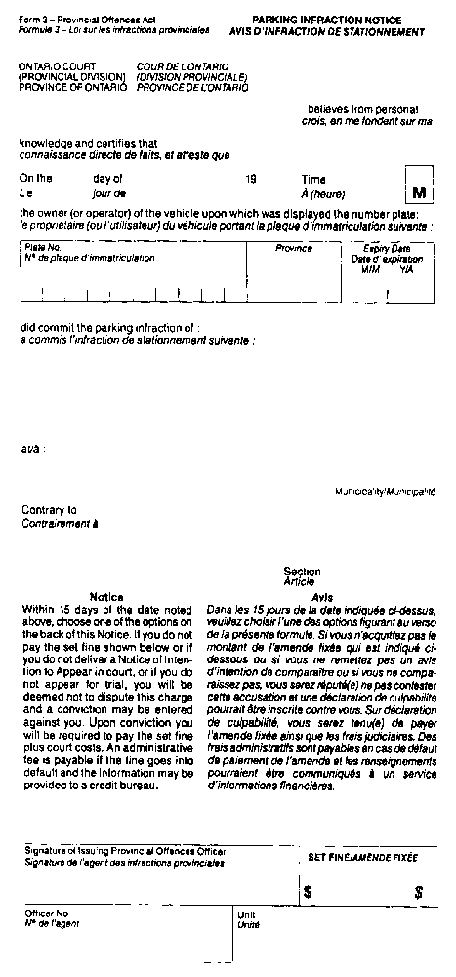
Insert regs\graphics\1990\949\949003bb.tif
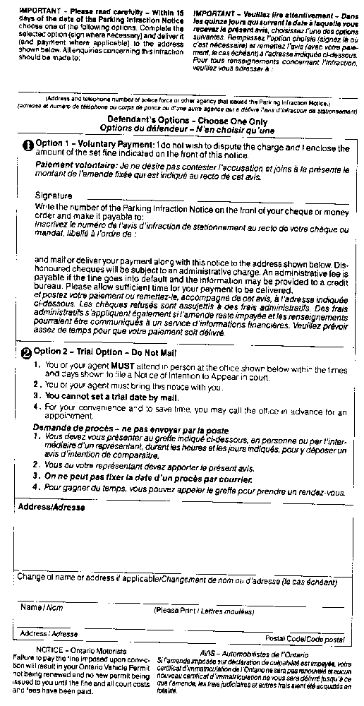
O. Reg. 494/94, s. 3.
Form 4/Formule 4
NOTICE OF impending conviction/avis de dÉclaration de culpabilitÉ imminente
Provincial Offences Act/Loi sur les infractions provinciales
Insert regs\graphics\1990\949\949004ab.tif
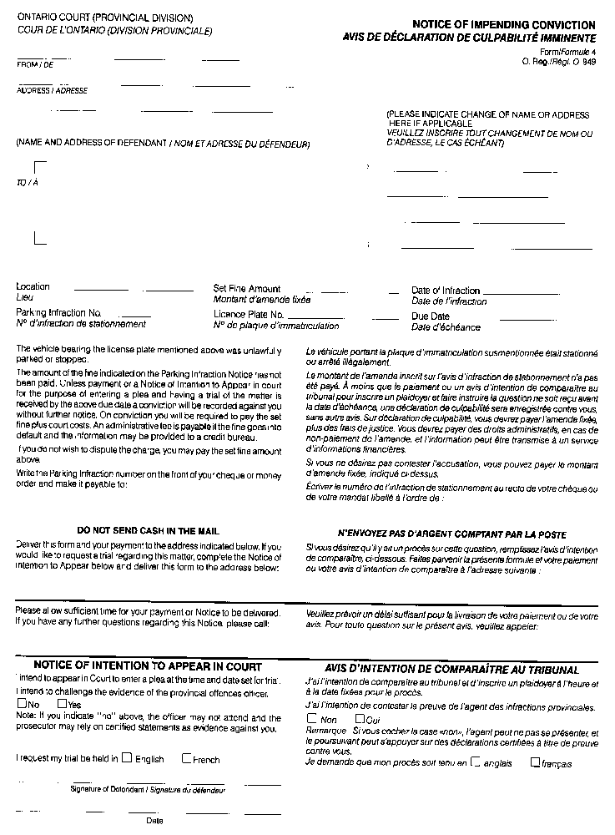

O. Reg. 494/94, s. 3.
Form 5/Formule 5
NOTICE OF impending conviction/avis de dÉclaration de culpabilitÉ imminente
Provincial Offences Act/Loi sur les infractions provinciales
Insert regs\graphics\1990\949\949005ab.tif
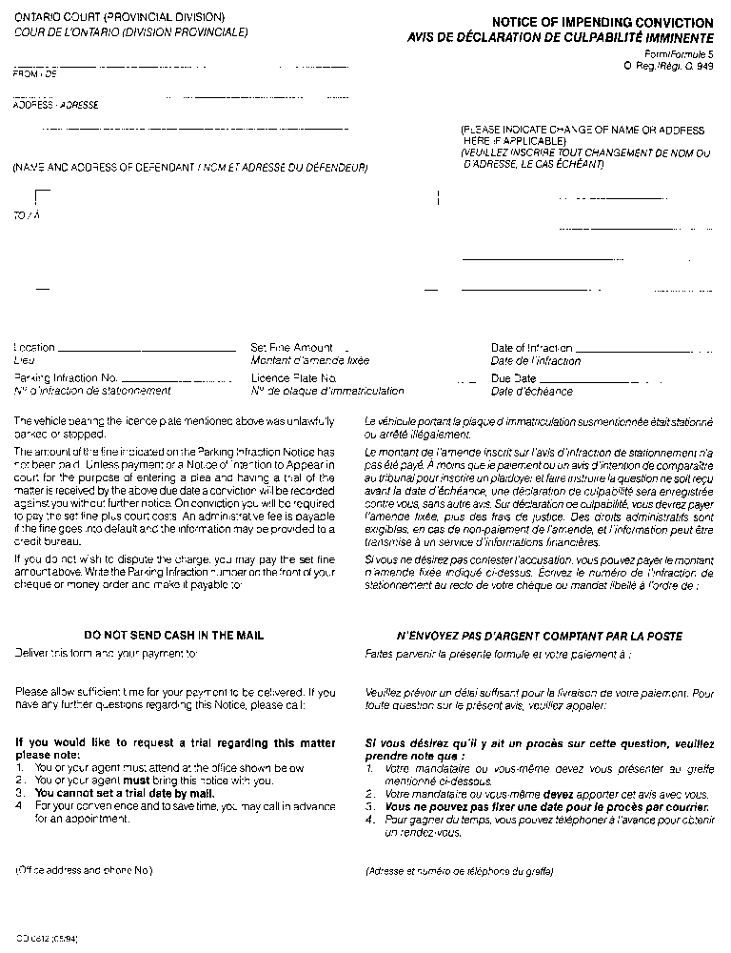

O. Reg. 494/94, s. 3.
Form 6/Formule 6
certificate requesting conviction/certificat de demande de dÉclaration de culpabilitÉ
Provincial Offences Act/Loi sur les infractions provinciales
Insert regs\graphics\1990\949\949006ab.tif
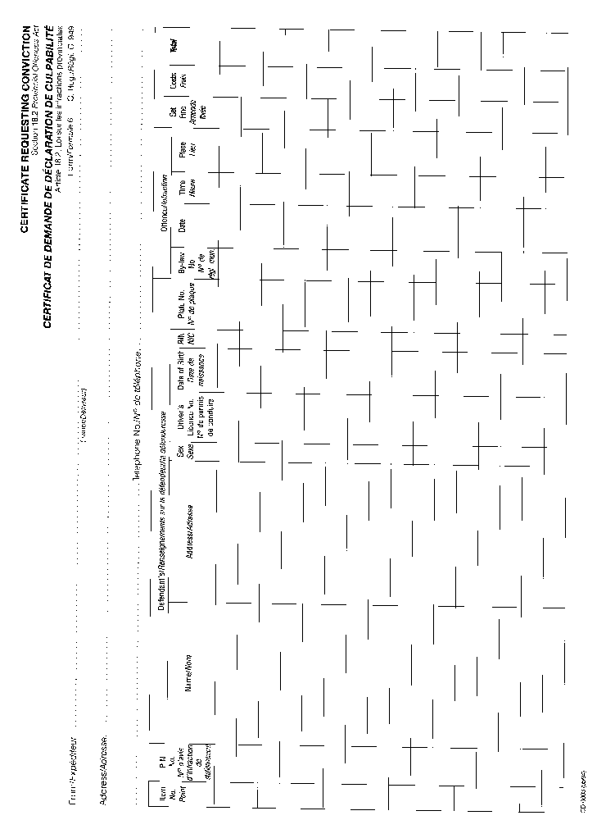

Insert regs\graphics\1990\949\949006bb.tif
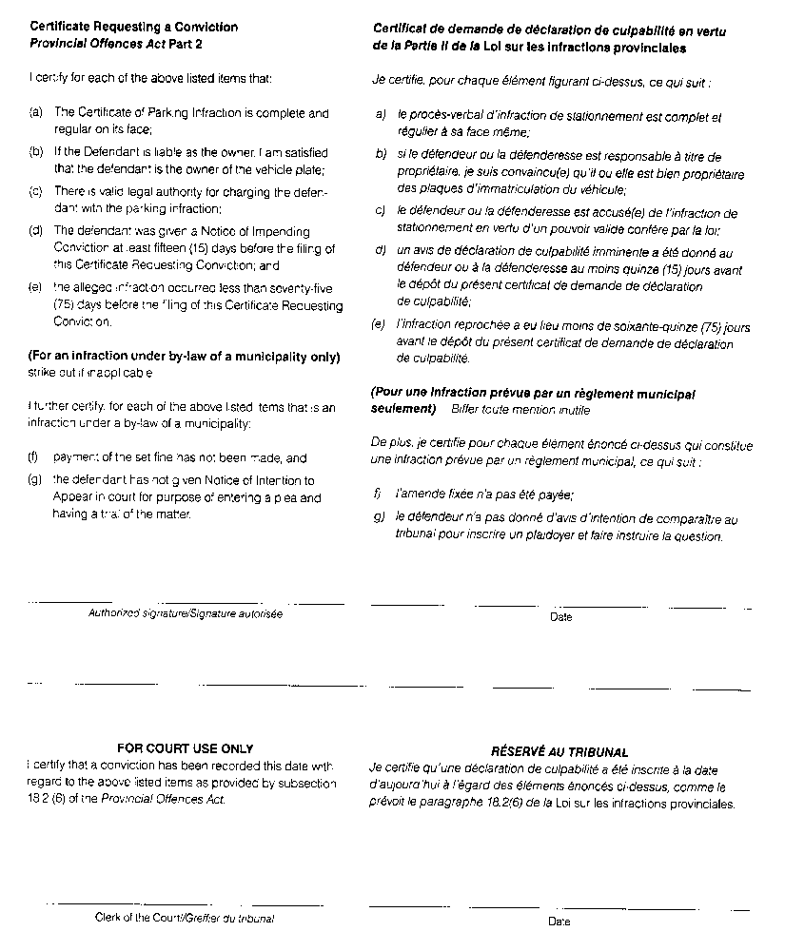
O. Reg. 494/94, s. 3.
Form 7/Formule 7
NOTICE OF fine and due date/avis d’amende et date d’ÉchÉance
Provincial Offences Act/Loi sur les infractions provinciales
Insert regs\graphics\1990\949\949007ab.tif
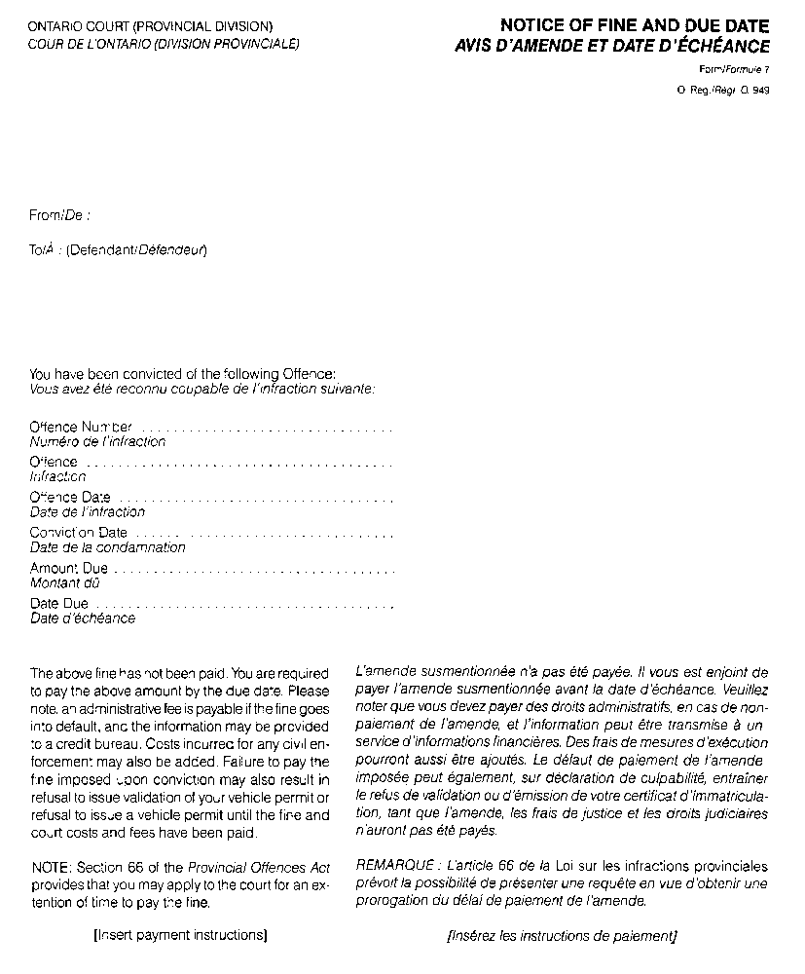
O. Reg. 494/94, s. 3.

Back to top

