Registry Act
Loi sur l’enregistrement des actes
R.R.O. 1990, REGULATION 995
FORMS AND RECORDS
Historical version for the period January 25, 1999 to August 31, 2011.
Last amendment: O. Reg. 20/99.
This Regulation is made in English only.
1. Revoked: O. Reg. 20/99, s. 1.
2. Revoked: O. Reg. 20/99, s. 1.
3. Revoked: O. Reg. 20/99, s. 1.
4. Revoked: O. Reg. 20/99, s. 1.
5. Revoked: O. Reg. 20/99, s. 1.
6. Revoked: O. Reg. 20/99, s. 1.
7. Revoked: O. Reg. 20/99, s. 1.
8. Revoked: O. Reg. 20/99, s. 1.
9. Revoked: O. Reg. 20/99, s. 1.
10. Revoked: O. Reg. 20/99, s. 1.
11. Revoked: O. Reg. 20/99, s. 1.
12. Revoked: O. Reg. 20/99, s. 1.
13. Revoked: O. Reg. 20/99, s. 1.
14. Revoked: O. Reg. 20/99, s. 1.
15. Revoked: O. Reg. 20/99, s. 1.
16. Revoked: O. Reg. 20/99, s. 1.
17. Revoked: O. Reg. 20/99, s. 1.
18. Subsections 20 (2) and 21 (5) of the Act do not apply to,
(a) an order of the Ontario Municipal Board or other instrument registered under section 68 of the Act;
(b) a municipal by-law other than a by-law under subsection 50 (4) or (7) of the Planning Act or a predecessor of those subsections;
(c) a will, letters probate, letters of administration with the will annexed, or any grant by a court based on a will; or
(d) a power of attorney or revocation thereof. R.R.O. 1990, Reg. 995, s. 18.
19. (1) Where a deed or other instrument includes a description of a servient right of way or other easement and refers to other land to which the right of way or easement is appurtenant, it is not necessary, only because of such reference, to record the deed or other instrument in the abstract index for the other land.
(2) Where a deed or other instrument contains or refers to a restrictive covenant or building scheme and refers to other land affected by the restrictive covenant or the building scheme, it is not necessary, only because of such reference, to record the deed or other instrument in the abstract index for the other land. R.R.O. 1990, Reg. 995, s. 19.
20. (1) A notice of,
(a) a lease;
(b) a sublease;
(c) an assignment of a lease;
(d) a mortgage of a lease;
(e) an assignment of the lessor’s interest in a lease;
(f) a determination or surrender of a lease;
(g) an agreement to lease; or
(h) an option to lease,
registered under subsection 22 (7) of the Act shall be in Form 10.
(2) A notice of an instrument to which this section applies shall not be registered unless it is signed by one of the parties to the instrument or the party’s solicitor.
(3) An attorney may sign on behalf of a person who is required by this section to sign a notice, in which case section 46 of the Act applies.
(4) A notice of a lease or of an agreement to lease, as the case may be, shall contain,
(a) the names of the parties;
(b) its date;
(c) the term and expiry date of the lease;
(d) where applicable, the expiry date of the agreement to lease;
(e) any right or option to purchase;
(f) any provision for renewal or extension and the conditions relating thereto; and
(g) the addresses of all parties mentioned in the lease or the agreement.
(5) A notice of a sublease, assignment of a lease, mortgage of a lease or assignment of the lessor’s interest in a lease shall contain,
(a) the registration number of the lease;
(b) the registration number of a notice of the lease, if the notice of the lease complies with Form 10; or
(c) particulars of the lease, including,
(i) the names of the parties,
(ii) its date,
(iii) the term and the expiry date of the lease,
(iv) any right or option to purchase,
(v) any provision for renewal or extension and the conditions relating thereto,
(vi) in the case of a mortgage of a lease or an assignment of the lessor’s interest in the lease, the amount of the indebtedness, and
(vii) the address of all parties mentioned in the notice.
(6) A notice of an option to lease shall contain,
(a) the name of the parties;
(b) its date;
(c) the expiry date of the option;
(d) the term of the lease;
(e) any right or option to purchase;
(f) any provision for renewal or extension of the lease and the conditions relating thereto; and
(g) the addresses of all the parties mentioned in the option to lease. R.R.O. 1990, Reg. 995 s. 20.
21. (1) Despite section 20, a notice of a lease of chattels that have become, or may become, fixtures shall be in Form 11.
(2) A notice of a lease in Form 11 shall not be registered unless the notice is signed by the owner of the chattels. R.R.O. 1990, Reg. 995, s. 21.
22. (1) In this section,
“agreement” means an agreement of purchase and sale of land;
“assignment” means an assignment of an agreement of purchase and sale of land or an assignment of an option for the purchase of land, as the case may be;
“option” means an option for the purchase of land.
(2) A notice registered under subsection 22 (8) of the Act shall be in Form 12.
(3) A renewal notice registered under subsection 22 (10) of the Act shall be in Form 13.
(4) A notice or renewal notice of an agreement, option or assignment shall not be registered unless the notice or renewal notice is signed by,
(a) the purchaser, grantee of the option or assignee named in the notice or renewal notice, as the case may be; or
(b) the solicitor for the purchaser, grantee of the option or assignee.
(5) An attorney may sign on behalf of a person who is required by subsection (4) to sign a notice, in which case section 46 of the Act applies.
(6) A notice registered under subsection 22 (8) of the Act and a renewal notice under subsection 22 (10) of the Act shall contain,
(a) the address of the person signing the notice;
(b) the names of the parties to the agreement, option or assignment to which the notice relates;
(c) the date of the agreement, option or assignment to which the notice relates;
(d) in the case of a notice of an agreement or notice of an assignment of an agreement, the date on which the sale is to be completed;
(e) in the case of a notice of an option or notice of an assignment of an option, the date on which the option will expire and any provision for renewal or extension and the conditions relating thereto; and
(f) in the case of a notice of an assignment,
(i) the registration number of the agreement or option, or
(ii) the registration number of the notice of the agreement or option, or
(iii) particulars of the agreement or option including the matters referred to in clauses (b), (c), (d) and (e).
(7) A renewal notice registered under subsection 22 (10) of the Act shall contain,
(a) the registration number of the notice to which it relates and every previous renewal notice thereof; and
(b) the date of registration of the notice to which it relates and every previous renewal notice thereof.
(8) An affidavit of good faith referred to in subsection 22 (11) of the Act shall be in Form 14 and shall be made by the person who signs the notice to which the affidavit refers. R.R.O. 1990, Reg. 995, s. 22.
23. A declaration under section 24 or 25 of the Act shall be in Form 15. R.R.O. 1990, Reg. 995, s. 23.
24. Revoked: O. Reg. 20/99, s. 2.
25. Revoked: O. Reg. 20/99, s. 2.
26. Revoked: O. Reg. 20/99, s. 2.
27. A notice of change of address for service under subsection 42 (2) of the Act shall be in Form 17. R.R.O. 1990, Reg. 995, s. 27.
Registration and Deposit of Instruments and Documents in French
28. (1) Revoked: O. Reg. 20/99, s. 3.
(2) Revoked: O. Reg. 20/99, s. 3.
(3) Despite section 43 of the Act, where a form is prescribed in the English language for an instrument, deposit or any related attachment but no form is prescribed in the French language and the land registrar is of the opinion that a translation of the form in the French language presented for registration is an accurate translation of the form prescribed in the English language, the French translation is a prescribed form for the purposes of the Act and the regulations.
(4) Despite subsection (1), all registry divisions are designated for the purposes of section 44 of the Act where the instrument to be registered or document to be deposited is the bilingual version of Form 1, 2, 3, 4 or 5 of Regulation 688 of the Revised Regulations of Ontario, 1990 (Documents).
(5) Where the instrument to be registered or document to be deposited is the bilingual version of Form 1, 2, 3, 4 or 5 of Regulation 688 of the Revised Regulations of Ontario, 1990 (Documents) and words have been added to the instrument or document and the land registrar is of the opinion that all the words that have been added appear in both the English and French languages, the instrument or document may be registered. R.R.O. 1990, Reg. 995, s. 28 (3-5).
29. A certificate of a judge under section 35 or subsection 46 (1) of the Act shall be in Form 18. R.R.O. 1990, Reg. 995, s. 29.
30. (1) Revoked: O. Reg. 20/99, s. 4.
(2) Revoked: O. Reg. 20/99, s. 4.
(3) Revoked: O. Reg. 20/99, s. 4.
(4) Revoked: O. Reg. 20/99, s. 4.
(5) Revoked: O. Reg. 20/99, s. 4.
(6) An instrument executed under a power of attorney shall not be registered unless the attorney states in the instrument that, to the best of the attorney’s knowledge and belief, the power of attorney is still in full force and effect and the principal was at least eighteen years of age when the power of attorney was executed. R.R.O. 1990, Reg. 995, s. 30 (6).
31. Revoked: O. Reg. 20/99, s. 5.
32. A certificate of a judge under subsection 47 (9) of the Act shall be in Form 21. R.R.O. 1990, Reg. 995, s. 32.
33. (1) Revoked: O. Reg. 20/99, s. 6.
(2) A facsimile of the signature of the land registrar may be used to authenticate a certificate under subsection (1). R.R.O. 1990, Reg. 995, s. 33 (2).
34. Revoked: O. Reg. 20/99, s. 7.
35. Revoked: O. Reg. 20/99, s. 7.
36. Revoked: O. Reg. 20/99, s. 7.
37. Revoked: O. Reg. 20/99, s. 7.
38. Revoked: O. Reg. 20/99, s. 7.
39. An affidavit where an instrument does not conform and refer to a plan as mentioned in subsection 86 (1) of the Act shall be in Form 28. R.R.O. 1990, Reg. 995, s. 39.
40. Revoked: O. Reg. 20/99, s. 8.
41. (1) A requisition under subsection 107 (3) of the Act shall be in Form 4 of Regulation 688 of the Revised Regulations of Ontario, 1990 made under the Land Registration Reform Act, and the document to be deposited shall be written on or attached to that Form 4.
(2) Only one document for deposit may be written on or attached to a requisition, but the land registrar may permit two or more related documents to be written on or attached to a requisition as if they were one document. R.R.O. 1990, Reg. 995, s. 41.
42. A certificate of deposit referred to in subsection 108 (2) of the Act shall be in Form 31. R.R.O. 1990, Reg. 995, s. 42.
43. Revoked: O. Reg. 20/99, s. 9.
44. Revoked: O. Reg. 20/99, s. 9.
45. Revoked: O. Reg. 20/99, s. 9.
46. Revoked: O. Reg. 20/99, s. 9.
47. Revoked: O. Reg. 20/99, s. 9.
48. A tax deed or notice of vesting under the Municipal Tax Sales Act in respect of land that, on the date of the deed or notice, was in a local municipality referred to in Schedule 2 shall not be registered under the Registry Act unless it bears a statement in Form 34 or 35 and the statement is completed and is signed by or includes a facsimile of the signature of the Director of the Land Management Branch of the Ministry of Natural Resources. R.R.O. 1990, Reg. 995, s. 48.
49. Revoked: O. Reg. 20/99, s. 10.
50. Revoked: O. Reg. 20/99, s. 11.
51. Revoked: O. Reg. 20/99, s. 11.
52. Revoked: O. Reg. 20/99, s. 11.
53. (1) Where the Archivist of Ontario considers that a plan of survey or other plan that is the property of the Crown and that is in the custody of a land registrar has historical significance and where the Archivist of Ontario requests the land registrar to transfer the plan to him or her, the land registrar shall, where he or she receives such a request and written instructions from the Director with respect to the plan, transfer the plan to the Archivist of Ontario.
(2) A plan shall not be transferred to the Archivist of Ontario under subsection (1) until the land registrar has obtained and certified a copy of the plan, reproduced on mylar or other suitable material, from which further copies may be made showing with reasonable clarity all or substantially all the measurements, bearings and other pertinent information that were legible on the plan when the copy was made.
(3) Where the Archivist of Ontario receives a plan under this section, the Archivist shall preserve it in his or her custody and the Archivist may, where he or she has the approval of the Director to the transfer, transfer the plan on loan to an historical society, university, museum, county archives or similar organization.
(4) This section applies to plans in land registry offices established under the Act or the Land Titles Act. R.R.O. 1990, Reg. 995, s. 53.
54. Revoked: O. Reg. 20/99, s. 12.
55. Revoked: O. Reg. 20/99, s. 12.
56. Revoked: O. Reg. 20/99, s. 12.
57. The land registrar shall enter in the new abstract index under the heading for each lot designated by a Land Registrar’s Compiled Plan or a municipal plan prepared under section 91 of the Act the following note:
“Caution: Section 50 of the Planning Act may continue to apply as though this plan had not been registered.”
R.R.O. 1990, Reg. 995, s. 57.
58. Where, by a by-law under subsection 50 (4) or (7) of the Planning Act or by an order under clause 47 (1) (b) of that Act, a registered plan of subdivision or part thereof is deemed for the purposes of subsection 50 (3) of that Act not to be a registered plan of subdivision or is exempted from part-lot control, the by-law or order upon registration shall be recorded in the abstract index for each lot included in the plan or such portion of the plan as is designated in the by-law or order. R.R.O. 1990, Reg. 995, s. 58.
59. (1) A notice of Claim registered under subsection 113 (2) of the Act shall be in Form 32.
(2) An affidavit in support of a Notice of Claim under subsection 113 (2) of the Act shall be in Form 33. R.R.O. 1990, Reg. 995, s. 59.
Schedule 1 Revoked: O. Reg. 20/99, s. 13.
Schedule 2
Item | Column 1 | Column 2
 | County, District, etc. | Local Municipalities
1. | County of Frontenac | Townships of
 |  | Barrie, Bedford,
 |  | Clarendon and Miller,
 |  | Hinchinbrooke,
 |  | Kennebec,
 |  | Loughborough,
 |  | Olden,
 |  | Palmerston and North and South Canonto,
 |  | Portland,
 |  | Storrington.
2. | County of Haliburton | All
3. | County of Hastings | Townships of
 |  | Dungannon,
 |  | Elzevir and Grimsthorpe,
 |  | Faraday,
 |  | Herschel,
 |  | Hungerford,
 |  | Huntingdon,
 |  | Limerick,
 |  | Madoc,
 |  | Marmora and Lake,
 |  | Mayo,
 |  | Monteagle,
 |  | Rawdon,
 |  | Tudor and Cashel,
 |  | Wollaston.
4. | County of Lanark | Townships of
 |  | Bathurst,
 |  | Darling,
 |  | Lavant, Dalhousie and North Sherbrooke,
 |  | North Burgess.
5. | County of Leeds | Township of
 |  | Bastard and South Burgess.
6. | County of Lennox and Addington | Townships of
 |  | Denbigh, Abinger and Ashby, Kaladar, Anglesea and Effingham,
 |  | Sheffield.
7. | County of Northumberland | Township of Seymour.
8. | County of Peterborough | Townships of
 |  | Belmont and Methuen,
 |  | Burleigh and Anstruther,
 |  | Chandos,
 |  | Galway and Cavendish,
 |  | Harvey.
9. | County of Renfrew | Townships of
 |  | Admaston,
 |  | Alice and Fraser,
 |  | Bagot and Blithfield,
 |  | Brougham,
 |  | Brudenell and Lyndoch,
 |  | Grattan,
 |  | Griffith and Matawatchan,
 |  | Hagarty and Richards,
 |  | Raglan,
 |  | Ross,
 |  | Sebastopol.
10. | County of Victoria | Townships of
 |  | Laxton, Digby and Longford,
 |  | Somerville.
11. | The Regional Municipally of Haldimand-Norfolk | Town of Haldimand.
12. | District of Algoma | All
13. | District of Cochrane | All
14. | District of Kenora | All
15. | District of Manitoulin | Townships of
 |  | Assiginack,
 |  | Howland.
16. | The District Municipality of Muskoka | Townships of
 |  | Georgian Bay,
 |  | Lake of Bays,
 |  | Muskoka Lakes.
17. | District of Nipissing | All
18. | District of Parry Sound | Town of Kearney,
 |  | Townships of
 |  | The Archipelago,
 |  | Armour,
 |  | Carling,
 |  | Chapman,
 |  | Foley,
 |  | North Himsworth,
 |  | South Himsworth,
 |  | Humphrey,
 |  | McDougall,
 |  | McKellar,
 |  | McMurrich,
 |  | Nipissing,
 |  | Ryerson,
 |  | Strong.
19. | District of Rainy River | All
20. | District of Sudbury | All (including all local municipalities in The Regional Municipality of Sudbury).
21. | District of Thunder Bay | All
22. | District of Timiskaming | All
R.R.O. 1990, Reg. 995, Sched. 2.
Form 1
APPOINTMENT OF ASSISTANT DEPUTY LAND REGISTRAR
Registry Act
Insert regs\graphics\1990\995\995001au.tif
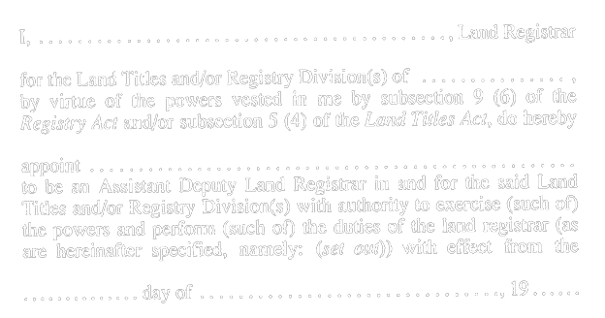
Insert regs\graphics\1990\995\995001bu.tif

R.R.O. 1990, Reg. 995, Form 1.
Form 2 Revoked: O. Reg. 20/99, s. 14.
Form 3 Revoked: O. Reg. 20/99, s. 14.
Form 4 Revoked: O. Reg. 20/99, s. 14.
Form 5
CERTIFICATE
Registry Act
Insert regs\graphics\1990\995\995005au.tif
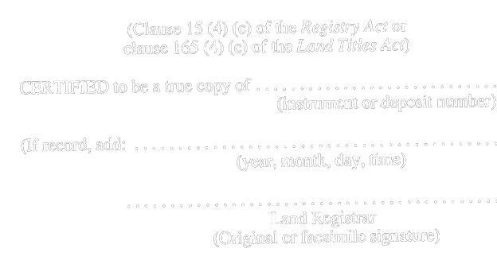
R.R.O. 1990, Reg. 995, Form 5.
Form 6
GENERAL REGISTER INDEX UNDER SUBSECTION 18 (8) OF THE ACT
Registry Act
Insert regs\graphics\1990\995\995006au.tif
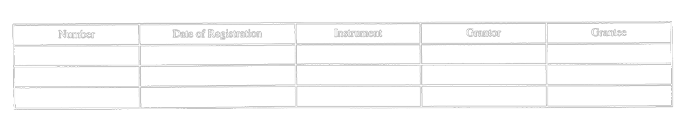
R.R.O. 1990, Reg. 995, Form 6.
Form 7
BY-LAW INDEX UNDER SUBSECTION 18 (1) OF THE ACT
Registry Act
Insert regs\graphics\1990\995\995007au.tif
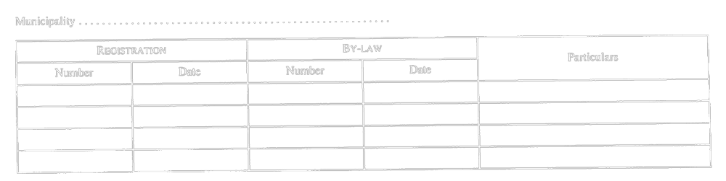
R.R.O. 1990, Reg. 995, Form 7.
Form 8
ALPHABETICAL INDEX OF WILLS, PROBATES, ETC., UNDER SUBSECTION 18(9) OF THE ACT
Registry Act
Insert regs\graphics\1990\995\995008au.tif
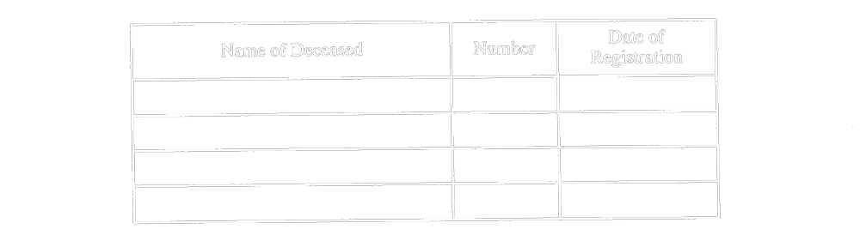
R.R.O. 1990, Reg. 995, Form 8.
Form 9 Revoked: O. Reg. 20/99, s. 14.
Form 10
NOTICE OF LEASE, AGREEMENT TO LEASE, OPTION TO LEASE OR INTEREST UNDER LEASE (Subsection 22 (7) of the Act)
Registry Act
Insert regs\graphics\1990\995\995010au.tif
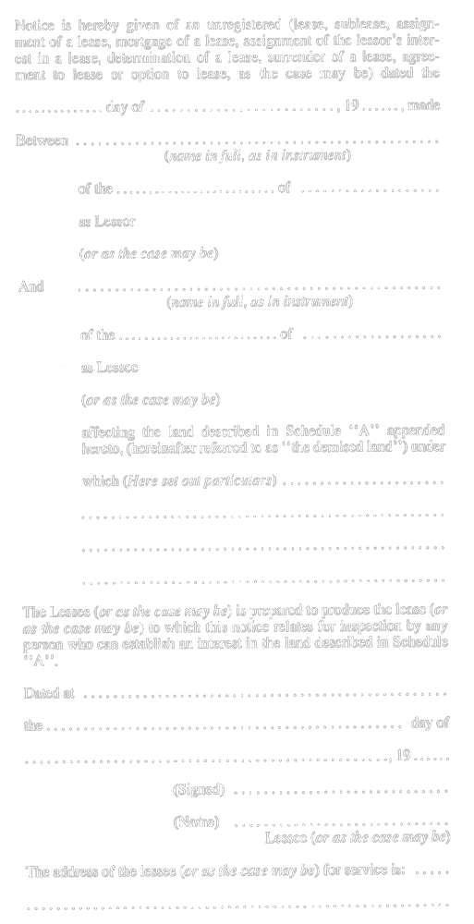
R.R.O. 1990, Reg. 995, Form 10.
Form 11
NOTICE OF LEASE OF CHATTELS (Subsection 22 (7) of the Act)
Registry Act
Insert regs\graphics\1990\995\995011au.tif
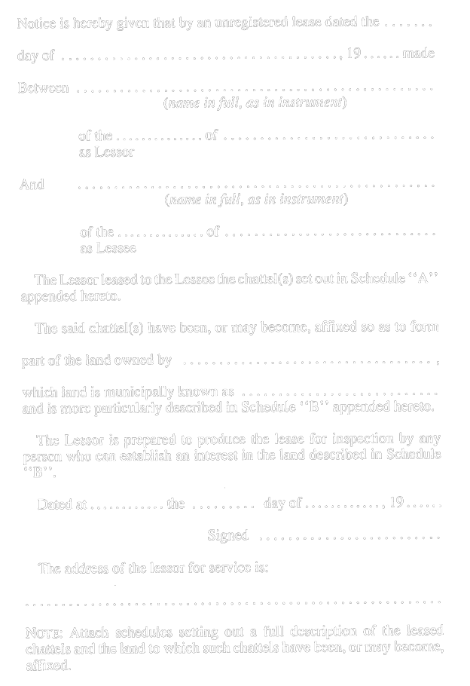
R.R.O. 1990, Reg. 995, Form 11.
Form 12
NOTICE OF AN AGREEMENT OF PURCHASE AND SALE, OPTION TO PURCHASE OR ASSIGNMENT THEREOF (Under subsection 22 (8) of the Act)
Registry Act
Insert regs\graphics\1990\995\995012au.tif

Insert regs\graphics\1990\995\995012bu.tif
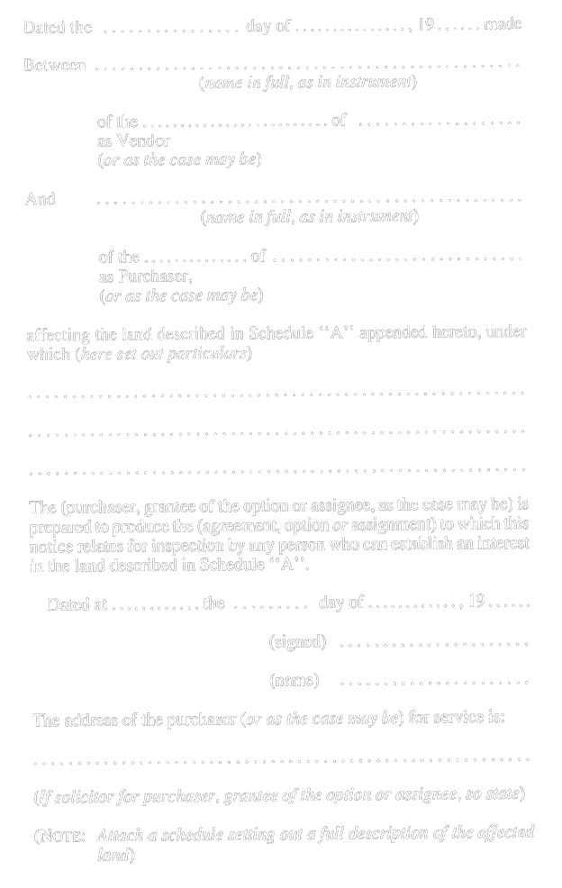
R.R.O. 1990, Reg. 995, Form 12.
Form 13
RENEWAL NOTICE OF AN AGREEMENT OF PURCHASE AND SALE OPTION TO PURCHASE OR ASSIGNMENT THEREOF (Under subsection 22 (10) of the Act)
Registry Act
Insert regs\graphics\1990\995\995013au.tif
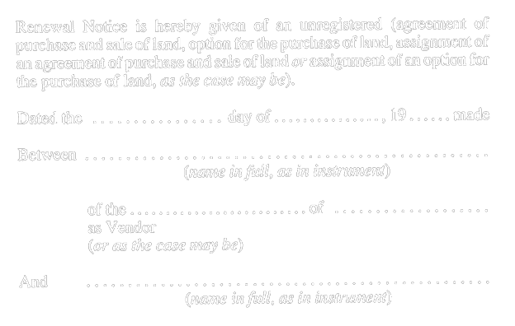
Insert regs\graphics\1990\995\995013bu.tif
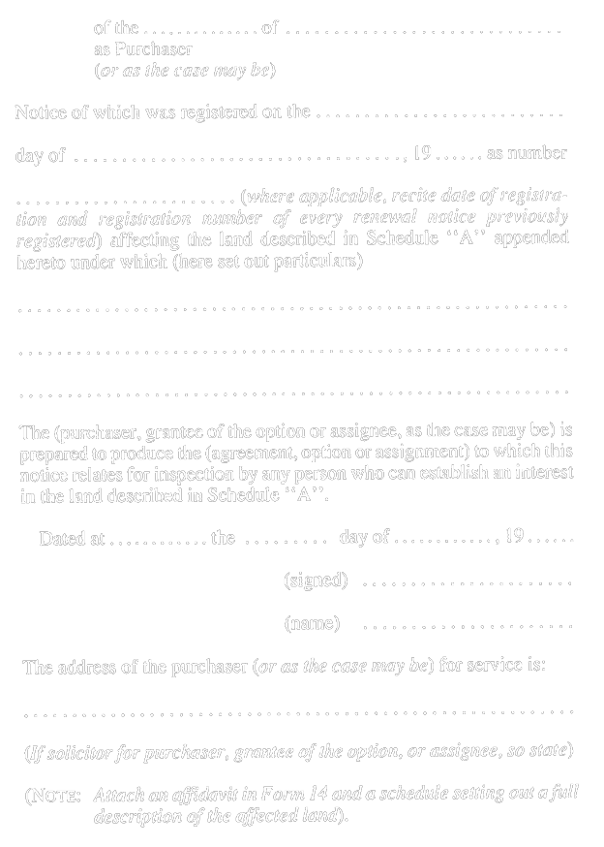
R.R.O. 1990, Reg. 995, Form 13.
Form 14
AFFIDAVIT OF GOOD FAITH UNDER SUBSECTION 22 (11) OF THE ACT
Registry Act
Insert regs\graphics\1990\995\995014au.tif
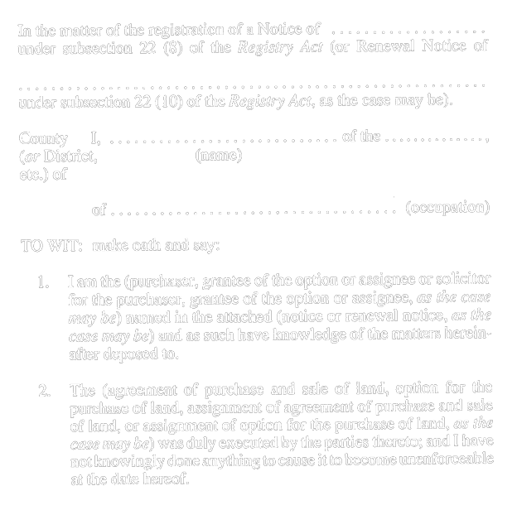
Insert regs\graphics\1990\995\995014bu.tif
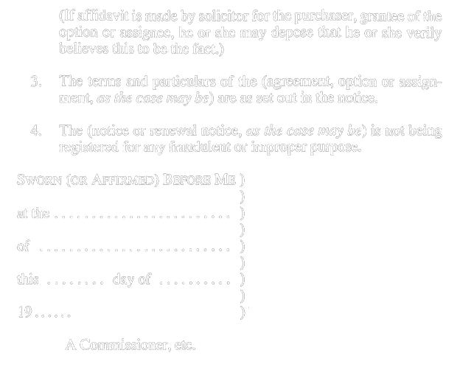
R.R.O. 1990, Reg. 995, Form 14.
Form 15
DECLARATION UNDER SECTION 24 OF THE ACT
Registry Act
Insert regs\graphics\1990\995\995015au.tif
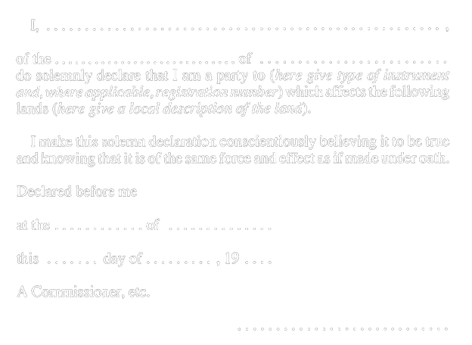
R.R.O. 1990, Reg. 995, Form 15.
Form 16 Revoked: O. Reg. 20/99, s. 14.
Form 17 Revoked: O. Reg. 20/99, s. 14.
Form 18
CERTIFICATE OF A JUDGE UNDER SECTION 35 OR UNDER SUBSECTION 46 (1) OF THE ACT
Registry Act
Insert regs\graphics\1990\995\995018au.tif
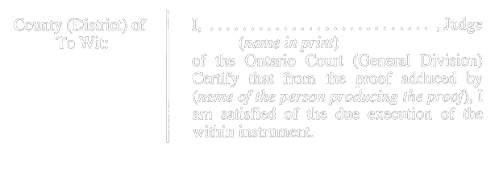
Insert regs\graphics\1990\995\995018bu.tif

R.R.O. 1990, Reg. 995, Form 18.
Form 19 Revoked: O. Reg. 20/99, s. 14.
Form 20 Revoked: O. Reg. 20/99, s. 14.
Form 21
CERTIFICATE OF A JUDGE UNDER SUBSECTION 47 (9) OF THE ACT
Registry Act
Insert regs\graphics\1990\995\995021au.tif
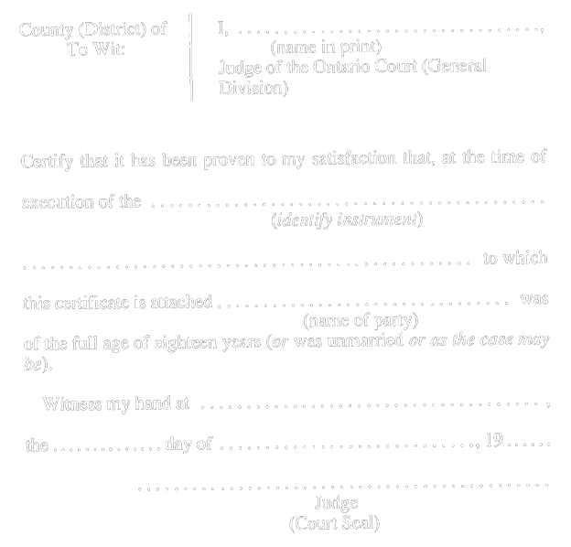
R.R.O. 1990, Reg. 995, Form 21.
Form 22 Revoked: O. Reg. 20/99, s. 14.
Form 23
CERTIFICATE OF REGISTRATION
Registry Act
Insert regs\graphics\1990\995\995023au.tif
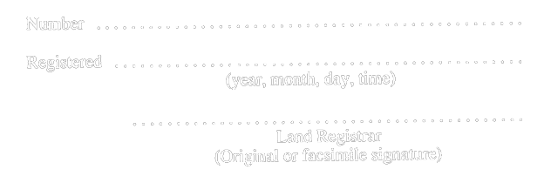
R.R.O. 1990, Reg. 995, Form 23.
Form 24 Revoked: O. Reg. 20/99, s. 14.
Form 25 Revoked: O. Reg. 20/99, s. 14.
Form 26 Revoked: O. Reg. 20/99, s. 14.
Form 27 Revoked: O. Reg. 20/99, s. 14.
Form 28
AFFIDAVIT WHERE INSTRUMENT DOES NOT CONFORM TO PLAN UNDER SUBSECTION 86 (1) OF THE ACT
Registry Act
Insert regs\graphics\1990\995\995028au.tif

Insert regs\graphics\1990\995\995028bu.tif
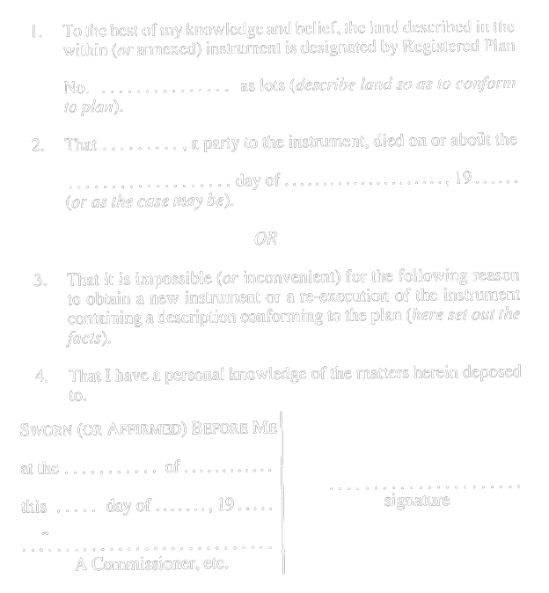
R.R.O. 1990, Reg. 995, Form 28.
Form 29 Revoked: O. Reg. 20/99, s. 14.
Form 30 Revoked: O. Reg. 20/99, s. 14.
Form 31
CERTIFICATE OF DEPOSIT
Registry Act
Insert regs\graphics\1990\995\995031au.tif

R.R.O. 1990, Reg. 995, Form 31.
Form 32
NOTICE OF CLAIM
Registry Act
Insert regs\graphics\1990\995\995032au.tif
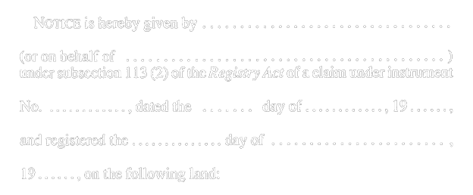
Insert regs\graphics\1990\995\995032bu.tif
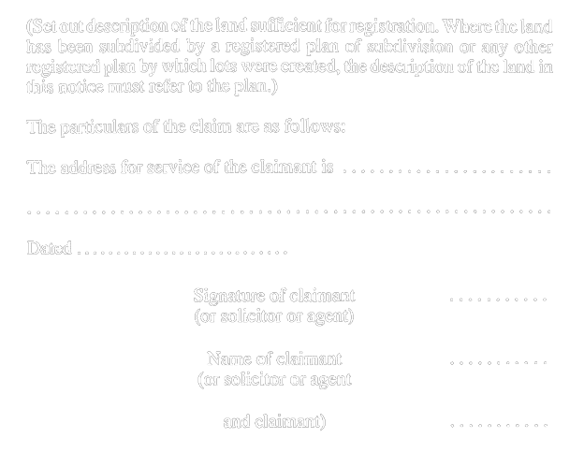
R.R.O. 1990, Reg. 995, Form 32.
Form 33
AFFIDAVIT IN SUPPORT OF NOTICE OF CLAIM UNDER SUBSECTION 113 (2) OF THE ACT
Registry Act
Insert regs\graphics\1990\995\995033au.tif
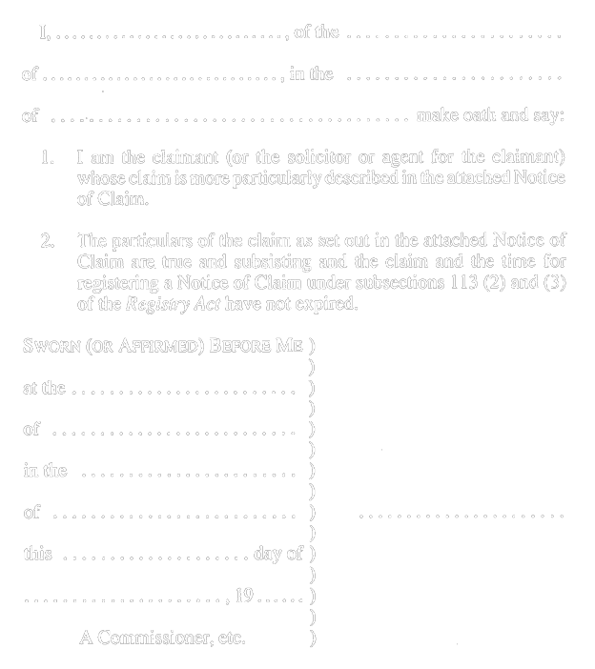
R.R.O. 1990, Reg. 995, Form 33.
Form 34
MINISTRY OF NATURAL RESOURCES (to be completed in certain municipalities)
Registry Act
Insert regs\graphics\1990\995\995034ae.tif

Formule 34
MINISTÈRE DES RICHESSES NATURELLES (à remplir dans certaines municipalités)
Loi sur l’enregistrement des actes
Insert regs\graphics\1990\995\995034af.tif
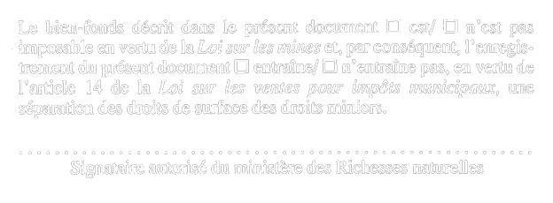
R.R.O. 1990, Reg. 995, Form 34.

Back to top

