Environmental Protection Act
Loi sur la protection de l’environnement
ONTARIO REGULATION 760/93
EFFLUENT MONITORING AND EFFLUENT LIMITS — PULP AND PAPER SECTOR
Historical version for the period August 1, 2007 to June 13, 2011.
Last amendment: O. Reg. 233/07.
This Regulation is made in English only.
Skip Table of Contents
CONTENTS
 |  | Sections
PART I | GENERAL
 | Interpretation | 1
 | Purpose | 2
 | Application | 3
 | Requirements under Approvals, Orders, etc. | 4
 | Non-application of General Effluent Monitoring Regulation | 5
 | By-passes | 6
 | Sampling and Analytical Procedures | 7
PART II | SAMPLING POINTS
 | Establishment and Elimination of Sampling Points | 8
 | Reports on Sampling Points | 9
 | Use of Sampling Points Established under This Part | 10
PART III | CALCULATION OF LOADINGS
 | Calculation of Loadings — General | 11
 | Calculation of Loadings — Process Effluent | 12
 | Calculation of Loadings — Cooling Water | 13
PART IV | PARAMETER AND LETHALITY LIMITS
 | Parameter Limits | 14
 | Revised Parameter Limits | 15
 | Lethality Limits | 16
PART V | MONITORING
 | Monitoring — General | 17
 | Monitoring — Process Effluent — Daily | 18
 | Monitoring — Process Effluent — Weekly | 19
 | Monitoring — Process Effluent — Quarterly | 20
 | Monitoring — Process Effluent — Quality Control | 21
 | Monitoring — Process Effluent — pH Measurement | 22
 | Monitoring — Cooling Water Effluent — pH and Specific Conductance Measurement | 22.1
 | Monitoring — Acute Lethality Testing — Rainbow Trout | 23
 | Monitoring — Acute Lethality Testing — Daphnia magna | 24
 | Monitoring — Chronic Toxicity Testing — Fathead Minnow and Ceriodaphnia Dubia | 25
 | Monitoring — Cooling Water Effluent — Weekly Assessment | 26
PART VI | EFFLUENT VOLUME
 | Flow Measurement | 27
 | Calculation of Plant Volumes | 28
PART VII | STORM WATER CONTROL STUDY | 29
PART VIII | RECORDS AND REPORTS
 | Record Keeping | 30
 | Reports Available to the Public | 31
 | Reports to the Director — General | 32
 | Reports to the Director on Compliance with Section 6 and Part IV | 33
 | Quarterly Reports to the Director | 34
 | Reports to the Director on Chronic Toxicity Testing | 35
 | AOX Progress Reports | 36
 | AOX Elimination Reports | 37
 | Review of AOX Reports | 38
PART VIII.1 | DELAYED APPLICATION OF PARTS IV, V AND VI | 38.1-40
Schedule 1 | List of regulated plants
Schedule 2 | Process effluent limits and monitoring frequency
Schedule 3 | Cooling water assessment monitoring
Schedule 4 | Reference production rates
PART I
GENERAL
Interpretation
1. (1) In this Regulation,
“AOX” means adsorbable organic halide;
“assessment parameter” means a parameter that is listed in Schedule 3;
“bleached pulp” means pulp that has been bleached through the use of chlorine or chlorine compounds;
“blowdown water” means recirculating water that is discharged from a cooling water system for the purpose of controlling the level of water in the cooling water system or for the purpose of discharging from the cooling water system materials contained in the cooling water system the further build-up of which would impair the operation of the system;
“cooling water effluent” means water and associated material that is used in an industrial process for the purpose of removing heat and that has not, by design, come into contact with process materials, but does not include blowdown water;
“cooling water effluent monitoring stream” means a cooling water effluent stream on which a sampling point is established under section 8;
“cooling water effluent sampling point” means a sampling point established on a cooling water effluent stream under section 8;
“Director”, in relation to obligations of a discharger, means a Director appointed under section 5 of the Act and responsible for the region in which the discharger’s plant is located and includes an alternate named by the Director;
“discharger” means an owner or person in occupation or having the charge, management or control of a plant to which this Regulation applies;
“dried” includes machine dried and, in relation to bleached pulp or other types of pulp, means dried in a manner so that the moisture content of the pulp does not exceed 10 per cent;
“finished product” means pulp, paper and paper products that have completed the production process at a plant, and includes bleached pulp;
“limited parameter”, in relation to a plant, means a parameter for which a limit is specified for the plant in Column 3 or 4 of Schedule 2;
“pick up”, in relation to a sample, means pick up for the purpose of transportation to and analysis at a laboratory;
“plant” means an industrial facility and the developed property, waste disposal sites and wastewater treatment facilities associated with it;
“process change” means a change in equipment, production processes, process materials or treatment processes;
“process effluent” means,
(a) effluent that, by design, has come into contact with process materials,
(b) blowdown water,
(c) effluent that results from cleaning or maintenance operations at a plant during a period when all or part of the plant is shut down,
(d) effluent from a waste disposal site at a plant,
(e) effluent from a bark storage site at a plant,
(f) effluent that is discharged from an intake water treatment operation at a plant, but does not include effluent that is discharged from an intake water screening operation at a plant, and
(g) any effluent described in clauses (a) to (f) combined with cooling water effluent or storm water effluent;
“process effluent monitoring stream” means a process effluent stream on which a sampling point is established under section 8;
“process effluent sampling point” means a sampling point established on a process effluent stream under section 8;
“process materials”, in relation to a discharger’s plant, means raw materials for use in an industrial process at the plant, manufacturing intermediates produced at the plant, or products or by-products of an industrial process at the plant, but does not include chemicals added to cooling water for the purpose of controlling organisms, fouling and corrosion;
“pulp” means processed cellulose fibre that is derived from wood, other plant material or recycled paper products;
“quarter” means all or part of a period of three consecutive months beginning on the first day of January, April, July or October;
“semi-annual period” means all or part of a period of six months beginning on the first day of January or July;
“specific parameter”, in relation to a plant, means 2, 3, 7, 8-tetrachlorodibenzo-para-dioxin, 2, 3, 7, 8-tetrachlorodibenzofuran, and 2, 3, 7, 8 substituted dioxin and furan congeners;
“storm water effluent” means run-off from a storm event or thaw that is not used in any industrial process.
(2) For greater certainty, this Regulation applies both to effluent streams that discharge continuously and to effluent streams that discharge intermittently.
(3) An obligation on a discharger to do a thing under this Regulation is discharged if another person has done it on the discharger’s behalf. O. Reg. 760/93, s. 1.
Purpose
2. The purpose of this Regulation is to monitor and control the quality of effluent discharged from the plants listed in Schedule 1 and to require dischargers to prepare reports that describe methods that could be used to work toward the Ministry’s goal of eliminating the generation of AOX at dischargers’ plants by the year 2002. O. Reg. 760/93, s. 2.
Application
3. (1) This Regulation applies only with respect to the plants listed in Schedule 1. O. Reg. 760/93, s. 3 (1).
(2) This Regulation does not apply with respect to the discharge of effluent to a municipal sanitary sewer. O. Reg. 760/93, s. 3 (2); O. Reg. 521/95, s. 1.
Requirements under Approvals, Orders, etc.
4. For greater certainty, subject to subsection 186 (4) of the Act, the requirements of this Regulation are in addition to and independent of requirements in an approval, order, direction or other instrument issued under any Act. O. Reg. 521/95, s. 2.
Non-application of General Effluent Monitoring Regulation
5. This Regulation is not a Sectoral Effluent Monitoring Regulation within the meaning of Ontario Regulation 695/88. O. Reg. 760/93, s. 5.
By-passes
6. Beginning on January 1, 1996, a discharger shall not permit effluent that would ordinarily flow past a sampling point established under this Regulation to be discharged from the discharger’s plant without flowing past that sampling point, regardless of whether it would be convenient to do so because of a maintenance operation, a breakdown in equipment or any scheduled or unscheduled event. O. Reg. 521/95, s. 3.
Sampling and Analytical Procedures
7. (1) Each discharger shall carry out the establishment of sampling point obligations of this Regulation and the sampling and analysis obligations of this Regulation, including quality control sampling and analysis obligations, in accordance with the procedures described in the Ministry of the Environment publication entitled “Protocol for the Sampling and Analysis of Industrial/Municipal Wastewater”, as amended from time to time. O. Reg. 233/07, s. 1.
(2) Each discharger shall maintain the sampling equipment used at the discharger’s plant for sampling required by this Regulation in a way that ensures that the samples collected at the plant under this Regulation accurately reflect the level of discharge of each limited parameter, assessment parameter and specific parameter from the plant. O. Reg. 760/93, s. 7 (2).
PART II
SAMPLING POINTS
Establishment and Elimination of Sampling Points
8. (1) Each discharger shall, by February 23, 1994, establish a sampling point on each process effluent and cooling water effluent stream at the discharger’s plant, as necessary so that the plant loadings calculated under sections 12 and 13 for each limited parameter and assessment parameter and the concentrations determined for each specific parameter accurately reflect the level of discharge of each such parameter from the plant. O. Reg. 760/93, s. 8 (1).
(1.1) Each discharger for the Thunder Bay Packaging Inc. plant shall, by December 20, 1995, establish a sampling point on each process effluent and cooling water effluent stream at the discharger’s plant, as necessary so that the plant loadings calculated under sections 12 and 13 for each limited parameter and assessment parameter and the concentrations determined for each specific parameter accurately reflect the level of discharge of each such parameter from the plant.
(1.2) A discharger referred to in subsection (1.1) need not comply with subsection (1). O. Reg. 521/95, s. 5.
(2) If circumstances change so that a new sampling point is necessary at a discharger’s plant in order to permit the calculation of plant loadings under sections 12 and 13 for each limited parameter and assessment parameter and the determination of concentrations for each specific parameter that accurately reflect the level of discharge of each such parameter from the plant, the discharger shall, within thirty days of the change, establish the new sampling point.
(3) A discharger may eliminate a sampling point established under subsection (1) or (2) if the sampling point is no longer necessary to permit the calculation of plant loadings under sections 12 and 13 for each limited parameter and assessment parameter and the determination of concentrations for each specific parameter that accurately reflect the level of discharge of each such parameter from the plant.
(4) For the purposes of this section, a plant loading for a parameter or a concentration for a parameter that is based on analytical results that are significantly affected by dilution or masking due to the merging of streams upstream of a sampling point at a plant is not a loading or a concentration that accurately reflects the level of discharge of the parameter from the plant.
(5) In determining what is necessary to meet a discharger’s obligations to establish sampling points under this section, the discharger shall consider both which streams should have sampling points and where on a stream a sampling point should be located. O. Reg. 760/93, s. 8 (2-5).
(6) Despite subsection (1), a discharger need not establish a sampling point on a by-pass. O. Reg. 521/95, s. 5.
Reports on Sampling Points
9. (1) By March 7, 1994, each discharger shall submit to the Director a list and plot plan showing the sampling points established under this Regulation at the discharger’s plant as of February 23, 1994. O. Reg. 760/93, s. 9 (1).
(1.1) By March 31, 1996, each discharger for the Thunder Bay Packaging Inc. plant shall submit to the Director a list and plot plan showing the sampling points established under this Regulation at the discharger’s plant as of December 20, 1995.
(1.2) A discharger referred to in subsection (1.1) need not comply with subsection (1). O. Reg. 521/95, s. 6.
(2) Within thirty days after establishing a sampling point under this Regulation that is not shown on a list and plot plan submitted under this section, the discharger shall give the Director a written notice describing the location of the sampling point, together with a revised list and plot plan showing the sampling point.
(3) Within thirty days after eliminating a sampling point under this Regulation that is shown on a list and plot plan submitted under this section, the discharger shall give the Director a written notice describing where the sampling point used to be, together with a revised list and plot plan without the sampling point. O. Reg. 760/93, s. 9 (2, 3).
Use of Sampling Points Established under This Part
10. Subject to section 22, each discharger shall use the sampling points established under this Part for all sampling required by this Regulation. O. Reg. 760/93, s. 10.
PART III
CALCULATION OF LOADINGS
Calculation of Loadings — General
11. (1) For the purposes of performing a calculation under sections 12 and 13, a discharger shall use the actual analytical result obtained by the laboratory. O. Reg. 760/93, s. 11 (1).
(2) Despite subsection (1), where the actual analytical result is less than one-tenth of the analytical method detection limit set out in the Ministry of the Environment publication entitled “Protocol for the Sampling and Analysis of Industrial/Municipal Wastewater”, as amended from time to time, the discharger shall use the value zero for the purpose of performing a calculation under sections 12 and 13. O. Reg. 233/07, s. 2.
(3) Each discharger shall ensure that each calculation of a process effluent loading required by section 12 is performed as soon as reasonably possible after the analytical result on which the calculation is based becomes available to the discharger. O. Reg. 760/93, s. 11 (3).
(4) Each discharger shall ensure that each calculation of a cooling water effluent loading required by section 13 is performed in time to comply with subsection 34 (4). O. Reg. 760/93, s. 11 (4).
Calculation of Loadings — Process Effluent
12. (1) Each discharger shall calculate, in kilograms, a daily process effluent stream loading for each limited parameter in each process effluent monitoring stream of the discharger for each day on which a sample is collected under this Regulation from the stream for analysis for the parameter.
(2) When calculating a daily stream loading under subsection (1), the discharger shall multiply, with the necessary adjustment of units to yield a result in kilograms, the analytical result obtained from the sample for the parameter by the daily volume of effluent, as determined under section 27, for the stream for the day.
(3) Each discharger shall calculate, in kilograms, a daily process effluent plant loading for each limited parameter for each day for which the discharger is required to calculate a daily process effluent stream loading for the parameter under subsection (1).
(4) For the purposes of subsection (3), a daily process effluent plant loading for a parameter for a day is the sum, in kilograms, of the daily process effluent stream loadings for the parameter calculated under subsection (1) for the day.
(5) Where a discharger calculates only one daily process effluent stream loading for a parameter for a day under subsection (1), the daily process effluent plant loading for the parameter for the day for the purposes of subsection (3) is the single daily process effluent stream loading for the parameter for the day.
(6) Each discharger shall calculate, in kilograms, a monthly average process effluent plant loading for each limited parameter for each month in which a sample is collected under this Regulation more than once from a process effluent monitoring stream at the discharger’s plant for analysis for the parameter.
(7) For the purposes of subsection (6), a monthly average process effluent plant loading for a parameter for a month is the arithmetic mean of the daily process effluent plant loadings for the parameter calculated under subsection (3) for the month. O. Reg. 760/93, s. 12.
Calculation of Loadings — Cooling Water
13. (1) Each discharger shall calculate, in kilograms, a daily cooling water effluent stream loading for each assessment parameter in each cooling water effluent monitoring stream of the discharger for each day on which a sample is collected under this Regulation from the stream for analysis for the parameter.
(2) When calculating a daily stream loading under subsection (1), the discharger shall multiply, with the necessary adjustment of units to yield a result in kilograms, the analytical result obtained from the sample for the parameter by the daily volume of effluent, as determined under section 27, for the stream for the day.
(3) Each discharger shall calculate, in kilograms, a daily cooling water effluent plant loading for each assessment parameter for each day for which the discharger is required to calculate a daily cooling water effluent stream loading for the parameter under subsection (1).
(4) For the purposes of subsection (3), a daily cooling water effluent plant loading for a parameter for a day is the sum, in kilograms, of the daily cooling water effluent stream loadings for the parameter calculated under subsection (1) for the day.
(5) Where a discharger calculates only one daily cooling water effluent stream loading for a parameter for a day under subsection (1), the daily cooling water effluent plant loading for the parameter for the day for the purposes of subsection (3) is the single daily cooling water effluent stream loading for the parameter for the day.
(6) Each discharger shall calculate, in kilograms, a monthly average cooling water effluent plant loading for each assessment parameter for each month in which a sample is collected under this Regulation more than once from a cooling water effluent monitoring stream at the discharger’s plant for analysis for the parameter.
(7) For the purposes of subsection (6), a monthly average cooling water effluent plant loading for a parameter for a month is the arithmetic mean of the daily cooling water effluent plant loadings for the parameter calculated under subsection (3) for the month. O. Reg. 760/93, s. 13.
PART IV
PARAMETER AND LETHALITY LIMITS
Parameter Limits
14. (1) Subject to subsection (2) and section 15, each discharger shall ensure that each daily process effluent plant loading calculated for a parameter under section 12 in connection with the discharger’s plant does not exceed the daily plant loading limit specified for the parameter and the plant in Column 3 of Schedule 2. O. Reg. 760/93, s. 14 (1).
(2) Subject to section 15, each discharger for which a daily plant loading limit for AOX is listed in Column 3 of Schedule 2 shall ensure that each daily process effluent plant loading calculated for the parameter under section 12 in connection with the discharger’s plant,
(a) from February 23, 1994 to December 30, 1995, does not exceed the phase-one daily plant loading limit specified for the parameter and the plant in Column 3 of Schedule 2;
(b) from December 31, 1995 to December 30, 1998, does not exceed the phase-two daily plant loading limit specified for the parameter and the plant in Column 3 of Schedule 2; and
(c) after December 30, 1998, does not exceed the phase-three daily plant loading limit specified for the parameter and the plant in Column 3 of Schedule 2. O. Reg. 760/93, s. 14 (2); O. Reg. 645/98, s. 1 (1).
(3) Subject to subsection (4) and section 15, each discharger shall ensure that each monthly average process effluent plant loading calculated for a parameter under section 12 in connection with the discharger’s plant does not exceed the monthly average plant loading limit specified for the parameter and the plant in Column 4 of Schedule 2. O. Reg. 760/93, s. 14 (3).
(4) Subject to section 15, each discharger for which a monthly average plant loading limit for AOX is listed in Column 4 of Schedule 2 shall ensure that each monthly average process effluent plant loading calculated for the parameter under section 12 in connection with the discharger’s plant,
(a) from February 23, 1994 to December 30, 1995, does not exceed the phase-one monthly average plant loading limit specified for the parameter and the plant in Column 4 of Schedule 2;
(b) from December 31, 1995 to December 30, 1998, does not exceed the phase-two monthly average plant loading limit specified for the parameter and the plant in Column 4 of Schedule 2; and
(c) after December 30, 1998, does not exceed the phase-three monthly average plant loading limit specified for the parameter and the plant in Column 4 of Schedule 2. O. Reg. 760/93, s. 14 (4); O. Reg. 645/98, s. 1 (2).
(5) Each discharger shall control the quality of each process effluent monitoring stream at the discharger’s plant to ensure that the concentration of 2, 3, 7, 8-tetrachlorodibenzo-para-dioxin and the concentration of 2, 3, 7, 8-tetrachlorodibenzofuran are both non-measurable in any sample collected at a process effluent sampling point at the plant. O. Reg. 760/93, s. 14 (5).
(6) For the purposes of subsection (5), the concentration of 2, 3, 7, 8-tetrachlorodibenzo-para-dioxin in a sample is non-measurable if analysis of the sample shows a concentration of 2, 3, 7, 8-tetrachlorodibenzo-para-dioxin of less than 20 picograms per litre and the concentration of 2, 3, 7, 8-tetrachlorodibenzofuran in a sample is non-measurable if analysis of the sample shows a concentration of 2, 3, 7, 8-tetrachlorodibenzofuran of less than 50 picograms per litre. O. Reg. 760/93, s. 14 (6).
(7) Each discharger shall control the quality of each process effluent monitoring stream at the discharger’s plant to ensure that the total toxic equivalent concentration of 2,3,7,8 substituted dioxin and furan congeners in any sample collected at a process effluent sampling point at the plant, calculated in accordance with the methods described in the Ministry of the Environment publication entitled “Protocol for the Sampling and Analysis of Industrial/Municipal Wastewater”, as amended from time to time, does not exceed 60 picograms per litre. O. Reg. 233/07, s. 3.
(8) Subject to subsection (9), each discharger shall control the quality of each process effluent monitoring stream at the discharger’s plant to ensure that the pH value of any sample collected at a process effluent sampling point at the plant is within the range of 6.0 to 9.5. O. Reg. 760/93, s. 14 (8).
(9) Throughout any day on which a discharger has used an alternate sampling point on a process effluent monitoring stream for sampling required by section 22, as permitted by subsections 22 (7) and (8), the discharger,
(a) shall control the quality of the stream to ensure that the pH value of any sample collected at the alternate sampling point on the stream is within the range of 6.0 to 9.5; and
(b) need not comply with subsection (8) with respect to the stream. O. Reg. 760/93, s. 14 (9).
Revised Parameter Limits
15. (1) Beginning on January 1, 1996, each discharger may annually calculate a revised daily plant loading limit and a revised monthly average plant loading limit for each limited parameter. O. Reg. 760/93, s. 15 (1).
(1.1) Beginning on January 31, 1997, each discharger for the Thunder Bay Packaging Inc. plant may annually calculate a revised daily plant loading limit and a revised monthly average plant loading limit for each limited parameter.
(1.2) Subsection (1) does not apply to a discharger referred to in subsection (1.1). O. Reg. 521/95, s. 9.
(2) Despite subsection (1), beginning on January 1, 1995, each discharger for which a limit for AOX is listed in Columns 3 and 4 of Schedule 2 may annually calculate a revised daily plant loading limit and a revised monthly average plant loading limit for AOX.
(3) Each discharger shall calculate, to three significant figures, a revised daily plant loading limit for a limited parameter by dividing the revised reference production rate of finished product at the discharger’s plant as determined under subsection (4) by the reference production rate of finished product specified in Schedule 4 for the discharger’s plant, and multiplying that ratio by the daily plant loading limit specified for the parameter and the plant in Column 3 of Schedule 2.
(4) For the purposes of subsection (3), the revised reference production rate of finished product at a discharger’s plant is equal to the highest value of the ninetieth percentiles of the daily production of finished product at the plant for the three calendar years preceding the calendar year in which the revised limit is to come into force.
(5) To determine the highest value of the ninetieth percentiles of the daily production of finished product at the plant for the three calendar years, the discharger shall do the following:
1. Determine, in tonnes, the amount of dried finished product that was produced by the plant on each day that the plant operated in each of the three calendar years.
2. For each of the three calendar years, determine the statistically derived value that is equal to the amount of dried finished product, produced daily by the plant, that was exceeded on 10 per cent of the days that the plant operated in that calendar year.
3. Take the highest of the values determined under step 2.
(6) The reference production rate and the revised reference production rate to be used for the purpose of calculating a revised daily plant loading limit for AOX are the rates of production of bleached pulp and, for the purpose, a reference in subsections (3) to (5) to finished product shall be deemed to be a reference to bleached pulp.
(7) For the purposes of subsection (3), the daily plant loading limit for AOX is the limit set out for the parameter and the plant in Column 3 of Schedule 2 that is in effect on the first day of January in the calendar year in which the revised limit is to come into force.
(8) If the revised daily plant loading limit calculated for a limited parameter under subsection (3) exceeds the daily plant loading limit specified for the parameter and the plant in Column 3 of Schedule 2 by no more than 15 per cent, the discharger may notify the Director in writing of the value of the revised limit and of the value of the revised reference production rate used for the purpose of calculating that limit.
(9) A notice under subsection (8) shall be given to the Director in writing on or before January 31 in the calendar year in which the revised limit is to come into force.
(10) Where a notice is given under subsection (8), the revised daily plant loading limit calculated for the limited parameter under subsection (3) shall be deemed to replace the daily plant loading limit specified for the parameter and the plant in Column 3 of Schedule 2.
(11) Despite subsection (10), the daily plant loading limit specified for a parameter and a plant in Column 3 of Schedule 2 shall always be used for the purpose of making a calculation under subsection (3) or for the purpose of making a determination under subsection (8) or (14).
(12) Where a notice is given under subsection (8) with respect to a limited parameter and a revised daily plant loading limit is already in force with respect to the limited parameter, the revised daily plant loading limit calculated for the limited parameter under subsection (3) shall be deemed to replace the revised daily plant loading limit that is currently in force.
(13) Subsections (3) to (12) apply with necessary modifications for the purpose of calculating and using a revised monthly average plant loading limit and, for the purpose, a reference in those subsections to a revised daily plant loading limit shall be deemed to be a reference to a revised monthly average plant loading limit, a reference to a daily plant loading limit shall be deemed to be a reference to a monthly average plant loading limit, and a reference to Column 3 of Schedule 2 shall be deemed to be a reference to Column 4 of Schedule 2.
(14) If a revised limit calculated for a limited parameter under subsection (3) exceeds the applicable limit specified for the parameter and the plant in Column 3 or 4 of Schedule 2 by more than 15 per cent, the discharger may apply to the Director for approval to revise the limit.
(15) An application under subsection (14) shall be submitted together with the results of a receiving water assessment study that the discharger has prepared for the purpose of identifying what effect the proposed revised limit would have on the receiving water.
(16) The Director shall approve an application under subsection (14) if the Director is satisfied, based on the results of the receiving water assessment study, that the proposed revised limit would not have an adverse effect on the receiving water. O. Reg. 760/93, s. 15 (2-16).
(17) Despite subsections (10), (12) and (16), a revised limit that is in force with respect to AOX expires,
(a) on January 31, 1996, if a phase-one limit is used for the purpose of the calculation of the revised limit;
(b) on January 31, 1999, if a phase-two limit is used for the purpose of the calculation of the revised limit. O. Reg. 760/93, s. 15 (17); O. Reg. 645/98, s. 2.
(18) Nothing in this section shall be interpreted to relieve a discharger of the obligation to apply for any certificate of approval that may be required under the Ontario Water Resources Act or the Environmental Protection Act. O. Reg. 760/93, s. 15 (18).
Lethality Limits
16. Each discharger shall control the quality of each process effluent monitoring stream and each cooling water effluent monitoring stream at the discharger’s plant to ensure that each rainbow trout acute lethality test and each Daphnia magna acute lethality test performed on any grab sample collected at a process effluent sampling point or cooling water effluent sampling point at the plant results in mortality for no more than 50 per cent of the test organisms in 100 per cent effluent. O. Reg. 760/93, s. 16.
PART V
MONITORING
Monitoring — General
17. (1) Despite sections 18 to 26, a discharger need not collect samples from any stream at the discharger’s plant on a day on which there is no process effluent that is being discharged from the plant.
(2) Where a discharger is required by this Regulation to pick up a set of samples and analyze it for certain parameters the discharger shall pick up a set of samples sufficient to allow all the analyses to be performed.
(3) A discharger shall use all reasonable efforts to ensure that all analyses required by this Regulation are completed as soon as reasonably possible and that the results of those analyses are made available to the discharger as soon as reasonably possible.
(4) Subject to subsection (5), each discharger shall pick up all sets of samples required to be picked up at the discharger’s plant under sections 18, 19 and 20 between the hours of 7 a.m. and 10 a.m.
(5) If the Director is satisfied, on the basis of written submissions from a discharger, that the circumstances at the discharger’s plant are such that it would be impractical to pick up a set of samples from each sampling point established at the plant under this Regulation within the time period specified in subsection (4), the Director may give the discharger a written notice in respect of the plant, varying the time period specified in subsection (4).
(6) Subject to subsections (7) and (8), where a discharger is required by section 18, 19 or 20 to pick up a set of samples the discharger shall pick up a set collected over the twenty-four-hour period immediately preceding the pick-up.
(7) The twenty-four-hour period referred to in subsection (6) may be shortened or enlarged by up to three hours to permit a discharger to take advantage of the three-hour range specified in subsection (4) or of a different three-hour period specified in a notice under subsection (5).
(8) Where a notice has been given under subsection (5) in respect of a plant specifying a time period longer than three hours, the twenty-four-hour period referred to in subsection (6) may be shortened or enlarged by up to that longer amount of time to permit the discharger to take advantage of the time period specified in the notice.
(9) If the circumstances at a plant change so that the Director is satisfied that the circumstances described in subsection (5) no longer apply at the plant, the Director may revoke a notice given in respect of a plant under subsection (5) by giving a notice of revocation in writing to a discharger for the plant. O. Reg. 760/93, s. 17.
Monitoring — Process Effluent — Daily
18. (1) Each discharger shall, on each day, pick up a set of samples collected at each process effluent sampling point at the discharger’s plant and shall analyze each set of samples for the parameters for which the frequency of monitoring, as set out in Column 2 of Schedule 2 for the discharger’s plant, is daily.
(2) A discharger need not meet the requirements of subsection (1) where it is impossible to do so because of sampling by a provincial officer. O. Reg. 760/93, s. 18.
Monitoring — Process Effluent — Weekly
19. (1) Each discharger shall, on one day in each week, pick up a set of samples collected at each process effluent sampling point at the discharger’s plant and shall analyze each set of samples for the parameters for which the frequency of monitoring, as set out in Column 2 of Schedule 2 for the discharger’s plant, is weekly.
(2) There shall be an interval of at least four days between successive pick-up days at the plant under subsection (1).
(3) All samples picked up under subsection (1) in a week shall be picked up on the same day in the week. O. Reg. 760/93, s. 19.
Monitoring — Process Effluent — Quarterly
20. (1) Each discharger shall, on one day in each quarter, pick up a set of samples collected at each process effluent sampling point at the discharger’s plant and shall analyze each set of samples for the parameters for which the frequency of monitoring, as set out in Column 2 of Schedule 2 for the discharger’s plant, is quarterly.
(2) There shall be an interval of at least forty-five days between successive pick-up days at the plant under subsection (1).
(3) All samples picked up under subsection (1) in a quarter shall be picked up on the same day in the quarter. O. Reg. 760/93, s. 20.
(4) Each discharger for the Kimberly-Clark Canada Inc., Huntsville plant shall, twice during all or part of each six-month period beginning on October 15, pick up a set of samples collected at each process effluent sampling point at the discharger’s plant, and shall analyze each set of samples for each specific parameter.
(5) Despite subsection (4), if process effluent is discharged continuously from the plant for a period lasting three months or more during any six-month period beginning on April 15, subsection (4) ceases to apply at the end of the three-month period and each discharger for the plant shall instead, on one day in each quarter, pick up a set of samples collected at each process effluent sampling point at the plant and shall analyze each set of samples for each specific parameter.
(6) If, during any six-month period beginning on April 15 during which subsection (5) applies, no process effluent is discharged from the plant for a period lasting three months or more, subsection (5) ceases to apply at the end of the three-month period and each discharger for the plant shall instead comply with subsection (4), until conditions at the plant make subsection (5) apply again.
(7) Each set of samples picked up at the discharger’s plant under subsection (4) or (5) shall be picked up on a day on which samples are picked up at the plant under subsection 19 (1).
(8) There shall be an interval of at least 45 days between successive pick-up days at the plant under subsection (4) or (5).
(9) All samples picked up under subsection (4) or (5) in a quarter shall be picked up on the same day in the quarter. O. Reg. 521/95, s. 10.
Monitoring — Process Effluent — Quality Control
21. (1) On one day in each year after 1993, on a day on which samples are picked up at the plant under subsection 19 (1), each discharger shall collect and pick up a duplicate sample for each sample picked up on that day under subsection 19 (1) at one process effluent sampling point at the discharger’s plant and shall analyze each duplicate sample for the parameters for which the frequency of monitoring, as set out in Column 2 of Schedule 2 for the discharger’s plant, is weekly. O. Reg. 760/93, s. 21 (1).
(2) Each discharger shall prepare a travelling blank and travelling spiked blank sample for each sample for which a duplicate sample is picked up at the plant under subsection (1) and shall analyze the travelling blank and travelling spiked blank samples in accordance with the directions set out in the Ministry of the Environment publication entitled “Protocol for the Sampling and Analysis of Industrial/Municipal Wastewater”, as amended from time to time. O. Reg. 233/07, s. 4.
(3) There shall be an interval of at least six months between successive pick-up days at the plant under subsection (1). O. Reg. 760/93, s. 21 (3).
Monitoring — Process Effluent — pH Measurement
22. (1) Each discharger shall, on each day during the time period applicable to the plant under subsection 17 (4) or (5), collect a grab sample from each process effluent monitoring stream at the discharger’s plant and shall analyze each sample for the parameter pH.
(2) Each discharger shall, within each twenty-four hour period beginning with the collection of the first grab sample at the plant under subsection (1) on each day, collect two more grab samples from each process effluent monitoring stream at the discharger’s plant and shall analyze each sample for the parameter pH.
(3) There shall be an interval of at least four hours between each of the three collections at a stream under subsections (1) and (2) in each twenty-four-hour period.
(4) Each grab sample collected under subsections (1) and (2) shall be picked up within twenty-four hours of when it was collected.
(5) Instead of complying with subsections (1) to (4) with respect to a stream, a discharger may use an on-line analyzer at the sampling point on the stream and analyze the effluent at the sampling point for the parameter pH once in each day during the time period applicable to the plant under subsection 17 (4) or (5), and two more times in each twenty-four-hour period beginning with the first analysis at the plant under this subsection in each day.
(6) There shall be an interval of at least four hours between each of the three analyses at a sampling point under subsection (5) in each twenty-four-hour period.
(7) For the purposes of this section, a discharger shall use either the sampling point established under section 8 on the stream or an alternate sampling point located downstream of the sampling point but before the point of discharge of the stream to surface water or to an industrial sewer used in common with another plant.
(8) Before using an alternate sampling point under subsection (7), a discharger shall give the Director a written notice describing the location of the alternate sampling point, together with a revised version of the list and plot plan submitted under section 9 showing the alternate sampling point. O. Reg. 760/93, s. 22.
Monitoring — Cooling Water Effluent — pH and Specific Conductance Measurement
22.1 (1) Each discharger shall, on one day in each week, on the day on which samples are picked up at the plant under section 26, collect a grab sample from each cooling water effluent sampling point at the discharger’s plant and shall analyze each sample for the parameter pH and the parameter specific conductance.
(2) Within the 24-hour period beginning with the collection of the first grab sample at the plant under subsection (1) in each week, the discharger shall collect two more grab samples from each cooling water effluent sampling point at the discharger’s plant and shall analyze each sample for the parameter pH and the parameter specific conductance.
(3) There shall be an interval of at least four hours between each of the three collections at a sampling point under subsections (1) and (2) in each 24-hour period.
(4) Each grab sample collected under subsections (1) and (2) shall be picked up within 24 hours of when it was collected.
(5) Instead of complying with subsections (1) to (4) with respect to a stream, a discharger may use an on-line analyzer at the sampling point on the stream and analyze the effluent at the sampling point for the parameter pH and the parameter specific conductance on one day in each week, on the day on which samples are picked up at the plant under section 26, and two more times in each 24-hour period beginning with the first analysis at the plant under this subsection for the week.
(6) There shall be an interval of at least four hours between each of the three analyses at a sampling point under subsection (5) in each 24-hour period. O. Reg. 521/95, s. 12.
Monitoring — Acute Lethality Testing — Rainbow Trout
23. (1) Where a discharger is required by this section to perform a rainbow trout acute lethality test, the discharger shall perform the test according to the procedures described in the Environment Canada publication entitled “Biological Test Method: Reference Method for Determining Acute Lethality of Effluents to Rainbow Trout”, as amended from time to time. O. Reg. 233/07, s. 5.
(2) Each rainbow trout acute lethality test required by this section shall be carried out as a single concentration test using 100 per cent effluent. O. Reg. 760/93, s. 23 (2).
(3) On one day in each month, on a day on which samples are picked up at the plant under subsection 19 (1), each discharger shall collect and immediately pick up a grab sample at each process effluent sampling point at the discharger’s plant and shall perform a rainbow trout acute lethality test on each sample. O. Reg. 760/93, s. 23 (3).
(4) There shall be an interval of at least fifteen days between successive pick-up days at the plant under subsection (3). O. Reg. 760/93, s. 23 (4).
(5) All samples picked up under subsection (3) in a month shall be picked up on the same day in the month. O. Reg. 760/93, s. 23 (5).
(6) Where a discharger has performed tests under subsection (3) for twelve consecutive months on samples collected from the same sampling point and the mortality of the rainbow trout in each test did not exceed 50 per cent, the discharger is relieved of the obligations under subsection (3) relating to the sampling point and shall instead collect and immediately pick up a grab sample at the sampling point on one day in each quarter and perform a rainbow trout acute lethality test on each sample. O. Reg. 760/93, s. 23 (6).
(7) Samples picked up at a plant under subsection (6) shall be picked up on a day on which samples are picked up at the plant under subsection (3). O. Reg. 760/93, s. 23 (7).
(8) If no samples are being picked up at a plant under subsection (3) during a quarter, samples picked up at the plant during the quarter under subsection (6) shall be picked up on a day on which samples are picked up at the plant under subsection 19 (1). O. Reg. 760/93, s. 23 (8).
(9) There shall be an interval of at least forty-five days between successive pick-up days at the plant under subsection (6). O. Reg. 760/93, s. 23 (9).
(10) All samples picked up under subsection (6) in a quarter shall be picked up on the same day in the quarter. O. Reg. 760/93, s. 23 (10).
(11) If a rainbow trout acute lethality test performed under subsection (6) on any sample from a sampling point results in mortality of more than 50 per cent of the test rainbow trout, subsections (6) to (10) cease to apply in respect to samples from that sampling point, and a discharger shall instead comply with the requirements of subsection (3) relating to the sampling point, until the tests performed under subsection (3) on all samples collected from the sampling point for a further twelve consecutive months result in mortality for no more than 50 per cent of the rainbow trout for each test. O. Reg. 760/93, s. 23 (11).
(12) A discharger shall notify the Director in writing of any change in the frequency of acute lethality testing under this Regulation at the discharger’s plant, within thirty days after the day on which the change begins. O. Reg. 760/93, s. 23 (12).
(13), (14) Revoked: O. Reg. 760/93, s. 23 (15).
(15) Spent: O. Reg. 760/93, s. 23 (15).
(16) Subsections (2) to (15) apply with necessary modifications to each cooling water effluent sampling point and, for the purpose, the reference in subsection (3) to each process effluent sampling point shall be deemed to be a reference to each cooling water effluent sampling point and the reference in subsections (3) and (8) to subsection 19 (1) shall be deemed to be a reference to subsection 26 (1). O. Reg. 760/93, s. 23 (16).
Monitoring — Acute Lethality Testing — Daphnia magna
24. (1) Where a discharger is required by this section to perform a Daphnia magna acute lethality test, the discharger shall perform the test according to the procedures described in the Environment Canada publication entitled “Biological Test Method: Reference Method for Determining Acute Lethality of Effluents to Daphnia magna”, as amended from time to time. O. Reg. 233/07, s. 6.
(2) Subsections 23 (2) to (16) apply with necessary modifications to Daphnia magna acute lethality tests and, for the purpose, a reference to rainbow trout shall be deemed to be a reference to Daphnia magna. O. Reg. 760/93, s. 24 (2).
(3) Each discharger shall pick up each set of samples required to be collected from a sampling point at the discharger’s plant under this section on a day on which the discharger collects a sample from the sampling point under section 23, to the extent possible having regard to the frequency of monitoring required at the sampling point under this section and section 23. O. Reg. 760/93, s. 24 (3).
Monitoring — Chronic Toxicity Testing — Fathead Minnow and Ceriodaphnia Dubia
25. (1) Where a discharger is required to perform a seven-day fathead minnow growth inhibition test, the discharger shall perform the test according to the procedure described in the Environment Canada publication entitled “Biological Test Method: Test of Larval Growth and Survival Using Fathead Minnows”, as amended from time to time. O. Reg. 233/07, s. 7.
(2) Where a discharger is required to perform a seven-day Ceriodaphnia dubia reproduction inhibition and survivability test, the discharger shall perform the test according to the procedure described in the Environment Canada publication entitled “Biological Test Method: Test of Reproduction and Survival Using the Cladoceran Ceriodaphnia dubia”, as amended from time to time. O. Reg. 233/07, s. 7.
(3) On one day in each semi-annual period, on a day on which samples are picked up at the plant under subsection 19 (1), each discharger shall collect and immediately pick up a grab sample from each process effluent sampling point at the discharger’s plant, and shall perform a seven-day fathead minnow growth inhibition test and a seven-day Ceriodaphnia dubia reproduction inhibition and survivability test on each sample. O. Reg. 760/93, s. 25 (3).
(4) There shall be an interval of at least ninety days between successive pick-up days at the plant under subsection (3). O. Reg. 760/93, s. 25 (4).
(5) All samples picked up under subsection (3) in a semi-annual period shall be picked up on the same day in the semi-annual period. O. Reg. 760/93, s. 25 (5).
(6) A discharger need not collect a sample from a sampling point in accordance with subsection (3) until twelve consecutive monthly rainbow trout acute lethality tests and twelve consecutive monthly Daphnia magna acute lethality tests performed on samples collected at the sampling point at a discharger’s plant result in mortality for no more than 50 per cent of the test organisms in 100 per cent effluent. O. Reg. 760/93, s. 25 (6).
Monitoring — Cooling Water Effluent — Weekly Assessment
26. (1) Each discharger shall, on one day in each week, pick up a set of samples collected at each cooling water effluent sampling point at the discharger’s plant and shall analyze each set of samples for each assessment parameter.
(2) There shall be an interval of at least four days between successive pick-up days at the plant under subsection (1).
(3) All samples picked up under subsection (1) in a week shall be picked up on the same day in the week. O. Reg. 760/93, s. 26.
PART VI
EFFLUENT VOLUME
Flow Measurement
27. (1) For the purposes of this section, a volume of effluent for a stream for a day is the volume that flowed past the sampling point established under Part II on the stream during the twenty-four-hour period preceding the pick-up of the first sample picked up from the stream for the day.
(2) Each discharger shall determine in cubic metres a daily volume of effluent for each process effluent stream at the discharger’s plant for each day on which a sample is collected under this Regulation from the stream, by integration of continuous flowrate measurements.
(3) Despite subsection (2), where a process effluent stream discharges on an intermittent basis, the daily volumes for the stream may be determined either by integration of continuous flowrate measurements or by the summation of individual batch volume measurements.
(4) Each discharger shall use flow measurement methods that allow the daily volumes for process effluent streams to be determined to an accuracy of within plus or minus 15 per cent.
(5) Each discharger shall determine in cubic metres a daily volume of effluent for each cooling water effluent stream at the discharger’s plant for each day on which a sample is collected under this Regulation from the stream.
(6) Each discharger shall use flow measurement methods that allow the daily volumes for cooling water effluent streams to be determined to an accuracy of within plus or minus 20 per cent.
(7) Each discharger shall, no later than the day that this section comes into force, determine by calibration or confirm by means of a certified report of a registered professional engineer of the Province of Ontario that each flow measurement method used under subsections (2) and (3) meets the accuracy requirements of subsection (4) and that each flow measurement method used under subsection (5) meets the accuracy requirements of subsection (6).
(8) Where a discharger uses a new flow measurement method or alters an existing flow measurement method, the discharger shall determine by calibration or confirm by means of a certified report of a registered professional engineer of the Province of Ontario that each new or altered flow measurement method meets the accuracy requirements of subsection (4) or (6), as the case may be, within two weeks after the day on which the new or altered method or system is used.
(9) Each discharger shall develop and implement a maintenance schedule and a calibration schedule for each flow measurement system installed at the discharger’s plant and shall maintain each flow measurement system according to good operating practices.
(10) Each discharger shall use reasonable efforts to set up each flow measurement system used for the purposes of this section in a way that permits inspection by a provincial officer. O. Reg. 760/93, s. 27.
Calculation of Plant Volumes
28. (1) Each discharger shall calculate, in cubic metres, a daily process effluent plant volume for each day.
(2) For the purposes of subsection (1), a process effluent plant volume for a day is the sum of the daily process effluent volumes determined under section 27 for the day.
(3) Each discharger shall calculate, in cubic metres, a monthly average process effluent plant volume for each month, by taking the arithmetic mean of the daily process effluent plant volumes calculated under subsection (1) for the month.
(4) Each discharger shall calculate, in cubic metres, a daily cooling water effluent plant volume for each day.
(5) For the purposes of subsection (4), a cooling water effluent plant volume for a day is the sum of the daily cooling water volumes determined under section 27 for the day.
(6) Each discharger shall calculate, in cubic metres, a monthly average cooling water effluent plant volume for each month, by taking the arithmetic mean of the daily cooling water effluent plant volumes calculated under subsection (4) for the month. O. Reg. 760/93, s. 28.
PART VII
STORM WATER CONTROL STUDY
29. (1) Each discharger shall complete a storm water control study in respect of the discharger’s plant, in accordance with the requirements of the Ministry of Environment and Energy publication entitled “Protocol for Conducting a Storm Water Control Study”, dated August, 1994. O. Reg. 760/93, s. 29 (1); O. Reg. 521/95, s. 13 (1).
(2) A discharger need not comply with subsection (1) in respect of the discharger’s plant if,
(a) the plant meets the exemption criteria set out in the Ministry of Environment and Energy publication entitled “Protocol for Conducting a Storm Water Control Study”, dated August, 1994; and
(b) the discharger notifies the Director in writing, by November 25, 1994, that the plant meets the exemption criteria referred to in clause (a). O. Reg. 760/93, s. 29 (2); O. Reg. 521/95, s. 13 (2).
(3) Subject to subsection (4), a discharger shall complete the storm water control study in respect of the discharger’s plant by July 3, 1996. O. Reg. 760/93, s. 29 (3); O. Reg. 521/95, s. 13 (3).
(4) A discharger may postpone completion of the storm water control study in respect of the discharger’s plant until January 1, 1997 if,
(a) in order to meet the requirements of Part IV, the discharger plans to make process changes, install waste water treatment facilities, implement management practices or make any other changes at the plant that would likely alter the quantity or quality of storm water discharged from the plant; and
(b) the discharger notifies the Director in writing, by November 27, 1995, of the plans referred to in clause (a). O. Reg. 760/93, s. 29 (4).
(4.1) Subsections (2) to (4) do not apply to a discharger for the Thunder Bay Packaging Inc. plant.
(4.2) A discharger for the Thunder Bay Packaging Inc. plant need not comply with subsection (1) in respect of the discharger’s plant if,
(a) the plant meets the exemption criteria set out in the Ministry of Environment and Energy publication entitled “Protocol for Conducting a Storm Water Control Study”, dated August, 1994; and
(b) the discharger notifies the Director in writing, by December 15, 1996, that the plant meets the exemption criteria referred to in clause (a).
(4.3) Subject to subsection (4.4), each discharger at the Thunder Bay Packaging Inc. plant shall complete the storm water control study in respect of the discharger’s plant by December 15, 1997.
(4.4) A discharger for the Thunder Bay Packaging Inc. plant may postpone completion of the storm water control study in respect of the discharger’s plant until January 1, 1999 if,
(a) in order to meet the requirements of Part IV, the discharger plans to make process changes, install wastewater treatment facilities, implement management practices or make any other changes at the plant that would likely alter the quantity or quality of storm water discharged from the plant; and
(b) the discharger notifies the Director in writing, by December 15, 1997, of the plans referred to in clause (a). O. Reg. 521/95, s. 13 (4).
(5) Each discharger shall ensure that a copy of each study completed under this section is available to Ministry staff at the discharger’s plant, on request, during the plant’s normal office hours. O. Reg. 760/93, s. 29 (5).
PART VIII
RECORDS AND REPORTS
Record Keeping
30. (1) Each discharger shall keep records, in an electronic format acceptable to the Director, of all analytical results obtained under sections 18, 19, 20, 22 and 26, all calculations performed under sections 12 and 13 and all determinations and calculations made or performed under sections 27 and 28.
(2) Each discharger shall keep records of all sampling and analytical procedures used in meeting the requirements of section 7, including, for each sample, the date, the time of pick-up, the sampling procedures used and any incidents likely to affect the analytical results.
(3) Each discharger shall keep records of all calculations performed under section 15.
(4) Each discharger shall keep records of the results of all monitoring performed under sections 21 and 23 to 25.
(5) Each discharger shall keep records of all maintenance and calibration procedures performed under section 27.
(6) Each discharger shall keep records of all problems or malfunctions, including those related to sampling, analysis, acute lethality testing, chronic toxicity testing or flow measurement, that result or are likely to result in a failure to comply with a requirement of this Regulation, stating the date, duration and cause of each malfunction, and including a description of any remedial action taken.
(7) Each discharger shall keep records of any incident in which process effluent is discharged from the discharger’s plant without flowing past a sampling point established on a process effluent stream in accordance with this Regulation before being discharged, stating the date, duration, cause and nature of each incident.
(8) Each discharger shall keep records of all process changes and redirections of or changes in the character of effluent streams that affect the quality of effluent at any sampling point established under this Regulation at the discharger’s plant.
(9) Each discharger shall keep records of the amount of dried finished product, calculated in tonnes, that is produced daily at the discharger’s plant.
(10) Each discharger for which a limit for AOX is listed in Columns 3 and 4 of Schedule 2 shall keep records of the amount of dried bleached pulp, calculated in tonnes, that is produced daily at the discharger’s plant.
(11) Each discharger shall keep records of the location of each sampling point established at the discharger’s plant under Part II.
(12) Each discharger shall make each record required by this section as soon as reasonably possible and shall keep each such record for a period of three years.
(13) Each discharger shall ensure that all records kept under this section are available to Ministry staff at the discharger’s plant, on request, during the plant’s normal office hours. O. Reg. 760/93, s. 30.
Reports Available to the Public
31. (1) On or before June 1 in each year, each discharger shall prepare a report relating to the previous calendar year and including,
(a) a summary of plant loadings calculated under sections 12 and 13;
(b) a summary of the results of monitoring performed under sections 18, 19, 20 and 22 to 26;
(c) a summary of calculations performed under subsections 28 (1) and (4);
(d) the value of any revised limits calculated under section 15;
(e) a summary of the loadings, concentrations or other results that exceeded a limit under section 14, 15 or 16; and
(f) a summary of the incidents in which process effluent was discharged from the discharger’s plant without flowing past a sampling point established on a process effluent stream in accordance with this Regulation before being discharged.
(2) Each discharger shall ensure that each report prepared under subsection (1) is available to any person at the discharger’s plant, on request, during the plant’s normal office hours.
(3) Each discharger shall provide the Director, upon request, with a copy of any report that the discharger has prepared under subsection (1). O. Reg. 760/93, s. 31.
Reports to the Director — General
32. (1) Each discharger shall notify the Director in writing of any change of name or ownership of the discharger’s plant occurring after November 25, 1993, within thirty days after the end of the month in which the change occurs.
(2) Each discharger shall notify the Director in writing of any process change or redirection of or change in the character of an effluent stream that affects the quality of effluent at any sampling point established under this Regulation at the discharger’s plant, within thirty days of the change or redirection.
(3) A discharger need not comply with subsection (2) where the effect of the change or redirection on effluent quality is of less than one week’s duration.
(4) Each discharger shall notify the Director in writing if the discharger’s plant has, for more than ninety consecutive days, operated at less than 75 per cent of the reference production rate specified in Schedule 4 for finished product at the discharger’s plant, within thirty days of the end of the ninety-day period.
(5) Each discharger for which a limit for AOX is listed in Columns 3 and 4 of Schedule 2 shall notify the Director in writing if the discharger’s plant has, for more than ninety consecutive days, operated at less than 75 per cent of the reference production rate specified in Schedule 4 for bleached pulp at the discharger’s plant, within thirty days of the end of the ninety-day period. O. Reg. 760/93, s. 32.
Reports to the Director on Compliance with Section 6 and Part IV
33. (1) Each discharger shall report to the Director any incident in which process effluent is discharged from the discharger’s plant without flowing past a sampling point established on a process effluent stream in accordance with this Regulation before being discharged.
(2) Each discharger shall report to the Director any loading, concentration or other result that exceeds a limit under section 14, 15 or 16.
(3) A report required under subsection (1) or (2) shall be given orally, as soon as reasonably possible, and in writing, as soon as reasonably possible. O. Reg. 760/93, s. 33.
Quarterly Reports to the Director
34. (1) No later than forty-five days after the end of each quarter, each discharger shall submit a report to the Director containing information relating to the discharger’s plant throughout the quarter as required by subsections (3) to (8).
(2) A report under this section shall be submitted both in an electronic format acceptable to the Director and in hard copy generated from the electronic format and signed by the discharger.
(3) A report under this section shall include all information included in a report given under section 33 during the quarter.
(4) Each discharger shall report, for each month in the quarter, the monthly average plant loadings and the highest and lowest daily plant loadings calculated under sections 12 and 13 for each limited parameter and each assessment parameter.
(5) Each discharger shall report, for each month in the quarter, the monthly average process effluent plant volume and the highest and lowest daily process effluent plant volumes calculated under section 28.
(6) Each discharger shall report, for each month in the quarter, the monthly average cooling water effluent plant volume and the highest and lowest daily cooling water effluent plant volumes calculated under section 28.
(7) Each discharger shall report the number of days in each month in the quarter on which process effluent was discharged from the discharger’s plant.
(8) Each discharger shall report, for each month in the quarter, the highest and lowest pH results obtained under section 22 for each process effluent monitoring stream at the discharger’s plant. O. Reg. 760/93, s. 34.
Reports to the Director on Chronic Toxicity Testing
35. (1) Each discharger shall report to the Director the results of all monitoring performed under section 25, together with the date on which each sample was picked up, no later than sixty days after the end of each semi-annual period in which the monitoring was performed.
(2) A report under subsection (1) shall include a plot of percentage reduction in growth or reproduction against the logarithm of test concentration and shall include a calculation of the concentration at which a 25 per cent reduction in growth or reproduction would occur. O. Reg. 760/93, s. 35.
AOX Progress Reports
36. (1) On or before December 31, 1994, each discharger for which a limit for AOX is listed in Columns 3 and 4 of Schedule 2 shall submit a report to the Director outlining the steps taken at the discharger’s plant to meet, on or before December 31, 1995, the phase-two limits that are specified for the parameter and the plant in Columns 3 and 4 of Schedule 2.
(2) On or before December 31 in each of the years 1996, 1997 and 1998, each discharger for which a limit for AOX is listed in Columns 3 and 4 of Schedule 2 shall submit a report to the Director outlining the steps taken at the discharger’s plant to meet, on or before December 31, 1999, the phase-three limits that are specified for the parameter and the plant in Columns 3 and 4 of Schedule 2.
(3) A discharger is not required to submit a report under this section if the discharger has met the AOX limit that is the subject of the report for a period of twelve months preceding the date on which the discharger is required to submit the report. O. Reg. 760/93, s. 36.
AOX Elimination Reports
37. (1)-(3) Revoked: O. Reg. 645/98, s. 3.
(4) On or before January 31 in each of the years 2000 and 2001, each discharger for which a limit for AOX is listed in Columns 3 and 4 of Schedule 2 shall submit a report to the Director that sets out the following information:
1. A detailed description of any additional methods to those described in any previous report prepared under this section, by which AOX generated from the bleaching of pulp at the discharger’s plant could be eliminated by the year 2002.
2. An evaluation of the technical feasibility of implementing at the discharger’s plant each additional method described under paragraph 1, and an identification of which methods are technically feasible.
3. The timetable that would be required to implement each method identified as technically feasible under paragraph 2 and each of the stages involved in the implementation of each method.
4. An estimate of the financial cost to the discharger of implementing each method identified as technically feasible under paragraph 2.
5. A re-evaluation, where necessary, of the technical feasibility of implementing at the discharger’s plant any method identified as technically feasible in any previous report prepared under this section, and a description of the factors that have contributed to the need for the re-evaluation.
6. The amount of AOX that was generated at the discharger’s plant during the previous calendar year, and the manner in which that amount was calculated.
(5) In describing, for the purposes of a report prepared under this section, the methods by which AOX generated from the bleaching of pulp at the discharger’s plant could be eliminated by the year 2002, the discharger shall consider,
(a) any methods that substitute other chemical or biochemical agents for chlorine and chlorine compounds for the purpose of bleaching pulp; and
(b) how products that are produced at the discharger’s plant could be redesigned so as to eliminate the need for the use of chlorine or chlorine compounds in the discharger’s bleaching processes and operations. O. Reg. 760/93, s. 37 (4, 5).
Review of AOX Reports
38. A report submitted under section 37 shall be reviewed by the Ministry in relation to its goal of eliminating the generation of AOX at dischargers’ plants by the year 2002, taking into account any relevant environmental, technological and economic considerations. O. Reg. 760/93, s. 38.
PART VIII.1
DELAYED APPLICATION OF PARTS IV, V AND VI
38.1 (1) A discharger for the Thunder Bay Packaging Inc. plant need not comply with any requirement of Part IV until January 31, 1997.
(2) A discharger for the Thunder Bay Packaging Inc. plant need not comply with any requirement of Parts V and VI until December 20, 1995. O. Reg. 521/95, s. 14.
39. Omitted (revokes other Regulations). O. Reg. 760/93, s. 39.
40. Omitted (provides for coming into force of provisions of this Regulation). O. Reg. 760/93, s. 40.
Schedule 1
List of regulated plants
Insert regs\graphics\1993\760\760001au.tif
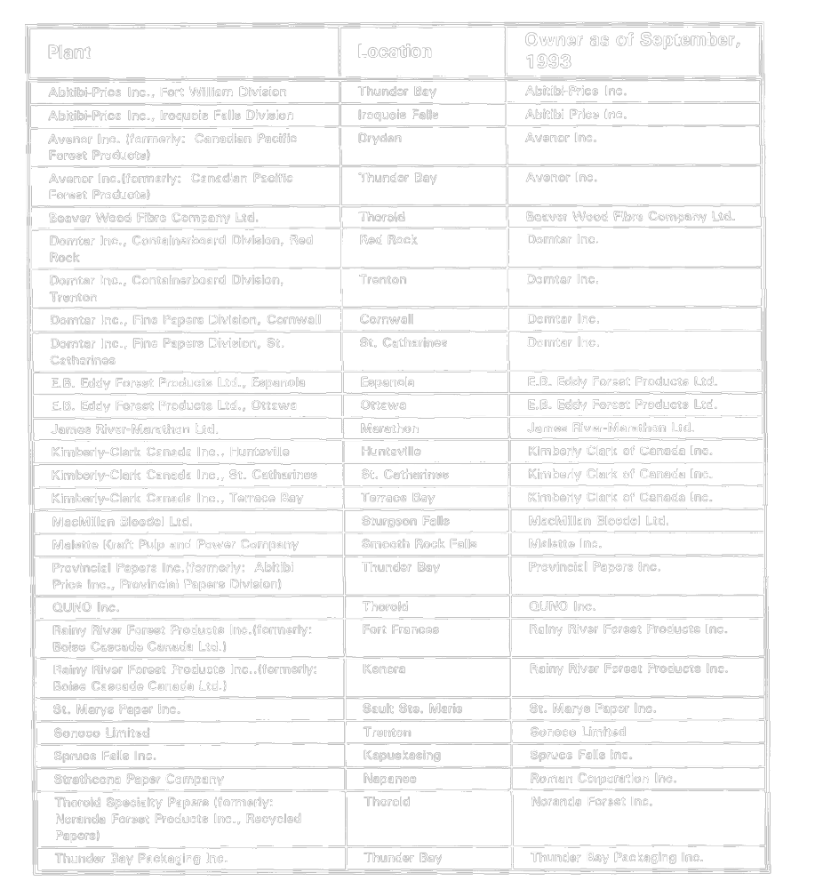
O. Reg. 521/95, s. 15.
Schedule 2
process effluent limits and monitoring frequency
Insert regs\graphics\1993\760\760002au.tif
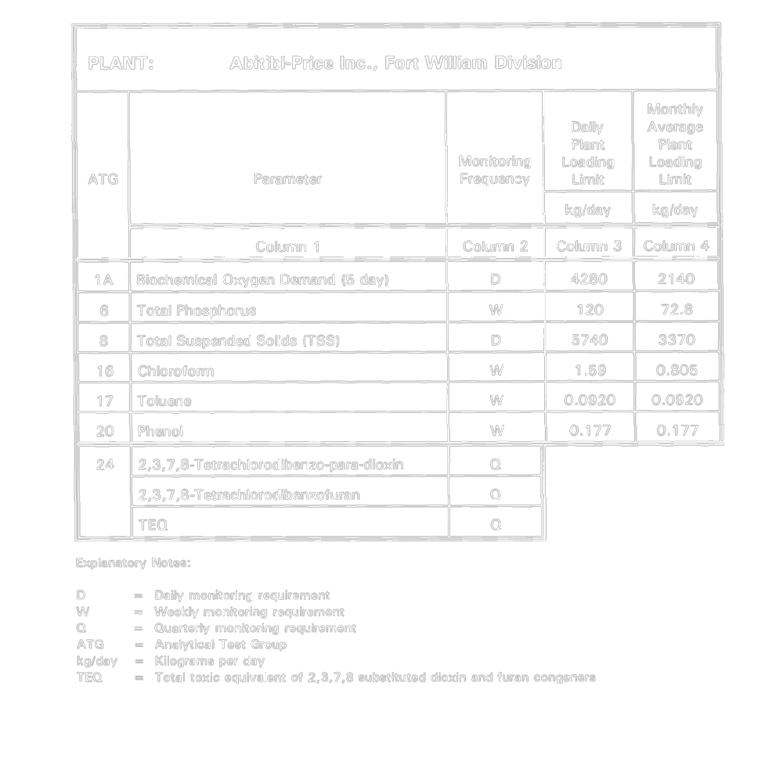
Insert regs\graphics\1993\760\760002bu.tif
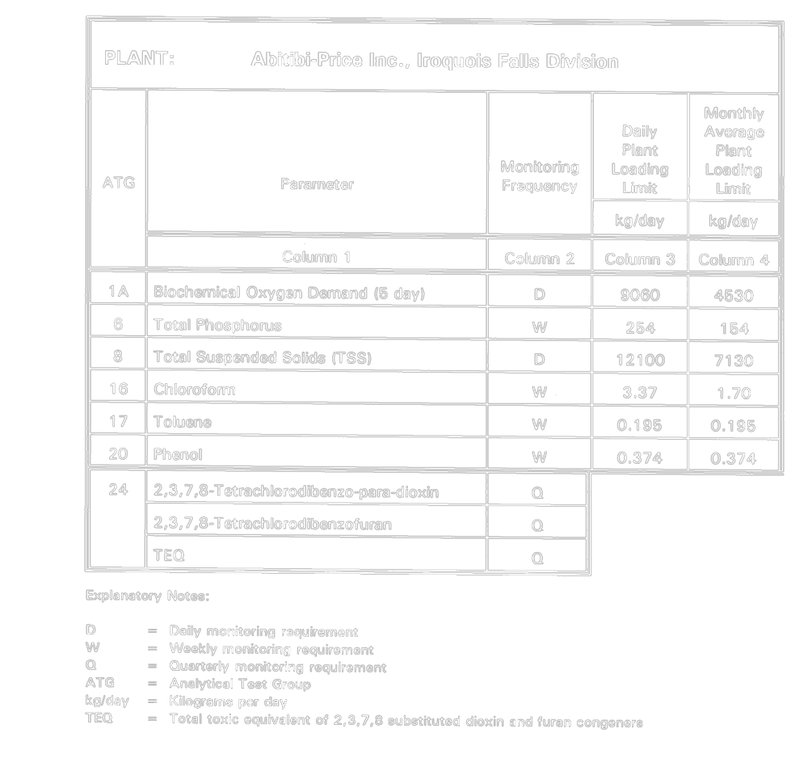
Insert regs\graphics\1993\760\760002cu.tif
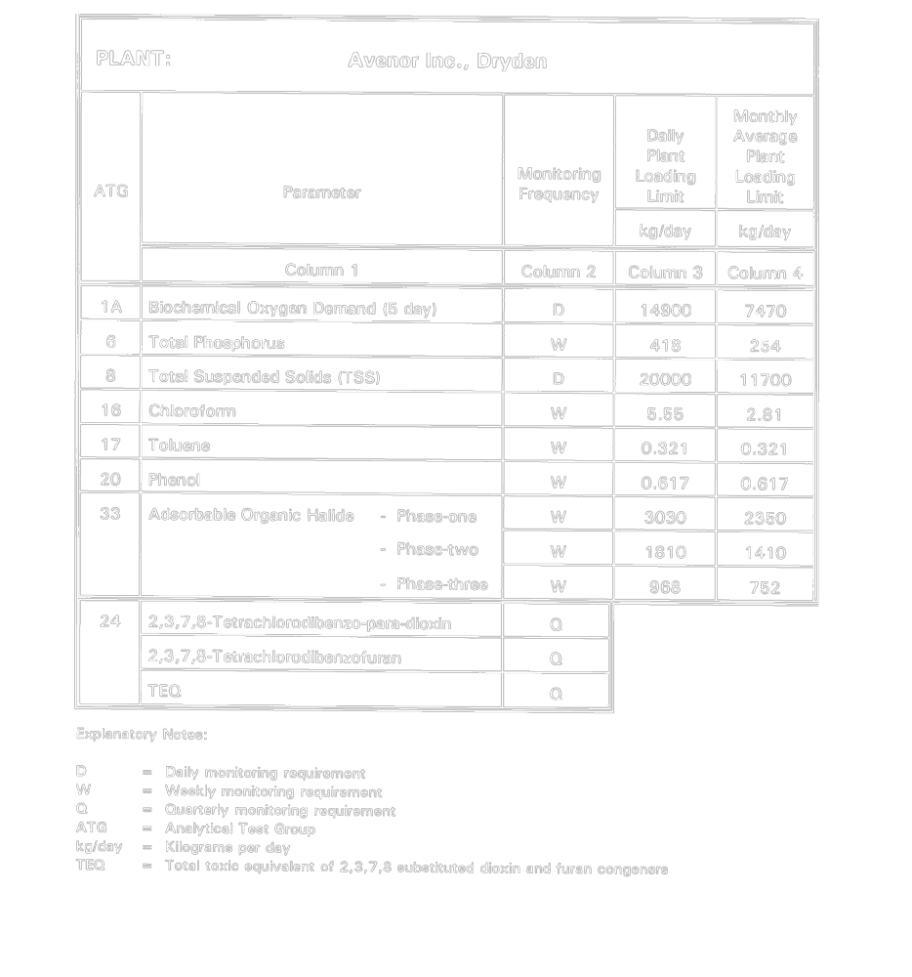
Insert regs\graphics\1993\760\760002du.tif
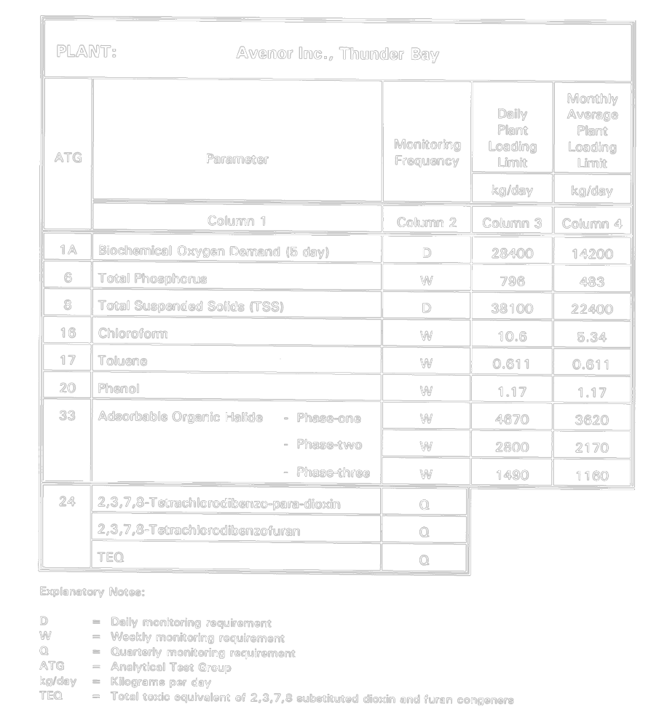
Insert regs\graphics\1993\760\760002eu.tif
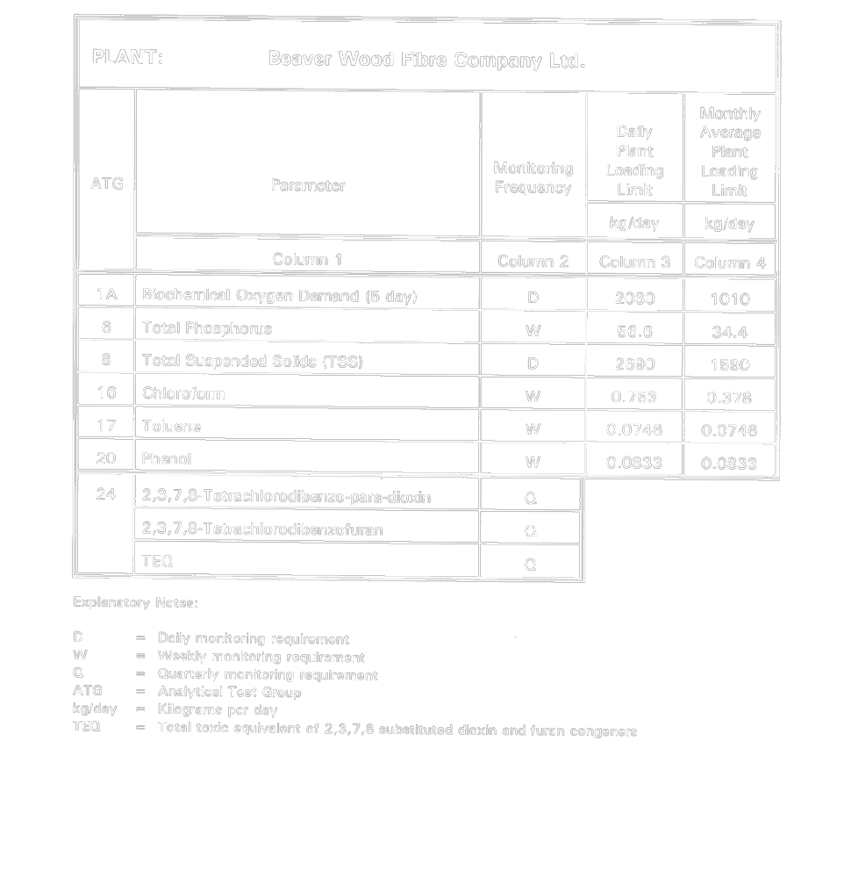
Insert regs\graphics\1993\760\760002fu.tif
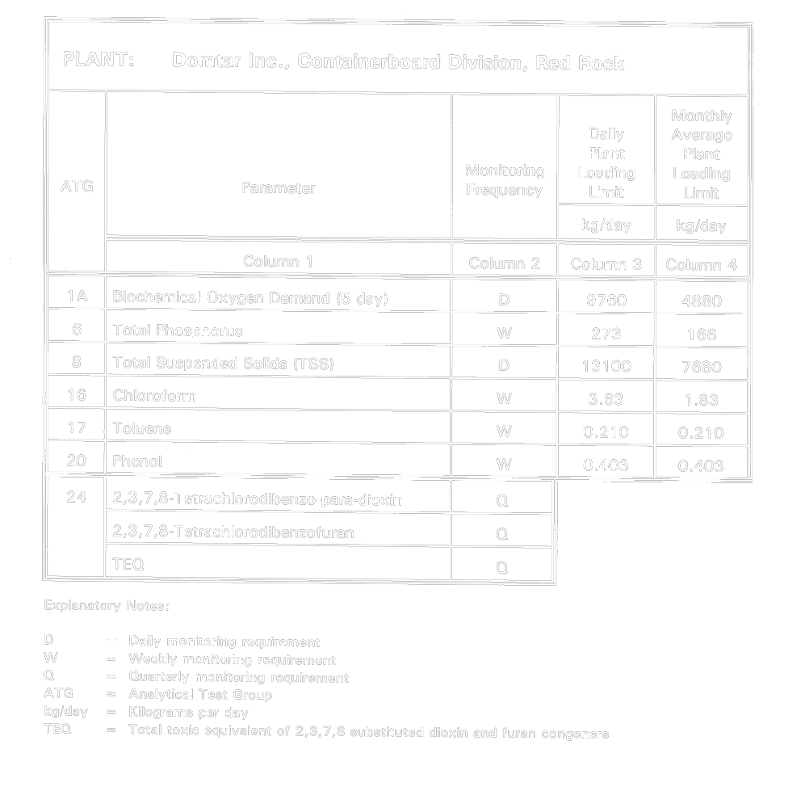
Insert regs\graphics\1993\760\760002gu.tif
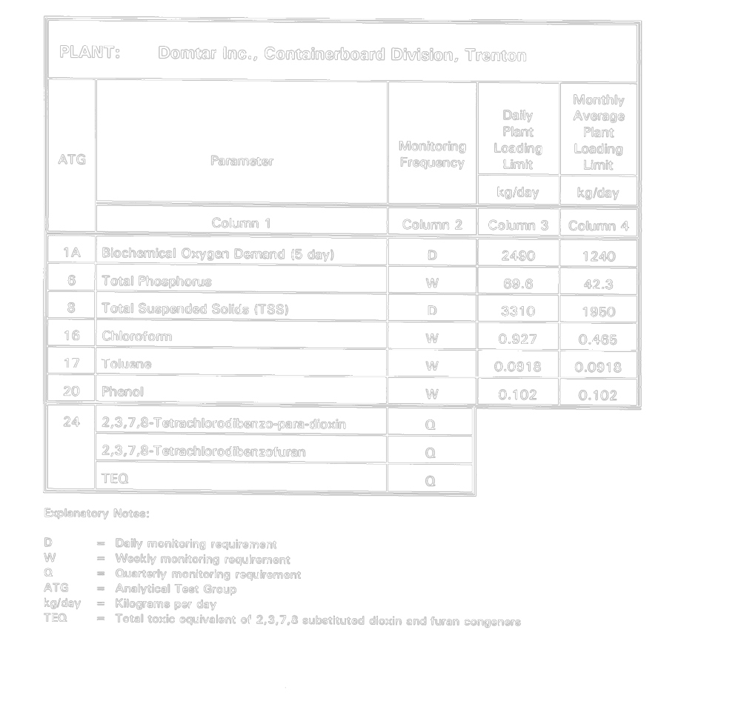
Insert regs\graphics\1993\760\760002hu.tif
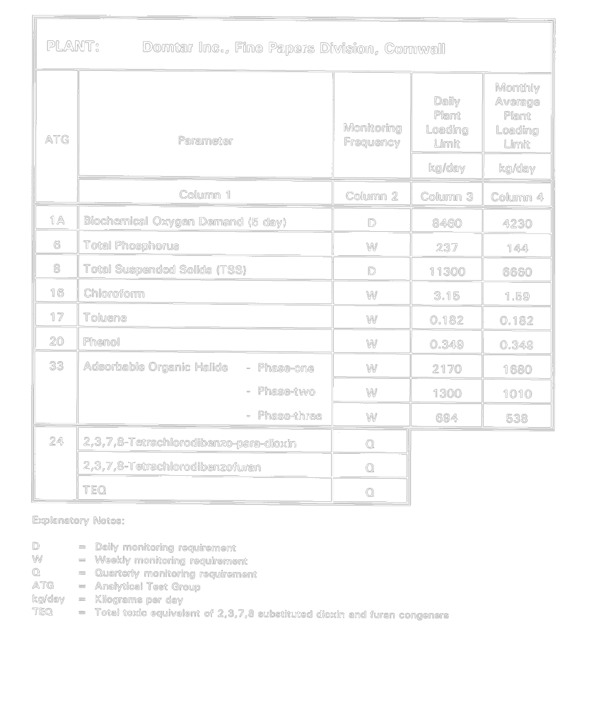
Insert regs\graphics\1993\760\760002iu.tif
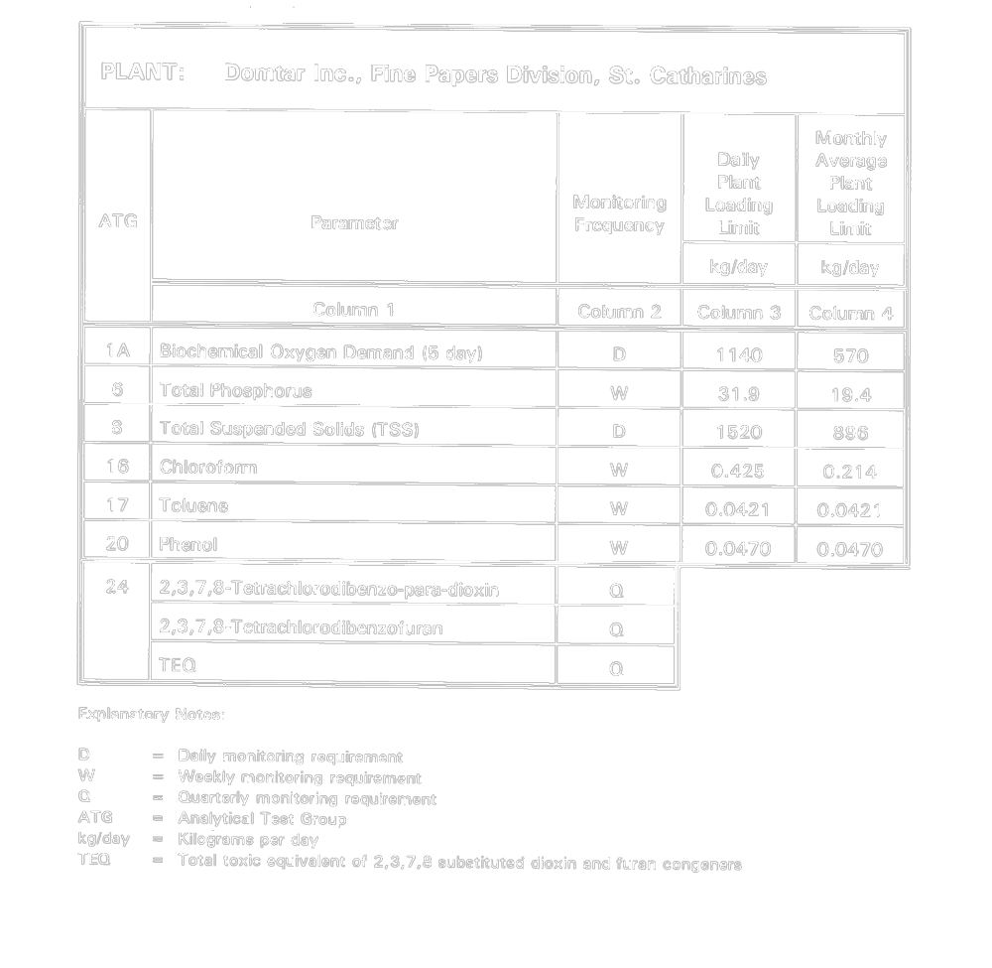
Insert regs\graphics\1993\760\760002ju.tif
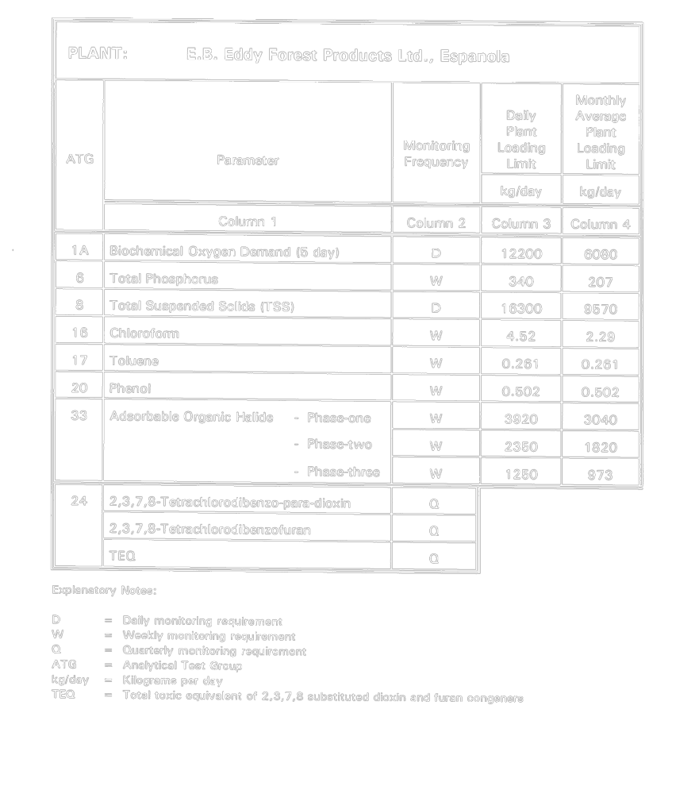
Insert regs\graphics\1993\760\760002ku.tif
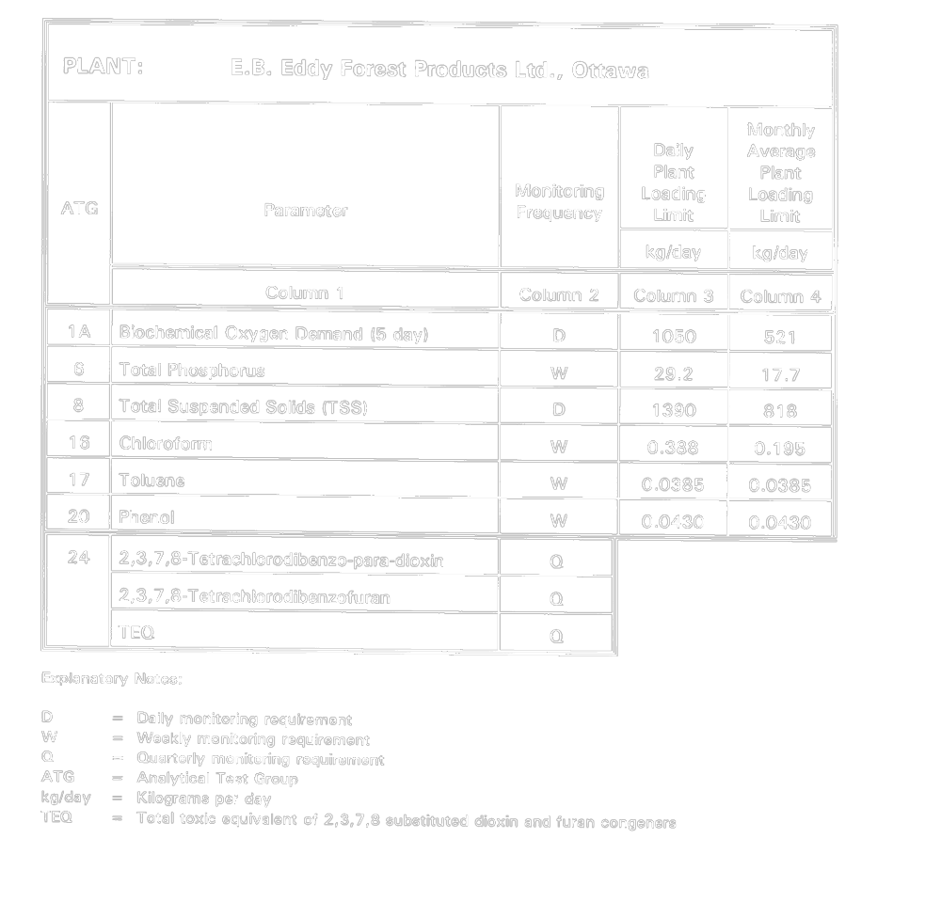
Insert regs\graphics\1993\760\760002lu.tif
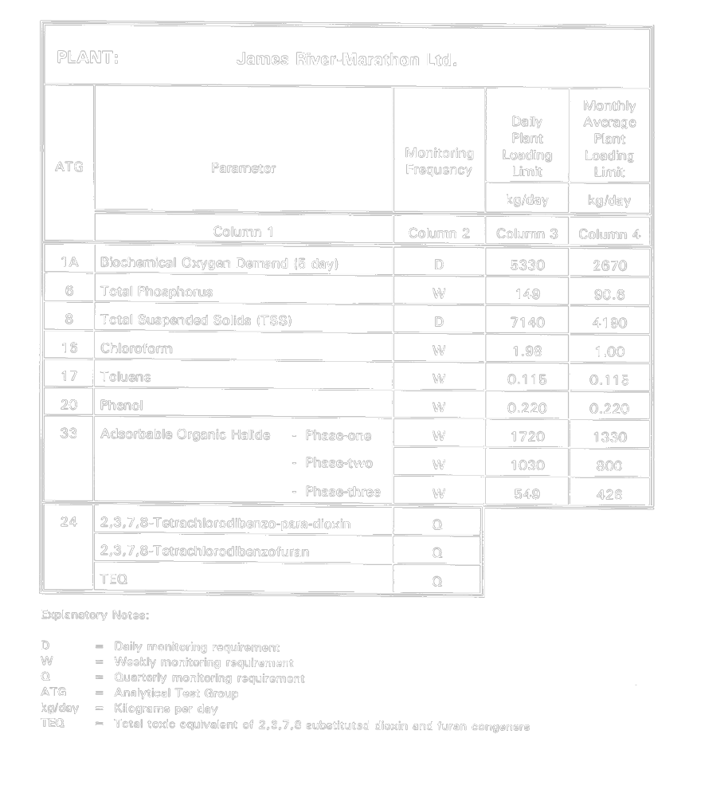
Insert regs\graphics\1993\760\760002mu.tif
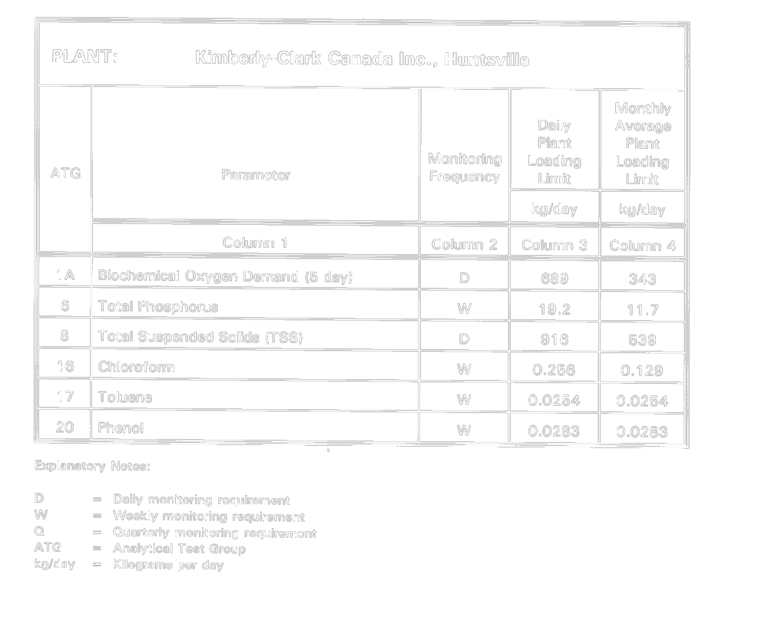
Insert regs\graphics\1993\760\760002nu.tif
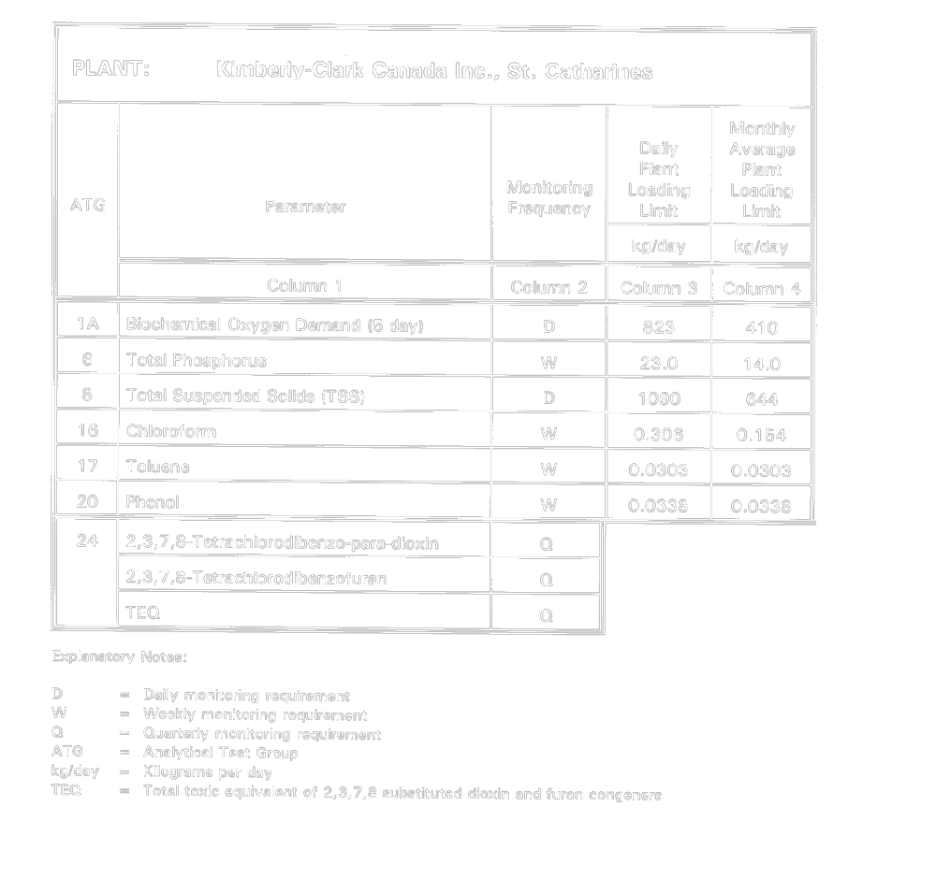
Insert regs\graphics\1993\760\760002ou.tif
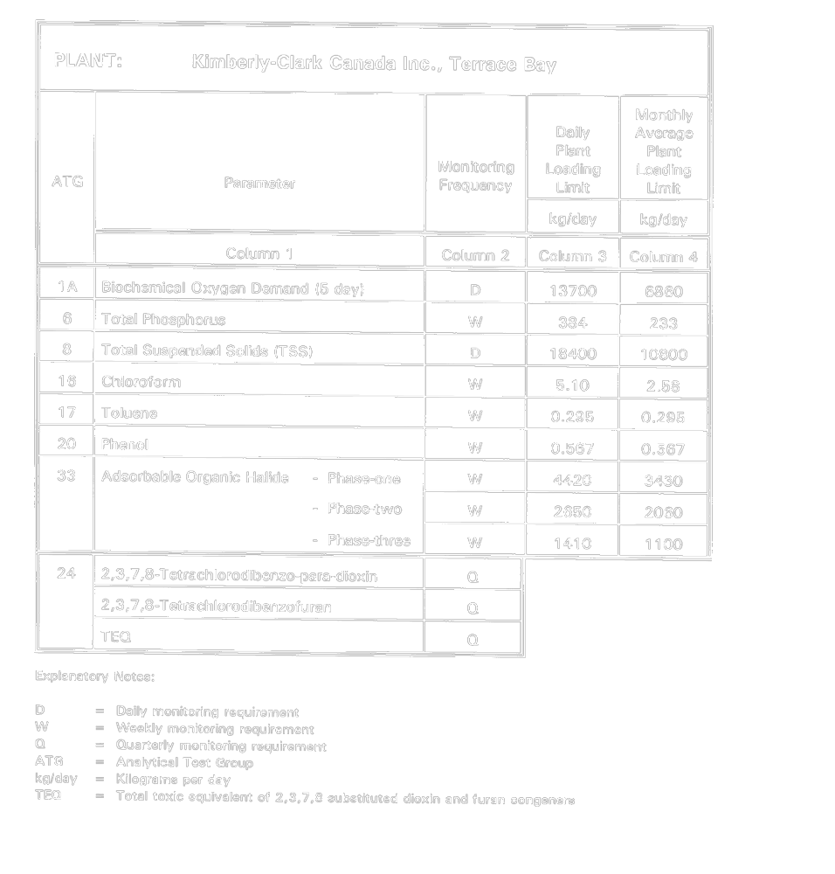
Insert regs\graphics\1993\760\760002pu.tif
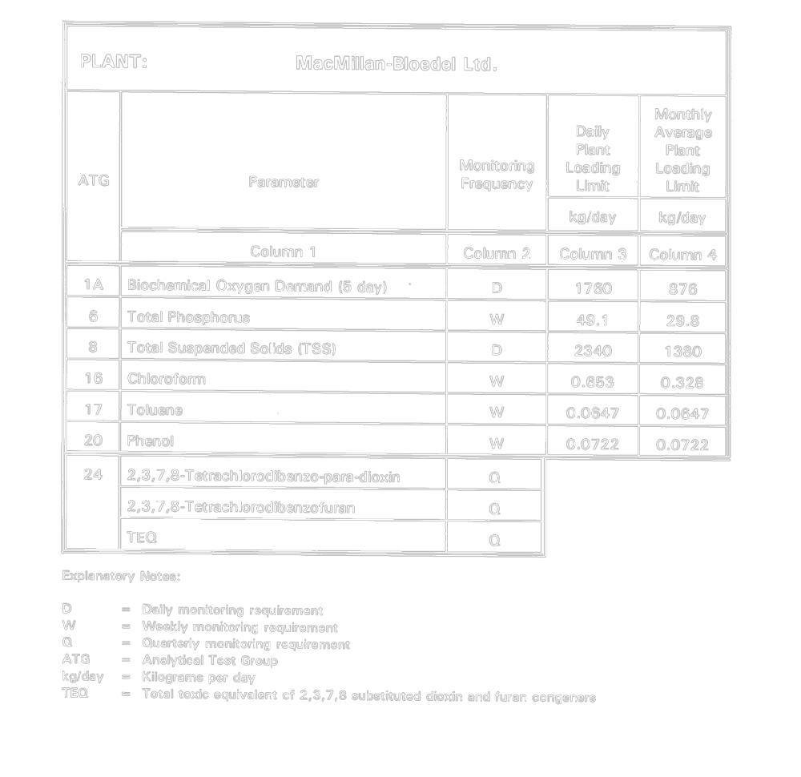
Insert regs\graphics\1993\760\760002qu.tif
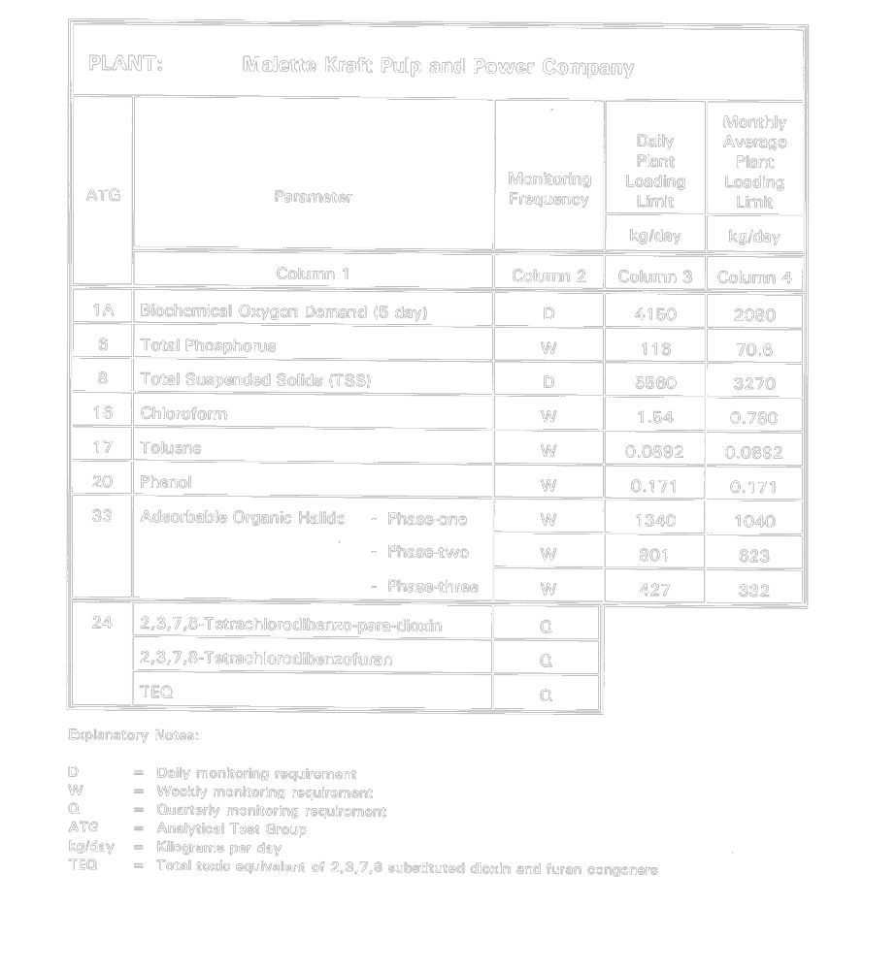
Insert regs\graphics\1993\760\760002ru.tif
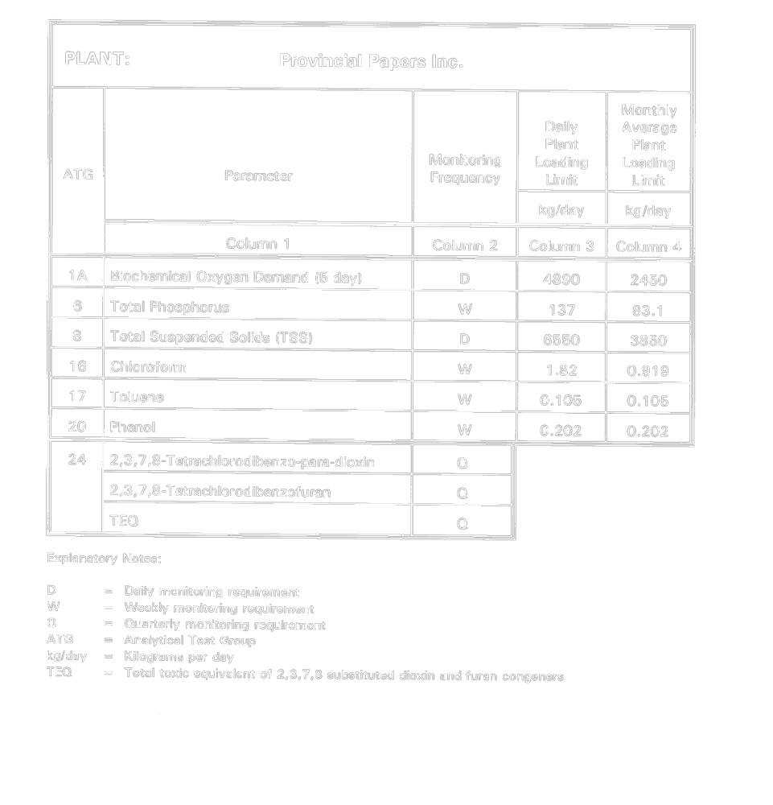
Insert regs\graphics\1993\760\760002su.tif
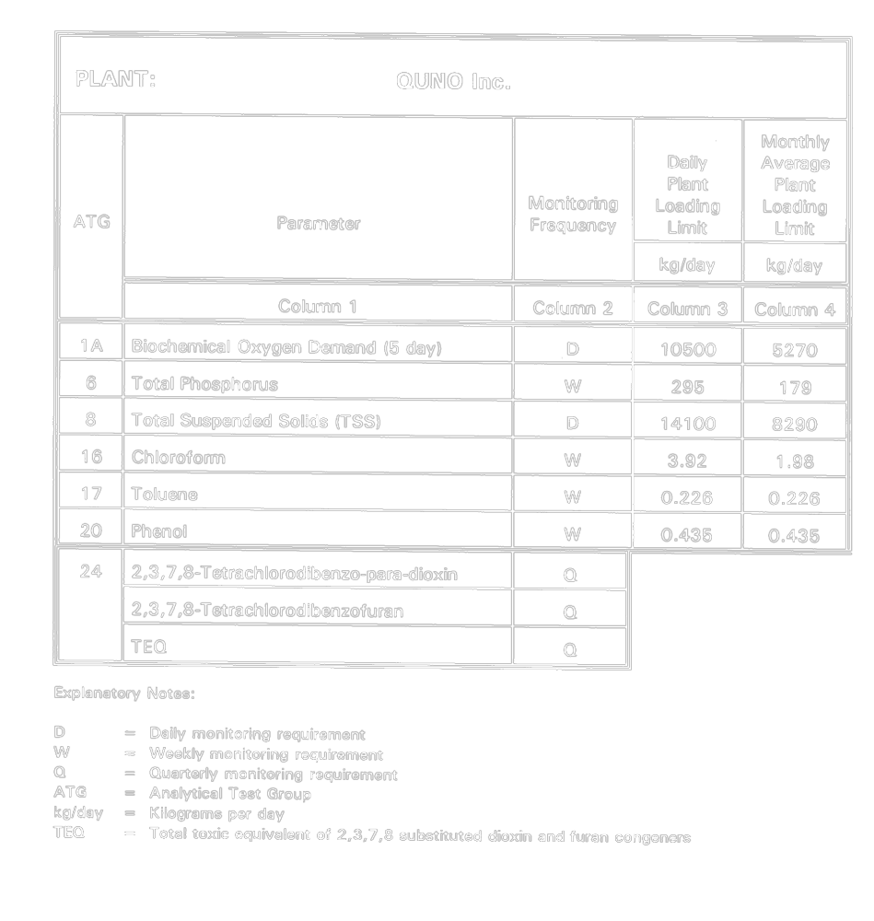
Insert regs\graphics\1993\760\760002tu.tif
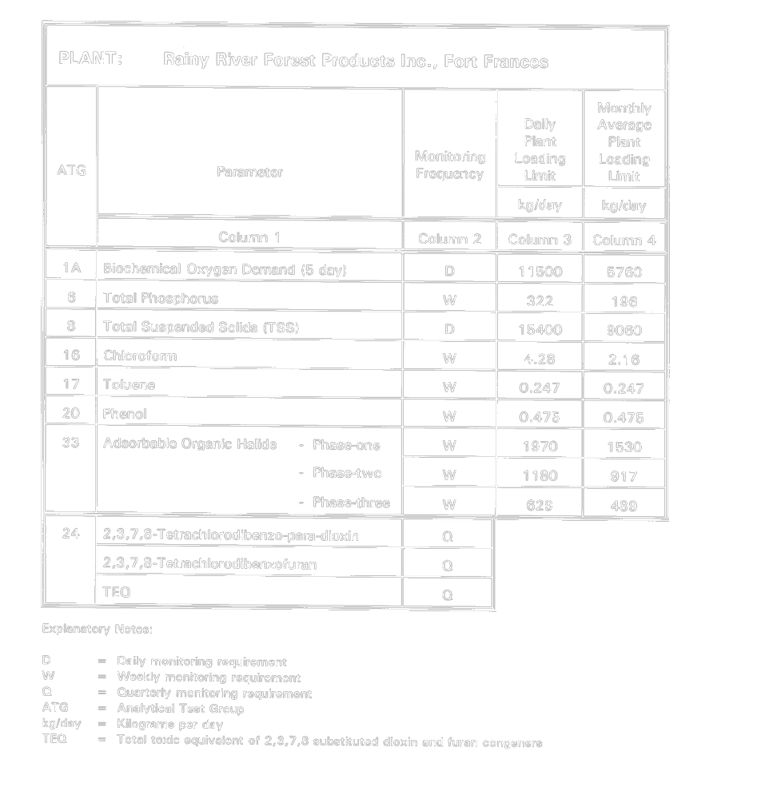
Insert regs\graphics\1993\760\760002uu.tif
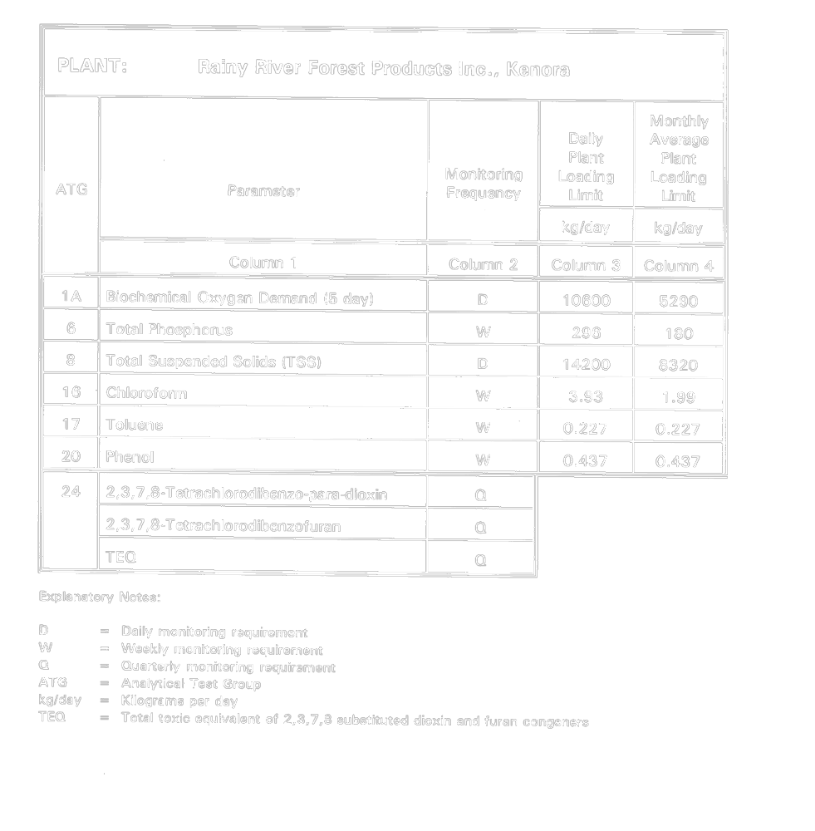
Insert regs\graphics\1993\760\760002vu.tif
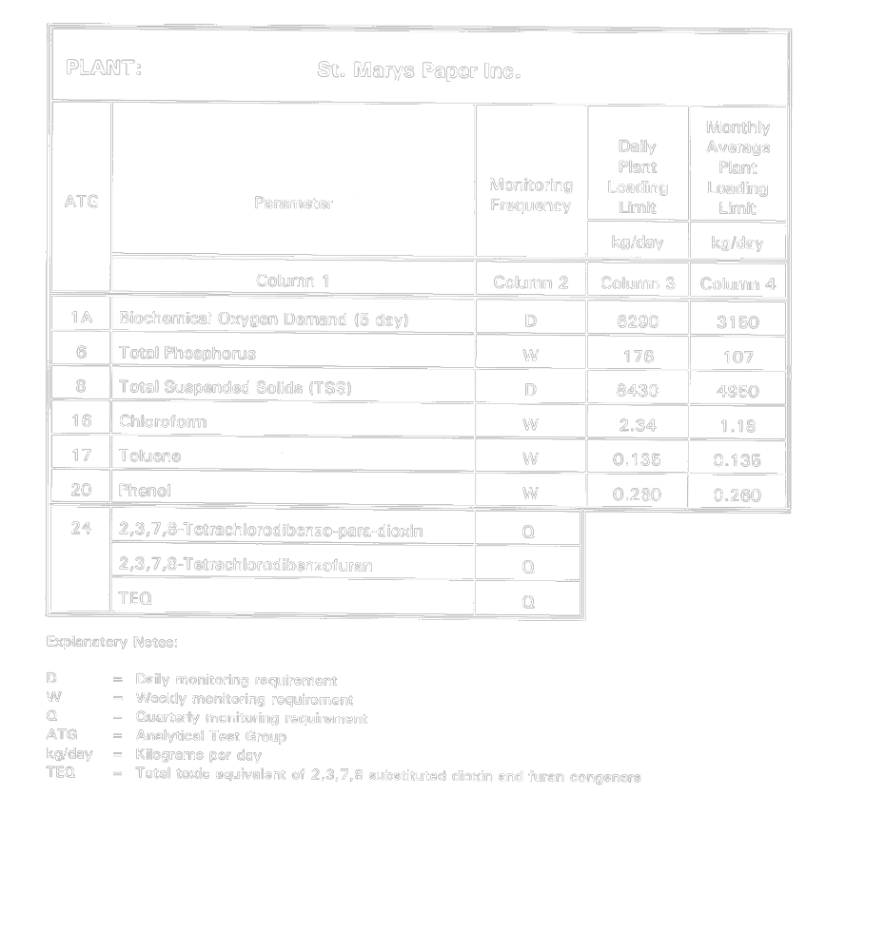
Insert regs\graphics\1993\760\760002wu.tif
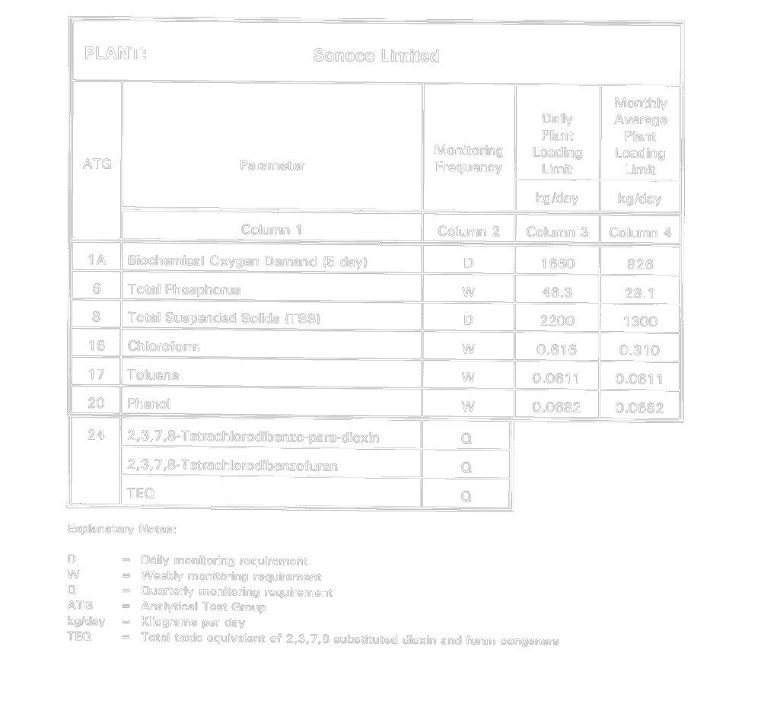
Insert regs\graphics\1993\760\760002xu.tif
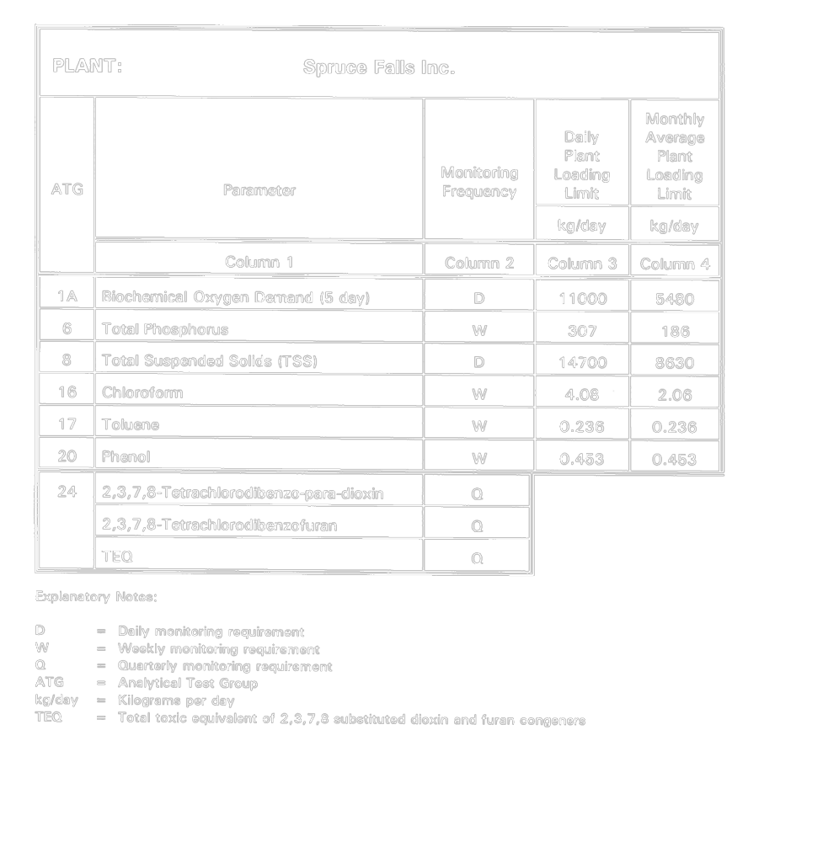
Insert regs\graphics\1993\760\760002yu.tif
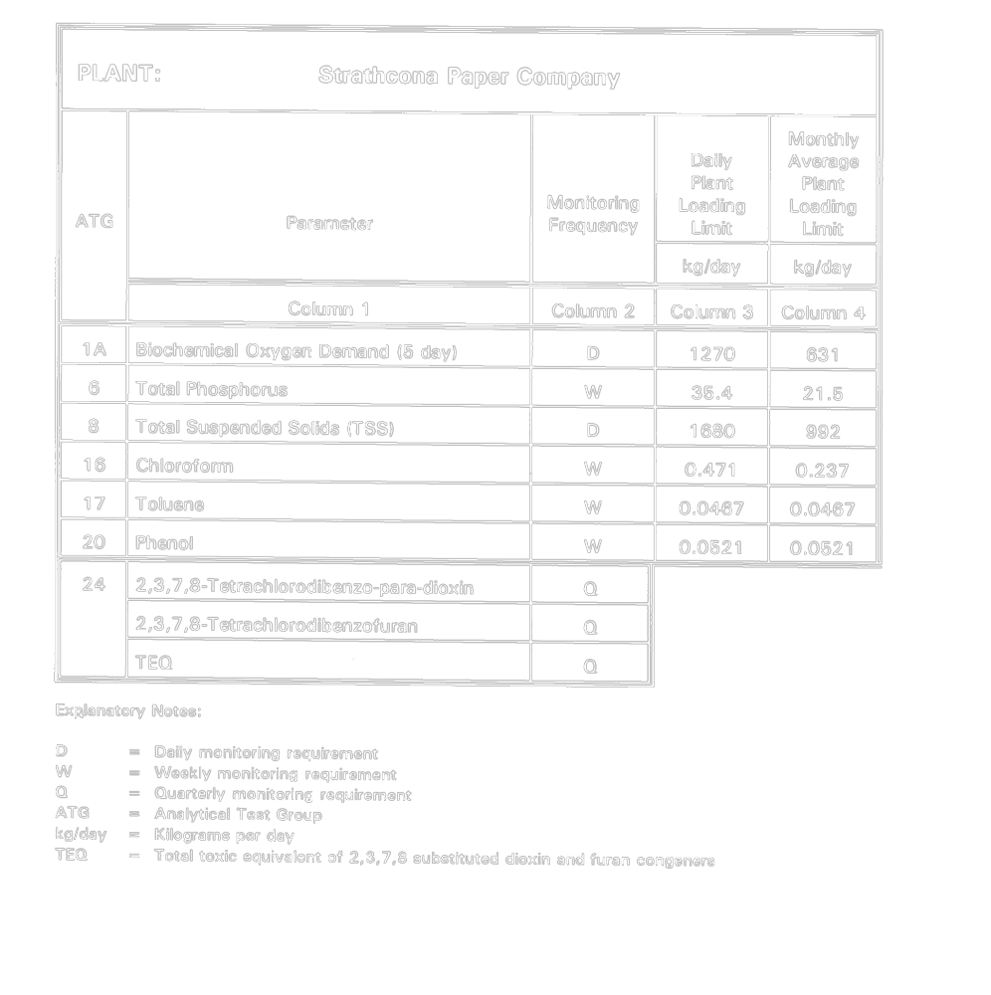
Insert regs\graphics\1993\760\760002zu.tif
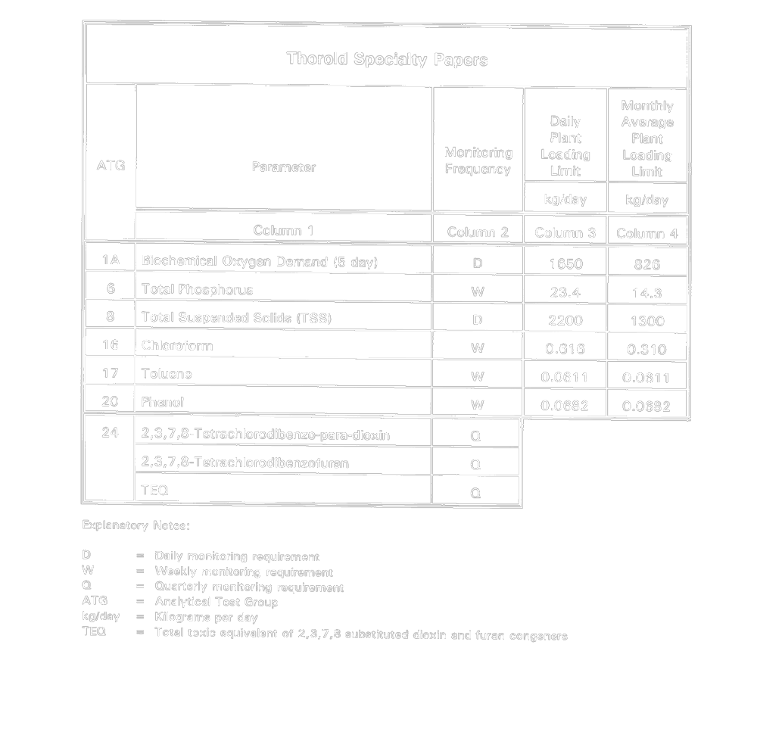
Insert regs\graphics\1993\760\76002zau.tif
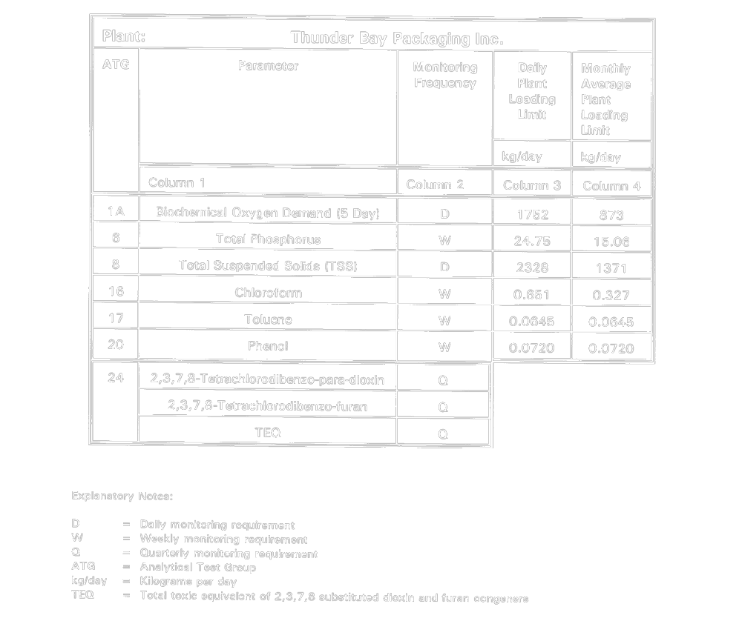
O. Reg. 521/95, s. 15.
Schedule 3
cooling water assessment monitoring
Insert regs\graphics\1993\760\760003au.tif
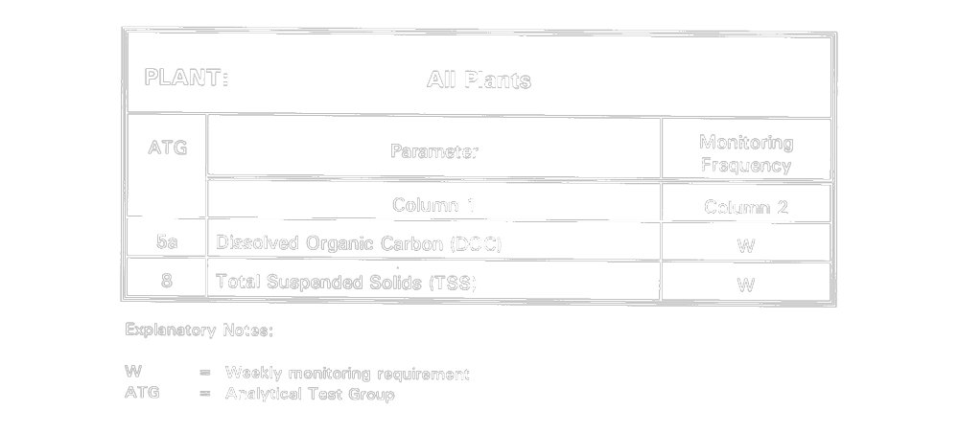
O. Reg. 521/95, s. 15.
Schedule 4
reference production rates

 | Reference Production Rate
Plant | Bleached Pulp | Finished Product
 | tonne/day | tonne/day
Abitibi-Price Inc., Fort William Division |  | 428
Abitibi-Price Inc., Iroquois Falls Division |  | 906
Avenor Inc., Dryden | 940 | 1493
Avenor Inc., Thunder Bay | 1449 | 2842
Beaver Wood Fibre Company Ltd. |  | 347
Domtar Inc., Containerboard Division, Red Rock |  | 976
Domtar Inc., Containerboard Division, Trenton |  | 427
Domtar Inc., Fine Papers Division, Cornwall | 673 | 846
Domtar Inc., Fine Papers Division, St. Catharines |  | 196
E.B. Eddy Forest Products Ltd., Espanola | 1216 | 1216
E.B. Eddy Forest Products Ltd., Ottawa |  | 179
James River-Marathon Ltd. | 533 | 533
Kimberly-Clark Canada Inc., Huntsville |  | 118
Kimberly-Clark Canada Inc., St. Catharines |  | 141
Kimberly-Clark Canada Inc., Terrace Bay | 1372 | 1372
MacMillan-Bloedel Ltd., Sturgeon Falls |  | 301
Malette Kraft Pulp and Power Company | 415 | 415
Provincial Papers Inc., Thunder Bay |  | 489
QUNO Inc., Thorold |  | 1053
Rainy River Forest Products Inc., Fort Frances | 611 | 1151
Rainy River Forest Products Inc., Kenora |  | 1057
St. Marys Paper Inc., Sault Ste. Marie |  | 629
Sonoco Limited, Trenton |  | 284
Spruce Falls Inc., Kapuskasing |  | 1096
Strathcona Paper Company, Napanee |  | 217
Thorold Specialty Papers |  | 284
Thunder Bay Packaging Inc., Thunder Bay |  | 300
O. Reg. 521/95, s. 15.

Back to top

