Français
Employment Agencies Act
REGULATION 320
Amended to O. Reg. 294/01
GENERAL
Note: This Regulation was revoked on July 20, 2001. See: O. Reg. 294/01, s. 1.
This is the English version of a bilingual regulation.
1. In this Regulation,
“homemaker” means a person who performs housekeeping services, including cleaning, other than as a sitter only; (“aide familiale”)
“operator” means a person who carries on the business of an employment agency; (“exploitant”)
“sitter” means a person who is responsible for the safekeeping of a person in his or her charge and who performs no other services. (“gardienne”) R.R.O. 1990, Reg. 320, s. 1.
2. Employment agencies are classified as,
(a) Class A employment agencies, consisting of employment agencies that procure persons for employment;
(b) Class B employment agencies, consisting of employment agencies that procure employment for persons other than sitters or homemakers;
(c) Class C employment agencies, consisting of employment agencies that procure employment for sitters only; and
(d) Class D employment agencies, consisting of employment agencies that procure employment for homemakers or homemakers and sitters. R.R.O. 1990, Reg. 320, s. 2.
3. No operator of an employment agency of a class shall have any financial interest, whether proprietary or otherwise, in an employment agency of another class. R.R.O. 1990, Reg. 320, s. 3.
4. (1) An application for a licence other than by renewal shall be in Form 1.
(2) Subject to subsection (3), an application for a renewal of a licence shall be in Form 2 and shall be made not later than the 1st day of March next following the date of issue of the licence being renewed.
(3) Where a licence is issued during the period from the 1st day of March to the 31st day of March next following, in any year, the application for renewal of the licence shall be made upon receipt of the licence.
(4) A licence to carry on an employment agency shall be in Form 3.
(5) The fee for a licence or renewal is,
(a) $500 for a Class A or Class B employment agency;
(b) $100 for a Class C employment agency; and
(c) $200 for a Class D employment agency.
(6) A licence is not transferable. R.R.O. 1990, Reg. 320, s. 4.
5. Every licensee shall immediately notify the supervisor in writing,
(a) of any proposed change,
(i) in the name of the licensee,
(ii) in the trade name of the employment agency, or
(iii) in the address of any place of business of the employment agency,
that is shown on the licence;
(b) in the case of a partnership, of any proposed change in the members of the partnership;
(c) of any proposed sale of the employment agency or of any place of business of the employment agency; or
(d) of the proposed termination of the employment agency or of any place of business of the employment agency. R.R.O. 1990, Reg. 320, s. 5.
6. (1) An applicant for a licence or a renewal shall be at least eighteen years of age.
(2) The business for which an applicant applies for a licence or a renewal shall have a permanent place of business in Ontario. R.R.O. 1990, Reg. 320, s. 6.
7. A licence shall not be issued where an application for a licence shows a trade name that is the same as or similar to a trade name that appears on a licence that has been issued to another applicant for another employment agency so as to be likely to confuse or to deceive and,
(a) the licence is in force; or
(b) an application for renewal of the licence has been made. R.R.O. 1990, Reg. 320, s. 7.
8. (1) In this section,
“franchise agreement” means an agreement under the terms of which the owner of a trade name grants to a person or group of persons the right to use the trade name.
(2) Where an application for a licence shows a trade name that has been granted to the applicant under a franchise agreement, the applicant may be issued a licence to operate an employment agency.
(3) Despite section 7, where a franchise agreement has been entered into, a trade name may be used in common by more than one licensee so long as each licensee who publishes or displays, or causes to be published or displayed, or permits to be published or displayed any notice, sign, advertisement, or publication inserts or causes to be inserted in the notice, sign, advertisement or publication the licensee’s name and address. R.R.O. 1990, Reg. 320, s. 8.
9. Where a licensee intends to terminate the business of the employment agency licensed for the purpose of applying for a licence to carry on an employment agency of a class other than the class licensed, the licensee shall immediately notify the supervisor in writing of the intention,
(a) to terminate the business of the employment agency licensed; and
(b) to apply for a licence to carry on an employment agency of the proposed class. R.R.O. 1990, Reg. 320, s. 9.
10. (1) The security furnished under clause 3 (c) of the Act shall be,
(a) where the employment agency is a Class A or Class B employment agency, $1,000 plus $500 in respect of a second place of business and $250 in respect of each additional place of business; or
(b) where the employment agency is a Class C or Class D employment agency, $100 in respect of each place of business.
(2) The security referred to in subsection (1) shall be secured by,
(a) a personal bond in Form 4 accompanied by collateral security; or
(b) a bond of a guarantee company approved under the Guarantee Companies Securities Act in Form 5.
(3) The collateral security accompanying a bond shall have a cash value of not less than the amount prescribed in clause (1) (a), where the employment agency is a Class A or Class B employment agency, and shall have a cash value of not less than the amount prescribed in clause (1) (b), where the employment agency is a Class C or Class D employment agency, and shall be a transferable and assignable bond issued or guaranteed by Canada or issued or guaranteed by Ontario.
(4) A bond may be cancelled by any person bound thereby by giving to the supervisor at least two months’ notice in writing of intention to cancel and it shall be deemed to be cancelled on the date stated in the notice which date shall be not less than two months after receipt of the notice by the supervisor.
(5) For the purpose of every act or omission occurring during the period when the bond was in effect prior to cancellation, every bond shall continue in force, and the collateral security, if any, shall remain on deposit for a period of six months after the cancellation of the bond. R.R.O. 1990, Reg. 320, s. 10.
11. A Class A employment agency shall not charge a fee for any service rendered to any person whom it procures for employment. R.R.O. 1990, Reg. 320, s. 11.
12. (1) A Class B employment agency shall not charge an applicant for employment a registration fee of more than $2 in each twelve-month period.
(2) A Class B employment agency shall not charge a fee for procuring employment for a person,
(a) where the employment is on an hourly basis, of more than one-eighth of the person’s pay for the first day;
(b) where the employment is on a daily basis, of more than the proportion of the first day’s pay of the person that one hour bears to the total number of hours worked in the day;
(c) where the employment is on a weekly basis, of more than one-seventh of the person’s pay for the first week;
(d) where the employment is on a monthly basis, of more than four-thirtieths of the person’s pay for the first month; and
(e) where the employment is on an annual basis, of more than 5 per cent of the person’s pay for the first year payable in three months.
(3) Where an annual employment referred to in clause (2) (e) is terminated before the end of the first year, the employment agency shall refund the same proportion of the fee as the proportion that the remaining part of the year bears to the year.
(4) A Class B employment agency shall not charge any fee, reward or other remuneration in addition to those referred to in this section. R.R.O. 1990, Reg. 320, s. 12.
13. (1) A Class C employment agency shall not charge a fee for procuring employment for a sitter of more than 15 per cent of the amount received by the sitter in respect of the employment procured by the agency, but the period for which the fee is charged shall not exceed thirty days.
(2) A Class C employment agency shall not charge any fee, reward or other remuneration in addition to the fee referred to in subsection (1). R.R.O. 1990, Reg. 320, s. 13.
14. (1) A Class D employment agency shall not charge a fee for procuring employment for a homemaker or sitter of more than 10 per cent of the amount received by the homemaker or sitter in respect of the employment procured by the agency, but the period for which the fee is charged shall not exceed four months.
(2) A Class D employment agency shall not charge any fee, reward or other remuneration in addition to the fee referred to in subsection (1). R.R.O. 1990, Reg. 320, s. 14.
15. Where a Class A, B, C or D employment agency advertises that employment is available, the employment agency shall at the request of the supervisor furnish the supervisor with the name and address of the employer who has the employment available. R.R.O. 1990, Reg. 320, s. 15.
16. An employment agency shall issue a receipt for all money received for its services showing the service for which the money was paid and shall retain a duplicate copy of the receipt in its records. R.R.O. 1990, Reg. 320, s. 16.
17. (1) No employment agency shall refer a person for employment unless,
(a) the employment agency has received a request from an employer for a person for the employment; or
(b) the person has requested the employment agency to find employment for him or her.
(2) Where a person is referred by an employment agency for employment, the employment agency shall provide the person with a statement showing,
(a) the trade name and address of the employment agency;
(b) the full name of the person referred for employment; and
(c) in the case of a person referred for employment in a private residence, that the person has had a negative X-ray or a negative tuberculin test indicating that the person does not have active tuberculosis, and showing that the person has been examined by a legally qualified medical practitioner and is considered,
(i) fit for employment, or
(ii) subject to specified work limitations, fit for employment,
within the twelve-month period preceding the date the person was referred for employment,
and the person shall submit the statement to the prospective employer for the employer’s information in determining whether or not to employ the person. R.R.O. 1990, Reg. 320, s. 17.
18. In addition to any other records required to be kept by an employment agency, every employment agency shall make and keep records showing,
(a) the name, address and qualifications of each person whose application for employment is accepted by the employment agency;
(b) the name and address of each person from whom the employment agency has received a request for a person for employment; and
(c) in the case of,
(i) a Class A employment agency, the name and address of every person whom the agency procures for employment and the name and address of the employer for whom such person is procured and the amount of fee, reward or other remuneration paid by each such employer to the employment agency, and
(ii) a Class B, C or D employment agency, the name and address of every person for whom employment has been procured and the amount of fee, reward or other remuneration paid by each such person to the employment agency and the name and address of the employer of each person for whom employment has been procured. R.R.O. 1990, Reg. 320, s. 18.
19. Where an applicant for a licence or a licensee is a corporation, the applicant or licensee, as the case may be, shall affix the seal of the corporation to any form required to be completed by the applicant or licensee, as the case may be, under this Regulation. R.R.O. 1990, Reg. 320, s. 19.
20. The supervisor, or a person designated by the supervisor, may at any time carry out an inspection of any employment agency. R.R.O. 1990, Reg. 320, s. 20.
Form 1
Employment Agencies Act
APPLICATION FOR LICENCE
Insert regs\graphics\1990\320\320001ae.tif
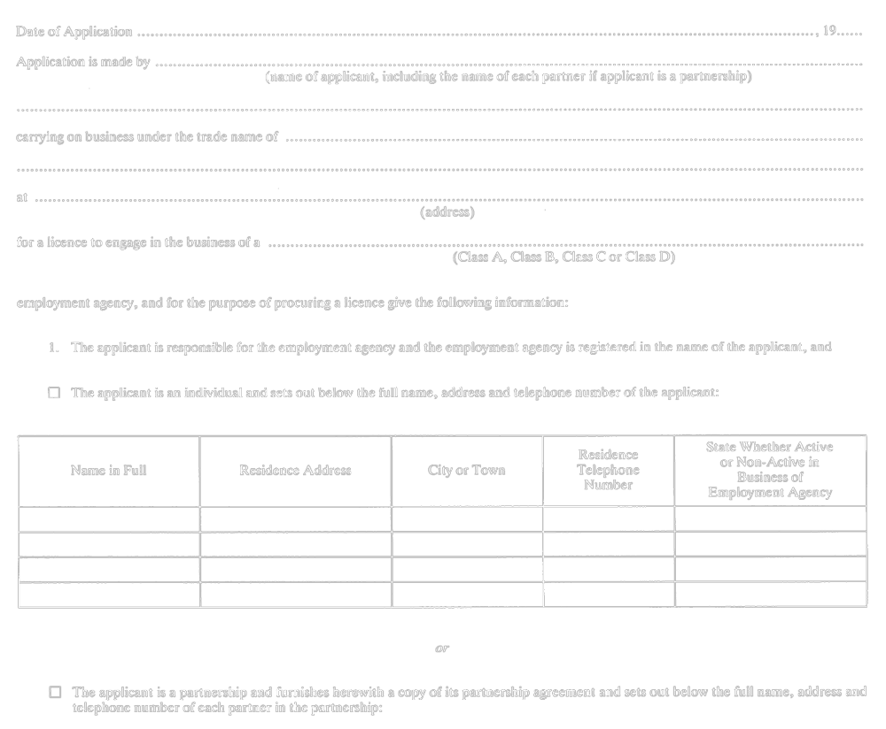
Insert regs\graphics\1990\320\320001be.tif
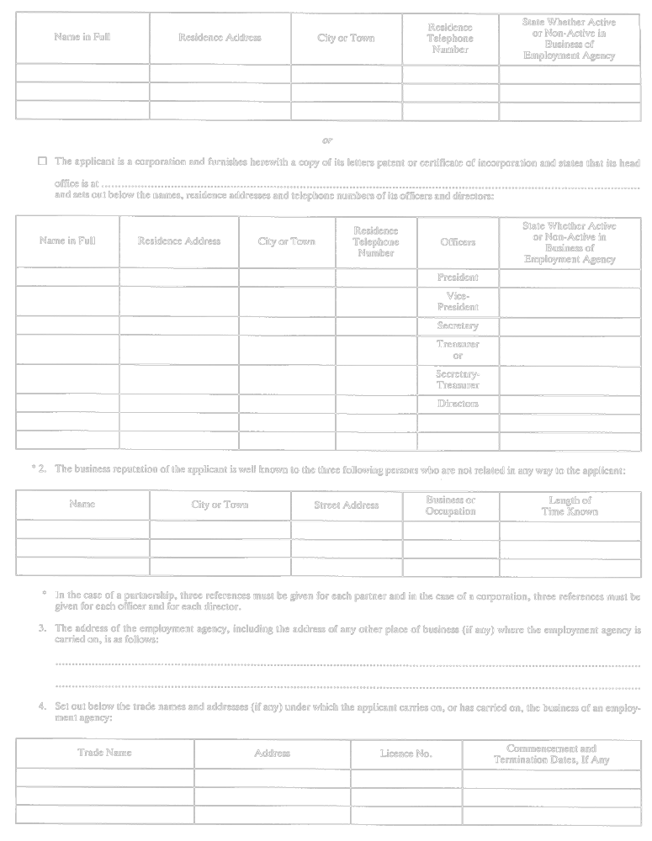
Insert regs\graphics\1990\320\320001ce.tif
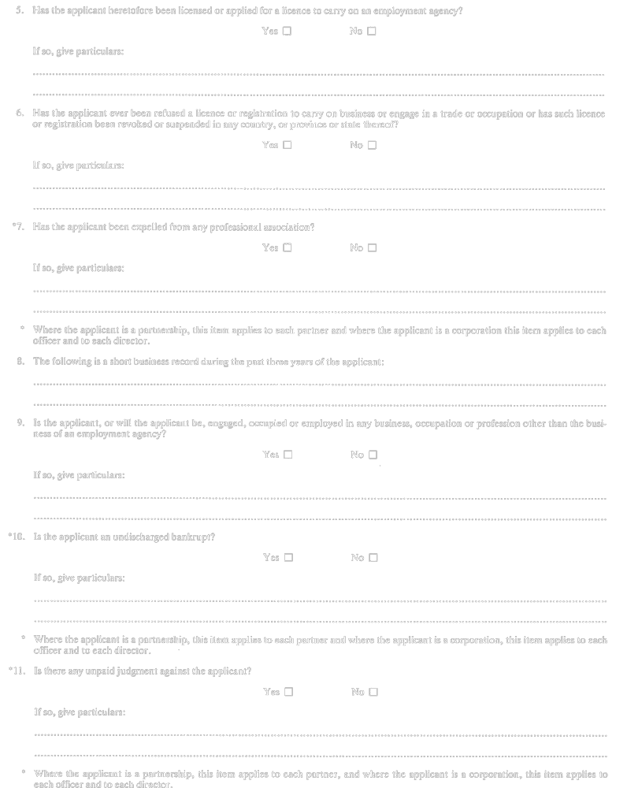
Insert regs\graphics\1990\320\320001de.tif
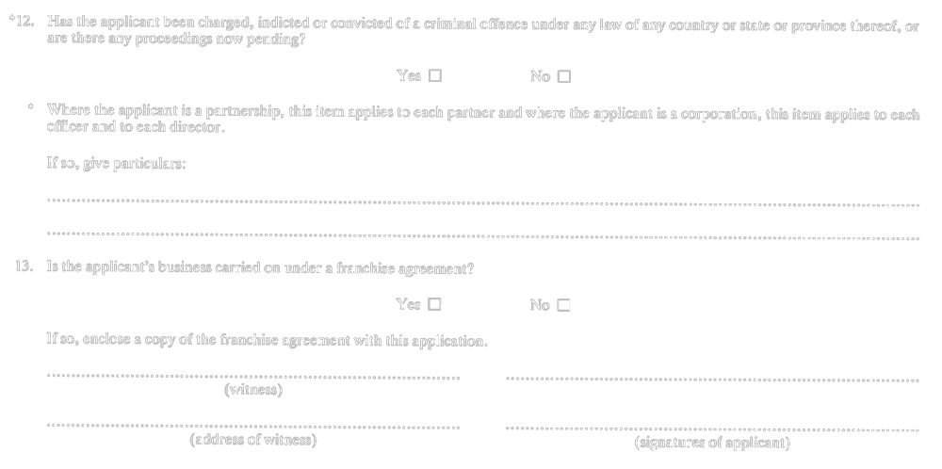
R.R.O. 1990, Reg. 320, Form 1.
Form 2
Employment Agencies Act
APPLICATION FOR RENEWAL OF LICENCE
Insert regs\graphics\1990\320\320002ae.tif
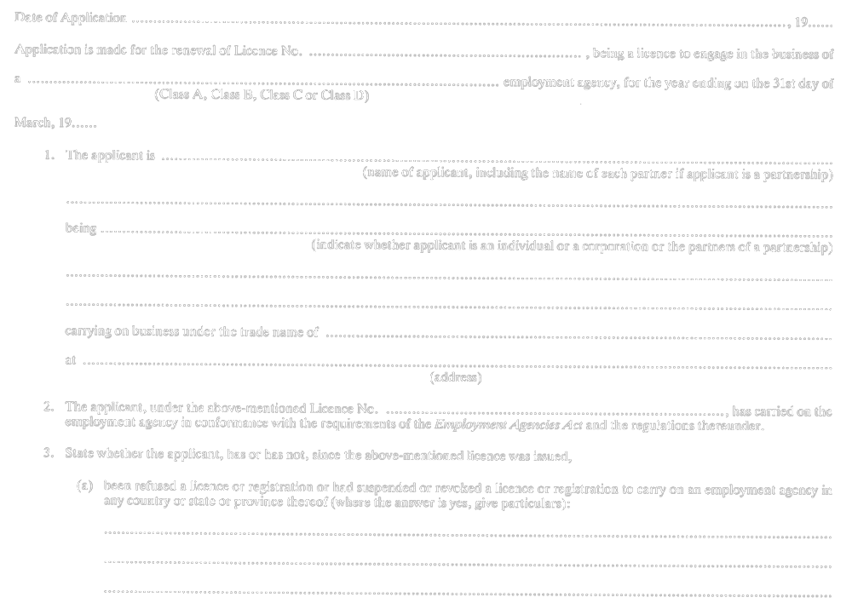
Insert regs\graphics\1990\320\320002be.tif

R.R.O. 1990, Reg. 320, Form 2.
Form 3
Employment Agencies Act

Insert regs\graphics\1990\320\320003ae.tif

R.R.O. 1990, Reg. 320, Form 3.
Form 4
Employment Agencies Act
PERSONAL BOND
Insert regs\graphics\1990\320\320004ae.tif

Insert regs\graphics\1990\320\320004be.tif

R.R.O. 1990, Reg. 320, Form 4.
Form 5
Employment Agencies Act
BOND OF A GUARANTEE COMPANY APPROVED UNDER
THE GUARANTEE COMPANIES SECURITIES ACT
Insert regs\graphics\1990\320\320005ae.tif
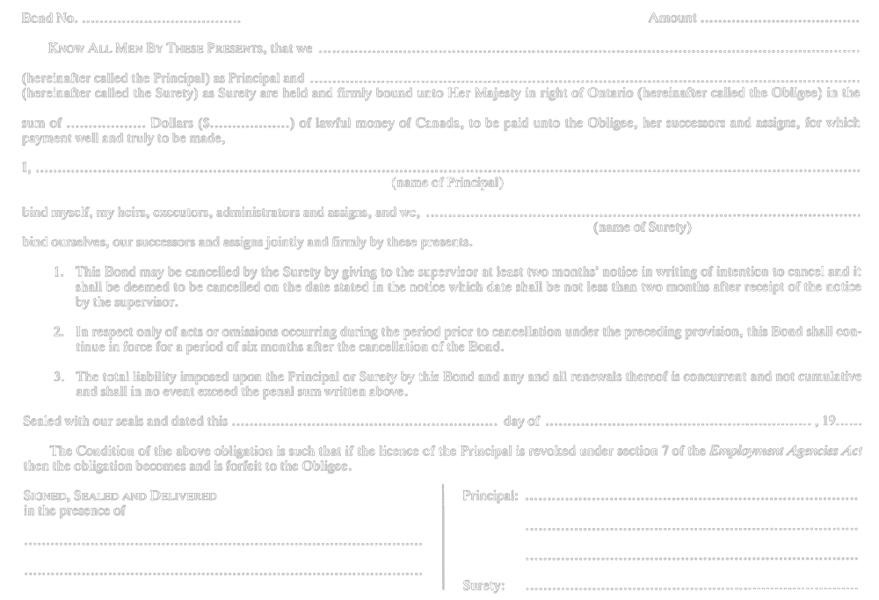
R.R.O. 1990, Reg. 320, Form 5.

Français

Back to top

