Race Tracks Tax Act
Loi de la taxe sur le pari mutuel
REGULATION 983
Amended to O. Reg. 415/00
FORMS
Note: This Regulation was revoked on July 4, 2000. See: O. Reg. 415/00, s. 1.
This Regulation is made in English only.
1. (1) A notice of objection required under section 24 of the Retail Sales Tax Act, as made applicable by section 11 of the Act, shall be in Form 1.
(2) A notice of appeal required under section 25 of the Retail Sales Tax Act, as made applicable by section 11 of the Act, shall be in Form 2. R.R.O. 1990, Reg. 983, s. 1.
Form 1
Race Tracks Tax Act
notice of objection
Insert regs\graphics\1990\983\983001ae.tif
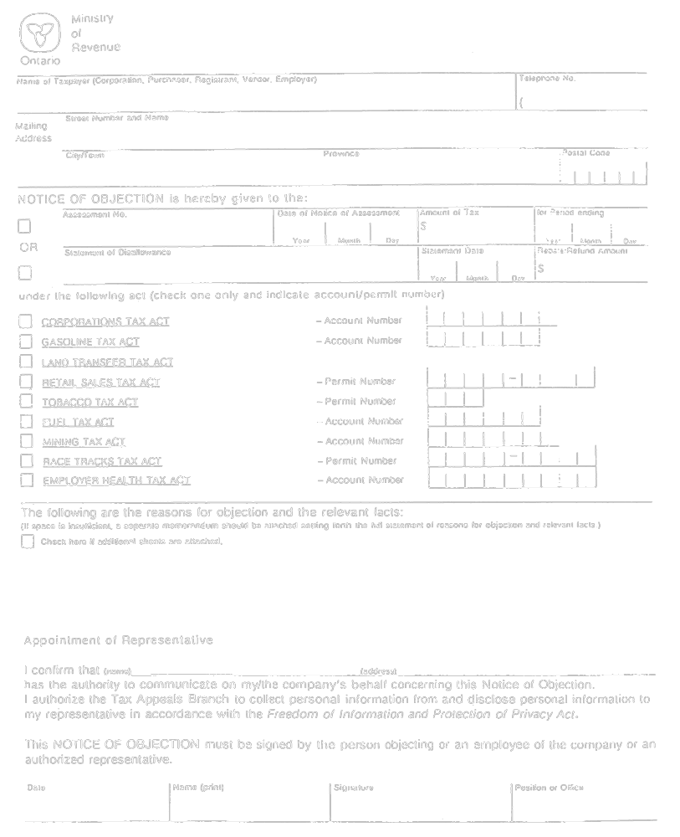
Formule 1
Loi de la taxe sur le pari mutuel
avis d’opposition
Insert regs\graphics\1990\983\983001af.tif
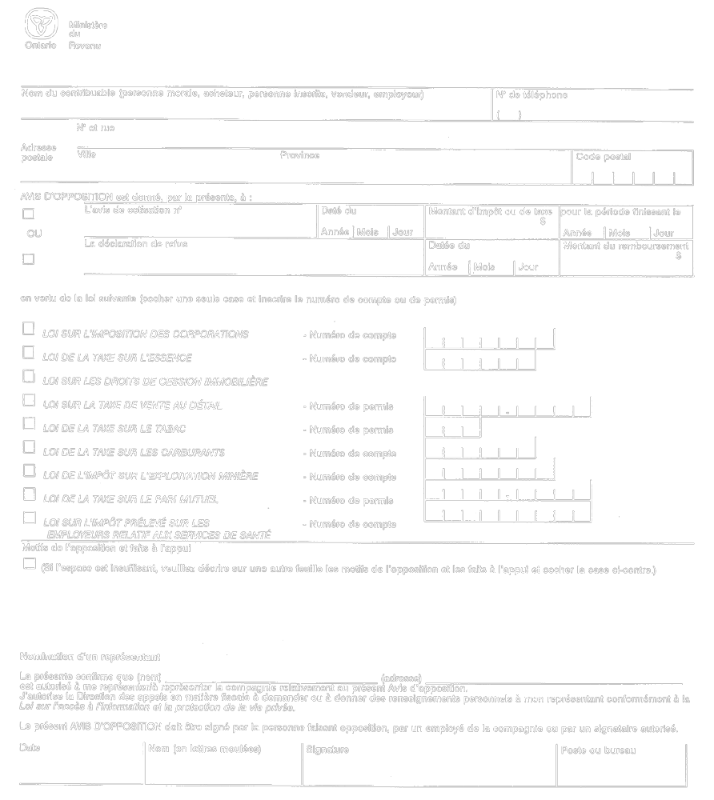
O. Reg. 647/91, s. 1.
Form 2
Race Tracks Tax Act
Insert regs\graphics\1990\983\983002ae.tif
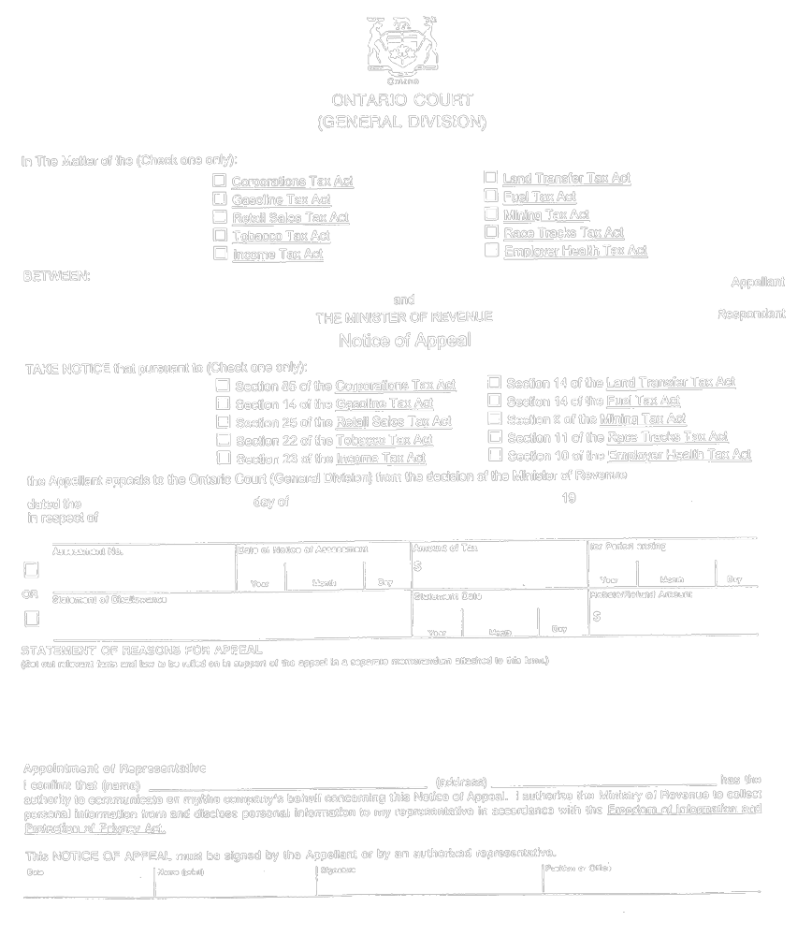
Formule 2
Loi de la taxe sur le pari mutuel
Insert regs\graphics\1990\983\983002af.tif
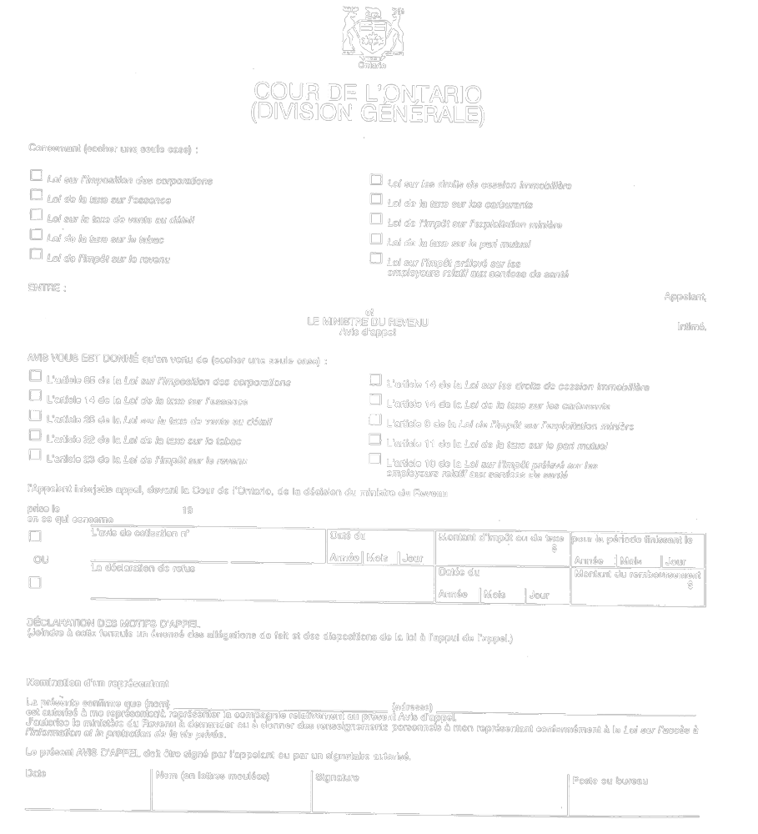
O. Reg. 647/91, s. 2.

Back to top

