Real Estate and Business Brokers Act
Loi sur le courtage commercial et immobilier
R.R.O. 1990, REGULATION 986
Amended to O. Reg. 567/05
GENERAL
Note: This Regulation was revoked on March 31, 2006. See: O. Reg. 567/05, ss. 43, 44.
This Regulation is made in English only.
Application
1. (1) An application for registration as a broker or a renewal of the registration shall be accompanied by the applicable fee set out in section 11 and shall be in a form provided by the Real Estate Council of Ontario. O. Reg. 323/00, s. 1.
(2) An application for registration as a salesperson or a broker who is employed by another broker or a renewal of the registration shall be accompanied by the applicable fee set out in section 11 and shall be in a form provided by the Real Estate Council of Ontario. O. Reg. 323/00, s. 1.
(3) A notice by a broker under clause 21 (a), (b) or (c) of the Act shall be in a form provided by the Real Estate Council of Ontario. R.R.O. 1990, Reg. 986, s. 1 (3); O. Reg. 161/97, s. 1 (3).
(4) A notice by a salesperson or a broker who is employed by another broker under subsection 21 (2) of the Act shall be in a form provided by the Real Estate Council of Ontario. R.R.O. 1990, Reg. 986, s. 1 (4); O. Reg. 161/97, s. 1 (4).
(5) A request for voluntary cancellation of registration under subsection 9 (7) of the Act shall be in a form provided by the Real Estate Council of Ontario. R.R.O. 1990, Reg. 986, s. 1 (5); O. Reg. 161/97, s. 1 (5).
2. Revoked: O. Reg. 323/00, s. 2 (1).
Note: Despite its revocation by subsection 2 (1) of Ontario Regulation 323/00, subsections 2 (2) to (5), as they read immediately before September 1, 2000, continue to apply to bonds that have not been cancelled by that date. See: O. Reg. 323/00, s. 2 (2).
2.1. Revoked: O. Reg. 323/00, s. 2 (1).
Note: Despite its revocation by subsection 2 (1) of Ontario Regulation 323/00, section 2.1, as it read immediately before September 1, 2000, continues to apply to bonds that have not been cancelled by that date. See: O. Reg. 323/00, s. 2 (2).
3. Revoked: O. Reg. 323/00, s. 2 (1).
Note: Despite its revocation by subsection 2 (1) of Ontario Regulation 323/00, section 3, as it read immediately before September 1, 2000, continues to apply to bonds that have not been cancelled by that date. See: O. Reg. 323/00, s. 2 (2).
4. Revoked: O. Reg. 323/00, s. 2 (1).
Note: Despite its revocation by subsection 2 (1) of Ontario Regulation 323/00, section 4, as it read immediately before September 1, 2000, continues to apply to bonds that have not been cancelled by that date. See: O. Reg. 323/00, s. 2 (2).
5. Revoked: O. Reg. 323/00, s. 2 (1).
Note: Despite its revocation by subsection 2 (1) of Ontario Regulation 323/00, section 5, as it read immediately before September 1, 2000, continues to apply to bonds that have not been cancelled by that date. See: O. Reg. 323/00, s. 2 (2).
6. Revoked: O. Reg. 323/00, s. 2 (1).
Note: Despite its revocation by subsection 2 (1) of Ontario Regulation 323/00, section 6, as it read immediately before September 1, 2000, continues to apply to bonds that have not been cancelled by that date. See: O. Reg. 323/00, s. 2 (2).
7. Revoked: O. Reg. 323/00, s. 2 (1).
Note: Despite its revocation by subsection 2 (1) of Ontario Regulation 323/00, section 7, as it read immediately before September 1, 2000, continues to apply to bonds that have not been cancelled by that date. See: O. Reg. 323/00, s. 2 (2).
8. Revoked: O. Reg. 323/00, s. 2 (1).
Note: Despite its revocation by subsection 2 (1) of Ontario Regulation 323/00, section 8, as it read immediately before September 1, 2000, continues to apply to bonds that have not been cancelled by that date. See: O. Reg. 323/00, s. 2 (2).
9. Revoked: O. Reg. 323/00, s. 2 (1).
Note: Despite its revocation by subsection 2 (1) of Ontario Regulation 323/00, section 9, as it read immediately before September 1, 2000, continues to apply to bonds that have not been cancelled by that date. See: O. Reg. 323/00, s. 2 (2).
10. Revoked: O. Reg. 323/00, s. 2 (1).
Note: Despite its revocation by subsection 2 (1) of Ontario Regulation 323/00, section 10, as it read immediately before September 1, 2000, continues to apply to bonds that have not been cancelled by that date. See: O. Reg. 323/00, s. 2 (2).
Fees
11. Fees payable to the Registrar are as follows:

1. | Upon application for registration as a broker or renewal of the registration:
 | i. beginning on the 1st day of January, 1992 to and including the 31st day of December, 1992 | $225
 | ii. beginning on the 1st day of January, 1993 to and including the 31st day of December, 1993 | 250
 | iii. beginning on the 1st day of January, 1994 | 275
2. | For each branch office of a broker:
 | i. beginning on the 1st day of January, 1992 to and including the 31st day of December, 1992 | 225
 | ii. beginning on the 1st day of January, 1993 to and including the 31st day of December, 1993 | 250
 | iii. beginning on the 1st day of January, 1994 | 275
3. | Upon application for registration as a salesperson or renewal of the registration:
 | i. beginning on the 1st day of January, 1992 to and including the 31st day of December, 1992 | 125
 | ii. beginning on the 1st day of January, 1993 to and including the 31st day of December, 1993 | 150
 | iii. beginning on the 1st day of January, 1994 | 175
R.R.O. 1990, Reg. 986, s. 11; O. Reg. 19/91, s. 1; O. Reg. 694/91, s. 1; O. Reg. 161/97, s. 9.
12. No person shall be registered as a salesperson or broker unless the person is,
(a) eighteen years of age or over;
(b) a resident of Canada for one year immediately prior to the date of application with the intention of making the person’s permanent home in Canada unless at the time of the application the person is registered either as a broker or salesperson under the laws relating to real estate and business brokers of the jurisdiction in which the person last resided and has been so registered for a period of not less than one year immediately preceding the date of such application and is otherwise suitable for registration; and
(c) declared eligible for membership in the Real Estate Council of Ontario by the Council. R.R.O. 1990, Reg. 986, s. 12; O. Reg. 83/99, s. 1.
Terms and Conditions of Registration
13. (1) Every registration expires on the date shown on the certificate of registration unless an application for renewal of registration in a form provided by the Real Estate Council of Ontario, together with the appropriate fee prescribed in section 11, is filed with the Registrar prior to the date of expiry. R.R.O. 1990, Reg. 986, s. 13 (1); O. Reg. 161/97, s. 10 (1).
(2) A registered broker shall not carry on business in a name other than the name in which the broker is registered or at a place other than that authorized by the registration. R.R.O. 1990, Reg. 986, s. 13 (2).
(3) A registered broker or salesperson shall not trade in Ontario real estate from an office that is located outside of Ontario. R.R.O. 1990, Reg. 986, s. 13 (3).
(4) Every registered broker shall prominently display the wall certificate of registration at the office where the broker is employed. R.R.O. 1990, Reg. 986, s. 13 (4).
(5) Where the registration of a broker is revoked, suspended or cancelled, the broker shall immediately return, by registered mail, the broker’s certificate of registration and the certificates of registration of each of the broker’s salespersons to the Registrar. R.R.O. 1990, Reg. 986, s. 13 (5).
(6) Revoked: O. Reg. 323/00, s. 3.
(7) Every registered broker shall be responsible for the safe-keeping, custody and control of the certificates of registration issued in respect of each of the broker’s salespersons. R.R.O. 1990, Reg. 986, s. 13 (7).
(8) Every salesperson’s certificate of registration shall be kept at the office where the salesperson is employed and shall be made available to any member of the public upon request. R.R.O. 1990, Reg. 986, s. 13 (8).
(9) Every registered broker and salesperson shall carry a copy of the certificate of registration in the form issued by the Registrar. R.R.O. 1990, Reg. 986, s. 13 (9).
(10) Where the registration of a salesperson is revoked, suspended or cancelled, or upon the termination of employment of a salesperson, for any reason, the salesperson shall immediately return his or her copy of the certificate of registration to the Registrar. R.R.O. 1990, Reg. 986, s. 13 (10).
(11) Upon the termination of the employment of a salesperson, for any reason, the broker employer shall immediately forward to the Registrar a written statement of the circumstances surrounding the termination. R.R.O. 1990, Reg. 986, s. 13 (11).
(12) A salesperson who requests a transfer shall forward his or her copy of the certificate of registration together with the request for transfer to the Registrar, or, if unable to forward the copy of the certificate of registration because of loss or otherwise, shall forward in writing to the Registrar the reasons that the copy cannot be forwarded. R.R.O. 1990, Reg. 986, s. 13 (12).
(13) A salesperson may only be registered where he or she is the salesperson of a registered broker. R.R.O. 1990, Reg. 986, s. 13 (13).
(14) Every applicant for registration shall state in the application an address for service in Ontario. R.R.O. 1990, Reg. 986, s. 13 (14).
(15) Where a broker has terminated an association with any other broker, or has ceased carrying on business for a period in excess of sixty days, or where a salesperson or a broker who is employed by another broker has not applied for a transfer of registration within sixty days of termination of employment the person shall,
(a) where the person intends to carry on in association with another broker or as an officer, director or partner of another broker, apply for registration by filing an application in a form provided by the Real Estate Council of Ontario together with the appropriate fee prescribed in section 11; or
(b) where the person intends to continue as a salesperson or a broker who is employed by another broker, apply for registration by filing an application in a form provided by the Real Estate Council of Ontario together with the appropriate fee prescribed in section 11. R.R.O. 1990, Reg. 986, s. 13 (15); O. Reg. 161/97, s. 10 (2, 3).
(16) Where a broker is a corporation, it shall, within five days after the event, notify the Registrar in a form provided by the Real Estate Council of Ontario where there is a change in a director of the corporation or where there is a change in its controlling interest. R.R.O. 1990, Reg. 986, s. 13 (16); O. Reg. 161/97, s. 10 (4).
(17) The Registrar may require further information or material to be submitted by any applicant or any registered person within a specified time limit and may require verification by affidavit or otherwise of any information or material then or previously submitted. R.R.O. 1990, Reg. 986, s. 13 (17).
(18) An applicant for first registration as a broker shall have been registered and actively employed as a registered salesperson for a period of two years during the immediately preceding three years or have related experience that, in the opinion of the Registrar, is equivalent thereto. R.R.O. 1990, Reg. 986, s. 13 (18).
(19) Every registered broker and registered salesperson shall be a resident of Canada. R.R.O. 1990, Reg. 986, s. 13 (19).
14. (1) A person who completes the course or courses of study approved by the Registrar, passes the written examination or examinations approved by the Registrar and applies for registration as a broker or salesperson within twelve months of the date of the last examination shall, where otherwise entitled to be registered under the Act and the regulations, be registered as a broker or salesperson, as the case may be. R.R.O. 1990, Reg. 986, s. 14 (1).
(2) Where a person who applies for registration has not been previously registered as a broker or salesperson and more than twelve months but fewer than eighteen months have elapsed since the date of the last examination, the person shall not be registered before again passing the written examination or examinations approved by the Registrar, and where the person fails to obtain a passing mark, he or she shall, prior to making further application for registration, again complete the course or courses of study approved by the Registrar and pass such examination or examinations as are approved by the Registrar. R.R.O. 1990, Reg. 986, s. 14 (2).
(3) Where a person who applies for registration has not been previously registered as a broker or salesperson and eighteen months or more have passed since the date of the last examination, the person shall not be registered before retaking the required course or courses of study approved by the Registrar and passing the written examination or examinations approved by the Registrar. R.R.O. 1990, Reg. 986, s. 14 (3).
(4) Where a person who applies for registration has previously been registered and has surrendered his or her registration or has had it terminated, if more than two years have elapsed since such surrender or termination, the person shall not be registered before completing the course or courses of study approved by the Registrar and passing the written examination or examinations approved by the Registrar. R.R.O. 1990, Reg. 986, s. 14 (4).
(5) Every salesperson shall within two years after being registered successfully complete and pass courses that are approved by the Registrar in real estate or that relate to real estate. R.R.O. 1990, Reg. 986, s. 14 (5).
15. A broker may only employ a salesperson to manage a branch office who has completed the course of study and passed the written examinations approved by the Registrar and who has been registered and actively employed as a registered salesperson for a period of two years during the three years immediately preceding the date of employment as a manager of a branch office or has related experience that, in the opinion of the Registrar, is equivalent thereto. R.R.O. 1990, Reg. 986, s. 15.
16. For the purposes of sections 14 and 15,
(a) examination papers shall be marked by the Registrar or his or her nominee;
(b) not less than 75 per cent shall be considered a pass mark for an examination;
(c) the Registrar or his or her nominee, where so requested in writing by an examinee who fails to obtain the pass mark prescribed in clause (b), shall review the examination paper and make such changes in the mark obtained as the Registrar or nominee considers proper;
(d) where a review under clause (c) is conducted by a nominee of the Registrar, and the examinee is not satisfied with the results of such review, the examinee may apply to the Registrar, who may review the examination paper and make such changes in the mark obtained as he or she considers proper;
(e) an examinee who fails to obtain the pass mark prescribed in clause (b) in an examination may write a supplementary examination but where the examinee fails the supplementary examination the examinee may not write another examination unless the examinee first repeats the required course in its entirety. R.R.O. 1990, Reg. 986, s. 16.
17. Despite section 14, where an applicant is registered as a broker under the laws relating to real estate and business brokers in a jurisdiction outside of Ontario in which the applicant was resident and has been so registered for a period of not less than one year immediately preceding the date of the application, and in the opinion of the Registrar is otherwise suitable for registration, the Registrar shall review the application and shall determine which examinations the applicant shall write. R.R.O. 1990, Reg. 986, s. 17.
17.1 (1) A person registered as a broker or salesperson shall become a member of the Real Estate Council of Ontario immediately after being registered if the person is not a member of the Council. O. Reg. 83/99, s. 2.
(2) The registration of a registered broker or salesperson described in subsection (1) expires if the person ceases to be a member of the Real Estate Council of Ontario. O. Reg. 83/99, s. 2.
Temporary Registration of Estates
18. (1) Where a registered real estate broker dies and no other member or officer in the partnership or corporation of which he or she was a member or officer is registered as a real estate broker, or where a registered real estate broker who carries on business as an individual broker dies, the Registrar may,
(a) grant to the executor or administrator of the broker temporary registration as a broker for a period of not more than six months in respect of the business of the deceased broker; and
(b) exempt any executor or administrator referred to in clause (a) from passing a written examination. R.R.O. 1990, Reg. 986, s. 18 (1).
(2) Every salesperson registered as a salesperson of the deceased broker or with the partnership or corporation of which the licensed broker was a member or officer at the time of his or her death shall be considered to be registered as a salesperson of the executor or administrator of the deceased broker. R.R.O. 1990, Reg. 986, s. 18 (2).
Exemptions
19. The Public Trustee or his or her nominee is exempted from registration in respect of any trades in real estate. R.R.O. 1990, Reg. 986, s. 19.
20. A company registered under the Loan and Trust Corporations Act, its brokers and salespersons are exempt from filing a bond when making application for registration. R.R.O. 1990, Reg. 986, s. 20.
21. A company registered under the Loan and Trust Corporations Act may change its officers without the consent required by subsection 3 (3) of the Act. R.R.O. 1990, Reg. 986, s. 21.
22. Revoked: O. Reg. 161/97, s. 11.
Trust Funds
23. (1) For the purpose of section 20 of the Act, no broker shall maintain more than one account designated as a trust account unless the broker has notified the Registrar and has the Registrar’s consent in writing. R.R.O. 1990, Reg. 986, s. 23 (1).
(2) The trust account shall be designated as the “Real Estate Trust Account”. R.R.O. 1990, Reg. 986, s. 23 (2).
(3) Every deposit received by the broker whether by cash, cheque or otherwise shall be deposited in the broker’s trust account within two banking days of its receipt. R.R.O. 1990, Reg. 986, s. 23 (3).
24. An entry in a trade record sheet or a trust account, as the case may be, required to be kept under section 19 of the Act shall be retained for a period of six years from the date of the entry. R.R.O. 1990, Reg. 986, s. 24.
Additional Forms
25. The trade record sheet under subsection 19 (1) of the Act shall be in Form 4. R.R.O. 1990, Reg. 986, s. 25.
26. An application for the consent of the Registrar to a change of officers under subsection 3 (3) of the Act shall be in a form provided by the Real Estate Council of Ontario. R.R.O. 1990, Reg. 986, s. 26; O. Reg. 161/97, s. 12.
Schedule
GLOSSARY
The following words and phrases are frequently used in respect of real estate transactions. The definition given pertains to the real estate meaning. The word “property” refers to real property.

1. | Abstract | A written history of the title to a parcel of real estate as recorded in a land registry office.
2. | Administrator | A person appointed by the Court to manage the estate of a deceased person who did not by will appoint an executor.
3. | Adverse Possession | When an individual, not the owner, takes actual possession of the property, hostile to, and without the consent of the owner.
4. | Agent | One who legally represents a person or company in business transactions.
5. | Agreement of Sale | A contract by which one party agrees to sell and another agrees to purchase.
6. | Agreement to Lease | A contract by which one party agrees to rent real estate to another party for a rental or other compensation.
7. | Amortization of a Mortgage | Arrangements for the paying off of a mortgage by instalments or periodic payments to a sinking fund.
8. | Appurtenances | All the rights that go with the property although not within the limits of the deed.
9. | Assessed Value or Assessment | Valuation placed on property by a municipality for taxation purposes.
10. | Business | As defined in section 1 of the Act.
11. | Chattels | Moveable possessions, personal property (generally items that may be removed without injury to the freehold estate).
12. | Cloud on Title | Any encumbrance or claim that affects title to real property.
13. | Commission | Remuneration paid to an agent on sale or lease of property, usually as a percentage of the amount involved.
14. | Consideration | Compensation, payment.
15. | Contract | An agreement between two or more parties upon lawful consideration, to do or refrain from doing some act (if affecting real estate, it must be in writing).
16. | Deed | A written instrument that has been signed, sealed and delivered.
17. | Deposit | Payment of money or other valuable consideration as pledge for fulfilment of contract.
18. | Depreciation | Amount by which property over a period of time has decreased in value.
19. | Easement | A right to some use of adjoining land or buildings, for example, a right of way or a right to light.
20. | Encumbrance | Outstanding claim or lien recorded against property or any legal right to the use of the property by another person who is not the owner.
21. | Equity | The difference between the market value of the property and the mortgages, liens, etc., against the property.
22. | Executor | Person appointed by testator to carry out the provisions of the testator’s will.
23. | Exclusive Listing | The giving of the sole right to sell the described property according to the terms of the agency agreement.
24. | Fee Simple | The highest estate or absolute right in real property.
25. | Fixtures | Permanent improvements to property that may not be removed at the expiration of the term of lease or tenure.
26. | Grantee | The person who receives the legal transfer of property from another.
27. | Grantor | The person who conveys or legally assigns property to another.
28. | Joint Tenancy | Ownership of land by two or more persons whereby, on the death of one, the survivor or survivors take the whole estate.
29. | Judgment | The decision of the Court.
30. | Landlord | The person from whom another holds tenancy.
31. | Lease | Contract between landlord (lessor) and tenant (lessee) for the occupation or use of the landlord’s property by the tenant for a specified time and for a specified consideration (rental).
32. | Lessee | Tenant under a lease.
33. | Lessor | The person who grants use of property under lease to a tenant.
34. | Lien | A right of encumbrance affecting any property.
35. | Lis Pendens | (legal phrase, Latin.) Notice of the commencement of a Court action recorded on the title of property in the land registry office (also referred to as a certificate of pending litigation).
36. | Mechanic’s Lien | A claim filed in the land registry office by an individual, or company, for labour or material, or both, supplied for the improvement of the property (also referred to as a construction lien or repairer’s lien).
37. | Mortgage | A conveyance of property to a creditor as security for payment of a debt with a right of redemption at a specified date.
38. | Mortgagee | The one to whom property is conveyed as security for the payment of a debt; the lender or creditor.
39. | Mortgagor | The one who makes the mortgage; the borrower or debtor.
40. | Option | A right given by the owner of property to another (for a valuable consideration) to buy certain property within a limited time at an agreed price.
41. | Personal Property | All property, except land and the improvements thereon.
42. | Power of Attorney | Delegated written authority to a person to legally act on behalf of another.
43. | Principal | The person or company who employs the agent; re money — constitutes the original sum invested or loaned.
44. | Quit Claim Deed | A general release of all claims or rights to a parcel of land.
45. | Real Estate | As defined in section 1 of the Act.
46. | Survey | The accurate mathematical measurements of land and buildings thereon, made with the aid of instruments.
47. | Tenant | One who occupies land or tenement under a landlord.
48. | Tenants-in-Common | Ownership of land by two or more persons; unlike joint tenancy in that interest of deceased does not pass to the survivor, but is treated as an asset of the deceased’s estate.
R.R.O. 1990, Reg. 986, Sched.
Form 1 Revoked: O. Reg. 323/00, s. 4.
Form 2 Revoked: O. Reg. 323/00, s. 4.
Form 3 Revoked: O. Reg. 323/00, s. 4.
Form 4
TRADE RECORD SHEET
Real Estate and Business Brokers Act
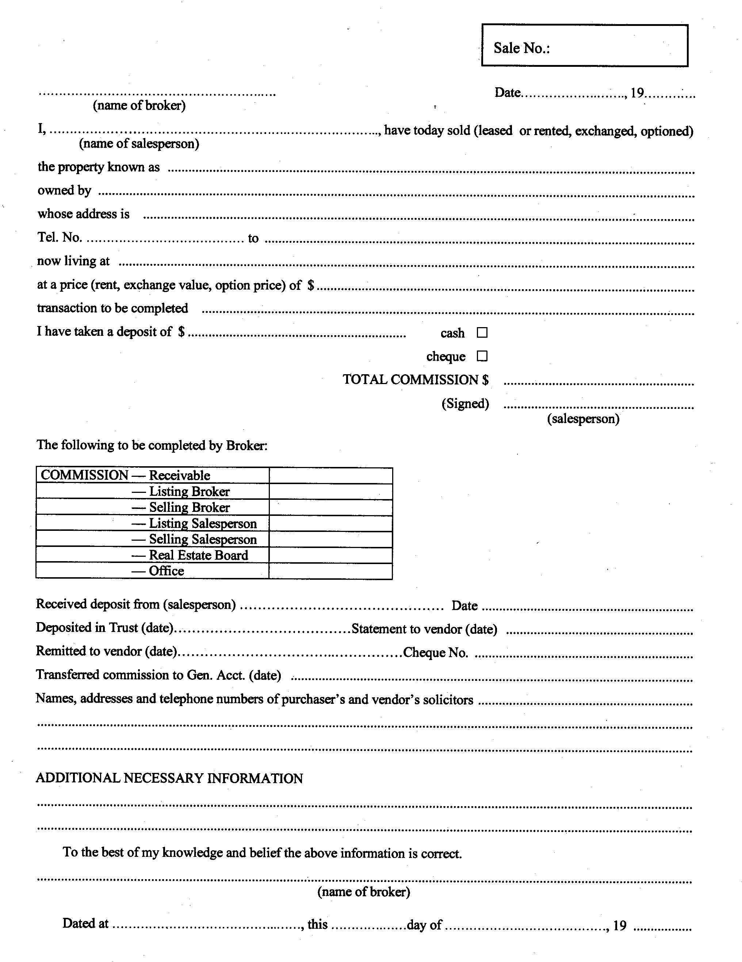
R.R.O. 1990, Reg. 986, Form 4.

Back to top

