Small Business Development Corporations Act
Loi sur les sociétés pour l’expansion des petites entreprises
REGULATION 1019
Amended to: O. Reg. 417/00
FORMS
Note: This Regulation was revoked on July 4, 2000. See: O. Reg. 417/00, s. 1.
This Regulation is made in English only.
1. A proposal referred to in section 3 of the Act shall be in Form 1. R.R.O. 1990, Reg. 1019, s. 1.
2. A certificate of registration referred to in section 6 of the Act shall be in Form 2. R.R.O. 1990, Reg. 1019, s. 2.
3. The certificate referred to in clause 20 (3) (a) or 21 (2) (a) of the Act or an application for,
(a) a grant under subsection 20 (1) or (6) of the Act; or
(b) a tax credit under section 21 of the Act,
shall be,
(c) in Form 3, where a person or corporation acquired equity shares of a small business development corporation before the 24th day of October, 1985; or
(d) in Form 4, where a person or corporation acquires equity shares of a small business development corporation on or after the 24th day of October, 1985. R.R.O. 1990, Reg. 1019, s. 3.
4. A notification of material change in investments under subsection 13 (2) of the Act shall be in Form 5. R.R.O. 1990, Reg. 1019, s. 4.
5. A notification of proposed corporate action under subsection 16 (2) of the Act shall be in Form 6. R.R.O. 1990, Reg. 1019, s. 5.
6. A notice of objection under section 28 of the Act shall be in Form 7. R.R.O. 1990, Reg. 1019, s. 6.
7. A return under subsection 16 (1) of the Act shall be in Form 8. R.R.O. 1990, Reg. 1019, s. 7.
Form 1
Small Business Development Corporations Act
Insert regs\graphics\1990\1019\019001au.tif
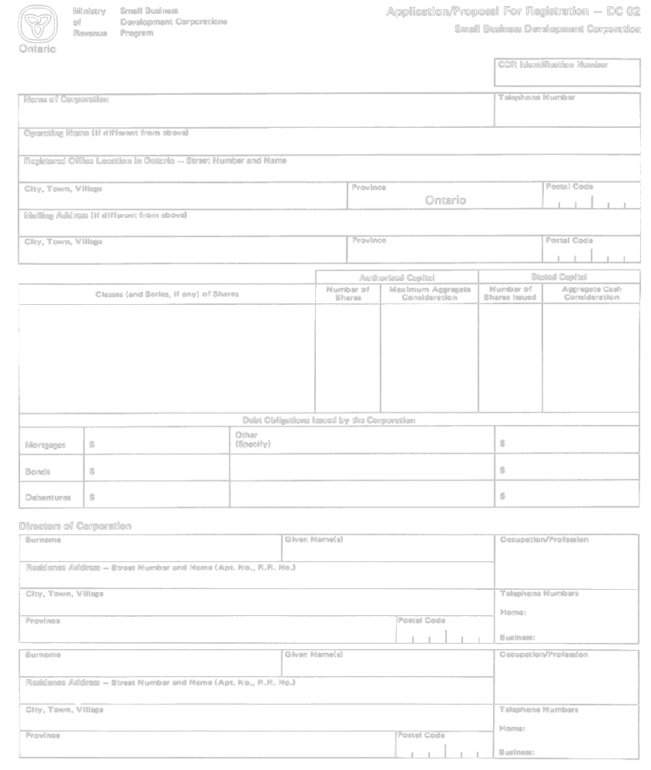
Insert regs\graphics\1990\1019\019001bu.tif
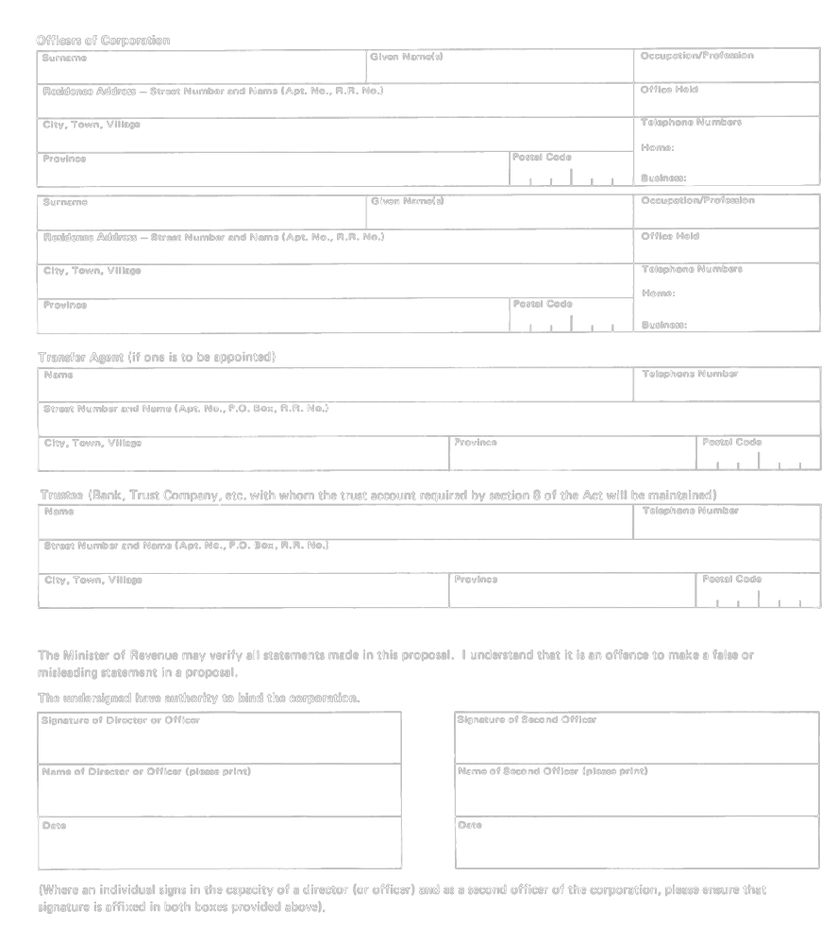
Insert regs\graphics\1990\1019\019001cu.tif
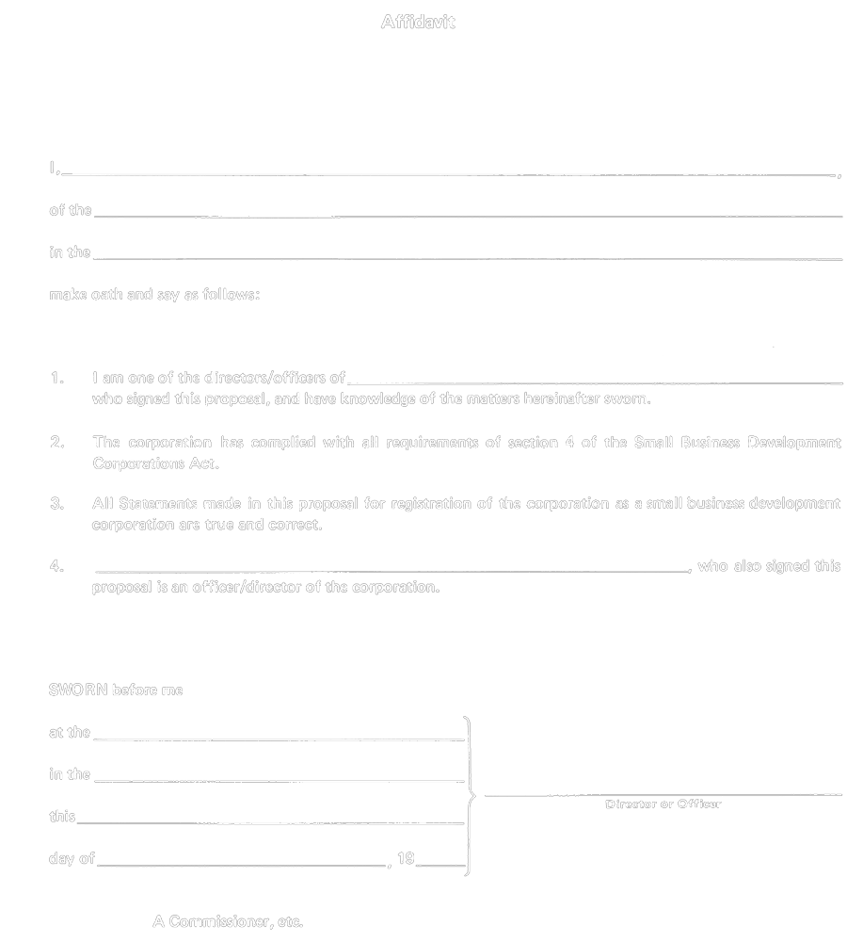
R.R.O. 1990, Reg. 1019, Form 1.
Form 2
Small Business Development Corporations Act
Insert regs\graphics\1990\1019\019002au.tif

R.R.O. 1990, Reg. 1019, Form 2.
Form 3
Small Business Development Corporations Act
Insert regs\graphics\1990\1019\019003au.tif
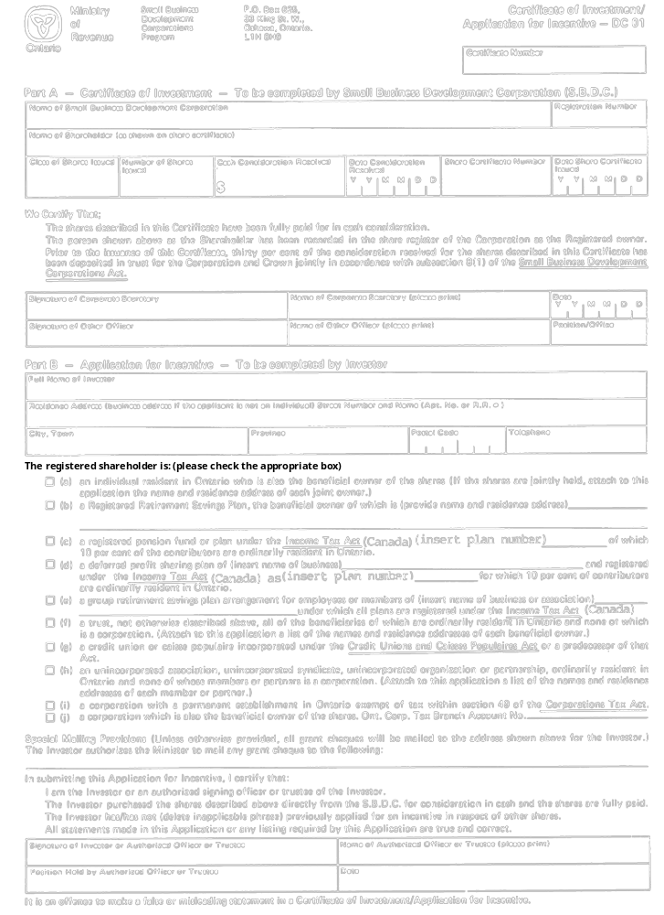
R.R.O. 1990, Reg. 1019, Form 3.
Form 4
Small Business Development Corporations Act
Insert regs\graphics\1990\1019\019004au.tif
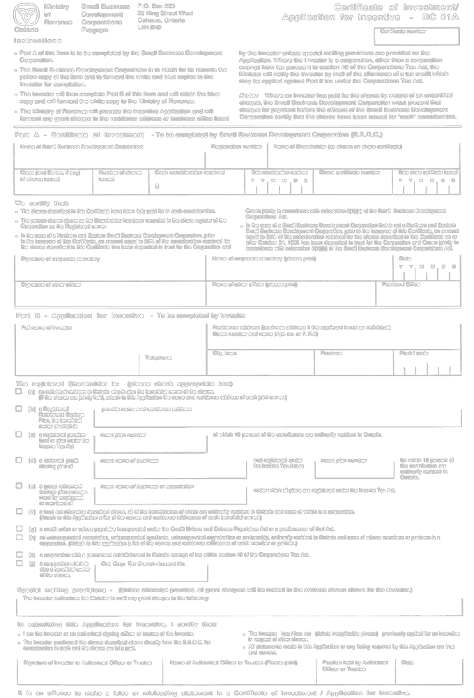
R.R.O. 1990, Reg. 1019, Form 4.
Form 5
Small Business Development Corporations Act
Insert regs\graphics\1990\1019\019005au.tif
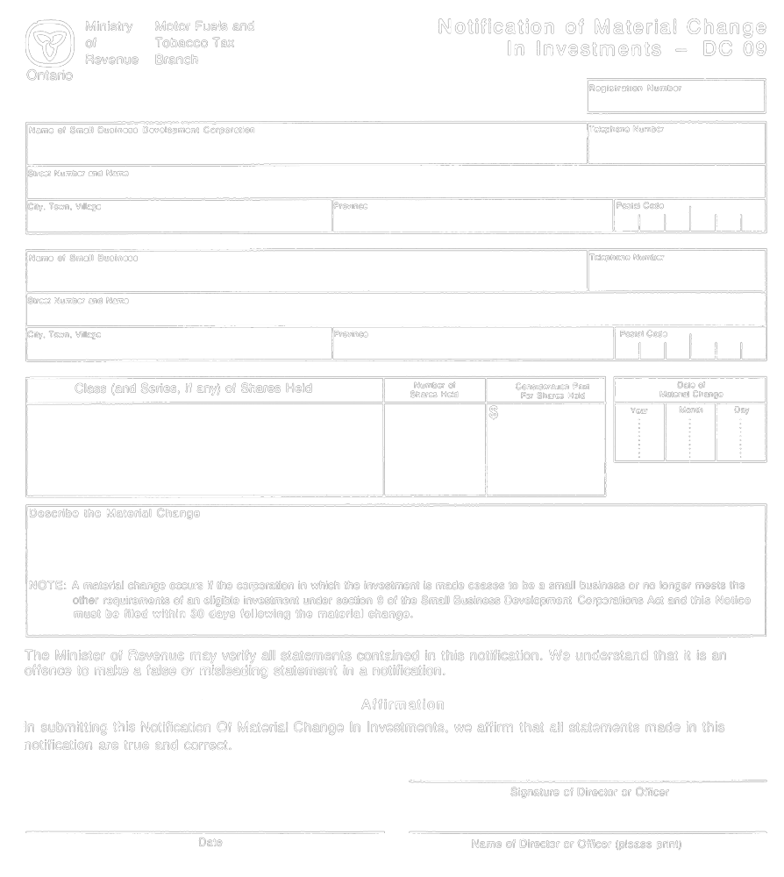
R.R.O. 1990, Reg. 1019, Form 5.
Form 6
Small Business Development Corporations Act
Insert regs\graphics\1990\1019\019006au.tif
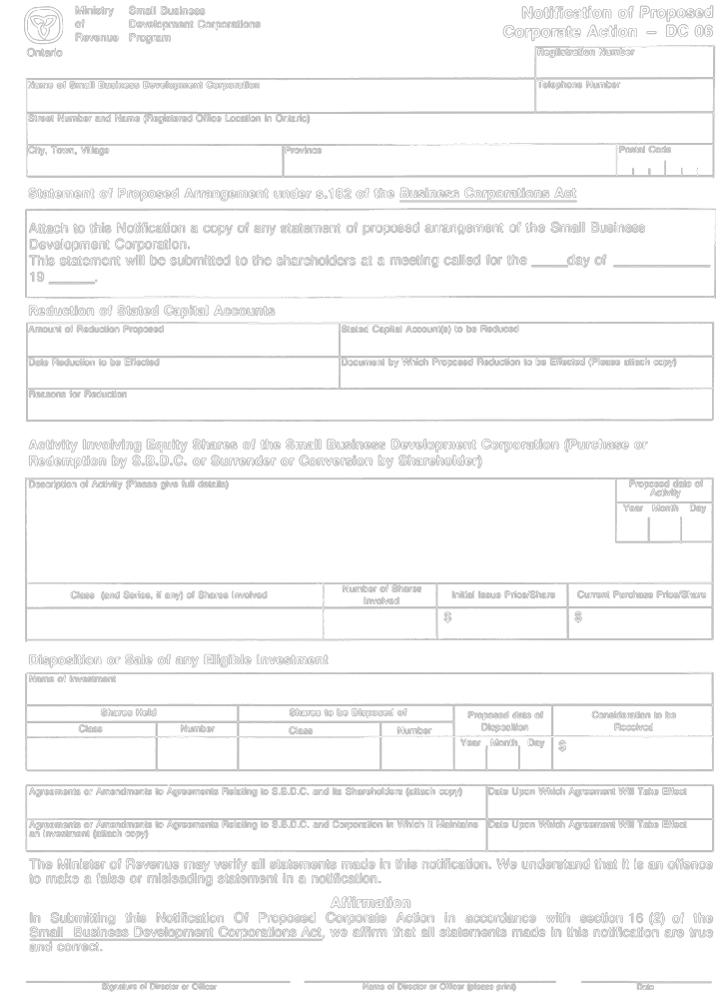
R.R.O. 1990, Reg. 1019, Form 6.
Form 7
Small Business Development Corporations Act
Insert regs\graphics\1990\1019\019007au.tif
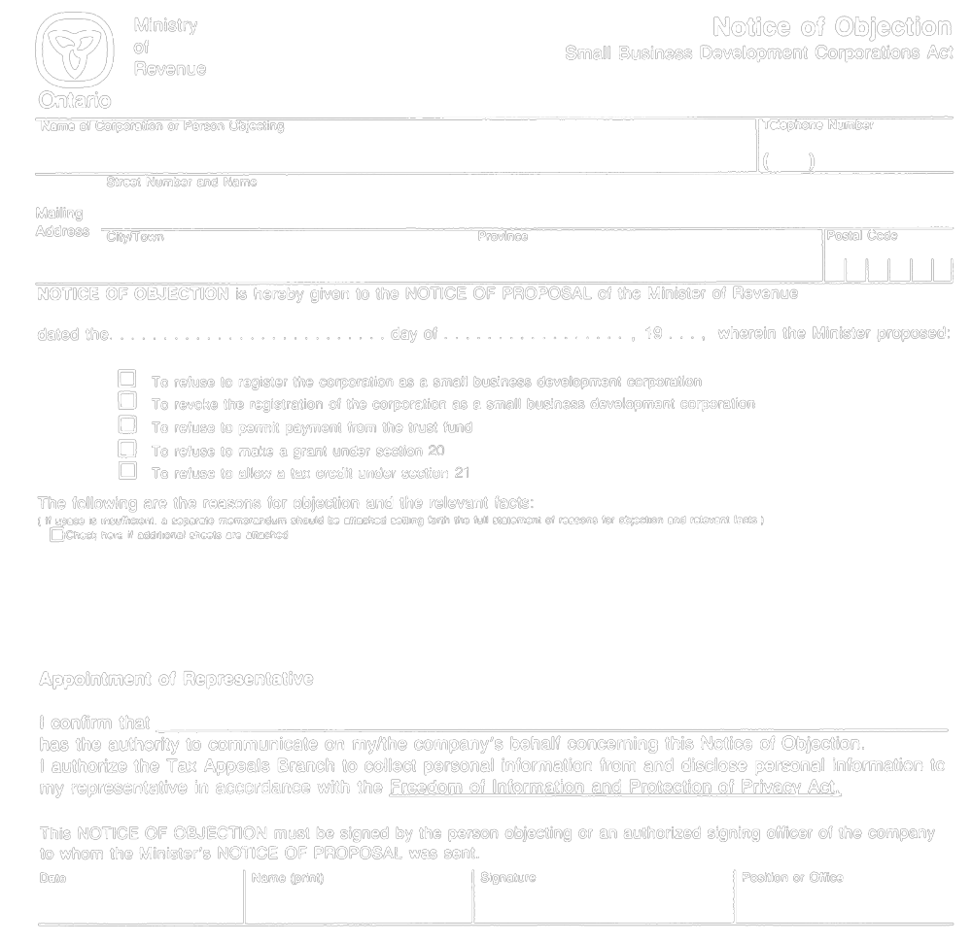
R.R.O. 1990, Reg. 1019, Form 7.
Form 8
Small Business Development Corporations Act
Insert regs\graphics\1990\1019\019008au.tif
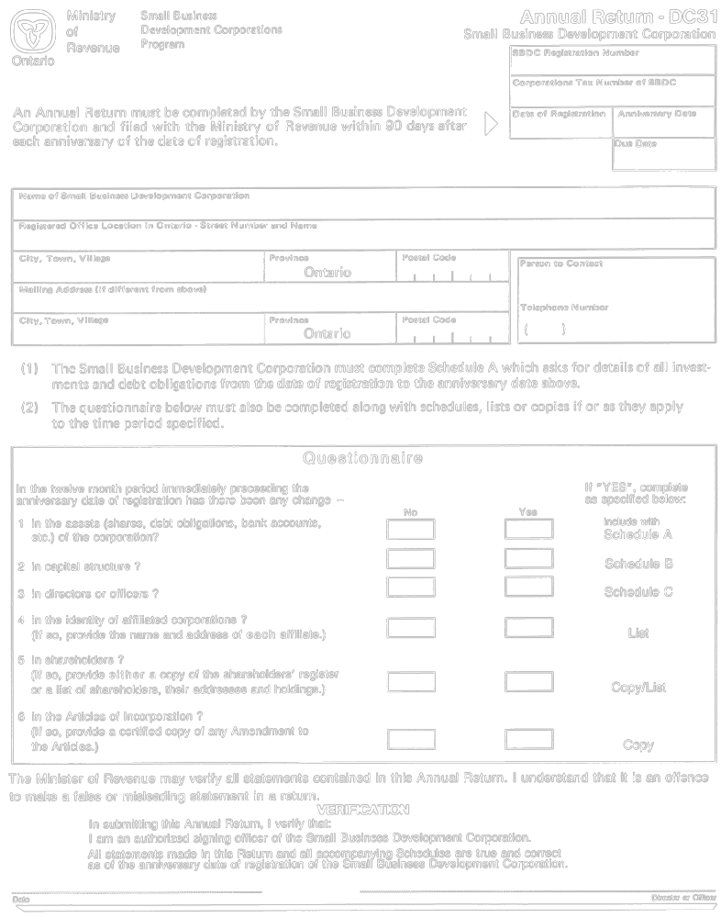
Insert regs\graphics\1990\1019\019008bu.tif
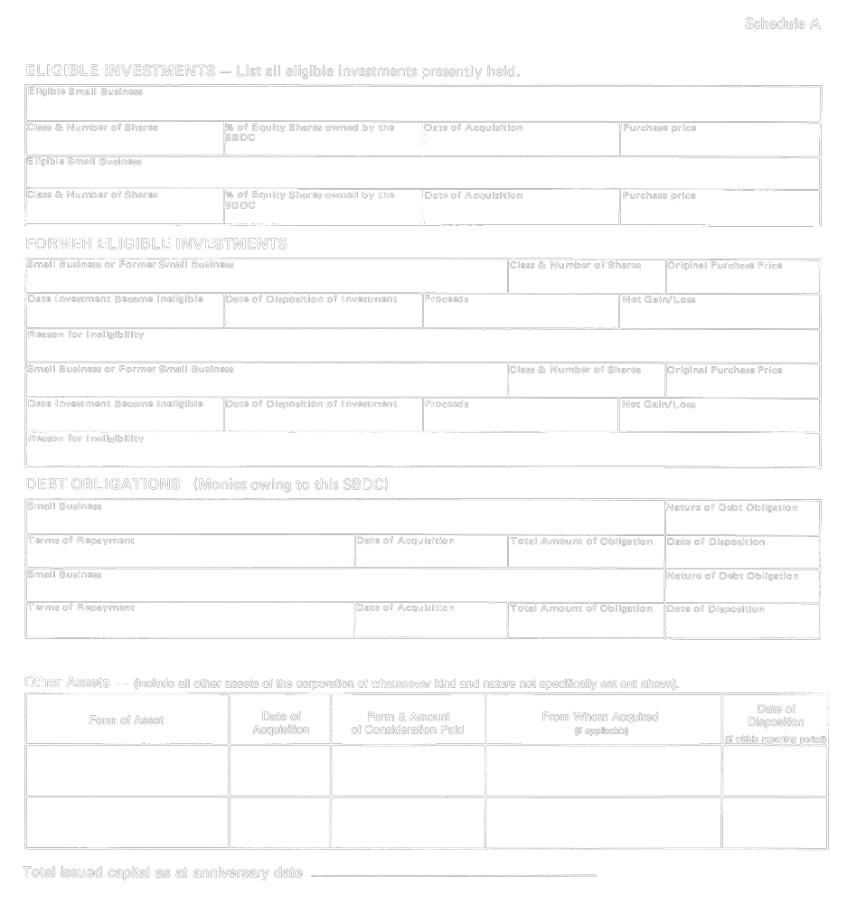
Insert regs\graphics\1990\1019\019008cu.tif
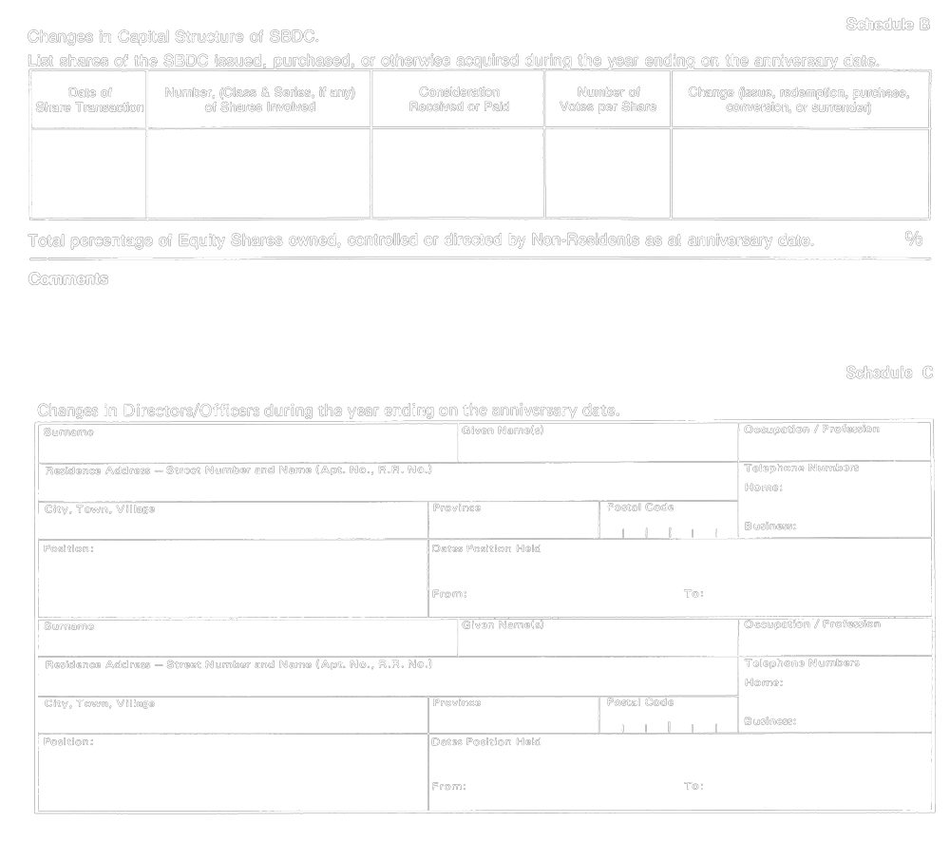
R.R.O. 1990, Reg. 1019, Form 8.

Back to top

