Français
Rent Control Act, 1992
ONTARIO REGULATION 415/92
Amended to O. Reg. 296/95
FORMS
Note: This Regulation became spent some time before January 1, 2004.
This is the English version of a bilingual regulation.
1. A notice for the purpose of clause 3 (7) (b) of the Act shall be in Form 3. O. Reg. 415/92, s. 1.
2. (1) A notice of rent increase under section 7 of the Act for a rental unit shall be,
(a) in Form 16 if subsection 3 (2), (4) or (7) of the Act applies to the rental unit;
(b) in Form 2 if,
(i) the increase cannot be charged or collected in full until,
(A) an order of the rent officer has been made under the Act on an application to increase the maximum rent of the rental unit by more than the guideline or a notice of carry forward has been issued under the Act, or
(B) an order has been made under the Residential Rent Regulation Act or a notice of phase-in has been given under that Act, or
(ii) at the time the notice is given there is an application outstanding under the Act or the Residential Rent Regulation Act to increase the maximum rent by more than the guideline for any rental unit in the residential complex in which the rental unit affected by the notice is located; or
(b.1) after January 1, 1995, in Form 21 for a rental unit in a care home if,
(i) the increase cannot be charged or collected in full until,
(A) an order of the rent officer has been made under the Act on an application to increase the maximum rent of the rental unit by more than the guideline or a notice of carry forward has been issued under the Act, or
(B) an order has been made under the Residential Rent Regulation Act or a notice of phase-in has been given under that Act, or
(ii) at the time the notice is given there is an application outstanding under the Act or the Residential Rent Regulation Act to increase the maximum rent by more than the guideline for any rental unit in the residential complex in which the rental unit affected by the notice is located;
(b.2) after January 1, 1995, in Form 22 for a rental unit in a care home if clause (b.1) does not apply; or
(c) in Form 1 in all other cases. O. Reg. 10/93, s. 1; O. Reg. 523/94, s. 1.
(2) The form for the notice of rent increase shall include Form 17 if subsection 7 (3) of the Act applies.
(3) Despite subsections (1) and (2), before the 1st day of August, 1993, a notice of rent increase under section 7 of the Act may be,
(a) if an order increasing the maximum rent above guideline is required, in Form 2 of Ontario Regulation 749/86, as it existed immediately before the 10th day of August, 1992; or
(b) in any other case, in Form 1 of Ontario Regulation 749/86, as it existed immediately before the 10th day of August, 1992. O. Reg. 10/93, s. 1.
3. An application by a landlord under section 13 of the Act for an above guideline increase shall be in Form 6. O. Reg. 415/92, s. 3.
4. A tenant’s consent for the purpose of subsections 17 (1) and 18 (1) of the Act shall be in Form 9. O. Reg. 415/92, s. 4.
5. An application by a tenant under section 23 of the Act for an order reducing rent shall be in a form approved by the Minister and provided by a rent control office. O. Reg. 296/95, s. 1.
6. An application for an advance determination under section 29 of the Act shall be in Form 7. O. Reg. 415/92, s. 6.
7. (1) An application under subsection 30 (2) of the Act for an order determining that a landlord has charged illegal rent shall be in Form 4.
(2) An application under subsection 32 (1) of the Act for an order determining that a person has collected money in a situation in which the collection is prohibited shall be in Form 4. O. Reg. 415/92, s. 7.
(2.1) A notice of abandonment for the purposes of subsection 28 (9), clause 30 (5) (a) or subsection 32 (3) of the Act shall be in Form 18. O. Reg. 296/95, s. 2 (1).
(3) A statement of care home information under subsection 104.1 (1) of the Act shall be in a form approved by the Minister and provided by a rent control office. O. Reg. 296/95, s. 2 (2).
(4) After January 1, 1995, a notice of increased charges for care services or meals shall be in Form 23. O. Reg. 523/94, s. 2.
8. An application under subsection 33 (1) or (2) of the Act for an order determining issues shall be in a form approved by the Minister and provided by a rent control office. O. Reg. 296/95, s. 3.
9. An application under subsection 37 (3) of the Act for a review of a work order shall be in Form 10. O. Reg. 415/92, s. 9.
10. An application under section 44 of the Act for an order withdrawing an order prohibiting a rent increase under section 43 of the Act shall be in Form 12. O. Reg. 415/92, s. 10.
11. A cost statement under clause 53 (a) of the Act shall be in Form 8. O. Reg. 415/92, s. 11.
12. A statement for the purposes of section 103 of the Act shall be in Form 13. O. Reg. 415/92, s. 12.
12.1 A statement of rent information under subsection 104 (1) of the Act shall be in Form 14. O. Reg. 570/92, s. 1.
12.2 A statement of change of information under subsection 107 (1) of the Act shall be in Form 15. O. Reg. 570/92, s. 1.
12.3 A search warrant under subsection 124 (1) of the Act shall be in Form 19. O. Reg. 553/93, s. 2.
13. Omitted (provides for coming into force of provisions of this Regulation). O. Reg. 415/92, s. 13.
Form 1
Rent Control Act, 1992
NOTICE OF RENT INCREASE
Insert regs\graphics\1992\415\415001ae.tif
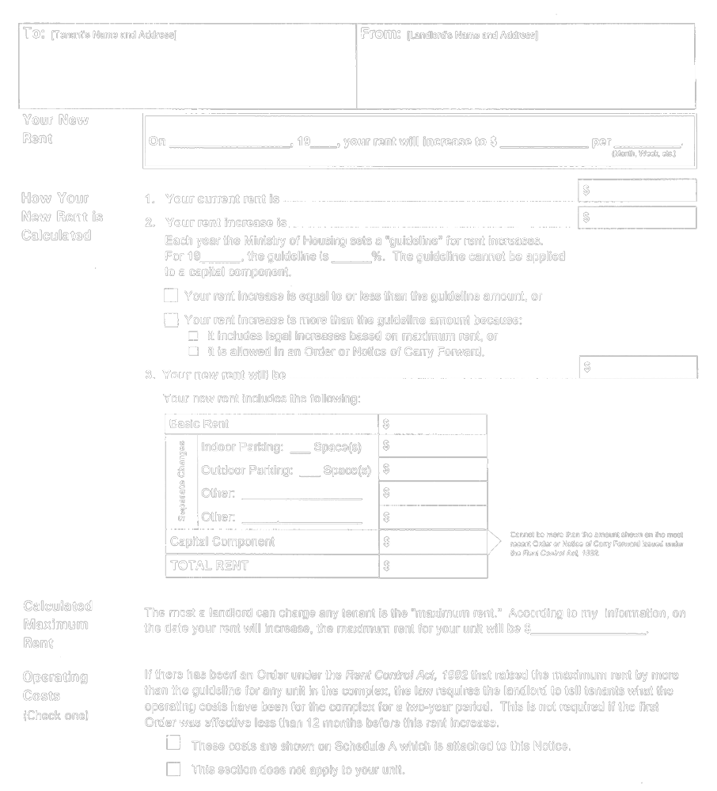
Insert regs\graphics\1992\415\415001be.tif
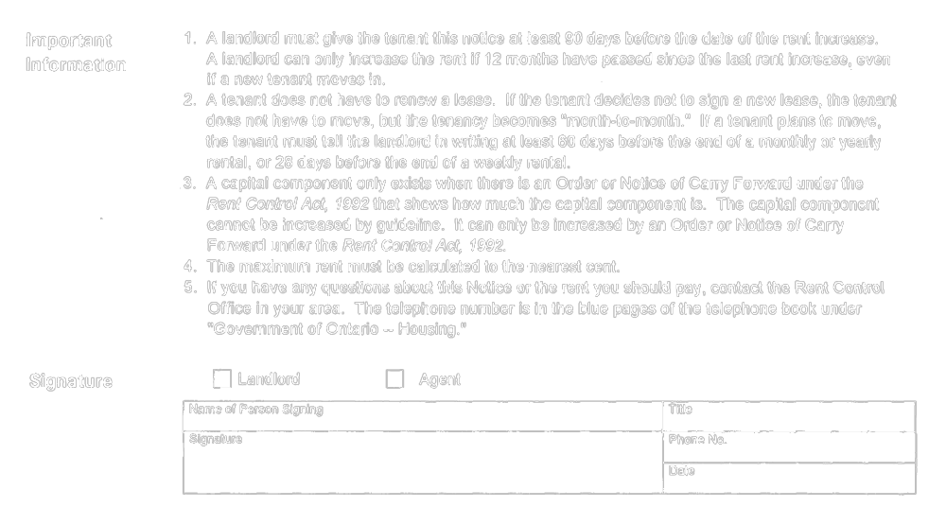
O. Reg. 10/93, s. 2.
Form 2
Rent Control Act, 1992
NOTICE OF RENT INCREASE
Insert regs\graphics\1992\415\415002ae.tif
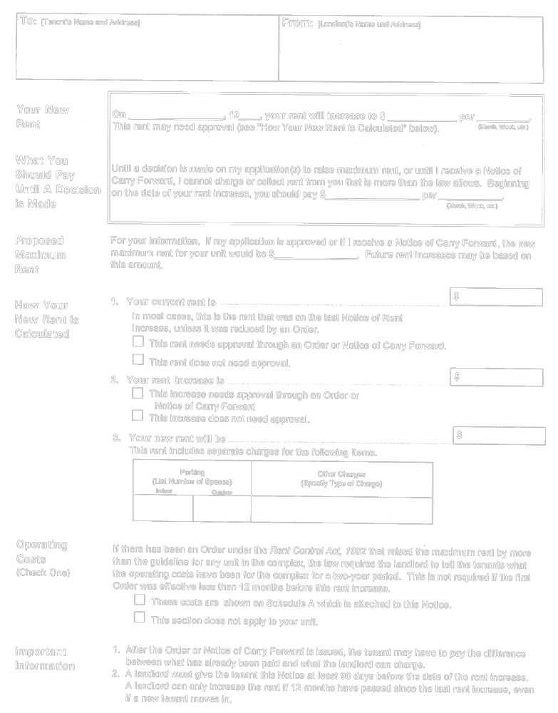
Insert regs\graphics\1992\415\415002be.tif
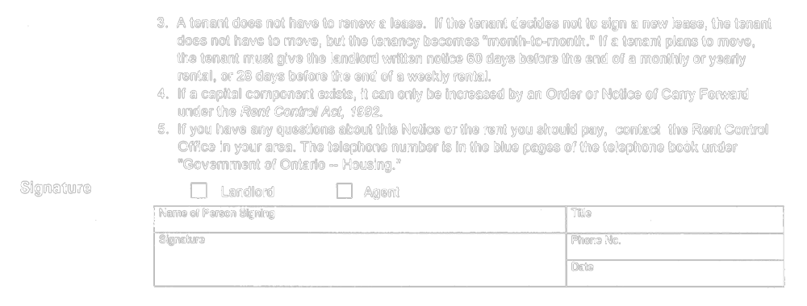
O. Reg. 10/93, s. 2.
Form 3
Rent Control Act, 1992
NOTICE OF A TEMPORARY EXEMPTION from RENT CONTROL
Insert regs\graphics\1992\415\415003ae.tif
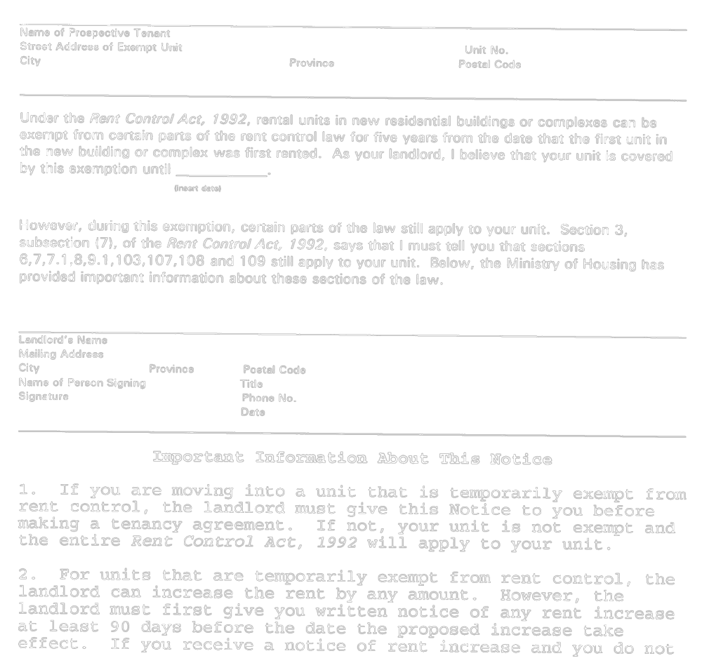
Insert regs\graphics\1992\415\415003be.tif
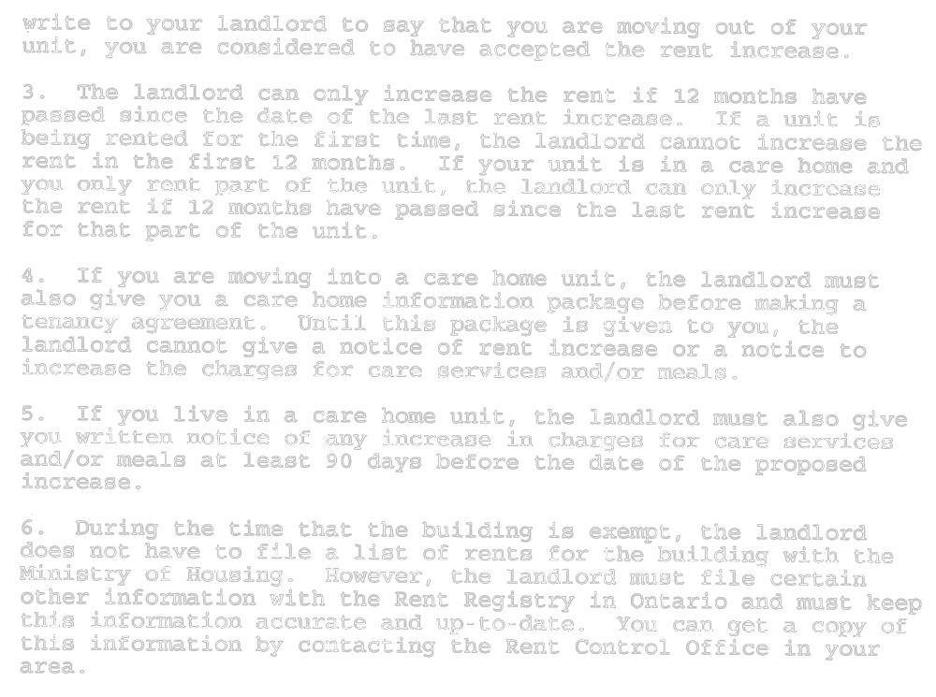
O. Reg. 523/94, s. 3.
Form 4
Rent Control Act, 1992
TENANT APPLICATION(S)
(ILLEGAL RENT/ILLEGAL CHARGES)
Insert regs\graphics\1992\415\415004ae.tif
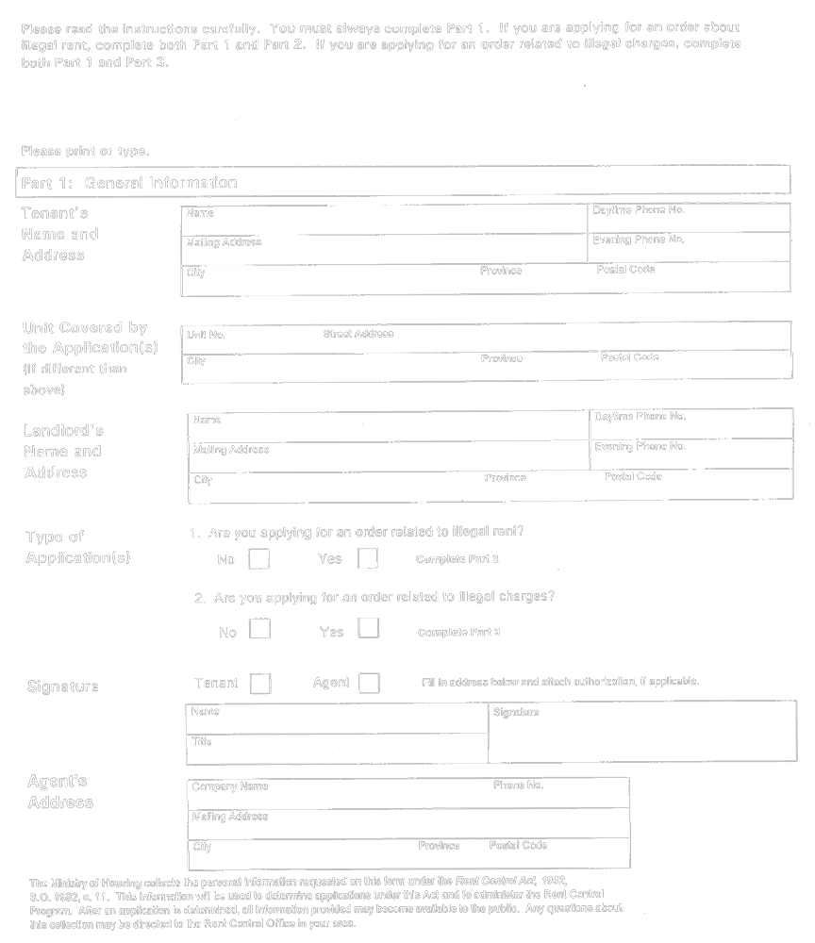
Insert regs\graphics\1992\415\415004be.tif
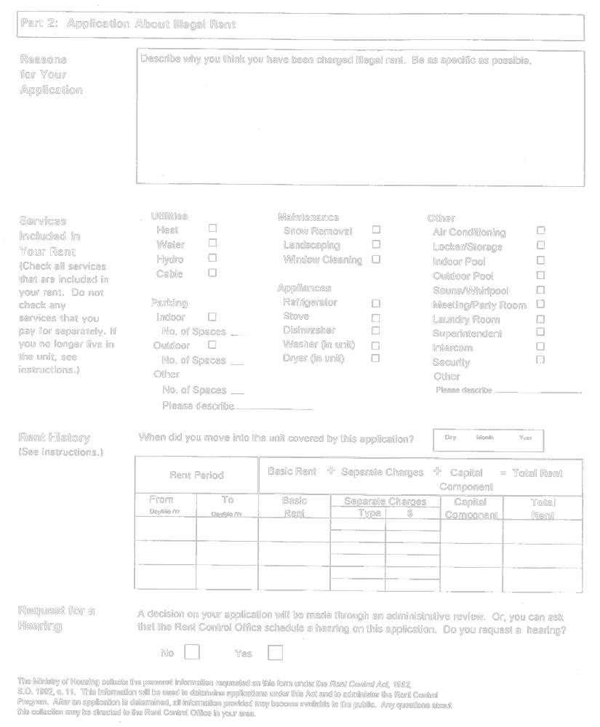
Insert regs\graphics\1992\415\415004ce.tif
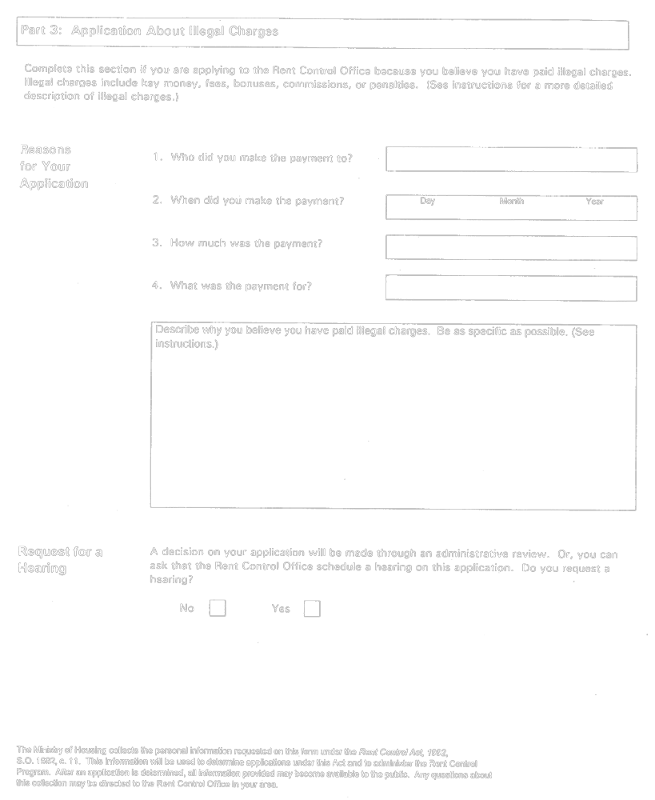
O. Reg. 415/92, Form 4.
Form 5 Revoked: O. Reg. 296/95, s. 4.
Form 6
Rent Control Act, 1992
APPLICATION FOR A RENT INCREASE
ABOVE GUIDELINE
Insert regs\graphics\1992\415\415006ae.tif
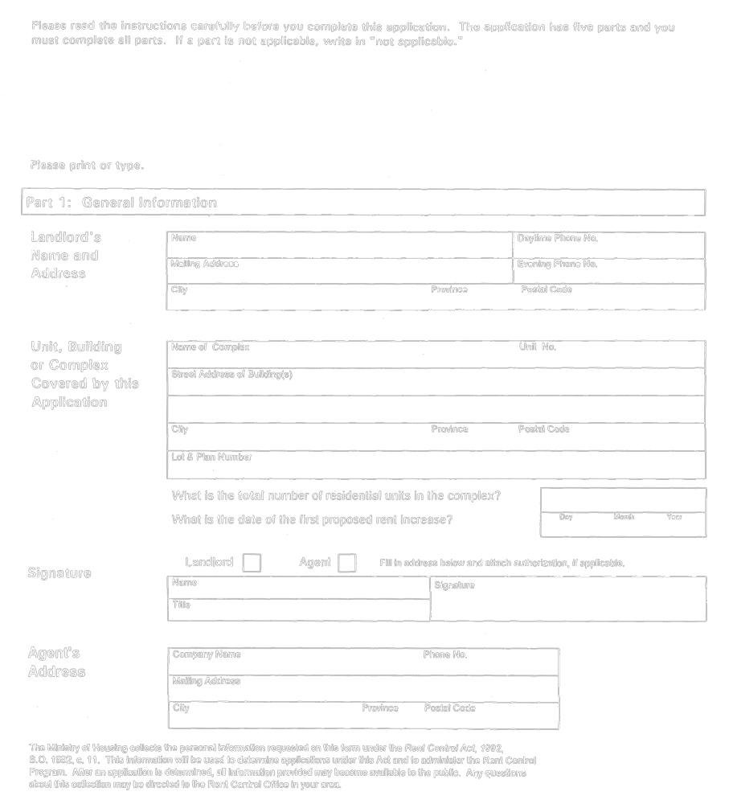
Insert regs\graphics\1992\415\415006be.tif
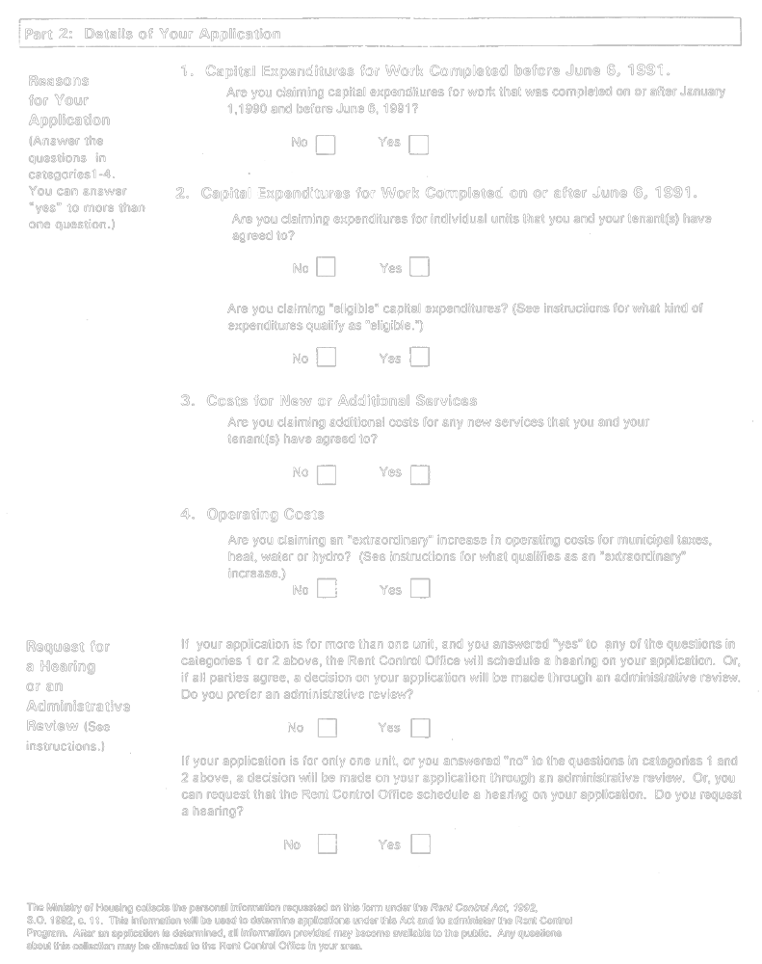
Insert regs\graphics\1992\415\415006ce.tif
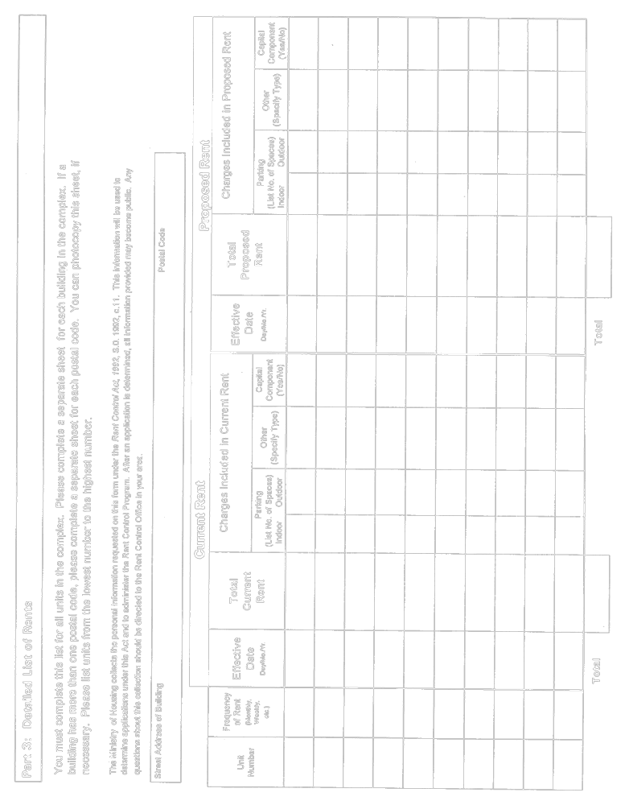
Insert regs\graphics\1992\415\415006de.tif
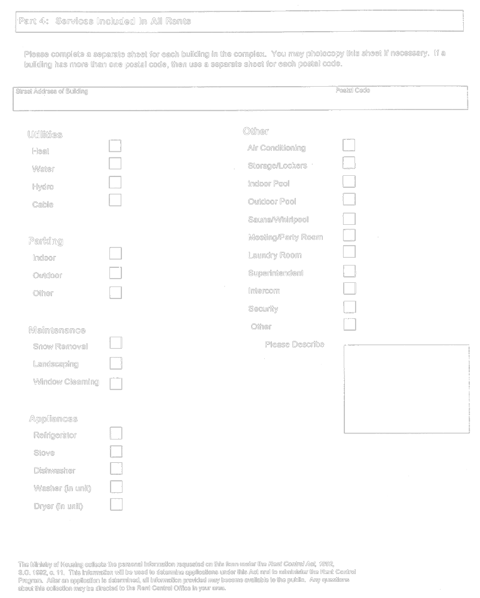
Insert regs\graphics\1992\415\415006ee.tif
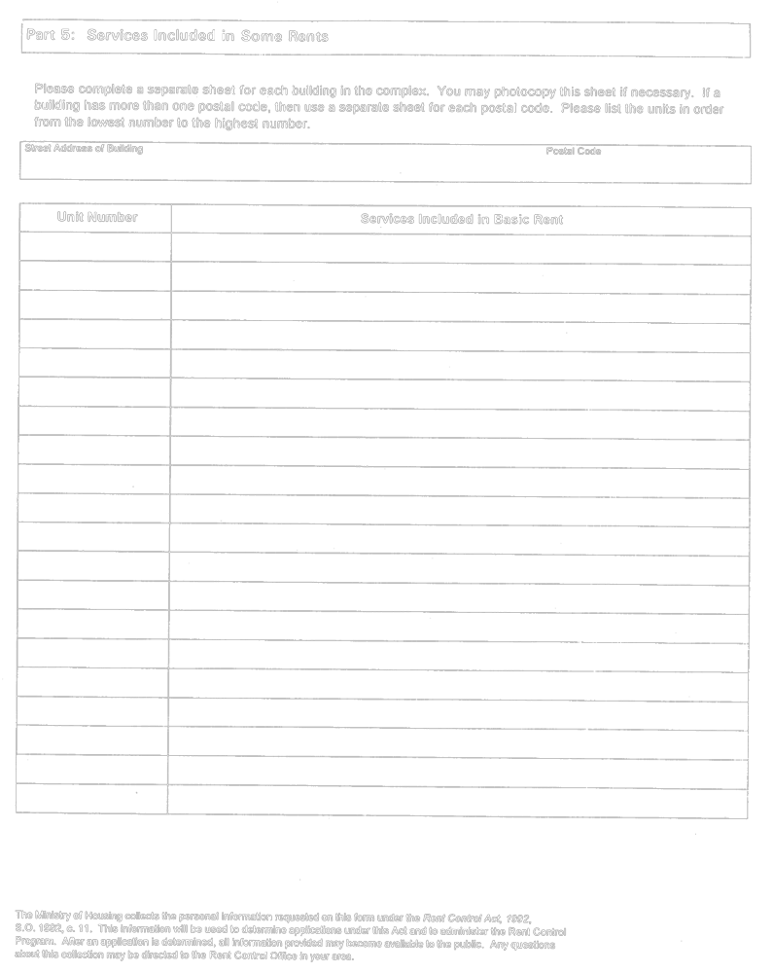
O. Reg. 415/92, Form 6.
Form 7
Rent Control Act, 1992
APPLICATION FOR ADVANCE DETERMINATION
Insert regs\graphics\1992\415\415007ae.tif
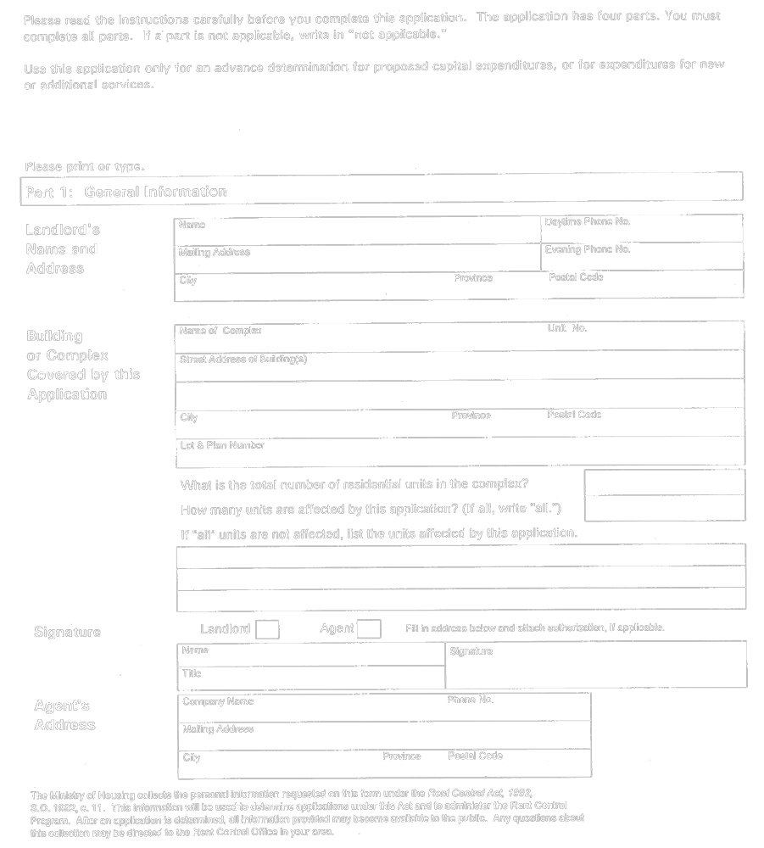
Insert regs\graphics\1992\415\415007be.tif
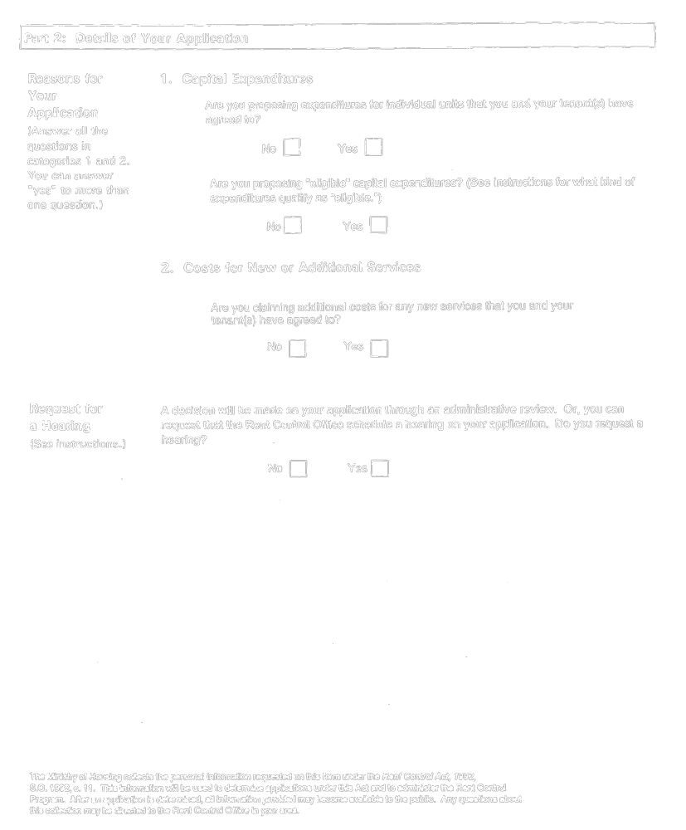
Insert regs\graphics\1992\415\415007ce.tif
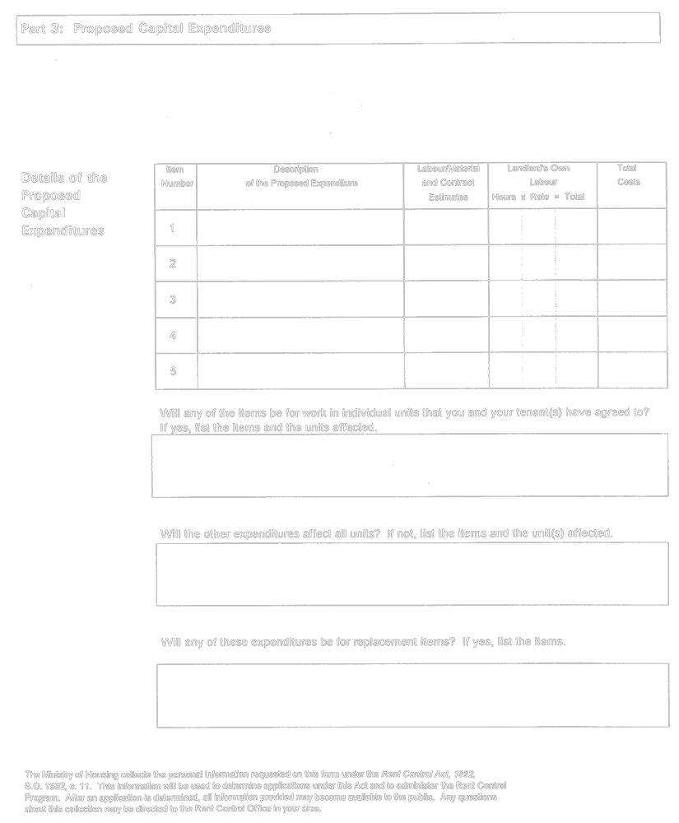
Insert regs\graphics\1992\415\415007de.tif
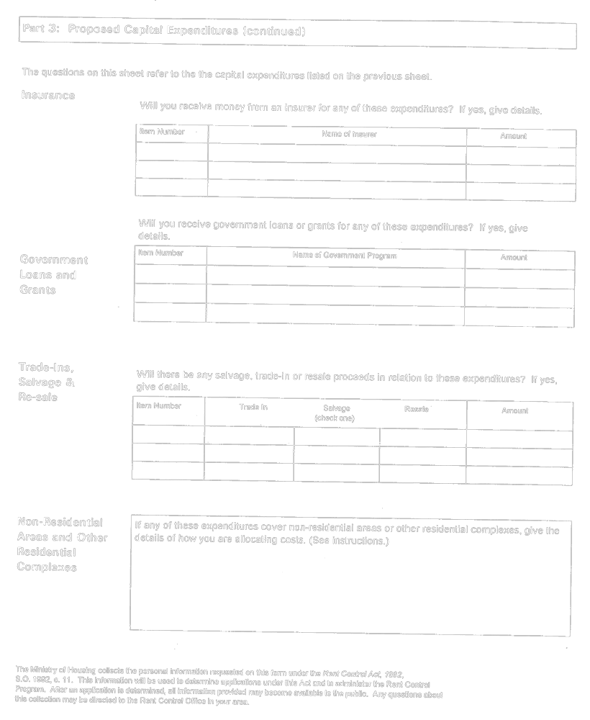
Insert regs\graphics\1992\415\415007ee.tif
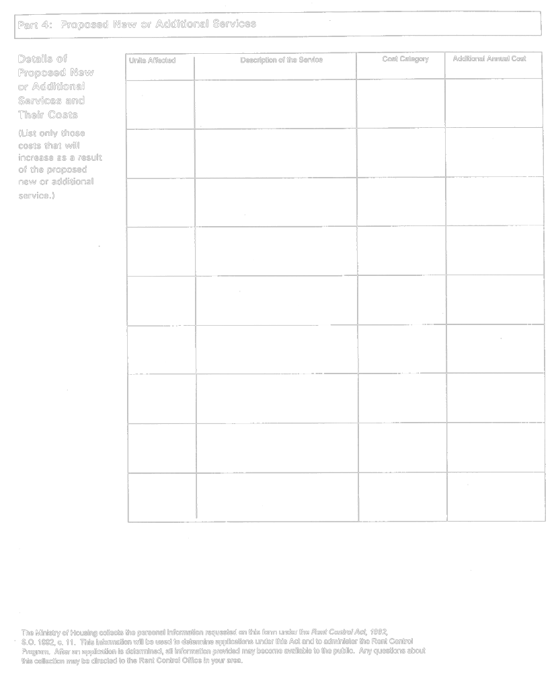
O. Reg. 415/92, Form 7; O. Reg. 570/92, s. 3.
Form 8
Rent Control Act, 1992
COST STATEMENT
Insert regs\graphics\1992\415\415008ae.tif
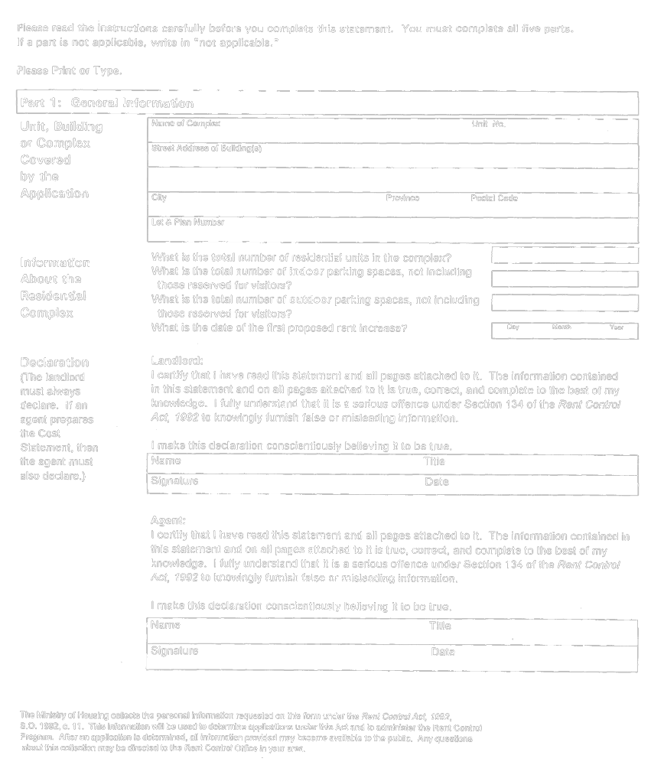
Insert regs\graphics\1992\415\415008be.tif
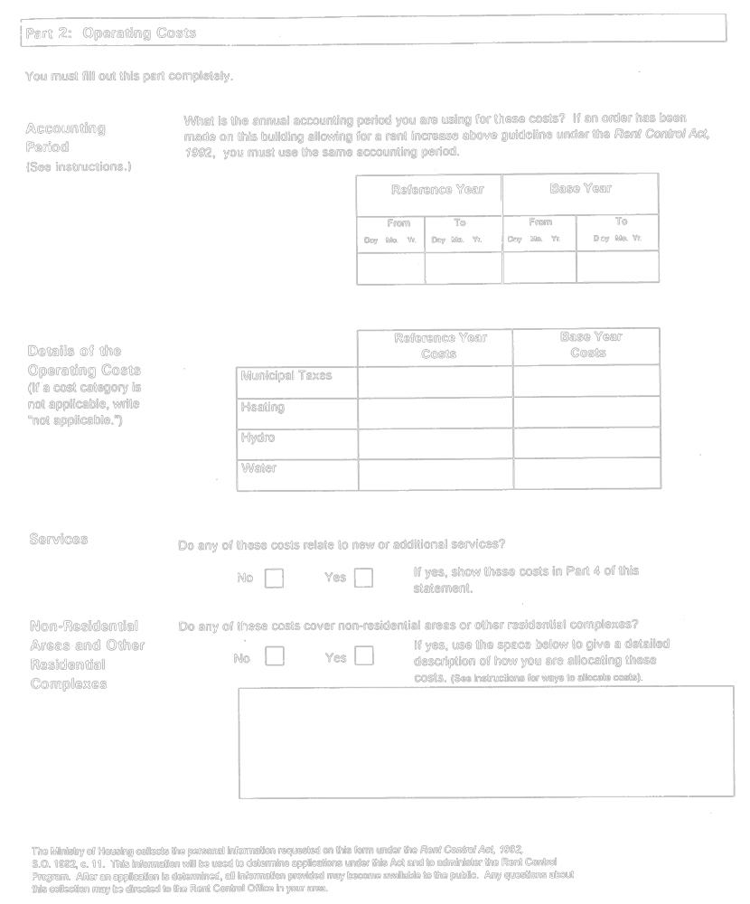
Insert regs\graphics\1992\415\415008ce.tif
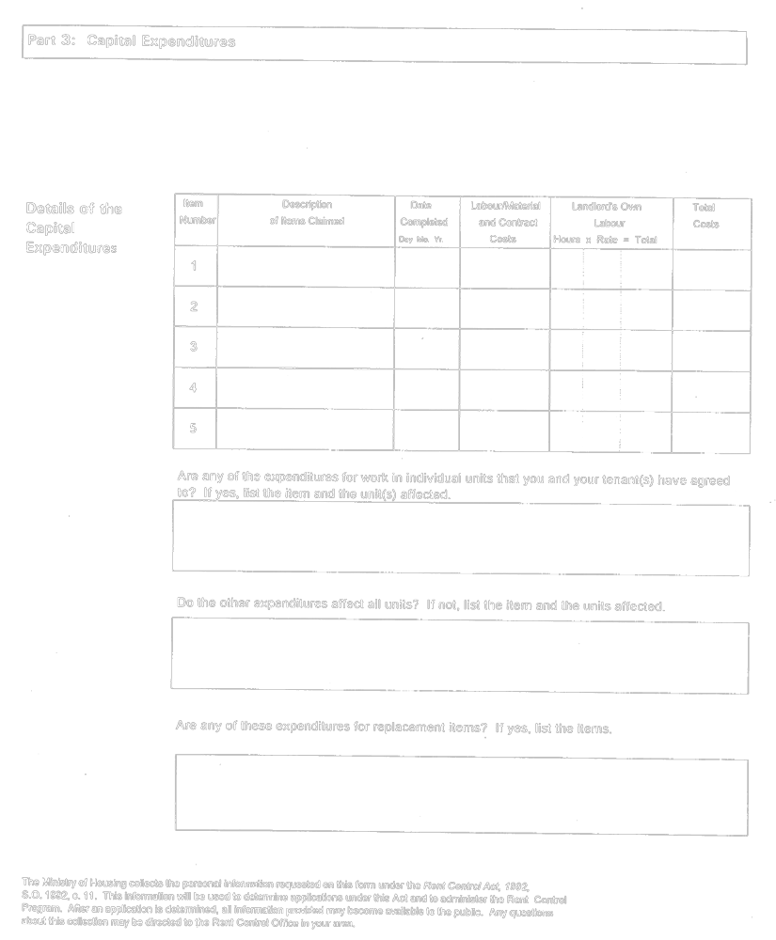
Insert regs\graphics\1992\415\415008de.tif
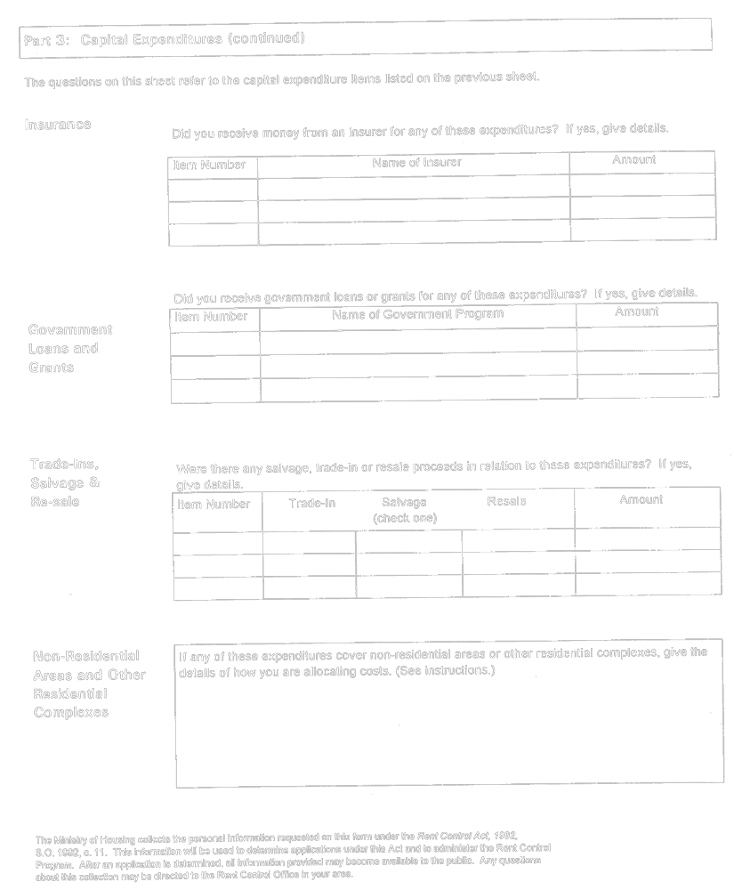
Insert regs\graphics\1992\415\415008ee.tif
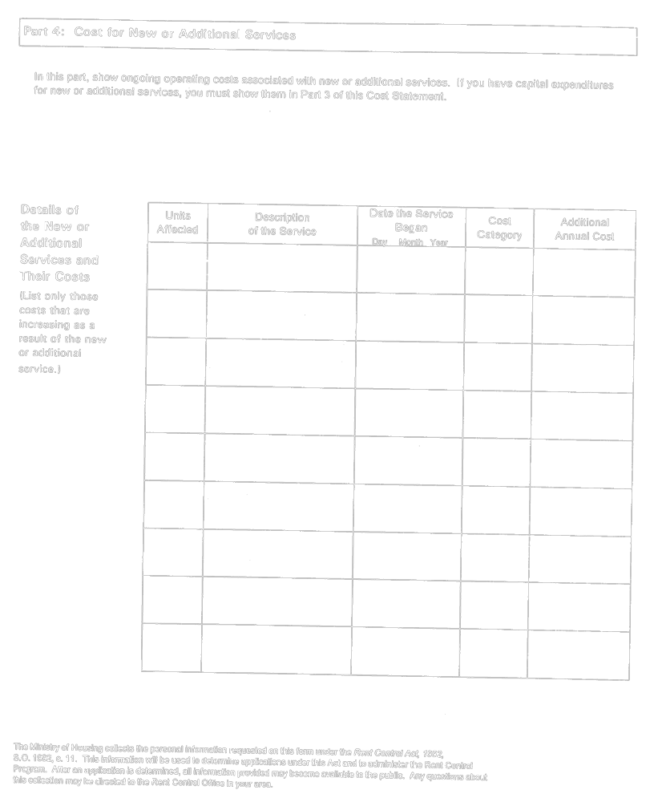
Insert regs\graphics\1992\415\415008fe.tif
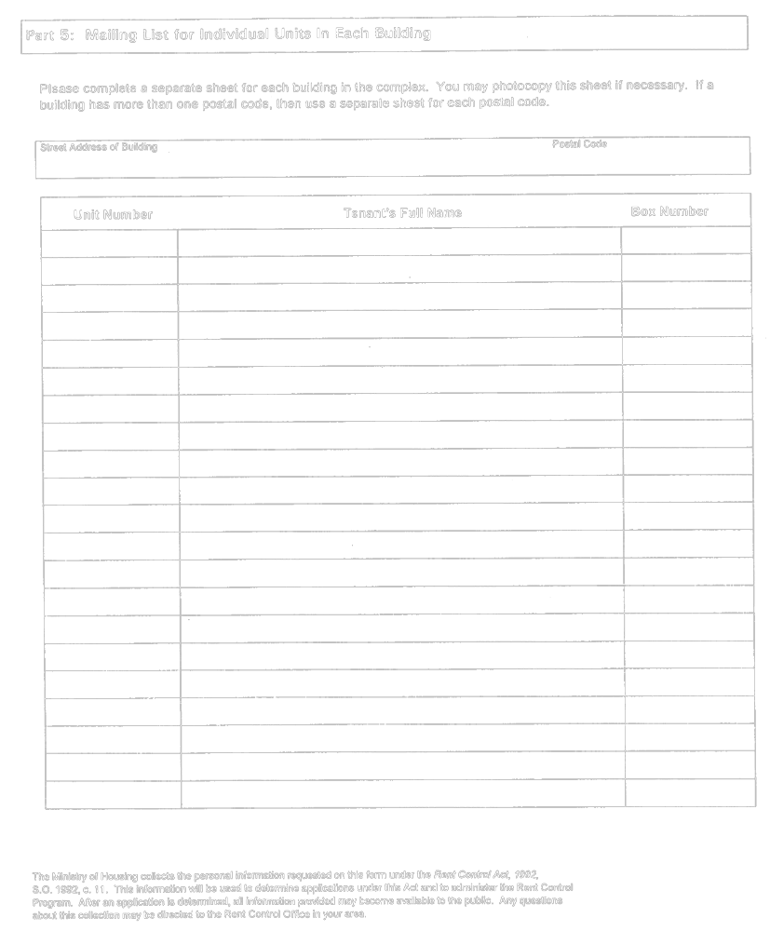
O. Reg. 415/92, Form 8.
Form 9
Rent Control Act, 1992
TENANT CONSENT
Insert regs\graphics\1992\415\415009ae.tif
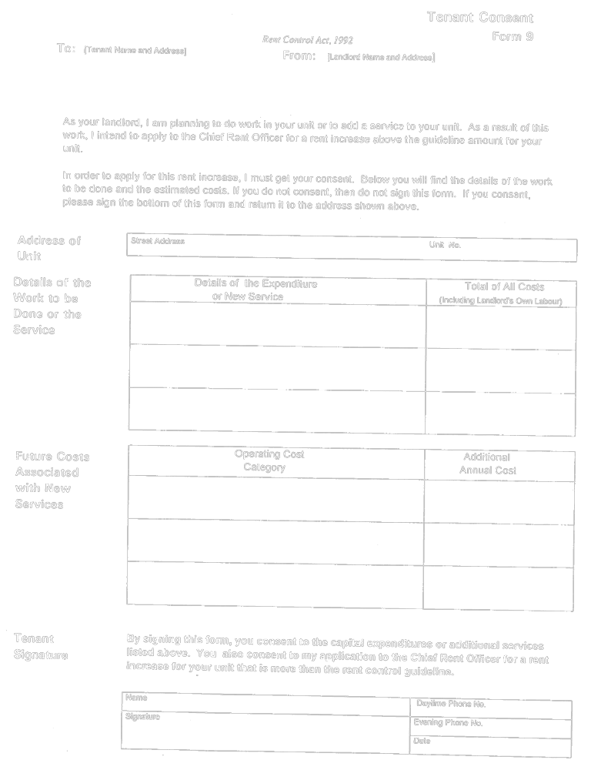
O. Reg. 415/92, Form 9.
Form 10
Rent Control Act, 1992
APPLICATION FOR A REVIEW
OF A WORK ORDER
Insert regs\graphics\1992\415\415010ae.tif
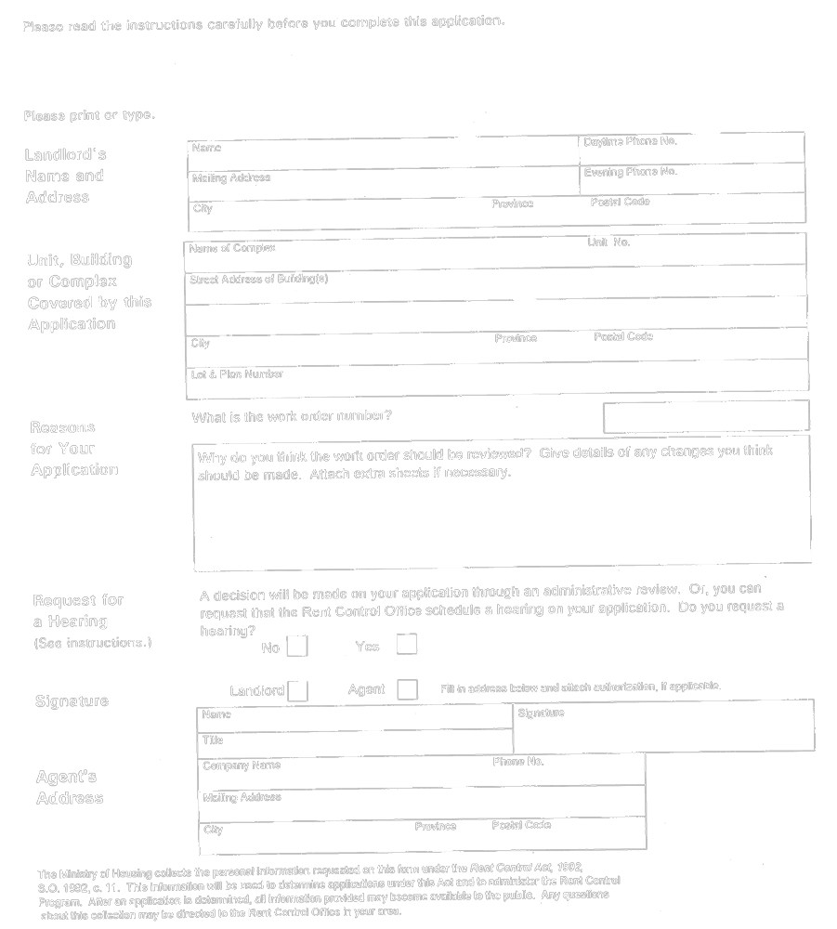
O. Reg. 415/92, Form 10.
Form 11 Revoked: O. Reg. 296/95, s. 4.
Form 12
Rent Control Act, 1992
APPLICATION FOR AN ORDER TO WITHDRAW AN
“ORDER PROHIBITING A RENT INCREASE”
Insert regs\graphics\1992\415\415012ae.tif
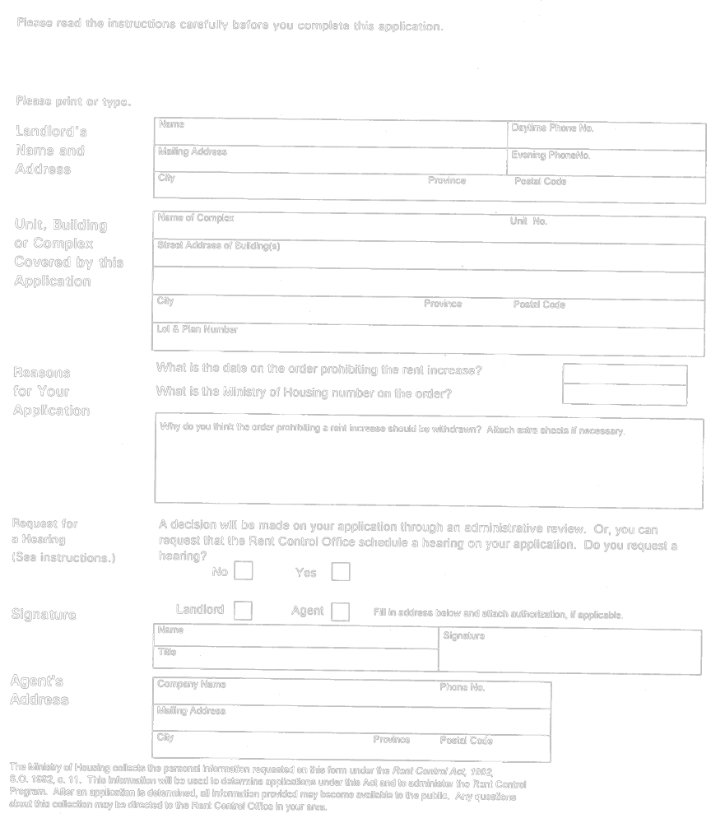
O. Reg. 415/92, Form 12.
Form 13
Rent Control Act, 1992
STATEMENT FOR A NEW RESIDENTIAL COMPLEX
Insert regs\graphics\1992\415\415013ae.tif
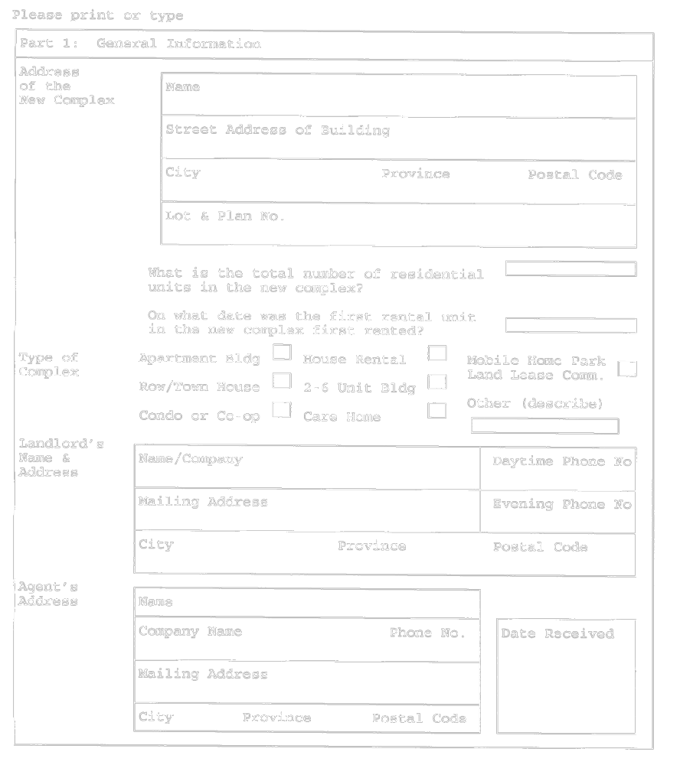
Insert regs\graphics\1992\415\415013be.tif
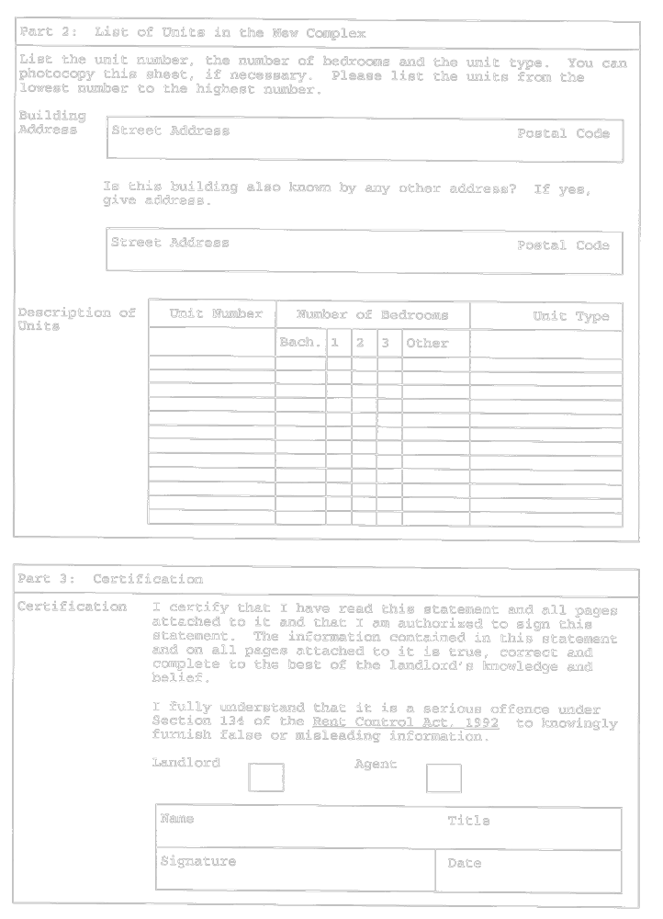
O. Reg. 523/94, s. 3.
Form 14
Rent Control Act, 1992
LANDLORD’S STATEMENT OF RENT INFORMATION
Insert regs\graphics\1992\415\415014ae.tif
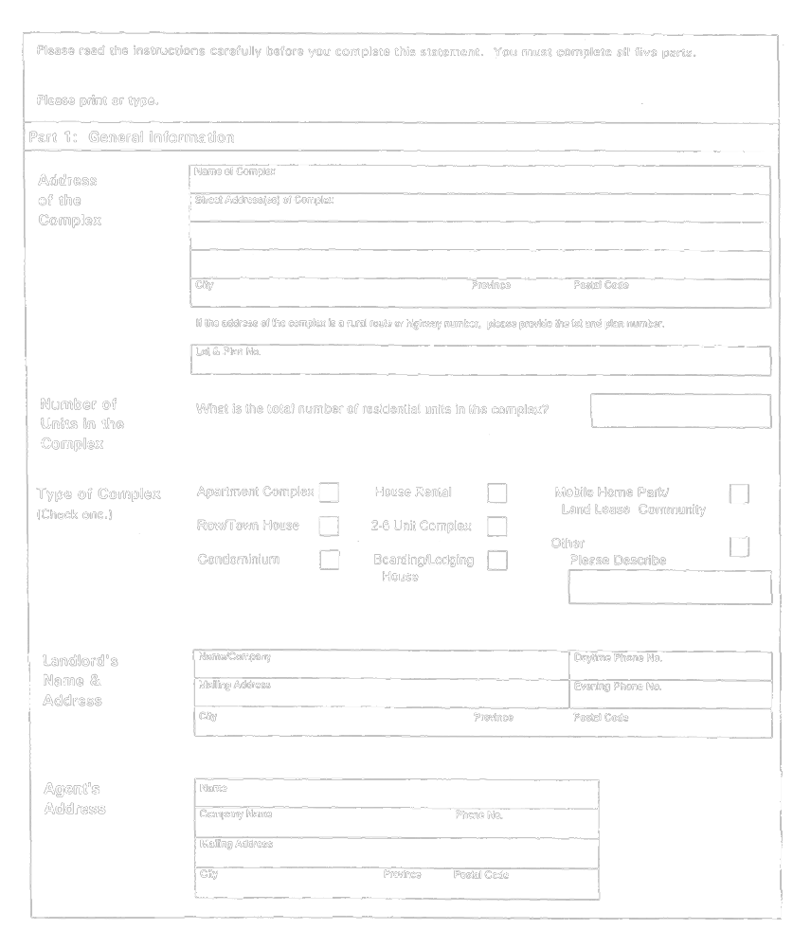
Insert regs\graphics\1992\415\415014be.tif
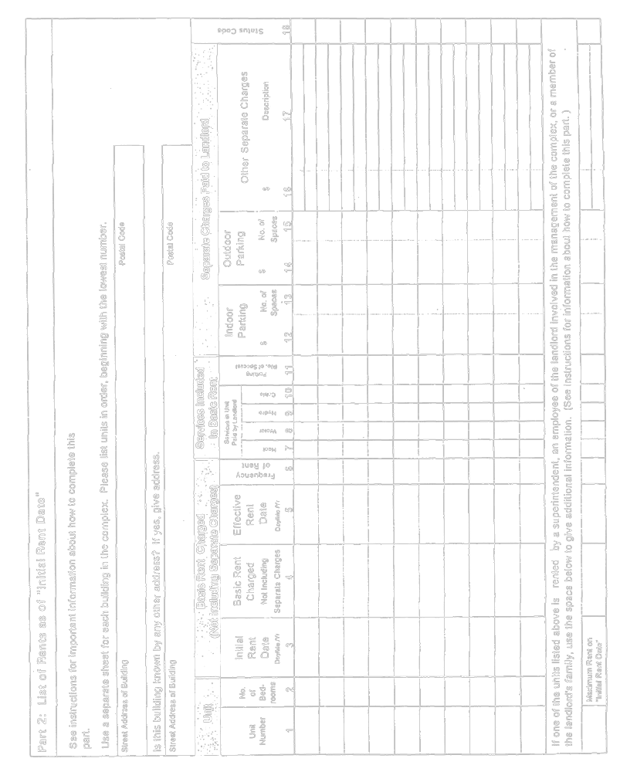
Insert regs\graphics\1992\415\415014ce.tif
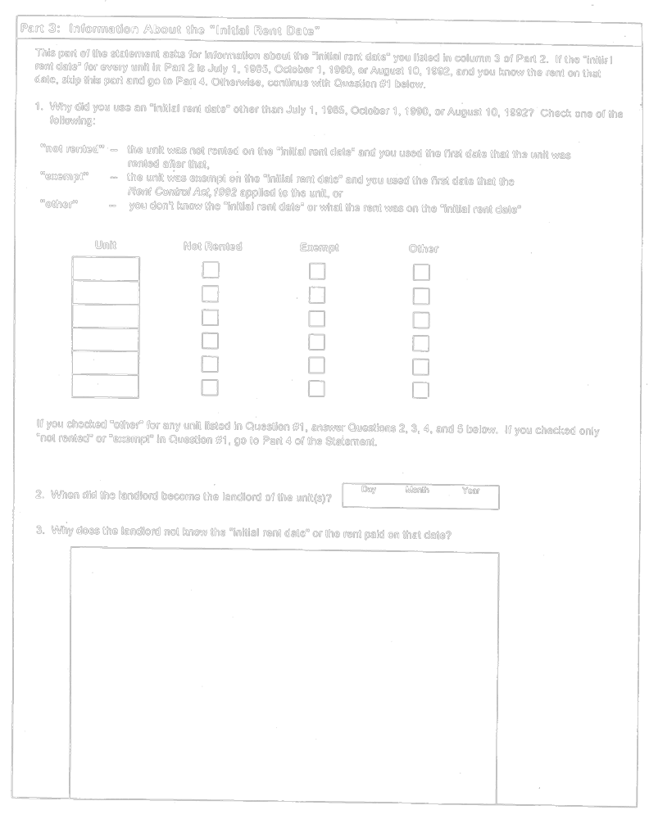
Insert regs\graphics\1992\415\415014de.tif
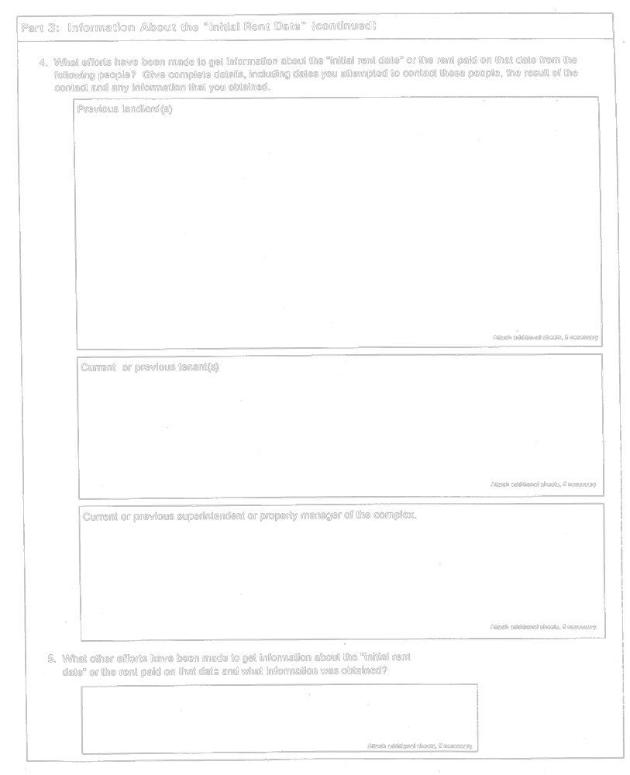
Insert regs\graphics\1992\415\415014ee.tif
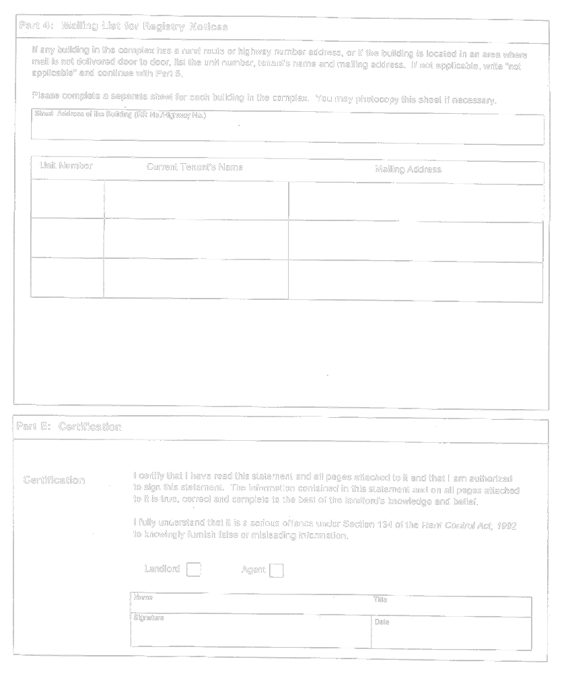
O. Reg. 570/92, s. 4.
Form 15
Rent Control Act, 1992
LANDLORD’S STATEMENT OF A CHANGE IN INFORMATION
Insert regs\graphics\1992\415\415015ae.tif
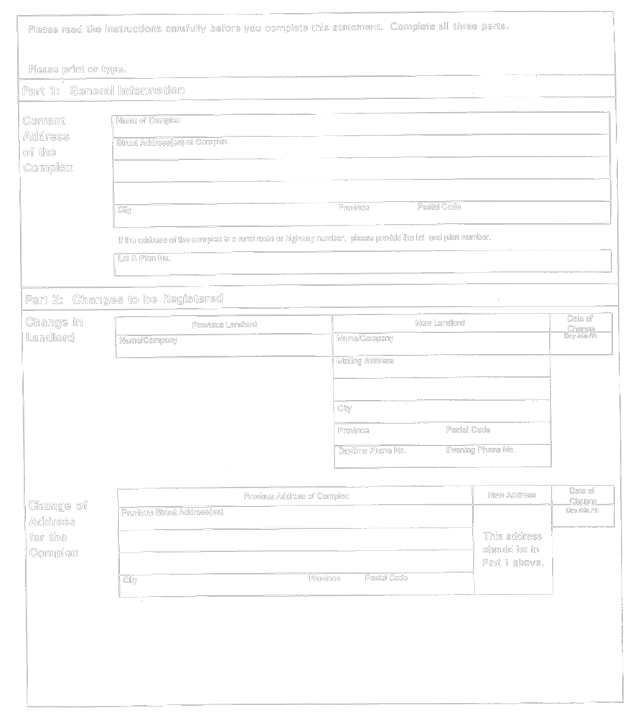
Insert regs\graphics\1992\415\415015be.tif
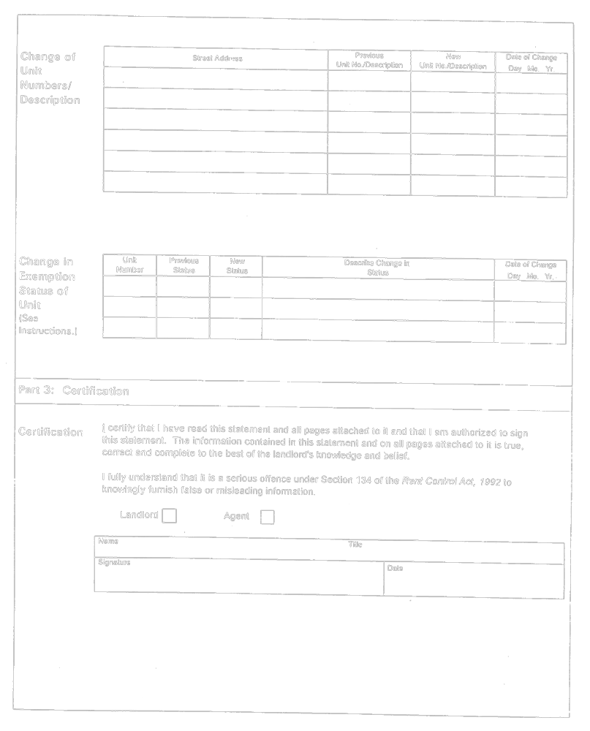
O. Reg. 570/92, s. 4.
Form 16
Rent Control Act, 1992
NOTICE OF RENT INCREASE
Insert regs\graphics\1992\415\415016ae.tif
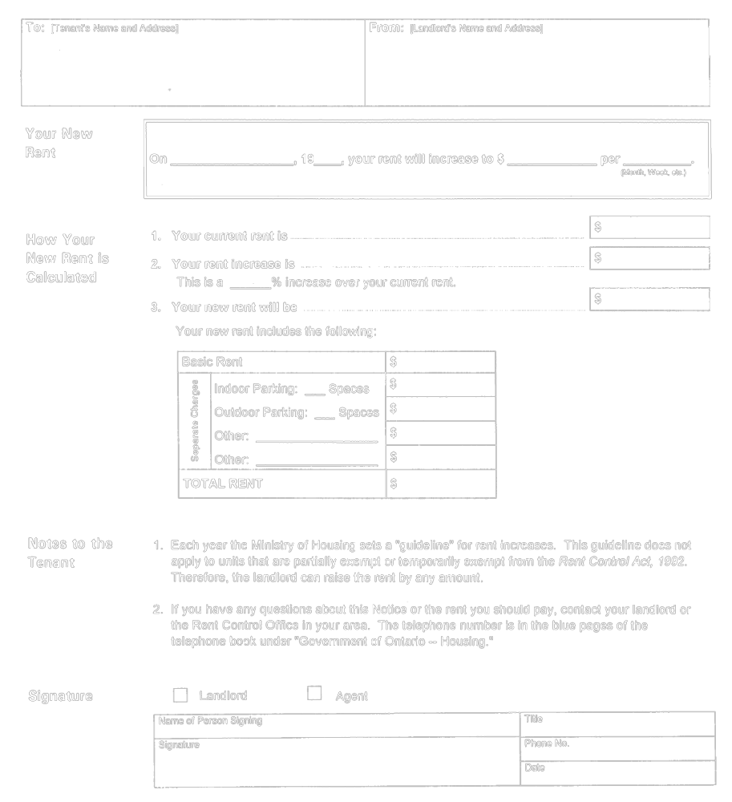
O. Reg. 10/93, s. 2.
Form 17
Rent Control Act, 1992
SCHEDULE A—OPERATING COSTS
Insert regs\graphics\1992\415\415017ae.tif
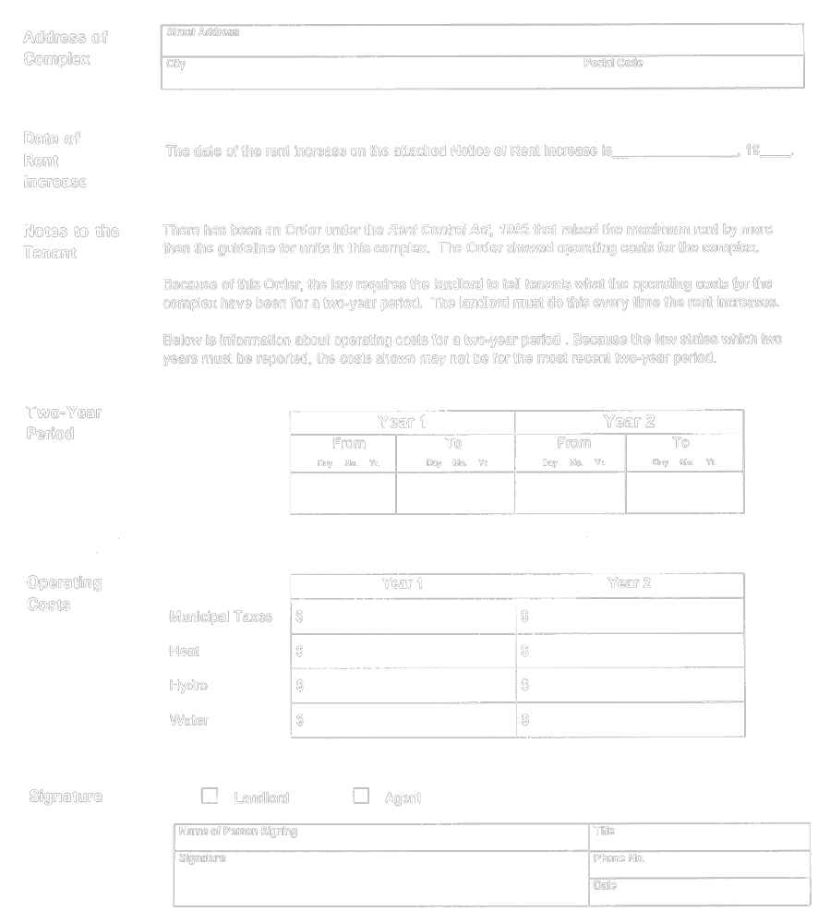
O. Reg. 10/93, s. 2.
Form 18
Rent Control Act, 1992
NOTICE OF WAIVER
Insert regs\graphics\1992\415\415018ae.tif
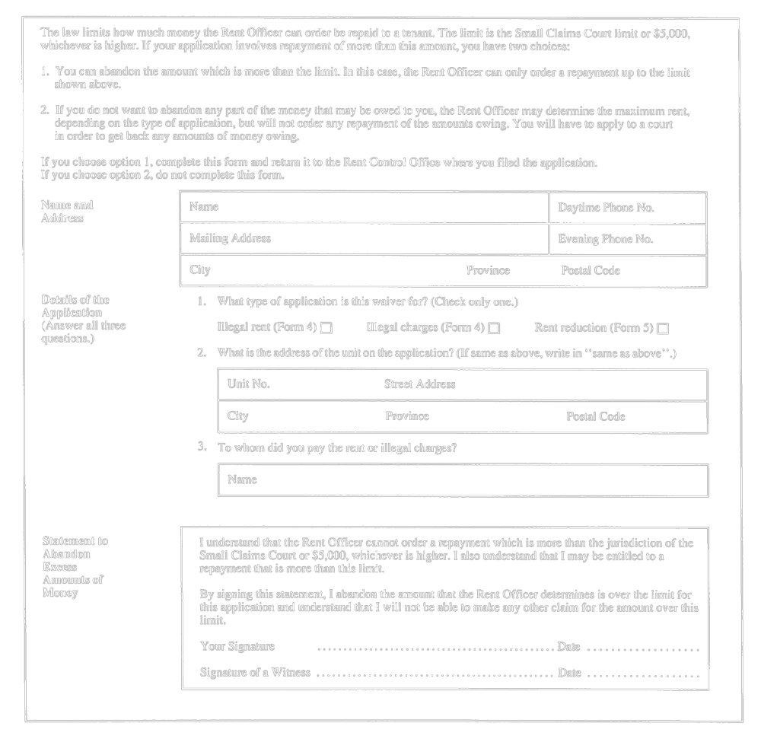
O. Reg. 553/93, s. 3.
Form 19
Rent Control Act, 1992
SEARCH WARRANT UNDER SECTION 124 OF THE ACT
Insert regs\graphics\1992\415\415019ae.tif
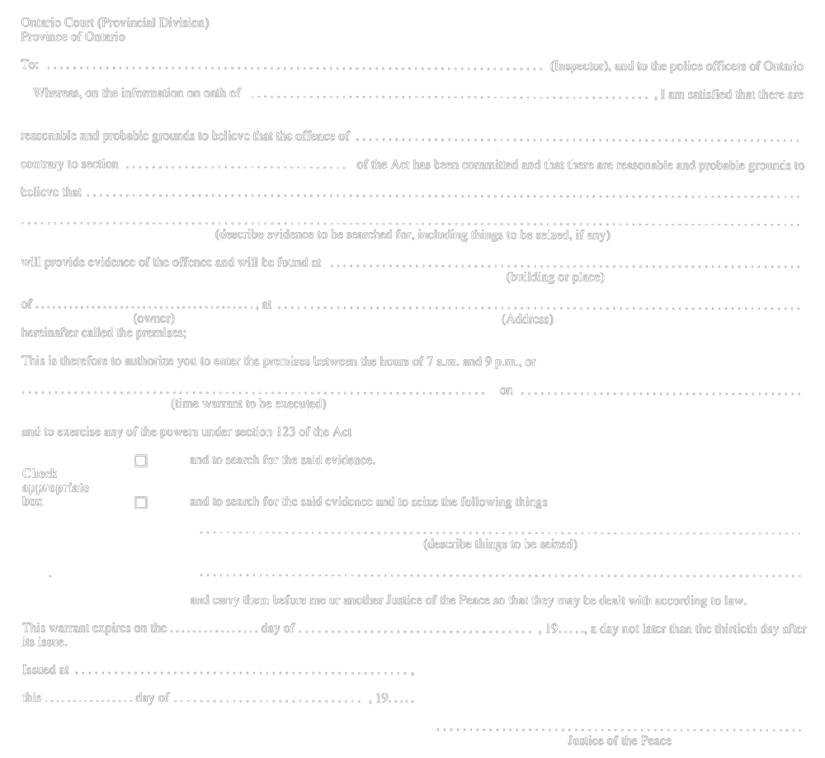
O. Reg. 553/93, s. 3.
Form 20 Revoked: O. Reg. 296/95, s. 4.
Form 21
Rent Control Act, 1992
notice of rent increase—care homes
Insert regs\graphics\1992\415\415021ae.tif
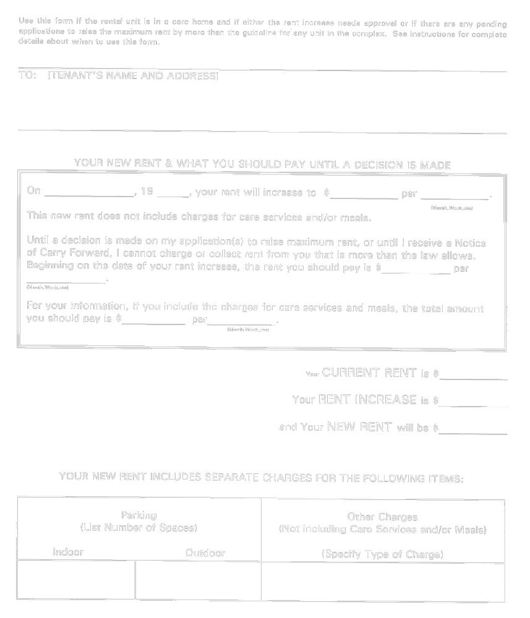
Insert regs\graphics\1992\415\415021be.tif
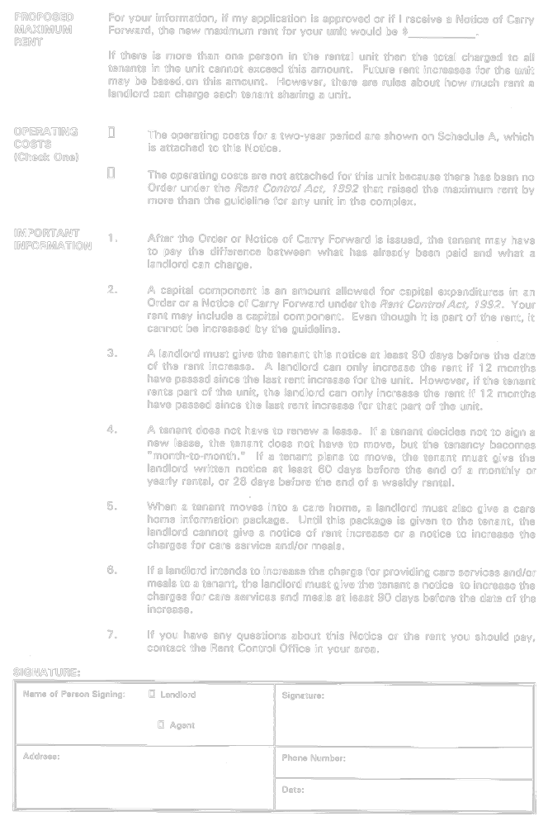
O. Reg. 523/94, s. 3.
Form 22
Rent Control Act, 1992
notice of rent increase—care homes
Insert regs\graphics\1992\415\415022ae.tif
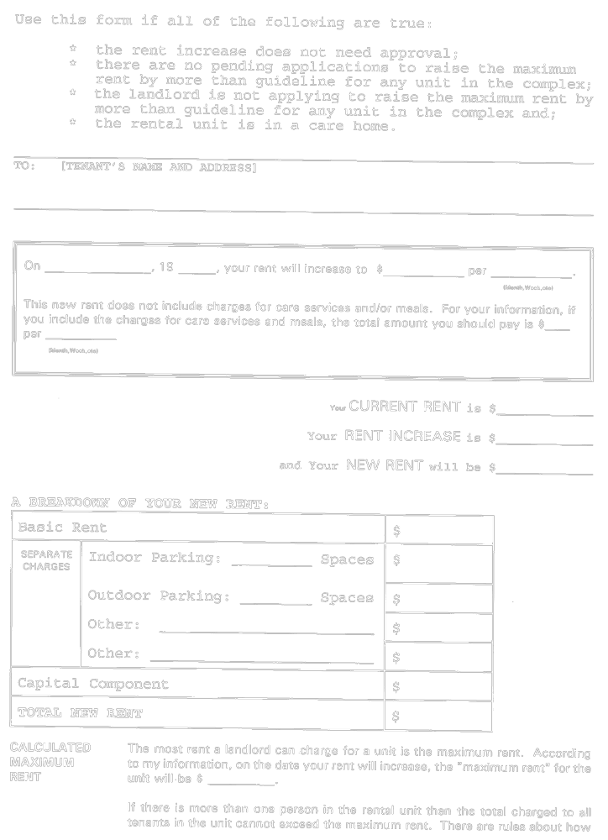
Insert regs\graphics\1992\415\415022be.tif
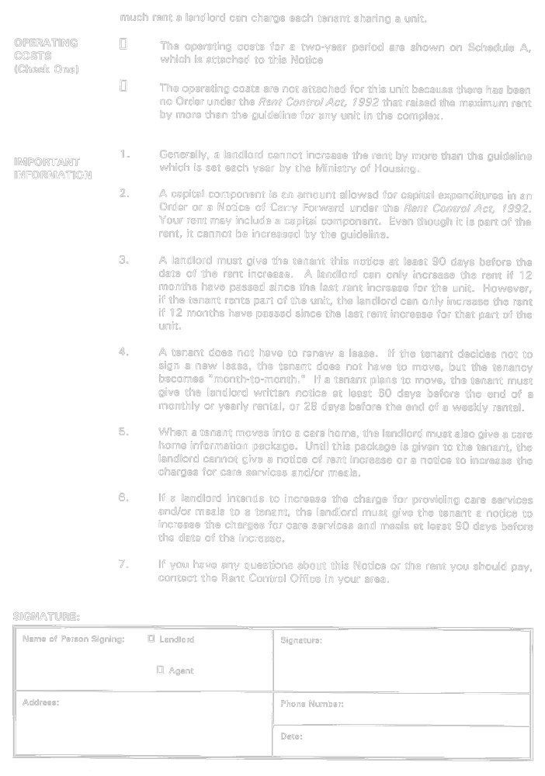
O. Reg. 523/94, s. 3.
Form 23
Rent Control Act, 1992
notice of increased charges for care services and meals
Insert regs\graphics\1992\415\415023ae.tif
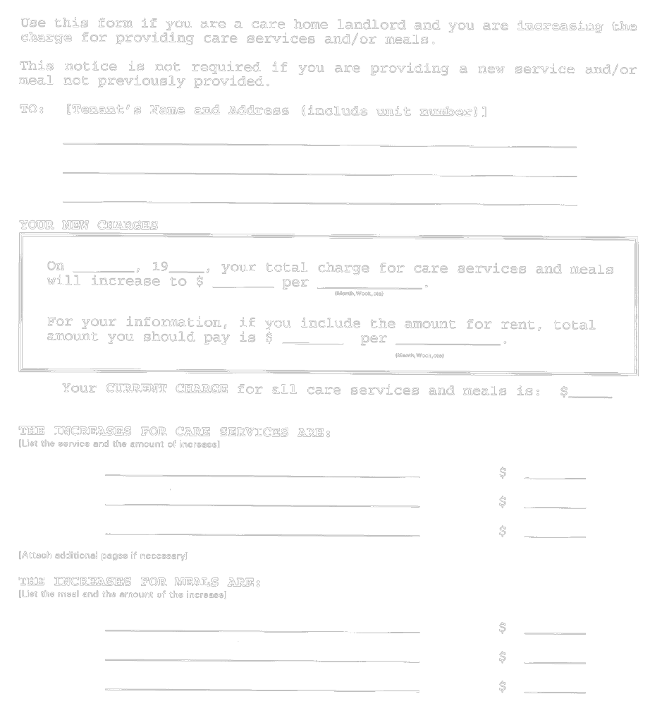
Insert regs\graphics\1992\415\415023be.tif
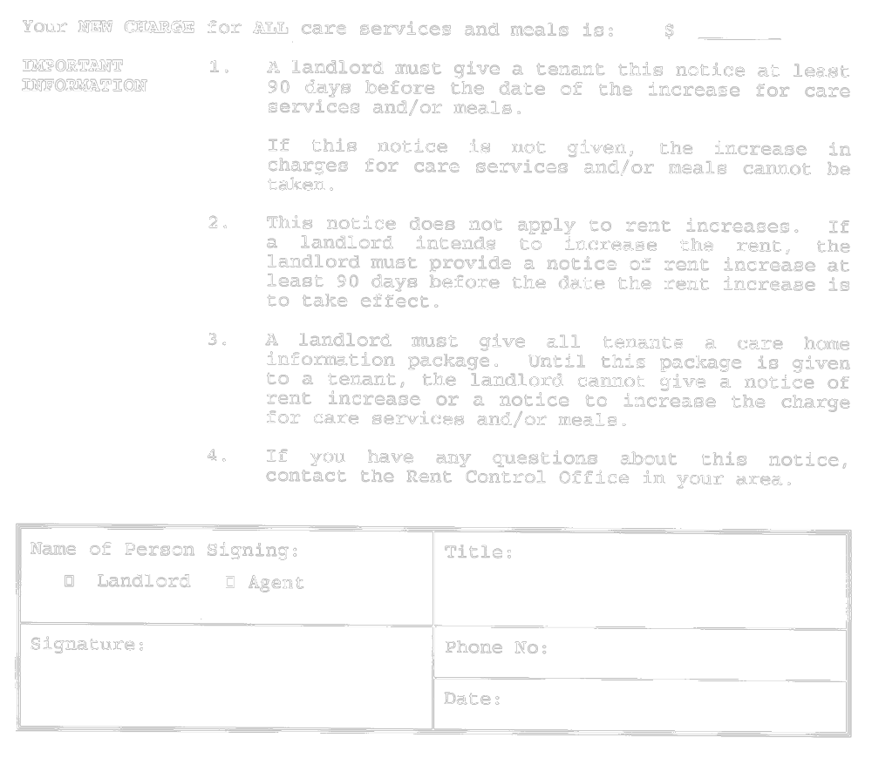
O. Reg. 523/94, s. 3.

Français

Back to top

